VERSIONING THE OBJECTS IN A BUCKET

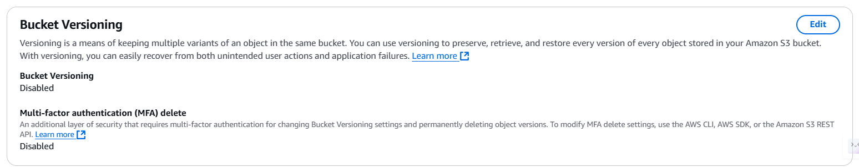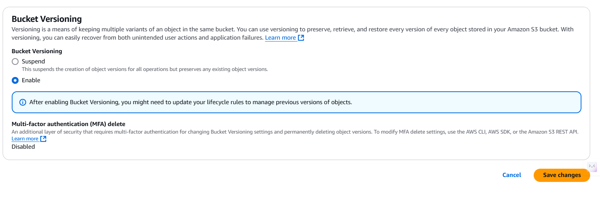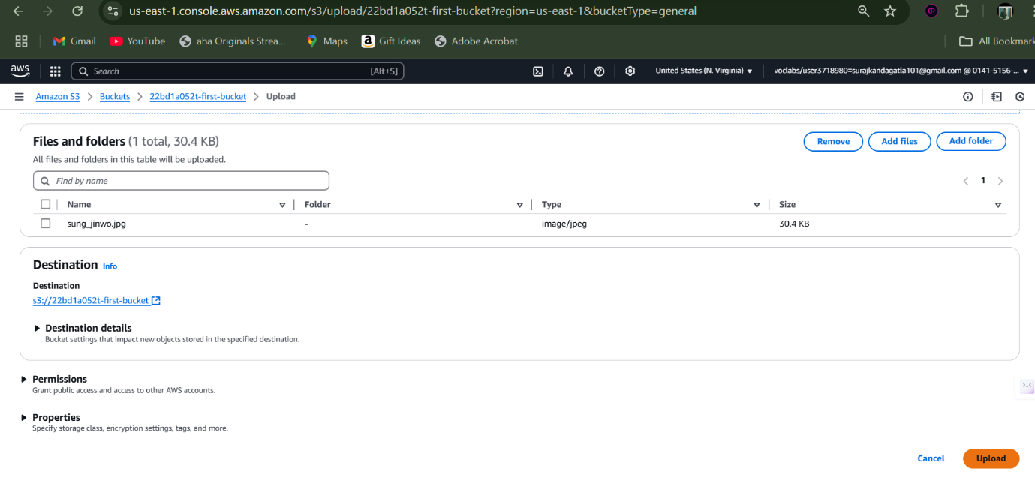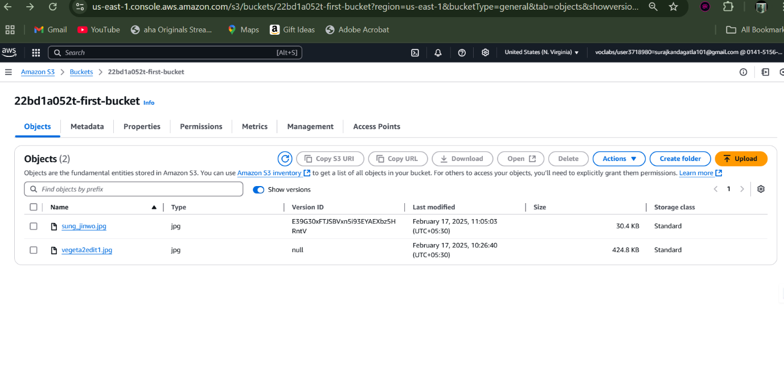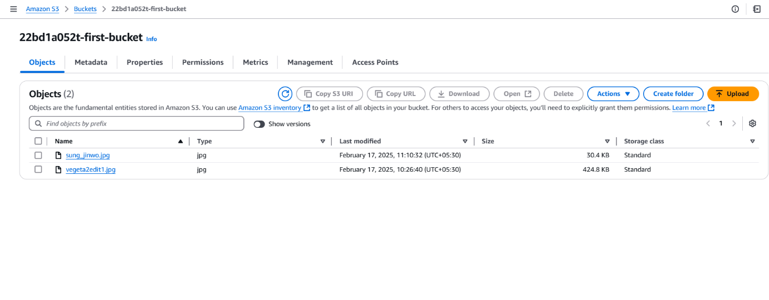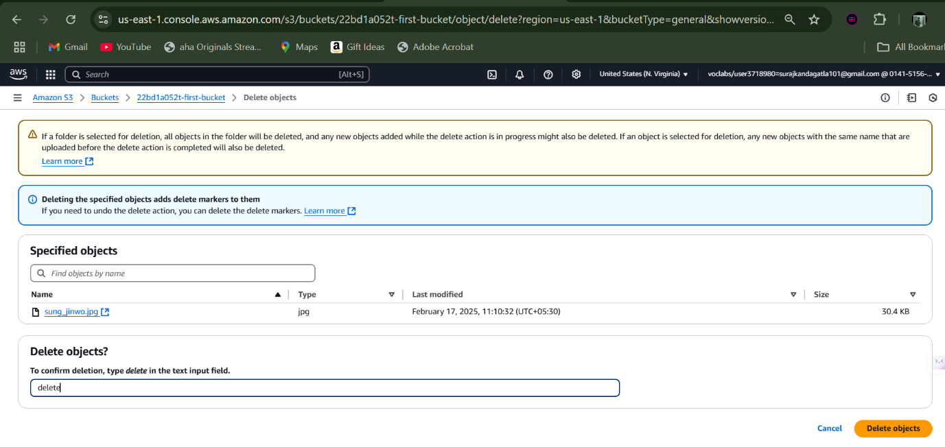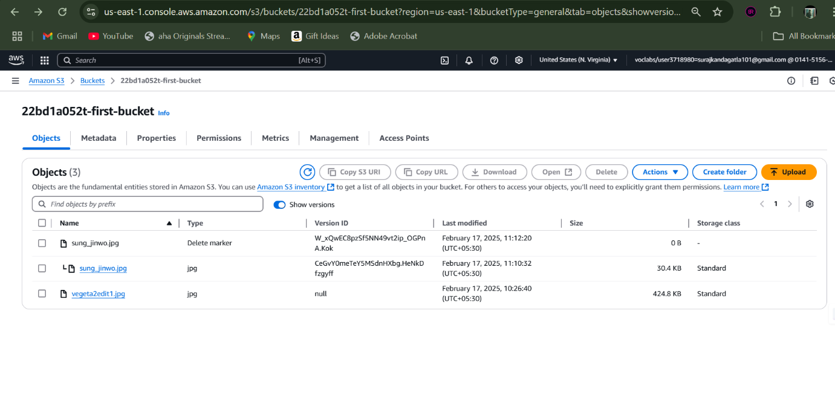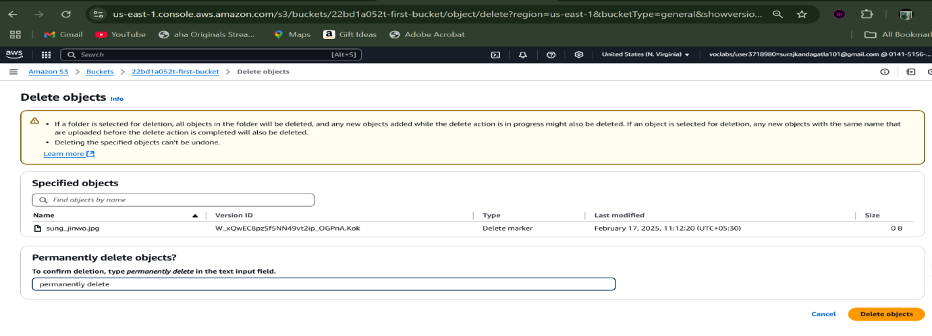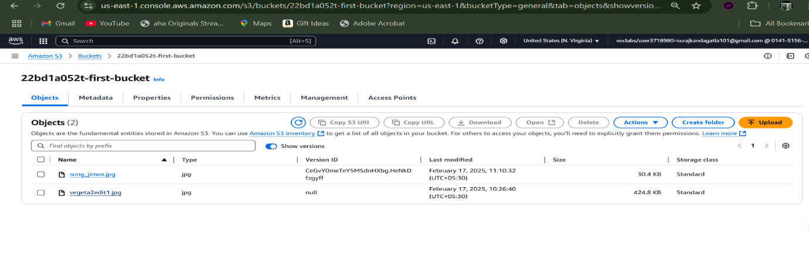

Now lets make another type of versioning, where we make changes to the object and re-upload it.

Firstly upload a new object

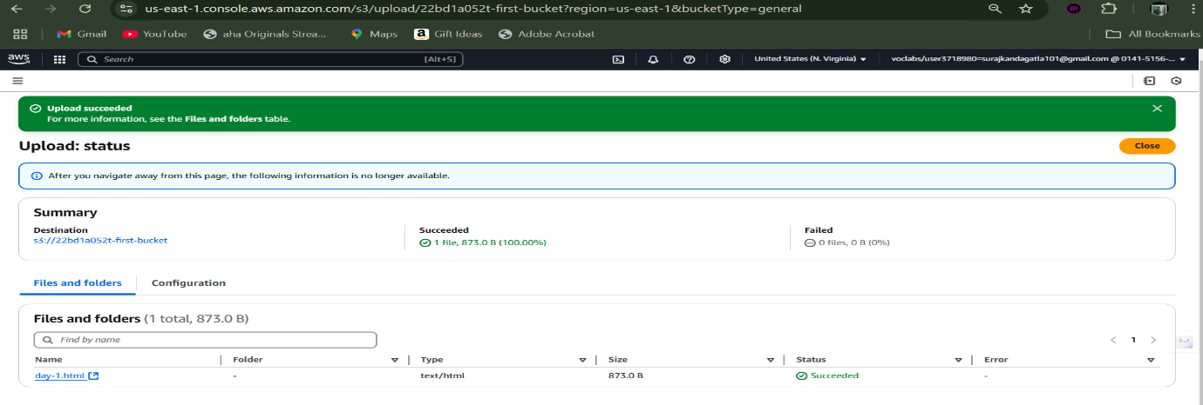

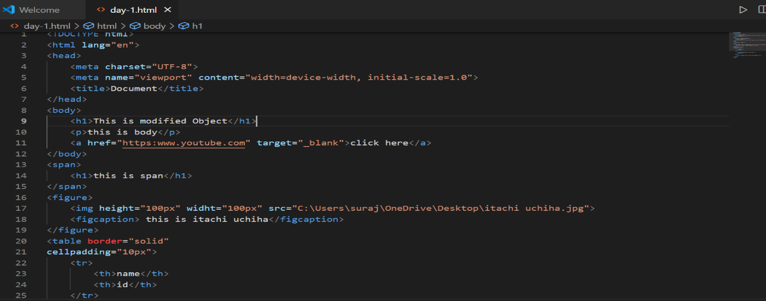

Then after making changes as shown above, re-upload the object.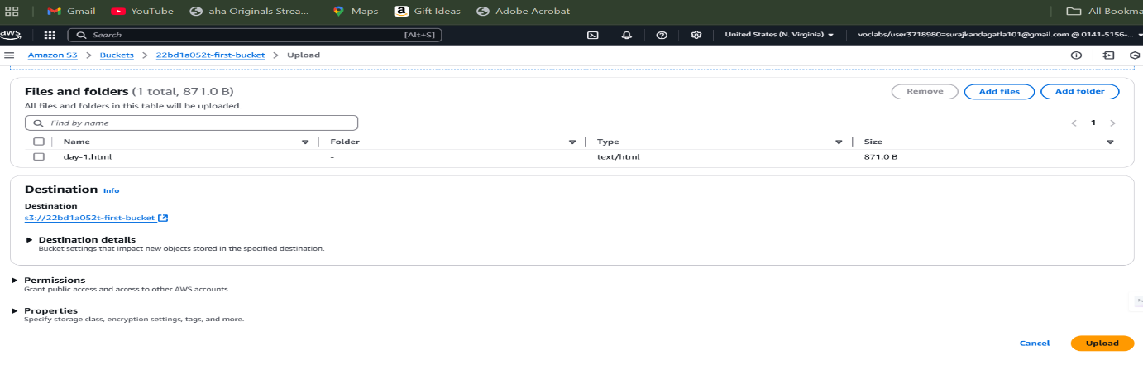

Now when observed in bucket we can only see the latest version by default.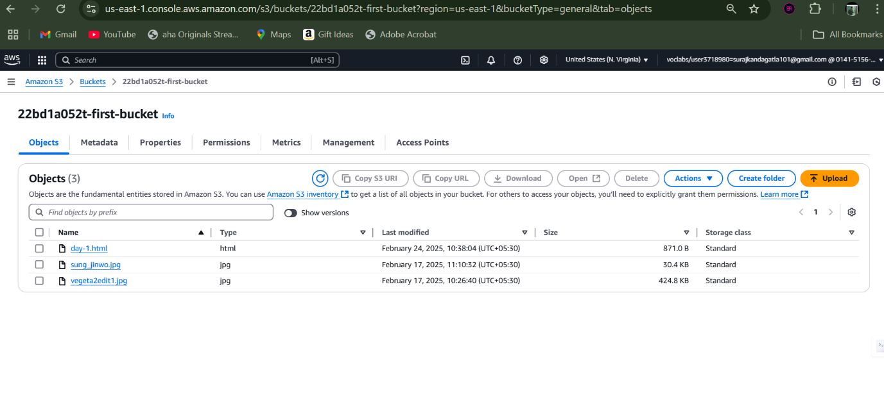

Once we enable the feature to display versions, we can now see different versions of same object.s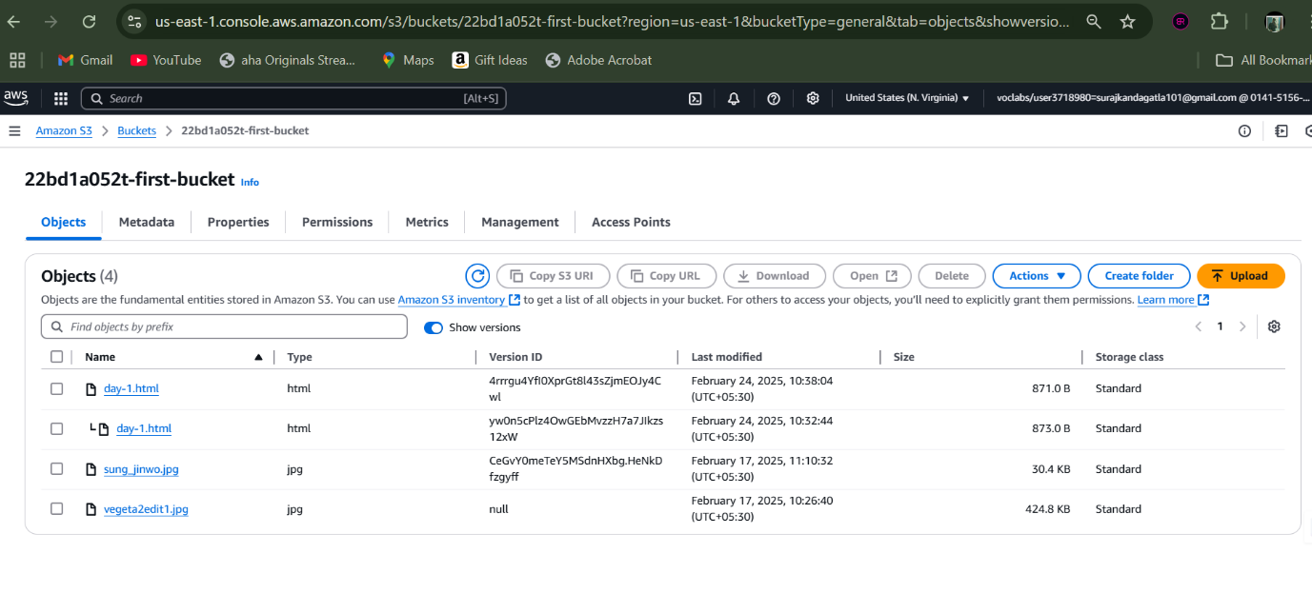

CROSS-REGION REPLICATION

Firstly from any other region create a bucket

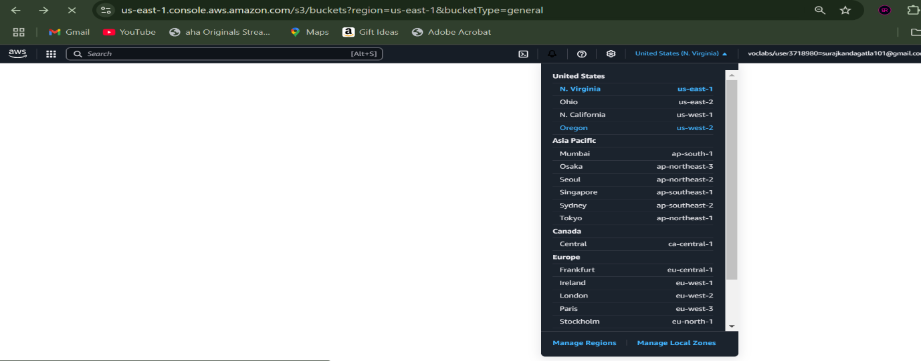

Then provide a global unique name for it.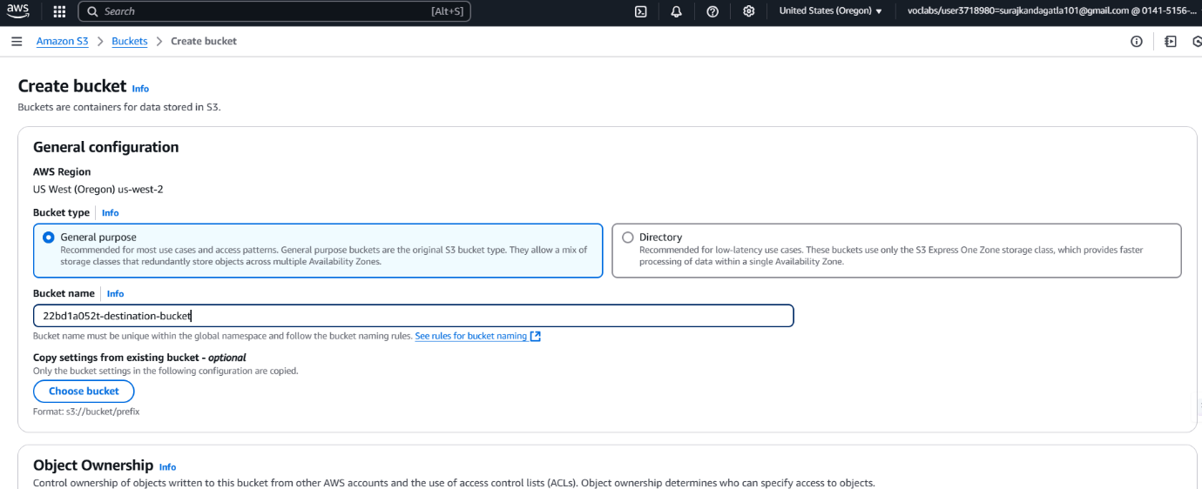

Now that we have two buckets from different regions, we can proceed.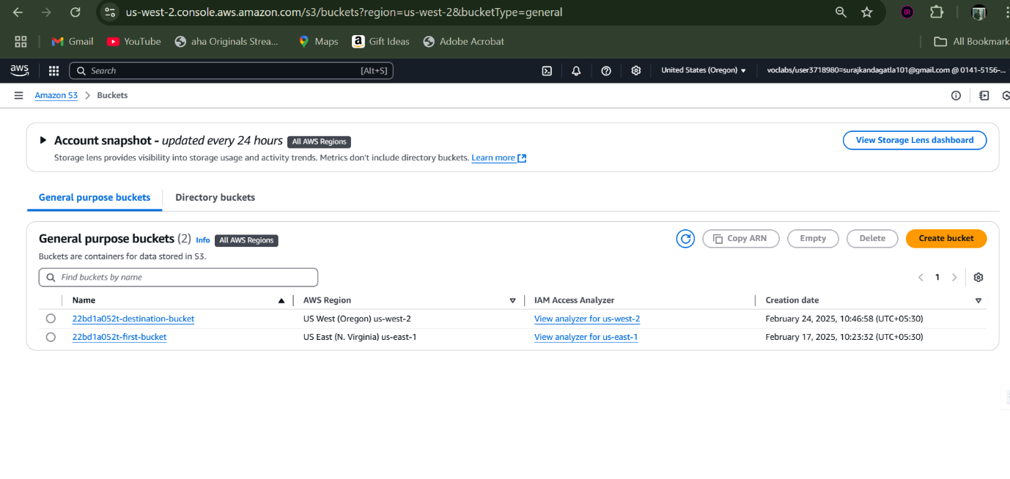

Ensure that the buckets are enabled with versioning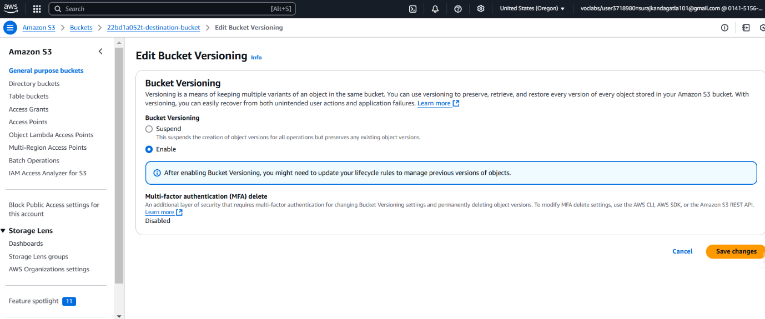

Under the source bucket’s management section go for creating a replication rule.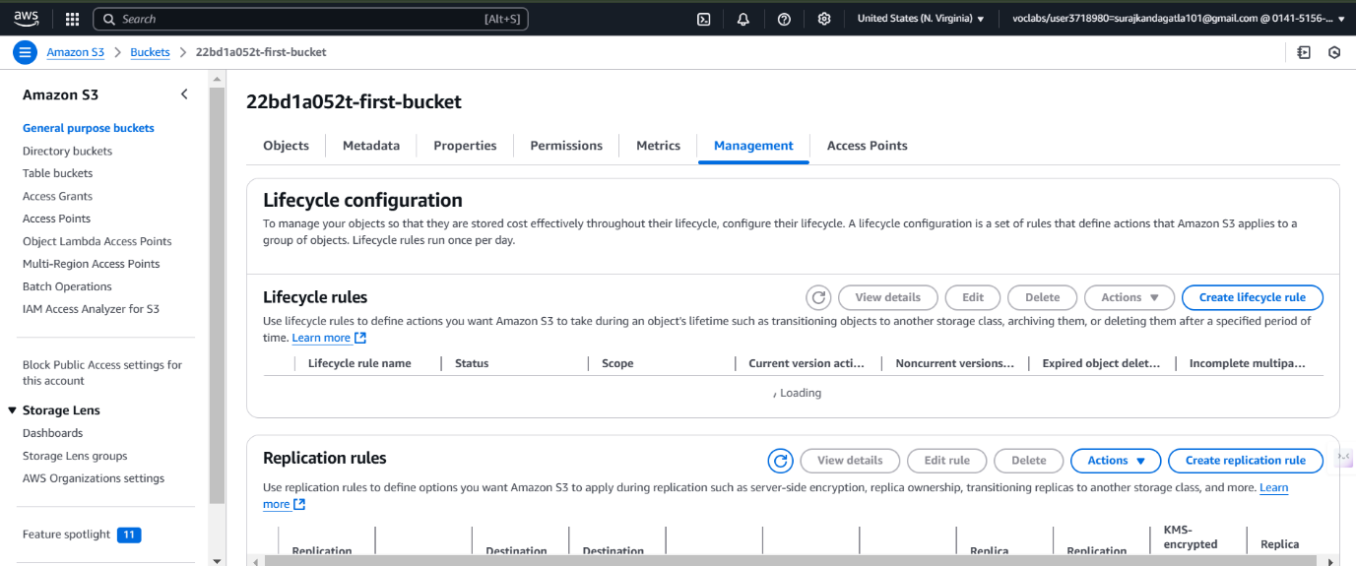

Now provide a name for this rule.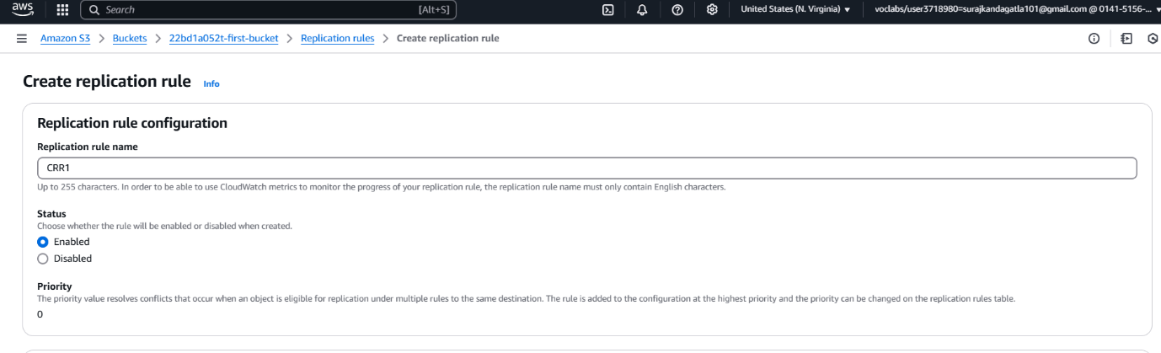

Source bucket is treated as current bucket by default we can choose any existing bucket as destination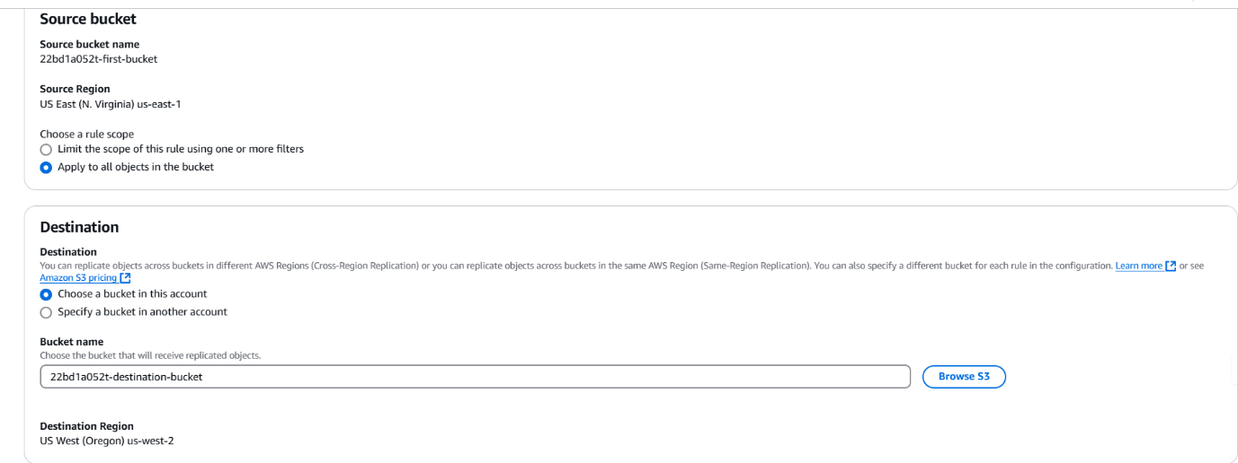

Select the LabRole as IAM rule.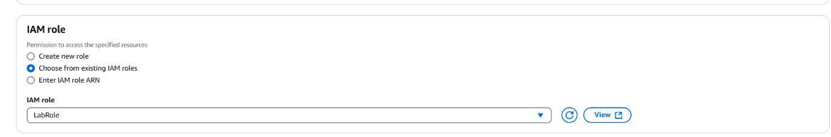

By select no, the objects which are added newly will only be replicated.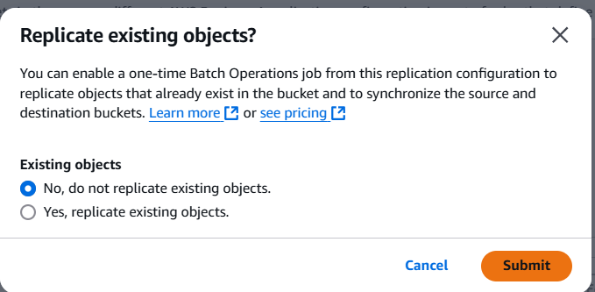

Now upload a new object in source bucket.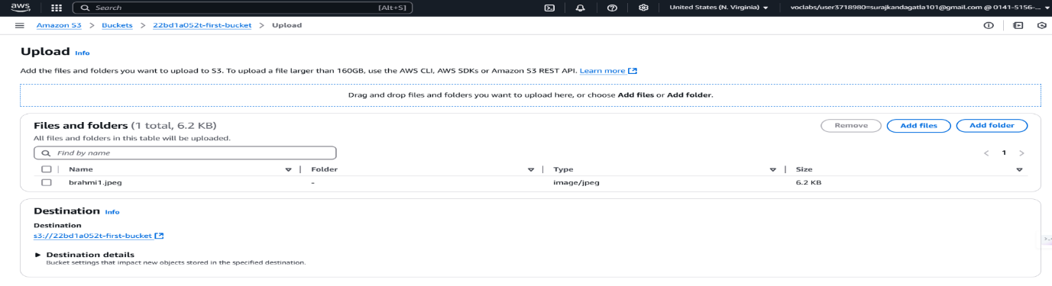

When we check the destination bucket, we can find the object replicated directly.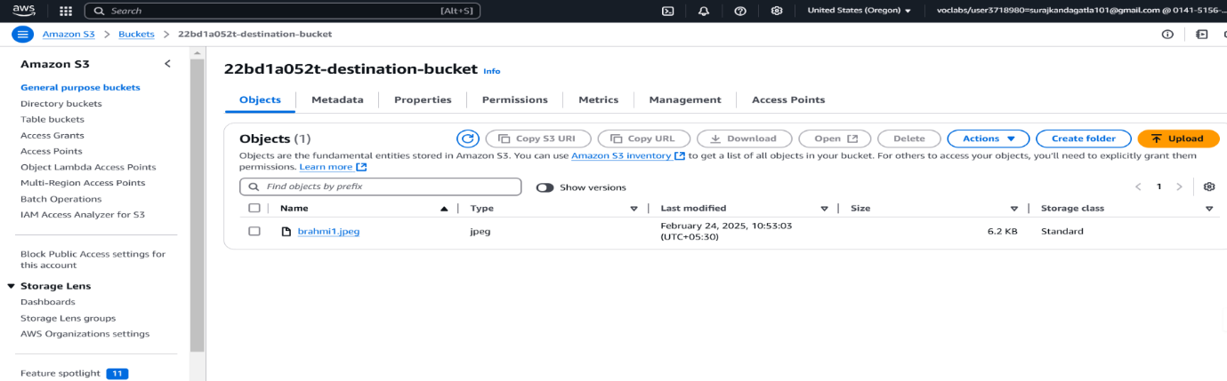

STATIC WEB HOSTING

Enable the static web hosting options for the bucket.

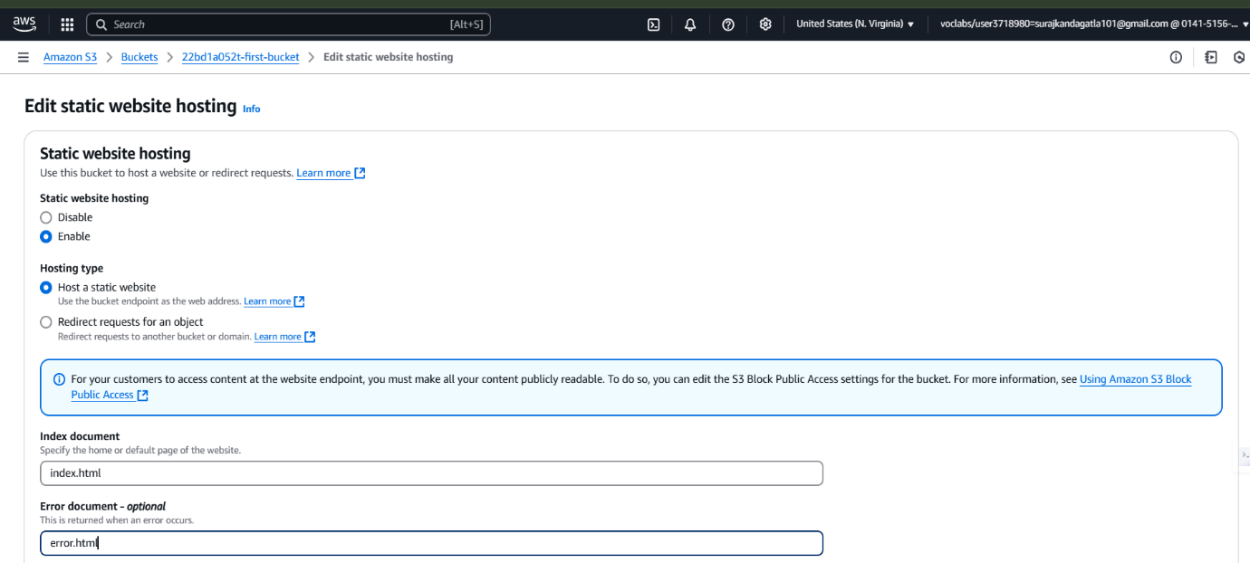

Upload a html file into bucket

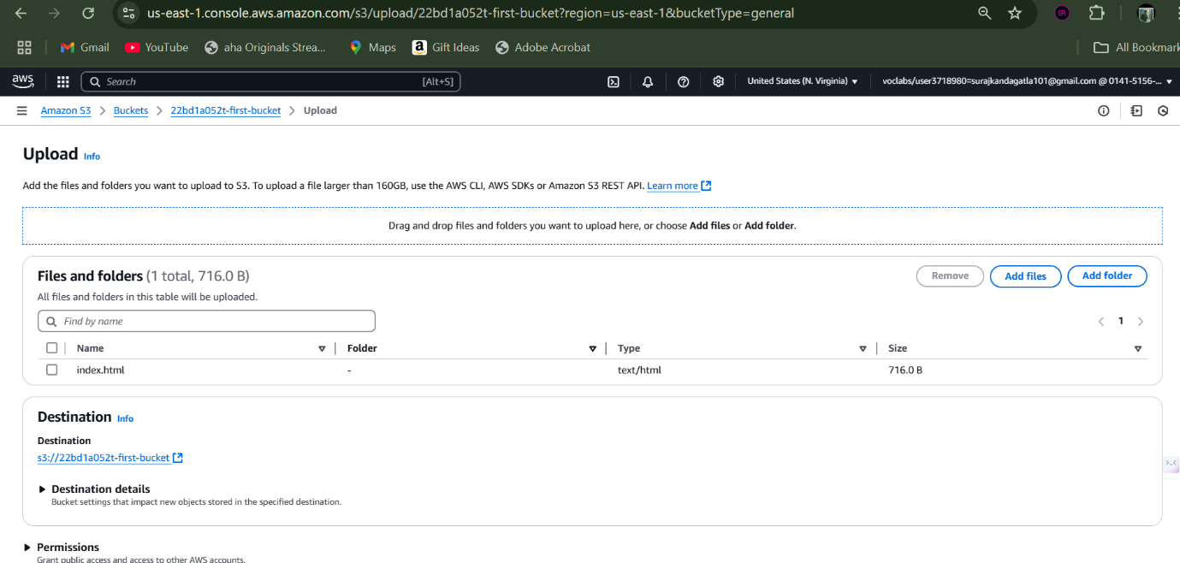

Now we have our html page in our bucket to display.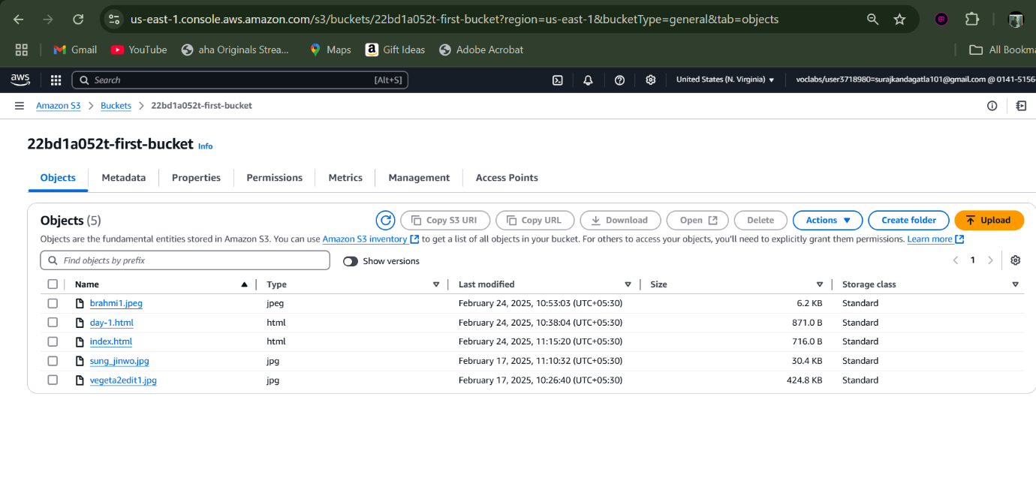

Now under object level permissions, provide ACL permissions.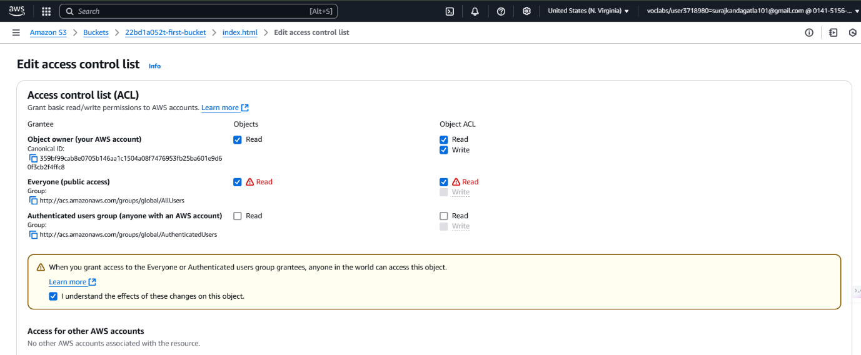

Now under bucket level properties section, copy the url for static web hosting to get the page displayed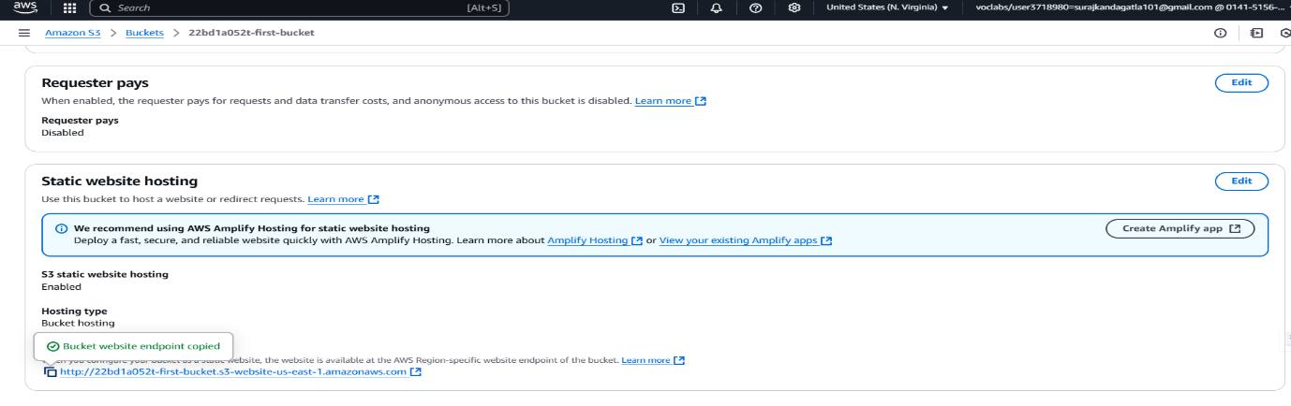

And now out page is being displayed.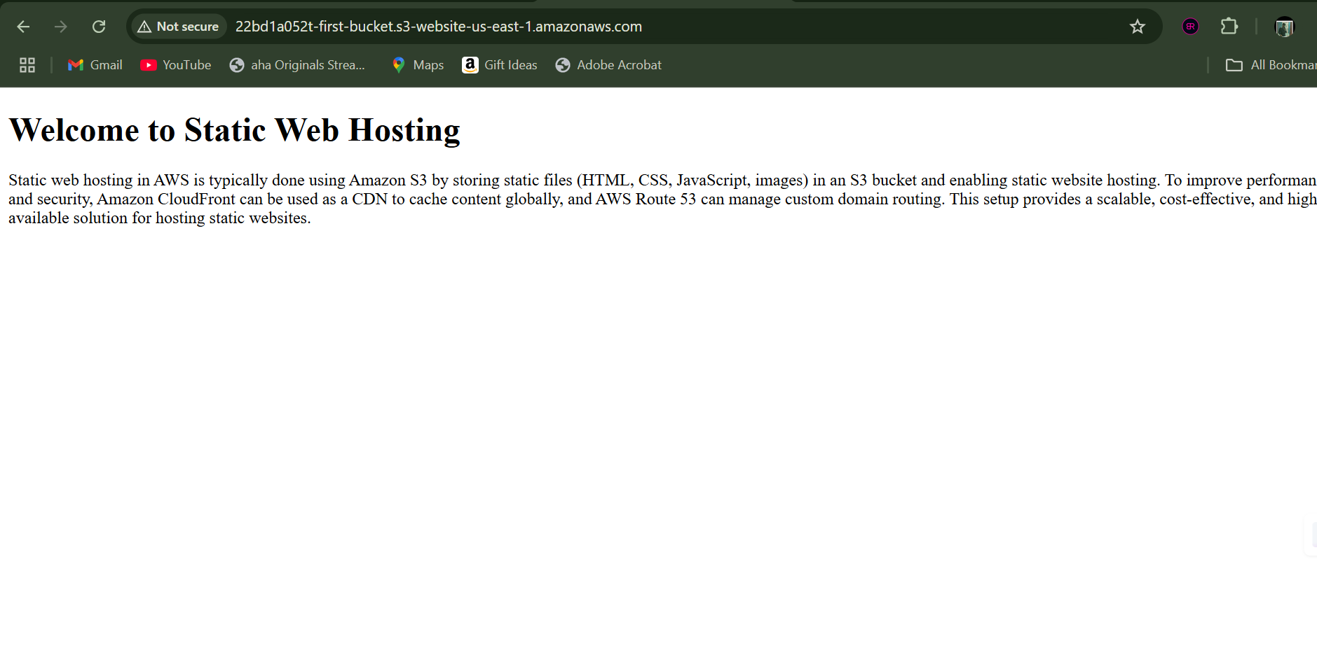

Now lets provide a error.html for handling errors in web hosting.

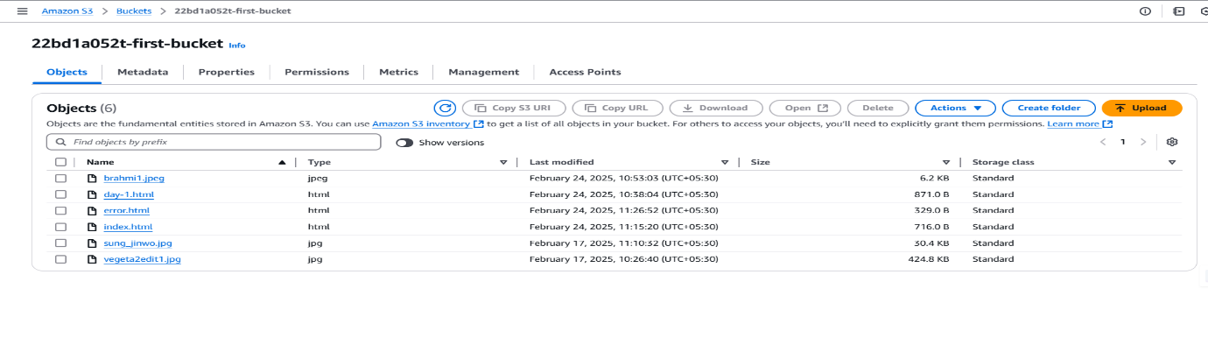

Allow object level permissions for the error.html page too. Then delete the index.html object.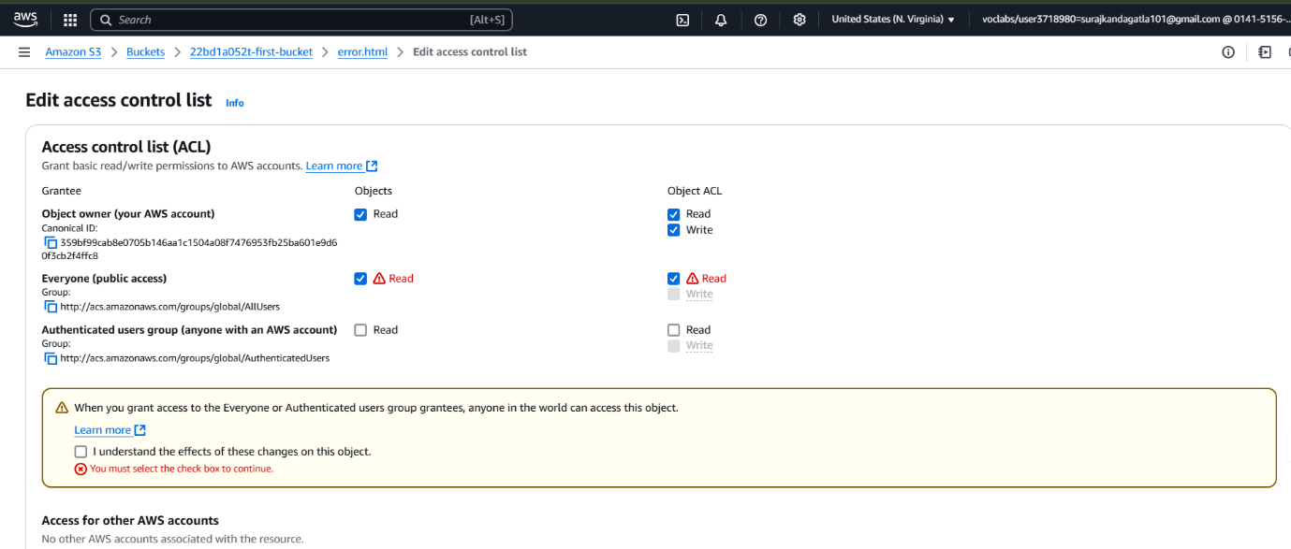

Now we are re-directed to our error.html page on error.