EBS-EFS-SNAPSHOT

Navigate to snapshot service and create a snapshot with one volume.

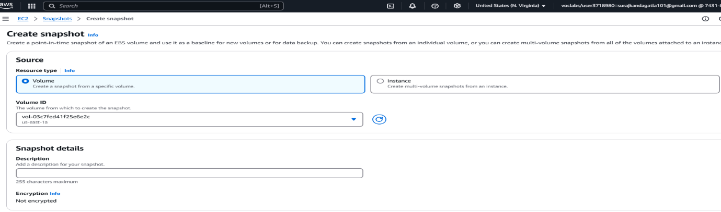

Now we need to copy that snapshot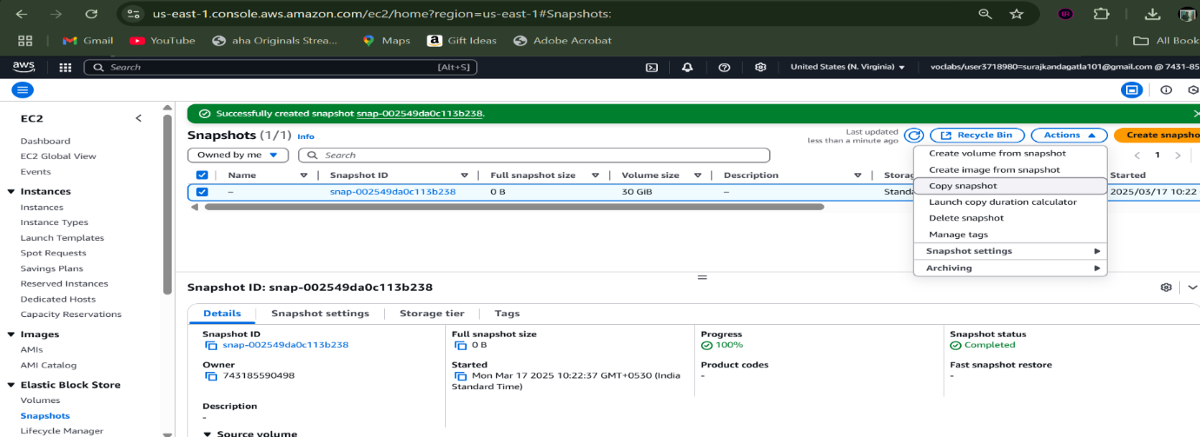

Now provide the other instance which is present in another region as destination.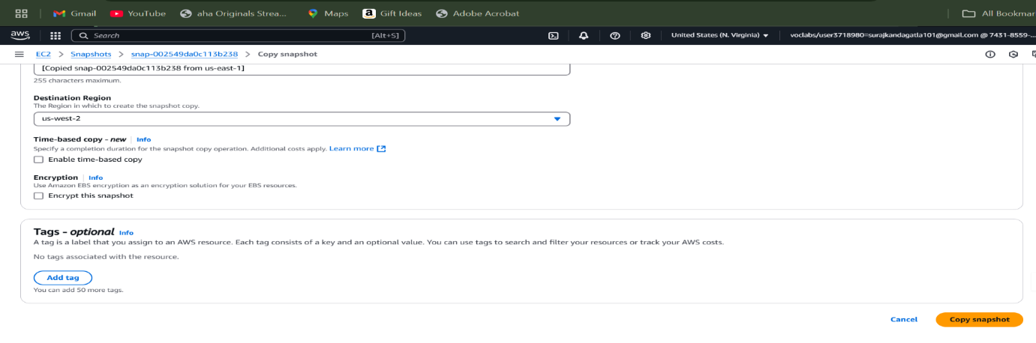

Now we can see that the snapshot is available in another instance of another region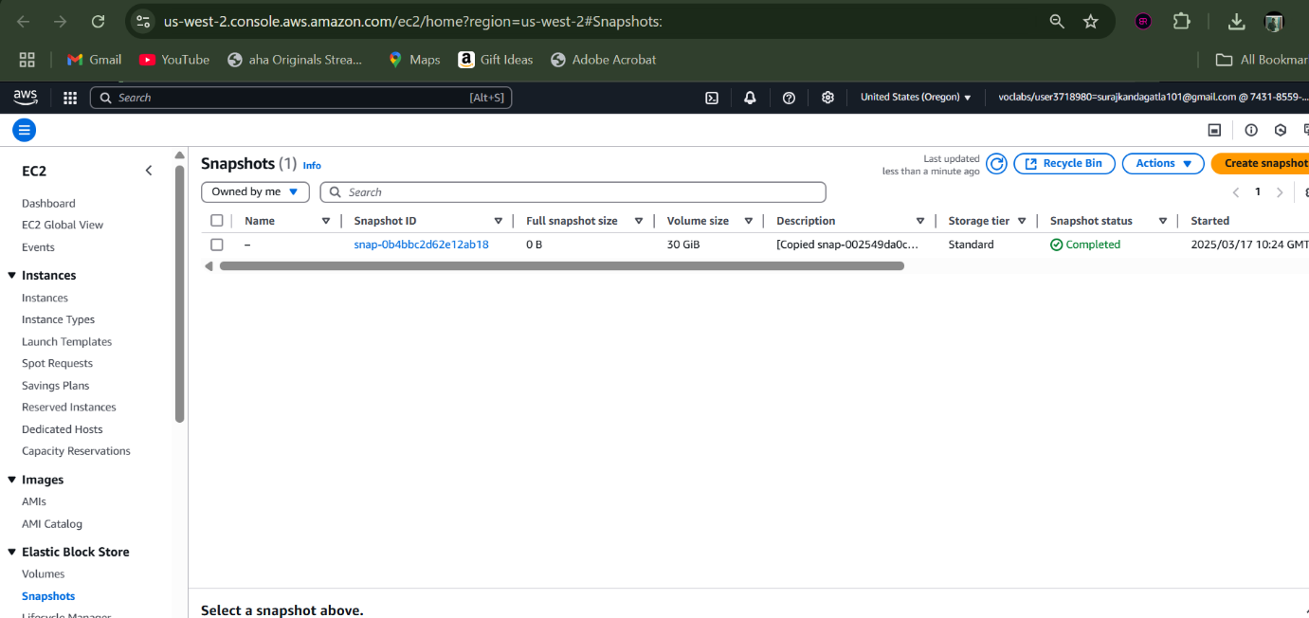

EFS-EXPERIMENT:

We need to create two instances

->ensure that both of them are in different availability zones.

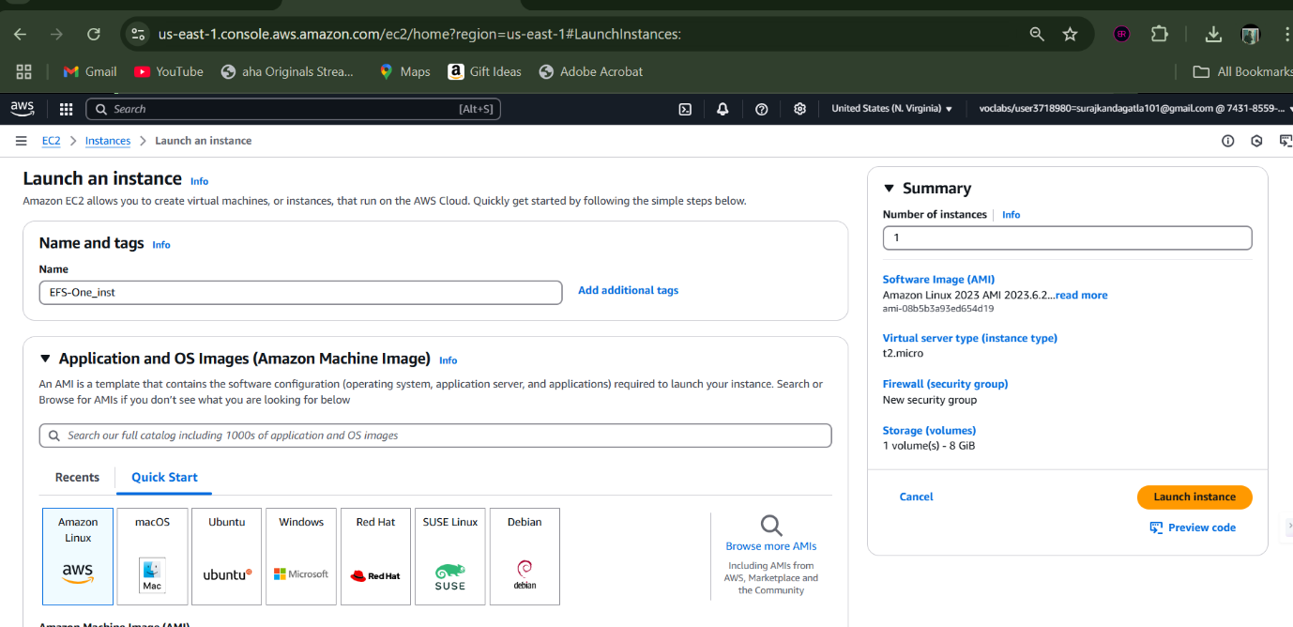

->this is another instance in different A.Z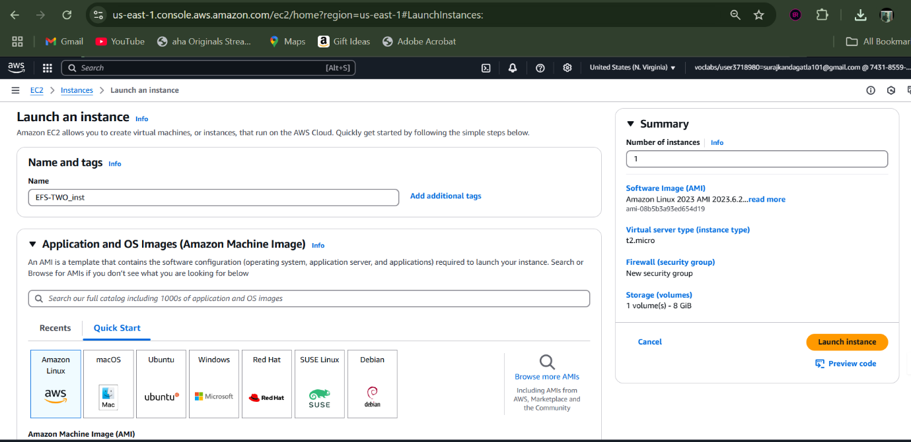

Now we should provide a common Inbound Rule named “NFS”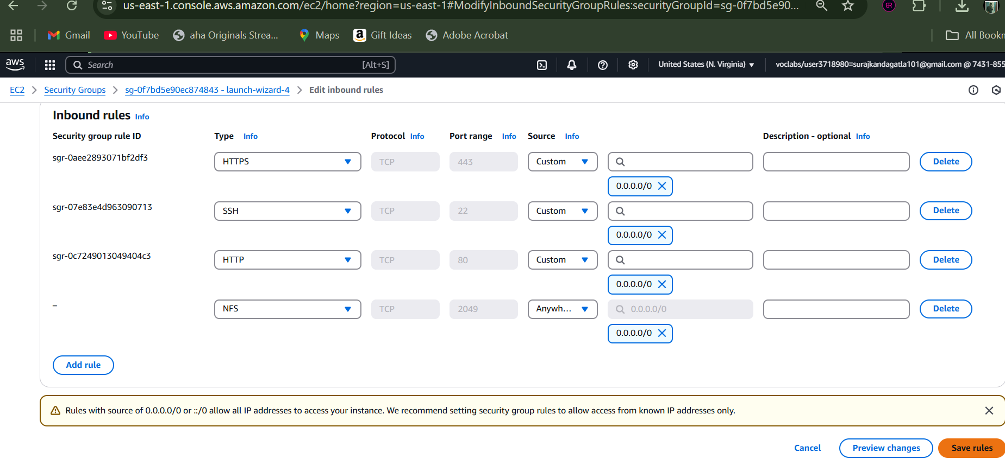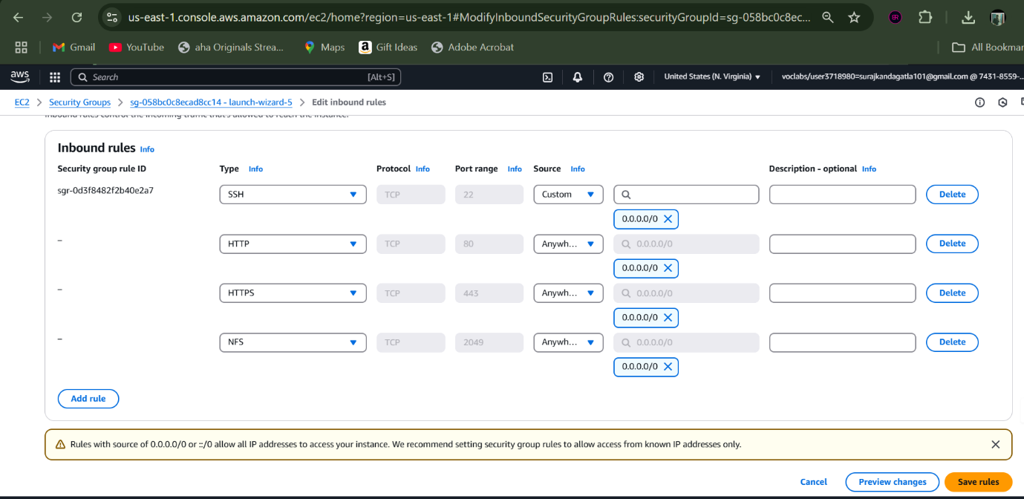

Now navigate to EFS service provided by AWS: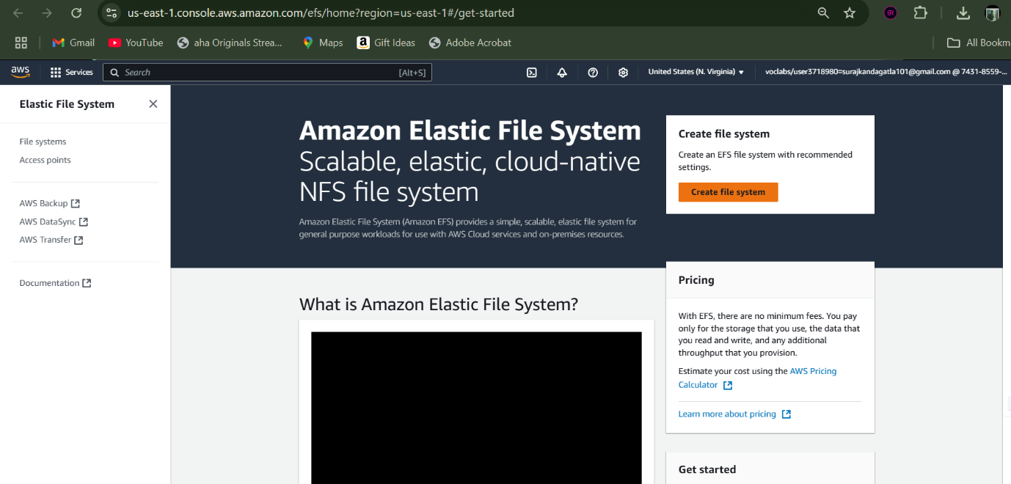

Creating a File System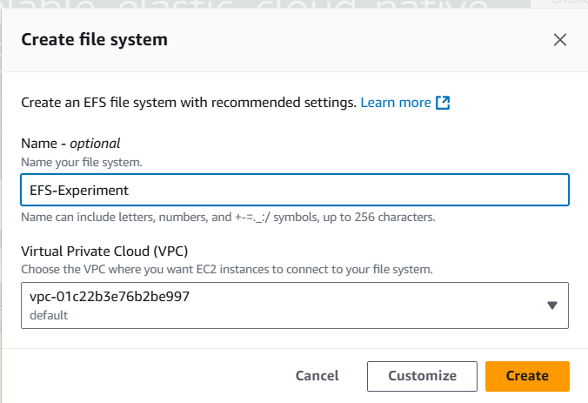

Now navigate to that file system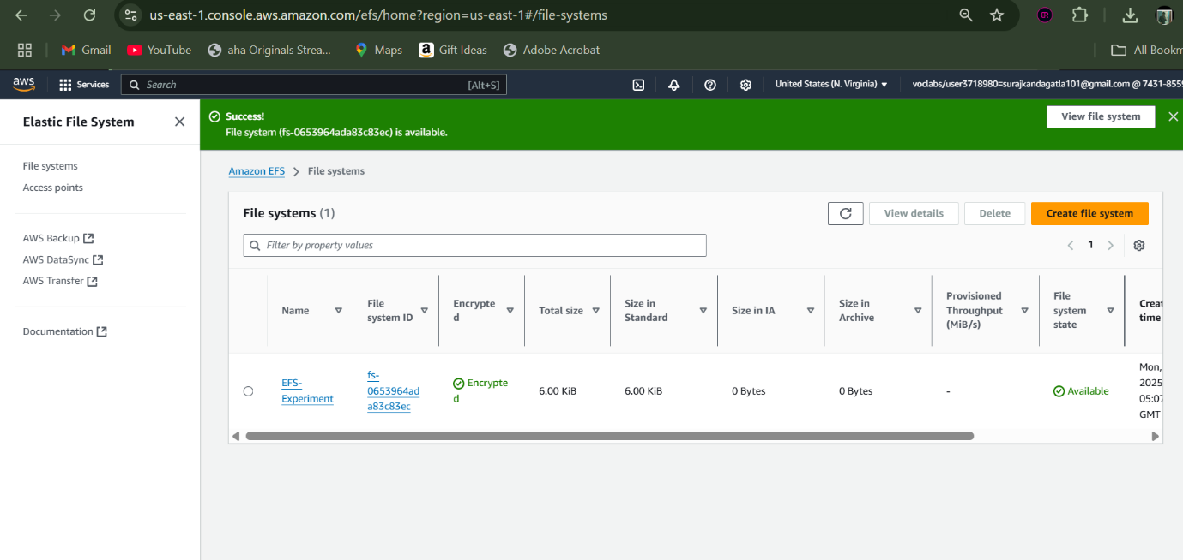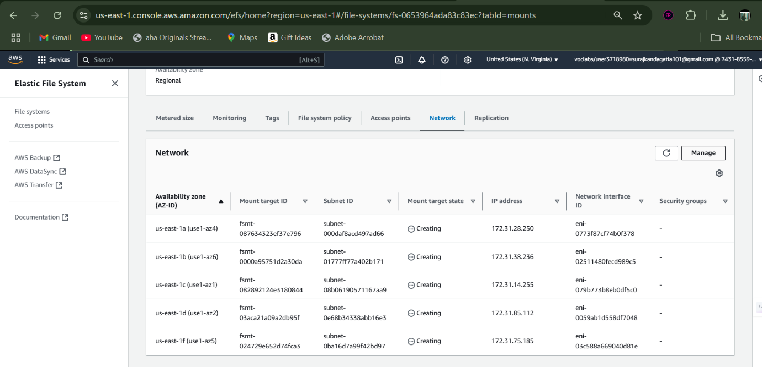

Provide the inbound rules of those instances.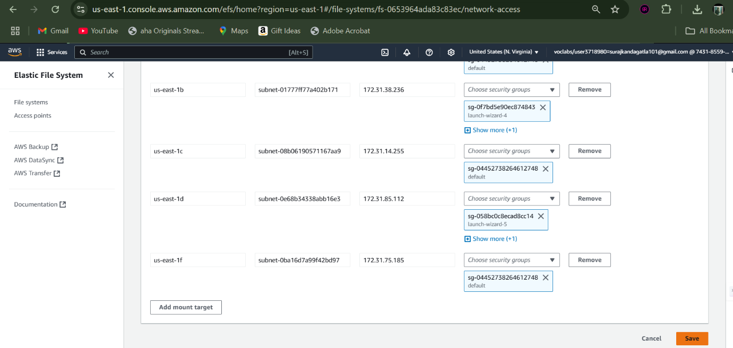

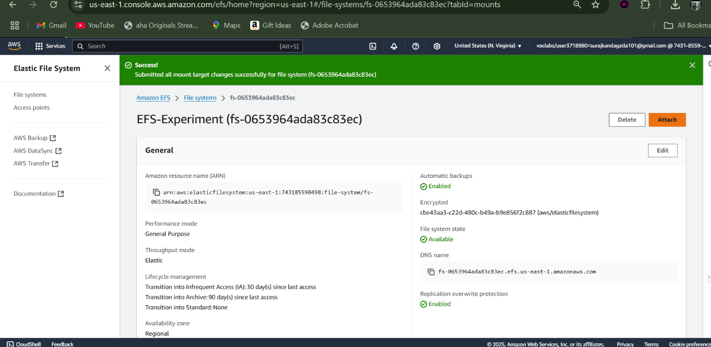

Now we need to connect both the instances using putty

Then:->sudo su, yum update -y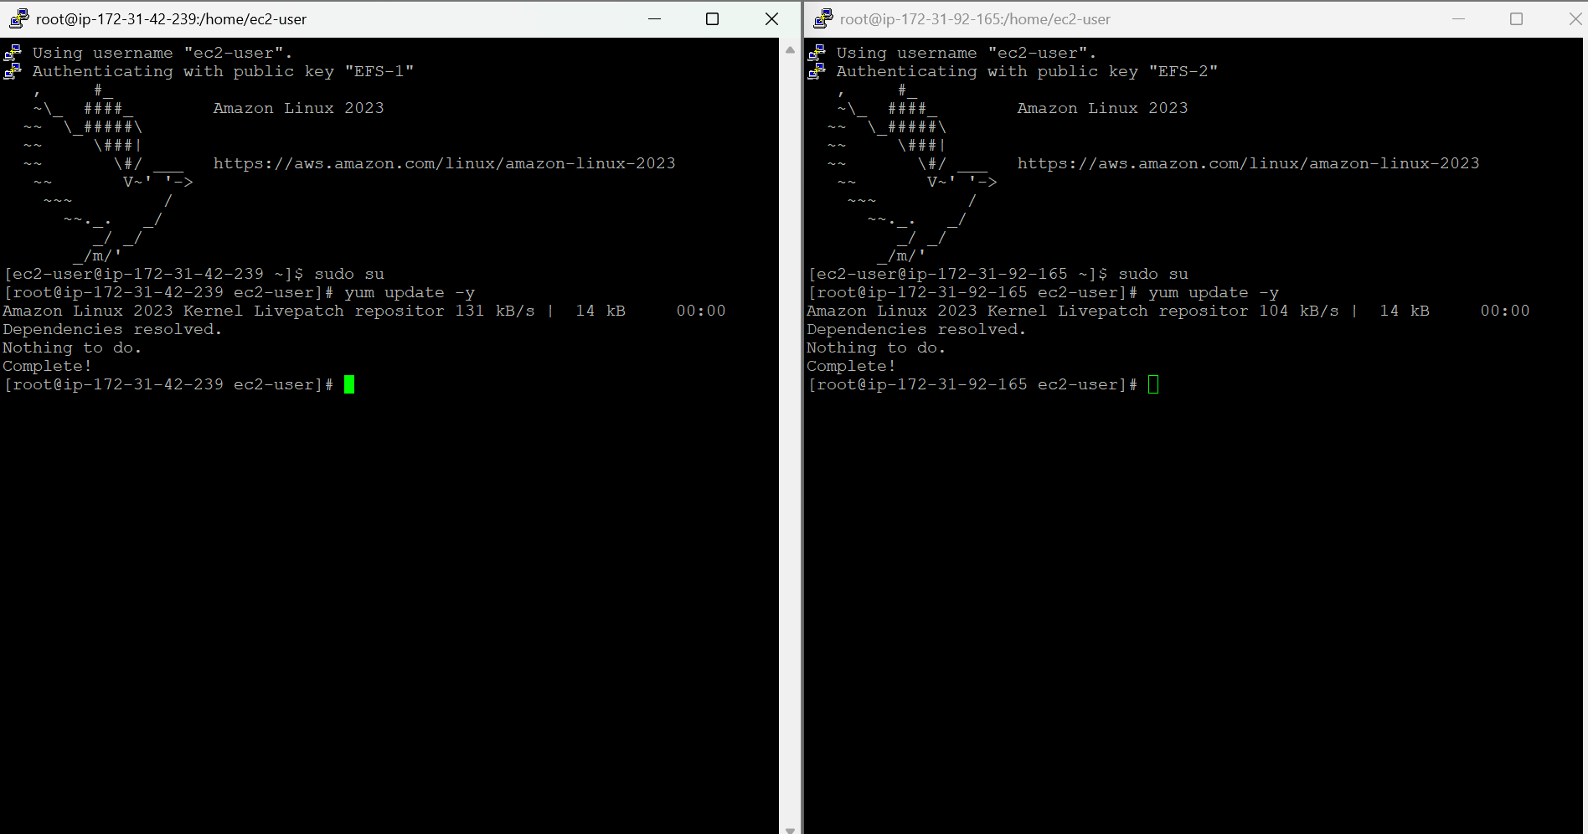now-> mkdir efs, yum install -y amazon-efs-utils

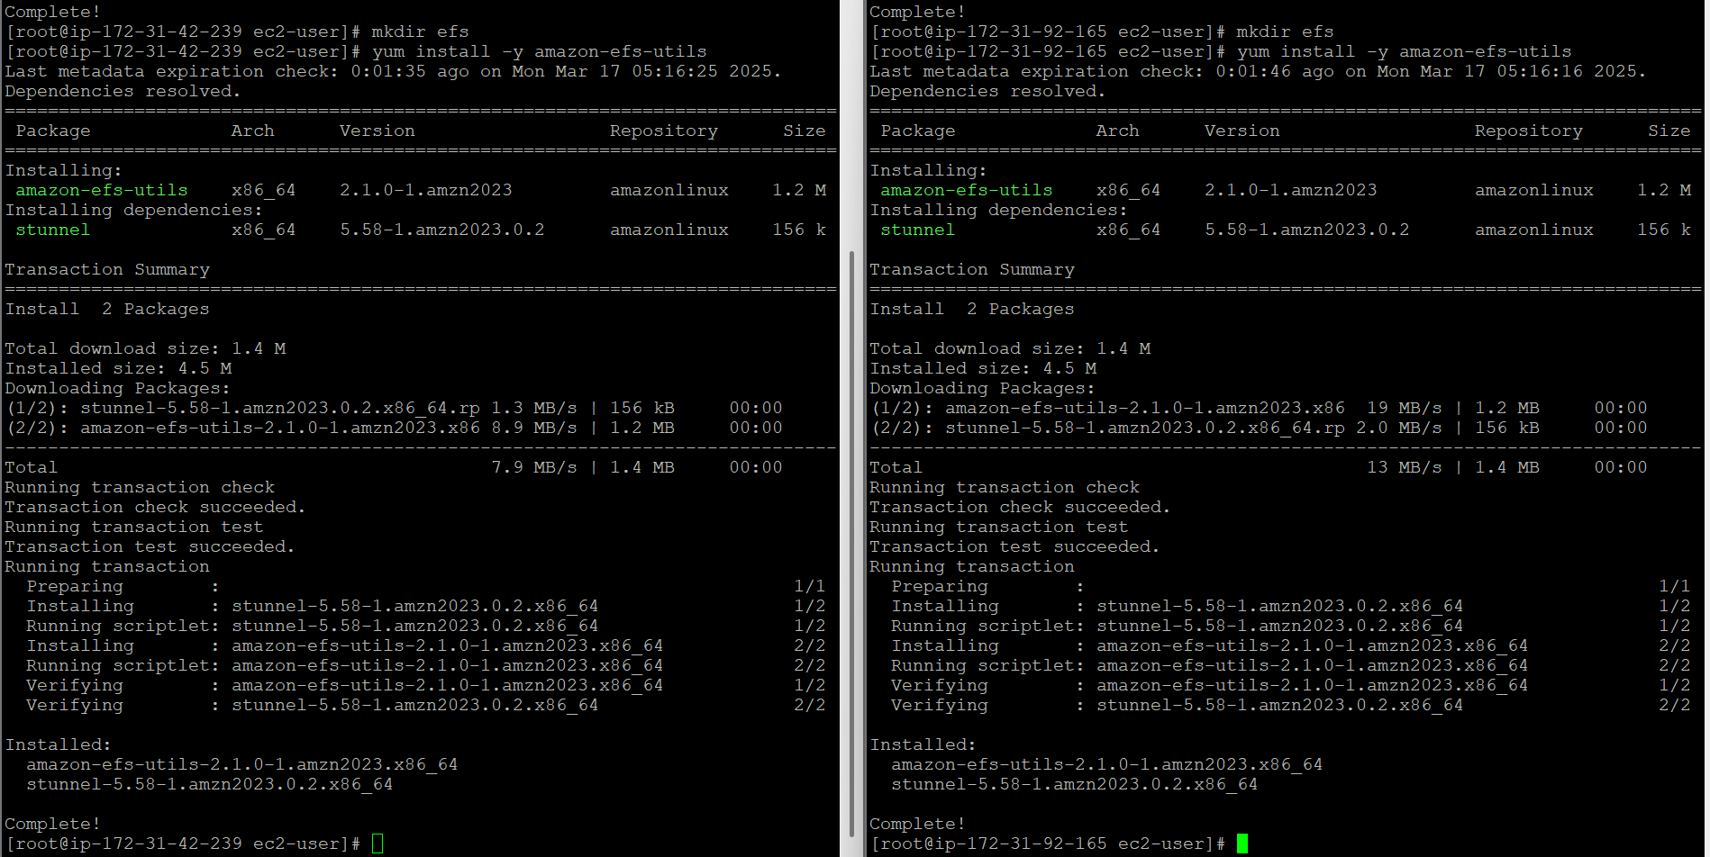

-> cd efs, copy the command from EFS for both the instances and now they are connected.

->create files in one instance and use “ls” to check in another instance.

->as we can see files in another instance. It is Done!.