Name: Suraj Vishwakarma

Roll no: A071

SapId: 86062300002

Msc SDS Batch 2

Cloud Computing Prac 1

1) Implement the Ubuntu machine using AWS EC2 and execute the Linux

commands.

Steps:

Open Amazon Web Services (AWS) and login into the services.

Search EC2 on the search tab.

Click on EC2

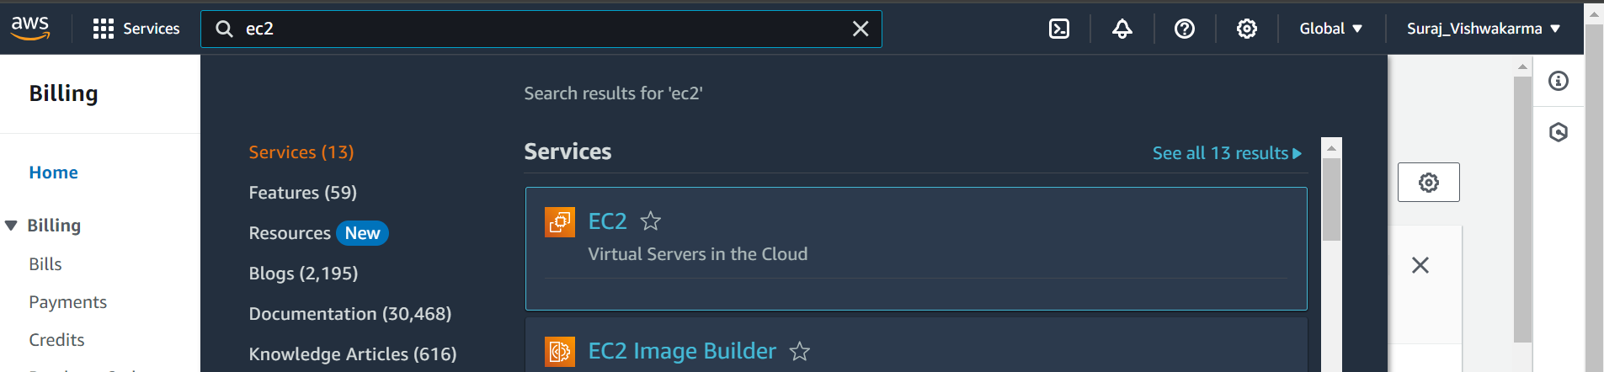

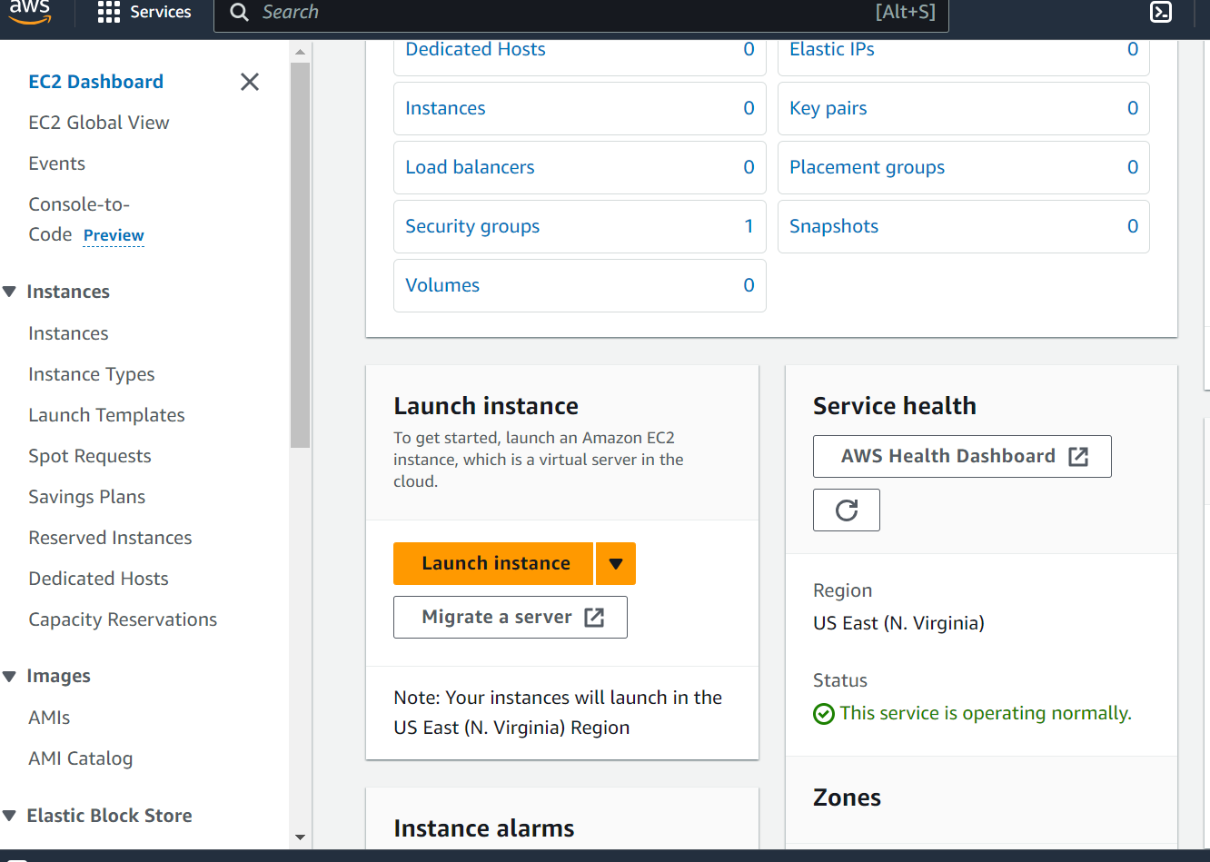

Click on instances

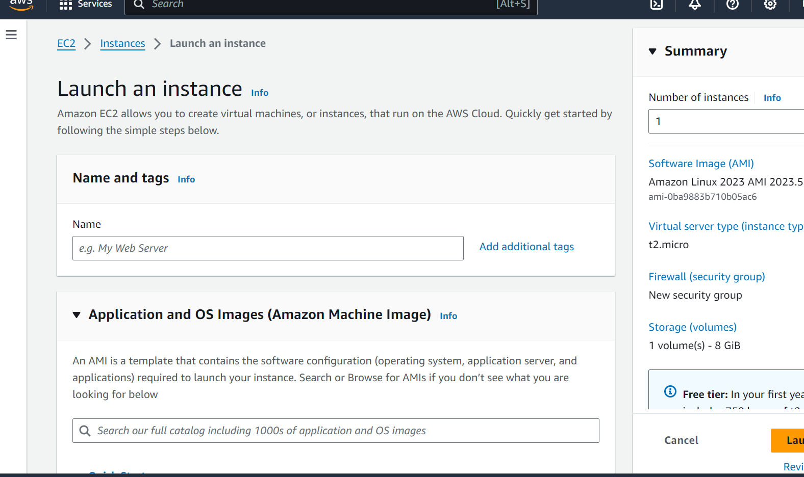

Give the name to the instance and select the Ubuntu options

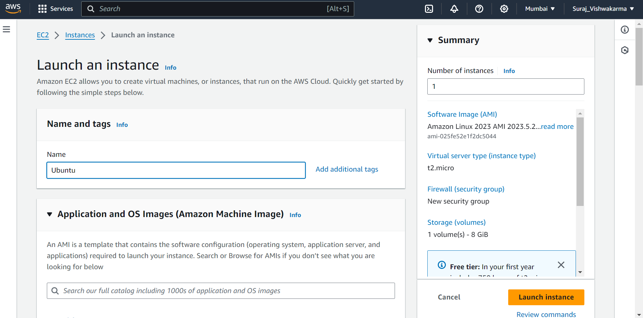

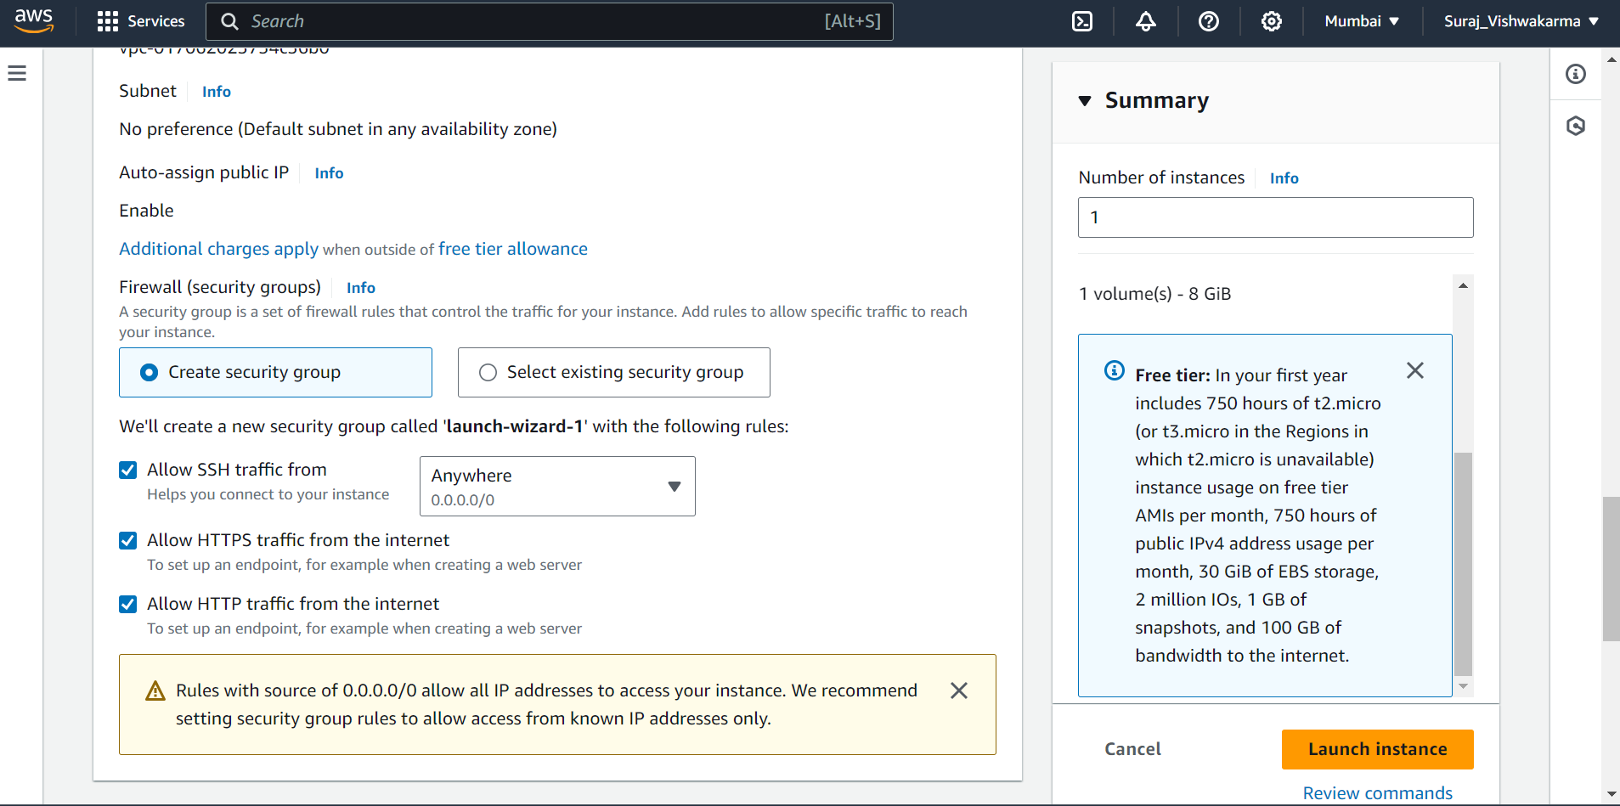

Click on Launch instance.

Next is to create a key pair so give a unique name to key pair and select .pem

option and by default RSA option should be selected if not select that option.

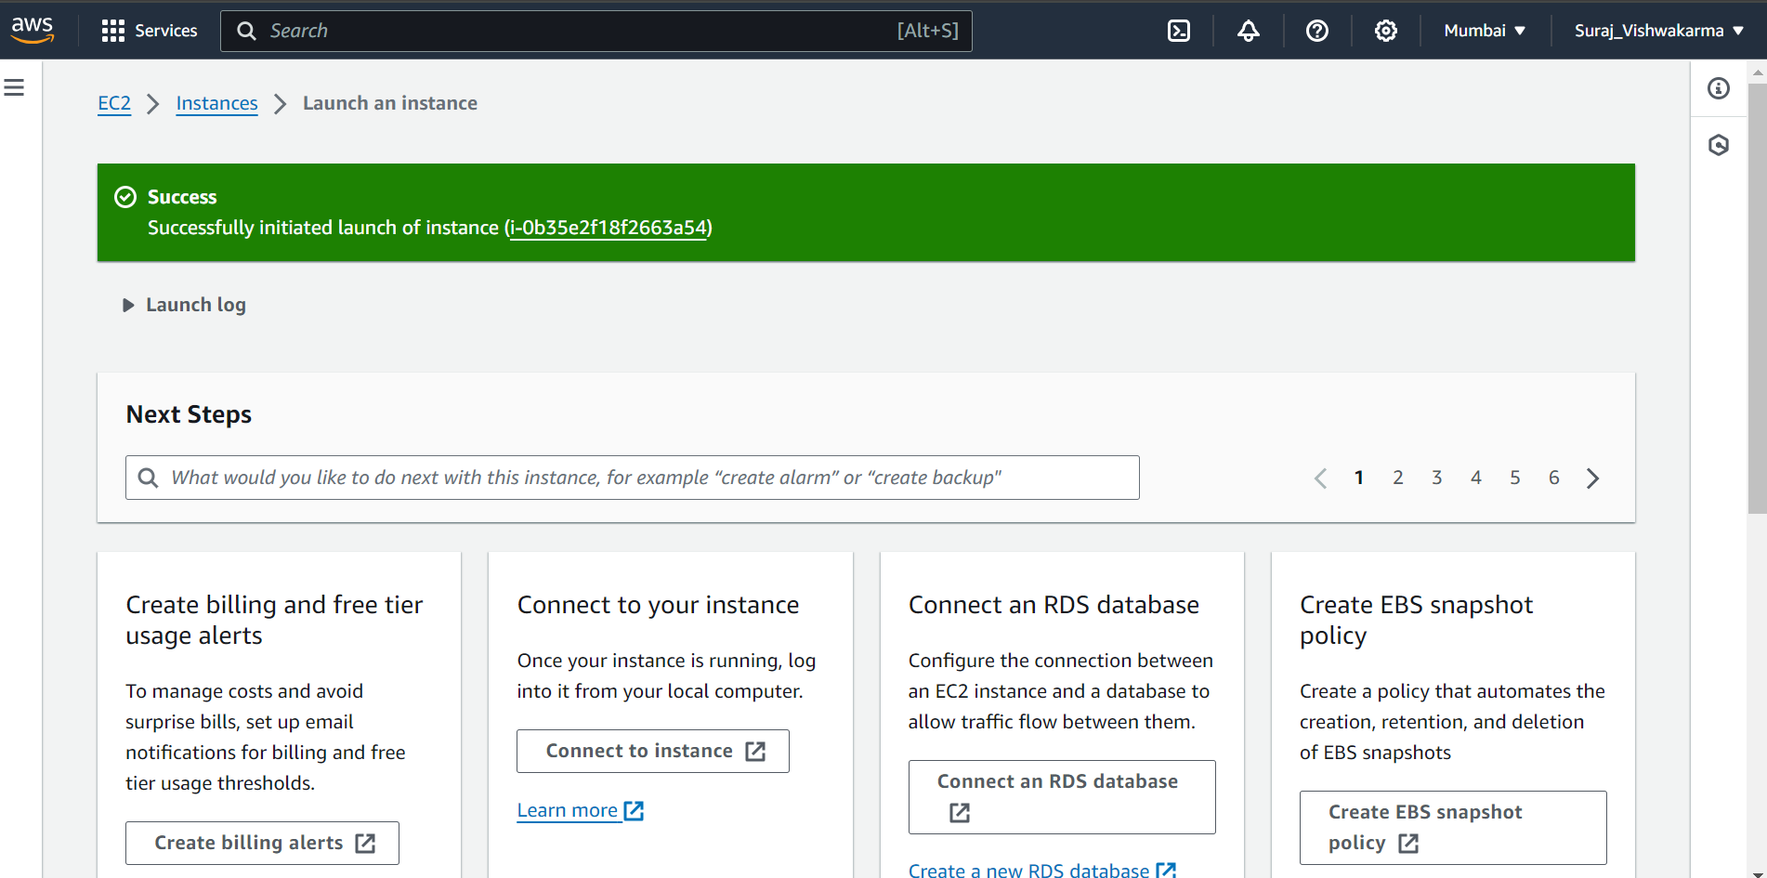

Now click on the three horizontal bar and then click on instances.

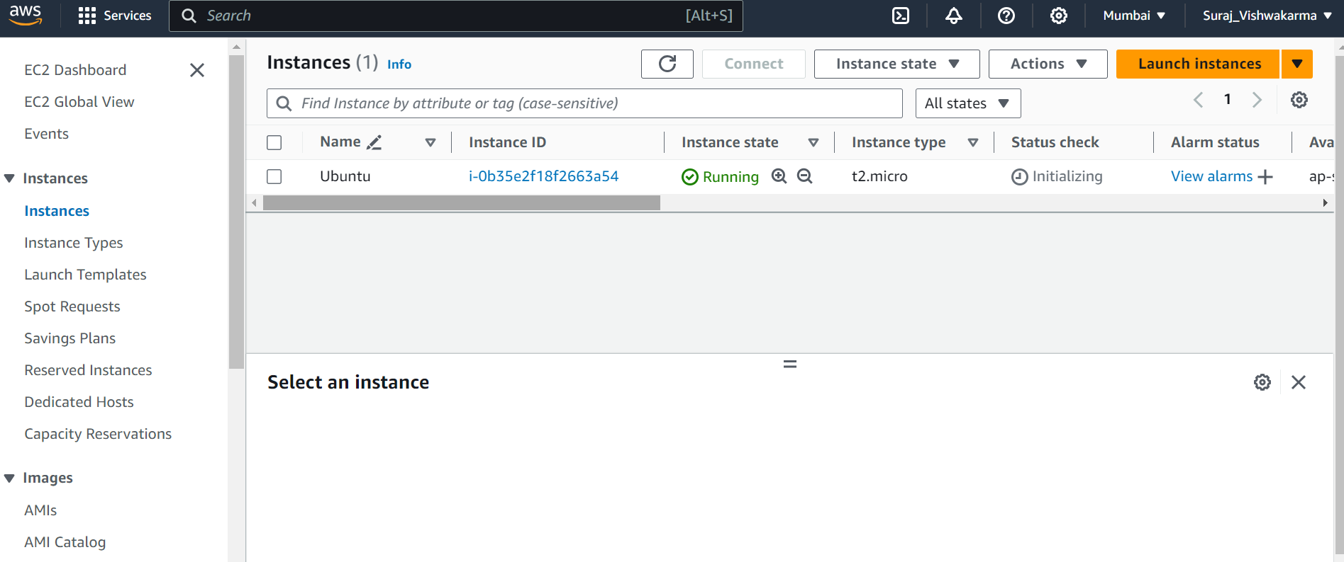

Now click on instance id link after that click on Connect .

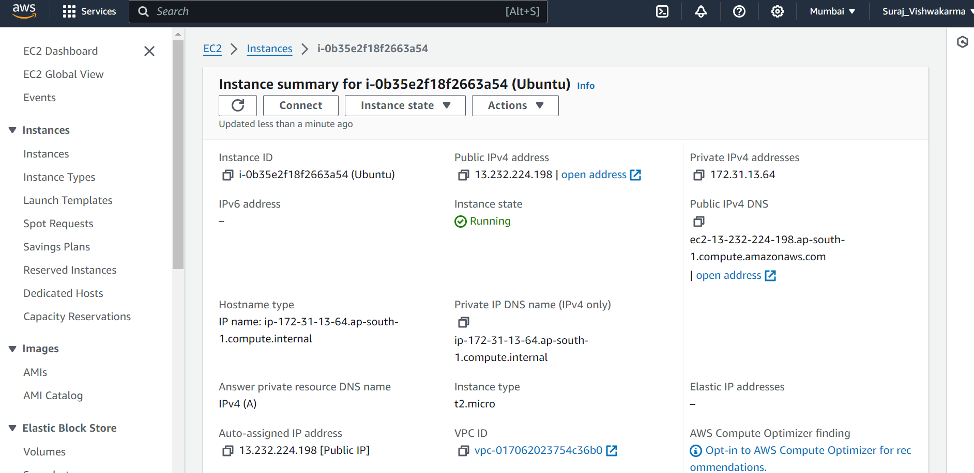

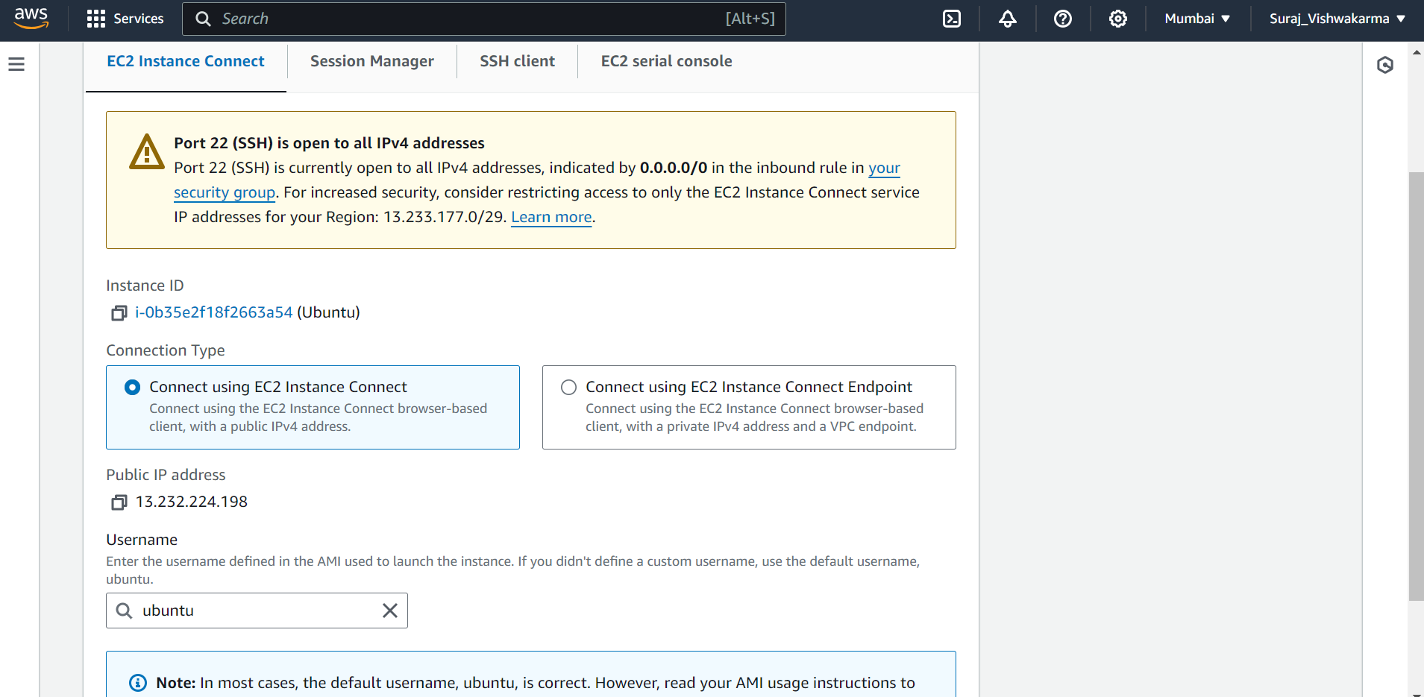

Click on Connect and a cmd prompt of Ubuntu Machine will load.

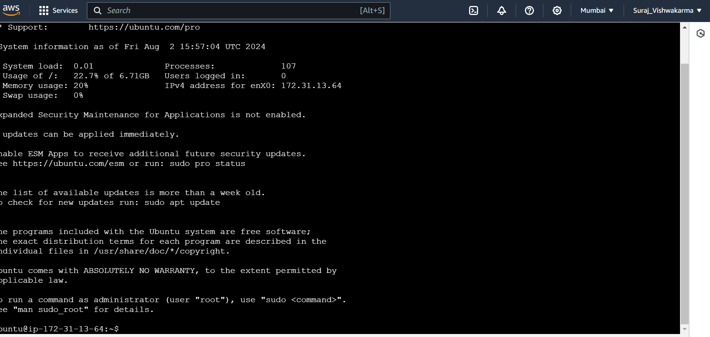

Now run some linux cmd prompts.

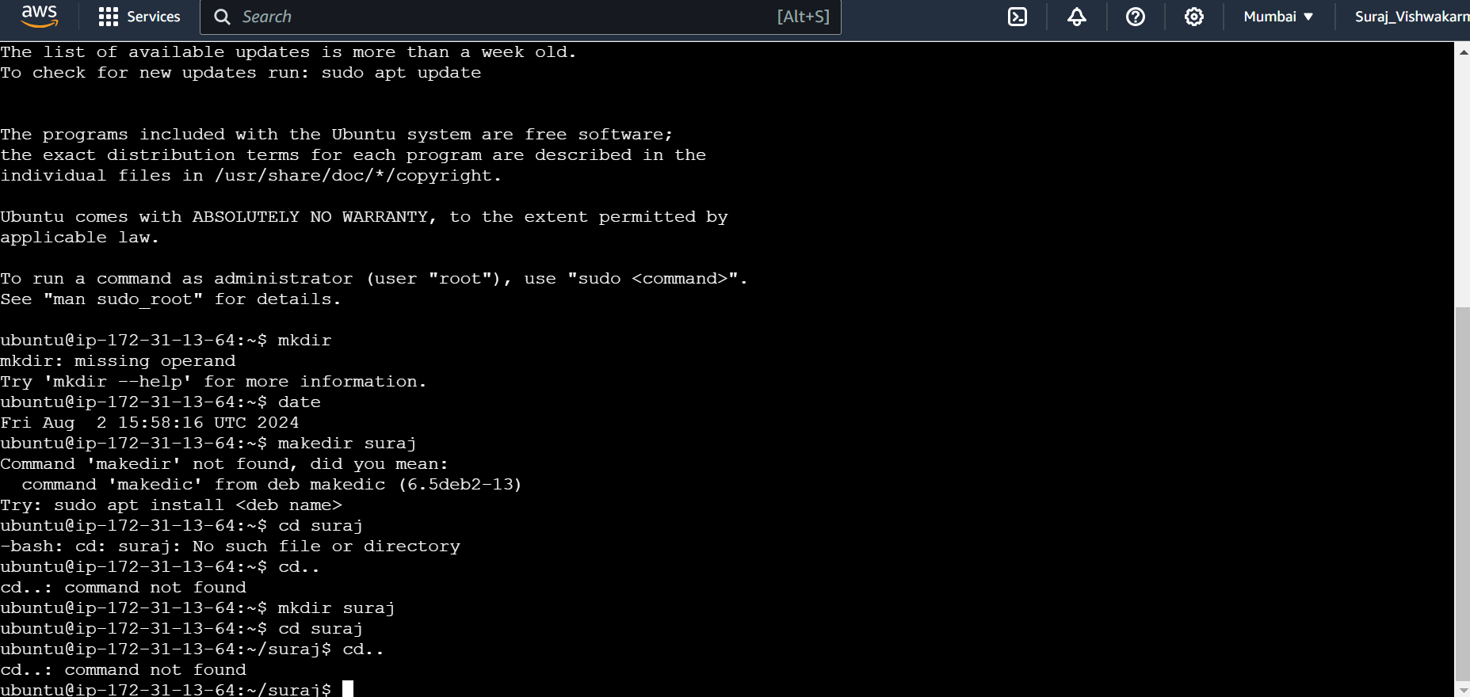

Now close this window and we will again see our instance window after working instance our step is to terminate this instance.

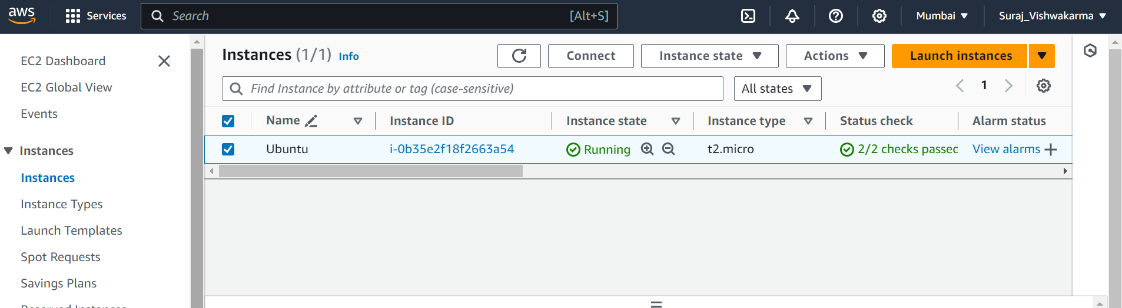

Click on instance state and then select Terminate instance.

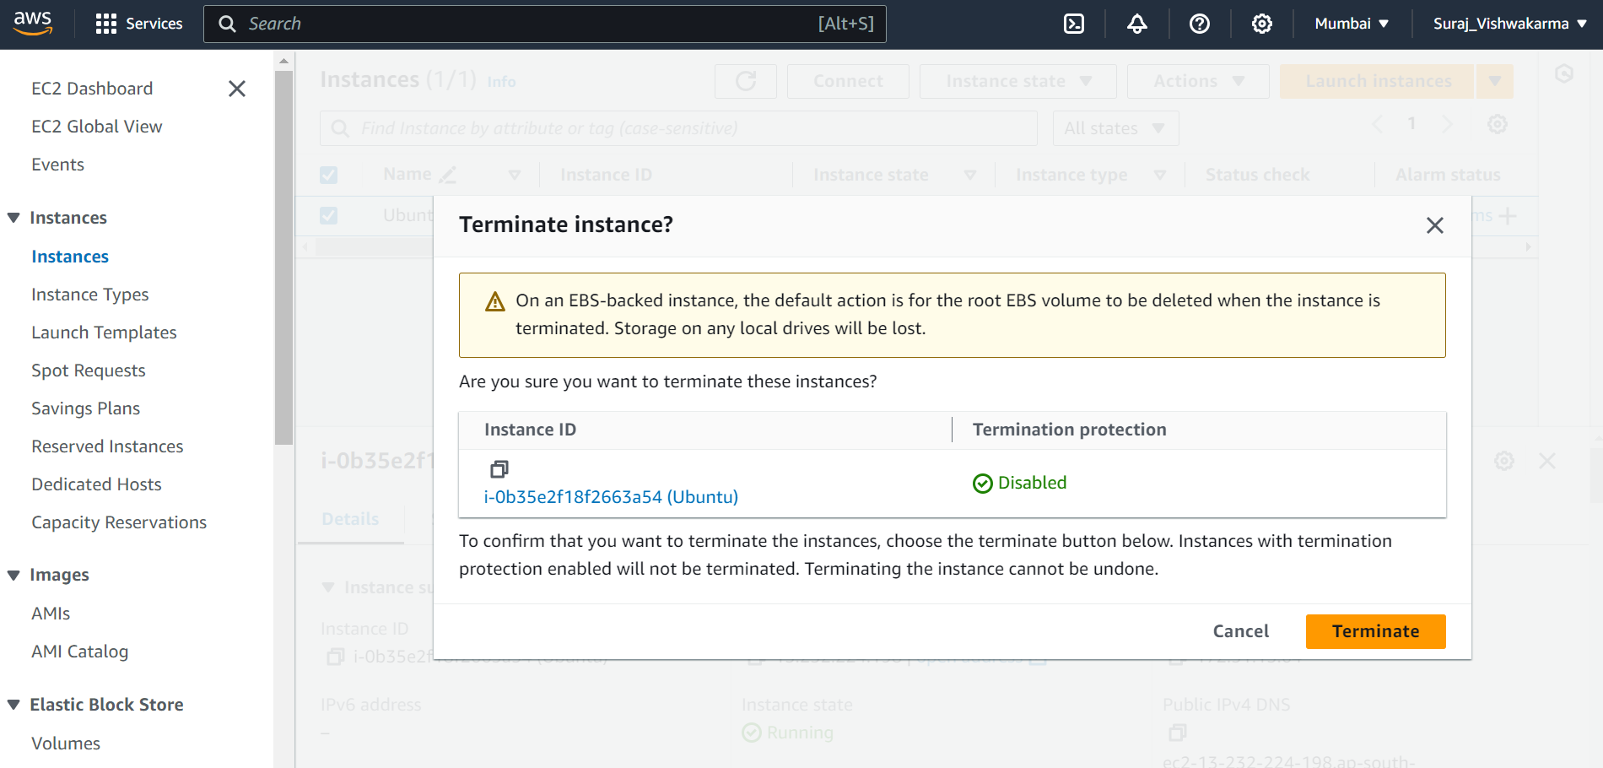

2) Implement the windows machine using AWS EC2.

Steps:

Repeat the same steps as mentioned above for Ubuntu machine EC2 instead of selecting Ubuntu we have to choose Windows Option. Otherwise when we are in our instance page and we did not logout from AWS then click on Launch instance for creating a new instance and then repeat same process as mentioned for ubuntu machine.

