**CLOUD COMPUTING**

**PRACTICAL 4:To Demonstrate Platform as a Service using Google app Engine**

**Suraj Vishwakarma**

**A071**

1. Create an account with Google Cloud Platform and Click on My First Project and then NEW PROJECT.

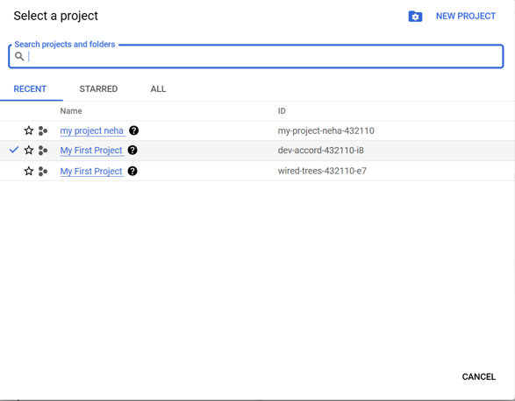

2. Provide Project name “my project ”. Location can be No organization.

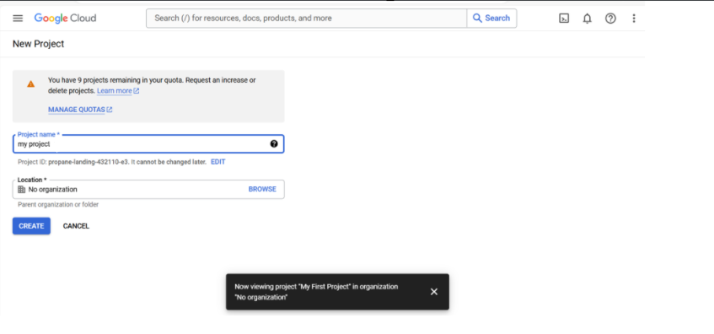

1. After Google cloud creates new project as per name specified in previous step, it opens up project home, showing dashboard.

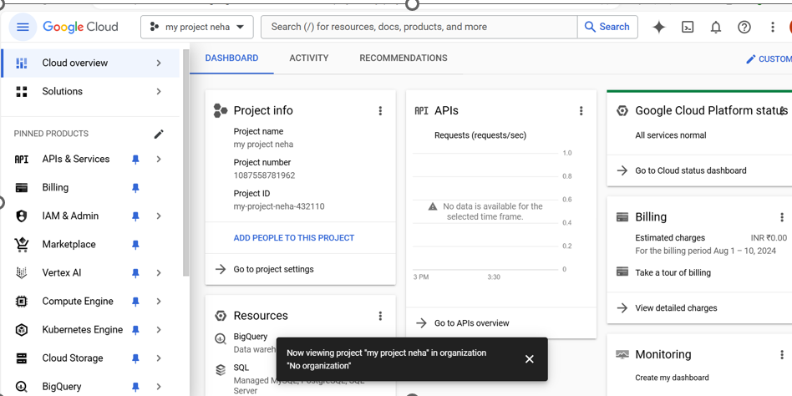

4. Create a new configuration file app.yaml. yaml file contains information about your app's code, such as the runtime and the latest version identifier. Each service in your app has its own app. yaml file, which acts as a descriptor for its deployment.

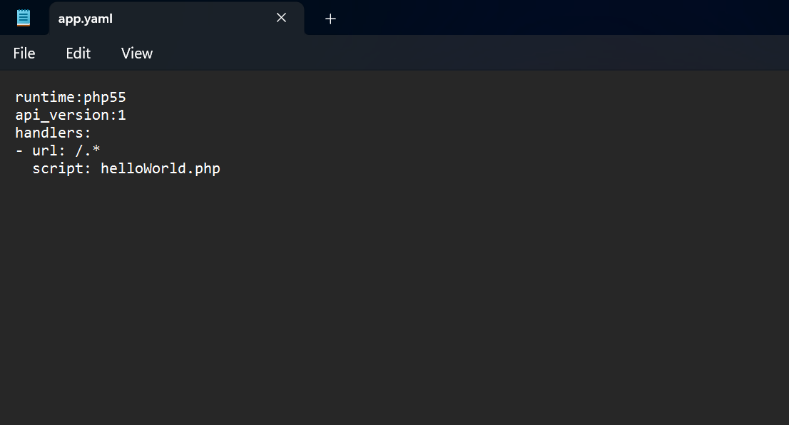

5. Create a PHP code to upload and run and save it as “helloWorld.php”

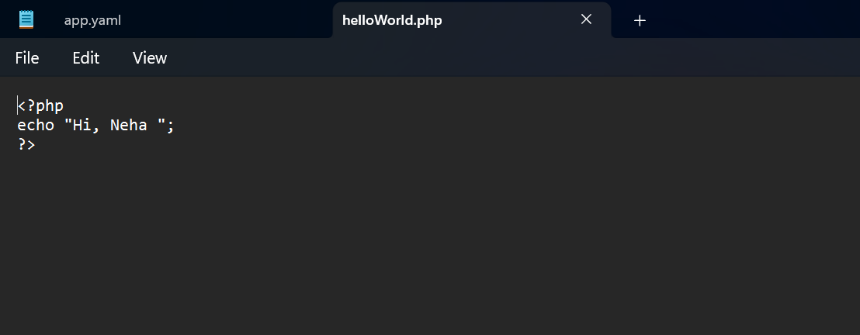

6:In order to deploy and run the PHP code on Google cloud platform, visit https://cloud.google.com/sdk/docs to download latest Google Cloud SDK and to know how to install it.

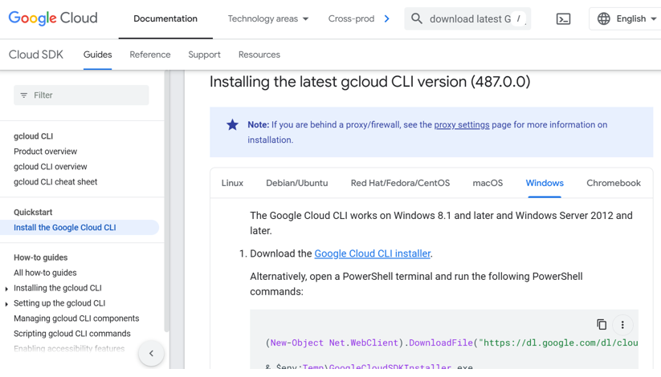

7.open Google cloud SDK installer. It will take some time to download and install SDK from Google Server. At end of installation check Start Google Cloud SDK Shell and Run ‘gcloud init’ to configure the Cloud SDK.

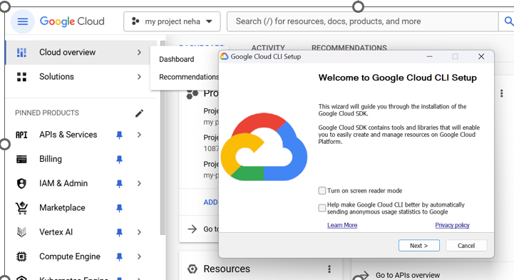

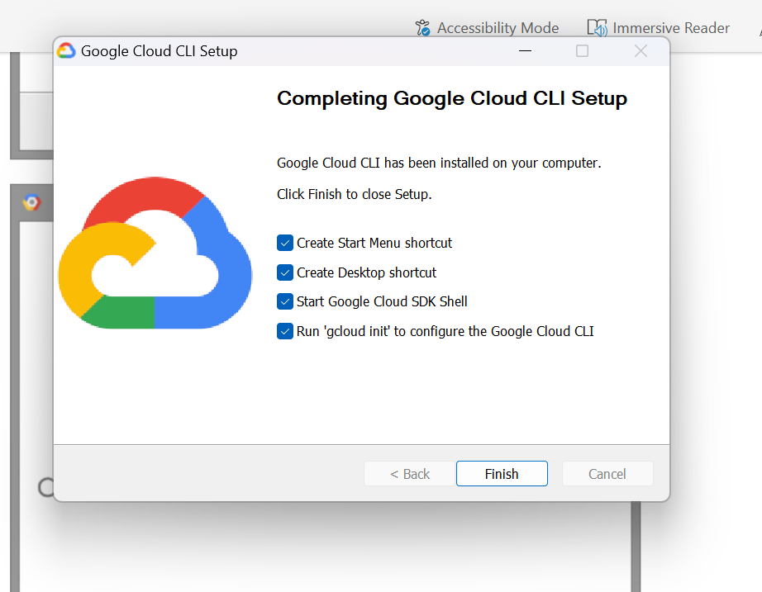

8. Previous step will open up command prompt with gcloud init command running automatically. It will ask you to login using Google account on which you have joined Google Cloud Platform. After successful login web browser page of cloud.google.com will show You are now authenticated with Google Cloud SDK.

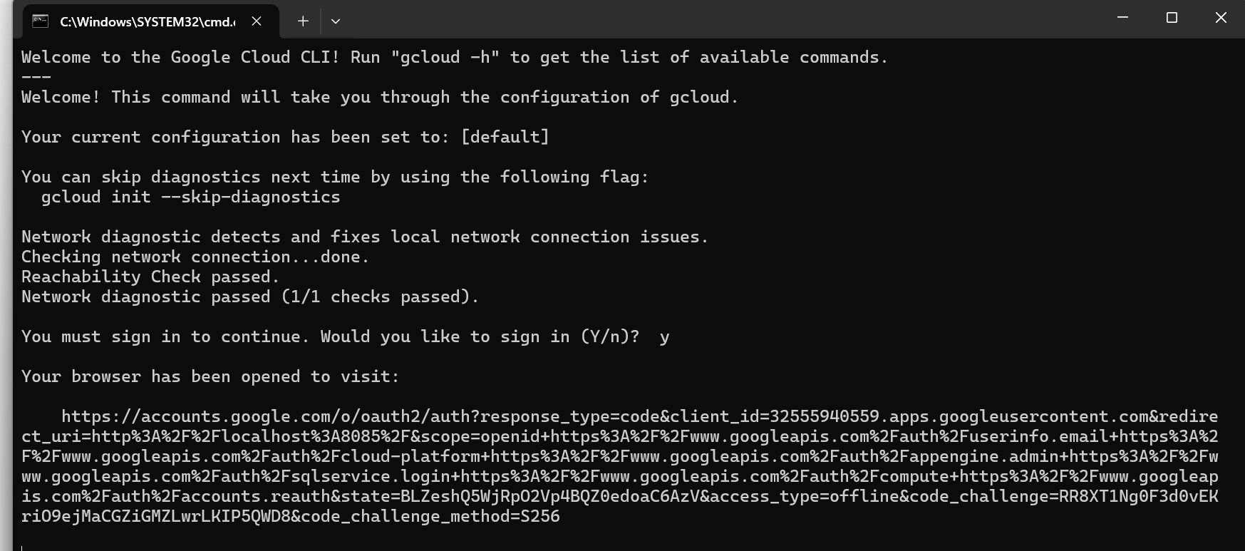

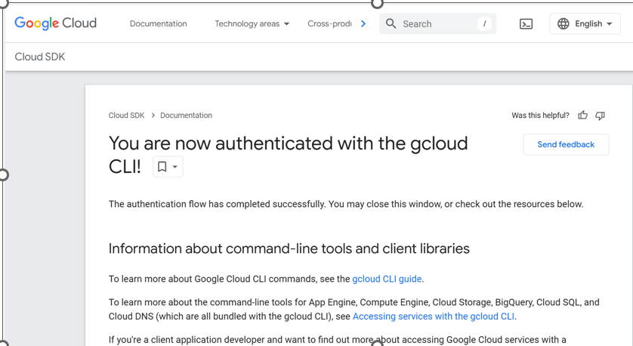

9. In command prompt, running in background will ask you to select project you want to deploy and run. Enter appropriate number and hit enter.

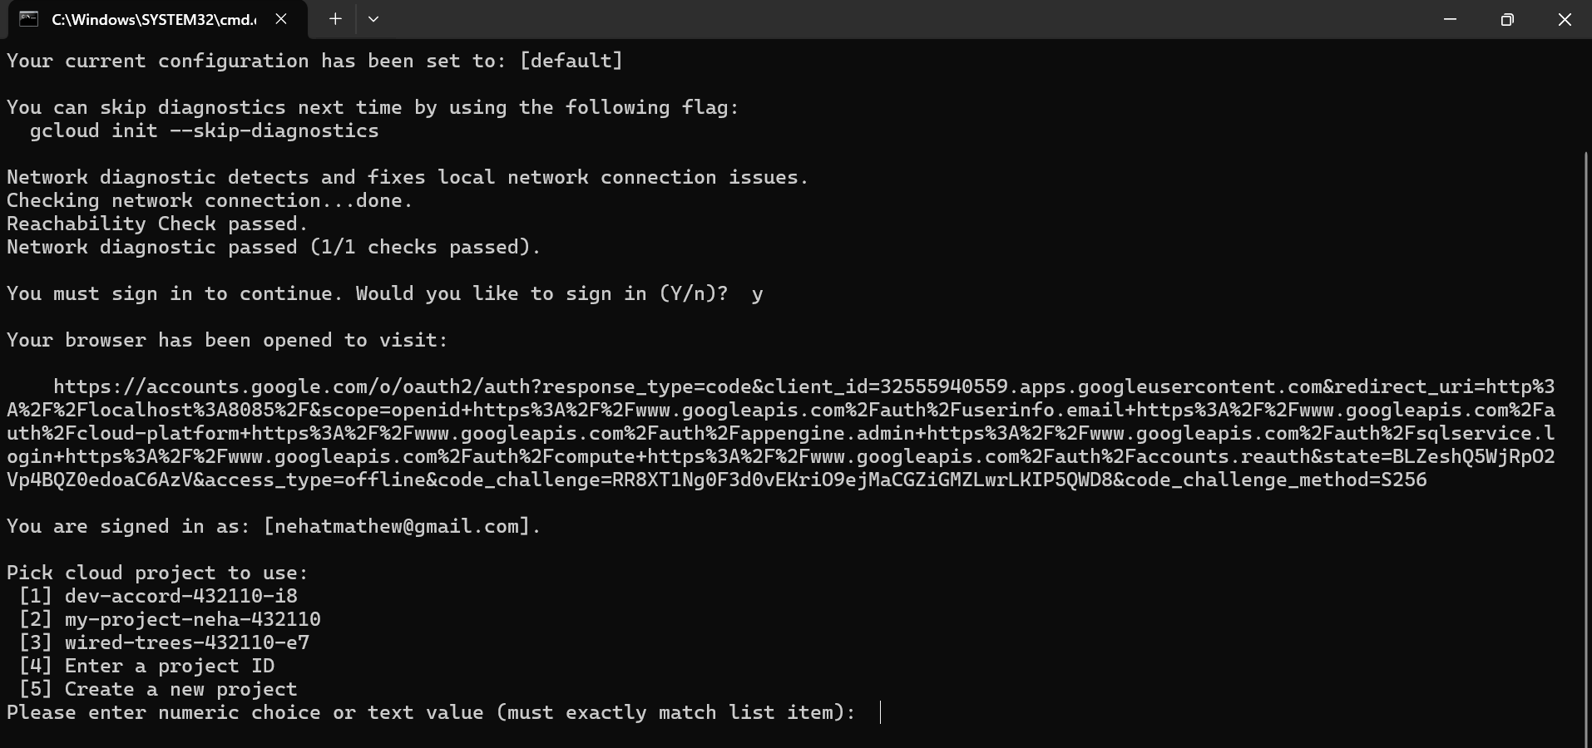

10. Change directory to folder where PHP and YAML file is residing.

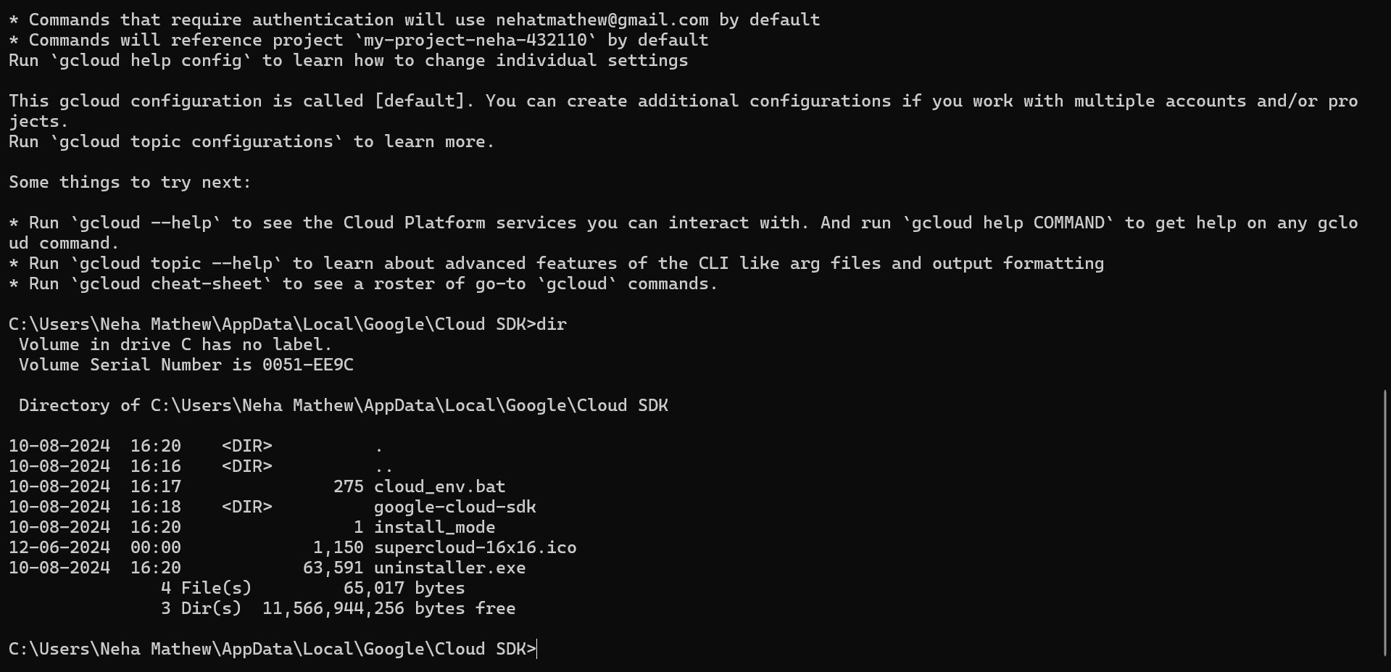

11.Type gcloud app deploy and select region of Google Data Center where you want to deploy your app, press 5 and press Enter for asia-south1, i.e. Mumbai. Press Y to continue with deployment. Result will show URL to launch your GoogleApp. Alternatively you can type gcloud app browse to open your App in browse

