Name: Suraj Vishwakarma

Roll no: A071

SapId: 86062300002

Msc SDS Batch 2

Cloud Computing Prac 5

1. Implement the Ubuntu machine using AWS EC2 and execute the Linux commands in MobaXterm.

# Steps:

Open Amazon Web Services (AWS) and login into the services. Search EC2 on the search tab.

Click on EC2.

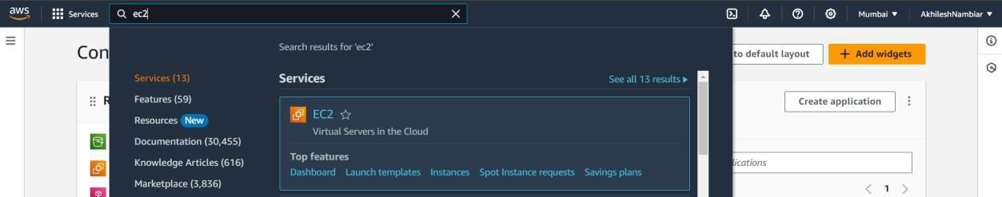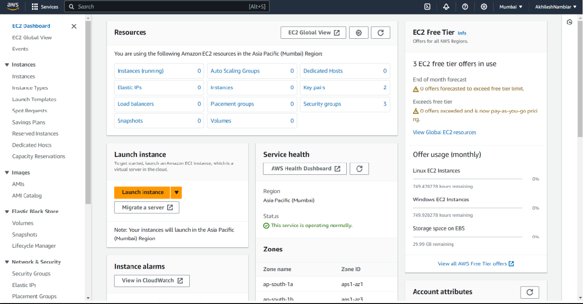



Click on Launch instance.

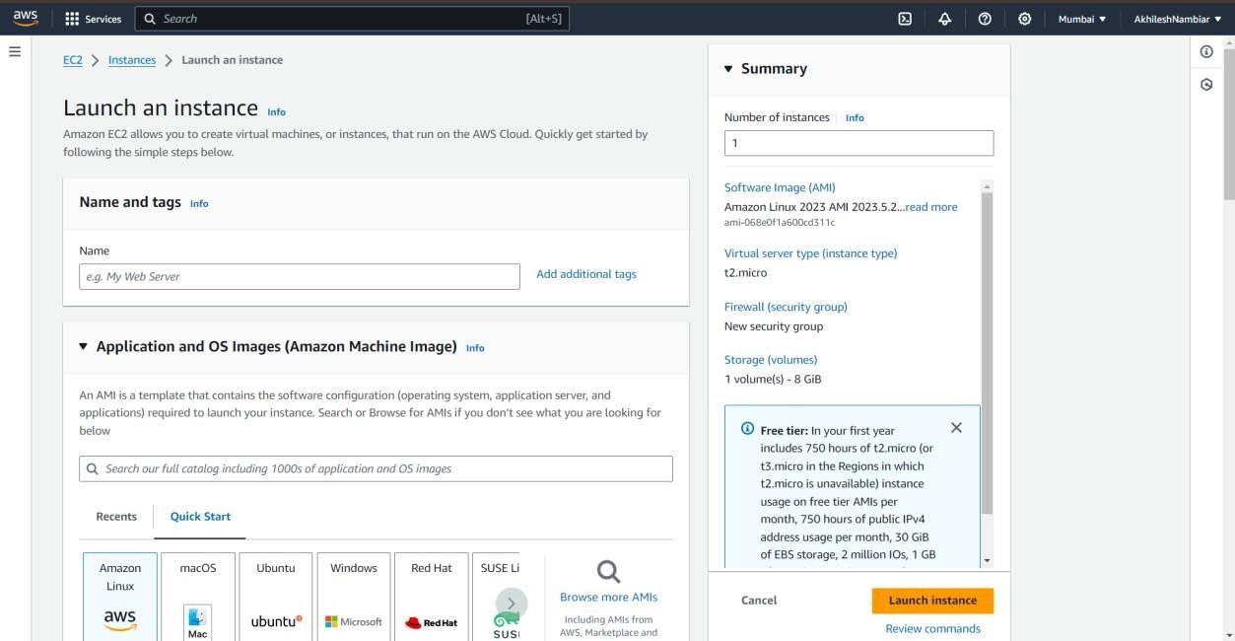

Give the name to the instance and select the Ubuntu option.

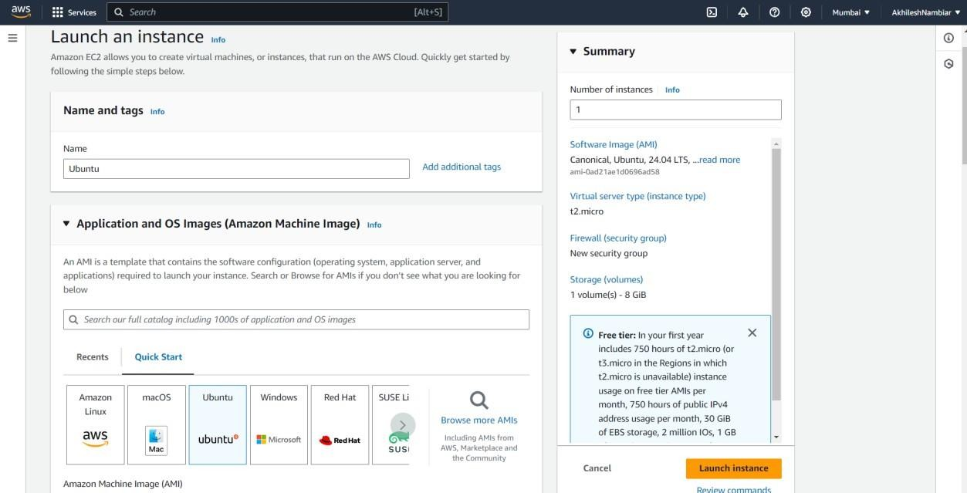

Scroll down and select all the three options i.e Allow SSH, HTTPS, HTTP.

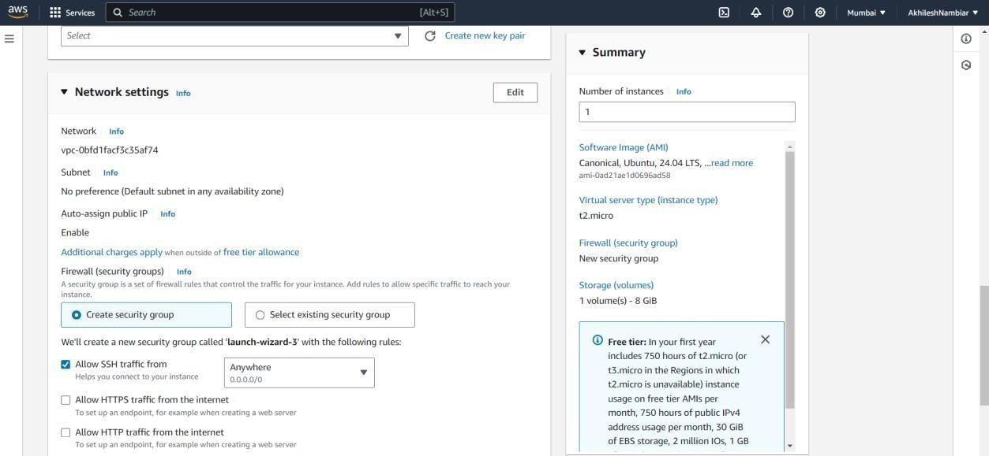

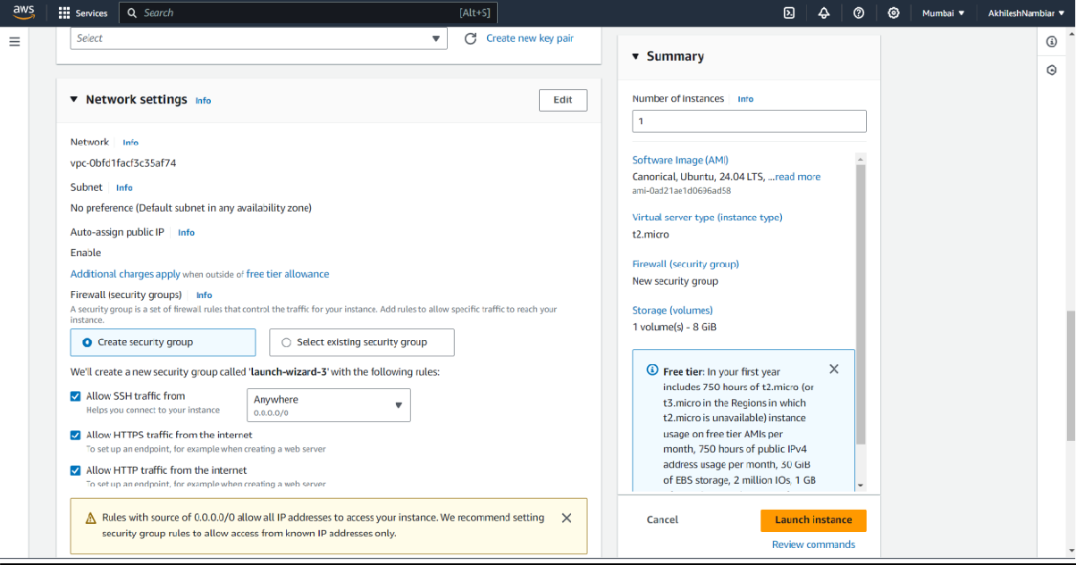

Click on Launch instance.

Next is to create a key pair so give a unique name to key pair and select .pem option and by default RSA option should be selected if not select that option.

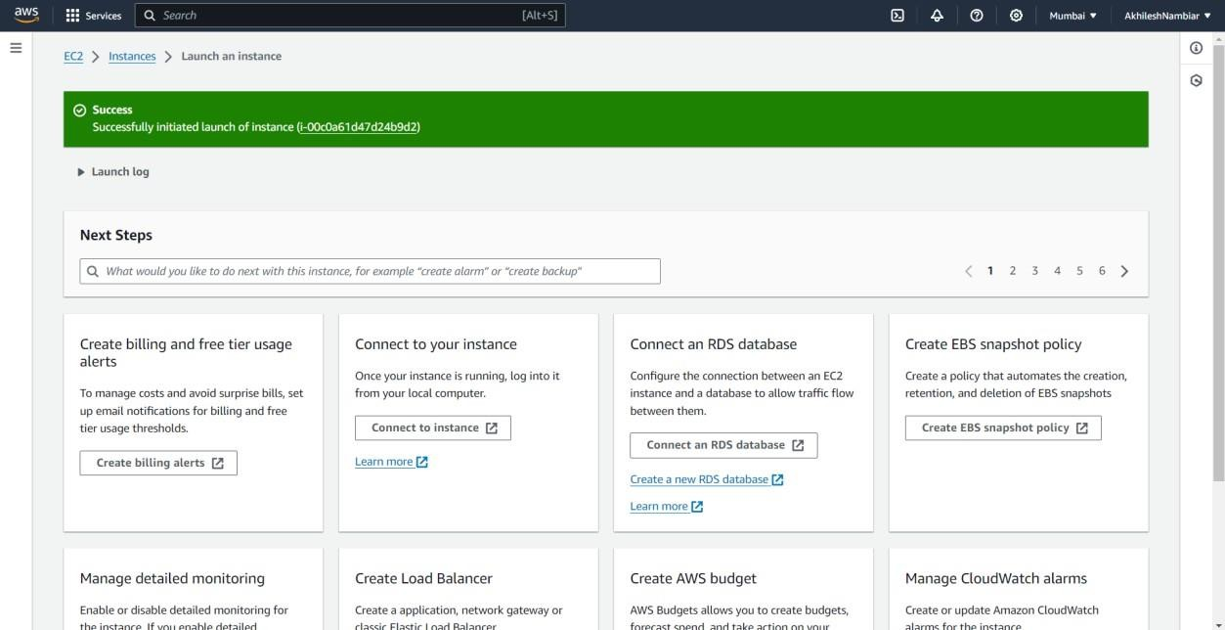

Now click on the three horizontal bar and then click on instances.

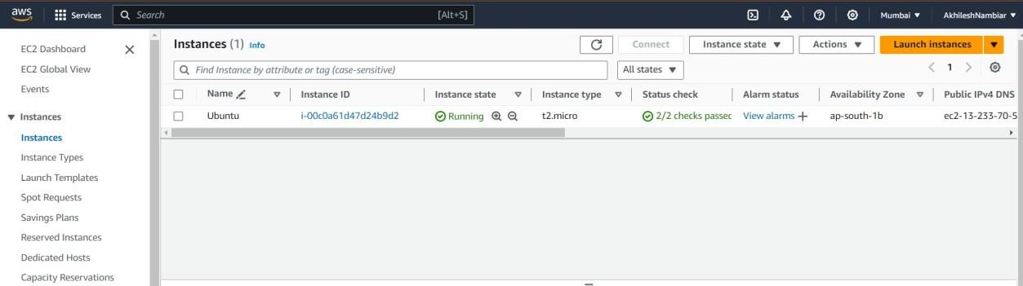

Now click on instance id link after that click on Connect .

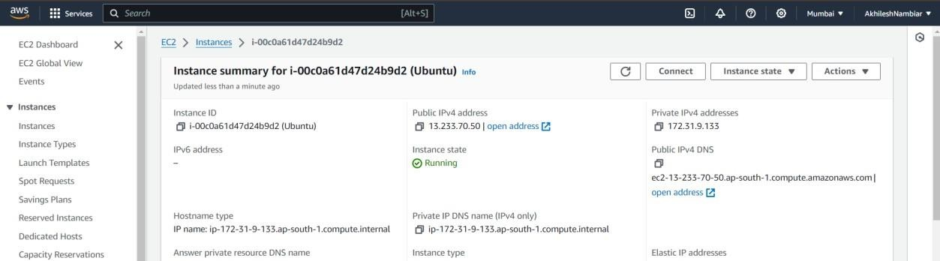

Download MobaXterm and open it.

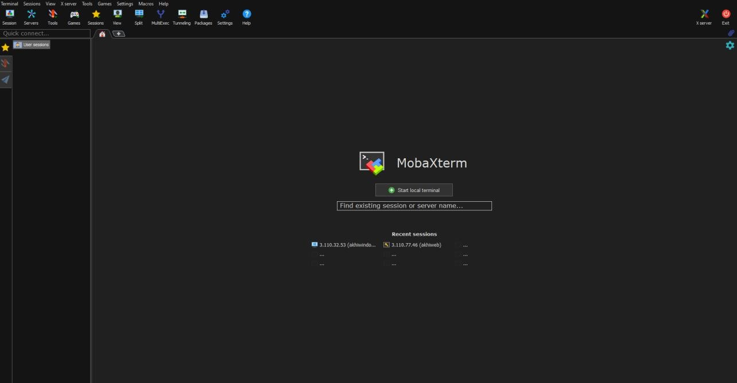

Click on New Session.

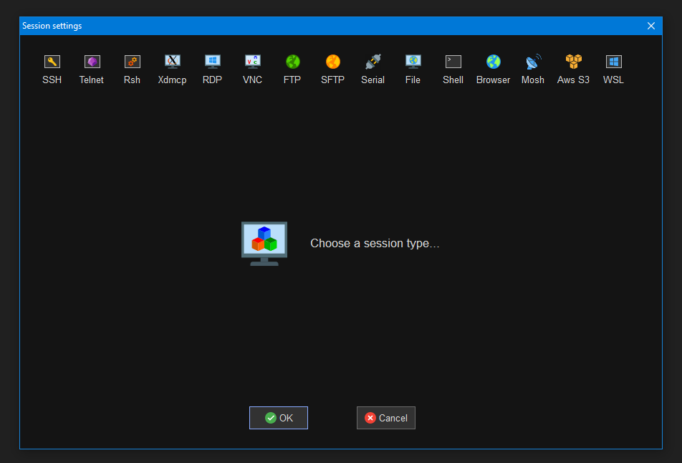

Click on SSH.

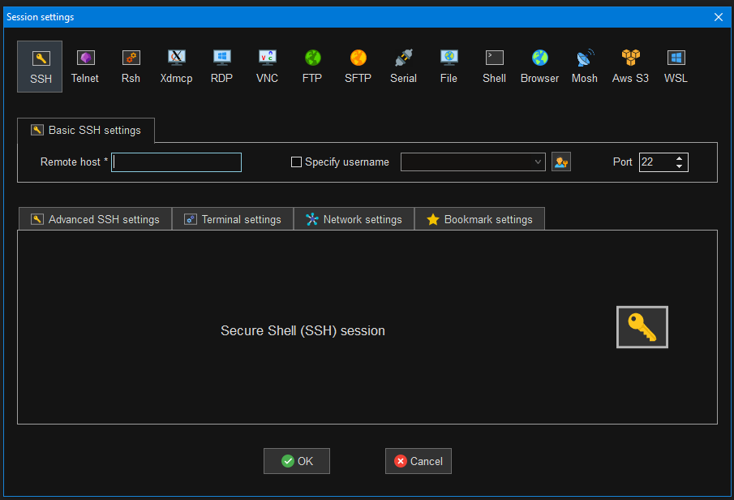

Copy the public-ip4-address from AWS Instance and click on specify username and give the name u have given to the EC2 instance and click on Advanced SSH settings.

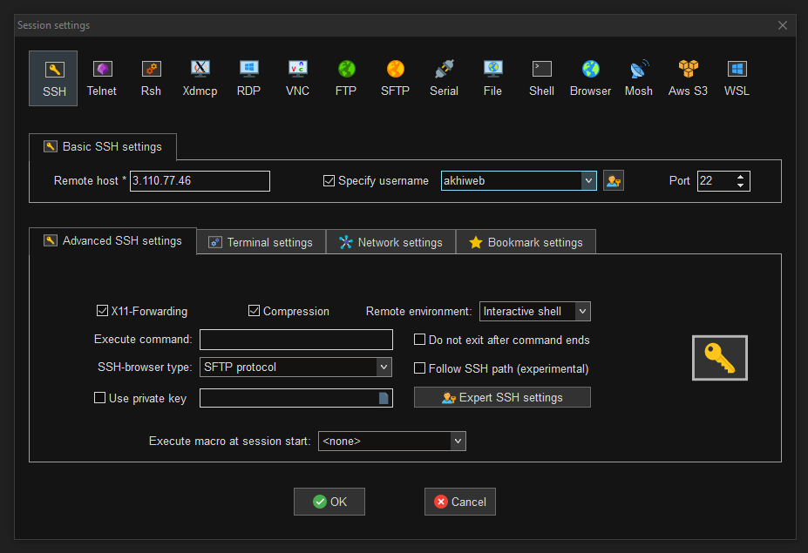

Click on Use private key and upload ur key pair and click on Ok.

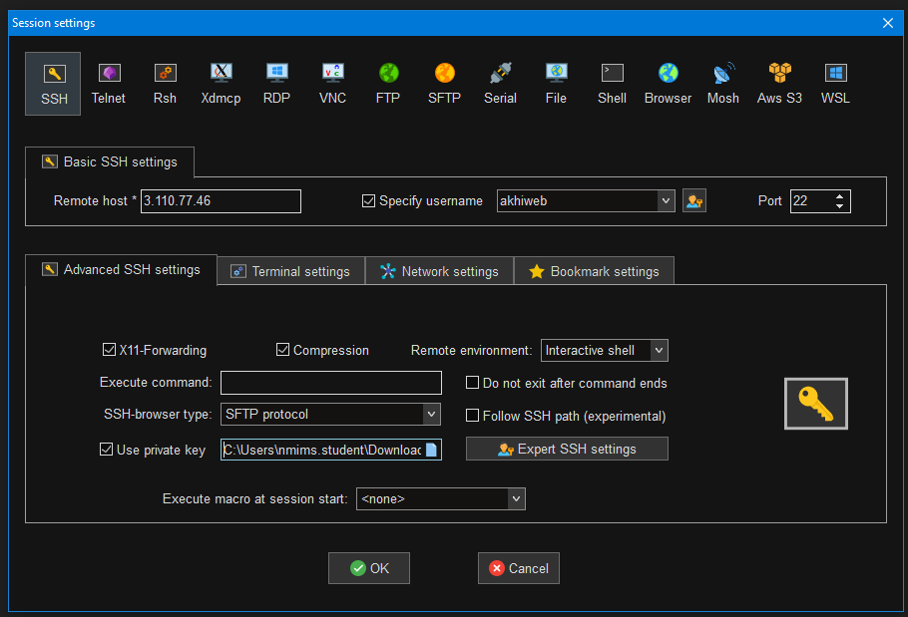

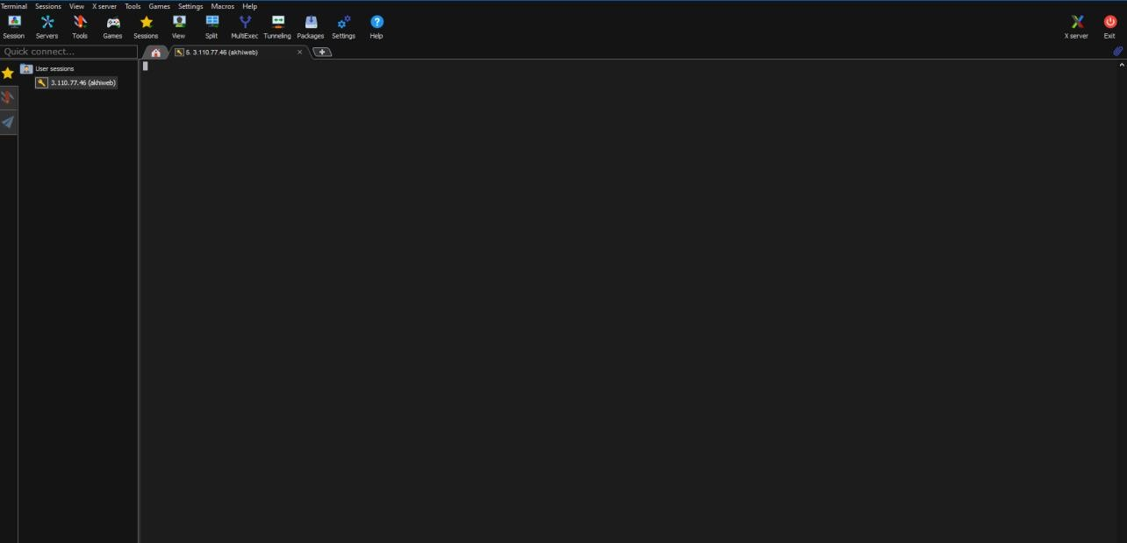

Now run some linux cmd prompts.

Now close this window and we will again see our instance window after working instance our step is to terminate this instance.

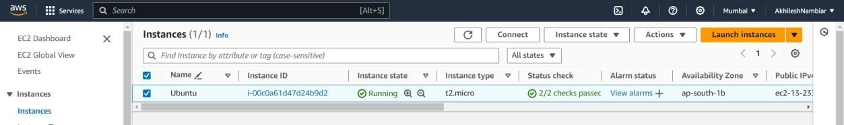

Click on instance state and then select Terminate instance.

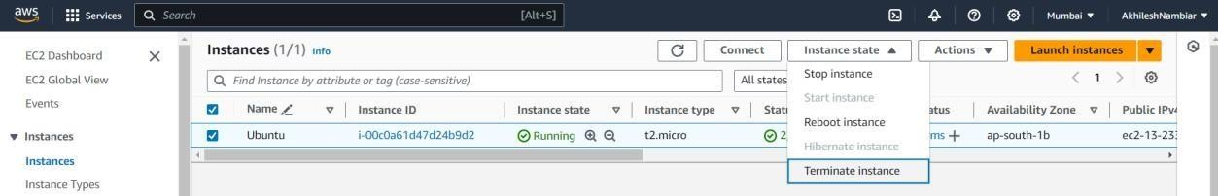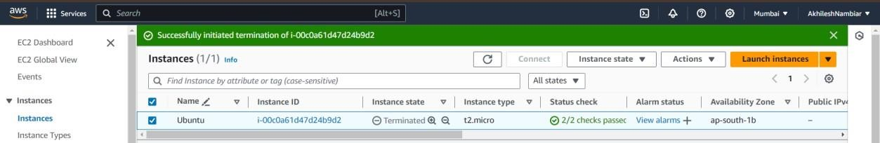

1. Implement the windows machine using AWS EC2 and MobaXterm.

# Steps:

Repeat the same steps as mentioned above for Ubuntu machine EC2 instead of selecting Ubuntu we have to choose Windows Option.

Otherwise when we are in our instance page and we did not logout from AWS then click on Launch instance for creating a new instance and then repeat same process as mentioned for ubuntu machine.

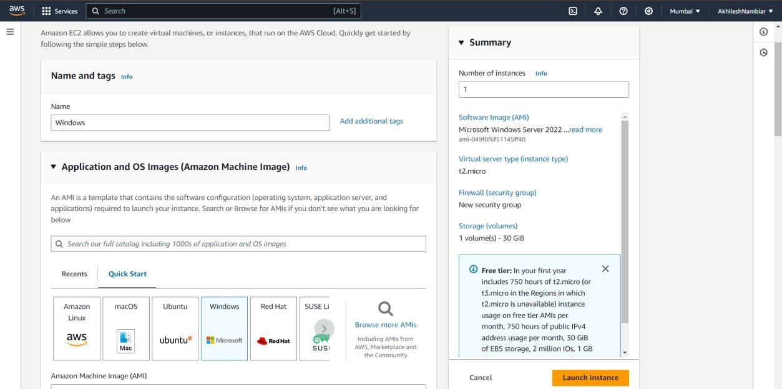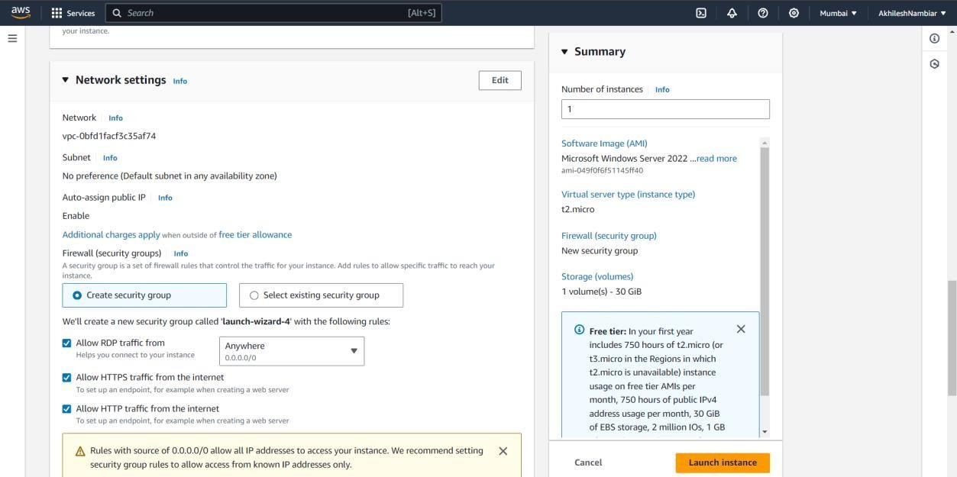

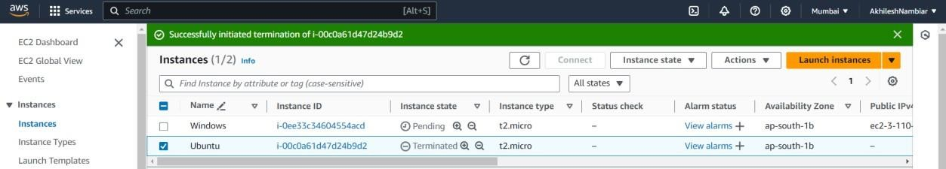

Click on Instance id of windows i.e the instance name created for virtually imputing windows into AWS and then new page opens and click on Connect.

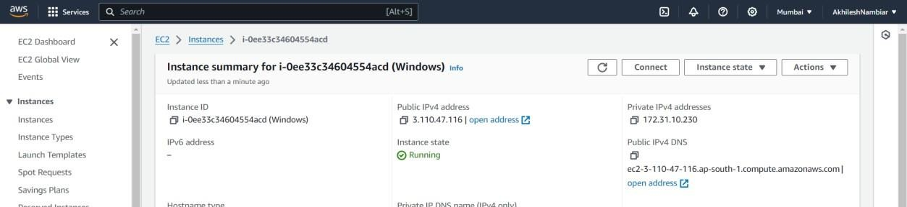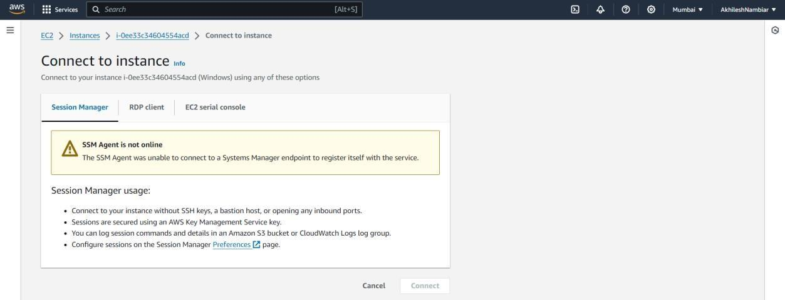

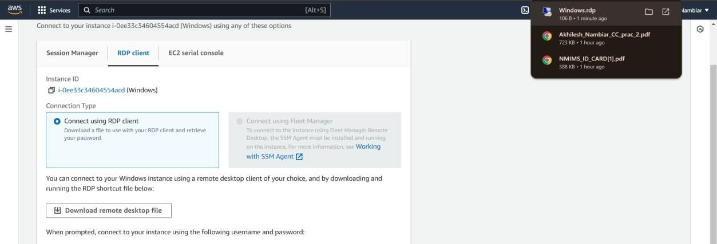

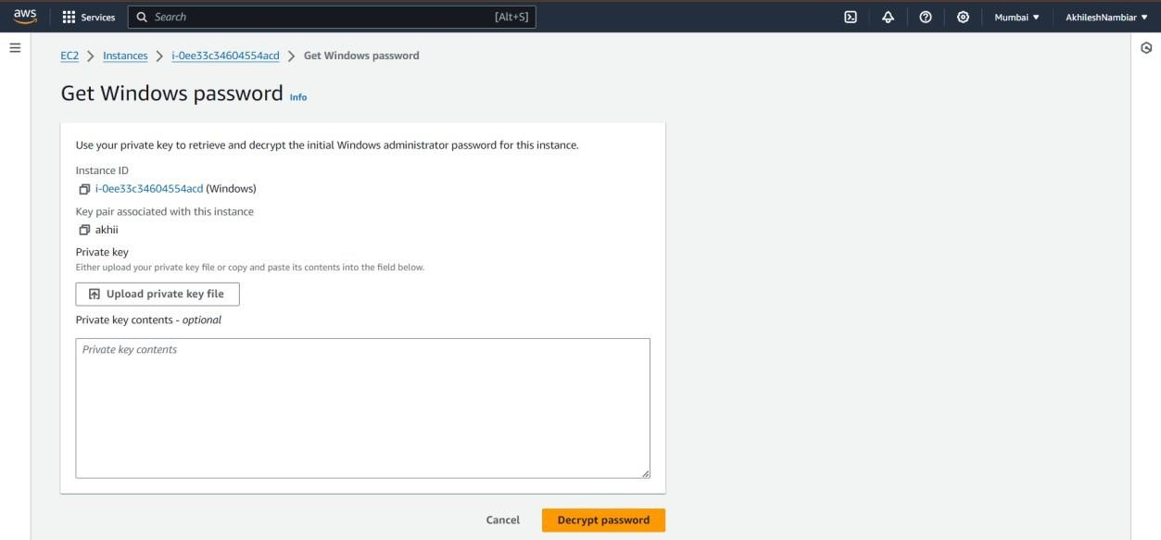

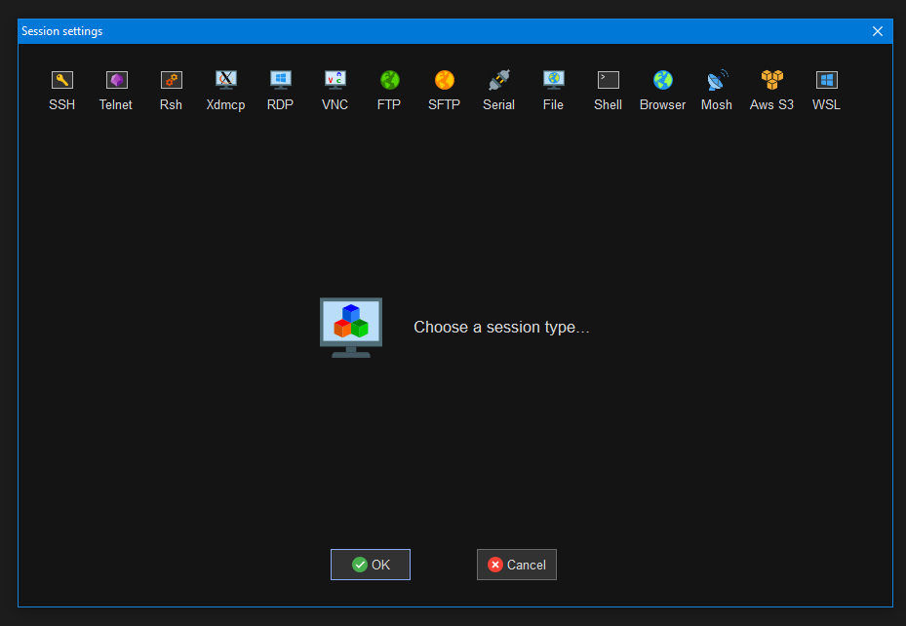Click on MobaXterm and click on new session and click on RDP.

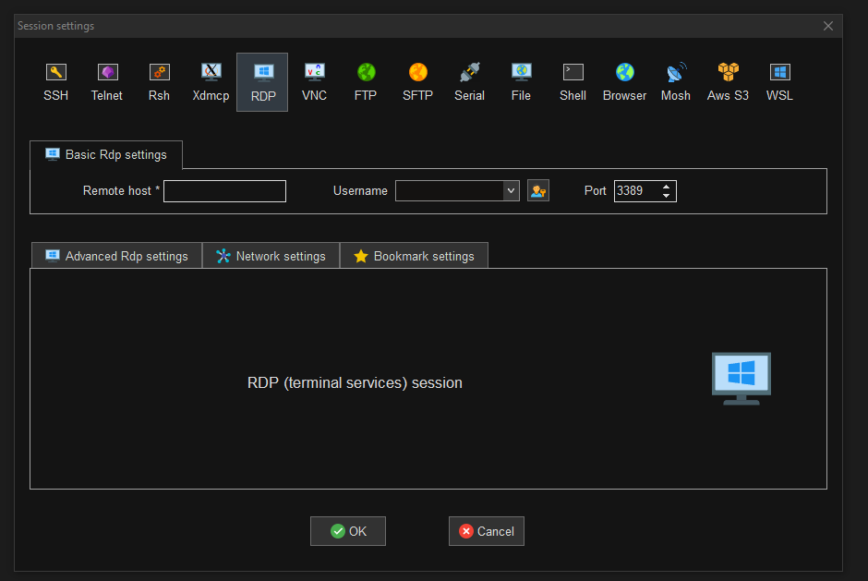

Give the name as Administrator and Remote host as Public-ip4-adress and then click on OK.

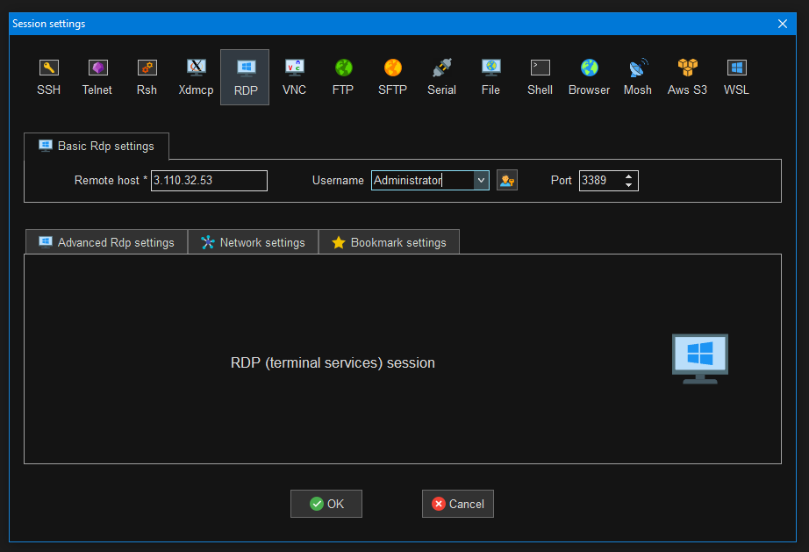

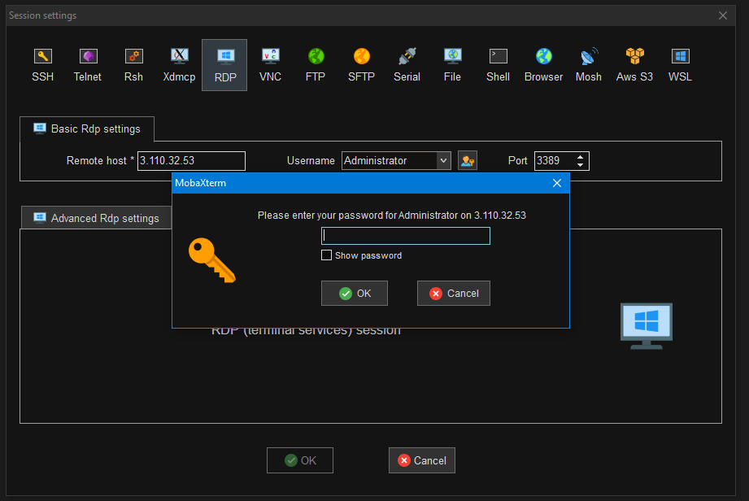

Here you have to upload your key pair file and then decrypt password and then copy that password and paste it then your virtual desktop will open.

