

SAVITRIBAI PHULE PUNE UNIVERSITY   
Project Report On

**“Online Bus Booking System”**

**Submitted By:**

**Abhishek Santosh Jadhav**

**Suraj Rakesh Vishwakarma**

GUIDED BY:

Prof. smt .Ketki Bhusare Mam



**Maratha Vidya Prasarak Samaj**

Department of Computer Science & Application

**Commerce , Management and Computer Science ( C.M.C.S.)College**

**Udoji Maratha Boarding Campus , Gangapur Road, Nashik -422013**

**(2021-2022)**

**SAVITRIBAI PHULE PUNE UNIVERSITY**

**Commerce , Management and Computer Science ( C.M.C.S.)College, Nashik-422013**



This is to Certified that the project report entitled

**“Online Bus Booking System”**

Has been successfully completed by:

**Mr. ABHISHEK SANTOSH JADHAV**

**Mr. SURAJ RAKESH VISHWKARMA**

As a partial fulfilment of Degree course in **BACHELOR OF COMPUTER APPLICATION** under **Savitribai Phule Pune University, Pune during the academic year 2021-2022** The said work has been assessed by us and we are satisfied that the same is up to the standard envisaged for the level of the course and that the said work may be presented to the external examiner.

Prof.smt.Ketki Bhusare Prof. D. W. Aher

(GUIDE) (HOD)

Prof.Dr.S.N.Shinde

(Internal Examiner) (External Examiner) (PRINCIPAL)

|  |  |  |
| --- | --- | --- |
| **Sr.no** | **Topic** | **Pg.no** |
| 1. | Introoduction |  |
| 2. | Existing System |  |
| 3. | Proposed System |  |
| 4. | Analysis design  -Fesiblity study  -Functional Requirements |  |
| 5. | Diagram  -E-R diagram  -Decision tree  -Data dictionary  -Data flow diagram |  |
| 6. | Input Screen |  |
| 7. | Reports |  |
| 8. | Sample code |  |
| 9. | Bibliography |  |

**INDEX**

**INTRODUCTION**

The focus of the project is to computerize traveling company to manage data, so that all the transactions become fast and there should not be any error in transaction like calculation mistake, bill generation and other things. It replaces all the paper work. It keeps records of all bills also, giving to ensure 100% successful implementation of the computerized Bus reservation system.

This reservation system has three modules. First module helps the customer to enquire the availability of seats in a particular bus at particular date. Second module helps him to reserve a ticket. Using third module he can cancel a reserved ticket.

|  |
| --- |
|  |

Traveling is a large growing business across all countries. Bus reservation system deals with maintenance of records of details of each passenger. It also includes maintenance of information like schedule and details of each bus.We observed the working of the Bus reservation system and after going through it, we get to know that there are many operations, which they have to do manually. It takes a lot of time and causing many errors while data entry. Due to this, sometimes a lot of problems occur and they were facing many disputes with customers. To solve the above problem, and further maintaining records of passenger details, seat availability, price per seat, bill generation and other things, we are offering this proposal of computerized reservation system.

**EXISTING SYSTEM**

Existing system refers to the system that is being followed till now. The existing system requires more computational time, more manual calculations, and the complexity involved in Selection of features is high. The other disadvantages are lack of security of data, Deficiency of Data accuracy, Time consuming etc. To avoid all these limitations and make the working more accurately the system needs to be computerized. Here in the Online bus booking system, a detailed study of existing system is carried along with all the steps in system analysis.

**Draw backs of existing system.**

      Here in the Online bus booking system, a detailed study of existing system is carried along with all the steps in system analysis. An idea for creating a better project was carried and the next steps were followed.

* Lack of security of data.
* More man power.
* Time consuming.
* Needs manual calculations.
* No direct role for the higher officials.

To avoid all these limitations and make the working more accurately the system needs to be computerized.

**PROPOSED SYSTEM**

The aim of proposed system is to develop a system of improved facilities. The proposed system can overcome all the limitations of the existing system. The system provides proper security and reduces the manual work. The existing system has several disadvantages and many more difficulties to work well. The proposed system tries to eliminate or reduce these difficulties up to some extent. The proposed system will help the user to reduce the workload and mental conflict. The proposed system helps the user to work user friendly and he can easily do his jobs without time lagging.

**Advantages of Proposed System**

The system is very simple in design and to implement. The system requires very low system resources and the system will work in almost all configurations. It has got following features

* Ensure data accuracy.
* Minimize manual data entry.
* Minimum time needed for the various processing
* Greater efficiency
* Better Service
* Minimum time required
* Customer can download the ticket.
* Ticket will contain all journey related data.
* User can send ticket on his mail.
* Admin use data for spread his routes.

**ANALYSIS AND DESIGN**

**INTRODUCTION**

System analysis is a process of gathering and interpreting facts, diagnosing problems and the information to recommend improvements on the system. It is a problem solving activity that requires intensive communication between the system users and system developers. System analysis or study is an important phase of any system development process. The system is studied to the minutest detail and analyzed. The system analyst plays the role of the interrogator and dwells deep into the working of the present system. The system is viewed as a whole and the input to the system are identified. The outputs from the organizations are traced to the various processes. System analysis is concerned with becoming aware of the problem, identifying the relevant and decisional variables, analyzing and synthesizing the various factors and determining an optimal or at least a satisfactory solution or program of action.

   Here in the project Online bus booking system, a detailed study of existing system is carried along with all the steps in system analysis. An idea for creating a better project was carried and the next steps were followed.

1. **FEASIBILITY STUDY**

An important outcome of the preliminary investigation is the determination that the system requested is feasible. Feasibility study is carried out to select the best system that meets the performance requirements.

Feasibility study is both necessary and prudent to evaluate the feasibility of the project at the earliest possible time. It involves preliminary investigation of the project and examines whether the designed system will be useful to the organization.

The different types of feasibility are: Technical feasibility, Operational feasibility, Economical feasibility.

**1 Technical feasibility**

Technical Feasibility deals with the hardware as well as software requirements. Technology is not a constraint to type system development. We have to find out whether the necessary technology, the proposed equipment’s have the capacity to hold the data, which is used in the project, should be checked to carryout this technical feasibility.

The technical feasibility issues usually raised during the feasibility stage of investigation includes these

* This software is running in windows 7 Operating System, which can be easily installed.
* The hardware required any high operational processor.
* The system can be expanded.

**2 Operational Feasibility**

This feasibility test asks if the system will work when it is developed and installed.

Operational feasibility in this project:

* The proposed system offers greater level of user-friendliness.
* The proposed system produces best results and gives high performance. It can be implemented easily .So this project is operationally feasible.

**3 Economical feasibility**

Economical Feasibility deals about the economical impact faced by the organization to implement a new system. Financial benefits must equal or exceed the costs. The cost of conducting a full system, including software and hardware cost for the class of application being considered should be evaluated. Economic Feasibility in this project:

* The cost to conduct a full system investigation is possible.
* There is no additional manpower requirement.
* There is no additional cost involved in maintaining the proposed system.

1. **Hardware And Software Specification**

**Hardware Specification**

Processor : Intel i3 7th Gen

Clock speed : 500 MHZ

System bit : 32 bits

RAM : 4GB RAM

HDD : 40 GB or Higher

**Software Specification**

Operating System : Windows 7 or Higher

Front End : HTMLCSS,JAVASCRIPT

Back End : PHP

Server : XAMPP SERVER

**PROPOSED SYSTEM**

The aim of proposed system is to develop a system of improved facilities. The proposed system can overcome all the limitations of the existing system. The system provides proper security and reduces the manual work. The existing system has several disadvantages and many more difficulties to work well. The proposed system tries to eliminate or reduce these difficulties up to some extent. The proposed system will help the user to reduce the workload and mental conflict. The proposed system helps the user to work user friendly and he can easily do his jobs without time lagging.

**Advantages of Proposed System**

The system is very simple in design and to implement. The system requires very low system resources and the system will work in almost all configurations. It has got following features

* Ensure data accuracy.
* Minimize manual data entry.
* Minimum time needed for the various processing
* Greater efficiency
* Minimum time required
* It would also help in providing adequate data to the corporation, particularly with regard to boarding of passengers from fare stages and important points
* This would help the corporation prepare and organize its schedules more efficiently on the basis of traffic demand.
* It would provide data on concessions given to various sections.

**Diagrams**

**E-R Diagram**

Feedback

m

Login

1

give

1

1

1

has

Admin

Customer

1

1

m

book

manage

Bus Route

m

Bus

1

Driver

generate

m

Ticket

**Decision Tree**

Login

Admin Customer

Manage Bus, Driver, Bus Search

Bus Route and Report

Available Not available

Go to Home

Booking Process

Valid Data Not valid Data

Go To Home

Book Ticket

Download ticket Send mail

Store to client Send ticket on

Side user mail

**Data Dictionary**

**Booking**

|  |  |  |  |  |
| --- | --- | --- | --- | --- |
| **Column** | **Type** | **Null** | **Default** | **Comments** |
| bookingid *(Primary)* | int(11) | No |  |  |
| busrouteid | int(11) | Yes | *NULL* | Foreign key |
| cust_id | int(11) | Yes | *NULL* | Foreign key |
| seats | int(11) | Yes | *NULL* |  |
| amount | int(11) | No |  |  |
| bdate | date | Yes | *NULL* |  |
| jdate | date | No |  | Foreign key |

# Breview

|  |  |  |  |  |
| --- | --- | --- | --- | --- |
| **Column** | **Type** | **Null** | **Default** | **Comments** |
| rno *(Primary)* | int(11) | No |  |  |
| cust_id | int(11) | Yes | *NULL* | Foreign key |
| review | varchar(255) | Yes | *NULL* |  |
| cname | varchar(50) | Yes | *NULL* | Foreign key |
| rdate | date | Yes | *NULL* | Foreign key |

# bus

|  |  |  |  |  |
| --- | --- | --- | --- | --- |
| **Column** | **Type** | **Null** | **Default** | **Comments** |
| bus_no *(Primary)* | varchar(50) | No |  |  |
| busname | varchar(50) | Yes | *NULL* |  |
| seat | int(11) | No |  |  |

# bus_route

|  |  |  |  |  |
| --- | --- | --- | --- | --- |
| **Column** | **Type** | **Null** | **Default** | **Comments** |
| busrouteid *(Primary)* | int(11) | No |  |  |
| source | varchar(20) | Yes | *NULL* |  |
| destination | varchar(20) | Yes | *NULL* |  |
| arrival_time | time | Yes | *NULL* |  |
| departure_time | time | Yes | *NULL* |  |
| distance | int(11) | Yes | *NULL* |  |
| fare | int(11) | Yes | *NULL* |  |
| bus_no | varchar(50) | Yes | *NULL* | Foreign key |
| driver_no | int(11) | Yes | *NULL* | Foreign key |

# Customer

|  |  |  |  |  |
| --- | --- | --- | --- | --- |
| **Column** | **Type** | **Null** | **Default** | **Comments** |
| cust_id *(Primary)* | int(11) | No |  |  |
| cust_name | varchar(30) | No |  |  |
| address | varchar(50) | No |  |  |
| contact_no | mediumtext | No |  |  |
| adharno | mediumtext | No |  |  |
| uname | varchar(20) | No |  |  |
| password | varchar(255) | No |  |  |
| email | varchar(60) | No |  |  |

# Driver

|  |  |  |  |  |
| --- | --- | --- | --- | --- |
| **Column** | **Type** | **Null** | **Default** | **Comments** |
| driver_no *(Primary)* | int(11) | No |  |  |
| driver_name | varchar(20) | Yes | *NULL* |  |
| address | varchar(20) | Yes | *NULL* |  |
| contact_no | mediumtext | Yes | *NULL* |  |
| license_number | mediumtext | Yes | *NULL* |  |

# Jreview

|  |  |  |  |  |
| --- | --- | --- | --- | --- |
| **Column** | **Type** | **Null** | **Default** | **Comments** |
| rno *(Primary)* | int(11) | No |  |  |
| busroute | varchar(50) | Yes | *NULL* |  |
| cust_id | int(11) | Yes | *NULL* | Foreign key |
| review | varchar(255) | Yes | *NULL* |  |
| cname | varchar(50) | Yes | *NULL* | Foreign key |
| rdate | date | Yes | *NULL* | Foreign key |

# Passenger

|  |  |  |  |  |
| --- | --- | --- | --- | --- |
| **Column** | **Type** | **Null** | **Default** | **Comments** |
| pid *(Primary)* | int(11) | No |  |  |
| pname | varchar(25) | Yes | *NULL* |  |
| age | int(11) | Yes | *NULL* |  |
|  |  |  |  |  |
| gender | varchar(7) | Yes | *NULL* |  |
| seat_no | int(11) | Yes | *NULL* |  |
| cust_id | int(11) | Yes | *NULL* | Foreign key |
| bookingid | int(11) | Yes | *NULL* | Foreign key |

**Data Flow Diagrams**

0.0

display

login

Client

Online Bus Booking

get receipt

Client

book

display

reports

login

changes

Admin

Admin

**Zero Level DFD-Bus Booking System**

Client

1.1

1.2

1.3

enter

**First Level DFD-Bus Booking System**

details

successful

login

view

username pwd

enter

book

login

1.1.0

client

enter detail

1.1.3

1.1.2

1.1.1

enter pass

enter

username

home page

check

password

1.2.0

client

enter detail

Search

1.2.3

1.2.2

1.2.1

Check bus

available

search

select bus

bus

1.3.0

client

enter detail

print

calculate

1.3.3

1.3.2

1.3.1

pdf

book

amount

Enter seat

send mail

**Second Level DFD-Bus Booking System**

**Input Screen**

**Bus Entry:**

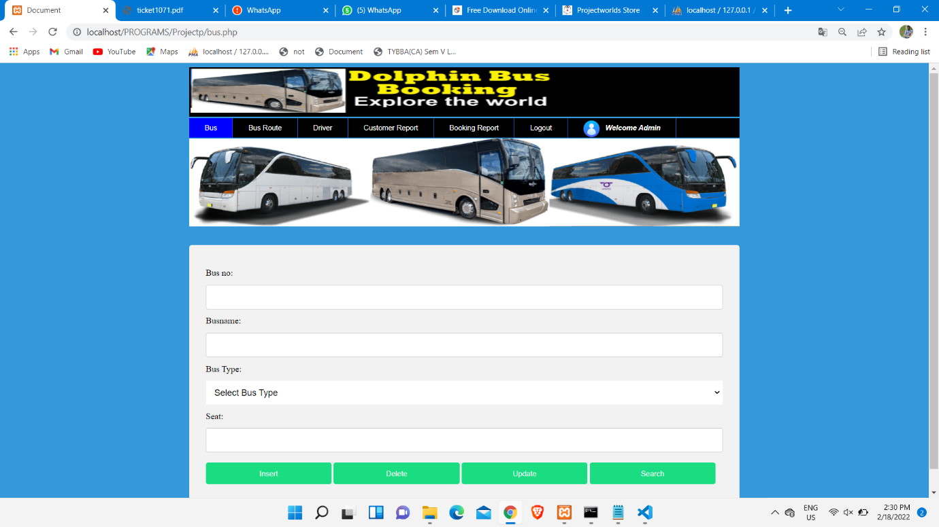

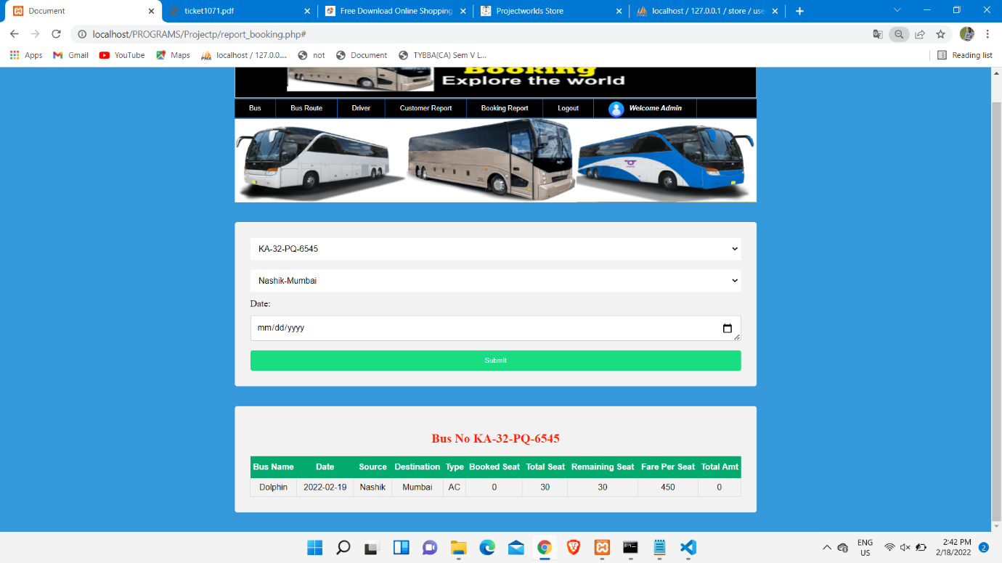

**Driver Entry:**

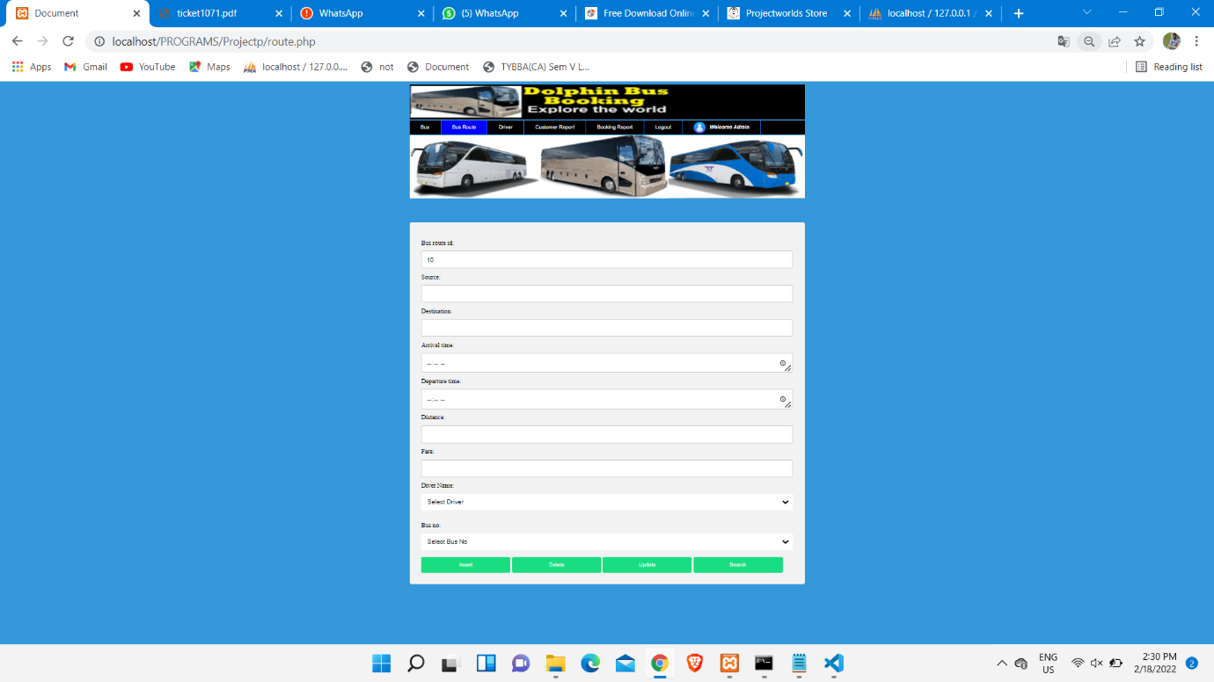

**Route Entry:**

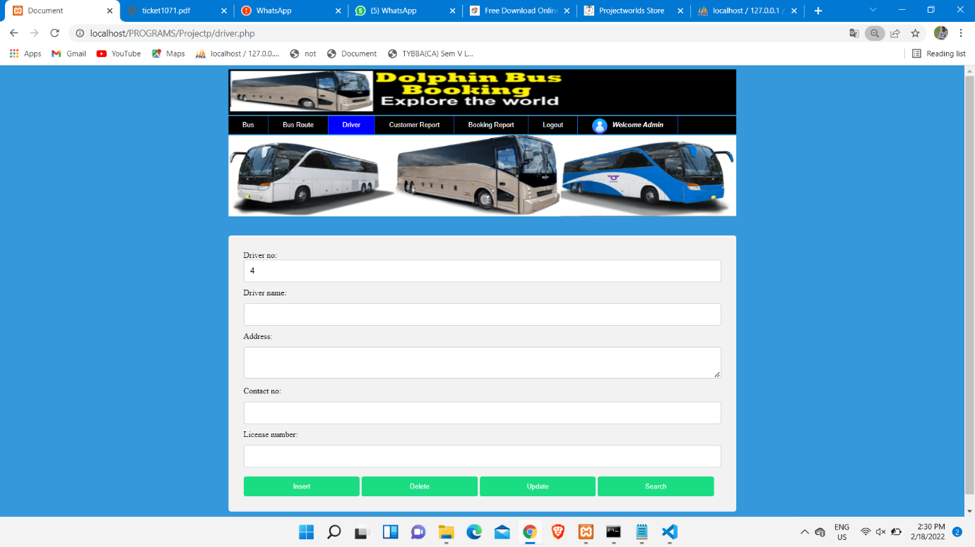

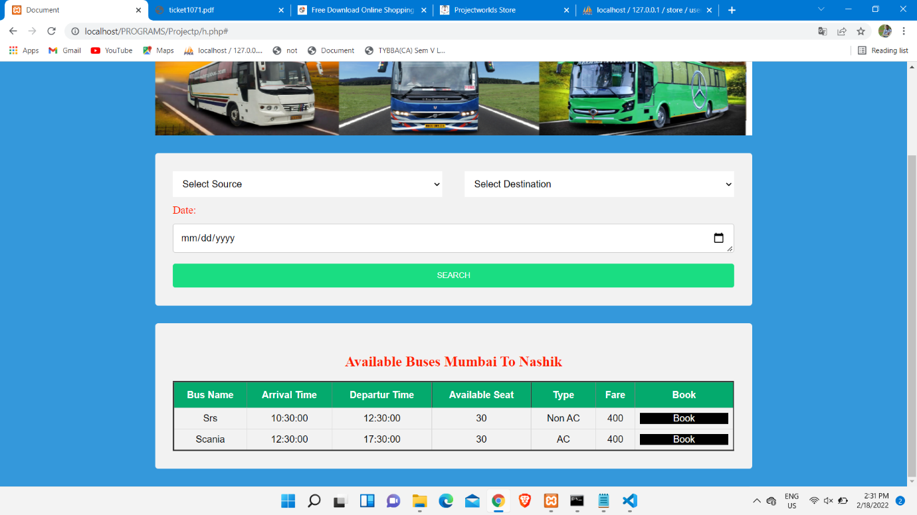**Booking Entry:**

**Reports**

**Ticket Modification:**

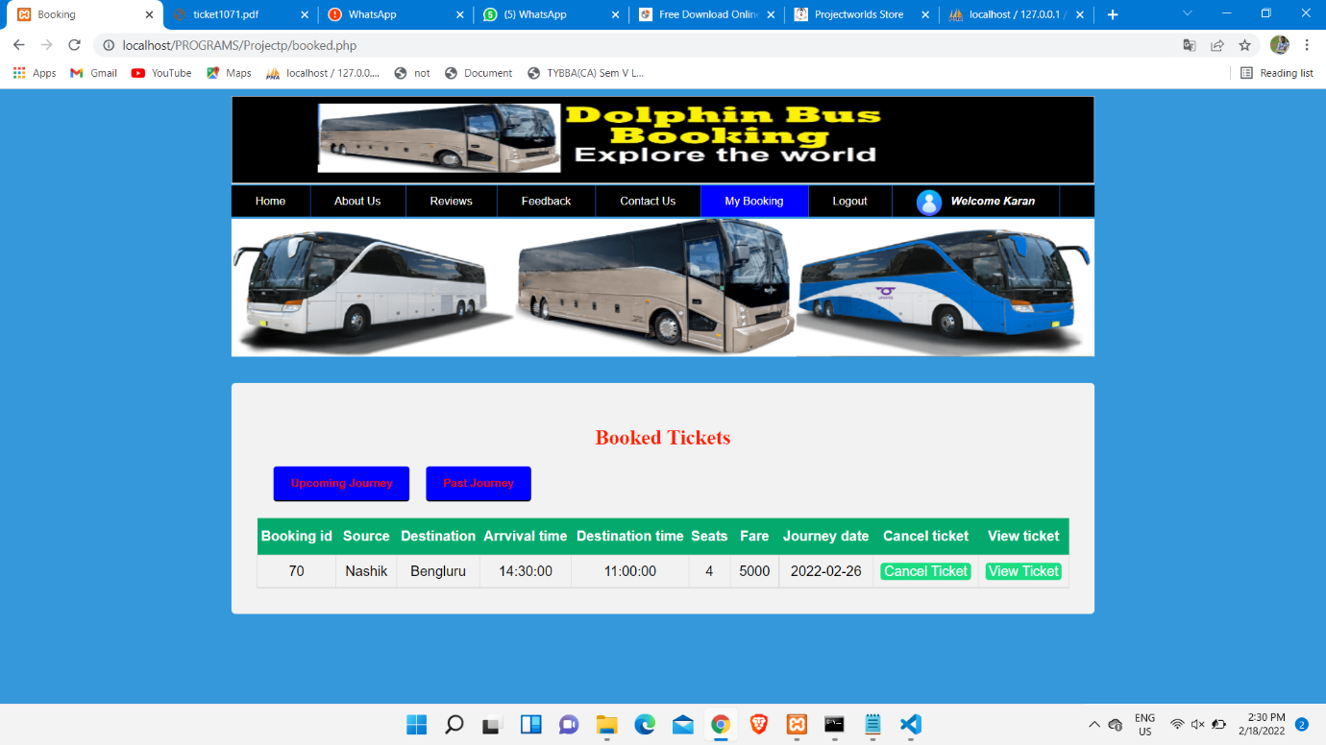

**OnRoute Bus:**



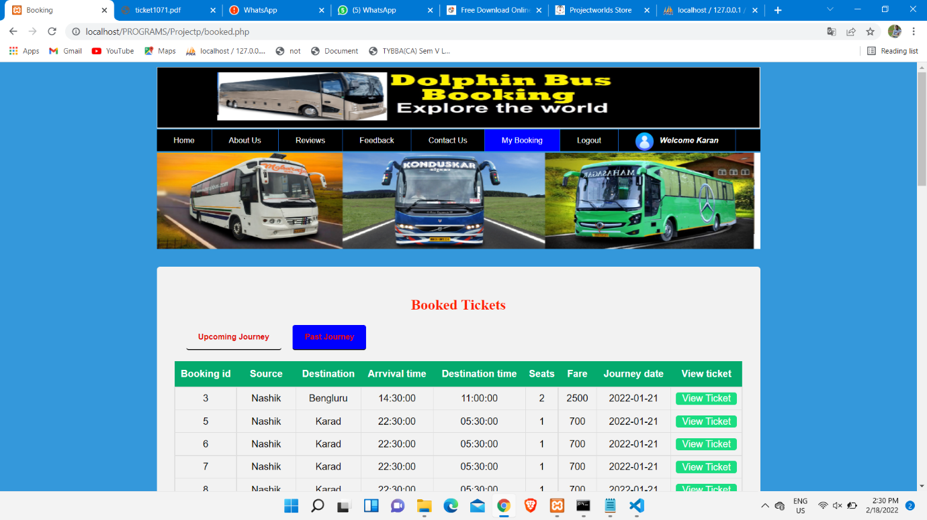**Booked Tickets:**

**Ticket:**

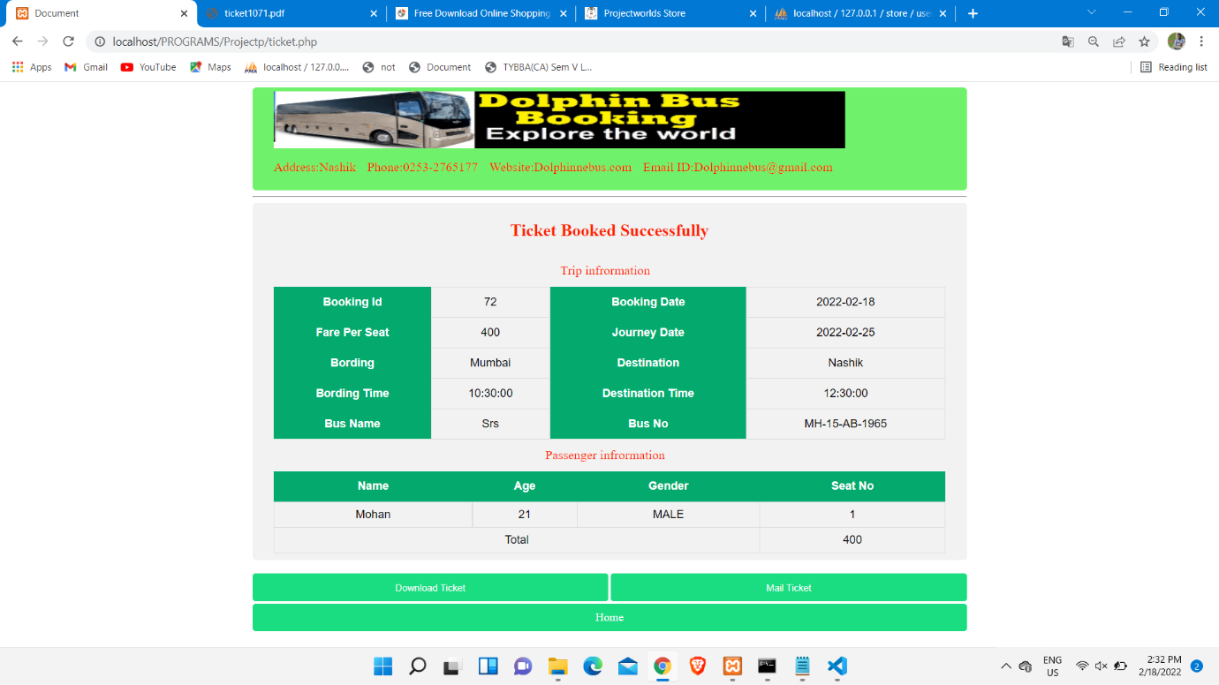

**Sample Code:**

**1)Signup.php/Input form code**

<?php

include("head.php");

?>

<!DOCTYPE html>

<html lang="en">

<head>

<meta charset="UTF-8">

<meta http-equiv="X-UA-Compatible" content="IE=edge">

<script src="JS/signUp.js"></script>

<link rel="stylesheet" href="CSS/index.css">

<meta name="viewport" content="width=device-width, initial-scale=1.0">

<title>Document</title>

<script>

function checkuname(uname)

{

var letter=/^[A-Za-z-0-9]+$/;

// let uname=document.getElementById("uName1").value;

if(!uname.match(letter))

{

document.getElementById("e4").innerHTML="<span style='color:red'>Enter only alphabates..</span>";

}

else if (uname.length<3)

{

document.getElementById("e4").innerHTML="<span style='color:red'>Username grater than 3..</span>";

}

else{

var xhr = new XMLHttpRequest();

xhr.onreadystatechange = function ()

{

if (this.readyState == 4 && this.status == 200)

{

document.getElementById("e4").innerHTML=this.responseText;

}

}

xhr.open("POST", "checkuname_ajax.php?uname="+uname, true);

xhr.send();

}

}

function checkemail(email)

{

var xhr = new XMLHttpRequest();

xhr.onreadystatechange = function ()

{

if (this.readyState == 4 && this.status == 200)

{

document.getElementById("e6").innerHTML=this.responseText;

}

}

xhr.open("POST", "checkemail_ajax.php?email="+email, true);

xhr.send();

}

</script>

</head>

<body bgcolor="#3498DB">

<div class="container">

<form method="post" action="#">

<label>Customer no:</label><input type="number" id="cId1" name="cId" required >

<label>Customer name:</label><input type="text" id="cName1" name="cName" onchange="validate1()" minlength="2" maxlength="20" required placeholder="Enter your name"><span id="e1"><br></span><br>

<label>Address:</label><textarea id="add1" name="add" required minlength="4" maxlength="50" pattern="[A-Za-z0-9]" placeholder="Enter your address"></textarea>

<label>Contact no:</label><input type="number" id="cNo1" name="cNo" onchange="validate2()" required minlength="10" maxlength="10" placeholder="Enter contact no"> <span id="e2"></span><br>

<label>Adhar no:</label><input type="number" id="aNo1" name="aNo" onchange="validate3()" required minlength="12" maxlength="12" placeholder="Enter adhar no"><span id="e3"></span><br>

<label>Username:</label><input type="text" id="uName1" name="uName" onchange="checkuname(value)" required minlength="5" maxlength="20" placeholder="Enter your userame"><span id="e4"></span><br>

<label>Password:</label><input type="password" id="pass1" name="pass" onchange="validate5()" required minlength="5" maxlength="20" placeholder="Enter your password"><span id="e5" ></span><br>

<label>Email:</label><input type="email" id="email1" name="email" onchange="checkemail(value)" required placeholder="Enter your Email id">

<span id="e6"></span><br><br>

<input type="submit" name="btn" value="Sign Up">

</form>

</div>

</body>

</html>

<?php

$con=mysqli_connect("localhost","root","","busbooking");

if(!$con)

{

die("Could not connect".mysqli_connect_error());

}

$sql=mysqli_query($con,"select max(cust_id) as cid from customer") or die(mysqli_error($con));

$res=mysqli_fetch_array($sql);

$count=$res['cid']+1;

?>

**2)Booking.php**/**Transaction Code**

<?php

include("head.php");

?>

<!DOCTYPE html>

<html lang="en">

<head>

<meta charset="UTF-8">

<meta http-equiv="X-UA-Compatible" content="IE=edge">

<meta name="viewport" content="width=device-width, initial-scale=1.0">

<link rel="stylesheet" href="CSS/index.css">

<title>Document</title>

<script>

function seatNum()

{

let fare=<?php echo $_REQUEST['fare']; ?>;

document.getElementById("passenger").innerHTML="";

let seat = document.getElementById("seat1").value;

if (seat > 6)

{

alert("Only 6 seat can book at one time...");

document.getElementById("am").value="";

}

else {

for (let i = 1; i <= seat; i++) {

document.getElementById("passenger").innerHTML += '<label>Passenger name ' + i + ' :<input type="text" name="p'+ i +'" required> <label>age:</label> <input type="number" name="age'+ i +'" required><label>Gemnder:</label>MALE<input type="radio" name="gen'+i+'" value="MALE">FEMALE<input type="radio" name="gen'+i+'" value="FEMALE">';

}

document.getElementById("am").value=fare*seat;

}

}

</script>

</head>

<body>

<div class="container">

<form action="#" method="post">

<label>Booking id:</label><input type="number" disabled name="bid" id="id">

<label>Seat:</label><input type="number" max=6 name="seat" id="seat1" onchange="seatNum()">

<div id="passenger"></div>

<label>Amount:</label><input type="number" disabled name="amt" id="am"><br><br>

<input type="submit" name="btn" value="BOOK">

</form>

</div>

</body>

</html>

<?php

if(!isset($_SESSION['cust_id']))

{

header("location:destroy.php");

}

$con=mysqli_connect("localhost","root","","busbooking");

if(!$con)

{

die("Could not connect".mysqli_connect_error());

}

$sql=mysqli_query($con,"select max(bookingid) as bid from booking") or die(mysqli_error($con));

$res=mysqli_fetch_array($sql);

$count=$res['bid']+1;

if(empty($_POST['p1']))

{

echo '<script>

alert("Enter The Seat");

</script>';

}

if(isset($_POST['btn']) and !empty($_POST['p1']))

{

$bid=$_REQUEST['busid'];

$cid=$_SESSION['cust_id'];

$brid=$_REQUEST['busroute'];

$fare=$_REQUEST['fare'];

$avilable=$_REQUEST['avi'];

$n=$_POST['seat'];

$date=$_REQUEST['date'];

$bus_seat=$_REQUEST['tseat'];

$_SESSION['brid']=$brid;

$_SESSION['bid']=$count;

for($i=1;$i<=$n;$i++)

{

//for get max pessanger id

$sql=mysqli_query($con,"select max(pid) as pid from passenger") or die(mysqli_error($con));

$res=mysqli_fetch_array($sql);

//for get max avaliable seat

$sql1=mysqli_query($con,"select * from bus_route where busrouteid=$brid") or die(mysqli_error($con));

$res1=mysqli_fetch_array($sql1);

$pid=$res['pid']+1;

$pname=$_POST['p'.$i];

$age=$_POST['age'.$i];

$gen=$_POST['gen'.$i];

if($avilable <= 0)

{

?>

<script>

alert("Sorry seat is not avilabale...");

location.href="h.php";

</script>

<?php

exit();

}

$av=$avilable-1;

$avilable=$avilable-1;

//getting seat no

$seat=$bus_seat-$av;

$sql=mysqli_query($con,"INSERT INTO `passenger` ( `pid`,`pname`, `age`, `gender`,`seat_no`, `cust_id`,`bookingid`) VALUES ($pid,'$pname',$age,'$gen',$seat,$cid,$count)") or die(mysqli_error($con));

}

$amt=$fare*$n;

$sql1=mysqli_query($con,"INSERT INTO `booking` (`bookingid`,`busrouteid`,`cust_id`, `seats`, `amount`, `bdate`,`jdate`) VALUES ($count,$brid,$cid,$n,$amt,curdate(),'$date')") or die(mysqli_error($con));

if($sql1)

{

?>

<script>

location.href="ticket.php";

</script>

<?php

}

?>

<script>

document.getElementById("seat1").value="<?php echo $n;?>";

</script>

<?php

}

?>

<script>

document.getElementById("id").value="<?php echo $count;?>";

</sc

**3)Ticket.php/Output code:**

<?php

session_start();

if(!isset($_SESSION['cust_id']))

{

header("location:destroy.php");

}

$con=mysqli_connect("localhost","root","","busbooking");

if(!$con)

{

die("Could not connect".mysqli_connect_error());

}

$cno=$_SESSION['cust_id'];

$brid=$_SESSION['brid'];

$bid=$_SESSION['bid'];

//for get bus and route data

$sql=mysqli_query($con," SELECT * FROM `bus_route`,bus where bus.bus_no=bus_route.bus_no and busrouteid=$brid ") or die("Error".mysqli_error($con));

$res=mysqli_fetch_assoc($sql);

//for get booking data

$sql1=mysqli_query($con,"SELECT * from booking where bookingid=$bid ") or die(mysqli_error($con));

$res1=mysqli_fetch_assoc($sql1);

//for get passenger data

$sql2=mysqli_query($con," select * from passenger where bookingid=$bid ") or die(mysqli_error($con));

//for getting user email

$sql3=mysqli_query($con,"SELECT * from customer where cust_id=$cno ") or die(mysqli_error($con));

$res3=mysqli_fetch_array($sql3);

?>

<!DOCTYPE html>

<html lang="en">

<head>

<meta charset="UTF-8">

<meta http-equiv="X-UA-Compatible" content="IE=edge">

<meta name="viewport" content="width=device-width, initial-scale=1.0">

<script src="https://cdnjs.cloudflare.com/ajax/libs/html2pdf.js/0.10.1/html2pdf.bundle.min.js"></script>

<!-- <script src="pdf.js"></script> -->

<link rel="stylesheet" href="CSS/table.css">

<title>Document</title>

<style>

.content {

max-width: 1000px;

margin: auto;

min-height: 40px;

}

a {

display: block;

text-decoration: none;

position: relative;

background-color: rgb(26, 221, 130);

color: white;

padding: 1%;

border: none;

border-radius: 4px;

cursor: pointer;

width: auto;

margin-top: .5%;

text-align: center;

}

a:hover {

background-color: #45a049;

}

input[type=button],input[type=submit]

{

background-color: rgb(26, 221, 130);

color: white;

padding: 12px 20px;

border: none;

border-radius: 4px;

cursor: pointer;

width: 49.8%;

float:right;

}

input[type=submit]

{

margin-left: .4%;

}

input[type=button]:hover

{

background-color: #45a049;

}

input[type=submit]:hover

{

background-color: #45a049;

}

</style>

<script>

function genpdf()

{

var name="<?php echo 'ticket'.$_SESSION['cust_id'].$res1['bookingid'].'.pdf';?>";

var element = document.getElementById("pdf");

var opt = {

margin: 1,

filename: name,

image: {

type: 'jpeg',

quality: 0.98

},

html2canvas: {

scale: 2

},

jsPDF: {

unit: 'in',

format: 'letter',

orientation: 'portrait'

}

};

html2pdf().set(opt).from(element).save();

}

</script>

</head>

<body>

<div class="content" id="pdf">

<div class="head">

<img src="imageheader/header1.jpg" alt="NIIT" width="800" height="80" />

<br><label>Address:Nashik</label>

<label>Phone:0253-2765177</label>

<label>Website:Dolphinnebus.com</label>

<label>Email ID:Dolphinnebus@gmail.com</label>

</div>

<hr>

<center>

<div class="table">

<h2>Ticket Booked Successfully</h2>

<label>Trip infrormation</label>

<table>

<tr>

<th>Booking Id</th>

<td>

<?php echo $res1['bookingid'];?>

</td>

<th>Booking Date</th>

<td>

<?php echo $res1['bdate'];?>

</td>

</tr>

<tr>

<th>Fare Per Seat</th>

<td>

<?php echo $res['fare'];?>

</td>

<th>Journey Date</th>

<td>

<?php echo $res1['jdate'];?>

</td>

</tr>

<tr>

<th>Bording</th>

<td>

<?php echo $res['source'];?>

</td>

<th>Destination</th>

<td>

<?php echo $res['destination'];?>

</td>

</tr>

<tr>

<th>Bording Time</th>

<td>

<?php echo $res['arrival_time'];?>

</td>

<th>Destination Time</th>

<td>

<?php echo $res['departure_time'];?>

</td>

</tr>

<tr>

<th>Bus Name</th>

<td>

<?php echo $res['busname'];?>

</td>

<th>Bus No</th>

<td>

<?php echo $res['bus_no'];?>

</td>

</tr>

<!-- <tr>

<th>Bus Type</th>

<td>

<?php echo $res['type'];?>

</td>

<th>Bus No</th>

<td>

<?php echo $res['bus_no'];?>

</td>

</tr> -->

</table>

<table>

<label>Passenger infrormation</label>

<tr>

<th>Name</th>

<th>Age</th>

<th>Gender</th>

<th>Seat No</th>

</tr>

<?php

while($res2=mysqli_fetch_assoc($sql2))

{

echo '<tr>

<td>'.$res2['pname'].'</td>

<td>'.$res2['age'].'</td>

<td>'.$res2['gender'].'</td>

<td>'.$res2['seat_no'].'</td>

</tr>';

}

?>

<tr>

<td colspan="3">Total</td>

<td>

<?php echo $res1['amount'];?>

</tr>

</tr>

</table>

</div>

</div>

<div class="content">

<br>

<form action="#" method="post">

<input type="submit" value="Mail Ticket" name="send" id="en">

</form>

<input type="button" id="btn" value="Download Ticket" onclick="genpdf()">

<br><br><a class="anch" href="h.php">Home</a>

</div>

</center>

</body>

</html>

**Bibliography**

* <https://www.javatpoint.com/>
* <https://stackoverflow.com/>
* <https://www.geeksforgeeks.org/>
* <https://www.w3schools.com/>
* <https://www.php.net/docs.php/>