

A Project Report On

**Online-Book-Store**

**By**

Suraj Bakchi

**Batch:** 2022-7400

**Center: Mumbai**

Under the Guidance of

**Chittaranjan Ghosh.**

**Technical Trainer**

**EduBridge**

(School of coding)

**Introduction:**

The aim of the project is to create an efficient & reliable online bookselling & buying platform to help both buyer and seller. It saves buyer time by facilitating access from anywhere & provide home delivery service.

**Modules:**

* Buyer Module.
* Seller Module.

I have developed this Application in **Java .**

The main objective of the Online Book Store is to reduce manual work and time. It is difficult and time-consuming for buyer to visit the physical library search for a book and then buy it. It is more difficult for seller. To avoid this problem, we have planned to develop a console-based Online Book Store.

In Buyer Module buyer get the list of books. In which if the buyer like a book buyer can check the description of the book and then if buyer want to buy the book.by filling the order form buyer can order the book directly at home.

In Seller Module seller just have to fill a form about his book and his book is ready to sell.

* Saves the time of visiting the physical library.
* Easy for seller to sell his book.

**Modules :**

* **Buyer Module:** Buyer can select a book from the list of books. And can order it.
* **Seller Module:** Seller can sell his book just by adding description about the book. And the book is ready for sell.

**Software Requirements :**

**Language:** Java.

**IDE:** Eclipse for Java EE Developers.

**Operating System:** Microsoft Windows.

Screenshot:

Buyer:

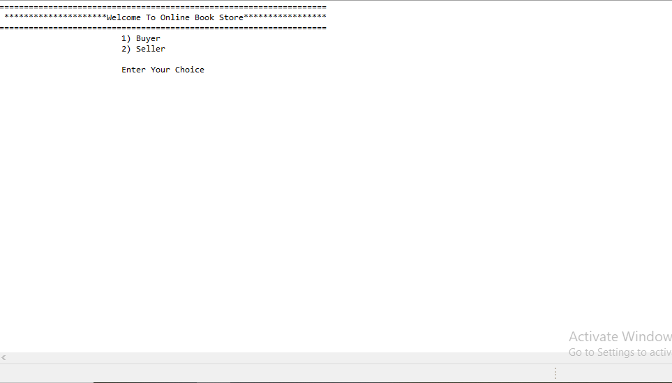

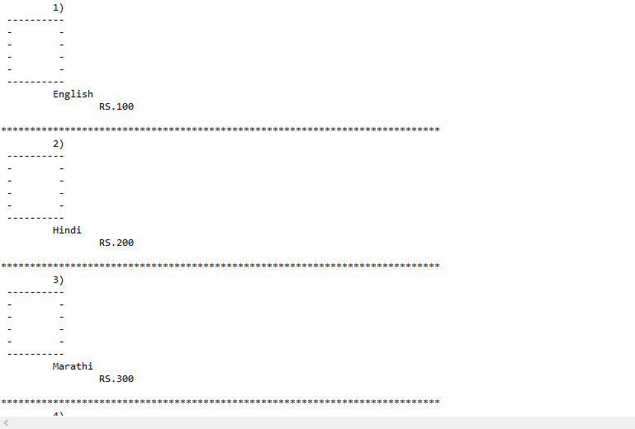

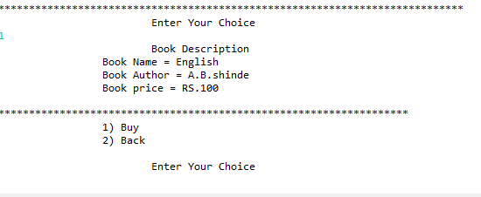

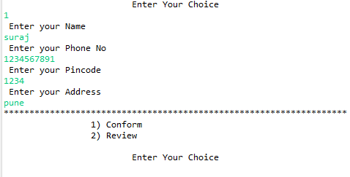

Seller:-

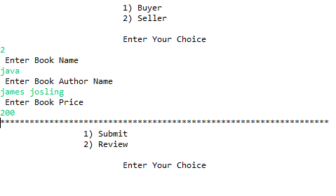

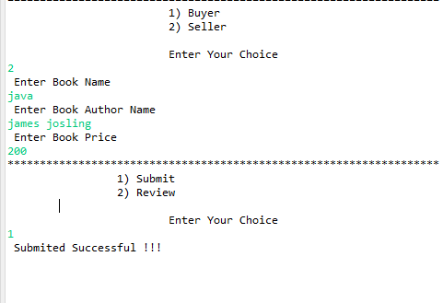

**Thank you…..**