*******SDLC (software development life cycle)*********

**phases**

--------------

1] Initial phase or Requirement phase

2] Analysis phase

3] Design phase

4] Coding phase

5] Testing phase

6] Delivery and maintanance phase

-----------------------------------------------------------

1] INTIAL AND REQUIREMENT PHASE:-

- 1)who will be there

2) what kind of java required

- here is may be BA (buisness analyist),he make a file called as FRS,BRS,BDD,URS

[FRS :-Functional Requirement Specification

BRS :-Buisness Requirement specification

BDD :-Buisness design document

URS :-Users requirement specification

BD :- Buisness document]

-------------------------------------------------------------

2] ANALYSIS PHASE

-system analist is there

-URS=>100 requirements=>cotation=>time=>required human resourses[required 50 persons (30 developer and 20 testers)]

===>after that SRS [system requirement specification] file is developed for next phase

------------------------------------------------------------------

3] DESIGN PHASE

-CA team[chief architechre] is there

-SRS(OPEN)=> 100 requirement =>80 high level and 20 low level=>decide application functionality

=> send design to customer to validiate it

=>creat folder,TDD [technical design document]

---------------------------------------------------------------------------

4] CODING PHASE

-programmer and developers team is there

-they analyies

-they don't send code to the testers

-they send staging URL

-they creat a folder ,SCD[source code document]

---------------------------------------------------------------------------

5]TESTING PHASE

-we need to create sinario

-we need one test case templete

-we need to make test case document

-we need to excute our test cases on our application

[after complition]

-how many defects we got

-how to inform to the developer

-once the developer fix the defect what we are going to do

-----------------------------------------------------------------------------

**TESTER APPROACH

-anlaies the requirement

-how many sinsrio going to prepare

-how many test cases going to prepare

-we are going to prepare test case templete

===========================================================

*************TESTING METHODS OR TECHNIQUES*******************

1] Black Box Testing (BBT)

2] White Box Testing (WBT)

3] Gray Box Testing (GBT)

--------------------------------------------

1]BLACK BOX TESTING :- who will verify the application functionality comes under BBT

2]WHITE BOX TESTING:- who will verify the application coding part that peoples are comes under devoloper are WBT

3]GREY BOX TESTING:- who will verify the application coding and testing part that people are comes under GBT testing

--------------------------------------------------------------------

=========================================================================================================

*******************LEVELS OF TESTING****************************

1]Unit level testing

2]Module level testing

3]Integration level testing

4]System level testing

5]User acceptance level testing

---------------------------------------------------------------------------------

1] UNIT LEVEL TESTING:- perticular element testing

2] MODULE LEVEL TESTING:- module (main function) which is involved more than application functionality inside of module level testing

3]INTEGRATION LEVEL TESTING:-some people are working in diffrent diffrent location on diffrent element or module

-once the coding will completed they will push the code to perticuler people or perticular persons

- these persons integrate all the codes based on custmer requirement'

-if we want to integrate , company people develop one frame ie. we called integration level testing

: > all---------->US [all button coding part developed in US]

AMAZON {HOMEPAGE} :>

[INDIA] : > sell--------->UK [sell button coding part developed in UK]

:>

:> best seller---->AMERICA [best seller coding part developed in AMERICA]

:>

: > todays deals------>CHINA [todays deals button coding part developed in CHINA]

All the coding are get integrated in india [in one place] after that the testing carried out then the testing is called integration level testing

---------------------------------------------------------------------------------------------------------------------------------------------------------

4] SYSTEM LEVEL TESTING:-

- what they are get integrated that element are properly working or not, we are going to validate it.

-the developers integrate some element that are that perticular element are properly woking or not we are going to validate that is done by blacl box testing

-----------------------------------------------------------------------------------------------------------------------------------------------

5] USER ACCEPTANCE LEVEL TESTING:-

-Once comleted the testing we are going to release the application to custmer.

- in custmer side some third party testers are thier they validate this quality or not

-------------------------------------------------------------------------------------------------------------------

=======================================================================================================================

******SOFTWARE DEVELOPMENT PROCESS or TESTING METHODOLOGIES********

=========================================================================

1]Waterfall model / Sequential model

2] Prototype model

3] Evolutionary model or increamental model

4] Spiral model

5] V-model (verification - validiation model)

6] Agile model

-----------------------

1} WATERFALL MODEL or SEQUENTIAL MODEL

- If you want to deliver the application to custmer we are going to use waterfall model

-when we are going to release the application to custmer in every 3 months , if customer does not satisfied

and he add new requirement we are unable to add new requirement in the project because of time consuming

-so we are not using now a days this model [ note: startup people are using this process]

-----------------------------------

2}PROTOTYPE MODEL

-prototype is nothing but rough diagram

-the customer provide some requirement to company people that people are unable to understand, out of 100 requirement 20 requirement are not clear

- then imidiatly go to our team lead and you can explain about unclear requirement at that time team lead able to understand he will provide clear confirmation

- if he is unable to understand about this unclear requirement we have one option that buisness analyst (BA), he is take care of it.

------------------------------------------------------

3}EVOLUTIONARY OR INCREAMENTAL MODEL

-if you want to release the application to custmer we are going to use this model.

- in this model we are going to release the application in every two months

-the main disadvantage in this model,if you want to release the application to custmer then the custmer is satisfied or not we don't know

-so this process is contineously happen like that

-in this time we are unable to deliver application to custmer within the time this is similer of waterfall model.

---------------------------------------------------------------------------------------

4}SPIRAL MODEL

-this completely secure based model

-this is not open source,this is paid version

-banking sector people use this model

-we are unable to handle this process im realtime ,if you want to use this model mostly we going to use for banking sector.

** Define the objectives:-purpose of the project or application

**Work analysis:- if you want to release the application to custmer what type of requirement we are going to release we analyies

** Constraints:- it is nothing but the custmeres instructions

**Risk root cause, analysis, estimation,conteingencies (solution plan)

-risk root cause analysis is not an easy task.

-before starting the project who are involved in this project the people are discussed in future we are getting any risk what is the solution for the plan

[note:-in realtime we got diffrent types of risk we never estimate what type of risk we are getting in future.]

**Refining and planning for the next cycle:-

-if you want to release the application to custmer by using spiral model , what type of requirement we are going to relese for next cycle

**Implemention:-

-it is nothing but deployment of code,deployment is nothing but if you want to release the application to customer before realese the application to customer

the developer check the application code is properly working or not

-implementation is nothing but deployment of code

---------------------------------------------------------------------------------------------------

5] V-MODEL [VERIFICATION - VALIDATION MODEL]

-this is the fastest process

-early deploy,when we are using the v-model developer develope the application,imidiatly what they are developed we are going to test that perticuler element

and at the same time we are going to release the application to customer

-in this main disadvantage we are unable to provide quality product to customer

-it causes the more defect in the application

==============================================================================================================================================

***************************AGILE MODEL (METHODOLOGY)******************************

-this is the quick process

-if you want to release the application to custmer by using this methodology we are going to follow Agile rules

-some terminologies in Agile methodologies

===========================

SPRINT:-time measurement/ how much you developed and how much you tested

-if you want to release the application to customer through sprintwise.

-the maximum sprint is 14 days or minimum is 7 days within the sprint how much we developed and tested we are going to release the customer[not whole application]

=======================================

SCRUM:-if want to release the application to custmer we are going to follow some process ie.scrum process

-if we want to develop and test the application we are going to follow scrum rule

-we have diffrent rolles their

1]product owner

2]scrum master

3]development team

4]scrum team

-------------------------

1]PRODUCT OWNER:it gather the users card and story cards,user board ,story board stores in folders ie.product backlog item.

[note:- in agile ,methodology we don't call requirement]

--------------------------------------------------------------

2] SCRUM MASTER:- he will explain the scrum rule

i] how to do the test

ii] how to achieve the quality

iii] how to achieve the goal

iv] how to deliver the deliverables in times

- he explain to team members

-------------------------------------------------------

3\4] SCRUM TEAM / DEVELOPMENT TEAM:

-who are involved in this project that people are comes under the scrum team or development team

-------------------------------------------------------------

========================================================================================

========================================================================================

*SCRUM EVENTES

-----------------------------

1]Scrum Events or Daily Meetings or Standup Meetings

2]Sprint Planning Meeting

3]Sprint Rievew Meeting

4]Ritrospective Meeting

---------------------------------------------

1} SCRUM EVENTS:-

a) what was completed yesterday

b) what we have to do today

c) what is the plan to tommrow

---------------------------------------------------------------

2} SPRINT PLANNING MEETING:-

- before release the application to custmer some plan is required, in this plan / meeting what type of requirement we are going to release next step

-in this meeting we can decide next sprint scope

------------------------------------------------------------------------

3} SPRINT RIVIEW MEETING:-

- before release the application to customer we will conduct the review meeting

-in this review meeting we are going to know about sprint

- the team lead he will the feedback above score this is before release meeting

-----------------------------------------------------------------------------

4} RETROSPECTIVE MEETING

a] what went to good

b] what went wrong

a]:- before doing the testing we are going to validate the test envoirnment everytning is proper / is there or not

- we are validate application is stable or not

b]:- once testing is completed we got some critical defect and major defecr in this application

- once fix all critical and majot deffect what is application defect is stable or not validate it

===========================================================================================================================================

**************TYPES OF TESTING***************

1.Build Acceptance testing

2.Retestig Testing

3.regression testing

4.static testing

5.dynamic testing

6.GUI Testing [graphical user interface testing]

7.smoke testing [build health cheack up testing]

8.sanity testing

9.usability testing

10.compatibility testing

11.intalation testing

12.desktop testing

13.web based testing

14.alpha testing

15.beta testing

16.port testing

17.security testing

18.firewall or privillage testing

19.end to end testing

20.spike/load/stress testing

21.gorilla testing

22.monkey testing

23.ad-hoc testing

24.exploritory testing

====================================================================

1]BUILD ACCEPTANCE TESTING

-once we got the build from the devlopment team we are going to do basic testing

-we need to validate application home page is properly working or not

-as a tester need to validate based on the custemer requirement all the element it should be displayed or not on our home page

-once we launch the application sometimes the application will be closed automatically without human intervention ie. application crash

-we are going to validiate all database connections.sometimes we go API issue e.g.400,401,403,404,405,501,503

=====================================================================================================================

2]RETESTING TESTING

-if we want to validate any element in our home page some elements is not working properly then we need to inform to perticuler developer

-the developer accept your defect they will fix the diffect

-once fix the issue sending the updated build or new buid

-in this new build we are going to balidate second time is fixed or not ie.called retesting

==========================================================================================================================

3]REGRESSION TESTING

-once we got the defect we need to inform the developer

-the developer fix the issue and sending the updated build to testing department

-in this time as a tester we need to validate defect is really fixed or not

-if we want to do the regression testing we need to validate existing functionality also because

-once the developer fix the issue any existing element affected or not we are going to validate

=================================================================================================================

4]STATIC TESTING

-without human effort we need to validate test envoirnment based on the requirement test plan is their or not properly

-based on the requirement test plan test case doc. is their or not properly

=============================================================================================================

5]DYNAMIC TESTING

-it is nothing but we need to apply some effort

-any changes is their in requirment doc. based on that req. we are going to creat sinario

-based on the sinario we are going to creat test case

-if we want to do these all thing we need to provide some effort ie. called dynamic testing

============================================================================================================

6]GUI TESTING

-once we got the build [application] we need to validate application homepage

-based on the custmer req. all the element or buttons and text boxes spelling are correct or not we are going validate

===================================================================================================

7]SMOKE TESTING

-it is nothing but build helth checkup

-this is not a deep testing

-this is done by the development envoirnmrnment and test envoirnment

-if we want to do the smoke testing we are going to validate main functinality and major functionality

-which is involved more than application functionality ie. we called main functionality

-once we got the build application is stable or not

-we are going to validate what is application before stability

===========================================================================================================

8]SANATY TESTING

-this is done by test envoinment

-this is deep testing

-this is narrow of the reggression testing

-we are going to validate once added new req. what is the application stability after

-after add the new req. the application stable or not

===========================================================================================================

9]USABILITY TESTING

-it is nonthing but user friendly

-when i launch my application i got any pop-up in that pop-up the text message every user able to understand or not

-every user able to understand ie. usability testing

-when in g-mail i enter invalid username and invalid password and click on login button then i got one error msg

-the error msg is every user able to understand or not

===========================================================================================================

10]COMPATIBILITY TESTING

-once the application is ready we are going to validate the application in diffrent types of operating system

-we dont'n know custmer using what type of operating system

application===========[windows; mac ;unix]

===========================================================================================================

11]INSTALLATION TESTING

-when i try to install any software in my office properties that time we got one admin pop-up or not, we are going to validate

-we are able to install any software without admin permission is called defect

============================================================================================================

12]WEB BASED TESTING

-we are going to validate diffrent types URL's with protocalls[http/],without protocalls [www.]

-eg. with protocalls [HDFC,HSBC]

- without protocalls[SBI]

============================================================================================================

13]ALPHA TESTING

-alpha testing is done by company side

-who are involved in this project those people are come under alpha tester

-before realease the application to custmer that delivery department / production team they validate alpha testing is completed or not

====================================================================================================================

14]BETA TESTING

-this is done by client side or custmer side

-once got application the custmer do the beta testing

-in this beta testing the custmer validate each and every application functionality based on my expection is their or not he will validate

=====================================================================================================================

15]PORT TESTING

-before giving demo to client the non-function team they will validate all the ports[connections] are working or not they validate

==================================================================================================================

16]SECURITY TESTING

-it is nothing but identify and uncover security loop holes [vulenrabilities]

-the main intension to protect the application data or application information from getting hackers

================================================================================================================

17]FIREWALL TESTING

-if i want to access any application without port connection (VPN, OKTA, PING) we are unable to access

-if i want to access the secured application must and should need to provide VPN credintials

-then we are able to access once we connect ot the VPN

============================================================================================

18] END TO END TESTING

- we need to validate the application behaviour each and every flow (starting to ending) based on the customer requirement

every flow is properly working or not we need to validate

eg.in Amazon homepage=>click on the search button=>search any item=>click on the item for purchase=>click on the add to cart button=>

click on the proceed to check out button=>verify the creat account or singn in page open or not =>enter email or phone no. edit box is seen=>

after entering the email or phone no. OTP is get to the register mobile no.=> after incertiing the OTP their is payment option is visible or not=>

after click on the option of payment option there is item summery displaying or not=>in item summery there is CGST,SGST AND TOTAL SUMMERY

=>if item is above 500 then free delivery is displaying or not

-this is called end to end testing

======================================================================================================

19]SPIKE/ LOAD/ STESS TESTING

*Spike=spike is nothing but what is the application behaviour in diffrent diffrent areas

*Load=in this appliction cross the maximum limit,we got some loading issue or buffering. the maintanance/ performance team they will take care of it.

*Stress= if application is used by more than expected people then application get some stress then users get log out automatically or homepage closes auomatically

-at the time we can say that application is in stress

-in this time the application getting some stress feeling

-eg. instragram application. at the morning users=>8Millian,=>at the afternoon =>20 millian,=>at the evening users=>40 millian

-as no of users increases the application loading take time

======================================================================================================

21] EXPLORATORY TESTING

-it is nothing but explore the application functionality with domain knowledge

-in this time we have some domain knowledge then we don't know the requirement specification

eg. x-person working in CAPGEMINI===>have domain knowledge of banking sector application

y-person working in INFOSYS=====> have domain knowledge of banking sector application

-if x -person resign the job before releasing the application to customer before 2 months,then company have less time to hire the candidate

if he hire the fresh candidate or hire the candidate from another domain knowledge then he don't know about banking sector domain knowledge

then it is difficult to release the application in time,thats why the comapny choose the candidate from same domain knowledge,ie it hire y - person

which is also finding the job, company people don't need to provide knowledge about application.

===============================================================================================================================

22]GORELLA TESTING

-we need to validiate the application with the random answers

-here the application flow everything is going fine ie. quality

eg. this test is carried out on gaming application

-in racing game we enter the game =we select the bike,car,truck anything ie random=then we select the colour of bike=

then we select the handle or auto accelrate or manual accelerate or auto brake or manual brake system =then we select the road=

then we select the righte hand driving or left hand driving=then drive as per we required

-this is called gorella testing

======================================================================================================================

23] MONKEY TESTING

- if we want to validate one element or module (main functionality) no. of times

-in this time what is the application behaviour

eg.in application home page here we are going to click one element,this process is carried out no. of times

here we verify the application behaviour at starting and at ending is same or not.

===================================================================================================

24] AD-HOC TESTING

-before release the application to customer the customer is provide any requirement that time we no need to follow the testing approach

-just you understand the requirement based on this requirement we are going to release/ exicute the application

===================================================================================================

******** TEST PLAN AND TEST STRATEGY**********

============================================

**Test plan **Test strategy

1]we are all involved in test plan 1]we are not involved in test strategy

2] this is project level 2] this is orgnisation level

3] this is carried out by team lead 3] this is carried out by project manager

4] it is possible to change test plan 4] we are unable to change test strategy

5]this is diffrent in project to project 5] whole company need to follow one strategy

================================================================================

*******ENTRY CRITERIA AND EXIT CRITERIA***********

=========================================

**Entry Criteria =

-before doing the testing we need to validate test envoirnment (test prerequisite )

-requirement document should be ready or not

-based on the requirement all the sinario we covered or not

-based on this sinario every test case is their or not in test case document

-this is entry criteria

-once entry is completed we need to start execution.

----------------------------------------------------------------------------

** EXIT criteria=

-once execution is completed we got diffrent types of defects

- these defects we need divide in critical and major

-once fix all the citical and major before exit the application we need to validate application behaviour ie. exit criteria

=====================================================================================================

******SEVIORITY AND PRIVORITY******

==================================

***SEVIORITY:- It is nothing but seriousness of the deffect

-there are diffrent types is there

1] Fatal

2] Major

3] Minor

4] Suggetion

-----------------------------------------------------------------------------------

1]Fatal:- 2] Error:-

-once we launch the application we got some blank -once we launch the application URL ie. nevigate to error page

page ie.we call fatal then we called error

-the fatal is not moving - the error its moving to error page

-eg.when we launch the application there is showing the -eg.when we launch the application there is showing the

blank page in fatal error message ie.404 page not found,405 server error

---------------------------------------------------------------------------------------------------------------------------------------------------------------------

2] Major:- once we launch the application as a tester we need to validate

in this application how many main or major functionality is there in our application

eg.in application home page module is main functionality,all button is major functionality

-------------------------------------------------------------------------------------------------------------------------------------------

3] Minor :-this is also graphical mistakes

- once we launch the application we need to validate all the element spelings on your homepage

-eg. in application home page spelling mistakes are there, background colour is not proper.

------------------------------------------------------------------------------------------------------------------------------------------

4] Suggetion:- we need to inform to developer to regarding issue in this time the developer

he will provide some suggetion to tester need to raise the ticket for this issue or not.

====================================================================================

***Priority:-it is nothing but which deffect we need to fix imidiatly

-1] Critical

2] High

3] Medium

4] Low

==========================================

1]Critical:-once we launch the application URL the URL is not working properly

then we are going to consider this is critical.

---------------------------------------------------------------------------------

2] High:- in my application some main functionality and major functionality is not working properly

in this time we are going to call this is high

------------------------------------------------------------------------------------------------------

3] Medium:- In this application homepage some elements are not working properly this is called medium

-------------------------------------------------------------------------------------------------------------------------

4] Low:- this is depends on companies

-some company people call graphical mistakes is low and some people call loading issue also low

============================================================================================

*****DIFFRANCE BETWEEN QA[QUALITY ASSURANCE] AND QC [QUALITY CONTROL]*****

==============================================================================

QA[quality assurance] QC [ quality control]

1] the QA provide some assurance to QC people 1] the QC they fullfil the request

how to achieve the quality

2] the QA main aim is prevent defect 2] the QC main aim is to identify and improve the defect

3] the QA having one technique,how to manage the quality 3]the QC having one technque or verify the quality

4] the QA does not involved during execution time 4] the QC involved during the execution time

5] QA take every responsibilities during execution 5] QC takes responsibilities only of QA people

6]QA is planned process 6]QC is action for executiing process

7]some people call it is verification 7] QC people call validation

============================================================================================================

**************STLC [SOFTWARE TESTION LIFE CYCLE ]******************

============================================================

1] Test planning

2] Test development

3] Test execution

4] Result Analysis

5] Bug tracking

6]Reporting

7] Test closer

--------------------------------------

1] TEST PLANNING:-

-once we got the requirement from customer based on this requirement we are going to creat tesr plan

-in this test plan based on the requirement we are going to prepare sinario

-how to do the testing

how to achieve the goal/ quality

-if you want to do the testing what types of software required,we need to maintain test plan

-if we want to do the testing what type of testing you are going to do

-which requirement you are going to test first

-these are all steps are need to maintain in test plan

-------------------------------------------------------------------------------------

** Content of test plan

-------------------------------

1]objective:

-it is nothing but purpose of project

eg. build / application

2] Referance:

-it is nothing but some documents we need to store, all the application information in below document

ie.FRS,BRS,URS,BDD,BD,SRS

==============================================================================

***COVERAGE OF TESTING**

there are two types

1] feature to be testing:-which requirement we are going to through mannual ie. we call feature to be test

2] feature not to be testing:-which requirement we are unable to test through mannual ie. we call feature not to be test

-the customer is provide 100 requirement ,80 requirement feature to be testing [manual] and 20 requirement feature not to be testing .

==========================================================================================

***TEST DESIGN TECHNIQUES***

-------------------------------------------------

1]BVA [boundry value analysis]

2]ECP [Equivalance class partician]

3]Decision table

4]State transaction

5]Error guessing

---------------------------------------------------

1] BVA [ boundry value analysis ]

-the customer provides reqirement to company people

eg.6-14

-based on the above requirement which is the best suitable technique as a tester we need to analysis before write the test case

-------------------------------------------------------------------------------------------------------------------------------

2]ECP [ equivalance class prtician ]

-based on the customer requirement which is suitable technique we need to available

-the customer provide diffrent types of requirement

-eg.username and passward it should accept 6-15 and 21-30....based on this requirement we need to validate which is the best suitable requirement

- [Note:-for this requirement the equivalacnce class partician is the best suitable method]

------------------------------------------------------------------------------------------------------------------------------------------------

3] Decision table

-if you want to work on any application we need to validate all the fields

-the customer is provide one dropdown,before selecting the dropdown,the child dropdown is in disable mode,

wehen we select the parents dropdown automatically the child dropdown comes under unable mode

eg. country............................enable

state..............................}before selecting the country this dropdown is in the disable mode

local/non..........................}-//-

-------------------------------------------------------------------------------------------------------------------------------------------------

4] State transation

-if you want to validate any banking domain,we need to analies which is the best suitable design technique for this requirement

-if you want to validate online banking homepage we need to validate based on the state transaction technique.

-----------------------------------------------------------------------------------------------------------------------------------

5]Error guessing

-this is done by only experianced people because they have some experiance in this domain,based on the domain knowledge

they wkill easily findout error in this application'

-based on the domain knowledge they expore the application they will find any mistake

==================================================================================================================

******SHEDULE********

-Before release the application to customer which requirement we are goinf to release to customer

-we are able to complete within the shedule time

----------------------------------------------------------------------------------------------

*****STAFFING AND TRAINING*******

++Staffing:-

-in this project only mannual tester is there ,the customer inform to the company people

-in application need to do automation testing

-the company people hire the automation testing people

++Training:-

-in this project already some mannual testers is there(exesting) they people

-the company people provide training to mannual tester is called training

============================================================================

2]TEST DEVELOPMENT

-there are two types

1)RTM(Requirement Tracebility Matrix)

2)DTM(Defect Tracebility Matrix)

1]RTM(Requirement Tracebility)

-Before release the application to customer we need to validate each and ever requirement covered or not ib=n test case document

-based on the test case doc,we need to trace every test case based on the requirement description

-here in RTM we need to creat four coloumn

=requirement number=requirement description=test case id =test case description

-the requirement tracebility matrix is a final verification doc

------------------------------------------------------------------

2)DTM(Defect Tracebility Matrix)

-we need to execute all the test cases based on RTM

-when we are execute all the test cases we got some defect,these defect related information we need to provide inside of DTM.

*Defect no.:-defect no. is nothing but is a test case no.

*Defect decription:-when we execute the test case how we got the defect , that defect info. we need to provide steps wise inside of the test decription

*System result:-when i execute the test case i got some actual result from system

*Test case no.:-which test case we need to execute then we are going to provide that test no,

*Test decription:-based on this description we need to execute the application

--------------------------------------------------------------------------------------------------------

3] test execution:-

-best on the test case document we need to execute on the test cases on our application

4] result analysis:-

-execution is completed we need to validate or analyse the expected result actual result

-both are same the test case- pass

-if both are different the taste case- fail

5] bug tracking:-once we got the defect in this application we need to inform to the particular developer to bug life cycle or defect tracking tool or jira.

6] reporting:-once testing is completed in our scope how many defect we found that information we need to report to team lead

7] test closer:-before closing the taste we need to upload all testing related document inside of the test closer

### manual testing terminologyterminology##

1) release

-we need to release the application to customer through sprint wise that is we call release

2) delivery

-once project deadline is completed we need to deliver whole application to customer.

3) slipageïŒextra time)

-we are unable to complete the task within the time we need to request to team lead

-we need some extra time that is sleep age

4) defectage:-

-it is a defect open time and close time that gap we call defectage

-defect open date and close date we call defectage

5) latent defect

-once we release the application to customer the customer found any defect in UAT time (user acceptance testing)ie. We call latent defect

6) test suite:-

-the combination of different types of test cases ie.test suite

7) test Bed:-

-the combination of test environment(prerequisites) and taste suite

8) prototype(rough diagram):-

-once we got unclear requirement we need to create prototype

-in this prototype we need to divide hardware and software requirement

9) check in= (upload)

A} object repository

B} SharePoint

A} object repository:-

-we need to upload every month project related document , attachments or updated framework

B} SharePoint:-

-once our execution is completed the scope related all evidences we need to store inside of the SharePoint.

-the shear point everyoneeveryone(who are involved in this project able to access)

10) check out=(download any document)

-we need to download any updated Framework from object repository

11) version control:-

-after delivery the application to customer, the customer inform to the company people need to update anything in application (enhancement)

-we need to handle the version control

============================================================================================================================================================

**######CORE JAVA######**

============================================================================================================================================================

*************Use of java****************

-we are going to use the Java in diffrent types of software backend like,

1)Embded system

2)Artificial Inteligance

3)Machine Learning Langague

4)Banking domain

5)insurance domain

-------------------------------------------------

*****FEATURES OF JAVA***************

1)simple

2)portability

3)Archetectural Neutral

4)secure

---------------------------------------------------------------

1] simple:-

- the java is a very simple language

- no need to learn any language before learning Java

- the java explain clearly it is a simple

---------------------------------------------------

2] portability:

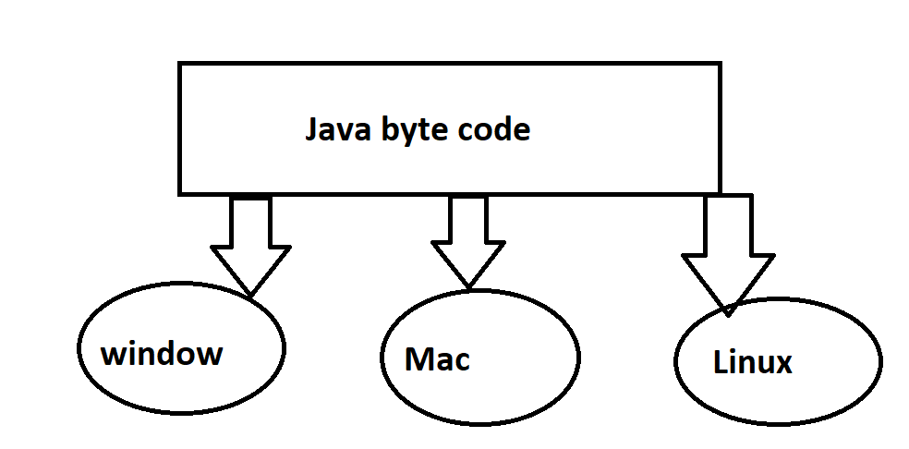

- when need to carry the bite code from one operating system to another operating system without changing the code.

-eg. Mobile number portability

-------------------------------------------------------------------------------------------

3] architectural neutral:-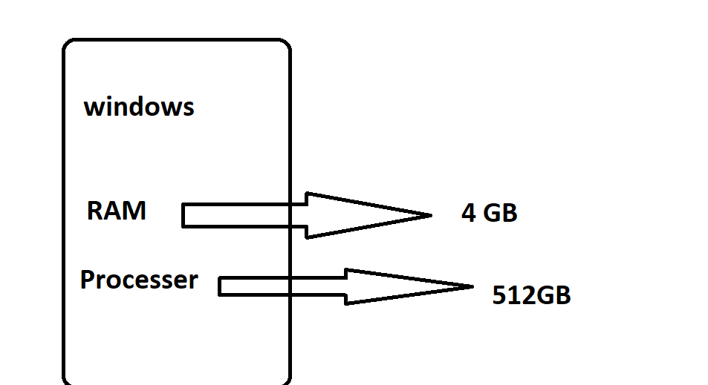

- once we execute the code the code will execute based on system configuration.

- we are different types of issues when we are the excue the code.

- sometime we got windows pop up like[ update window operating system]

-sometime we got buffering issues on browsing issue

- the type of issue, door Ram and processor we need to update.

----------------------------------------------------------------------------------------

4] secure:-

- Java programming is completely secure because, once we execute the code internal Java virtual machine

convert the byte code to machine learning language

- the operating system able to understand the machine learning language s then you will got a output.

============================================================================================================

***** identifiers in Java*********

-----------------------------------

1] project

2] package

a)class

b)object

c)variable

** conditions in Java ***

if

else

else if

**Loops in java***

for

for each

while

do while

**keywords in java**

static

public

new

===========================================

1]project:-

- project is nothing but application or built.

- project is nothing but collection of package and collection classes .

--------------------------------------------------------------------

2]package:-

-it is nothing but different types of classes .

-----------------------------------------------------------

3] class :-

- class is nothing but collection of data or collection of information .

-----------------------------------------------------------------------

4] object :-

- it is a reference of the class .

------------------------------------------------

5]variable:-

- if you want to store any value or any data in our storage place, must and should we need to create one variable ie. mandotary

- the variable name is optional

======================================================================================

******* data types in Java***************

[note:- if you want to store any value with note to follow mandatory steps]

1) if I want to store the value in database must and should need to create one variable and

before the variable we need to declare int data type

eg.int a =56

2) if we want to store in data must and should we need to provide the data within the double

course("") and we need to declare one variable and we need to declare before the variable string data type

-eg.Stringn condition ="selenium"

=====================================================================================

######### **Types of methods**###########

1)main methods

2)normal methods

--------------------

1]Main Method: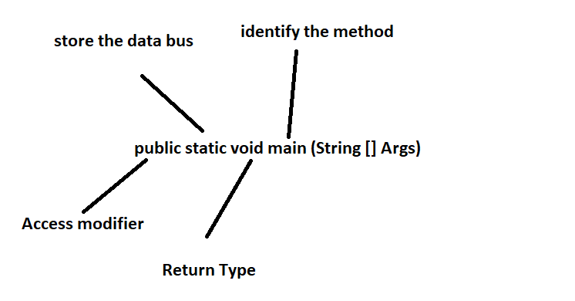

1)Public:-

- this is access modifier

- we are able to access within the package any class

- we are able to access out of the package also

----------------------------------------------------------

2)Static:-

- The static keyword is helpful to store the data in storage place when we are execute the code

----------------------------------------------------------------

3)void:-

- it a is return type this is not return any value.

-------------------------------------------------------

4)Main:-

- this identification of main method

-------------------------------------------

(String []args):-

- when we are execute the code in command prompt{cmd} the String[] args

very helpful in execute the code in command prompt

====================================================

2] Normal method:



- the method is a block of code

- inside of normal method public is a optional

- without public able to write method also

- in this normal method public is optional and wide is mandatory and method name is mandatory

eg.public void A1()------------->void A1()

===============================================================

###Types of codes #######

1] within the main method we need to write the code

2]within the class we need to write the code through method wise

3]within the class we need to write the code through methods wise with arguments.

=======================================

###How to creat new project#####

-once laumch the eclipse-->go to file-->put the curser on new button-->click on "Java project"-->creat a java project pop up

-->need to provide one valueable name-->click on finish button-->project will be created

------------------------------------------------------------------

**Package

-once creat the project-->right click on project-->new-->select the package-->click on package button-->

creat name-->click on finish button

------------------------------------------------------------

**Class:-

-right click on the package-->go to new-->select "class"-->we need to provide class name-->select the check box main method

-->[public static void main (String [] args)]-->click on finish button

==================================================================================

###how to write the code within the main method##

-if you want to write the code within the main method,we need to write the codes directly in main method ,

here we need provide main method without method

[Note:-the main disadvantages is non-it people freshers unable to understand the code,because this is clumsy]

-------------------------------------------

## How to write the codes within the methids through arguments

-when we are pass the argument inside of the method ,that argument related information we need to provide inside of the main method

when we are creating the class

=========================================================================

####TYPES OF METHODS####

1]Local method

2]Static method

1]Local Method:-

-when we are creating some method inside of the class ie. local method

-if i want to execute local method we need to creat obj for class within the main method and after that

-we need to call the local methods inside of main method through "obj.name"ie local method

===========================================================================================

***how to write the code within the class through methods***

-we need to creat a methods within the class

-when we are creating a methods, every methods we need to provide some implementation

-if i want to execute all the methods with the class , we need to creat object for the class within the main method

-then we are able to execute the code

-when we are providing the “static” Keyword inside of the method that time we call static method

-If I want to execute static method ,we need to create objective for the class inside of the main method

-If if I want to execute the static method ,we need to call through class name inside of the main method

Eg.Classname .method name ();

####Types of variables #####

1] Instance variable

2] Local variables

3] Static variables

1] Instance variable :-Whatever we provide inside of the class and outside of the method the type of method /variable we call instance variable

2] Local variables :-Whatever we provide inside of the class ie. we call local variable

3] Static variables :-Whatever we provide inside of the class and inside of the static method we need to provide some variable ie. We call static variable

**####Constructor in Java #######**

**-**When we are creating a constructor class we need to create one constructor method also

-The class name and method name both are same

-When we are creating a constructor method we no need to call

-The constructor does not allow return type

[note:-Constructor is nothing but class name ]

-When we are creating object for the class inside of the main method after “new “keyword we call constructor

-When we are creating object for the class the constructor go to memory location .

-The constructor validate the space in memory location

-Some space is there in memory location, the constructor back to class ,then explain to object .

-The object store the all local method inside of the memory location .

-Then we got a output

**\*\*\*\*\*Types of constructor \*\*\*\***

1] Default constructor

2] Parameterized constructor

3] No- arg constructor

**1] Default constructor :-**

**-**When we are execute the code the Java compiler validate line by line

-When the Java compiler reach the constructor class, the Java compiles able to understand this is the constructor class .

-The Java compiler able to understand one constructor method is there inside of the constructor class .

-Here the Java compiler validate inside of the constructor method, the user provide any implementation or not

-If there is no implementation inside of the constructor method, the Java compiler inject some piece of code inside of the constructor method

-The code is not visible

-The user provide any implementation in the constructor method, the Java compiler do not inject any code inside of the constructor,Because user already already do implementation

**2] Parameterized constructor :-**

-When we are providing the arguments or parameter inside of the constructor method ie.We call parameterized constructor .

**3] No- arg constructor:-**

-The constructor sometimes does not supports arguments ,ie. No-args

**####### Array in java ##########**

-It is a storage place or container

-array is static data structure

-Once we provide the size we are unable to change

-We are unable to increase or decrease the array size

-the array index start with “0” and end with” n – 1 “

-If you want to store bunch of data or value we need to use array

-If you want to store value or data we need to store in same order .

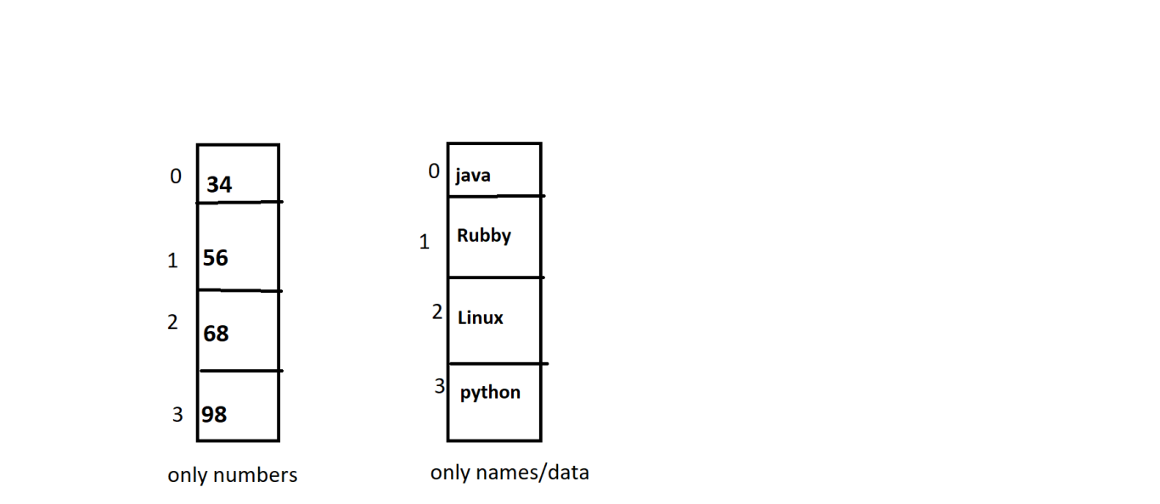

Sysntax:-

Data_type[]array_name=new data_type[]; //[] storage size

Int[] a= new [3] ; //value

String[] data= new String [3]; //data

Example:-

package Core_JAVA;

public class Array_Exp1 {

public static void main(String[] args) {

//syntax of Array

//strore the values

int[] a=new int[3];

a[0]=34;//0

a[1]=56;

a[2]=45;//n-1 3-1=2

a[3]=67;

System.out.println("The value is:"+a[2]);

**### One diamensional array###**

-if I want to store any value ,we need to store through container name

-only we need to store based on the size

-once we cross the size,we got the “out of bounds” exception

[if I have 4ltr capacity can is their ,if I want to pour more than 4ltr it will be felt out we cannot store]

Example:-

package Core_JAVA;

public class Array_Exp1 {

public static void main(String[] args) {

//syntax of Array

//strore the values

int[] a=new int[3];

a[0]=34;//0

a[1]=56;

a[2]=45;//n-1 3-1=2

a[3]=67;

System.out.println("The value is:"+a[2]);

This is one dimensional array

**### two diamensional array###**

-if I want to store value/data need to store value

-we need to store the value / data in same order

0 1

|  |  |
| --- | --- |
| (0,0) | (0,1) |
| (1,0) | (1,1) |

0

1

Example:-

**package** salenium12;

**public** **class** Array_twodimensiona {

**public** **static** **void** main(String[] args) {

**int**[][]data =**new** **int** [2][2]; //int is used for the store the numbers

//[][] is used for the two dimensional array

data[0][0]=58;

data[0][1]=49;

data[1][0]=86;

data[1][1]=30;

System.***out***.println("the value is="+data[0][1]);

}

}

//two diamensional array for store the numbers

**### three diamensional array###**

0 1 2

|  |  |  |
| --- | --- | --- |
| (0,0) | (0,1) | (0,2) |
| (1,0) | (1,1) | (1,2) |
| (2,0) | (2,1) | (2,2) |

Example:-

**package** salenium12;

**public** **class** Array_threedimensional2 {

**public** **static** **void** main(String[] args) {

String[][]suraj=**new** String[3][3]; //for three dimensional array we fill 3 in the square

suraj[0][0]="java"; //we do as per the two dimensional element

suraj[0][1]="python";

suraj[0][2]="selenium";

suraj[1][0]="lenux";

suraj[1][1]="rubby";

suraj[1][2]="suraj";

suraj[2][0]="umakant";

suraj[2][1]="saraswati";

suraj[2][2]="dhiraj";

System.***out***.println("the name i called is :"+suraj[1][0]);

}

}

//this is three dimensional array for names/data

**##oops in java##**

1] object

2] class

3] Inheritance

4] Polymorphism

5] Encapslation

6] Abstraction

1] object :-

- it is a user define

- object is the optional this is the reference of the class

2] class :-

- it is a user define

-this is also optional and the class is nothing but collection of information and data

3] Inheritance :-

A]single inheritance

B] Multi Level inheritance

C] Hierachical Inheitance

D] Hybrid inheritance

E] Multiple Inheritance

**A]single** inheritance**:-**

**\*\*** class A / super class / parent class

Class B / sub class / child class

-the single inheritance having two classes write in above

-the single inheritance nothing but two classes is their

1) parent class

2) child class

-the parent class having some methods

- if I want to execute parent class methods ,we need to execute inside of the child class only

-if I want to execute parent class method inside of the child class we need to call parent class with “extends” keyword.

[ we need to provide main method in parent class]

-if you want to provide main method inside of the parent class ie. Not a inheritant class ie. Normal class

-if you want execute any parent property only we need to execute inside of the child class only

-Example:-

**parent class

**package** salenium123;

**public** **class** Single_inheritance_parentclass_pr1 {

**public** **void** malikarjun()

{

**int** a=67+3;

System.***out***.println("the value of addition is:"+a);

}

**public** **void** dhiraj()

{

**int** b=78-2;

System.***out***.println("the value of substraction is:"+b);

}

**public** **int** swapnil()

{

**int** c=2*50;

**return** c;

}

}

***child class

**package** salenium123;

**public** **class** Single_inheritance_childclass_ecxp1

**extends** Single_inheritance_parentclass_pr1{

**public** **static** **void** main(String[] args) {

Single_inheritance_childclass_ecxp1 obj=**new** Single_inheritance_childclass_ecxp1();

obj.malikarjun();

obj.dhiraj();

System.***out***.println("the value of multiplication is:"+ obj.swapnil());

}

}