Project Proposal

On

**Bus Ticketing Management System**

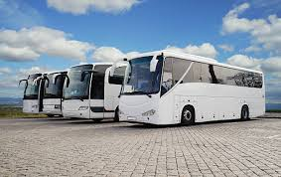

Suraj Gurung

00163973

Computing Project

Level 5 Diploma in Computing

Softwarica College of IT and E-Commerce

Kathmandu, Nepal

Submitted To: Kiran Rana

Part1 3

Introduction 3

1.1 Background of the project 3

1.2 Problem statement 3

1.2.1 Existing system 4

1.2.2 Drawbacks 4

1.2.3 Desired system 4

1.2.4 Merits of desired system 4

1.2.5 Technology stack used 4

1.2.6 Features 5

Part2 5

Project scope 5

2.1 Scope and limitation 5

2.2 Aims and objectives 5

Part3 6

Development methodology 6

3.1 Methodology used 6

3.2 Design pattern 8

3.3 System Architecture 9

Part4 10

4.1 Work Breakdown Structure (WBS) 10

4.2 Milestones 10

4.3 Scheduling/Gantt Chart 13

Part5 14

Risk Management 14

Part6 16

Configuration Management 16

Part7 16

Conclusion of the Project 16

Part8 17

References 17

# List of figures:-

Figure 1-waterfall model 7

Figure 2-MVC design pattern 9

Figure 3-Three-tier architecture 9

Figure 4- WBS diagram 10

Figure 5- Scheduling 13

Figure 6- Gantt Chart 14

Figure 7- Configuration management 16

Figure 8- Github folder 17

**Part1**

## Introduction

We are on the 21st century, the century of advanced science and the smart people, where without technology our life cannot be imagined. As the rise of science and technology every hard things becoming easier as well as very faster that we couldn’t imagined before. Its innovation has become an essential part of our life. For example before humans used to take more time to travel from one place to another. There was no such a transportations means like vehicles, airplane, ships, etc. But these days every means of transportation plays a vital role in our lives. Each part of humans has touched and taken which making our lives more convenient. And on the other hand our daily schedule is becoming busier and rush. Even we don’t have time for ourselves. At the time of travel to other place, it’s really difficult to buy a ticket with no time. The staff who working for bus company also fetches the same problem. They have less time but have to manage large number of passengers which they are doing on paper. So bus ticketing management system can be the best option to get relief. It will be faster, time saver, safe, efficient and effective.

This system will allows the bus company to manage the ticket in a more scientific and convenient way. Bus ticketing management system can help the passenger to book ticket for tour by sitting at home or may be from office. This will contain a simple contents in which passenger can easily access the site and can take benefits. It will more understandable than that of paper which going to solve different problems as well as it will remove the paperwork.

## Background of the project

Bus Ticketing Management System (BTMS) is a web based software which focuses for the people who don’t have time to visit the bus ticket counter for ticket and it allows them to book ticket from home/office. For booking they can make a phone call or by using the software.

This system would also be benefit for each of the individual staffs of the counter which would increase the efficiency of the whole company. It would manage the information in a systematic and scientific way, also stores the data of the passengers for long term use. It would also addressed the needs of the company like their problem and their solutions.

## Problem statement

As the increasing number of the business it is the trouble for Bus Company to manage their daily routines and schedules. It is really difficult for them to manage the ticket counter as the counter is being over loaded. It is not the trouble for company only, but it is also the big problem for the traveler. Similarly it is very hard to take over all the problems by standing on the traditional system.

Hence, to manage all this trouble the system is being developed. And the system will addressed all our current troubles and makes us aware from possible worry.

## Existing system

* It is the current system being used and can be replaced with a new system to addressed all problems.
* In this system, it is not possible to store data information for long period of time because it is based on paper which can be lost.
* It is really hard to analyze the data of the system.

## Drawbacks

* It is time consuming system which also hampers the efficiency of business.
* Anybody can operate this which means data can be theft.
* It is not the scientific and systematic way, so lack of awareness about the technology is can be seen.

## Desired system

* The system will improve all the possible functionality which the current system cannot deliver.
* The passengers can easily know their bus departure time, arrival time and ticket price from anywhere.
* It will be more advanced in terms of technology which will be useful for long period of time.
* It can display the counters telephone number and address with location.
* It will provide the users bus options with different offers.

## Merits of desired system

* Reduction of operation time.
* Passengers can choose the offered services by different company.
* It can identify the passenger’s details which control the fraudulent booking on ticket.
* It is well coordinated and centralized structure for service identification.
* It is easy to use and perform proof of concepts.
* It is flexible as it allows the edit, update the system services as well as customers details.

## Technology stack used

* Front end : HTML, CSS
* Back end : My SQL database, PHP
* Framework : laravel

## Features

The features of bus ticketing management system are as follows:-

* Registration
* Login
* Book ticket
* Payment form
* Contact us
* Add bus
* Add route
* Administration reports

# Part2

## Project scope

## 2.1 Scope and limitation

Scope can be defined as the information required starting a project and from which the features of the product can meet the stakeholder’s requirements. It is the part of the project planning that determines the project specific goals, functions, tasks, features and ultimately the cost. In this project we will be able to give the passenger the bus ticket on a very fast way. This will provide the staffs a easy user interface application software from which they can operate their daily routines in a convenient way.

Limitation can be defined as the term that indicates any project has its limited boundary up to there it can be flexible or can be expanding or can perform its tasks. But beyond that limit it doesn’t or it cannot go. In this project there are some limitations like: - we have limited storage capacity, if this system did not register in a domain then it’s not online, old age people prefer traditional way of buying ticket, there is the fear of people booking ticket from new software because they fear of losing money, etc.

## 2.2 Aims and objectives

The vital aim of the project is to build a user interface for managing all the detailed information about the bus ticket in where all the details of the buses, routes, customers, staffs, etc can be stored in an organized way. All the details of the company can be regularly updated for the customers. It would helps in developing business process.

Some of the basic aims of the software:-

* To be a central portal where customers can enjoy the advantage of booking tickets of any bus from anywhere.
* To act as the means of easiest way for anyone to book any bus company ticket from this system.
* To empower the basic facilities.
* To involve more passengers in our system.
* Making the availability of bus ticket to the customer at low cost.

Above is the goal of the project which we have to achieve and to achieve those goals performing some actions. The bus ticketing management system will focus on its main objectives which would guide the company in its direction as well as making in decisions. Some of the major objectives are:-

* Analysis of bus management system to make it systematic.
* Providing the features of CRUD functions.
* All the manual work should be converted into computerized so that the load of employees should decrease.
* Proper training should be provided to the employee.
* Detail analysis of each and every individual problem.
* To meet all the requirements a best design should be done.
* Implementation and testing should be done properly.
* The project should be deployed in time.
* User friendly for booking and paying.
* For saving from thieving and crashing a safe and secure system should be developed.
* System should be easy to use and cost effective.
* It should be error free and any one can use it easily once they learn.

# Part3

## Development methodology

The process of dividing software development work into distinct stages to improve design, product managements and project management called development methodology. It is also known as software development life cycle.

## 3.1 Methodology used

To develop this software traditional way of systems development lifecycle (SDLC) waterfall model is going to be used. This model is the first process of model in the history of software development life cycle. It is too simple to understand and use. The waterfall model has the basic principle of completing each phase before the next phase begins. Finally, there is no overlapping between the phases.

The different stage of waterfall model with figure and description:-

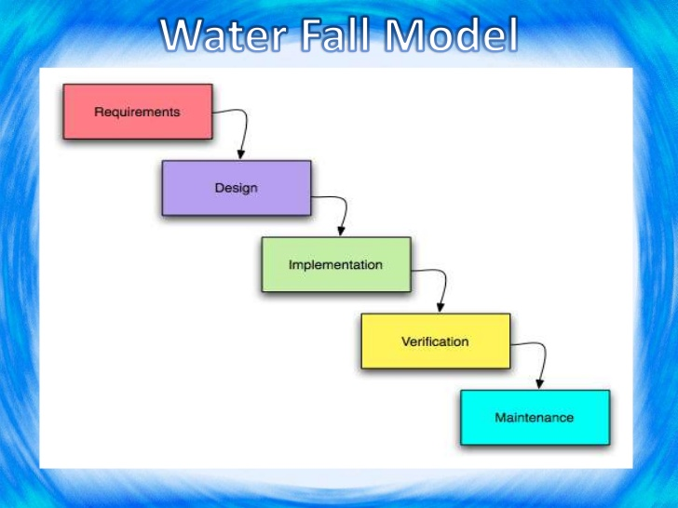

Figure -waterfall model

* **Requirements:** The first step of waterfall model is to gather the requirements from the clients. From those requirements have to identify the vital one. And those vital documented requirements integrate our new systems purpose.
* **Design:** After requirement gathered and analysis our next phase is designing our system. In this phase we use various programming techniques to design both hardware as well as software to meet the objectives of the previous phase.
* **Coding:** It is one of the major steps to give the output of our design which is also our software. For this we will use various programming languages to implement the program as per the design that we already made at previous phase.
* **Testing:** In this stage we try to ensure that whether our output software works as it should be or the output from the software is correct or not, for this we tested the software for many times. This will ensure that whether the software meets the client requirements or not.
* **Implementation:** This is the final step of the waterfall model which is used to implement the software which was tested in previous step. In this process we give training about the software usability to the users. Also we see whether some errors going to occur or not.
* **Maintenance:** it is all about the evolution of the software. Before the software was not live the tester of the company cannot find out all the errors or bugs. But after software goes to the real environment the user may find out many problems which have to be addressed by the developer. So it is also a vital step of waterfall model.

All above steps of waterfall model should be following in a sequential manner. If you try to not follow the sequential manner then software development process cannot be done. It is easy to use and manage so we chose it for our project. The all process and results are well documented with systematic way.

**Some advantages of waterfall model are:-**

* It is suitable for small projects.
* Easy to manage.
* Requirements and analysis are well understood.
* Easy to understand.
* Milestones of software development are clear.
* Well documented.

**Some disadvantages of waterfall model are:-**

* It does not allow much revision or reflection.
* It is not suitable for large project and randomly changing requirement.
* High amount of risk and uncertainty.
* Poor model for long and on-going projects.
* Not a good model for complex object oriented projects.

**When to use it**

* When the requirements are well known, clear and fixed.
* If the project is short.
* If no ambiguous requirements.
* If the product define is stable.

## 3.2 Design pattern

It can be defined as the software design pattern which is a general, reusable solution to commonly occurring problem within a given context in the field of software designing; it is not the completed design that can be transformed directly into machine code.

In this project we use Model View Controller (MVC) design pattern, which is consist of three major aspects such as model which means data, view which means user interface and last one controller means process that handle all the input of the system. It is used to develop modern user interfaces of the system.

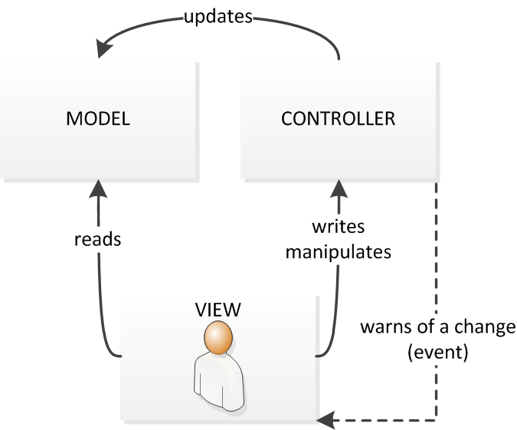

Figure -MVC design pattern

For this project laravel is the framework which is going to be used. It is a free, open source PHP web framework which follows the model-view-controller (MVC) architectural pattern and is hosted on GitHub.

## 3.3 System Architecture

For the system architecture development of this project we are going to use three-tier architecture. It can be defined as the client-server architecture in which the functional process logic, computer data storage, user interface and data access are developed and can be maintained as independent modules on separate platforms. It is consist of three basic tiers which are presentation tier, business logic tier and data processing tier.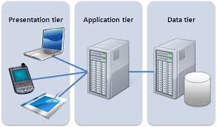

Figure -Three-tier architecture

**Presentation tier**: - It is the front end layer of the 3 tier system and consists of user interface from which the user input the request and it displays the request which is done. The user interface is graphical one accessible through a web browser or web based application. Its main function is to display the content and information useful for the end user.

**Application tier**: - This is the tier of full of business logical tier and which is the processor or indicates the central application server of the system.

**Data tier**: - It is a clustered database which is used in the network storage. If the primary server goes down it helps to maintain the smooth run of the system.

# Part4

## 4.1 Work Breakdown Structure (WBS)

For developing the project in an easy and managed way all tasks are divided into small multiple portions on base of work breakdown structure.

It is the key for the project development that organizes each and every works into the team work into the different manageable sections. According to the Project Management Body of Knowledge (PMBOK) the WBS as a deliverable oriented hierarchical decomposition of the task which should be executed by the project team.

We use WBS because it helps to reduce complicated complex activities into the simple activities by changing complexity into simplicity. This would help the project manager to oversee all the complex activities with effectively which helps to grow the efficiency of software development process. All the task are clearly defined which are independent to each other.

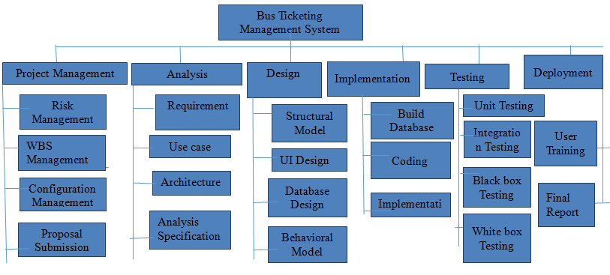

Figure - WBS diagram

## 4.2 Milestones

The milestones for this project are represented below in the table. We have figured out the some date with objectives and aim to reach all those date.

|  |  |
| --- | --- |
| **Milestones** | **Date** |
| **Project Management**  Risk Management  WBS  Configuration Management  Proposal Submission | 21/12/18-3/1/19  21/12/18-25/12/18  26/12/18-28/12/18  29/12/18-30/12/18  31/12/18-3/1/19 |
| **Analysis**  Requirement  Use Case  Architecture  Analysis specification | 4/1/19-28/1/19  4/1/19-10/1/19  11/1/19-16/1/19  17/1/19-22/1/19  23/1/19-28/1/19 |
| **Design**  Structural model  Behavioral model  UI Design  Database Design | 18/1/19-16/2/19  18/1/19-25/1/19  26/1/19-1/2/19  2/2/19-8/2/19  9/2/19-16/2/19 |
| **Implementation**  Building Database  Coding | 17/2/19-18/3/19  17/2/19-22/2/19  23/2/19-18/3/19 |
| **Testing**  Unit Testing  Integration Testing  Blackbox Testing  Whitebox Testing | 19/3/19-29/3/19  19/3/19-20/3/19  21/3/19-22/3/19  23/3/19-25/3/19  26/3/19-28/3/19 |
| **Deployment**  User Training  Final Report | 29/3/19-7/4/19  29/3/19-2/4/19  3/4/19-7/4/19 |

It is the tools used for the project management to focus on specific points along with a project timeline which planned for significant events and scheduled to occur at specific times. These events may be like project start date and end date. And milestones do not hamper in the project duration.

* **Project Management (14days)**

In this stage of milestone, I have successfully submitted my proposal for the project. Its task took 14 days all together. With proper planning and scoping the proposal was completed for the further milestone.

**Subtasks are:-**

* **Risk Management (5days)**
* **WBS Management (3 days)**
* **Configuration Management (2days)**
* **Proposal Submission (4days)**
* **Analysis (25days)**

It is the process of analyzing the gathered requirements to specify the vital requirements of the system. It is the predictable features of the software.

**Subtasks are:-**

* **Requirements (7days)**
* **Use case (6days)**
* **Architecture (6days)**
* **Analysis Specification (6days)**
* **Design (30 days)**

It is the core structure of the system which includes the design pattern like MVC design pattern etc. It is the representation of structural, behavioral and process of data carrying and the user interface design.

**Subtasks are:-**

* **Structural Model (8days)**
* **Behavioral Model (7days)**
* **UI design (7days)**
* **Database design (8days)**
* **Implementation (30days)**

In this step we give the last final system to the real world environment. It is the process of installing the finished product.

**Subtasks are:-**

* **Build Database (6days)**
* **Coding (24days)**
* **Testing (10 days)**

In this process testing is done within the team, its main motto is to find out the basic errors which can be solved in short period of time. It fixes all the initial trouble. It ensures the final system to be launch.

**Subtasks are:-**

* **Unit testing (2days)**
* **Integration testing (2days)**
* **Black box testing (3days)**
* **White box testing (3days)**
* **Deployment (10days)**

After the completion of the step of implementation people will first phase the problem of confusion, they may feel uneasy to run the system. So to solve this user training program can be conducted for 5 days and on the basis of training final report can be given.

**Subtasks are:-**

* **User training (5days)**
* **Final report (5days)**

## 4.3 Scheduling/Gantt Chart

Scheduling can be defined as the process of listing of a project’s milestones, deliverables, and activities which intended start and finish dates. It is commonly used for the project planning and project portfolio management.

The development of project is started from the

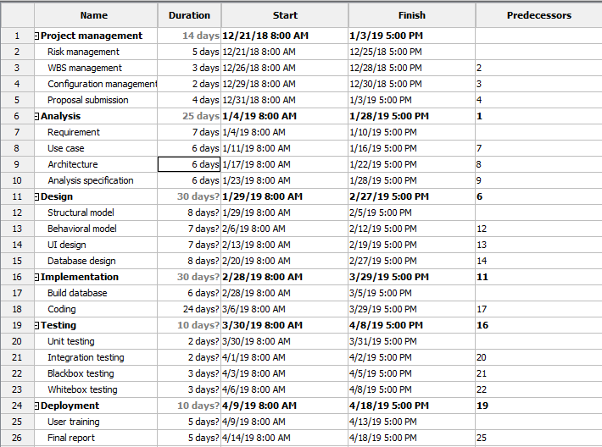

Figure - Scheduling

Similarly, A Gantt chart can be defined as the type of a bar chart which illustrates the project schedule with its start date and end date. In this chart vertical axis indicates the task to perform where as on the horizontal axis indicates the time intervals of the project. From this chart, it can be useful for planning, coordinating and track all the specific task of that project.

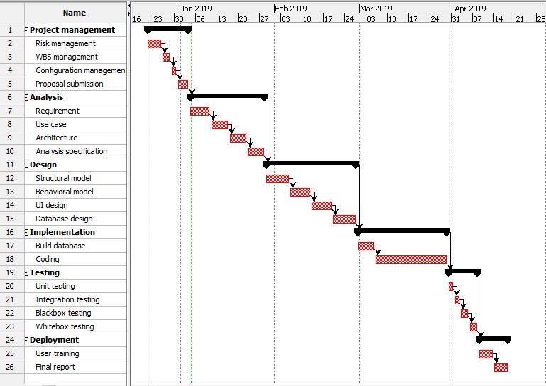

Figure - Gantt Chart

# Part5

## Risk Management

It is the process of identifying, evaluating, and prioritizing the possible risk or present risk and to minimize, to monitor and to control the impact of that risk is called risk management.

Risk Likelihood values are shown as follows

|  |  |
| --- | --- |
| Likelihood | Value |
| Low | 1 |
| Medium | 2 |
| High | 3 |

Risk Consequence values are shown below

|  |  |
| --- | --- |
| Consequence | Value |
| Very low | 1 |
| Low | 2 |
| Medium | 3 |
| High | 4 |
| Very High | 5 |

**Calculation of impact**

Here we have calculated all the impact that our software could encounter and effect. So we have calculated all possible the risk with the following method:-

Impact = likelihood * consequences

|  |  |  |  |  |
| --- | --- | --- | --- | --- |
| **Risk** | **Likelihood** | **Consequences** | **Impact** | **Solution** |
| Changing Requirement | 3 | 5 | 15 | All requirements should be fixed initially. |
| Malicious | 2 | 2 | 4 | Up to date the antivirus and scan everyday if possible. |
| Hard Disk Crash | 2 | 4 | 8 | Data Backup every week. |
| Requirement Failure | 3 | 3 | 9 | Planning well and analysis intelligently. |
| Data Security | 3 | 4 | 12 | Identifying the users. |
| Chances of data loss | 2 | 3 | 6 | Manage the secondary storage like hard disk, pen drive, etc. |
| Server failure | 3 | 5 | 15 | Weekly backup and regular maintenance of the devices. |
| Data modification | 2 | 3 | 6 | Firewall rules Access control must be implemented. |
| Spyware | 2 | 3 | 6 | Security mechanism must be implementing. |
| Spam | 1 | 2 | 2 | Traffic filtering and blocking the unnecessary entry. |

Figure 7: Table showing Risk Management

# Part6

## Configuration Management

It is a system in which the process of engineering occurs for establishing and maintaining consistency of a product’s performance, functional, and physical attributes with its all requirements and design. Or it is also a task of controlling and tracking the changes in the software.

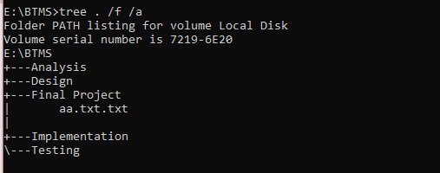

Figure - Configuration management

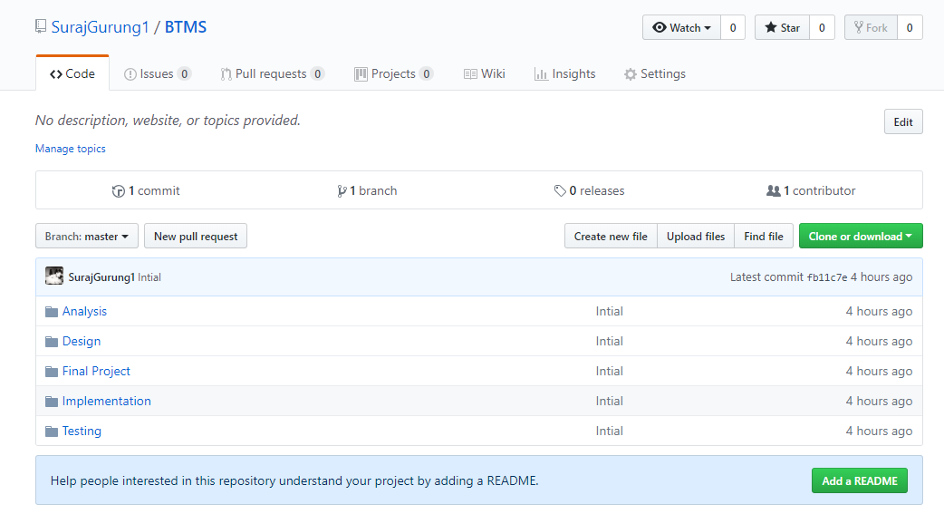

Figure - Github folder

# Part7

## Conclusion of the Project

While in this way we developed our bus ticketing management system. I hope this will sort out all the difficulties fetched in old system. It fulfills the working capabilities of company and meets up the requirements of the client. Finally this system will be best part for the company and for the passengers who wasted their large amount of time before on the line. Thus this system will decrease the loads by effective optimization of service.

# Part8

## References

(2018, 12 21). Retrieved from https://xbsoftware.com/blog/software-development-life-cycle-waterfall-model/

Anon. (2018, 12 28). Retrieved from https://study.com/academy/lesson/waterfall-model-advantages-disadvantages.html

Anon. (2019, 01 03). Retrieved from http://www.softwaretestingandistqb.com/waterfall-model-advantages-and-disadvantages/

Anon. (2019, 01 04). Retrieved from http://istqbexamcertification.com/what-is-waterfall-model-advantages-disadvantages-and-when-to-use-it/

). Retrieved from https://www.google.com.np/search?q=WBS+definition&rlz=1C1CHBD_enNP742NP742&oq=WBS+definition&aqs=chrome..69i57j0l5.19048j1j9&sourceid=chrome&ie=UTF-8

Anon. (2019, 01 04). Retrieved from https://www.google.com.np/search?q=reasons+behind+using+wbs&rlz=1C1CHBD_enNP742NP742&oq=reasons+behind+using+wbs+&aqs=chrome..69i57.11145j1j7&sourceid=chrome&ie=UTF-8

Anon. (2019, 01 05). Retrieved from https://www.google.com.np/search?rlz=1C1CHBD_enNP742NP742&ei=FIN6WqqiKMz_vgSa4qPwAQ&q=meaning+of+scheduling+in+project+management&oq=scheduling+meaning+in+project+management&gs_l=psy-ab.3.0.0i8i30k1.100465.104580.0.106766.19.15.0.0.0.0.367.2286.0j9j1j1.1