 

INSTITUTE FOR ADVANCED COMPUTING AND SOFTWARE DEVELOPMENT AKURDI, PUNE

Documentation On

**“BITCODE TUTORIALS”**

PG-DAC SEPT-2022

*Submitted By:*

**Group No: 86**

Mr. Prajwal Raju Patil Roll No: 9182

Mr. Suraj J. Khokrale Roll No. 9221

**Rohit Puranik Mrs. Rupali Thorat**

**Centre Coordinator Project Guide**

**Table of Contents**

1. Introduction

* Document Purpose
* Problem Statement
* Product Scope

1. **Aim And Objectives**
2. **Overall Description**
3. **Operating Environment**

* Server Side
* Client Side

1. **Design and Implementation Constraints**
2. **Specific Requirements**

* External Interface Requirements
* Functional Requirements
* Non-Functional Requirements

1. **System Design**

* ER Diagram
* Activity Diagram
* Sequence Diagram
* DFD Diagram
* Class Diagram
* Usecase Diagram

1. **Table Structure**
2. **Website UI**

* Guest UI
* Subscribed UI
* Admin UI

1. **Conclusion**
2. **References**

# Introduction

BitCode Tutorials is an online learning platform that provides various courses on a variety of programming languages. These tutorials are developer documentation based, with the best interpretation of technical jargons into simplified layman terms.

The detailed requirements and specifications for the development of BitCode Tutorials website are provided in this document.

## 

## Document Purpose

BitCode Tutorials website aims to create a E-learning programming tutorials website to

provide free, extensive and accurate knowledge to the learners at one single place.

## Problem Statement

With the advent in technology and with the perpetual increase in the strength of the students and the number of departments in the educational institutions, it is laborious to exchange the study materials between the students and the faculties.

The main objective of the E-Learning is to help the students get over the traditional methods of learning and make them accustomed to the internet where the notes for their respective subjects are easily available. It provides an automation procedure of studying the notes online. The implementation of this project helps the students. The students can gain access to these notes by searching for the name of the file under their respective department.

This project not only helps to facilitate easier access to notes for the students but also helps cutting down on expenditure for the universities as well. Students and Universities alike spend a considerable amount of money on printing costs which can be prevented.

E-Learning is an inexpensive, efficient and comfortable way for students to easily access notes and an easier alternative to study for exams.

## Product Scope

This web application is an online E-learning tutorials website that helps programmers with

extensive knowledge of various programming languages, along with plenty of coding

examples. Each user can signup to this website and keep a track record of their learning

journey.

There are options to subscribe for premium contents of this tutorials website which

provides user with exclusive content. A course purchase history is maintained for every

subscription made.

* **Aims & Objectives**

Specific goals are: -

* To produce a web-based system that allow users to access the content depending upon the courses available which can be free and paid.
* To produce a web-based system that allow admins to add the contents in the existing courses and additional information.
* To maintain a track for the admin on the respective courses about the purchase ratios. And also keep tract upon the transactions.
* **Overall Description**
* This programming tutorials website provides plenty of code snippets to make user familiar with the programming environment and programming syntax. Each code snippet is followed by a in depth explanation.
* The content is thoroughly tested and designed in a manner that assures easy understanding to leaners.
* An online coding compiler is made available for users with paid subscriptions for immediate hands on.
* Admins have right to access all the user profiles and other related informations such as progress tracking, course enrollments, payment transactions, etc. Admins can add new contents within the existing courses and also can add new courses.
* The users are provided various courses with specific contents and relative information as per requirements. Users registration is done for the purchase various paid contents and profile is maintained along with the progress tracking.
* **Operating Environment:**

Server Side:

**Processor:** Intel® Xeon® processor 3500 series

**HDD:** Minimum 500GB Disk Space

**RAM:** Minimum 4GB

**OS:** Windows 10, Linux 6

**Database:** MySQL

Client Side (minimum requirement):

**Processor:** Intel Dual Core

**HDD:** Minimum 80GB Disk Space

**RAM:** Minimum 1GB

**OS:** Windows 8 and above, Linux

## Design and Implementation Constraints:

* + The application will use ReactJS, Spring Boot API, Ajax, JavaScript, jQuery and CSS as main web technologies.
  + HTTP and FTP protocols are used as communication protocols. FTP is used to upload the web application in live domain and the client can access it via HTTP protocol.
  + Several types of validations make this web application a secured one.
  + Since BitCode Tutorials is a web-based application, internet connection must be established.
  + BitCode Tutorials will be used on PCs and will function via internet or intranet in any web browser.
* **Specific Requirement**

## External Interface Requirements:

User Interfaces:

* + - All the users will see the same page when they enter in this website. This page asks the users a username and a password.
    - After being authenticated by correct username and password, user will be redirect to their corresponding profile where they can do various activities.
    - The user interface will be simple and consistence, using terminology commonly understood by intended users of the system. The system will have simple interface, consistence with standard interface, to eliminate need for user training of infrequent users.

Hardware Interfaces:

* + - No extra hardware interfaces are needed.
    - The system will use the standard hardware and data communication resources.
    - This includes, but not limited to, general network connection at the server/hosting site, network server and network management tools.

**Functional Requirements**

* Access Website

New users can register to this website for free and start their programming

journey, or simply browse through the website for free content without registration.

* Admin Profile

The admin has all the rights to have an access to the entire courses and the

users profile which contains the user profile tracking, progress of the course for all

users. The admin have an access to the payments related detailed information

regarding the courses with respect to all users. Admin have an access to modify the

existing course contents and also to add a new course as per required.

* User Profile

Each user has a personalized dashboard that displays user specific information

like course purchase history, learning track record, etc.

Various personal details like profile name, password, etc can be updated via this

dashboard as well.

* Enrollment of the course

The user can enroll the courses which are free as well as paid. Users need to

enroll the paid courses by purchasing the course respective to their enrollment

amounts.

* Progress Tracking

The course or contents enrolled by the specific user is been added to

respective profiles with proper progress tracking bar. As the contents are been

marked as done it reflects the progress within the profile.

* Application Interfaces:

**OS:** Windows 10, Linux

**Web Browser:**

The system is a web-based application; clients need a modern web browser such as Mozilla Firebox, Internet Explorer, Opera, and Chrome. The computer must have an Internet connection in order to be able to access the system.

Communications Interfaces:

* + - This system uses communication resources which includes but not limited to, HTTP protocol for communication with the web browser and web server and TCP/IP network protocol with HTTP protocol.
    - This application will communicate with the database that holds all the booking information. Users can contact with server side through HTTP protocol by means of a function that is called HTTP Service. This function allows the application to use the data retrieved by server to fulfil the request fired by the user.

**Non-Functional Requirements**

* Security

The system’s back-end servers shall only be accessible to authenticated administrators. Sensitive data will be encrypted before being sent over insecure connections like the internet.

* Availability

The system should be available at all times, meaning the user can access it using

a web browser, only restricted by the downtime of the server on which the system

runs. In case of an of a hardware failure or database corruption, a replacement page

will be shown. Also, in case of a hardware failure or database corruption, backups of

the database should be retrieved from the server and saved by the administrator.

Then the service will be restarted. It means 24 X 7 availability.

* Reliability

The reliability of the overall program depends on the reliability of the separate components. The main pillar of the reliability of the system is the backup of the

database which is continuously maintained and updated to reflect the most recent

changes. Thus, the overall stability of the system depends on the stability of

container and its underlying operating system.

* Maintainability

A commercial database is used for maintaining the database and the

application server takes care of the site. In case of a failure, a re-initialization of the

program will be done. Also, the software design is being done with modularity in

mind so that maintainability can be done efficiently.

* Accessibility

The system will be a web-based application it is going to be accessible on the

web browser.

* Back up

We will take a backup in our system database. In order to enable the

administrator and the user to access the data from our system.

* Performance

The product shall be based on web and has to be run from a web server. The

product shall take initial load time depending on internet connection strength which

also depends on the media from which the product is run. The performance shall

depend upon hardware components of the client/customer

* **System Design**

## ER Diagram:

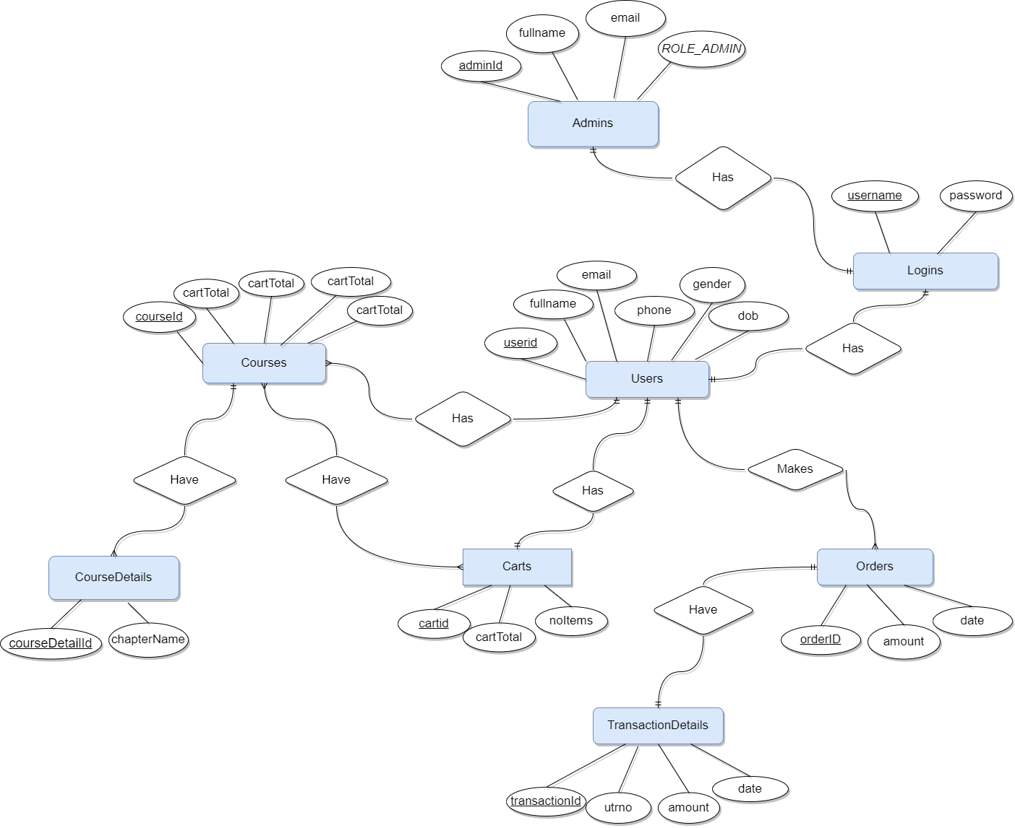

## Activity Diagram

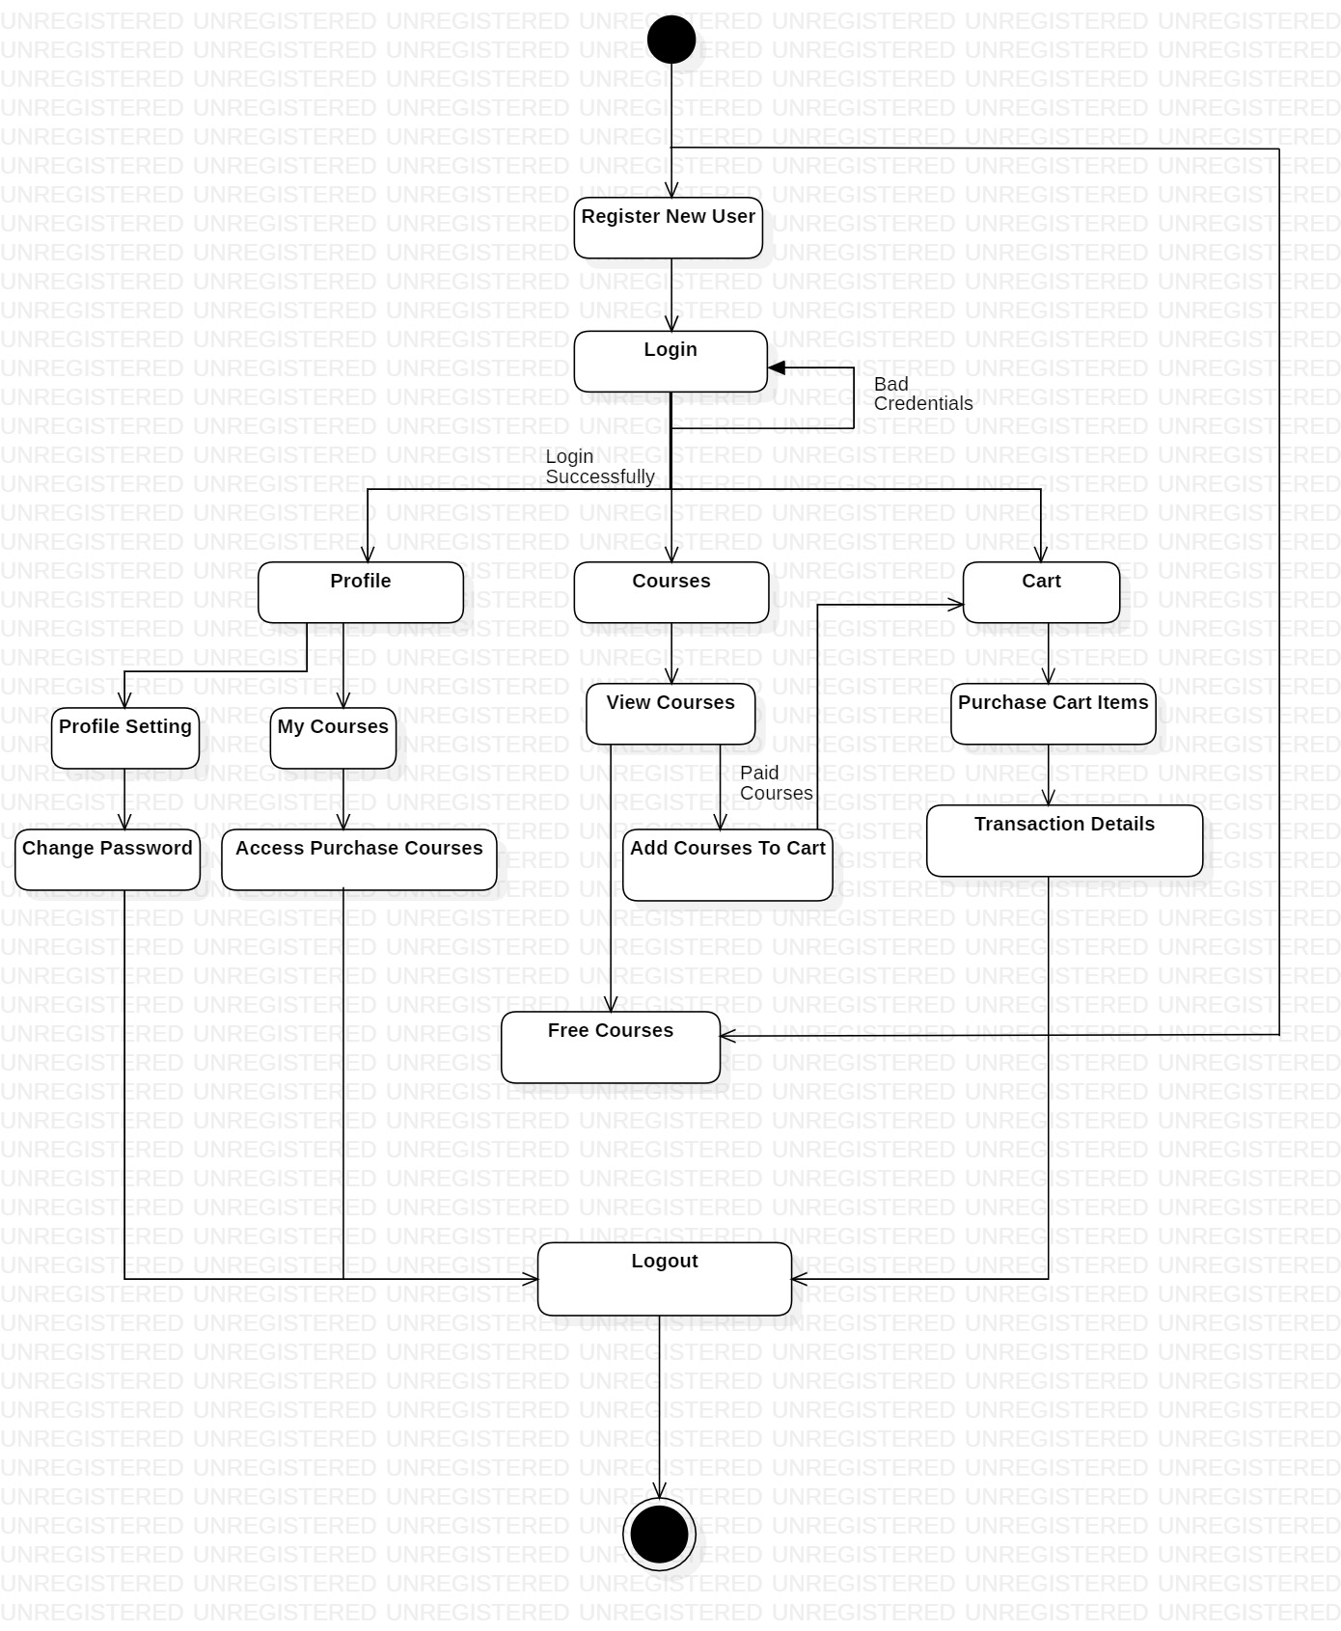

**Sequence Diagram**

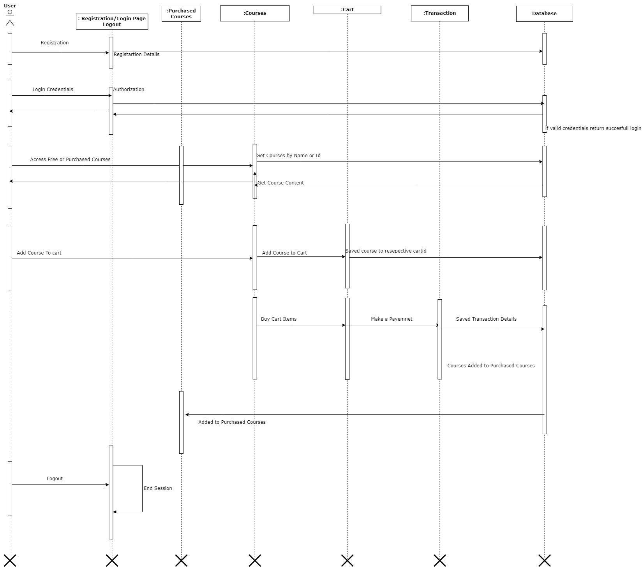

## Data Flow Diagram

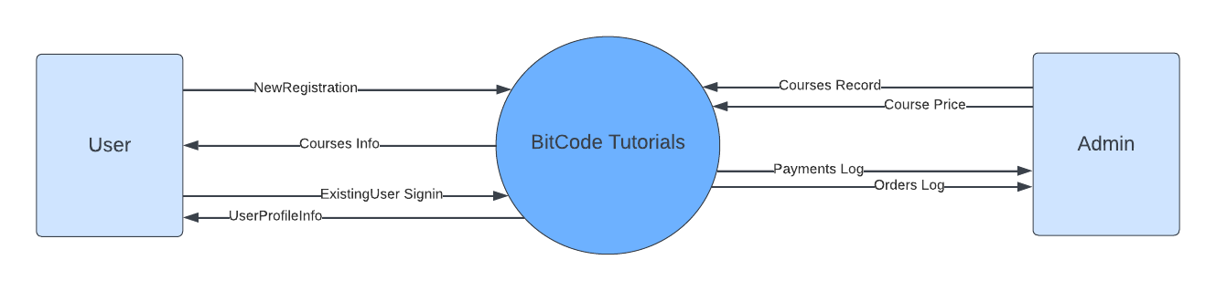

**Level 0**

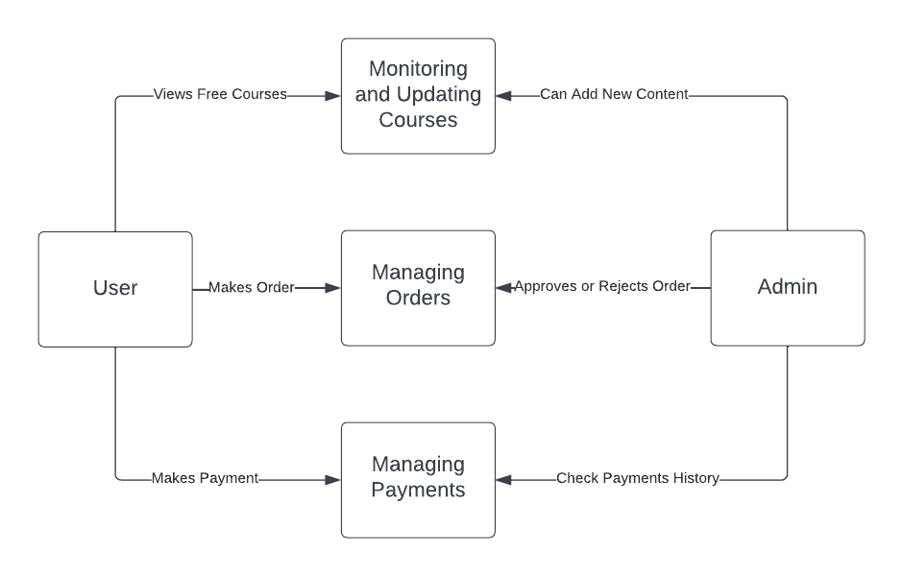

**Level 1**

## Class Diagram

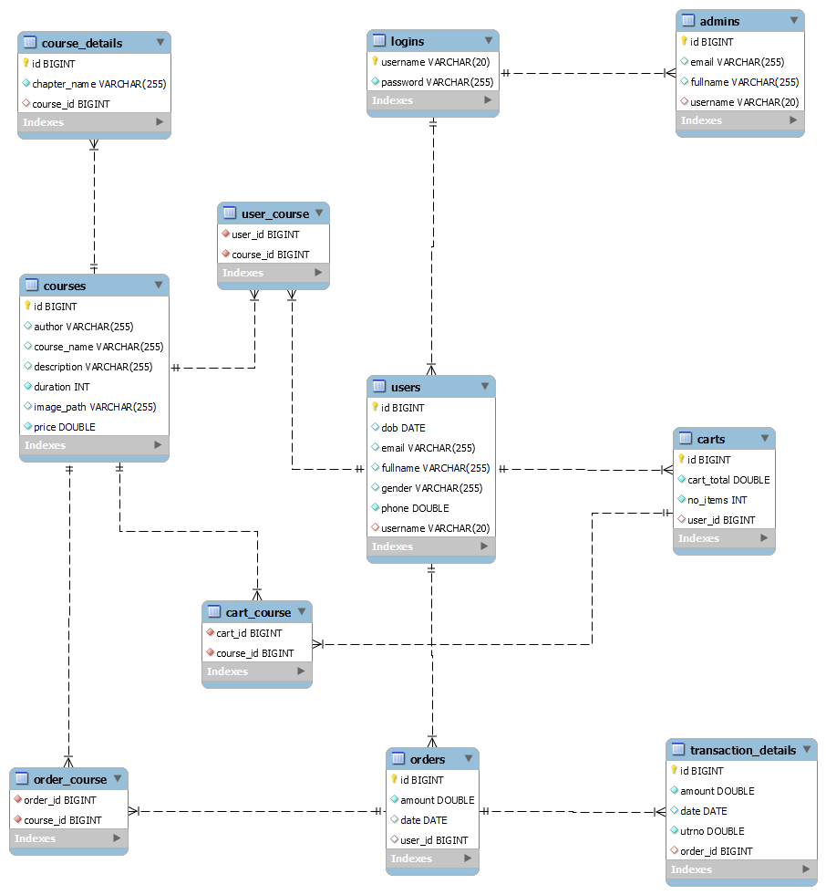

## Use Case Diagram

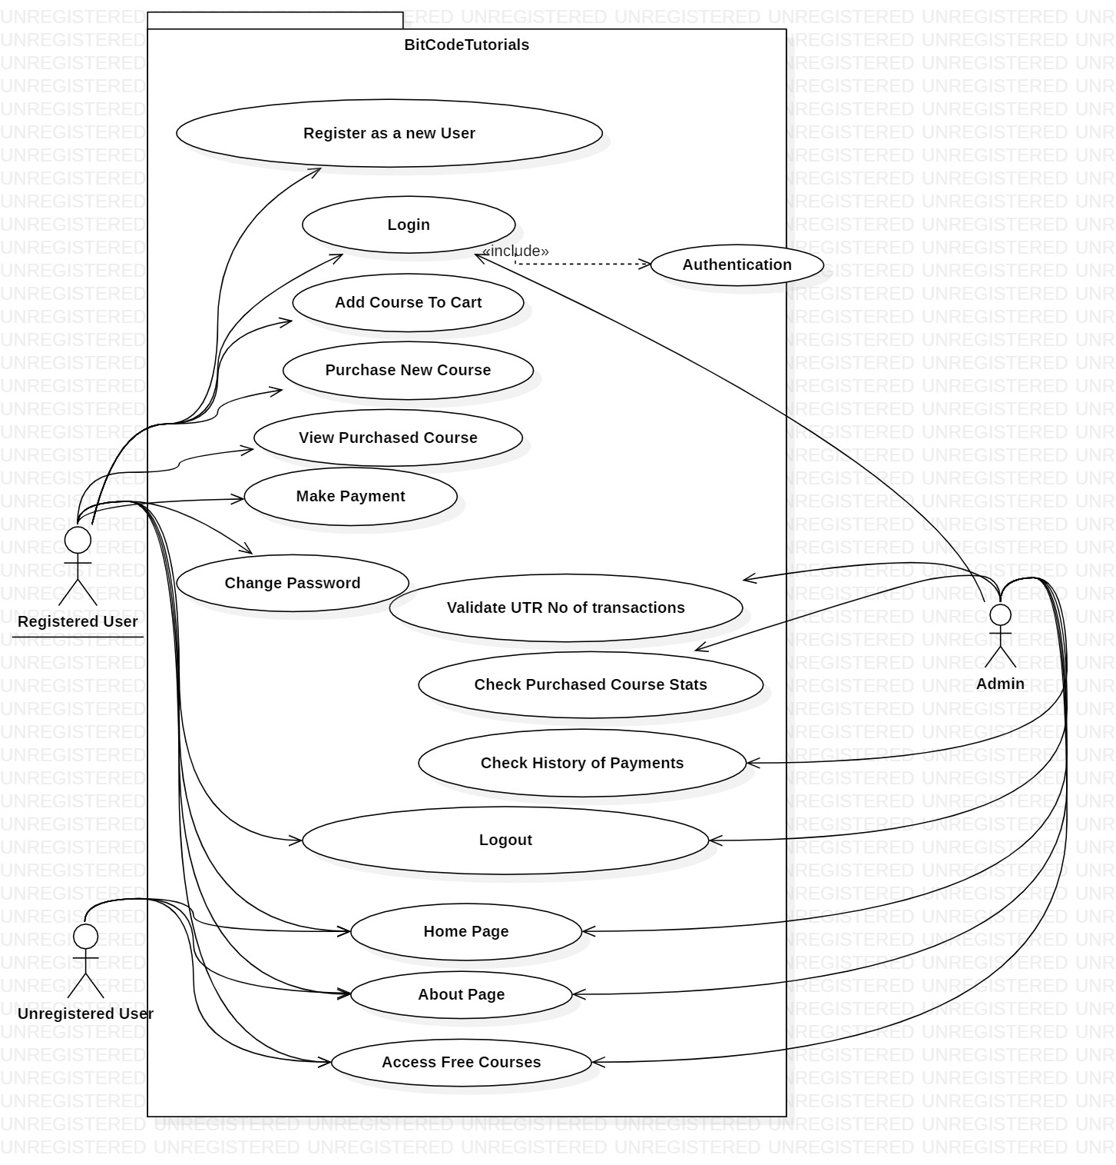

# Table Structure

Admin:

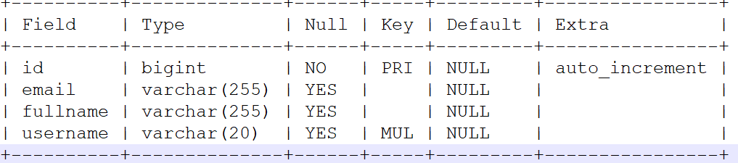

Cart_Courses

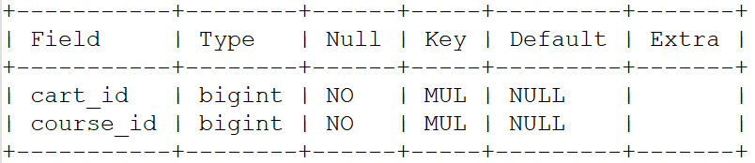

Cart

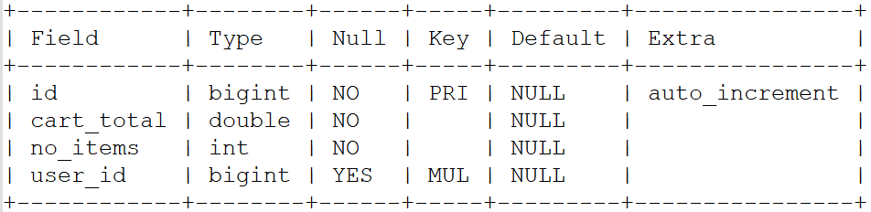

Course_Details

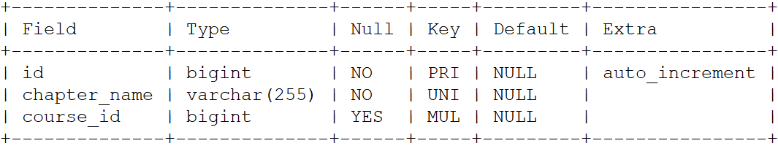

Courses

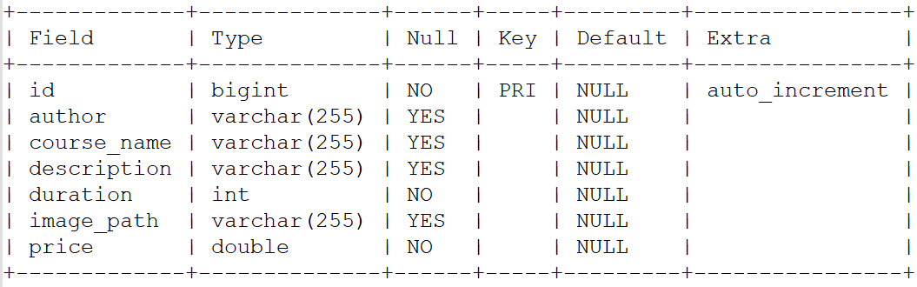

Logins

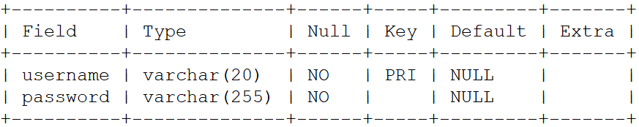

Order _Courses

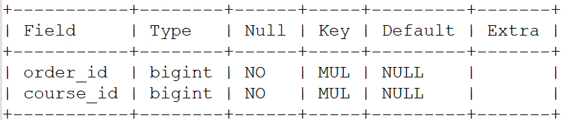

Orders

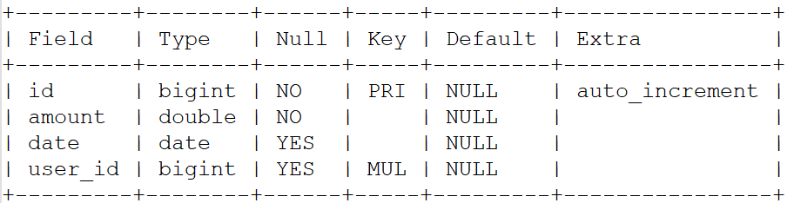

Transaction_details

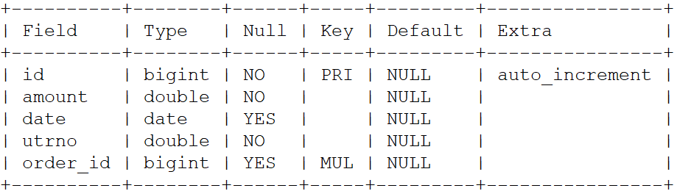

User_Course

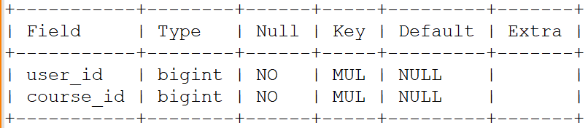

User

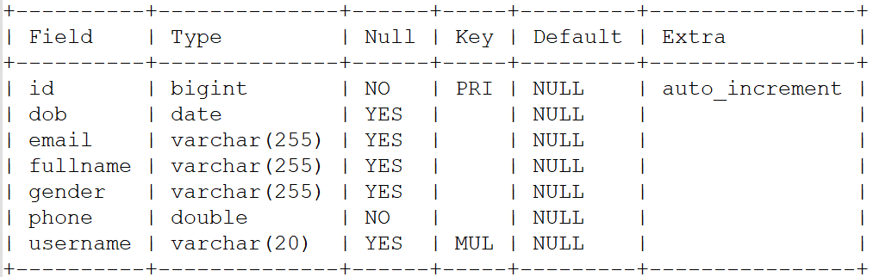

**Website UI:**

* Guest UI

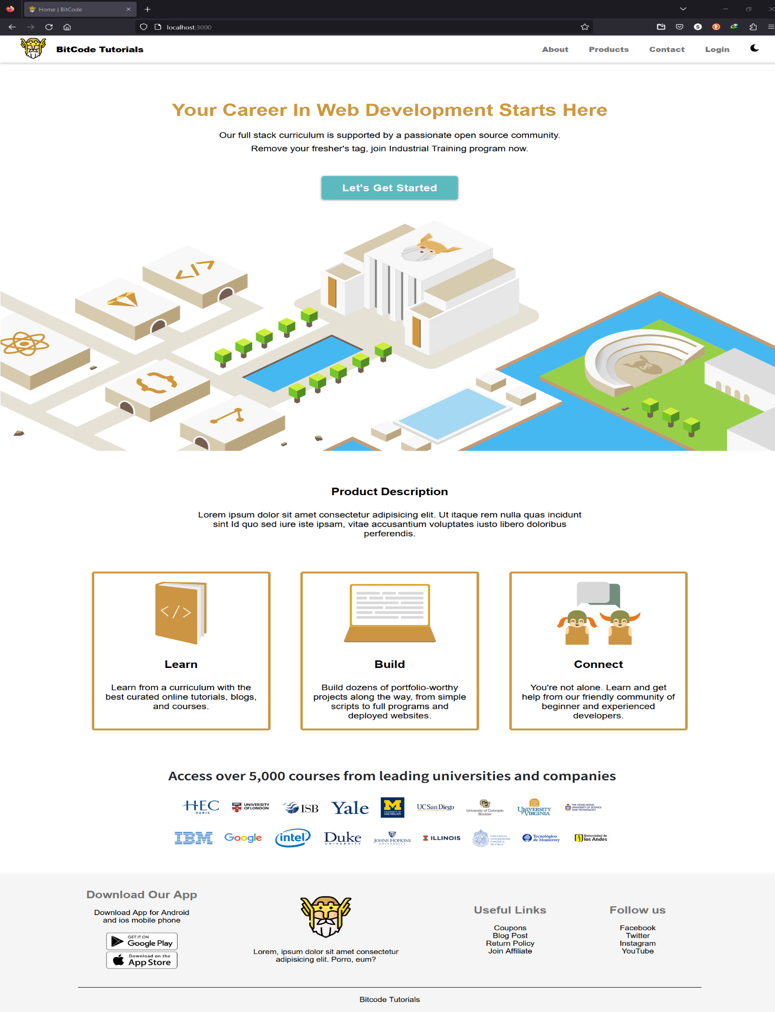

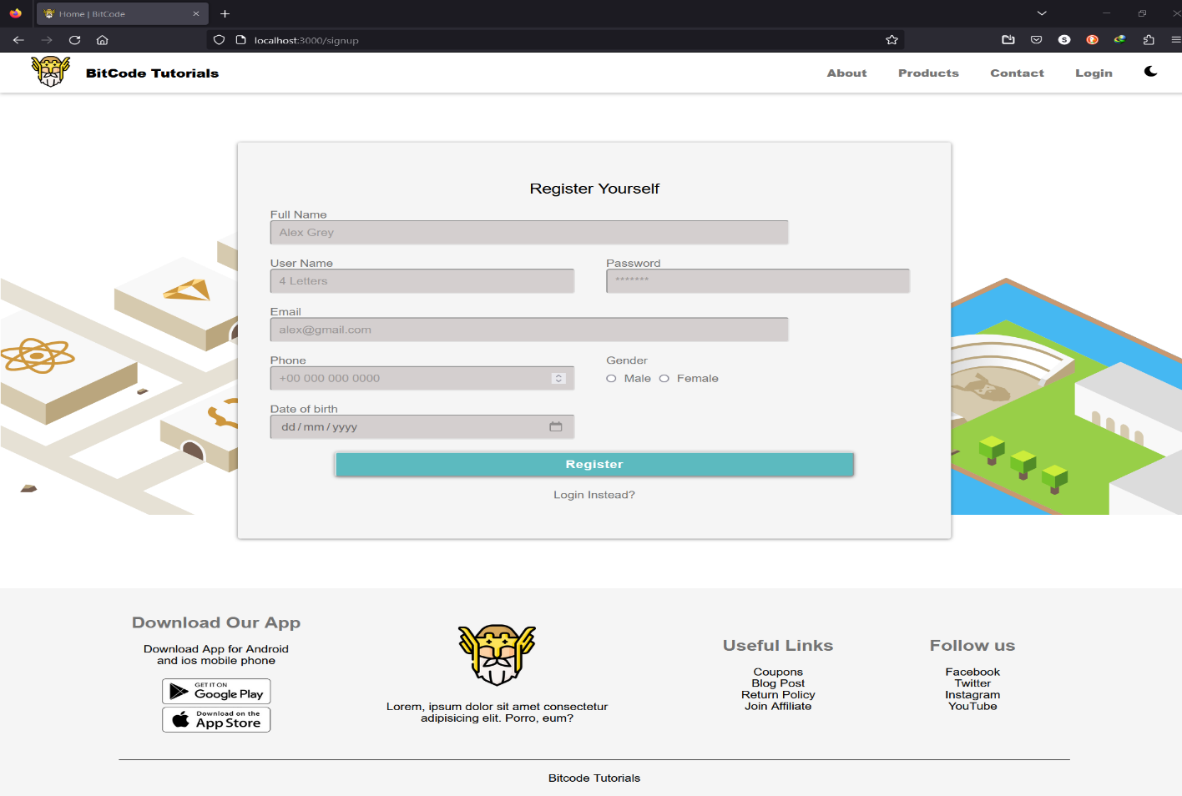

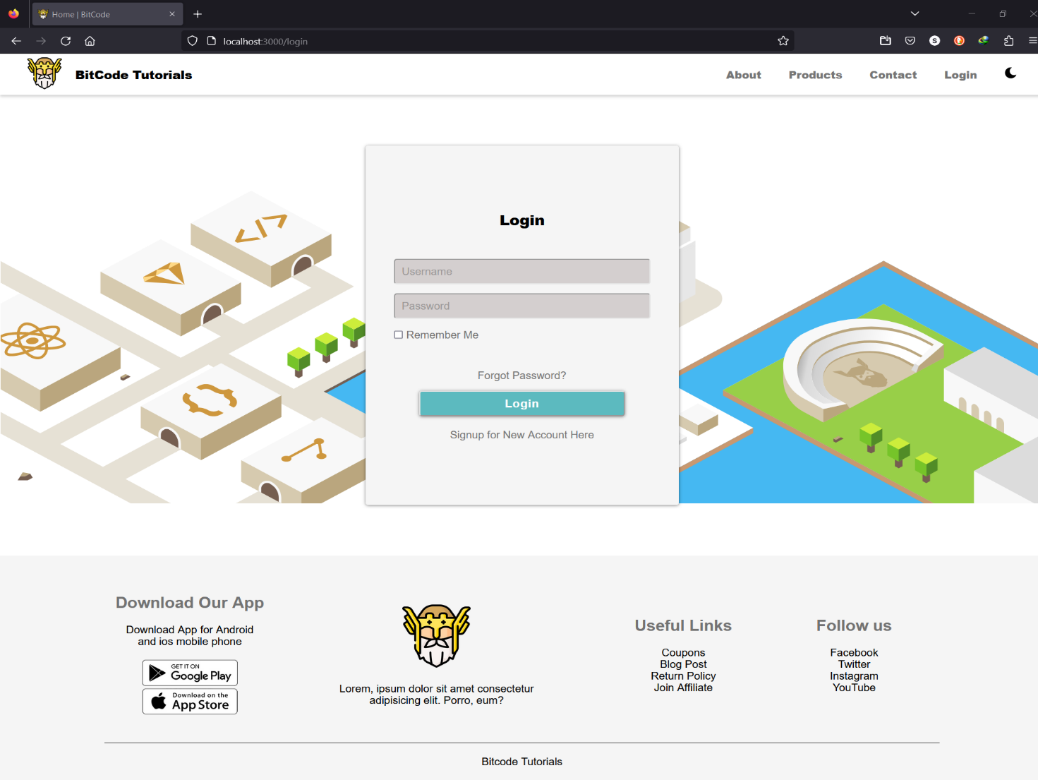

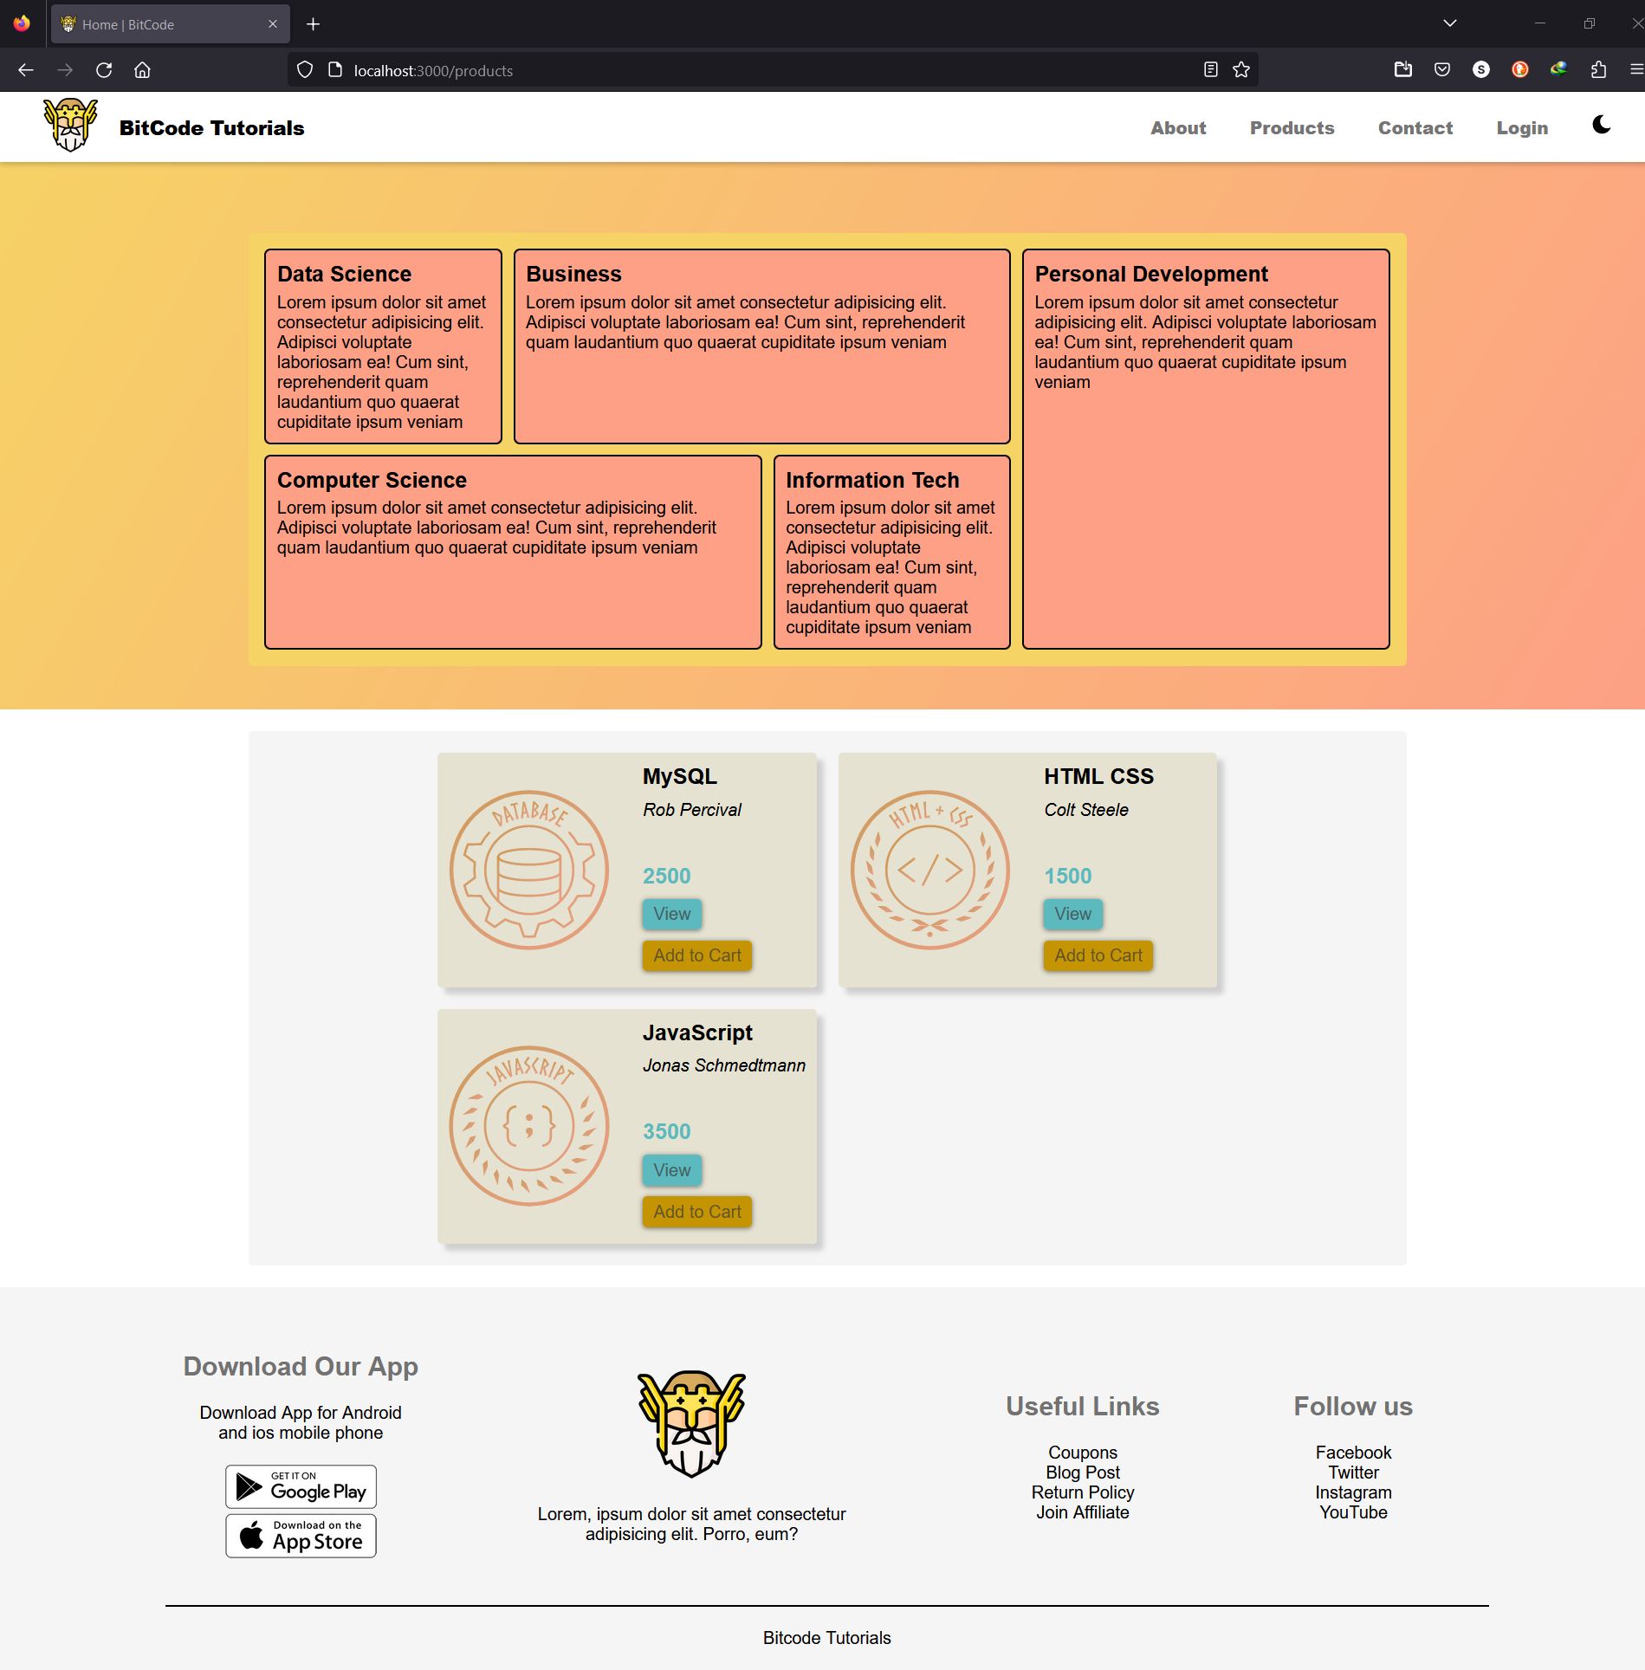

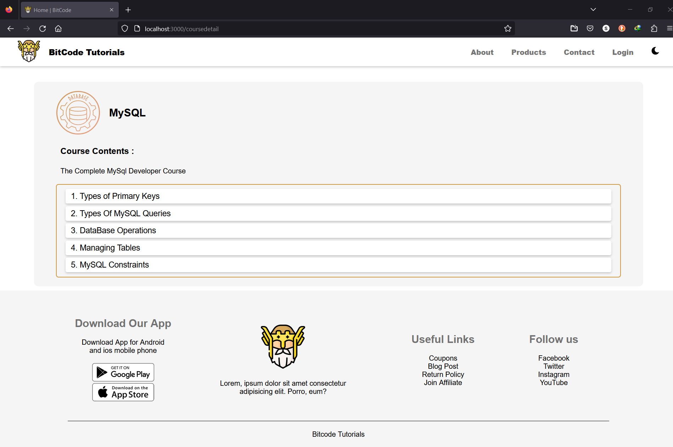

* Subscriber UI

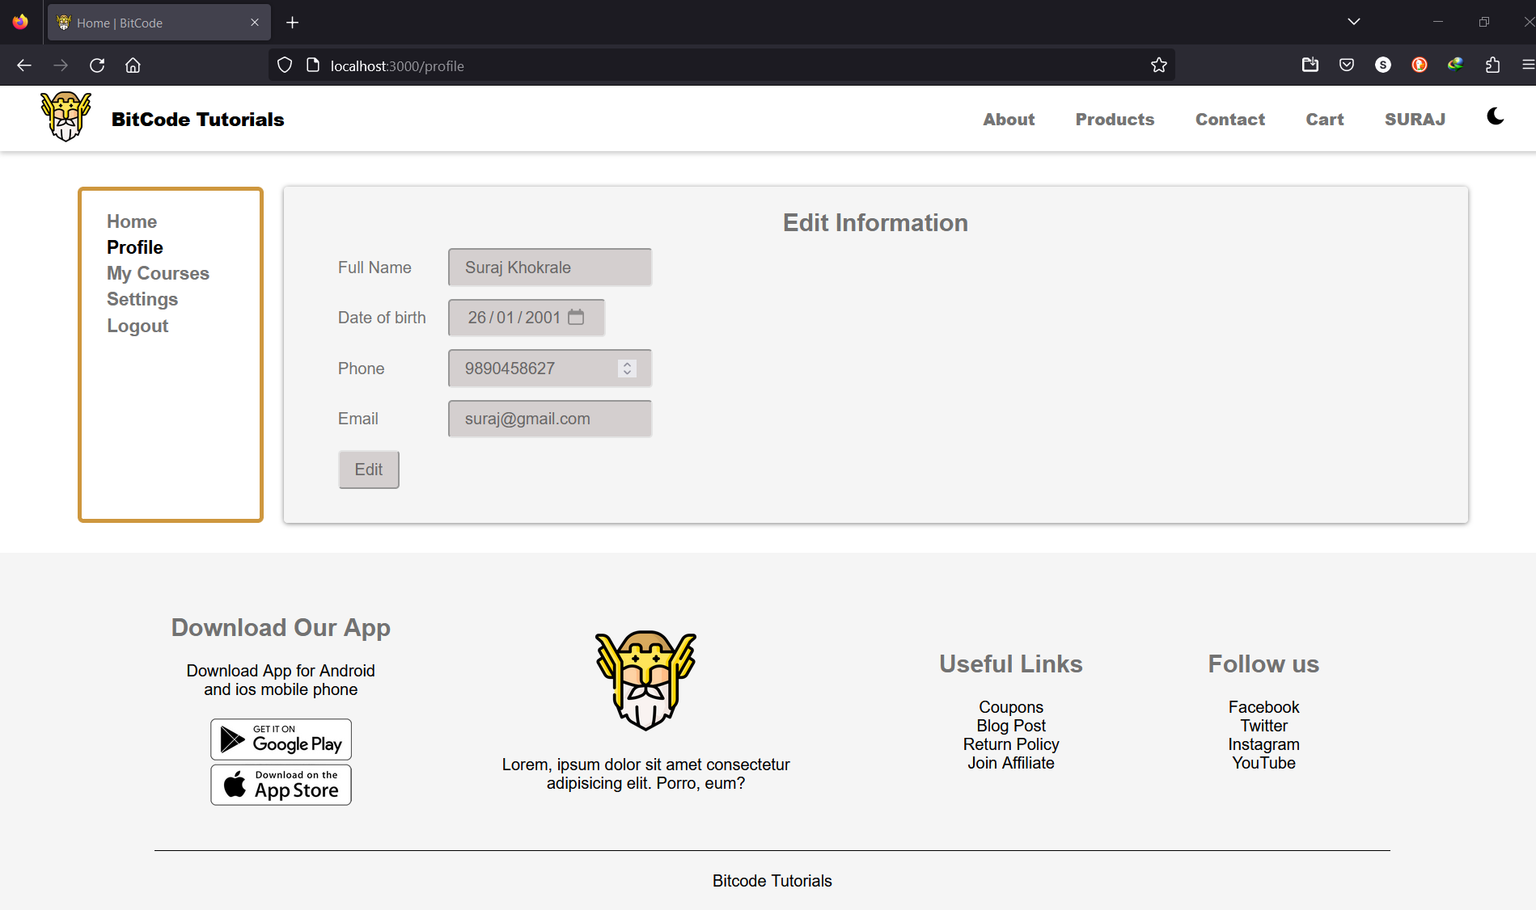

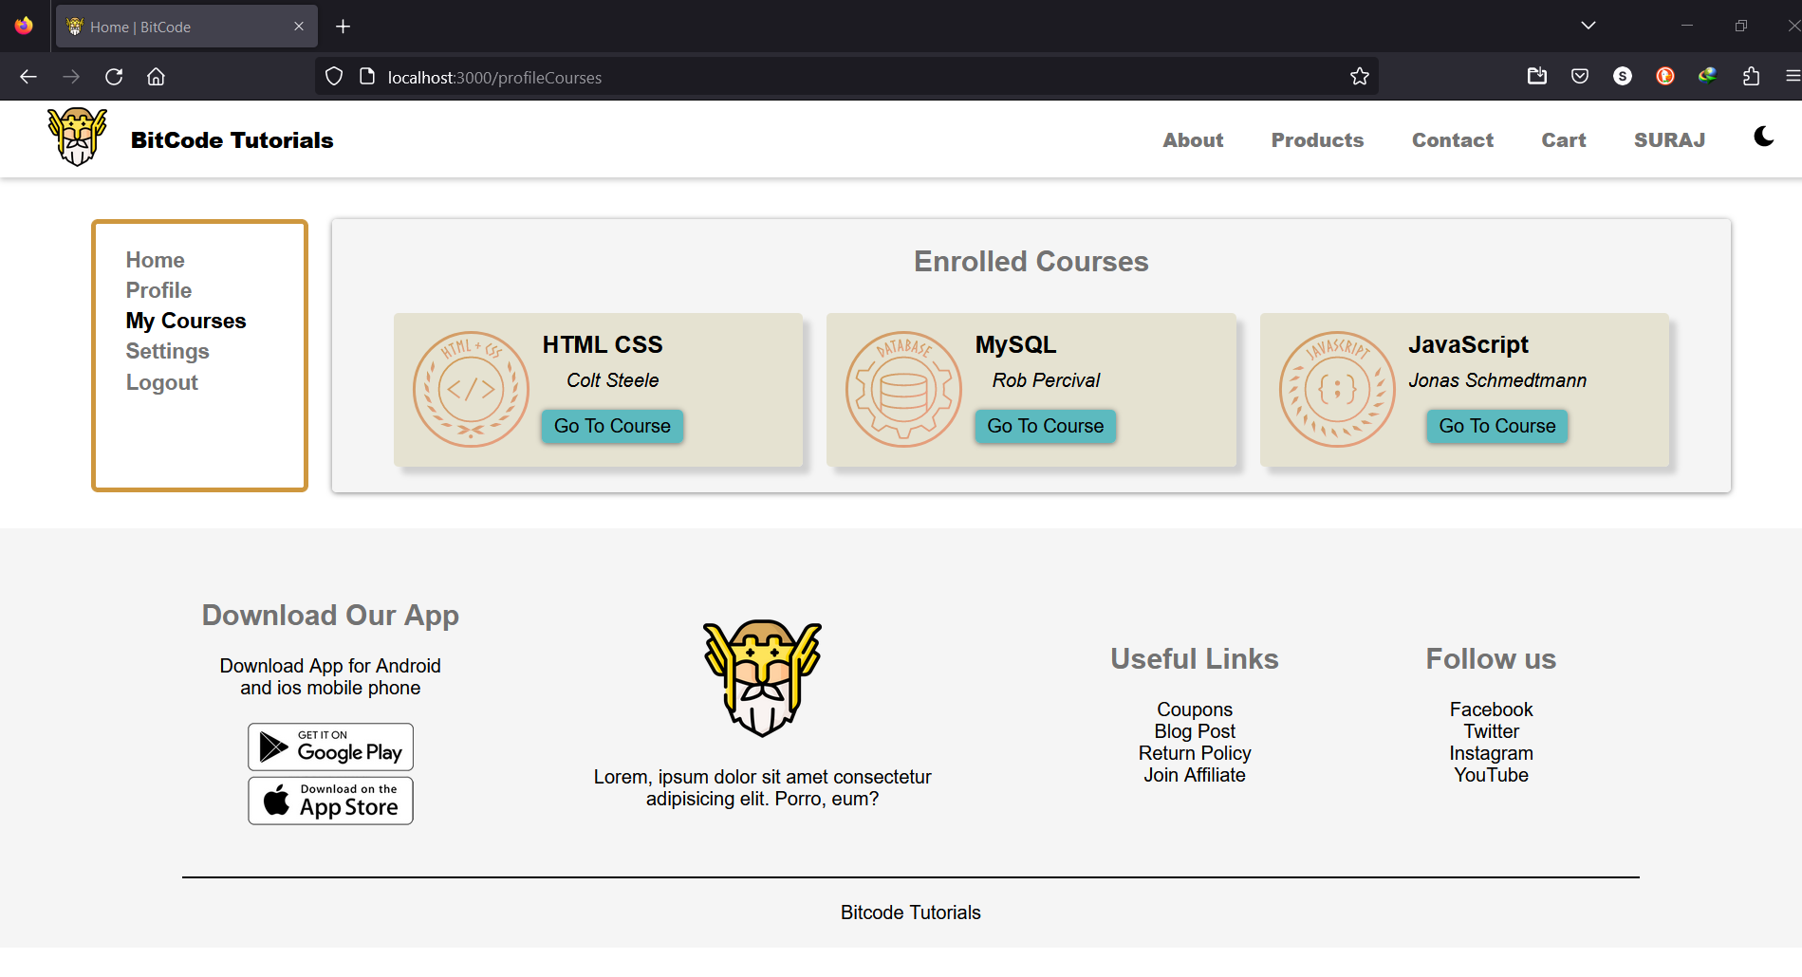

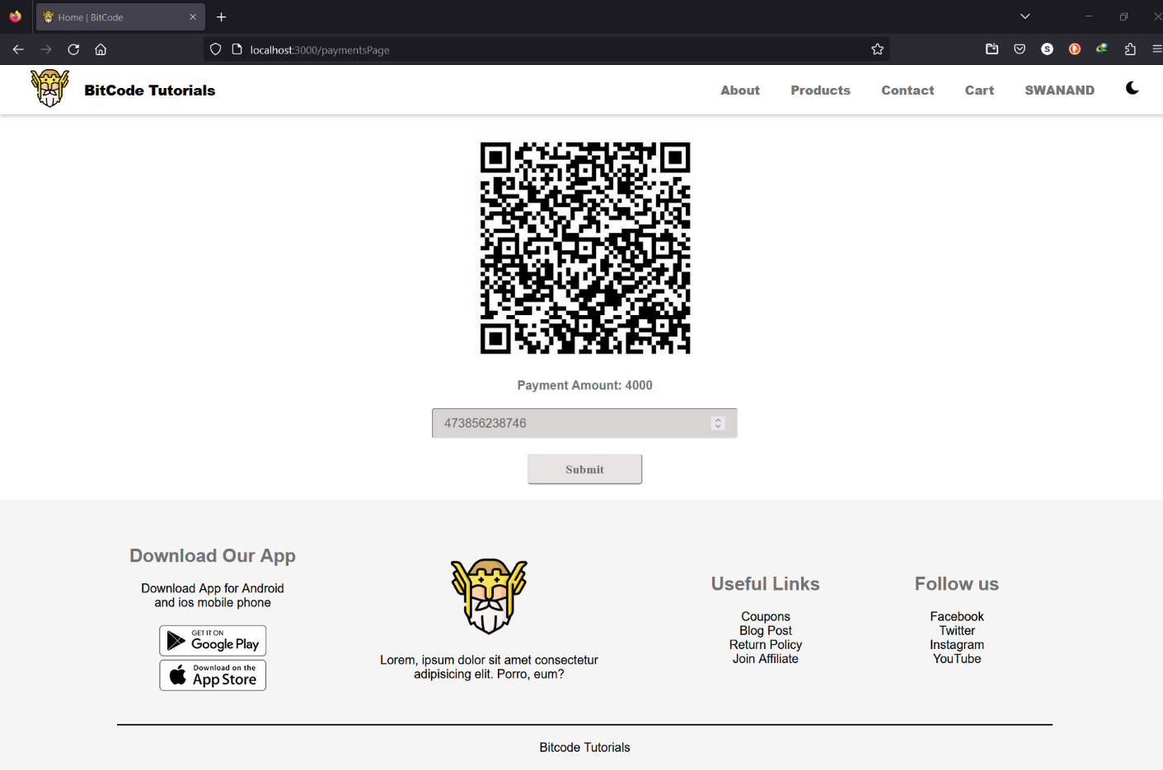

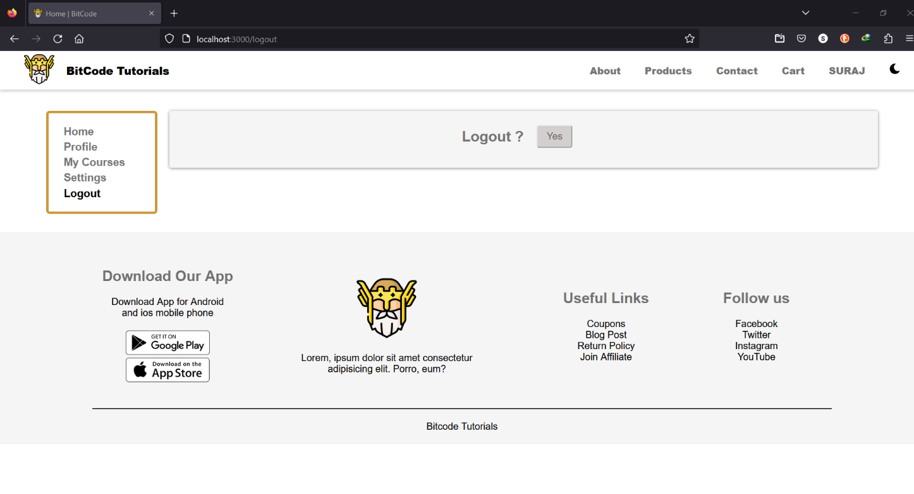

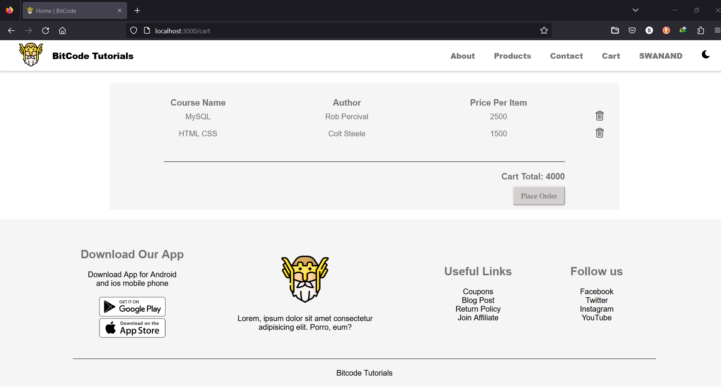

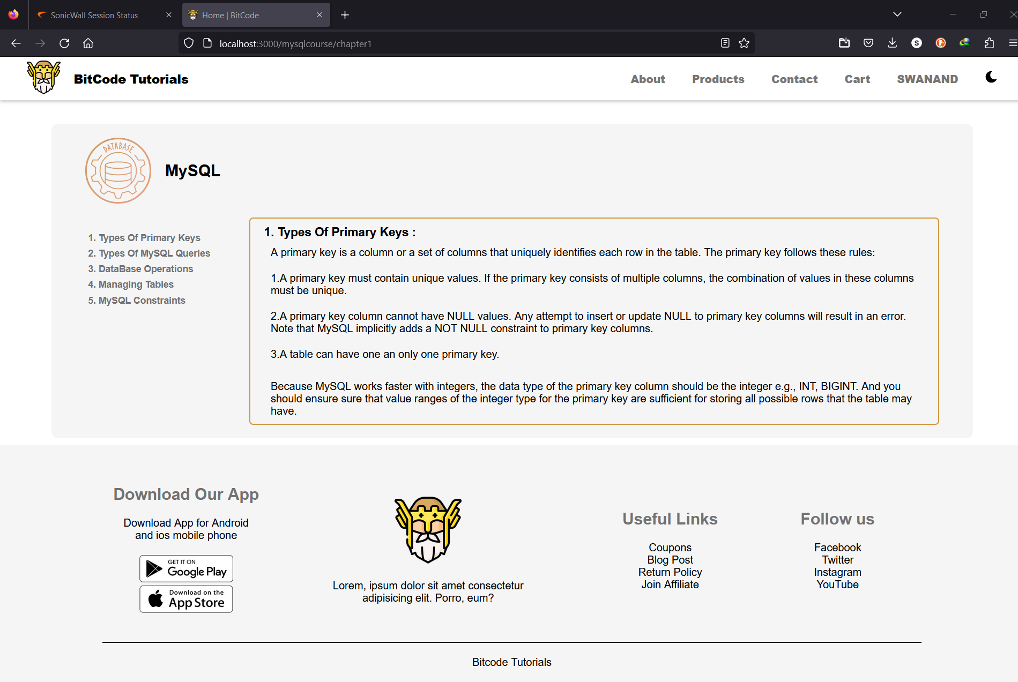

* Admin UI

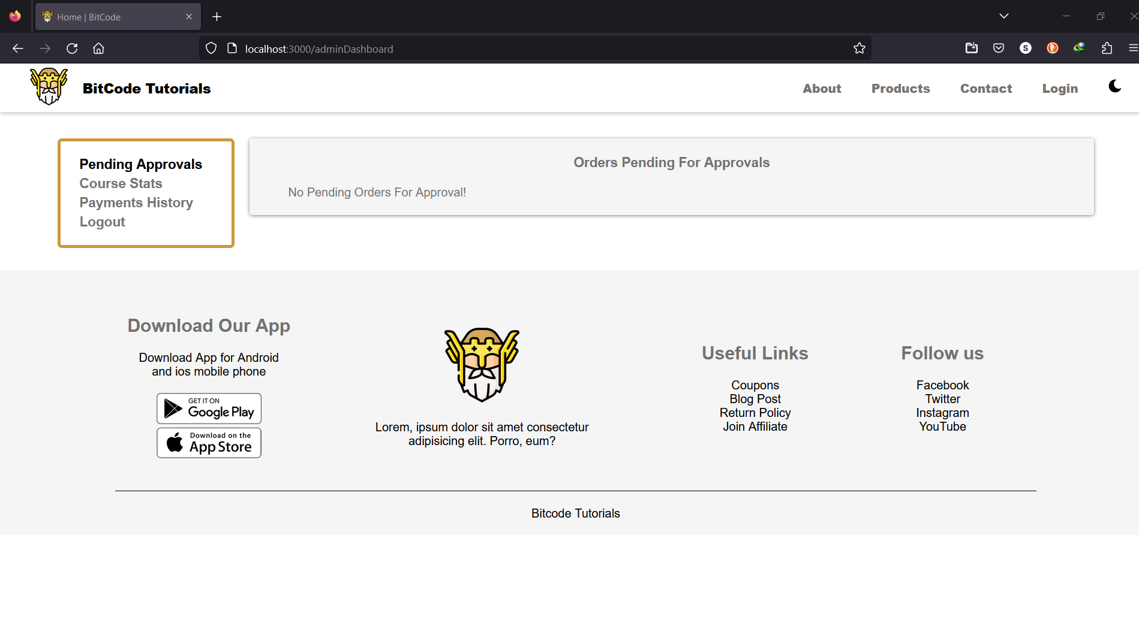

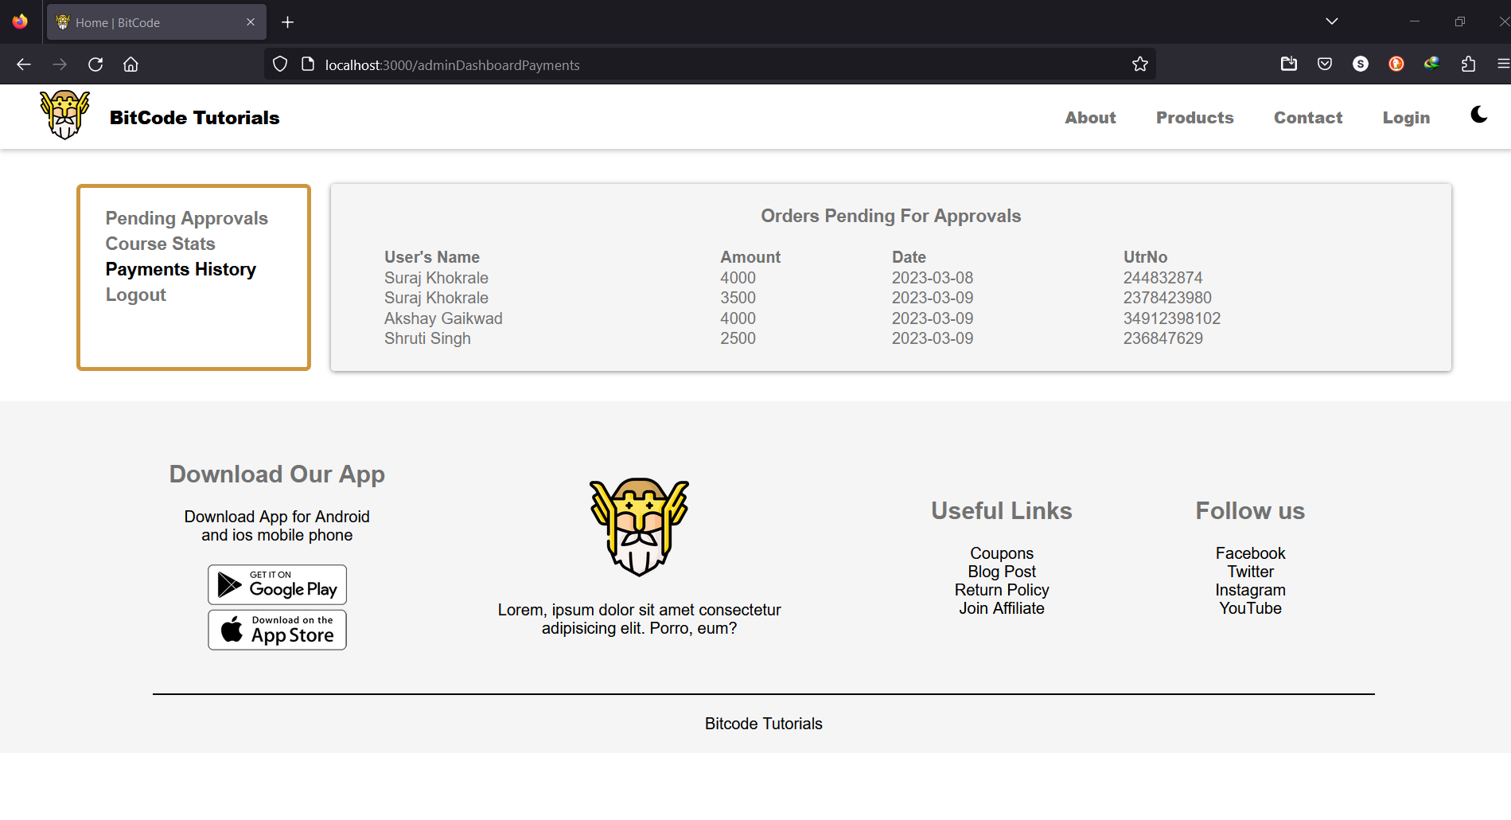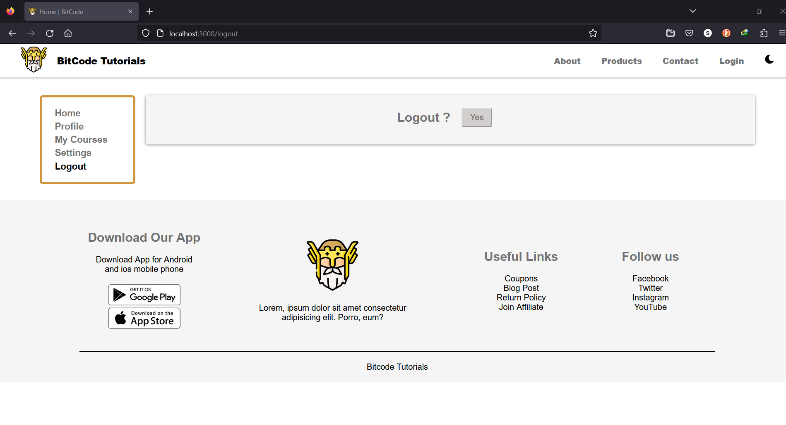

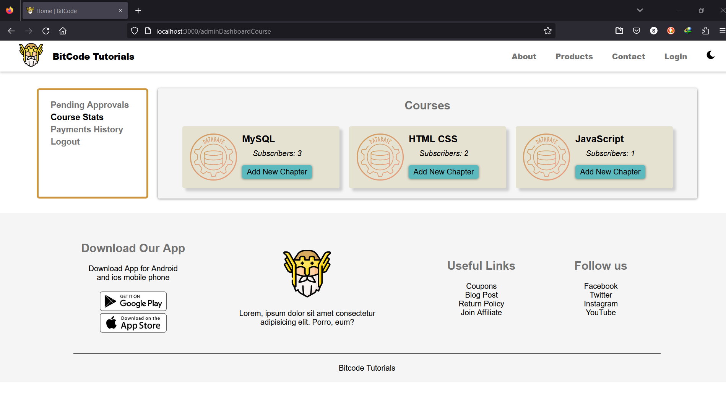

# Conclusion

In conclusion, Bitcode tutorial can be an effective tool for students of all ages and backgrounds to enhance their academic performance. The website can provide a variety of resources, such as interactive quizzes, practice problems, and study tips, to cater to different learning styles and preferences. Additionally, it can offer flexibility and convenience for students who may have busy schedules or limited access to traditional learning resources.

For a successful online study tutorial website, it is important to conduct thorough research on the target audience and their specific needs and preferences. The website is user-friendly and accessible, with clear and concise instructions for accessing and using the resources. Regular updates and improvements to the website can also help to keep the content fresh and relevant.

Overall, Bitcode tutorial website is a valuable tool for students seeking to improve their academic performance and achieve their educational goals. By providing accessible and comprehensive resources, the website can help to support students in their learning journey and contribute to their long-term success.

**References**

1. <https://docs.spring.io/spring-boot/docs>
2. <http://www.ijcstjournal.org/volume-7/issue-1/IJCST-V7I1P4.pdf>
3. <https://bootstrapmade.com/mentor-free-education-bootstrap-theme/>
4. <https://reactjs.org/docs>
5. <https://javaee.github.io/javaee-spec/javadocs/>
6. <https://axios-http.com/docs>
7. <https://jwt.io/introduction/>
8. <https://www.w3schools.com/>