# Credit Card Market Research & A/B Testing

# 👤 Role: Data Scientist

# Business Objective

To identify target demographics, analyse consumer behaviour, and validate product strategies through statistical methods to support the launch of a new financial product.

# Project Workflow

* Data Collection
* Data Cleaning
* Exploratory Data Analysis
* Customer Segmentation0
* Statistical Testing (A/B Testing)
* Insights & Recommendations

# Tools & Technologies

Languages: Python 3.x  
Libraries: Pandas, NumPy, Seaborn, Matplotlib, scikit-learn  
Environment: Visual Studio Code, Jupyter Notebook, MySQL

# github repository

<https://github.com/SurajK221b/credit-card-eda>

# pROBLEM STATEMENT

Atliqo Bank is preparing to launch a new credit card product aimed at enhancing customer engagement and capturing untapped market segments.

Prior to deployment, the bank requires comprehensive data-driven insights to support strategic decision-making in the following areas:

* Identification of the optimal target age group for initial rollout
* Analysis of preferred transaction platforms across customer segments
* Evaluation of spending behaviour to tailor rewards and coupon strategies
* Design and execution of pre-launch testing (e.g., A/B testing) to assess product performance and user adoption potential

# PROJECT PHASES

**Phase 1: Data Cleaning & Exploratory Analysis**  
Conducted comprehensive data preprocessing, including handling missing values and outliers, followed by detailed exploratory data analysis to uncover customer behaviour patterns, spending trends, and credit profiles.

**Phase 2: A/B Testing & Performance Evaluation**  
Designed and implemented controlled experiments (A/B tests) to assess the impact of the new credit card on user engagement, spending behaviour, and platform adoption. Statistical validation was performed to ensure the significance of observed differences.

# PHASE 1: DATA CLEANING AND EXPLORATION

* Performed dataset-specific cleaning on customer, transaction, and credit profile data to ensure consistency and integrity across sources.
* Addressed data quality issues through:

1. **Missing Value Imputation** using occupation-wise median values
2. **Outlier Treatment** by replacing extreme values with average or median-based thresholds

* Conducted exploratory analysis to evaluate customer behaviour across key dimensions:

**Age brackets**

**Annual income levels**

**Preferred payment methods**

**Credit history and score distribution**

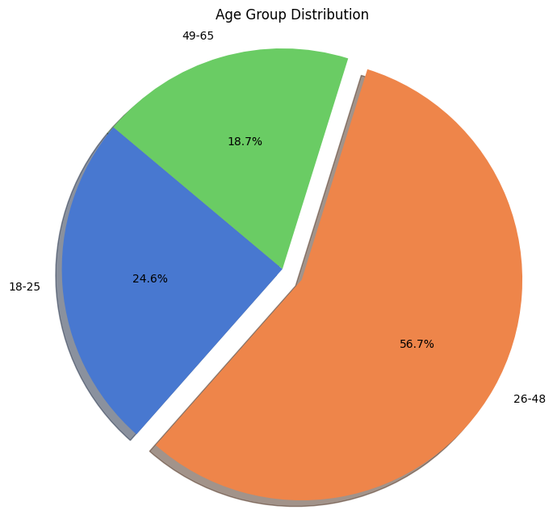

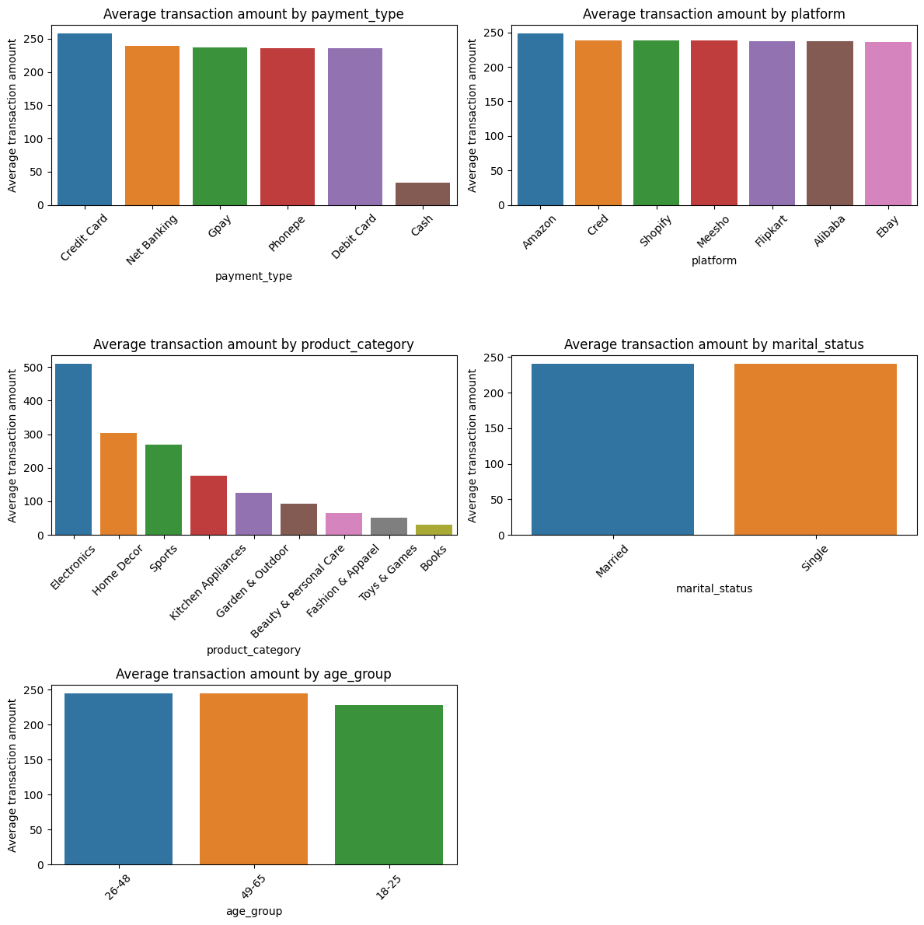

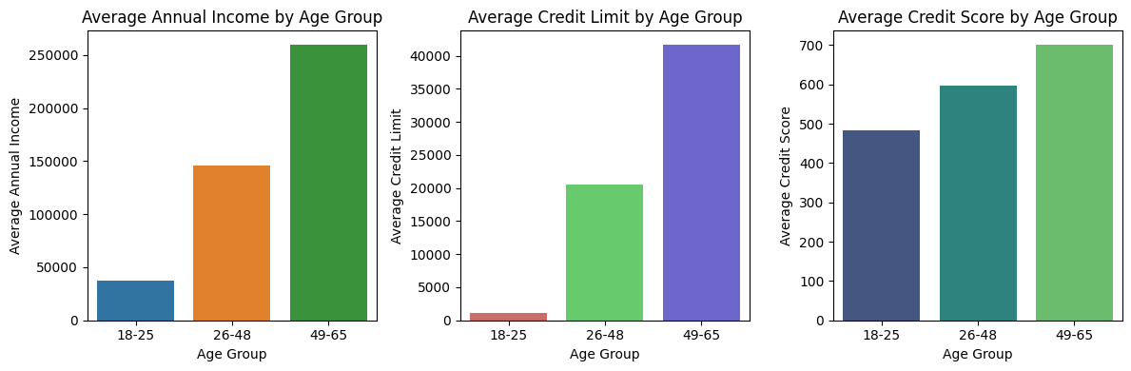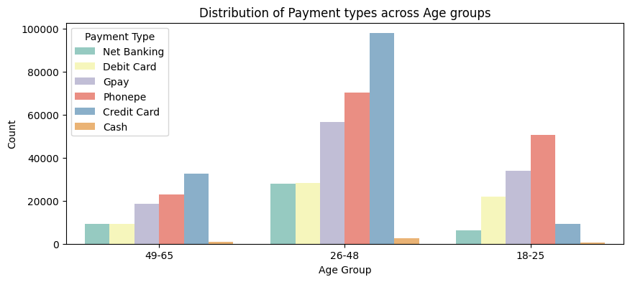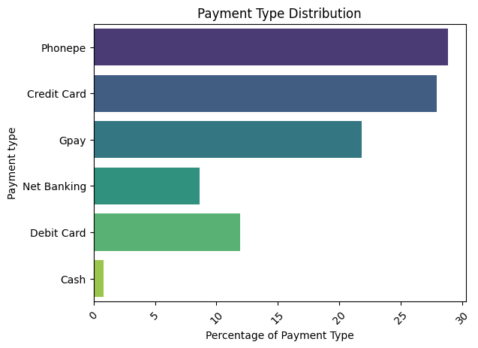

# PHASE 2: A/B Testing & Performance Evaluation

* Designed and executed a statistically rigorous **A/B testing framework** to evaluate the impact of the newly proposed credit card offering on customer behaviour and platform usage.
* Key experiment components included:

1. **Control Group**: Existing credit card users
2. **Test Group**: New card users from the identified 18–25 target segment
3. **Effect Size**: 0.4 | **Significance Level**: 0.05 | **Power**: 0.8
4. **Methodology**: Two-sample t-test to measure differences in spending and engagement metrics
5. **Sample Size**: 40 users in each group
6. **Duration**: 2-month observation period

* The campaign led to the following validated outcomes:

1. **p-value < 0.05** indicating statistical significance
2. **Null hypothesis rejected**, confirming a measurable impact
3. **Test group** showed increased spending and platform engagement

**🎯 Target Segment – Age Group 18–25**

* Based on exploratory data analysis and visual insights, the **18–25 age group** was identified as the optimal segment for the new credit card launch.
* Key characteristics of this segment:
  + Represents approximately **25% of the customer base**
  + Average annual income **below ₹50,000**
  + **Limited credit history**, ideal for entry-level financial products
  + Heavy usage of **UPI platforms** such as PhonePe and GPay
  + **Low competition** from existing credit card providers
* Strategic positioning: Entry-level credit card with **mobile app integration** and targeted **reward programs**

**🧪 A/B Testing – Experiment Setup**

* **Control Group**: Existing card users
* **Test Group**: New card users (age 18–25)
* **Effect Size**: 0.4 | **Significance Level**: 0.05 | **Statistical Power**: 0.8
* **Test Duration**: 2 months
* **Sample Size**: ~40 users in each group
* **Methodology**: Two-sample t-test to evaluate differences in spending behaviour and engagement

**📈 A/B Testing – Key Results**

* **p-value < 0.05** → Result is **statistically significant**
* **Null hypothesis rejected**
* **Test group** exhibited:
  + Higher overall spend
  + Increased usage frequency

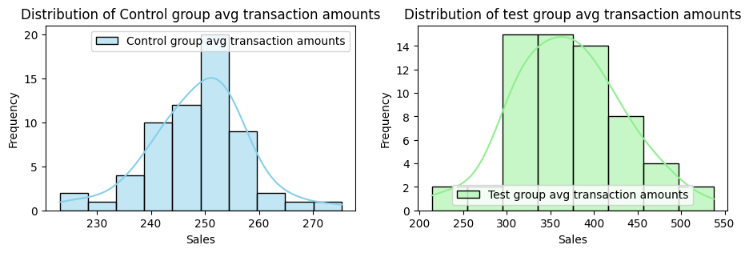

# CONCLUSION

This project demonstrates a complete data science workflow applied to a real-world financial product launch. Through robust **data cleaning**, **exploratory analysis**, and a well-structured **A/B testing framework**, we were able to derive actionable insights that directly informed strategic business decisions.

Key achievements include:

* **Identification of a high-potential target segment (Age 18–25)** with strong digital payment affinity and low existing credit product penetration
* **Validation of product-market fit** using statistically sound A/B testing, confirming a significant uplift in customer engagement and spend behaviour
* Translation of raw data into **strategic recommendations** that align with business objectives, market trends, and customer preferences

Overall, the project underscores the impact of **data-driven decision-making** in financial services and highlights the value of integrating analytics into product strategy.

# SUMMARY And thank you

* Successfully identified an **untapped youth segment (age 18–25)** with high growth potential and low credit penetration
* Conducted **A/B testing** to validate the performance of the proposed credit card, demonstrating a statistically significant uplift in engagement and spend
* Showcased a **practical, end-to-end application of data science** for business problem-solving—from data cleaning to strategic recommendation
* This project highlights my ability to combine analytical rigor with business insight to drive impactful outcomes

# let’s connect and collaborate

**Feel free to explore more of my work and connect with me on:**

🔗 [LinkedIn](https://www.linkedin.com/in/surajkhodade/) 💻 [GitHub](https://github.com/SurajK221b) 🌐 [Portfolio](https://dev-persona.vercel.app/home)