Basis Path Testing in Software Testing
- \

Prerequisite – Path Testing Basis Path Testing is a white-box testing technique based on the control structure of a program or a module. Using this structure, a control flow graph is prepared and the various possible paths present in the graph are executed as a part of testing. Therefore, by definition, Basis path testing is a technique of selecting the paths in the control flow graph, that provide a basis set of execution paths through the program or module. Since this testing is based on the control structure of the program, it requires complete knowledge of the program’s structure. To design test cases using this technique, four steps are followed :
- Construct the Control Flow Graph
- Compute the Cyclomatic Complexity of the Graph
- Identify the Independent Paths
- Design Test cases from Independent Paths
Let’s understand each step one by one. 1. Control Flow Graph – A control flow graph (or simply, flow graph) is a directed graph which represents the control structure of a program or module. A control flow graph (V, E) has V number of nodes/vertices and E number of edges in it. A control graph can also have :
- Junction Node – a node with more than one arrow entering it.
- Decision Node – a node with more than one arrow leaving it.
- Region – area bounded by edges and nodes (area outside the graph is also counted as a region.).
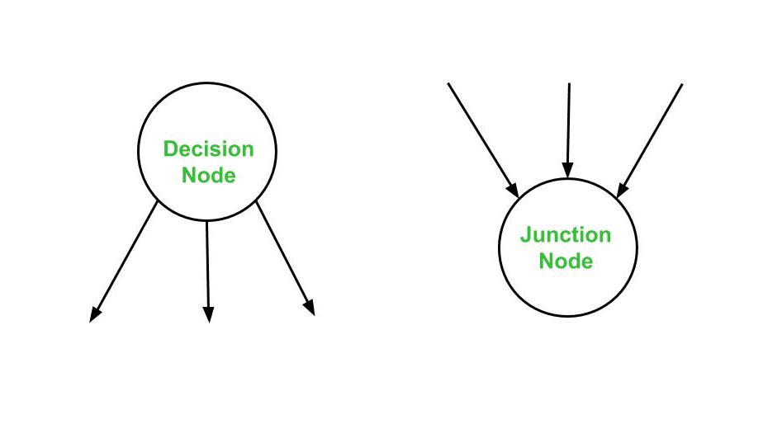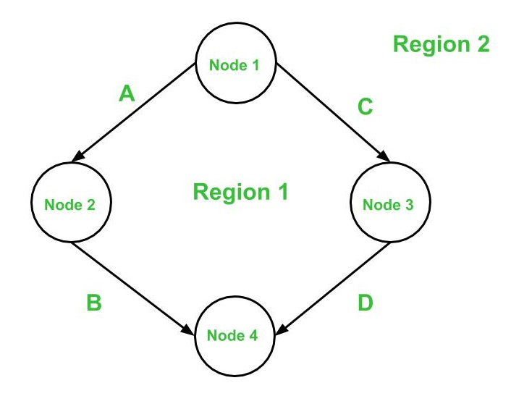Below are the notations used while constructing a flow graph :
- Sequential Statements –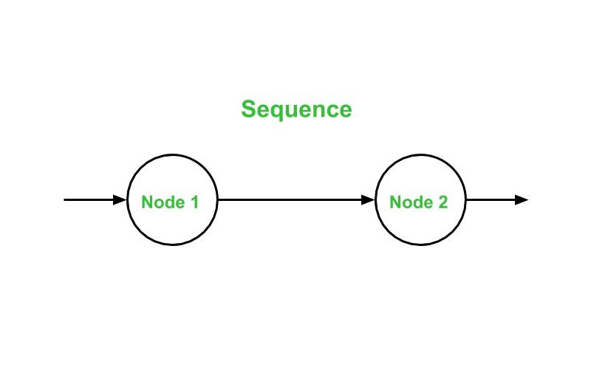
- If – Then – Else –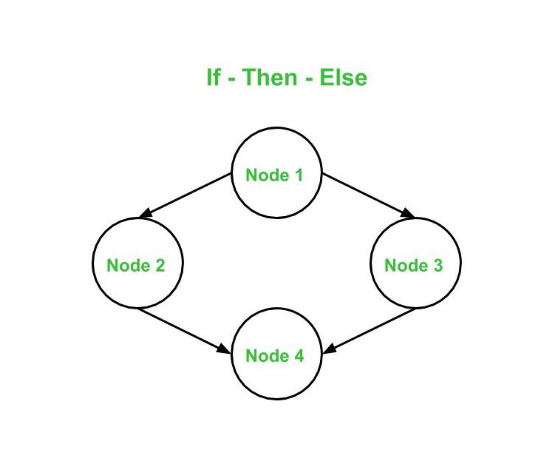
- Do – While –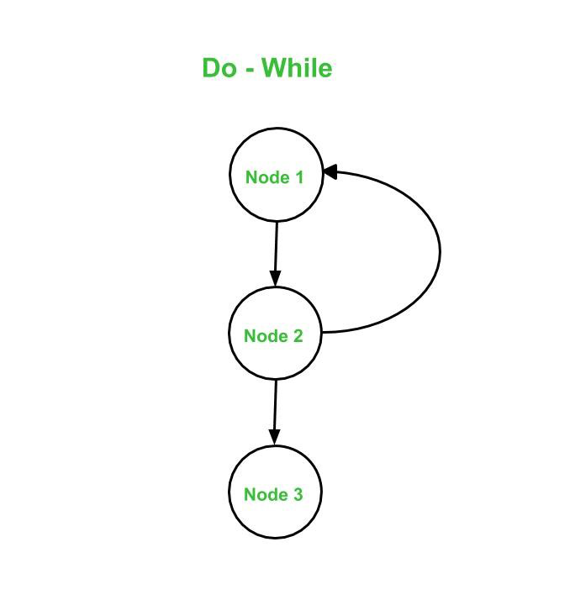
- While – Do –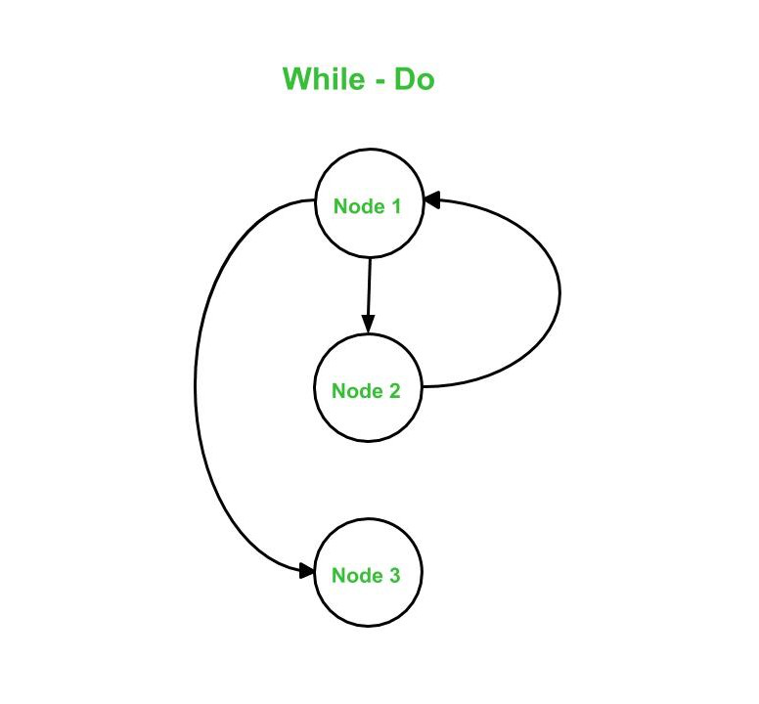
- Switch – Case –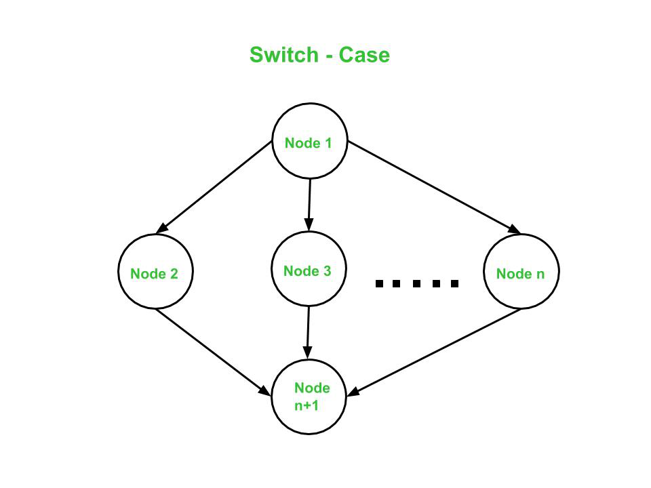
. Advantages : Basis Path Testing can be applicable in the following cases:
- More Coverage – Basis path testing provides the best code coverage as it aims to achieve maximum logic coverage instead of maximum path coverage. This results in an overall thorough testing of the code.
- Maintenance Testing – When a software is modified, it is still necessary to test the changes made in the software which as a result, requires path testing.
- Unit Testing – When a developer writes the code, he or she tests the structure of the program or module themselves first. This is why basis path testing requires enough knowledge about the structure of the code.
- Integration Testing – When one module calls other modules, there are high chances of Interface errors. In order to avoid the case of such errors, path testing is performed to test all the paths on the interfaces of the modules.
- Testing Effort – Since the basis path testing technique takes into account the complexity of the software (i.e., program or module) while computing the cyclomatic complexity, therefore it is intuitive to note that testing effort in case of basis path testing is directly proportional to the complexity of the software or program.

SOFTWARE MAINTENNACE

Software Maintenance refers to the process of modifying and updating a software system after it has been delivered to the customer. It is a critical part of the software development life cycle (SDLC) and is necessary to ensure that the software continues to meet the needs of the users over time. This article focuses on discussing Software Maintenance in detail.

What is Software Maintenance?
Software maintenance is a continuous process that occurs throughout the entire life cycle of the software system.
- The goal of software maintenance is to keep the software system working correctly, efficiently, and securely, and to ensure that it continues to meet the needs of the users.
- This can include fixing bugs, adding new features, improving performance, or updating the software to work with new hardware or software systems.
- It is also important to consider the cost and effort required for software maintenance when planning and developing a software system.
- It is important to have a well-defined maintenance process in place, which includes testing and validation, version control, and communication with stakeholders.
- It’s important to note that software maintenance can be costly and complex, especially for large and complex systems. Therefore, the cost and effort of maintenance should be taken into account during the planning and development phases of a software project.
- It’s also important to have a clear and well-defined maintenance plan that includes regular maintenance activities, such as testing, backup, and bug fixing.

Several Key Aspects of Software Maintenance
- Bug Fixing: The process of finding and fixing errors and problems in the software.
- Enhancements: The process of adding new features or improving existing features to meet the evolving needs of the users.
- Performance Optimization: The process of improving the speed, efficiency, and reliability of the software.
- Porting and Migration: The process of adapting the software to run on new hardware or software platforms.
- Re-Engineering: The process of improving the design and architecture of the software to make it more maintainable and scalable.
- Documentation: The process of creating, updating, and maintaining the documentation for the software, including user manuals, technical specifications, and design documents.

Several Types of Software Maintenance
- Corrective Maintenance: This involves fixing errors and bugs in the software system.
- Patching: It is an emergency fix implemented mainly due to pressure from management. Patching is done for corrective maintenance but it gives rise to unforeseen future errors due to lack of proper impact analysis.
- Adaptive Maintenance: This involves modifying the software system to adapt it to changes in the environment, such as changes in hardware or software, government policies, and business rules.
- Perfective Maintenance: This involves improving functionality, performance, and reliability, and restructuring the software system to improve changeability.
- Preventive Maintenance: This involves taking measures to prevent future problems, such as optimization, updating documentation, reviewing and testing the system, and implementing preventive measures such as backups.
Maintenance can be categorized into proactive and reactive types. Proactive maintenance involves taking preventive measures to avoid problems from occurring, while reactive maintenance involves addressing problems that have already occurred.
Maintenance can be performed by different stakeholders, including the original development team, an in-house maintenance team, or a third-party maintenance provider. Maintenance activities can be planned or unplanned. Planned activities include regular maintenance tasks that are scheduled in advance, such as updates and backups. Unplanned activities are reactive and are triggered by unexpected events, such as system crashes or security breaches. Software maintenance can involve modifying the software code, as well as its documentation, user manuals, and training materials. This ensures that the software is up-to-date and continues to meet the needs of its users.
Software maintenance can also involve upgrading the software to a new version or platform. This can be necessary to keep up with changes in technology and to ensure that the software remains compatible with other systems. The success of software maintenance depends on effective communication with stakeholders, including users, developers, and management. Regular updates and reports can help to keep stakeholders informed and involved in the maintenance process.
Software maintenance is also an important part of the Software Development Life Cycle(SDLC). To update the software application and do all modifications in software application so as to improve performance is the main focus of software maintenance. Software is a model that runs on the basis of the real world. so, whenever any change requires in the software that means the need for real-world changes wherever possible.

Need for Maintenance
Software Maintenance must be performed in order to:
- Correct faults.
- Improve the design.
- Implement enhancements.
- Interface with other systems.
- Accommodate programs so that different hardware, software, system features, and telecommunications facilities can be used.
- Migrate legacy software.
- Retire software.
- Requirement of user changes.
- Run the code fast

Challenges in Software Maintenance
The various challenges in software maintenance are given below:
- The popular age of any software program is taken into consideration up to ten to fifteen years. As software program renovation is open-ended and might maintain for decades making it very expensive.
- Older software programs, which had been intended to paint on sluggish machines with much less reminiscence and garage ability can not maintain themselves tough in opposition to newly coming more advantageous software programs on contemporary-day hardware.
- Changes are frequently left undocumented which can also additionally reason greater conflicts in the future.
- As the era advances, it turns into high prices to preserve vintage software programs.
- Often adjustments made can without problems harm the authentic shape of the software program, making it difficult for any next adjustments.
- There is a lack of Code Comments.
- Lack of documentation: Poorly documented systems can make it difficult to understand how the system works, making it difficult to identify and fix problems.
- Legacy code: Maintaining older systems with outdated technologies can be difficult, as it may require specialized knowledge and skills.
- Complexity: Large and complex systems can be difficult to understand and modify, making it difficult to identify and fix problems.
- Changing requirements: As user requirements change over time, the software system may need to be modified to meet these new requirements, which can be difficult and time-consuming.
- Interoperability issues: Systems that need to work with other systems or software can be difficult to maintain, as changes to one system can affect the other systems.
- Lack of test coverage: Systems that have not been thoroughly tested can be difficult to maintain as it can be hard to identify and fix problems without knowing how the system behaves in different scenarios.
- Lack of personnel: A lack of personnel with the necessary skills and knowledge to maintain the system can make it difficult to keep the system up-to-date and running smoothly.
- High-Cost: The cost of maintenance can be high, especially for large and complex systems, which can be difficult to budget for and manage.
To overcome these challenges, it is important to have a well-defined maintenance process in place, which includes testing and validation, version control, and communication with stakeholders. It is also important to have a clear and well-defined maintenance plan that includes regular maintenance activities, such as testing, backup, and bug fixing. Additionally, it is important to have personnel with the necessary skills and knowledge to maintain the system.

Categories of Software Maintenance
Maintenance can be divided into the following categories.
- Corrective maintenance: Corrective maintenance of a software product may be essential either to rectify some bugs observed while the system is in use, or to enhance the performance of the system.
- Adaptive maintenance: This includes modifications and updations when the customers need the product to run on new platforms, on new operating systems, or when they need the product to interface with new hardware and software.
- Perfective maintenance: A software product needs maintenance to support the new features that the users want or to change different types of functionalities of the system according to the customer’s demands.
- Preventive maintenance: This type of maintenance includes modifications and updations to prevent future problems with the software. It goals to attend to problems, which are not significant at this moment but may cause serious issues in the future.

Reverse Engineering
Reverse Engineering is the process of extracting knowledge or design information from anything man-made and reproducing it based on the extracted information. It is also called back engineering. The main objective of reverse engineering is to check out how the system works. There are many reasons to perform reverse engineering. Reverse engineering is used to know how the thing works. Also, reverse engineering is to recreate the object by adding some enhancements.

Software Reverse Engineering
Software Reverse Engineering is the process of recovering the design and the requirements specification of a product from an analysis of its code. Reverse Engineering is becoming important, since several existing software products, lack proper documentation, are highly unstructured, or their structure has degraded through a series of maintenance efforts.

Why Reverse Engineering?
- Providing proper system documentation.
- Recovery of lost information.
- Assisting with maintenance.
- The facility of software reuse.
- Discovering unexpected flaws or faults.
- Implements innovative processes for specific use.
- Easy to document the things how efficiency and power can be improved.

Uses of Software Reverse Engineering
- Software Reverse Engineering is used in software design, reverse engineering enables the developer or programmer to add new features to the existing software with or without knowing the source code.
- Reverse engineering is also useful in software testing, it helps the testers to study or detect the virus and other malware code.
- Software reverse engineering is the process of analyzing and understanding the internal structure and design of a software system. It is often used to improve the understanding of a software system, to recover lost or inaccessible source code, and to analyze the behavior of a system for security or compliance purposes.
- Malware analysis: Reverse engineering is used to understand how malware works and to identify the vulnerabilities it exploits, in order to develop countermeasures.
- Legacy systems: Reverse engineering can be used to understand and maintain legacy systems that are no longer supported by the original developer.
- Intellectual property protection: Reverse engineering can be used to detect and prevent intellectual property theft by identifying and preventing the unauthorized use of code or other assets.
- Security: Reverse engineering is used to identify security vulnerabilities in a system, such as backdoors, weak encryption, and other weaknesses.
- Compliance: Reverse engineering is used to ensure that a system meets compliance standards, such as those for accessibility, security, and privacy.
- Reverse-engineering of proprietary software: To understand how a software works, to improve the software, or to create new software with similar features.
- Reverse-engineering of software to create a competing product: To create a product that functions similarly or to identify the features that are missing in a product and create a new product that incorporates those features.
- It’s important to note that reverse engineering can be a complex and time-consuming process, and it is important to have the necessary skills, tools, and knowledge to perform it effectively. Additionally, it is important to consider the legal and ethical implications of reverse engineering, as it may be illegal or restricted in some jurisdictions.

Advantages of Software Maintenance
- Improved Software Quality: Regular software maintenance helps to ensure that the software is functioning correctly and efficiently and that it continues to meet the needs of the users.
- Enhanced Security: Maintenance can include security updates and patches, helping to ensure that the software is protected against potential threats and attacks.
- Increased User Satisfaction: Regular software maintenance helps to keep the software up-to-date and relevant, leading to increased user satisfaction and adoption.
- Extended Software Life: Proper software maintenance can extend the life of the software, allowing it to be used for longer periods of time and reducing the need for costly replacements.
- Cost Savings: Regular software maintenance can help to prevent larger, more expensive problems from occurring, reducing the overall cost of software ownership.
- Better Alignment with business goals: Regular software maintenance can help to ensure that the software remains aligned with the changing needs of the business. This can help to improve overall business efficiency and productivity.
- Competitive Advantage: Regular software maintenance can help to keep the software ahead of the competition by improving functionality, performance, and user experience.
- Compliance with Regulations: Software maintenance can help to ensure that the software complies with relevant regulations and standards. This is particularly important in industries such as healthcare, finance, and government, where compliance is critical.
- Improved Collaboration: Regular software maintenance can help to improve collaboration between different teams, such as developers, testers, and users. This can lead to better communication and more effective problem-solving.
- Reduced Downtime: Software maintenance can help to reduce downtime caused by system failures or errors. This can have a positive impact on business operations and reduce the risk of lost revenue or customers.
- Improved Scalability: Regular software maintenance can help to ensure that the software is scalable and can handle increased user demand. This can be particularly important for growing businesses or for software that is used by a large number of users.

Disadvantages of Software Maintenance
- Cost: Software maintenance can be time-consuming and expensive, and may require significant resources and expertise.
- Schedule disruptions: Maintenance can cause disruptions to the normal schedule and operations of the software, leading to potential downtime and inconvenience.
- Complexity: Maintaining and updating complex software systems can be challenging, requiring specialized knowledge and expertise.
- Risk of introducing new bugs: The process of fixing bugs or adding new features can introduce new bugs or problems, making it important to thoroughly test the software after maintenance.
- User resistance: Users may resist changes or updates to the software, leading to decreased satisfaction and adoption.
- Compatibility issues: Maintenance can sometimes cause compatibility issues with other software or hardware, leading to potential integration problems.
- Lack of documentation: Poor documentation or lack of documentation can make software maintenance more difficult and time-consuming, leading to potential errors or delays.
- Technical debt: Over time, software maintenance can lead to technical debt, where the cost of maintaining and updating the software becomes increasingly higher than the cost of developing a new system.
- Skill gaps: Maintaining software systems may require specialized skills or expertise that may not be available within the organization, leading to potential outsourcing or increased costs.
- Inadequate testing: Inadequate testing or incomplete testing after maintenance can lead to errors, bugs, and potential security vulnerabilities.
- End-of-life: Eventually, software systems may reach their end-of-life, making maintenance and updates no longer feasible or cost-effective. This can lead to the need for a complete system replacement, which can be costly and time-consuming.

Structural Testing
In this section, we are going to understand structural testing, which is a significant part of Software testing.
And we also learn about its needs, types of structural testing, tools compatible for Structural testing, advantage, and disadvantage.

Introduction of Structural Testing
Another type of software testing technique is Structural testing, which is used to test the internal design of the software or structure of the coding for the particular software.
In this testing, the development team members are included in the testing team to execute the software's internal design. The working of structural testing is opposite to Behavioral testing.
In other words, we can say that structural testing tests the different features of an application based on its types.
Structural testing is also known as white-box testing, glass box testing, and clear-box testing. Developers mostly implement it to identify the issue and fix them quickly.
The structural testing process requires an in-depth knowledge of the programming language and is opposite to Functional Testing.
The knowledge of the code's internal executions and how the software is implemented is a necessity for the test engineer to implement the structural testing.
Throughout the structural testing, the test engineer intends on how the software performs, and it can be used at all levels of testing.
For example, the coverage of menu options or significant business transactions could be the system's structural element or acceptance testing.

Types of Structural Testing
Structural testing is divided into four different categories, which are as follows:
- Mutation testing
- Data flow testing
- Control flow testing
- Slice-based testing
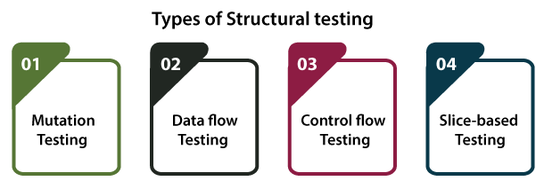

Mutation testing
- It is used to check the quality of the test case that should fail the mutant code.
- Mutation testing involves the development of new tests to be implemented on the software for its testing process.
- When we identify various errors, it implies that either the program is correct or the test case is inefficient in locating the fault.
- In the mutation testing, the developers make small modifications to the previously accessible software tests and generate a mutant of the old software test.
- It used to cause an error in the program, which implies that the mutation testing is performed to evaluate the test case's productivity.
Refers to the below link for detailed information about the Mutation testing: https://www.javatpoint.com/mutation-testing

Data flow testing
- It is a group of testing approaches used to observe the control flow of programs to discover the sequence of variables as per the series of events.
- It implements a control flow graph and analysis the points where the codes can change the data.
- If we execute the data flow testing technique, the information is kept safe and unchanged during the code's implementation.
Refers to the below link for the detailed information related to the data flow testing: https://www.javatpoint.com/data-flow-testing-in-white-box-testing

Control flow testing
- The control flow testing is the basic model of Structural testing.
- It is to check the implementation order of commands or statements of the code over a control structure.
- In the control flow testing, a specific part of an extensive program is selected by the test engineer to set the testing path.
- Generally, the control flow testing technique is used in unit testing.
- In this testing, the entire test is based on how the control is executed during the code.
- The complete information of all the software's features and logic is necessary to execute the control flow testing.
For detailed information about the Control flow testing is, refer to the below link: https://www.javatpoint.com/control-flow-testing-in-white-box-testing

Slice-based testing
- It was initially created and established to keep the software.
- The basic idea is to sort the complete code into small chunks and then evaluate each portion carefully.
- The slice-based testing is very beneficial for the maintenance of the software along with fixing the application too.

Note: The developers can use these four types of structural testing as per their requirements.

Advantages and Disadvantages of Structural Testing
Below are the benefits and drawback of structural testing:

Advantages of Structural Testing
The benefits of Structural testing are as follows:
- Structural testing does not require a lot of manual work as it is an automated process.
- Structural testing is not a time-consuming process.
- All the early defects can easily be identified
- It removes the dead code (extra code) or statements easily.
- It provides easy coding and implementation.
- It delivers detailed testing of the software.

Disadvantages of Structural Testing
The drawback of the structural testing are as follows:
- To perform structural testing, in-depth knowledge of programming languages is required.
- Even though structural testing is automatic, it might turn out very difficult because it involves training in the tool used for testing.
- It is expensive in respect of money because sometimes resources are necessary to efficiently perform structural testing.
- There is also a small chance that some commands, statements or branches could be missed unintentionally.

Overview
In this tutorial, we have understood structural testing, the type of structural testing, advantages and disadvantages.
After learning all the specific topics, we can easily conclude that Structural testing, which is also called White-box testing, glass box testing, and clear box testing is used to verify the structure of code.
And apart from that, we can say that while executing the different types of software testing, there is no guarantee of 100% efficiency of the product. Therefore, it is always helpful if we associate different categories of testing and methods.
The various structural testing types, which we have looked at, such as data flow testing, mutation testing, slice-based testing, and control flow testing, could be copied back to errors such as:
- Mutation testing (using the wrong operator).
- Data flow testing (referencing a variable before using it).
In case someone is looking to use the structural testing methods, they need to consider both the benefits and drawbacks of the structural testing.
Furthermore, they need to take care of the fact that structural testing is implemented successfully.

A quick summary for Verification and Validation in Software Testing
- Verification evaluates software artifacts (such as requirements, design, code, etc.) to ensure they meet the specified requirements and standards. It ensures the software is built according to the needs and design specifications.
- Validation evaluates software to meet the user’s needs and requirements. It ensures the software fits its intended purpose and meets the user’s expectations.
The IEEE-STD-610, a set of software engineering standards, defined verification testing as “A test of a system to prove that it meets all its specified requirements at a particular stage of its development.”
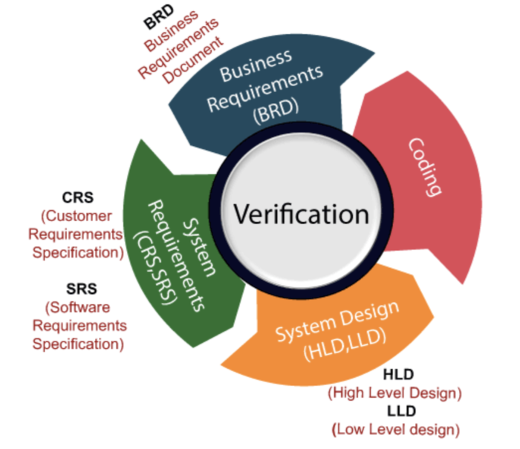
Source
- Code reviews, walkthroughs, inspections, design, and specification analysis are common components of verification testing.
- Some important documents to be reviewed in this stage are requirements specification, design blueprints, ER diagrams, database table design, test cases, test scenarios, traceability matrix, etc.
- Verification tests ensure that all development elements (software, hardware, documentation, and human resources) adhere to organizational and team-specific standards and protocols.
- It checks to authenticate that the system design and architecture are accurately engineered and error-free.
- Verification checks are often like studying the specifications and checking them against the code logic.

Advantages of Verification Testing
- Early and frequent verification reduces the number of bugs and defects that may show up in later stages.
- By verifying at each stage, devs, product managers, and stakeholders can get more insight into what the product may need to be developed better in the coming stages.
- Even if they can’t solve all bugs immediately, verifying helps QAs estimate the emerging issues and help them better prepare to handle those when they appear.
- Verification helps keep software closely aligned with customers and business requirements at every stage. This ensures that devs have to put in less unnecessary work as development continues.
Read More: How to create test scenarios with examples

When to use Verification Testing?
Verification tests must be run at every stage of development before any feature is implemented.
- For example, consider a button labeled “Add to Cart”. Before creating this button, verification tests would review all relevant requirements previously decided in the ideation and brainstorming phases.
- Let’s say the documentation says the button must be black with the lettering in white. It should be no larger than 10mm X 10mm, and it should constantly be visible in the top right corner of every website product page. Another button with the exact text, color, and dimensions should be placed under every product on the page.
- Before creating the button, design and requirements documents must be reviewed, and all necessary specifications must be listed before work begins.
- Before working on every feature or element on the page, this must be done so the devs do not miss any guidelines.

What is Validation Testing?
The IEEE-STD-610 defines validation testing as “An activity that ensures that an end product stakeholder’s true needs and expectations are met.”

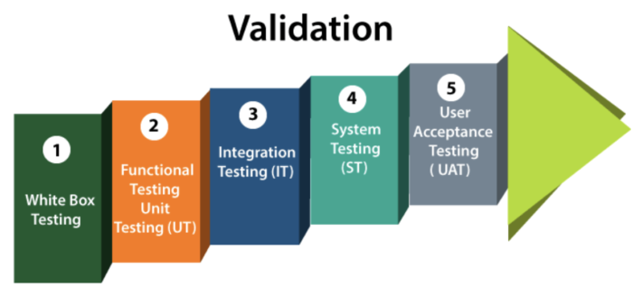
Source
Unlike verification testing, which occurs at every stage in development, validation testing occurs at the end of a specific module or even after the software has been entirely built. Its primary intent is to ensure the final product matches the stakeholder and customer requirements.
Most forms of QA fall under this category. All tests, from unit tests to User Acceptance Tests, are Validation tests. Some of the standard tests under this heading:
- Unit Testing
- Integration Testing
- Smoke Testing
- Functional Testing
- Performance Testing
- Regression Testing
- Security Testing
- System Testing
- Accessibility Testing
- Cross Browser Testing
- User Acceptance Testing
All validation tests ensure that a system works as planned by running all its functions and tracking tangible, quantifiable results.

Advantages of Validation Testing
- Any bugs missed during verification will be detected while running validation tests.
- If specifications were incorrect and inadequate, validation tests would reveal their inefficacy. Teams will have to spend time and effort fixing them, but it will prevent a bad product from hitting the market.
- Validation tests ensure that the product matches and adheres to customer demands, preferences, and expectations under different conditions (slow connectivity, low battery, etc.)
- These tests are also required to ensure the software functions flawlessly across different browser-device-OS combinations. In other words, it authenticates software for cross browser compatibility.

When to use Validation Testing?
Validation tests must be run after every feature or step in the development process is completed.
- For example, unit tests, a form of validation tests, are run after every unit of code has been created.
- Integration tests are run after multiple modules have been completed individually and are ready to be combined.
- An essential element of validation testing is the running of cross browser testing. QAs must check that every function, feature, and design element appears and functions as expected on different browser-device-os combinations. For example, does the “Add to Cart” button work perfectly on Google Chrome running Samsung Galaxy A23 and Safari running on iPhone 13?

Difference between Verification and Validation in Software engineering
Verification Testing | Validation Testing
It is the static practice of studying and verifying the specific requirements of a particular stage in development. | It is the dynamic practice of testing the final product after development to ensure it meets customer requirements.
It does not require executing code. | It always requires executing code.
This involves only human verification of required assets. | This involves both human and machine-based checking and approval of software.
It uses document reviews, inspections, product walkthroughs, and desk-checking techniques. | It involves various types of product testing – unit tests, integration tests, regression tests, cross-browser and cross-device testing, etc.
It is meant to detect bugs at the beginning of each development phase. | It is meant to detect all unnoticed bugs at the verification stage.
Its targets are specification documents, application and software architecture design docs, ER diagrams, database table design, test cases and scenarios, traceability matrix, etc. | Its target is the product to be used by the customer after public release.
It is undertaken by both developers and testers to ensure that the software adheres to predetermined standards and exactions. | It is primarily undertaken by experienced Quality Assurance engineers who comb through all features of an application to ensure they work as expected.
It comes before validation testing. | It follows verification testing.
It does not require any devices, platforms, browsers, or operating systems for its execution. | It is best executed by using real browsers, devices, and operating systems.

Start by numbering the statements:
insertion_procedure (int a[], int p [], int N)
{
(1) Int i,j,k;
(2) for ((2a)i=0; (2b)i<=N; (2c)i++)
(3) p[i] = i;
(4) for ((4a)i=2; (4b)i<=N; (4c)i++)
{
(5) k=p[i];j=1;
(6) while (a[p[j-1]] > a[k]) {
(7) p[j] = p[j-1];
(8) j--
}
(9) p[j] = k;
}
Now you can clearly see which statement executes first and which last etc. so drawing the cfg becomes simple.
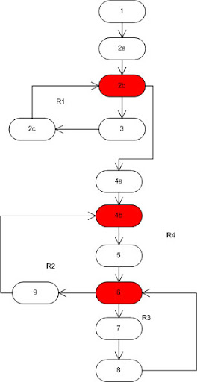
Now, to calculate cyclomatic complexity you use one of three methods:
- Count the number of regions on the graph: 4
- No. of predicates (red on graph) + 1 : 3 + 1 = 4
- No of edges - no. of nodes + 2: 14 - 12 + 2 = 4.

