Mutation Testing

What is mutation testing?
Mutation testing is a white box method in software testing where we insert errors purposely into a program (under test) to verify whether the existing test case can detect the error or not. In this testing, the mutant of the program is created by making some modifications to the original program.
The primary objective of mutation testing is to check whether each mutant created an output, which means that it is different from the output of the original program. We will make slight modifications in the mutant program because if we change it on a massive scale than it will affect the overall plan.
When we detected the number of errors, it implies that either the program is correct or the test case is inefficient to identify the fault.
Mutation testing purposes is to evaluate the quality of the case that should be able to fail the mutant code hence this method is also known as Fault-based testing as it used to produce an error in the program and that why we can say that the mutation testing is performed to check the efficiency of the test cases.

What is mutation?
The mutation is a small modification in a program; these minor modifications are planned to typical low-level errors which are happened at the time of coding process.
Generally, we deliberate the mutation operators in the form of rules which match the data and also generate some efficient environment to produce the mutant.

Types of mutation testing
Mutation testing can be classified into three parts, which are as follows:
- Decision mutations
- value mutations
- Statement mutations
Let us understand them one by one:


Decision mutations
In this type of mutation testing, we will check the design errors. And here, we will do the modification in arithmetic and logical operator to detect the errors in the program.
Like if we do the following changes in arithmetic operators:
- plus(+)→ minus(-)
- asterisk(*)→ double asterisk(**)
- plus(+)→incremental operator(i++)
Like if we do the following changes in logical operators
- Exchange P > → P<, OR P>=
Now, let see one example for our better understanding:
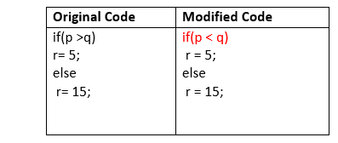

Value mutations
In this, the values will modify to identify the errors in the program, and generally, we will change the following:
- Small value à higher value
- Higher value àSmall value.
For Example:
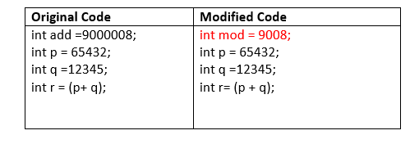

Statement Mutations
Statement mutations means that we can do the modifications into the statements by removing or replacing the line as we see in the below example:
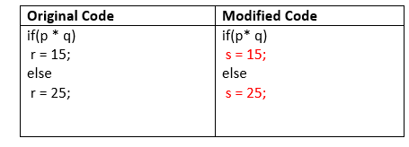
In the above case, we have replaced the statement r=15 by s=15, and r=25 by s=25.

How to perform mutation testing
To perform mutation testing, we will follow the below process:
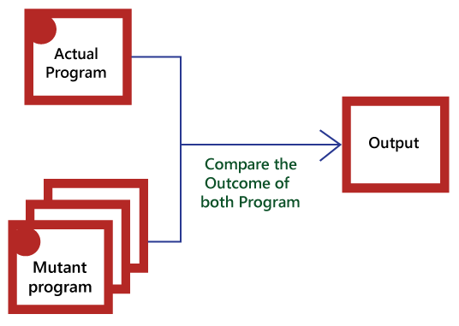
- In this, firstly, we will add the errors into the source code of the program by producing various versions, which are known mutants. Here every mutant having the one error, which leads the mutant kinds unsuccessful and also validates the efficiency of the test cases.
- After that, we will take the help of the test cases in the mutant program and the actual application will find the errors in the code.
- Once we identify the faults, we will match the output of the actual code and mutant code.
- After comparing the output of both actual and mutant programs, if the results are not matched, then the mutant is executed by the test cases. Therefore the test case has to be sufficient for identifying the modification between the actual program and the mutant program.
- And if the actual program and the mutant program produced the exact result, then the mutant is saved. And those cases are more active test cases because it helps us to execute all the mutants.

Advantages and disadvantages of Mutation Testing

Advantages
The benefits of mutation testing are as follows:
- It is a right approach for error detection to the application programmer
- The mutation testing is an excellent method to achieve the extensive coverage of the source program.
- Mutation testing helps us to give the most established and dependable structure for the clients.
- This technique can identify all the errors in the program and also helps us to discover the doubts in the code.

Disadvantages
The drawbacks of mutant testing are as follows:
- This testing is a bit of time taking and costlier process because we have many mutant programs that need to be created.
- The mutation testing is not appropriate for Black-box testing as it includes the modification in the source code.
- Every mutation will have the same number of test cases as compare to the actual program. Therefore the significant number of the mutant program may need to be tested beside the real test suite.
- As it is a tedious process, so we can say that this testing requires the automation tools to test the application.

Data Flow Testing
Data flow testing is used to analyze the flow of data in the program. It is the process of collecting information about how the variables flow the data in the program. It tries to obtain particular information of each particular point in the process.
Data flow testing is a group of testing strategies to examine the control flow of programs in order to explore the sequence of variables according to the sequence of events. It mainly focuses on the points at which values assigned to the variables and the point at which these values are used by concentrating on both points, data flow can be tested.
Data flow testing uses the control flow graph to detect illogical things that can interrupt the flow of data. Anomalies in the flow of data are detected at the time of associations between values and variables due to:
- If the variables are used without initialization.
- If the initialized variables are not used at least once.
Let's understand this with an example:
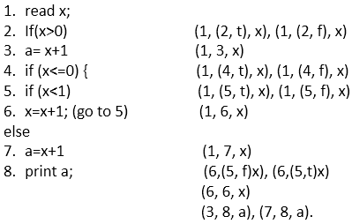
In this code, we have a total 8 statements, and we will choose a path which covers all the 8 statements. As it is evident in the code, we cannot cover all the statements in a single path because if statement 2 is true then statements 4, 5, 6, 7 not covered, and if statement 4 is true then statement 2 and 3 are not covered.
So, we are taking two paths to cover all the statements.
1. x= 1
Path - 1, 2, 3, 8
Output = 2
When we set value of x as 1 first it come on step 1 to read and assign the value of x (we took 1 in path) then come on statement 2 (x>0 (we took 2 in path)) which is true and it comes on statement 3 (a= x+1 (we took 3 in path)) at last it comes on statement 8 to print the value of x (output is 2).
For the second path, we take the value of x is 1
2. Set x= -1
Path = 1, 2, 4, 5, 6, 5, 6, 5, 7, 8
Output = 2
When we set the value of x as ?1 then first, it comes on step 1 to read and assign the value of x (we took 1 in the path) then come on step number 2 which is false because x is not greater than 0 (x>0 and their x=-1). Due to false condition, it will not come on statement 3 and directly jump on statement 4 (we took 4 in path) and 4 is true (x<=0 and their x is less than 0) then come on statement 5 (x<1 (we took 5 in path)) which is also true so it will come on statement 6 (x=x+1 (we took 6 in path)) and here x is incremented by 1.
So,
x=-1+1
x=0
There is value of x become 0. Now it goes to statement 5(x<1 (we took 5 in path)) with value 0 and 0 is less than 1 so, it is true. Come on statement 6 (x=x+1 (we took 6 in path))
x=x+1
x= 0+1
x=1
There x has become 1 and again goes to statement 5 (x<1 (we took 5 in path)) and now 1 is not less than 1 so, condition is false and it will come to else part means statement 7 (a=x+1 where the value of x is 1) and assign the value to a (a=2). At last, it come on statement 8 and print the value (Output is 2).
Make associations for the code:

Associations
In associations we list down all the definitions with all of its uses.
(1, (2, f), x), (1, (2, t), x), (1, 3, x), (1, (4, t), x), (1, (4, f), x), (1, (5, t), x), (1, (5, f), x), (1, 6, x), (1, 7, x), (6,(5, f)x), (6,(5,t)x), (6, 6, x), (3, 8, a), (7, 8, a).

How to make associations in data flow testing <link>
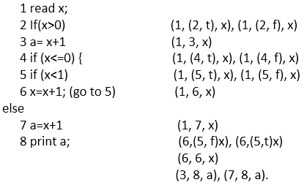
- (1, (2, t), x), (1, (2, f), x)- This association is made with statement 1 (read x;) and statement 2 (If(x>0)) where x is defined at line number 1, and it is used at line number 2 so, x is the variable.
Statement 2 is logical, and it can be true or false that's why the association is defined in two ways; one is (1, (2, t), x) for true and another is (1, (2, f), x) for false.
- (1, 3, x)- This association is made with statement 1 (read x;) and statement 3 (a= x+1) where x is defined in statement 1 and used in statement 3. It is a computation use.
- (1, (4, t), x), (1, (4, f), x)- This association is made with statement 1 (read x;) and statement 4 (If(x<=0)) where x is defined at line number 1 and it is used at line number 4 so x is the variable. Statement 4 is logical, and it can be true or false that's why the association is defined in two ways one is (1, (4, t), x) for true and another is (1, (4, f), x) for false.
- (1, (5, t), x), (1, (5, f), x)- This association is made with statement 1 (read x;) and statement 5 (if (x<1)) where x is defined at line number 1, and it is used at line number 5, so x is the variable.
Statement 5 is logical, and it can be true or false that's why the association is defined in two ways; one is (1, (5, t), x) for true and another is (1, (5, f), x) for false.
- (1, 6, x)- This association is made with statement 1 (read x;) and statement 6 (x=x+1). x is defined in statement 1 and used in statement 6. It is a computation use.
- (1, 7, x)- This association is made with statement 1 (read x) and statement 7 (a=x+1). x is defined in statement 1 and used in statement 7 when statement 5 is false. It is a computation use.
- (6, (5, f) x), (6, (5, t) x)- This association is made with statement 6 (x=x+1;) and statement 5 if (x<1) because x is defined in statement 6 and used in statement 5. Statement 5 is logical, and it can be true or false that's why the association is defined in two ways one is (6, (5, f) x) for true and another is (6, (5, t) x) for false. It is a predicted use.
- (6, 6, x)- This association is made with statement 6 which is using the value of variable x and then defining the new value of x.
x=x+1
x= (-1+1)
Statement 6 is using the value of variable x that is ?1 and then defining new value of x [x= (-1+1) = 0] that is 0.
- (3, 8, a)- This association is made with statement 3(a= x+1) and statement 8 where variable a is defined in statement 3 and used in statement 8.
- (7, 8, a)- This association is made with statement 7(a=x+1) and statement 8 where variable a is defined in statement 7 and used in statement 8.

Definition, c-use, p-use, c-use some p-use coverage, p-use some c-use coverage in data flow testing <link>
The next task is to group all the associations in Definition, c-use, p-use, c-use some p-use coverage, p-use some c-use coverage categories.
See the code below:
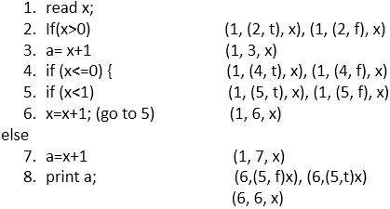
So, these are the all association which contain definition, Predicate use (p-use), Computation use (c-use)
(1, (2, f), x), (1, (2, t), x), (1, 3, x), (1, (4, t), x), (1, (4, f), x), (1, (5, t), x), (1, (5, f), x), (1, 6, x), (1, 7, x), (6,(5, f)x), (6,(5,t)x), (6, 6, x), (3, 8, a), (7, 8, a), (3, 8, a), (7, 8, a)

Definition
Definition of a variable is the occurrence of a variable when the value is bound to the variable. In the above code, the value gets bound in the first statement and then start to flow.
- If(x>0) is statement 2 in which value of x is bound with it.
Association of statement 2 is (1, (2, f), x), (1, (2, t.)
- a= x+1 is statement 3 bounded with the value of x
Association of statement 3 is (1, 3, x)
All definitions coverage
(1, (2, f), x), (6, (5, f) x), (3, 8, a), (7, 8, a).

Predicate use (p-use)
If the value of a variable is used to decide an execution path is considered as predicate use (p-use). In control flow statements there are two
Statement 4 if (x<=0) is predicate use because it can be predicate as true or false. If it is true then if (x<1),6x=x+1; execution path will be executed otherwise, else path will be executed.

Computation use (c-use)
If the value of a variable is used to compute a value for output or for defining another variable.
Statement 3 a= x+1 (1, 3, x)
Statement 7 a=x+1 (1, 7, x)
Statement 8 print a (3, 8, a), (7, 8, a).
These are Computation use because the value of x is used to compute and value of a is used for output.
All c-use coverage
(1, 3, x), (1, 6, x), (1, 7, x), (6, 6, x), (6, 7, x), (3, 8, a), (7, 8, a).
All c-use some p-use coverage
(1, 3, x), (1, 6, x), (1, 7, x), (6, 6, x), (6, 7, x), (3, 8, a), (7, 8, a).
All p-use some c-use coverage
(1, (2, f), x), (1, (2, t), x), (1, (4, t), x), (1, (4, f), x), (1, (5, t), x), (1, (5, f), x), (6, (5, f), x), (6, (5, t), x), (3, 8, a), (7, 8, a).
After collecting these groups, (By examining each point whether the variable is used at least once or not) tester can see all statements and variables are used. The statements and variables which are not used but exist in the code, get eliminated from the code.

Control Flow Testing
Control flow testing is a testing technique that comes under white box testing. The aim of this technique is to determine the execution order of statements or instructions of the program through a control structure. The control structure of a program is used to develop a test case for the program. In this technique, a particular part of a large program is selected by the tester to set the testing path. It is mostly used in unit testing. Test cases represented by the control graph of the program.
Control Flow Graph is formed from the node, edge, decision node, junction node to specify all possible execution path.

Notations used for Control Flow Graph
- Node
- Edge
- Decision Node
- Junction node

Node
Nodes in the control flow graph are used to create a path of procedures. Basically, it represents the sequence of procedures which procedure is next to come so, the tester can determine the sequence of occurrence of procedures.
We can see below in example the first node represent the start procedure and the next procedure is to assign the value of n after assigning the value there is decision node to decide next node of procedure as per the value of n if it is 18 or more than 18 so Eligible procedure will execute otherwise if it is less than 18 Not Eligible procedure executes. The next node is the junction node, and the last node is stop node to stop the procedure.

Edge
Edge in control flow graph is used to link the direction of nodes.
We can see below in example all arrows are used to link the nodes in an appropriate direction.

Decision node
Decision node in the control flow graph is used to decide next node of procedure as per the value.
We can see below in example decision node decide next node of procedure as per the value of n if it is 18 or more than 18 so Eligible procedure will execute otherwise if it is less than 18, Not Eligible procedure executes.

Junction node
Junction node in control flow graph is the point where at least three links meet.

Example
- public class VoteEligiblityAge{

- public static void main(String []args){
- int n=45;
- if(n>=18)
- {
- System.out.println("You are eligible for voting");
- } else
- {
- System.out.println("You are not eligible for voting");
- }
- }
- }
Diagram - control flow graph
The above example shows eligibility criteria of age for voting where if age is 18 or more than 18 so print message "You are eligible for voting" if it is less than 18 then print "You are not eligible for voting."
Program for this scenario is written above, and the control flow graph is designed for the testing purpose.
In the control flow graph, start, age, eligible, not eligible and stop are the nodes, n>=18 is a decision node to decide which part (if or else) will execute as per the given value. Connectivity of the eligible node and not eligible node is there on the stop node.
Test cases are designed through the flow graph of the programs to determine the execution path is correct or not. All nodes, junction, edges, and decision are the essential parts to design test cases.

Branch Coverage Testing
Branch coverage technique is used to cover all branches of the control flow graph. It covers all the possible outcomes (true and false) of each condition of decision point at least once. Branch coverage technique is a whitebox testing technique that ensures that every branch of each decision point must be executed.
However, branch coverage technique and decision coverage technique are very similar, but there is a key difference between the two. Decision coverage technique covers all branches of each decision point whereas branch testing covers all branches of every decision point of the code.
In other words, branch coverage follows decision point and branch coverage edges. Many different metrics can be used to find branch coverage and decision coverage, but some of the most basic metrics are: finding the percentage of program and paths of execution during the execution of the program.
Like decision coverage, it also uses a control flow graph to calculate the number of branches.

How to calculate Branch coverage?
There are several methods to calculate Branch coverage, but pathfinding is the most common method.
In this method, the number of paths of executed branches is used to calculate Branch coverage. Branch coverage technique can be used as the alternative of decision coverage. Somewhere, it is not defined as an individual technique, but it is distinct from decision coverage and essential to test all branches of the control flow graph.
Let's understand it with an example:
- Read X
- Read Y
- IF X+Y > 100 THEN
- Print "Large"
- ENDIF
- If X + Y<100 THEN
- Print "Small"
- ENDIF
This is the basic code structure where we took two variables X and Y and two conditions. If the first condition is true, then print "Large" and if it is false, then go to the next condition. If the second condition is true, then print "Small."

Control flow graph of code structure
In the above diagram, control flow graph of code is depicted. In the first case traversing through "Yes "decision, the path is A1-B2-C4-D6-E8, and the number of covered edges is 1, 2, 4, 5, 6 and 8 but edges 3 and 7 are not covered in this path. To cover these edges, we have to traverse through "No" decision. In the case of "No" decision the path is A1-B3-5-D7, and the number of covered edges is 3 and 7. So by traveling through these two paths, all branches have covered.
Path 1 - A1-B2-C4-D6-E8
Path 2 - A1-B3-5-D7
Branch Coverage (BC) = Number of paths
=2
Case | Covered Branches | Path | Branch coverage
Yes | 1, 2, 4, 5, 6, 8 | A1-B2-C4-D6-E8 | 2
No | 3,7 | A1-B3-5-D7 | 2

Statement Coverage Testing
Statement coverage is one of the widely used software testing. It comes under white box testing.
Statement coverage technique is used to design white box test cases. This technique involves execution of all statements of the source code at least once. It is used to calculate the total number of executed statements in the source code out of total statements present in the source code.
Statement coverage derives scenario of test cases under the white box testing process which is based upon the structure of the code.
In white box testing, concentration of the tester is on the working of internal source code and flow chart or flow graph of the code.
Generally, in the internal source code, there is a wide variety of elements like operators, methods, arrays, looping, control statements, exception handlers, etc. Based on the input given to the program, some code statements are executed and some may not be executed. The goal of statement coverage technique is to cover all the possible executing statements and path lines in the code.
Let's understand the process of calculating statement coverage by an example:
Here, we are taking source code to create two different scenarios according to input values to check the percentage of statement coverage for each scenario.

Source Code Structure:
- Take input of two values like a=0 and b=1.
- Find the sum of these two values.
- If the sum is greater than 0, then print "This is the positive result."
- If the sum is less than 0, then print "This is the negative result."
- input (int a, int b)
- {
- Function to print sum of these integer values (sum = a+b)
- If (sum>0)
- {
- Print (This is positive result)
- } else
- {
- Print (This is negative result)
- }
- }
So, this is the basic structure of the program, and that is the task it is going to do.
Now, let's see the two different scenarios and calculation of the percentage of Statement Coverage for given source code.
Scenario 1:
If a = 5, b = 4
- print (int a, int b) {
- int sum = a+b;
- if (sum>0)
- print ("This is a positive result")
- else
- print ("This is negative result")
- }
In scenario 1, we can see the value of sum will be 9 that is greater than 0 and as per the condition result will be "This is a positive result." The statements highlighted in yellow color are executed statements of this scenario.
To calculate statement coverage of the first scenario, take the total number of statements that is 7 and the number of used statements that is 5.
- Total number of statements = 7
- Number of executed statements = 5
- Statement coverage = 5/7*100
- = 500/7
- = 71%
Likewise, in scenario 2,
Scenario 2:
If A = -2, B = -7
- print (int a, int b) {
- int sum = a+b;
- if (sum>0)
- print ("This is a positive result")
- else
- print ("This is negative result")
- }
In scenario 2, we can see the value of sum will be -9 that is less than 0 and as per the condition, result will be "This is a negative result." The statements highlighted in yellow color are executed statements of this scenario.
To calculate statement coverage of the first scenario, take the total number of statements that is 7 and the number of used statements that is 6.
Total number of statements = 7
Number of executed statements = 6
- Statement coverage = 6/7*100 <br>
- = 600/7
- = 85%
But, we can see all the statements are covered in both scenario and we can consider that the overall statement coverage is 100%.
So, the statement coverage technique covers dead code, unused code, and branches.

