Software Myths
Software myths are the beliefs that people consider are true but are not, regarding software and its development process. The software myths have been carried over several years and are now identified by software engineering professionals.
The managers and software practitioners are habitual to these myths. However, the old habits are difficult to modify.

Different Types of Software Myths
- Management Myths
- Customer Myths
- Practitioner’s Myth

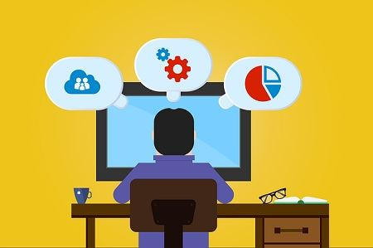

Management Software Myths
The manager who is responsible for developing software is often under pressure regarding many attributes of the software such as:
- The budget of the software.
- Delivering the software within the time limit.
- Enhance the quality of the software.
- Providing customer care services, etc.
Under such pressure, even the software manager develops belief in a software myth that lessens. These software myths grasped by the software manager lessen his pressure up to a certain level but this is temporary.
Let us discuss some myths perceived by the software manager:
Myth 1
The software building team has a book that explains all standards and procedures that are required for developing software.
The manager has a myth that the book provides everything to the team required for the software development.
Reality 1
Though there exists a book that has all the standards and procedures required to develop software. But are the developers aware of its existence? Do they ever refer to such books? Is the book complete?
Can it be referred to? Does the book help the developers to stick to the time-to-deliver even maintain the quality of the software?
Most of the time answer to such questions is no.
Myth 2
If more programmers are added to the software development team we can stick to the schedule.
Reality 2
Developing is software is totally different from manufacturing a product. It is not a mechanistic process. In fact, adding up more people in the team would rather delay the delivery of the software.
This is because when new members are introduced to the team, the members already working on the software will have to explain the work done till now. This will even reduce the time from the time that has to spend on the development of the software.
Although more members can be added to the team in a planned and co-ordinate manner.
Myth 3
Outsourcing the software project to a third party will let the manager relax. The third-party will be solely responsible for the development of the software.
Reality 3
If the company has outsourced the software project to a third party, it means the company is not aware of the details of the software project. It doesn’t know how to manage and control the software project.

Customer Myths
The customer is one who requests software either from a software engineer, a technical group, or the marketing sales department. The customer always requests the software under a contract.
The customer has some myths regarding the development of software. Hence customer develops false expectations which lead to dissatisfaction with the developer. Let us discuss some myths developed by the customer.
Myth 1
Customers believe that giving a general statement would let the software developer start writing the program. The rest of the details can be filled in later.
Reality 1
Although it is not possible for a customer to provide a comprehensive and stable statement. And an ambiguous statement will lead to disaster. The unambiguous statement comes with an iterative communication between the customer and the developer.
Myth 2
Customers can ask for the changes in software as many times as desired as software is flexible.
Reality
Well, the customer can ask for the changes in the software. But the impact of the changes varies from the time it has been introduced. If the customer asks for the changes early during the development of the software the cost impact is less.
However, over time impact of changes grows gradually may it be in terms of cost or duration, or the quality of the software.

Practitioner’s Software Myth
Software practitioners are the ones who are involved in the development and maintenance of the software. Earlier developing software is considered as an art. So, the software practitioners have developed some myths regarding the software.
Myth 1
Once you write the code and develop the software your job is done.
Reality
Practically 60% – 80% of the efforts are expended on the software when the software is delivered to the customer for the first time.
When the software is delivered to the customer for the first time. When a customer starts using the software they figure out the improvements that can be made to enhance the quality of the software.
Myth 3
A successful project is one where the delivered software is working
Reality
Although the working software is the essential part of software configuration there are many other elements that count in a success of a software project. Such as models of the software, its documents, and plans.
These are the elements that are essential in the foundation of a successful engineering product.
Myth 4
Practicing software engineering while developing software will tend you to create voluminous documentation and this will eventually slow down the process of software development.
Reality
Practicing software engineering will never tend you to create huge documentation instead it focuses on the quality of the developed software. A better-quality software reduces the number of iterations and thus faster the delivery time.
In the section above, we have discussed the software myths from the customers’, developers’, and the manager’s point of view. Thus, recognizing the realities of the software will let you formulate some practical solutions.

What legacy software explains the software myth?
Any piece of software that cannot continue to get updates or maintenance from its creator or that does not adhere to current compliance standards is considered legacy software. Enterprise-level legacy software can take many distinct forms. A business that has been operating for more than a year is very likely to be using at least some legacy-tier tools.

What are some issues with software?
Software myths are preconceived notions about software and its creation that people hold to be true but are in fact untrue. Professionals in software engineering have now identified the software myths that have persisted throughout the years. These fallacies are common knowledge to managers and software developers.

What are the characteristics of software?
Any piece of software that cannot continue to get updates or maintenance from its creator or that does not adhere to current compliance standards is considered legacy software. Enterprise-level legacy software can take many distinct forms. The characteristics of software are: Functionality, Reliability, Efficiency, Usability, Maintainability, and Portability.

What are the most common problems that the software engineers face?
Any organization's ultimate goal is to create a high-quality product, but the software development process is changing as automation spreads widely and new tools and libraries are being created every day. To lessen the effect they have on your final product, these software development difficulties must be addressed nearly immediately.

Q1.What are umbrella activities in software engineering?
Ans. Umbrella activities in software development ensure progress, quality, and risk management through generic development phases.

Q2.What are software engineering paradigms?
Ans. Software engineering: Developing software using systematic methodologies and past experience for reliable, scalable products.

Q3. What are different types of generic software?
Ans. Some commonly used generic software are Firefox, Excel, Word, PowerPoint, Notes, Outlook, etc. A Generic Software is not limited to a particular application and can perform numerous different tasks, such as a spreadsheet application. A spreadsheet application is a generic software.
Software Myths:
Most, experienced experts have seen myths or superstitions (false beliefs or interpretations) or misleading attitudes (naked users) which creates major problems for management and technical people. The types of software-related myths are listed below.
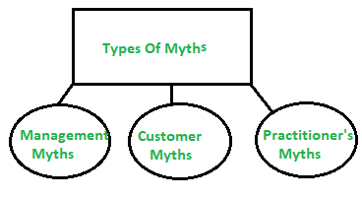
`Types of Software Myths
(i) Management Myths:
Myth 1:
We have all the standards and procedures available for software development.
Fact:
- Software experts do not know all the requirements for the software development.
- And all existing processes are incomplete as new software development is based on new and different problem.
Myth 2:
The addition of the latest hardware programs will improve the software development.
Fact:
- The role of the latest hardware is not very high on standard software development; instead (CASE) Engineering tools help the computer, they are more important than hardware to produce quality and productivity.
- Hence, the hardware resources are misused.
Myth 3:
- With the addition of more people and program planners to Software development can help meet project deadlines (If lagging behind).
Fact:
- If software is late, adding more people will merely make the problem worse. This is because the people already working on the project now need to spend time educating the newcomers, and are thus taken away from their work. The newcomers are also far less productive than the existing software engineers, and so the work put into training them to work on the software does not immediately meet with an appropriate reduction in work.
(ii)Customer Myths:
The customer can be the direct users of the software, the technical team, marketing / sales department, or other company. Customer has myths leading to false expectations (customer) & that’s why you create dissatisfaction with the developer.
Myth 1:
A general statement of intent is enough to start writing plans (software development) and details of objectives can be done over time.
Fact:
- Official and detailed description of the database function, ethical performance, communication, structural issues and the verification process are important.
- Unambiguous requirements (usually derived iteratively) are developed only through effective and continuous
communication between customer and developer.
Myth 2:
Software requirements continually change, but change can be easily accommodated because software is flexible
Fact:
- It is true that software requirements change, but the impact of change varies with the time at which it is introduced. When requirements changes are requested early (before design or code has been started), the cost impact is relatively small. However, as time passes, the cost impact grows rapidly—resources have been committed, a design framework has been established, and change can cause upheaval that requires additional resources and major design modification.
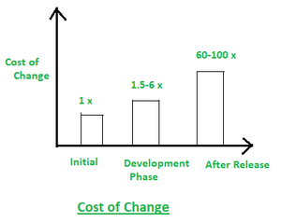
Different Stages of Myths
(iii)Practitioner’s Myths:
Myths 1:
They believe that their work has been completed with the writing of the plan.
Fact:
- It is true that every 60-80% effort goes into the maintenance phase (as of the latter software release). Efforts are required, where the product is available first delivered to customers.
Myths 2:
There is no other way to achieve system quality, until it is “running”.
Fact:
- Systematic review of project technology is the quality of effective software verification method. These updates are quality filters and more accessible than test.
Myth 3:
An operating system is the only product that can be successfully exported project.
Fact:
- A working system is not enough, the right document brochures and booklets are also required to provide guidance & software support.
Myth 4:
Engineering software will enable us to build powerful and unnecessary document & always delay us.
Fact:
- Software engineering is not about creating documents. It is about creating a quality product. Better quality leads to reduced rework. And reduced rework results in faster delivery times

Here are the most commonly held software myths that persist about IT:
- An extra developer will speed things up.
- Developers aren’t creative.
- Open source software is less secure.
- Agile doesn’t require documentation.
- Programmers need to be experts at math.
- Programming is boring.
- All programming languages are the same.
- Open source software is built by individuals.
- Writing tests is a waste of time.
- ChatGPT will make programmers obsolete.

An extra developer will speed things up
A common management myth in software is that adding bodies to a project linearly increases productivity. It doesn’t work that way.
When a new developer joins a team, there is always an initial decrease in per-person productivity. Onboarding takes time, and acclimating a new developer to a project takes time away from the development team’s development-focused activities.
Furthermore, in the world of software development, smaller teams are proven to be more product, adaptable and agile than larger ones. That’s why the Scrum framework limits teams to 10 members, which includes the Scrum Master and the product owner.
Diminishing returns from adding bodies to a development team is a manifestation of Brooks’ Law, which states: Adding manpower to a late software project makes it later.

Developers aren’t creative
It always frustrates me when I hear kids say they wouldn’t like computer programming because they like to be creative.
Actually, software development takes a great deal of creativity.
Anybody can learn how an API works. However, the ability to use an API and apply it to an unsolved problem takes a great deal of creativity.
The people who standout on a software development team are the ones who twist and turn methods and functions in unpredictable ways, and conjure up incredibly creative solutions to difficult and complex problems
There’s certainly a creative difference between developing a microservice and choreographing a tap dance. Nevertheless, it’s a software myth to suggest that developers aren’t creative people.

Open source software is less secure
There is no qualitative evidence to suggest that open source software is any more or less secure than software developed by a vendor.
Many contend that because the source code behind open source software is publicly available, any hacker with nefarious intent could easily crack that code. In fact, the opposite is true.
With open source software, hundreds if not thousands of people scour through updates, enhancements and even stale source code that hasn’t been touched in years to regularly check and test the codebase.
All that work makes open source software more secure than proprietary software that is maintained by only a handful of programmers.
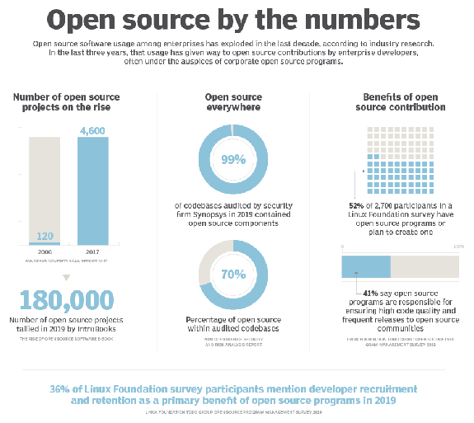
A popular open source software myth suggests vendor-backed software is more secure.

Programmers need to be experts at math
The assertion that programmers need to be great at math is a common software myth that sadly discourages people from getting into software development.
Software development probably isn’t a great career choice for someone who has trouble with addition and multiplication, but you don’t need to know how to differentiate the Heisenberg equation to build a microservice.
There is very little math involved in enterprise software development, and what little math there is doesn’t typically go beyond addition, multiplication and the modulus operator.
Not being great at math shouldn’t discourage anyone from getting into software development. The idea that you need to be an expert mathematician to program a computer is just another software myth.

Programming is boring
It’s amazing how a person becomes full of life when they are engaged and challenged on a software project.
Talk to any software developer who’s been in the industry for half a dozen years. They’ll regale you with stories of working late through the night to solve a problem, and then waking up early to go straight to the keyboard to test out an inspiration that woke them out of dream.
I personally have been on project where I was so engrossed in the project that I lost track of time and stayed so late in a secure facility that I was locked inside until the morning crew arrived.
People don’t behave like that if they’re bored.

Agile doesn’t require documentation
One of the core tenets of the Agile Manifesto is: Working software over comprehensive documentation.
Somehow this simple statement has morphed into the software myth that insists Agile software development teams don’t need to produce documentation at all.
Agile certainly takes the approach to documentation that less is more, but it still requires documentation.
Every software project needs documentation that pertains to how a particular product was built, and the rationale behind key design decisions. Furthermore, users need documentation that explains how to use a product, and help desk personnel need documentation that explains how to support a given product.
The idea that Agile or Scrum projects don’t need any documentation is a software myth that isn’t helpful to anyone.

All programming languages are the same
At the core, all programming languages perform three functions:
- Manage data in the form of variables.
- Perform conditional logic through if..else statements.
- Do things really fast and iteratively in loops.
Beyond these fundamentals, though, things change drastically:
- Some languages are object oriented while others are functional.
- Some languages are interpreted while others are compiled.
- Some languages are close to the metal while others are virtualized.
- Some languages are strongly typed while others don’t use types at all.
Social media is always rife with debates over which language is best and why. If all programming languages were the same, those flame wars would die out quickly — but they don’t. They rage on because it’s a software myth to assert that all programming languages are the same.

Open source software is built by individual contributors
Many people have a mental image that open source software is built entirely by young, motivated developer savants who work late into the night after they put in a full day at work. Despite my secure-facility adventure above, the reality is typically quite different.
The biggest contributors to open source software are often proprietary vendors.
For example, according to Jonathan Corbet of lwn.net, Huawei had 117 developers working on the 6.1 Linux kernel, and 37% of the lines of code changed were contributed by Oracle, AMD, Google, Intel and IBM.

Writing tests up-front is a waste of time
Test-driven design asserts that tests should be written up front, before the code is actually written.
A common software myth is that this approach is a waste of time. It’s not a waste of time.
Before you write code, you must first think about how it works. You must also think about how external applications will invoke and use that code.
Test-driven design asks you to write those thoughts into code that tests your logic. It’s simply a way to codify what you’re already thinking.
Furthermore, you need to write tests eventually. It actually saves time to write the tests while you think about how the code works, rather than crank out unit tests after the code is supposedly complete.
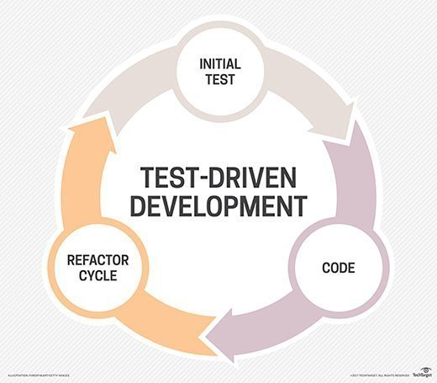
It’s a test-driven software myth to suggest writing tests up front is a waste of time.

ChatGPT will make software developers obsolete
The promise of OpenAI and machine learning tools such as GitHub CoPilot is to write code that works according to the provided requirements. This has certainly woken up the software development community to the power of AI, but the software development career isn’t going anywhere yet.
As good as ChatGPT is, it still creates broken code that either doesn’t compile or doesn’t quite meet the requirements.
Programmers who know how to code and how to turn detailed requirements into deployable software will continue to be in demand into the near future.
It’s a software myth to think the world could ever survive without skilled developers and programmers to build the applications needed in the future. AI-driven tools won’t replace developers they’re going to need more of them, and also more from them.

- Myth: More Features = Better Software
  - Reality: The number of features doesn't always correlate with the software's quality or usefulness. What matters is how well the features meet the users' needs and how intuitive they are to use.
- Myth: The Best Software is Bug-Free
  - Reality: No software can be entirely bug-free. Bugs are an inherent part of software development, and the focus should be on minimizing and resolving them to improve the software's reliability.
- Myth: Open Source Software is Always Free
  - Reality: While many open source projects are freely available, the term "free" refers to freedom, not necessarily cost. Some open source software may have associated costs for support, customization, or maintenance.
- Myth: All Software Developers Are the Same
  - Reality: Software development requires a diverse skill set, and not all developers are interchangeable. Different developers have varying expertise, experiences, and specialties that make them uniquely suited for specific projects.
- Myth: Software Development is Quick and Easy
  - Reality: Developing high-quality software is a complex and time-consuming process. It involves planning, designing, coding, testing, and iterating. Rushing through these stages can result in subpar software.
- Myth: More Code Means Better Software
  - Reality: The quality of software is not determined by the quantity of code but by the efficiency, maintainability, and effectiveness of the code. Bloated or overly complex code can lead to more problems and difficulty in maintenance.
- Myth: You Need to Be a Genius to Code
  - Reality: While coding requires logical thinking and problem-solving skills, anyone can learn to code with dedication and practice. It's more about understanding the principles and languages and applying them effectively.
- Myth: Software Security is a One-Time Job
  - Reality: Ensuring software security is an ongoing process that requires constant monitoring, updates, and adaptation to new threats. It's not a one-time task but an ongoing commitment to protecting users and their data.
- Myth: Software Can Fully Replace Human Intelligence
  - Reality: While software and AI can automate tasks and processes, they cannot completely replace human creativity, critical thinking, and decision-making abilities. Technology should complement human intelligence, not supplant it.
- Myth: Software Can Solve Every Problem
  - Reality: Software is a tool, and like any tool, it has its limitations. Not every problem can be effectively solved with software, and some issues may require a combination of technological, social, and human approaches.
Object-Oriented Programming Languages:
- Java: A widely used, class-based, object-oriented language known for its platform independence.
- C++: An extension of the C programming language that supports object-oriented programming through classes and objects.
- C#: Developed by Microsoft, C# is an object-oriented language often used for building Windows applications and games.
- Python: While Python is a versatile language, it supports object-oriented programming with classes and objects.
- Ruby: A dynamic, object-oriented language known for its simplicity and productivity in web development.
- Swift: Developed by Apple, Swift is an object-oriented language commonly used for iOS and macOS application development.
- Objective-C: Another language used for iOS and macOS development, with a strong emphasis on object-oriented programming.
Functional Programming Languages:
- Haskell: A pure functional programming language known for its strong static typing and emphasis on immutability.
- Lisp: A family of programming languages known for their strong support for functional programming and powerful macro systems.
- Scheme: A dialect of Lisp and a minimalist, elegant, and expressive functional programming language.
- Clojure: A dialect of Lisp that runs on the Java Virtual Machine (JVM) and is designed for concurrency and functional programming.
- Erlang: A language known for its concurrency and fault tolerance capabilities, often used in distributed and fault-tolerant systems.
- F#: A functional-first programming language developed by Microsoft and heavily integrated with the .NET ecosystem.
- Scala: A hybrid functional and object-oriented language that runs on the JVM and blends functional and object-oriented programming paradigms.
- OCaml: A statically typed functional programming language with a strong emphasis on type safety and expressive type systems.
It's important to note that many modern programming languages, including those listed above, often support a mix of programming paradigms, combining elements of both object-oriented and functional programming.

Interpreted Languages:
- Python: Python source code is executed directly by an interpreter without the need for an explicit compilation step.
- JavaScript: JavaScript is primarily an interpreted language that runs in web browsers, executing the source code directly.
- Ruby: Ruby code is interpreted and executed by the Ruby interpreter without the need for compilation.
- PHP: PHP scripts are interpreted and executed by the PHP interpreter, commonly in a web server environment.
- Perl: Perl is an interpreted language where the source code is executed by the Perl interpreter.
- R: R is an interpreted language commonly used for statistical computing and graphics.
- Bash: Bash (Bourne-Again SHell) scripts are interpreted and executed by the Bash interpreter in a Unix-like environment.
Compiled Languages:
- C: C is a compiled language where the source code is translated into machine code by a compiler before execution.
- C++: C++ is a compiled language that requires compilation before running, generating machine code from the source code.
- Java: Java is a hybrid language; the source code is compiled into an intermediate bytecode by a Java compiler and then interpreted by the Java Virtual Machine (JVM) at runtime.
- C#: C# is compiled into an intermediate language (IL) by a compiler and then executed by the .NET runtime.
- Swift: Swift is a compiled language, and the source code is compiled into native machine code for execution.
- Go (Golang): Go is a compiled language where the source code is compiled into native machine code for the target platform.
- Rust: Rust is a compiled language that produces native machine code for efficient and secure execution.
In summary, interpreted languages execute the source code directly using an interpreter, while compiled languages require a compilation step to generate executable machine code before running. Some languages, like Java, use a combination of compilation and interpretation, compiling to an intermediate form (bytecode) that is then interpreted at runtime.

Close to the metal" typically refers to languages that allow for low-level programming and direct manipulation of hardware, while "virtualized languages" often run on top of a virtual machine or runtime environment, providing an additional layer of abstraction. Here's a list for both:
Languages Close to the Metal:
- Assembly Language:
  - Assembly languages provide a direct correspondence between the language and the architecture's machine code instructions.
- C:
  - C is often considered close to the metal due to its low-level memory manipulation capabilities and direct hardware access.
- C++:
  - C++ allows for low-level memory management and is an extension of the C language, providing both high-level and low-level features.
- Rust:
  - Rust is designed for system-level programming, offering memory safety and fine-grained control over system resources.
- Ada:
  - Ada is a statically typed, high-level language used for system and embedded programming.
- Assembler (ASM):
  - Assembler languages like NASM (Netwide Assembler) provide a direct correspondence between instructions and machine code.
Virtualized Languages:
- Java:
  - Java programs run on the Java Virtual Machine (JVM), allowing for platform-independent execution of bytecode.
- C# (C Sharp):
  - C# code is compiled into an intermediate language (IL) and runs on the .NET Common Language Runtime (CLR).
- Python:
  - Python is an interpreted language and often runs on the Python Virtual Machine (CPython).
- Ruby:
  - Ruby programs run on the Ruby interpreter, providing an additional layer of abstraction.
- PHP:
  - PHP scripts are interpreted and executed in a web server environment, abstracting the underlying system.
- JavaScript:
  - JavaScript code is executed in a web browser environment, providing a high-level language running on top of the browser's JavaScript engine.
- Haskell:
  - Haskell code is typically compiled to an intermediate language and executed on various Haskell runtimes.
These virtualized languages operate on top of a runtime or virtual machine, which abstracts the underlying hardware, allowing for improved portability and platform independence.
Strongly Typed Languages:
- Java:
  - Java is strongly typed, meaning variable types must be declared and adhered to during the program's execution.
- C#:
  - C# is strongly typed and enforces type safety, requiring explicit type declarations and adherence to types.
- C++:
  - C++ is a strongly typed language, with a strong emphasis on type safety and explicit type declarations.
- Swift:
  - Swift is strongly typed, ensuring strict adherence to types and type safety.
- Scala:
  - Scala is strongly typed and emphasizes static typing and type safety.
- Haskell:
  - Haskell is a strongly typed functional language known for its strong static typing and type inference capabilities.
Dynamically Typed Languages:
- Python:
  - Python is dynamically typed, meaning variable types are determined at runtime, and type declarations are not required.
- JavaScript:
  - JavaScript is dynamically typed, allowing for flexibility in variable typing without requiring explicit type declarations.
- Ruby:
  - Ruby is dynamically typed, allowing variables to change types during execution without explicit type declarations.
- PHP:
  - PHP is dynamically typed, allowing for loose typing and type coercion.
- Perl:
  - Perl is dynamically typed, allowing variables to be assigned without specifying their types explicitly.
- Lisp:
  - Lisp is dynamically typed, with a flexible typing system that allows for easy manipulation of types during runtime.
In dynamically typed languages, the type of a variable can change during the program's execution, and type checking is performed at runtime. In strongly typed languages, types are enforced and checked at compile time, ensuring a higher level of type safety.

GitHub Copilot is an AI-powered code completion tool developed by GitHub in collaboration with OpenAI. It assists developers by suggesting and generating code snippets based on the context and requirements of the code they are writing. It uses a combination of machine learning models and the vast amount of code available on GitHub to provide helpful and contextually relevant suggestions.
The tool is designed to increase developers' productivity by automating repetitive tasks and providing code suggestions in real-time. It can help with writing functions, classes, comments, and other parts of the code. GitHub Copilot supports various programming languages and frameworks, making it a versatile tool for a wide range of developers.
It's important to note that while GitHub Copilot can be a powerful aid, developers should review and understand the code generated by the tool to ensure it meets the project's requirements and adheres to best practices and coding standards.

- Interpreter: An interpreter is a program that reads the source code line by line and directly executes the instructions in the source code. It translates and runs the code in a step-by-step manner, often interpreting and executing the code in smaller chunks or units. Interpreters are typically used in scripting languages like Python, JavaScript, and Ruby. They are advantageous for ease of use and debugging, as they can quickly detect and report errors during the interpretation process.
- Compiler: A compiler is a program that translates the entire source code from a high-level programming language into machine code (binary code) in a single step. It analyzes the entire source code and generates an executable file or object code, which can be run directly by the computer without needing the original source code. Compiled languages include C, C++, Java (to some extent), and others. Compilers are known for their efficiency and speed of execution once the code is compiled, but they require a separate compilation step before running the program.
In summary, interpreters execute source code directly, line by line or in smaller units, while compilers translate the entire source code into machine code in one go, producing an executable file that can be run independently.

