A Minor Project Proposal Report on
“ Smart Student Management System ”
Submitted in Partial Fulfillment of the Requirements for the Degree of
Bachelors of Engineering in Information Technology
under Pokhara University
Submitted by:
Anamika Aryal, 231502
Dip Kiran Limbu, 231512
Sumit kumar Das, 231536
Suraj Kumar Jha, 2315537
Date:
4 Jun, 2026
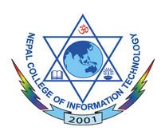
Department of IT Engineering
NEPAL COLLEGE OF
INFORMATION TECHNOLOGY

Balkumari Lalitpur, Nepal.

