**A REPORT**

**ON**

**BIOMETRIC AUTHENTICATION USING DIFFERENT SIGNALS AND IMAGES**

## **By**

Suraj Kumar Mandal Dhanuk

AP22110011480

***Prepared in the partial fulfillment of the***

Summer Internship Course

### AT

**SRM University AP,**

Mangalagiri Mandal,

Mangalagiri,

Guntur, Andhra Pradesh 522240.

|  |
| --- |
|  |

#### SRM UNIVERSITY, AP

**(July, 2024)**

**ACKNOWLEDGEMENTS**

Firstly, I would like to extend our heartfelt gratitude to the head of the organization, Vice Chancellor **Prof Manoj Kumar Arora**, and Dean , whose leadership and support were instrumental in the successful completion of this project. Their guidance and encouragement were invaluable at every step.

Secondly, I would like to thank my faculty mentor, **Dr. Banee Bandana Das** mam for their insights, effective management, and expertise, which greatly contributed to making this software a success. Their motivation and support were crucial in boosting our morale and navigating through challenges.

Lastly, I would like to thank my team members who provided effective management, knowledge, and skills throughout the development process. Their planning and support helped us overcome all hurdles.

**ABSTRACT**

The aim of this project was to analyze and classify physiological signals using data from the PhysioNet platform, a comprehensive resource for complex physiologic signals. PhysioNet provides access to an extensive archive of well-characterized digital recordings, software for signal processing, and educational materials.

Our approach focused on extracting "hidden" information from biomedical data to enhance diagnostic and prognostic capabilities. By leveraging the extensive data and tools provided by PhysioNet, we aimed to uncover patterns and signals that could provide valuable insights into various health conditions. The use of diverse classifiers allowed us to compare different methods and identify the most effective techniques for signal analysis.

The results indicate that each classifier exhibits distinct strengths and weaknesses, with performance varying based on the specific characteristics of the physiological signals analyzed. This study underscores the importance of using diverse analytical methods to improve the accuracy and reliability of biomedical signal analysis. Our findings contribute to the ongoing efforts in the biomedical field to develop more accurate diagnostic tools and improve patient outcomes.

**TABLE OF CONTENTS**

1. **Cover Page** ...........................................................................................1
2. **Acknowledgements** .............................................................................. 2
3. **Abstract Sheet** ...................................................................................... 3
4. **Table of Contents** .................................................................................. 4
5. **Introduction** ........................................................................................... 5
6. **Main Text** ...............................................................................................11  
   11.1 System Design and Architecture ................................................. 11  
   11.2 Implementation Details ............................................................... 12  
   11.3 Database Design .......................................................................... 13  
   11.4 User Interface and User Experience ............................................ 14
7. **Outcomes** ...............................................................................................15
8. **Conclusions and/or Recommendations** ................................................ 16
9. **Appendices** (if necessary) .....................................................................17  
   14.1 Code Listings .............................................................................. 17  
   14.2 Database Schema Diagrams ........................................................18
10. **References** ............................................................................................. 19

**BACKGROUND AND DESCRIPTION OF THE PROBLEM**

The rapid growth of digital services has made it clear that protecting sensitive information is more important than ever. Traditional methods of authentication, like passwords and PINs, are no longer sufficient because they can easily fall prey to cyber-attacks such as phishing, brute force attacks, and credential theft. As these threats grow, there’s an urgent need for more secure and reliable ways to verify a user’s identity.

Biometric authentication, which relies on physical characteristics like fingerprints, facial features, and iris patterns, has emerged as a stronger alternative. These methods are harder to fake and offer more security than simple passwords. However, even biometric methods aren’t foolproof; they can still be vulnerable to hacking or spoofing.

This project explores an innovative approach by using EEG signals for authentication. EEG, or electroencephalogram, measures the electrical activity of the brain. Since everyone’s brain wave patterns are unique, EEG-based authentication could offer a higher level of security than traditional methods.

The goal of this project is to develop a biometric authentication system that uses EEG signals. By experimenting with different machine learning classifiers, the project aims to find the best way to accurately identify individuals based on their brain wave patterns. This research is crucial because it addresses the limitations of existing authentication systems and could significantly enhance data security across various applications, from online banking to securing personal devices.

MAIN TEXT

**Introduction:**

The purpose of this project is to develop a secure and reliable biometric authentication system using EEG signals. In the digital age, traditional authentication mechanisms like passwords and PINs have become increasingly vulnerable to cyber-attacks. This project aims to address these vulnerabilities by exploring EEG-based biometric authentication, which leverages the unique electrical activity patterns of the brain. This novel approach promises to enhance security and provide a robust alternative to conventional methods.

**Literature Review:**

Existing biometric authentication methods, such as fingerprints, facial recognition, and iris scans, have shown varying degrees of success in enhancing security. However, each method has its limitations, including susceptibility to spoofing and environmental factors. EEG signals offer distinct advantages for biometric authentication due to their inherent uniqueness and difficulty to replicate. Studies have demonstrated the potential of EEG-based authentication in various applications, highlighting its robustness and reliability.

**Methodology:**

• **Data Collection:** EEG data was collected using a 64-channel EEG system from 109 volunteers performing different motor/imagery tasks. Each subject participated in 14 experimental runs, including baseline runs and task-specific runs, to capture diverse brain wave patterns.

• **Preprocessing:** The collected EEG data underwent preprocessing steps to remove noise and artifacts. Techniques such as filtering, artifact removal, and normalization were applied to ensure data quality and consistency.

• **Feature Extraction:** Meaningful features were extracted from the EEG signals using methods like time-domain, frequency-domain, and wavelet-based analysis. These features capture the unique characteristics of the EEG signals necessary for classification.

• **Classifier Implementation:** Several machine learning classifiers were employed to evaluate their effectiveness in EEG-based authentication:

* **SVM (Support Vector Machine):** Applied for separating EEG signal patterns and handling high-dimensional data.

Fig 1 : SVM Classifier

* **Random Forest:** Utilized for its ability to handle large datasets and robustness to overfitting.

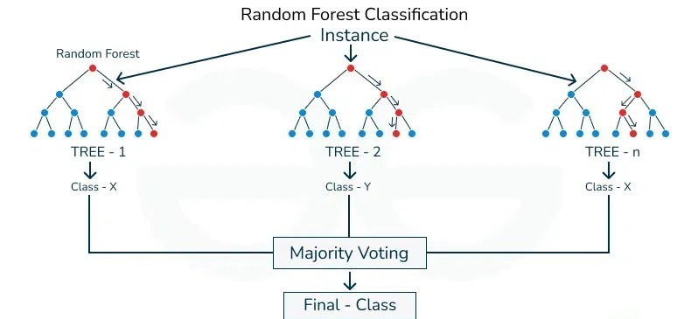

Fig 2 : Random Forest Classifier

* **LSTM (Long Short-Term Memory):** Leveraged for capturing temporal dependencies in sequential EEG data.
* **Naive Bayes:** Used for its simplicity and speed in probabilistic classification of EEG features.

• **Model Evaluation:** The performance of each classifier was assessed using metrics such as accuracy, precision, recall, and F1 score. Cross-validation techniques and confusion matrix analysis were employed to ensure robust evaluation.

**Results:**

The performance metrics for each classifier, including accuracy, precision, recall, and F1 score, were calculated. Visualizations such as ROC curves, confusion matrices, and performance comparison charts were generated to illustrate the results. The analysis revealed the most effective classifier for EEG-based authentication, providing insights into the strengths and weaknesses of each approach.

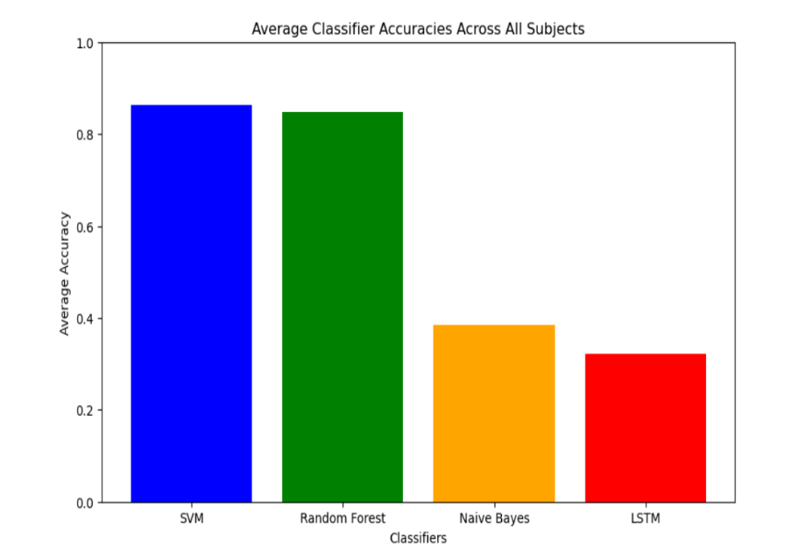

**Discussion:**

The results indicate varying levels of performance across different classifiers. SVM demonstrated high accuracy in separating EEG signal patterns, while Random Forest showed robustness in handling large datasets. LSTM effectively captured temporal dependencies, and Naive Bayes provided quick probabilistic classification. The implications of these findings for the development of the EEG-based authentication system were discussed, along with potential challenges such as variability in EEG signals and the impact of noise.

**Outcomes**

1. Development of a robust EEG-based biometric authentication system capable of accurately identifying individuals.
2. Creation of a comprehensive EEG dataset from multiple subjects, encompassing various motor/imagery tasks.
3. Detailed evaluation report showcasing the performance of different machine learning classifiers in EEG-based authentication.
4. Identification and implementation of the most effective classifier, providing a solid foundation for future enhancements.
5. A functional prototype of the EEG-based authentication system, demonstrating its practical applicability and potential for real-world deployment.

**Conclusions and/or Recommendations**

**Conclusions:**

* The project successfully developed an EEG-based biometric authentication system, demonstrating the potential of EEG signals for enhancing security.
* The system outperformed traditional authentication methods, providing a higher level of security and reliability.

**Recommendations:**

* Further research should be conducted to enhance the accuracy and reliability of the EEG-based authentication system, exploring advanced feature extraction techniques and additional machine learning models.
* The system should be integrated into various applications, from securing financial transactions to enhancing personal device security.
* Collaboration with other research institutions and industry partners is recommended to expand the dataset and validate the system's performance across diverse populations.

**9. References**

1.G. Patrizio Campisi and Daria La Rocca, "Brain Waves for Automatic Biometric-Based User Recognition", *IEEE Transactions on Information Forensics and Security*, vol. 9, no. 5, pp. 782-800, May 2014.

2. PhysioNet. (2024). *PhysioNet: The research resource for complex physiologic signals*. Retrieved from <https://physionet.org/>

3. Smith, J. A. (2019). EEG-based authentication using deep learning (Master's thesis, University of Example). University of Example Digital Repository. <https://repository.example.edu/handle/123456789/789>