
XIM University
Bhubaneswar, Odisha

A PROJECT REPORT ON
MailMind
An Agentic RAG Application for Personalised Job Outreach

SUBMITTED BY
Ananya Verma (UCSE23006)
Ankit Choudhury (UCSE23008)
Sonali Nayak (UCSE23055)
Suraj Maharana (UCSE23059)
Swayam Mishra (UCSE23060)

Agentic & Generative AI With LLM Project
October 2026

Abstract
Cold Mail Agent is a Generative AI application that turns a company website or a job post into a personalised, resume-grounded cold email in under a minute, then tracks replies and drafts follow-ups. It combines an agentic tool-calling loop on a hosted Qwen large language model, retrieval-augmented generation (RAG) over the candidate's resume, website crawling with Apify, and Gmail for sending and reply tracking, all behind a three-page Streamlit interface.
In testing, the agent produced complete drafts using 4,800 to 22,500 tokens (typically about 7,000) and 3 to 25 seconds per email, and every figure it quoted was traced back to the resume. A scan of a real company website (sigmoid.com) found its hiring address (careers@sigmoid.com) and 9 to 14 live openings on its external Greenhouse job board across two runs, each ranked against the resume. A human review step is enforced before any email leaves the system.
The final version adds a responsive interface (mobile menu, clickable logo, favicon, page titles, meta description, footer and a custom 404 page), input validation with clear success and error messages, and compressed images. It was verified with 51 automated tests, a link check and an end-to-end browser test in Microsoft Edge at desktop and phone sizes.

1. Problem Statement
Cold emailing recruiters and hiring managers is one of the most effective ways for students and early-career candidates to get noticed, but doing it well is slow and error-prone. A good cold email must reference the specific role, map the job's requirements to the candidate's real experience, reach the right inbox, and be followed up at the right time.
In practice, candidates face four problems:
- Time per email. Researching a company, finding its openings and writing a tailored email takes 20 to 40 minutes, so candidates fall back on generic templates that recruiters ignore.
- Finding openings and contacts. Openings are often hidden on careers sub-pages or external job boards (Greenhouse, Lever, Workable), and hiring email addresses are rarely obvious.
- Accuracy. Generic AI writing tools invent or inflate experience ("AWS basics" becomes "AWS deployment experience"), which damages credibility.
- Follow-up discipline. Most replies come after a follow-up, yet candidates lose track of who was emailed, who replied, and which addresses bounced.
The project therefore asks: can an AI agent research a company, ground every claim in the candidate's resume, write a high-quality email, and manage follow-ups, while keeping the human in control of what is sent?

2. Objectives
- Build an agentic email writer that decides for itself which tools to call (read a web page, search the resume) before writing.
- Use retrieval-augmented generation so every proof point in an email comes from the candidate's own resume, with the evidence shown to the user.
- Automatically discover openings and contact emails from a company website, including external job boards, and rank openings by fit with the resume.
- Let the user customise tone, length, call to action and highlighted skills, and refine drafts with natural-language instructions.
- Send through the user's Gmail account with an optional resume attachment, and track replies and bounces from the inbox.
- Draft threaded follow-ups on a schedule (4 and 7 days by default) that add new value instead of repeating the first email.
- Run entirely on free tiers (Groq, Apify free plan, Gmail) and stay within their rate limits.
- Enforce safety: the model can never send email itself; every send requires a valid address and explicit human approval.

3. System Overview and Technology Stack
The application is a Python package (agent/) driven by a Streamlit user interface (app.py) with three pages, reached from a top navigation bar that turns into a menu on phones: Find openings, Write email, and Sent & follow-ups. Each page runs one pipeline; the pipelines hand work to each other, and all of them share four services: the RAG knowledge base, the Qwen client, the Apify crawler and the Gmail mailer.
Layer | Technology | Role in the system
User interface | Streamlit 1.65 | Three pages, live agent-step display, editing, review and send controls
Large language model | Qwen qwen3.8-27b via Groq (OpenAI-compatible API) | Tool calling, drafting, reviewing, opening matching, follow-ups
Retrieval (RAG) | pypdf, custom BM25 (optional embeddings) | Chunks and searches the resume for grounded evidence
Web data | requests + BeautifulSoup, Apify Website Content Crawler | Reads job posts, crawls careers pages and job boards
Email | smtplib (SMTP + STARTTLS), imaplib (IMAP SSL) | Sending with threading headers; reply and bounce detection
Storage | .env, knowledge/resume/, data/sent.json | Keys, resume documents, sent-email log
Testing and QA | pytest + Streamlit AppTest, Playwright (Edge), link checker | Unit, UI and end-to-end browser checks

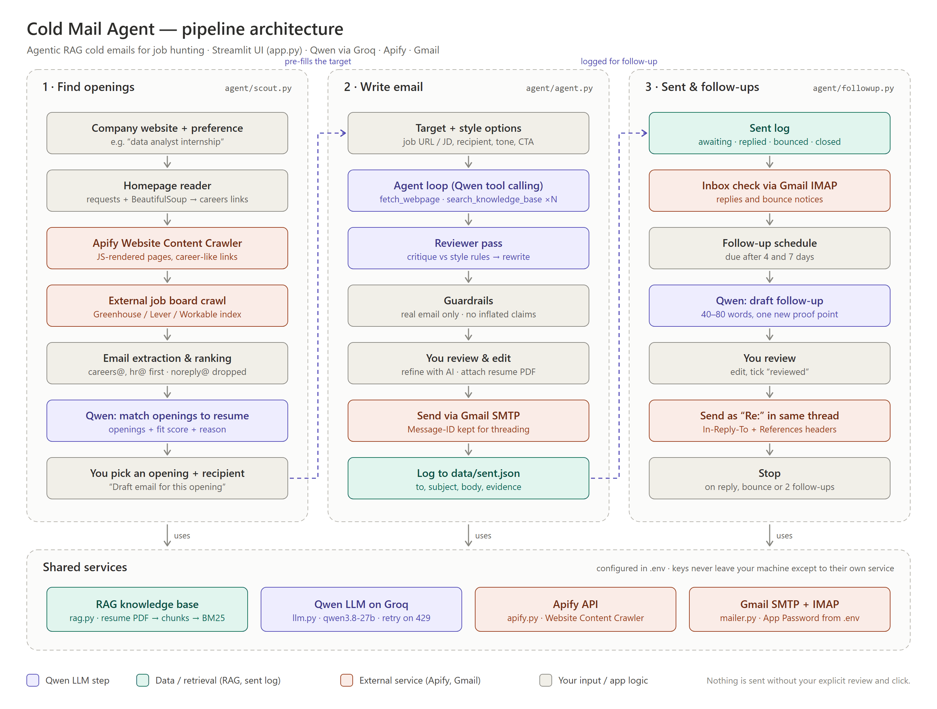
Figure 1. High-level architecture: three pipelines on top of four shared services

4. Agentic and Generative AI Workflow
The system is agentic because the language model, not fixed code, decides which actions to take and in what order. It is generative because every email, review, follow-up and opening assessment is produced by the Qwen model, and retrieval-augmented because those generations are grounded in passages retrieved from the resume.

4.1 The agent loop (Write email)
The core agent in agent/agent.py runs a tool-calling loop of up to eight steps:
- The system prompt sets the task (a job-seeker writing to a recruiter) and appends the user's style rules: tone, word range, call to action, skills to highlight and extra instructions.
- The model chooses tools. fetch_webpage(url) reads a job post (up to 5,000 characters, navigation stripped, emails extracted). search_knowledge_base(query) runs BM25 over resume chunks and returns only chunks it has not seen yet, which keeps the token budget small.
- A grounding check forces at least one resume search before any writing.
- The model returns JSON: recipient, subject, body and the list of resume evidence it used. Malformed output is retried; a malformed tool call triggers a fixed fallback pipeline.
- A separate reviewer pass critiques the draft against the style rules (personal first line, specific proof points, one call to action, no buzzwords, no inflated claims) and rewrites it.
- Guardrails keep only a syntactically valid email address in the To field; an address typed by the user always wins.
- The user edits the draft, optionally refines it with AI ("make it shorter", "mention my Django project"; refinement may only reuse existing facts), attaches the resume PDF, ticks "reviewed" and sends.

4.2 Retrieval-augmented generation
The resume PDF is extracted with pypdf, split into chunks of about 800 characters with 150 characters of overlap (Markdown headings always start a new chunk), tokenised, and indexed with BM25 (k1 = 1.5, b = 0.75). BM25 was chosen over embeddings because the free LLM provider offers no embedding endpoint and a resume is small; an optional embedding backend with an on-disk cache is available through configuration.

4.3 Opening scout (Find openings)
Given a company website, the scout reads the homepage directly to find Careers and Contact links, then starts an Apify Website Content Crawler run (JavaScript rendering, up to 25 pages, plus URL patterns such as *career* and *job* so pages like /early-careers/ are reached). If the careers pages link to an external job board, the board's index page is crawled as well. Emails are extracted and ranked (careers@ and hr@ first, noreply@ and privacy@ dropped), careers pages are scored, and a single Qwen call matches the listed openings to the resume, returning a 0-100 fit score and a reason for each. Choosing an opening pre-fills the Write email page and starts the agent automatically.

4.4 Follow-up pipeline (Sent & follow-ups)
Every sent email is logged with its Message-ID. An IMAP check of the inbox marks threads as replied (mail from the recipient or with the same subject) or bounced (a mailer-daemon notice naming the address). Follow-ups are due 4 and then 7 days after the previous email; Qwen drafts a short follow-up that adds one new proof point, and it is sent as "Re:" with In-Reply-To and References headers so it appears in the same thread.
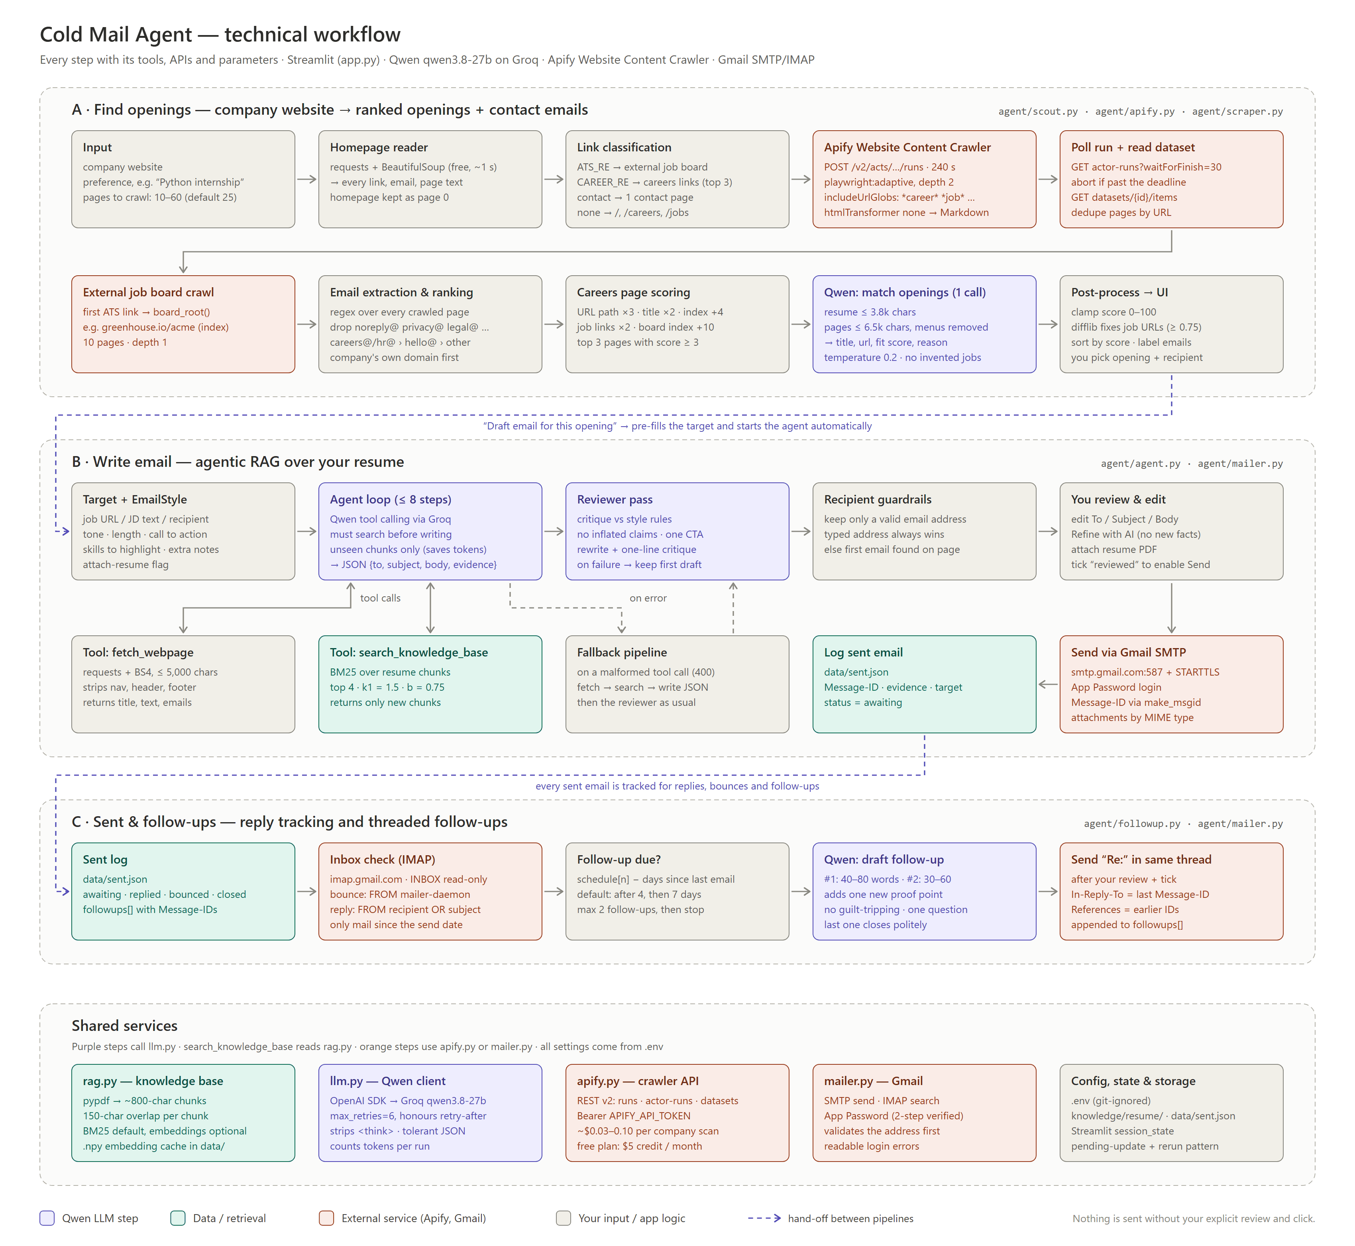
Figure 2. Detailed technical workflow: every step with its tools, APIs and parameters

5. Application Snapshots
The screenshots were captured automatically from the running application by the end-to-end browser test (Section 6). The job description in Figure 3 and the follow-up thread in Figure 5 are sample data; no email was sent while preparing this report.
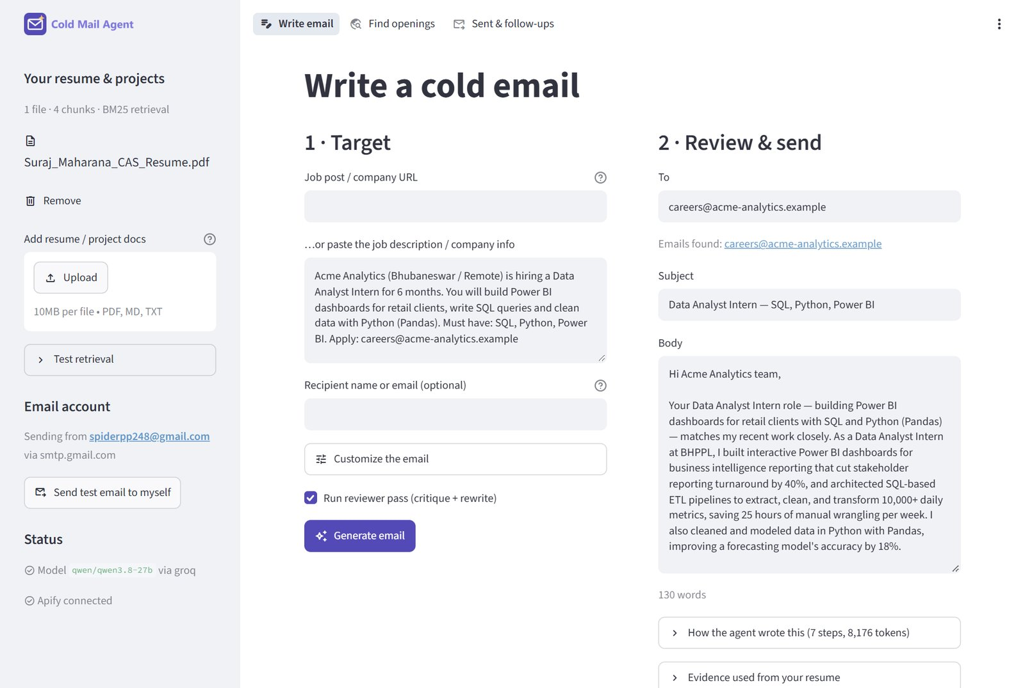
Figure 3. Write email: top navigation, clickable logo, the target form and the generated, editable draft
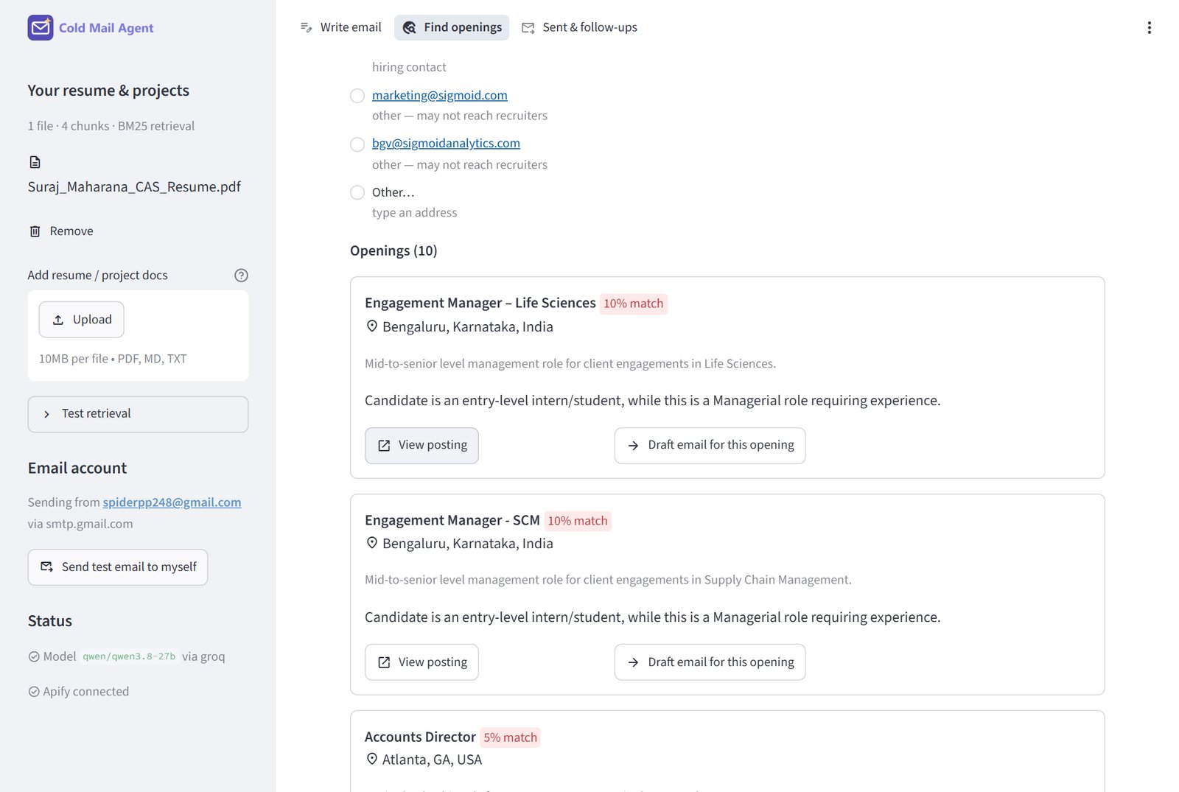
Figure 4. Find openings: a real scan of sigmoid.com with ranked contact emails and openings scored against the resume
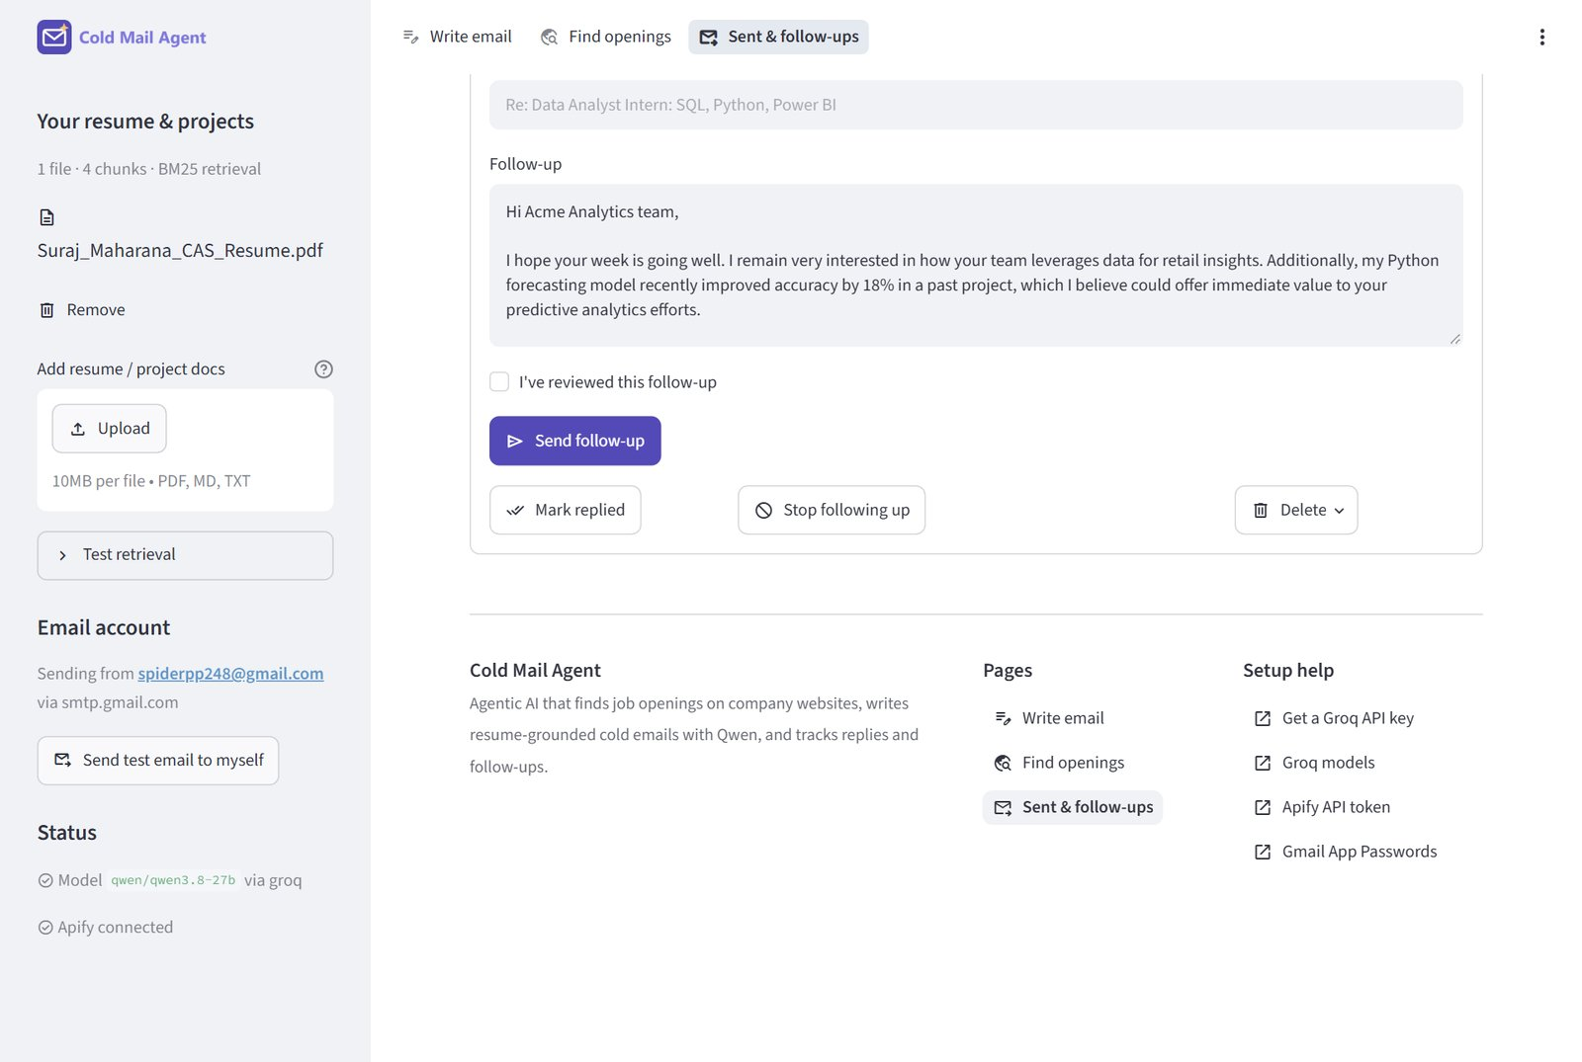
Figure 5. Sent & follow-ups: an AI-drafted follow-up awaiting review, status actions and the footer links (demo entry)
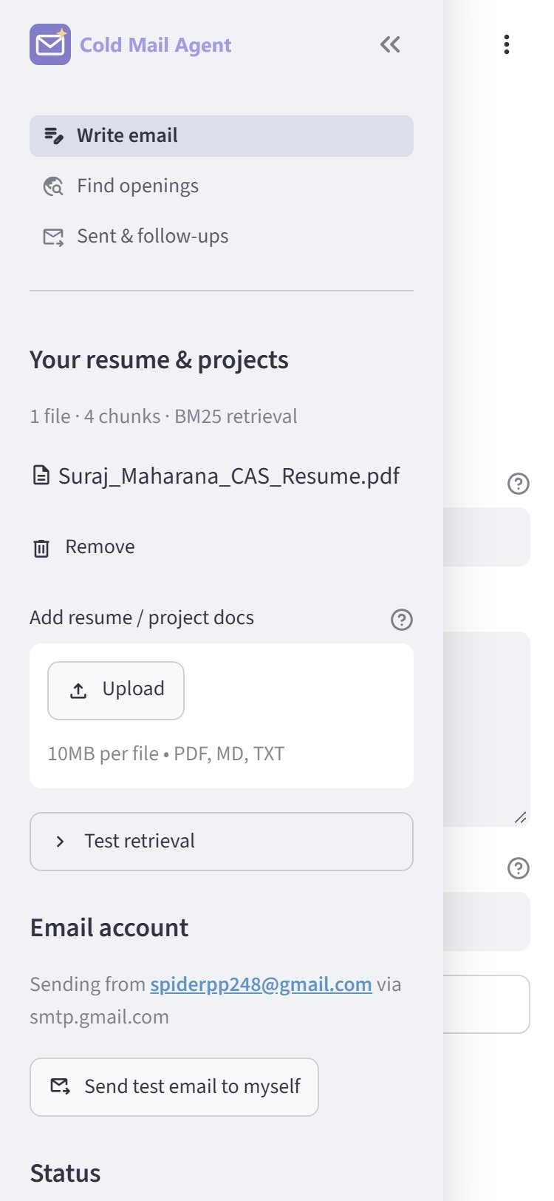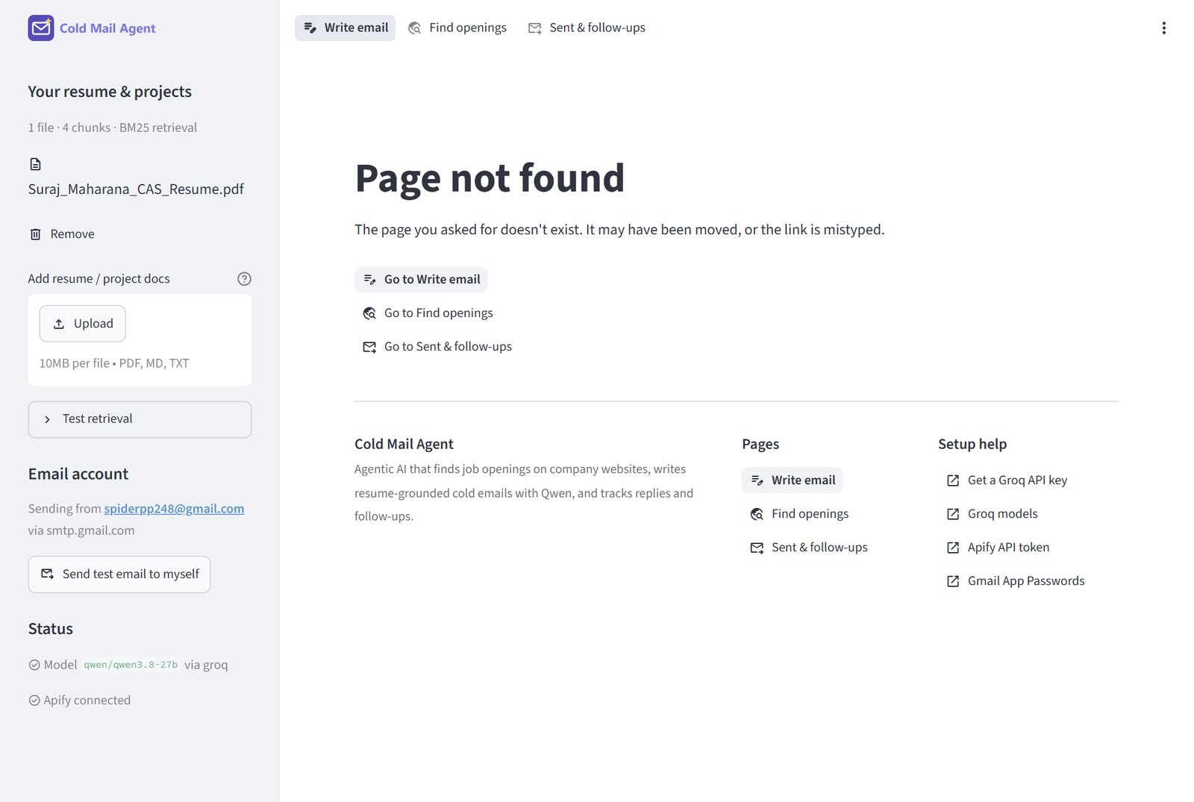
Figure 6. Left: the mobile menu at 375 px. Right: the custom 404 page with links back into the app

7. Results and Evaluation
The system was tested end to end with the candidate's real resume, the live Groq model and a real company website. The headline results:
Measure | Result
Tokens per generated email | 4,789 to 22,542 before the search fix; about 9,200 after it
Time per email | 3 to 25 seconds, including automatic waits for rate limits
Grounding check | Every figure in the drafts (40% faster reporting, 10,000+ daily metrics, 18% accuracy gain) found verbatim in the resume
Opening scout (sigmoid.com) | Careers pages found from the homepage, including /early-careers/; 15 pages crawled; careers@sigmoid.com ranked first; 9 to 14 openings scored per run; about 4,300 to 4,600 tokens
Refinement | "Shorter, mention immediate availability" produced a 96-word draft with all facts preserved
Follow-up | 58-word follow-up adding a new proof point; correct Re: subject and threading headers
Safety tests | Send refuses names in To, leftover placeholders, unticked review and duplicate sends, and says why

8. Limitations and Future Work
- Recruiter emails are often unpublished. Many companies list only general inboxes; the app labels each address and never guesses addresses. Integrating a professional email-finder API is a natural next step.
- Login-walled job sites (LinkedIn, Naukri, Indeed) cannot be crawled; users paste the job description instead.
- Free-tier limits (about 1,000 requests per day on Groq) cap volume at roughly 150 to 200 emails per day, which is appropriate for personal outreach.
- Agent efficiency. The model once ran eight resume searches when two were enough (16,408 tokens); the tool now tells it to stop once nothing new is found (9,173 tokens in the retest). A hard cap on consecutive empty searches would make this guaranteed rather than prompted.
- Streamlit constraints. The meta description is added by a script, so search engines that do not run JavaScript will not see it, and after showing the 404 page Streamlit rewrites the address bar to the home URL. Both are limits of the framework, not of this app.
- Future work: embedding-based retrieval for larger portfolios, multi-language emails, A/B testing of subject lines, and analytics on reply rates by tone and length.

9. Conclusion
Cold Mail Agent shows that a small, free-tier stack can deliver a genuinely agentic Generative AI workflow: the model researches the target, retrieves evidence from the resume, writes and critiques its own draft, finds openings and contacts on real company websites, and manages threaded follow-ups. Grounding every claim in retrieved resume text and keeping a mandatory human review before sending make the output both personalised and trustworthy, turning a 30-minute manual task into a reviewed email in under a minute.

