**A PROJECT REPORT**

**on**

**“NBA SPONSORS GROWTH INSIGHTS”**

**Submitted to**

**KIIT Deemed to be University**

**In Partial Fulfillment of the Requirement for the Award of**

**BACHELOR’S DEGREE IN**

**INFORMATION TECHNOLOGY**

**BY**

**Diksha Singh**

**Suraj Kumar Nayak**

**Vivek Shivam Saharia**

**Tarun Kumar**

2106207

2106270

2106275

2106279

**UNDER THE GUIDANCE OF**

**AJIT KUMAR PASAYAT**



**SCHOOL OF COMPUTER ENGINEERING**

**KALINGA INSTITUTE OF INDUSTRIAL TECHNOLOGY**

**BHUBANESWAR, ODISHA - 751024**

**April 2024**

A PROJECT REPORT

on

“NBA SPONSORS GROWTH INSIGHTS”

Submitted to

KIIT Deemed to be University

In Partial Fulfillment of the Requirement for the Award of

BACHELOR’S DEGREE IN INFORMATION TECHNOLOGY

BY

Diksha Singh 2106207

Suraj Kumar Nayak 2106270

VivekShivamSaharia 2106275

Tarun Kumar 2106279

UNDER THE GUIDANCE OF

AJIT KUMAR PASAYAT

SCHOOL OF COMPUTER ENGINEERING

KALINGA INSTITUTE OF INDUSTRIAL TECHNOLOGY

BHUBANESWAR, ODISHA -751024

April 2024

KIIT Deemed to be University

School of Computer Engineering

Bhubaneswar, ODISHA 751024



CERTIFICATE

This is certify that the project entitled

“NBA SPONSORS GROWTH INSIGHTS“

submitted by

Diksha Singh

Suraj Kumar Nayak

Vivek Shivam Saharia

Tarun Kumar

2106207

2106270

2106275

2106279

is a record of bonafide work carried out by them, in the partial fulfilment of the requirement for the award of Degree of Bachelor of Engineering (Computer Sci-ence & Engineering OR Information Technology) at KIIT Deemed to be university, Bhubaneswar. This work is done during the year 2023-2024, under our guidance.

Date: 09/04/2024

(Ajit Kumar Pasayat)

Project Guide

**Acknowledgements**

We are profoundly grateful to **AJIT KUMAR PASAYAT** of **Affiliation** for his expert guidance and continuous encouragement throughout to see that this project meets its target since its commencement to its completion.

Diksha Singh

Suraj Kumar Nayak

Vivek Shivam Saharia

Tarun Kumar

**ABSTRACT**

The exploration of growth patterns in NBA sponsorships through the lens of data analytics reveals a dynamic intersection between sports marketing and data science. This study utilizes a comprehensive dataset encompassing various dimensions of sponsorship deals from the past decade, including sponsor categories, financial details, duration, and the impact of digital media evolution. By applying advanced analytical techniques, such as time series analysis and machine learning models, the research uncovers trends, patterns, and predictors of sponsorship value growth. The findings highlight the increasing sophistication in how sponsors evaluate their investments in sports properties, driven by a deeper understanding of fan engagement and digital media's role in amplifying brand visibility.

Moreover, this research delves into the role of social media metrics, team performance, and market size as critical factors influencing sponsorship deal values. By correlating these factors with sponsorship growth, the study provides insights into how data analytics can optimize marketing strategies in the sports industry. The analysis not only benefits academic researchers and marketing professionals but also offers practical implications for sports organizations seeking to enhance their attractiveness to current and potential sponsors. In doing so, the study sets a foundation for future research on leveraging data analytics for strategic decision-making in sports marketing and sponsorships.

**Keywords:** NBA Sponsorships, Data Analytics, Sports Marketing, Machine Learning, Digital Media Impact



Contents

| 1 | Introduction | | 1 |
| --- | --- | --- | --- |
| 2 | Literature Review | | 3 |
|  | 2.1 Research Paper | | 3 |
|  | 2.2 Gap | | 4 |
|  | 2.3 Nobility | | 4 |
| 3 | Problem Statement / Requirement Specifications | | 5 |
|  | 3.1 Project Planning | | 5 |
|  | 3.2 Project Analysis | | 5 |
| 4 | Methodology | | 6 |
|  | 4.1 Discussion | | 7 |
|  | 4.2 Main Algorithm used | | 8 |
|  | 4.3 Advantages | | 9 |
| 5 | Result | | 12 |
|  | 5.1 Result Analysis | | 13 |
|  | 5.2 Screenshots | | 14 |
| 6 | Standard Adopted | | 19 |
|  | 6.1 Design Standards | | 19 |
|  | 6.2 Coding Standards | | 20 |
| 7 | Conclusion and Future Scope | | 21 |
|  | 7.1 Conclusion | | 21 |
|  | 7.2 Future Scope | | 22 |
| References | | | 23 |





Chapter 1

Introduction

The National Basketball Association (NBA) is a professional basketball league in North America composed of 30 teams (29 in the United States and 1 in Canada). It is one of the major professional sports leagues in the United States and Canada and is considered the premier professional basketball league in the world.The league was founded in New York City on June 6, 1946, as the Basketball Association of America (BAA).

The NBA has two main types of sponsors:

League-Level Sponsors: These companies have partnerships with the NBA itself, meaning their branding is visible across all 30 teams. Examples include Nike (apparel), PepsiCo (beverages), and Microsoft (technology).

Team-Level Sponsors: These companies partner with individual NBA teams for jersey sponsorships, arena advertising, and other promotional opportunities. Examples can vary depending on the team, but might include financial institutions, car manufacturers, or local businesses.

This project aims to leverage data analytics to understand the growth trends of sponsorships within the National Basketball Association (NBA). The main objective is to identify if the company had a financial growth or downfall after investing in NBA over a decade.

The main objective of the NBA Sponsor Growth Insights project using data analytics is to uncover trends and patterns in sponsorships associated with the NBA. It measures the year over year changes in number of sponsors, revenue generated and sponsors categories.

Out of 500+ data collected which included more than 150 companies, the percentage of companies which had growth in terms of revenue is around 73%. rest did not incur any profit approximately 27 companies either suffered loss or no growth in revenue.





*School of Computer Engineering, KIIT, BBSR* 1





This project leverages data analytics to investigate trends in National Basketball Association (NBA) sponsorships. Data collection encompasses various sources to construct a comprehensive dataset. Subsequently, Linear Discriminant Analysis (LDA) is employed to extract key features and identify patterns within the sponsorship data. By leveraging these insights, the project aims to predict the future growth trajectory of NBA sponsorships.

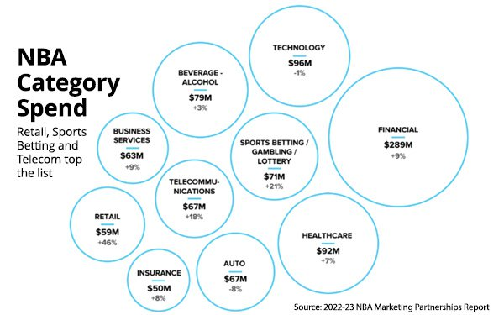



2 

Chapter 2

Basic Concepts/ Literature Review

Research Papers:

Paper 1:- <https://www.sciencedirect.com/science/article/pii/S014829632100312X>

Paper 2:- <https://www.researchgate.net/publication/376131943_Research_on_NBA_Business_Operation_and_Brand_Development_Strategy_A_Case_Study_Based_on_NBA_Characteristic_Event_Concept?_sg=UVoyTJuq00Q_3HLktNyxxFZ_73NunZvy8C9cChQ5fsB7IEntR7LJlNG0ctIuEa15FfSYn0dTAxuncw8&_tp=eyJjb250ZXh0Ijp7ImZpcnN0UGFnZSI6Il9kaXJlY3QiLCJwYWdlIjoiX2RpcmVjdCJ9fQ>

Paper 3:- <https://www.researchgate.net/publication/364951041_Research_Based_on_the_Operation_of_NBA_Marketing_Strategy>

Paper 4:- [https://www.researchgate.net/publication/366579989_Research_on_the_Developing_Trend_and_Strategies_of_the_NBA_Games_and_NBA_Player](https://www.researchgate.net/publication/366579989_Research_on_the_Developing_Trend_and_Strategies_of_the_NBA_Games_and_NBA_Players)

Paper 5:- <https://doi.org/10.1108/IJSMS-10-2019-0111>

Paper 6:- <https://doi.org/10.1108/IJSMS-16-03-2015-B003>

Paper 7:- <https://doi.org/10.1108/IJSMS-14-02-2013-B002>

Paper 8:- <https://doi.org/10.1504/IJSMM.2014.073208>

Paper 9:- <https://doi.org/10.1080/00036846.2014.899672>

Paper 10:- [https://intapi.sciendo.com/pdf/10.2478/pcssr-2014](https://intapi.sciendo.com/pdf/10.2478/pcssr-2014-0005)



*School of Computer Engineering, KIIT, BBSR* 3



Gap (Potential Interpretation):

Traditionally, sponsor growth analysis might have relied on subjective interpretations or limited data sets. By leveraging data analytics and machine learning techniques, your project has the potential to provide more objective, data-driven insights into factors influencing sponsor growth and predict future trends with greater accuracy. This can contribute to a more comprehensive understanding of the sponsorship landscape within the NBA.

Nobility (Potential Interpretation):

There is no existing research on NBA sponsorships insight data, our project's specific focus is on applying data analytics and machine learning techniques to analyze and predict growth trends is a novel approach. This methodological novelty can contribute to a more comprehensive understanding of the NBA sponsorship landscape and inform more effective sponsorship acquisition and program development strategies.

 4

Chapter 3

Problem Statement / Requirement Specifications

The National Basketball Association (NBA) is a highly visible and commercially successful sports league. Understanding sponsor growth trends is crucial for the NBA to optimize its sponsorship programs and attract new partners. However, current methods for analyzing sponsor growth may lack a systematic approach or rely on qualitative assessments.

This project aims to address this gap by using LDA, logistic regression, data analytics and machine learning concepts to forecast NBA sponsors growth.

3.1 Project Planning

The steps followed to build this project are,

i. Collection of data from various sources

ii. Performing Linear Discriminant Analysis (LDA)

iii. Using Machine Learning concept Logistic Regression

iv. Prediction of the growth or downfall trend

3.2 Project Analysis

After the requirements are collected by employing data analytics, the project can move beyond subjective interpretations and uncover objective, quantifiable trends in sponsor growth. This data-driven approach provides a more reliable foundation for strategic decision-making by the NBA regarding sponsorship acquisition and program development.



*School of Computer Engineering, KIIT, BBSR* 5



Chapter 4

Methodology



This project will employ data analytics to uncover and forecast trends in National Basketball Association (NBA) sponsorships. The following steps outline the methodology:

1. Data Source:

Initiate data gathering from diverse sources, acknowledging inherent limitations:

Public reports: Leverage reports from organizations like SponsorUnited, but recognize they might offer limited historical data.

Official NBA statistics and press releases: Utilize these for league-level sponsorships, but consider the restricted scope of the data.

Individual team websites and social media platforms: Collect data on team-level sponsorships. However, be aware of the challenge of ensuring consistency across different websites, which might necessitate manual data cleaning or potentially web scraping techniques (ensure these techniques adhere to ethical and legal guidelines).

6

2. Data Cleaning and Preprocessing:

Address missing values using imputation techniques like mean/median filling or deletion, carefully considering the potential biases introduced by each method and the data characteristics.

Employ methods like winsorization or capping to handle outliers, while evaluating if these outliers represent valuable insights or indicate data quality issues.

Standardize or normalize features if they exhibit varying scales to ensure all features contribute equally to the analysis.

Encode categorical variables if necessary (e.g., one-hot encoding for sponsor categories).

3. Dimensionality Reduction with Linear Discriminant Analysis (LDA):

Leverage LDA to unearth latent patterns and relationships within the sponsorship data. This technique aids in reducing dimensionality and focusing on features that hold the most significance for growth analysis.

Be mindful of potential limitations of LDA, such as its assumption of normally distributed data. Explore alternative dimensionality reduction techniques like Principal Component Analysis (PCA) if necessary.

4. Classification Modeling with Logistic Regression:

Implement logistic regression to construct a classification model capable of predicting the future growth category (e.g., high, medium, low) of NBA sponsorships based on the extracted features.

5. Prediction and Interpretation:

Utilize the trained logistic regression model to generate predictions regarding future sponsor growth categories for the NBA. Discuss the level of confidence associated with these predictions.

Analyze the results and elucidate the factors exerting the strongest influence on sponsor growth predictions. Identify the features with the highest coefficients in the logistic regression model to understand which factors most significantly impact growth.



*School of Computer Engineering, KIIT, BBSR* 7

6. Data Visualization:

Craft informative visualizations (charts, graphs) to clearly communicate project findings and illuminate growth trends.

Consider visualizations like bar charts for sponsor category growth over time or heatmaps to depict correlations between different features and sponsor growth.

Software Tools:

Programming languages like Python with libraries such as pandas (data manipulation), scikit-learn (machine learning algorithms), and matplotlib (data visualization) can be instrumental in implementing this methodology.

**Main algorithm used in the project is as follows:**

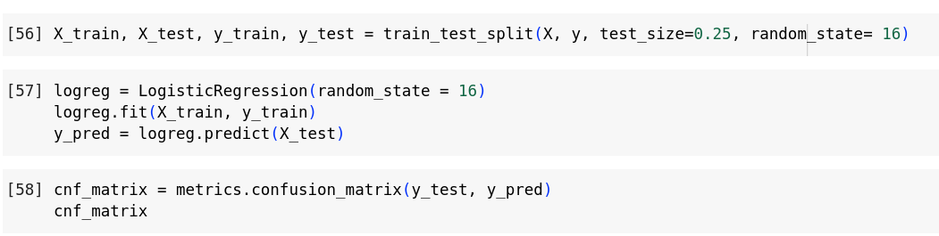

Logistic regression is a statistical method for predicting binary classes. The outcome or target variable is dichotomous in nature. Dichotomous means there are only two possible classes. Logistic regression is a statistical method for predicting binary classes. The outcome or target variable is dichotomous in nature. Dichotomous means there are only two possible classes. It is a special case of linear regression where the target variable is categorical in nature.



*School of Computer Engineering, KIIT, BBSR* 8

**ADVANTAGES**

This project offers a multitude of advantages by leveraging data analytics to investigate NBA sponsor growth:

Data-Driven Decisions:

Replaces subjective interpretations with data-driven, quantifiable trends in sponsor growth. This provides a more dependable foundation for the NBA's strategic decision-making regarding sponsorship acquisition and program development.

Actionable Insights:

By uncovering year - over - year growth patterns and potential future trends, the project equips the NBA with actionable intelligence to make strategic decisions, such as:

i. Prioritizing high-growth sponsor categories for targeted acquisition efforts.

ii. Refining sponsorship programs to maximize their growth potential (e.g., developing sponsorship packages that cater to specific sponsor needs and objectives).

iii. Establishing metrics to assess and gauge the effectiveness of sponsorship initiatives (e.g., return on investment (ROI), brand awareness lift, social media engagement).

Broad Applicability:

The methodology developed can be potentially adapted to analyze sponsor growth across other sports leagues or even entirely different industries, offering valuable insights to a wider audience. For instance, the same approach could be applied to analyze sponsorship growth trends in Major League Baseball (MLB) or English Premier League (EPL) football, enabling comparisons and identification of best practices across different sports. Similarly, this methodology could be adapted to assess sponsor growth within the video game industry, helping game developers understand which sponsor categories are experiencing the most significant growth and identify opportunities for mutually beneficial partnerships.



*School of Computer Engineering, KIIT, BBSR* 9

Increased Efficiency:

Data analytics can streamline the process of identifying and evaluating potential sponsors, resulting in significant time and resource savings compared to traditional methods.

Automates tasks associated with data collection and analysis, allowing for faster turnaround times and facilitating quicker decision-making.

Enables a more comprehensive analysis of a larger data set compared to manual methods, providing a more holistic view of the sponsorship landscape.

Enhanced Understanding:

By pinpointing the key factors driving sponsor growth, the NBA can tailor its approach to maximize sponsor satisfaction and engagement.

Identifies which sponsor categories are experiencing the most significant growth, allowing the NBA to prioritize these categories in its acquisition efforts and program development.

Helps uncover potential blind spots or emerging trends that might be missed through traditional methods, such as the growing importance of social media engagement for sponsorships or the increasing influence of sustainability initiatives on sponsor selection.

Competitive Advantage:

Utilizing data analytics equips the NBA with a data-driven advantage in attracting and retaining sponsors compared to leagues or organizations relying solely on intuition.

Provides a more objective and data-supported approach to sponsorship acquisition and program development, enabling the NBA to target high-value sponsors with data-driven insights.

Demonstrates the NBA's commitment to innovation and its ability to measure and optimize its sponsorship programs effectively, fostering trust and confidence

among potential sponsors



*School of Computer Engineering, KIIT, BBSR* 10

Improved Communication and Transparency:

Data-driven findings can be effectively communicated to stakeholders (sponsors, media, fans) through visualizations and clear explanations, fostering transparency and trust.

Stakeholders can gain a clearer understanding of the NBA's sponsorship landscape and growth trends, enabling them to make more informed decisions. For example, sponsors can leverage these insights to assess the potential return on investment (ROI) for their NBA sponsorships, while fans can gain insights into the types of companies that are choosing to partner with the NBA.

Builds trust by demonstrating the NBA's data-driven approach to

decision-making and its commitment to transparency with all stakeholders.



*School of Computer Engineering, KIIT, BBSR* 11



Chapter 5

Result

The main result obtained from the project is visualized as follows

5.1 Result Analysis

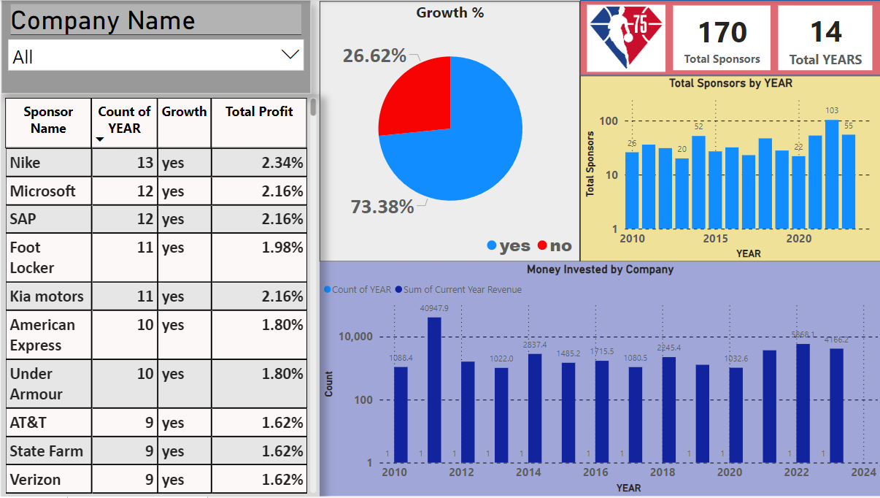

It shows top 10 companies who invested in nba for over a decade, with their growth percentage, total profit and graphs of the growth,money invested and total sponsors per year.

From 500+ data collected for the period of 14 year there are in total 170 unique sponsors in which 73% of them had a growth

The companies who invested for over the span of 5 years had a growth whereas the companies who invested for 1 or 2 year incurred no growth

In 2020, many sponsors refrained from investing and the ones who invested suffered a loss or did not get any growth due to covid being on its peak and market being down. From the year 2021, companies started to invest again but the growth was back on track for most of the companies in the year 2022 as the pandemic was over and there was a huge relief in the market.



*School of Computer Engineering, KIIT, BBSR* 12





5.2 Screenshots

This table represents top 10 sponsors along with the number of years they invested,growth and total profit.

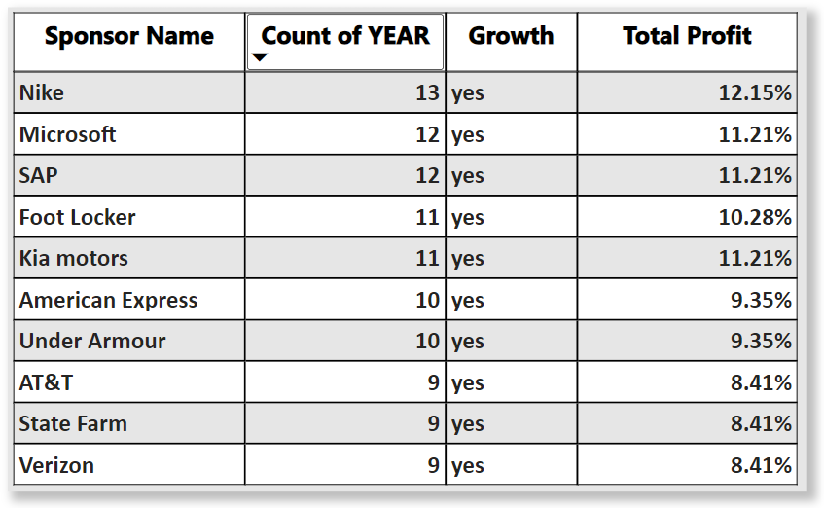

1. At the top position, with the most count year nike as invested for 13 years continuously starting 2010 and continuously sponsoring. They had growth in all the years except 2020 due to covid but their growth was again observed in 2022.

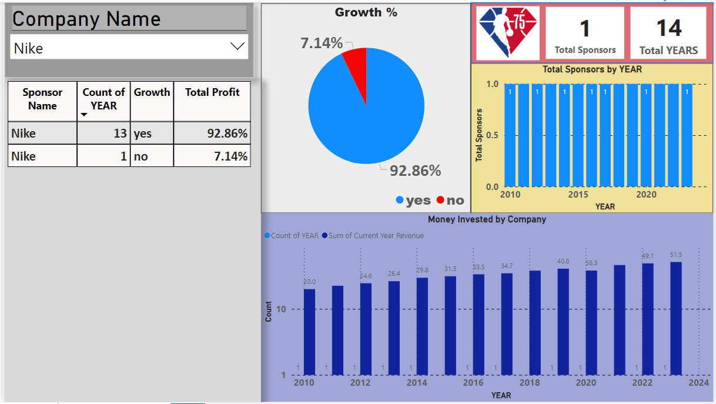



*School of Computer Engineering, KIIT, BBSR* 13

1. Microsoft holds second position, continuously sponsoring since 2011. In 2015 there was a slight decrease in their growth and in 2022 they had no growth. They invested for 13 years and had growth in 12 years

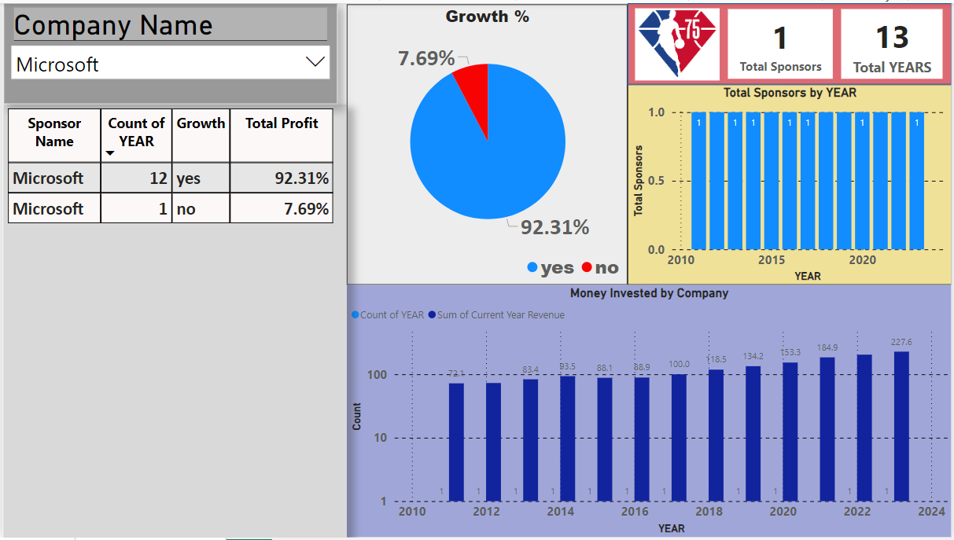

1. SAP invested for 13 years. They had growth for 12 years, in 2020 due to covid they did not sponsor. 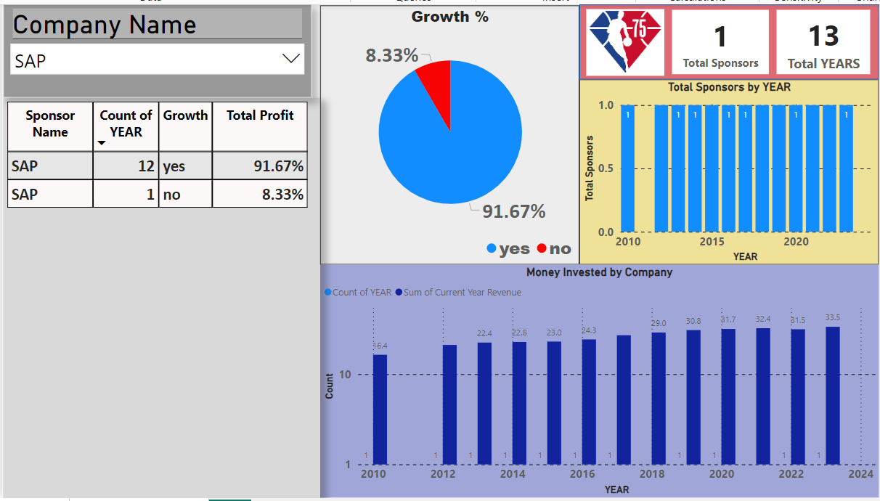



*School of Computer Engineering, KIIT, BBSR* 14

1. Foot Locker invested for 12 years. They had growth for 11 years, in 2020 due to covid they had no growth. They did not sponsor in the year 2022 and invested again in 2023.

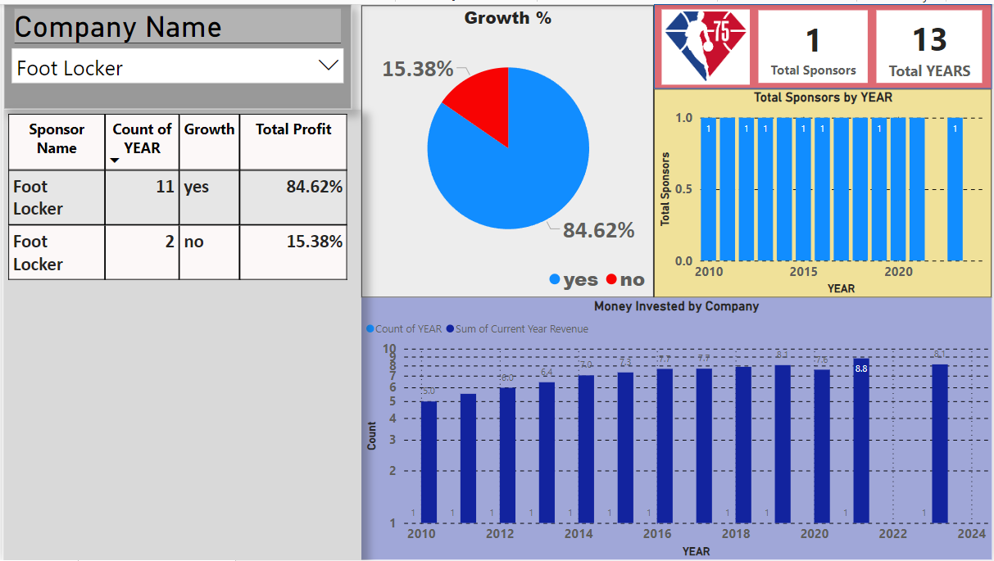

1. Kia Motor invested for 12 years. From 2011 to 2021 they invested continuously. They invested through two brands in 2017 Kia Motors and kia. They incurred a loss in 2015 but had growth in the rest of years, 11 years of growth with 1 year loss.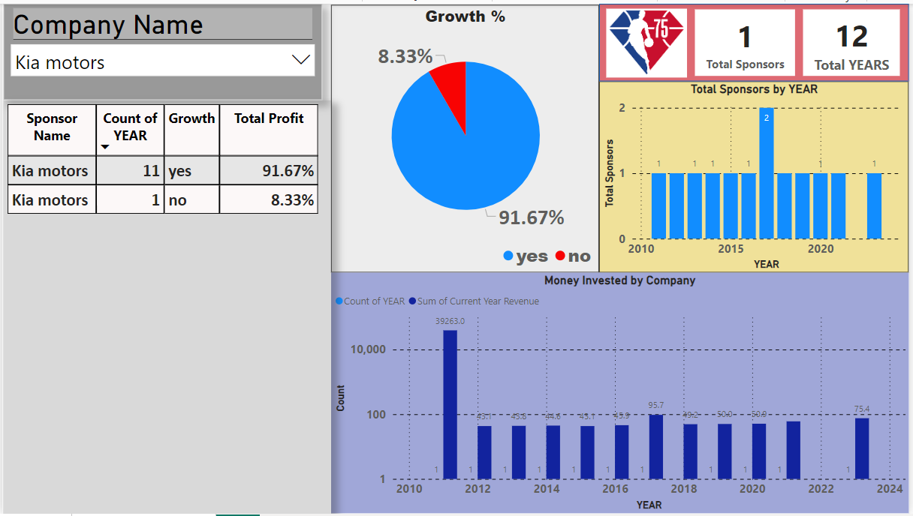



*School of Computer Engineering, KIIT, BBSR* 15

The next few of the top 10 companies are as follows:

1. American Express:

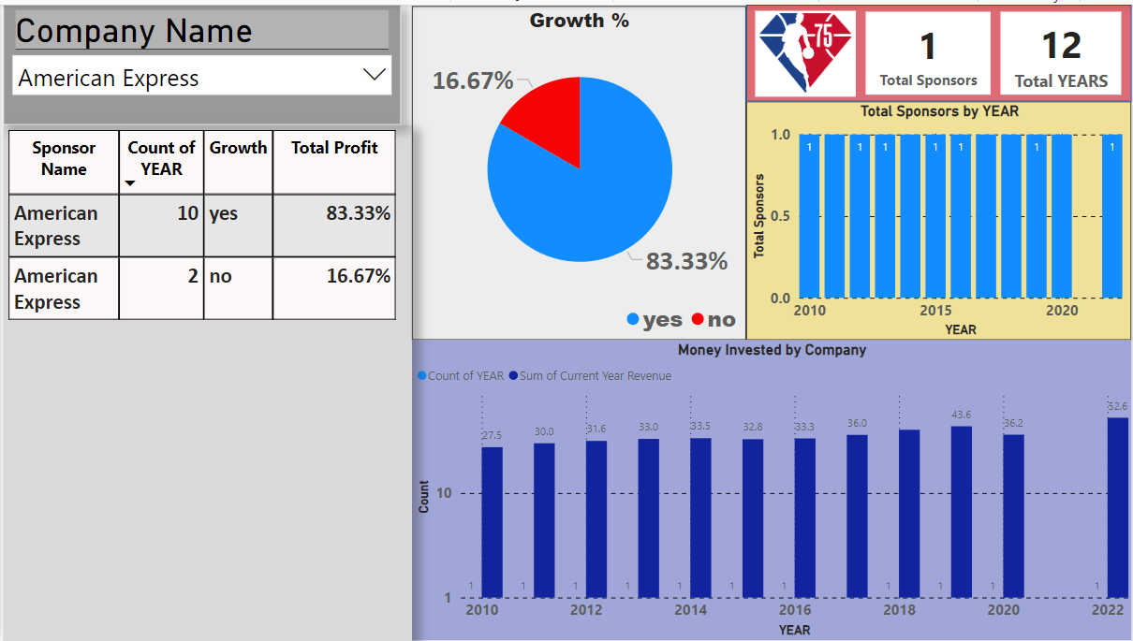

1. Under Armour:

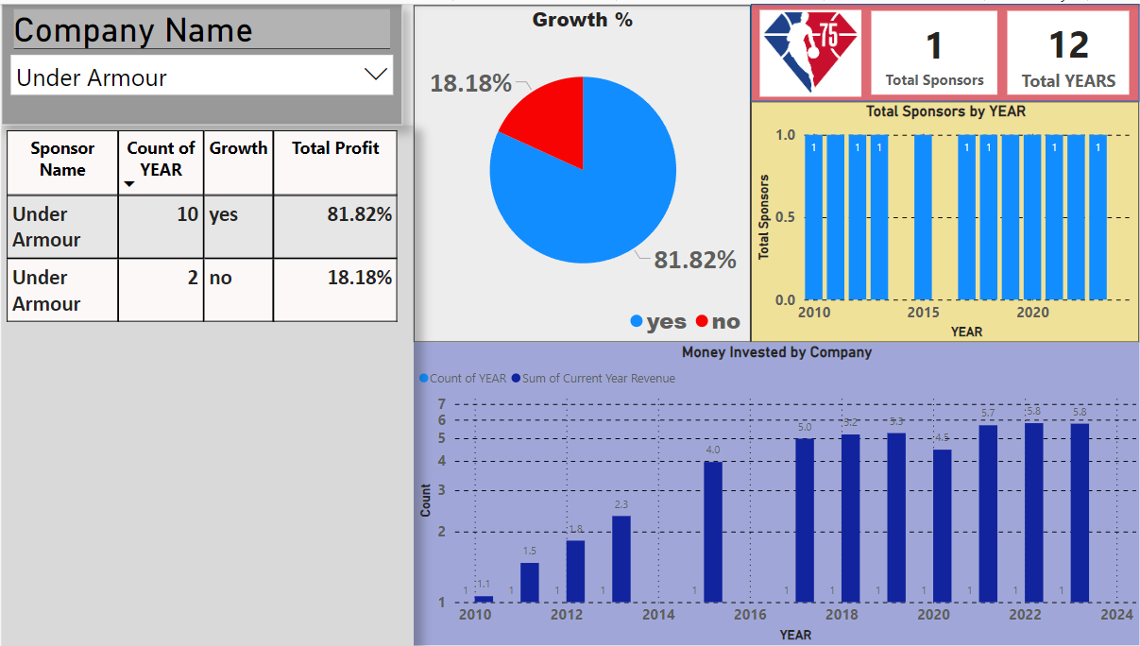



*School of Computer Engineering, KIIT, BBSR* 16

1. AT&T

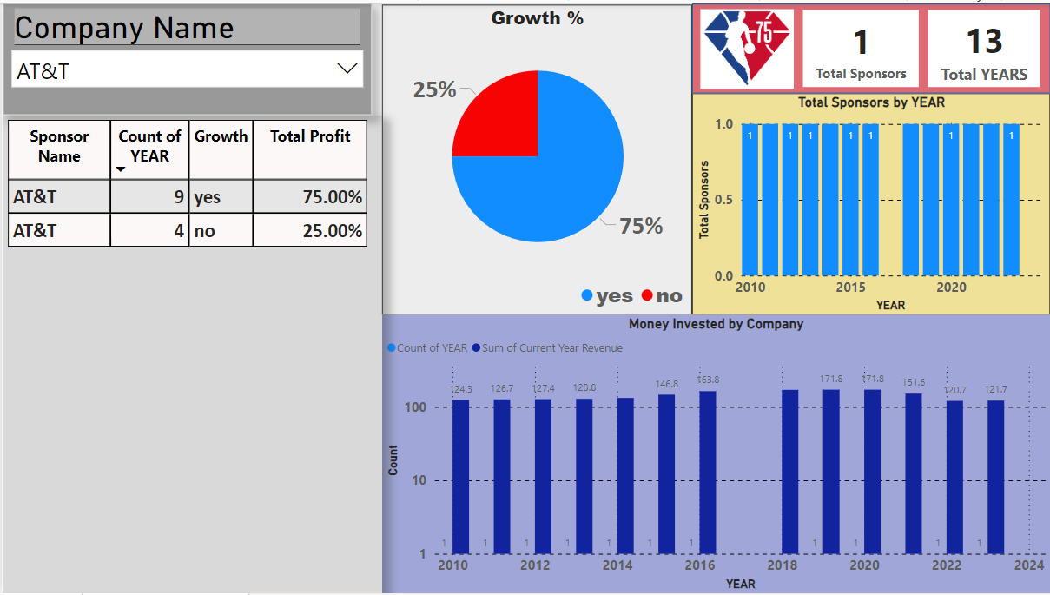

9. State Farm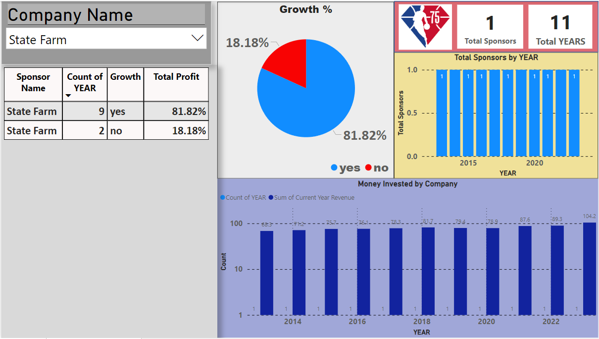



*School of Computer Engineering, KIIT, BBSR* 17

10. Verizon:

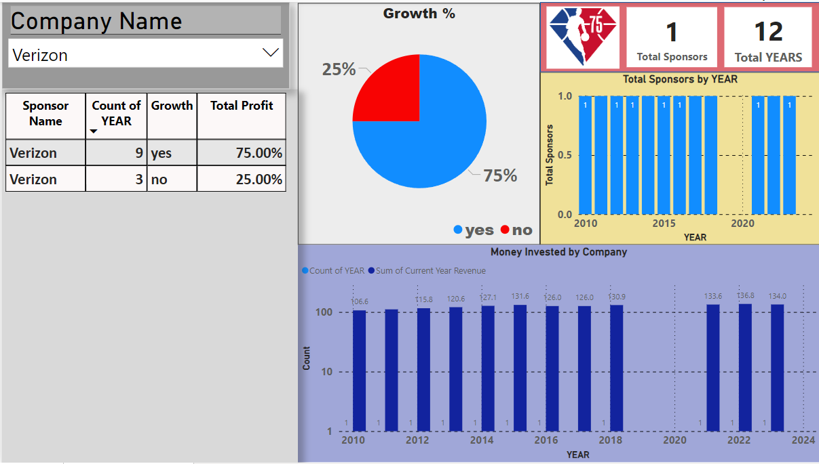



*School of Computer Engineering, KIIT, BBSR* 18





Chapter 6

Standards Adopted

6.1 Design Standards

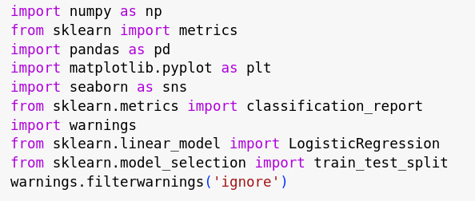

6.2 Coding Standards

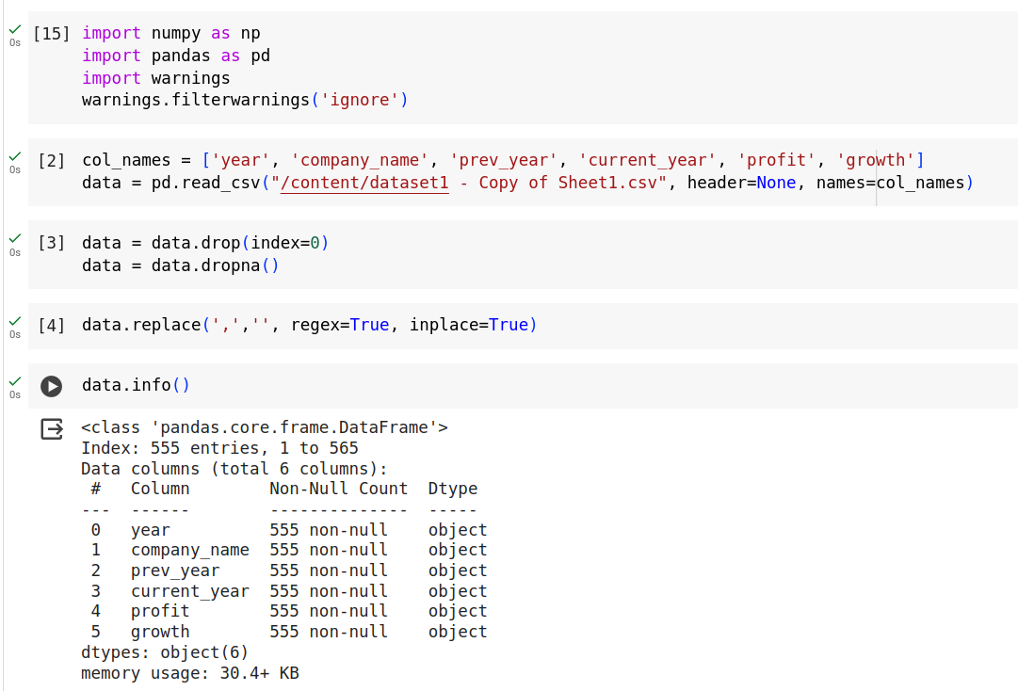



*School of Computer Engineering, KIIT, BBSR* 19

Initially, the modules were imported in specific order. We employed third-party libraries after first using standard libraries. Avoid using too many white spaces. An operator should have one white space surrounding it on all sides, one following the comma, and no white space inside the parenthesis' opening or closing.Metrics for Evaluation: Provide pertinent evaluation metrics for logistic regression, such as the F1-score, accuracy, precision, and recall. appropriate indentation is applied



*School of Computer Engineering, KIIT, BBSR* 20





Chapter 7

Conclusion and Future Scope

In conclusion, NBA sponsorships offer a strategic channel for brands to connect with a massive and highly engaged audience. By aligning sponsorship goals with target demographics, selecting impactful activation strategies, and implementing data-driven measurement, brands can leverage the NBA platform to achieve significant marketing wins. This project has established a strong foundation for further exploration. Future research could investigate specific sponsorship types in greater detail, such as jersey patches, naming rights, or media partnerships, to illuminate their unique strengths and weaknesses. Additionally, analyzing the influence of individual players on brand image, particularly considering the rise of social media engagement, could provide valuable insights for brands selecting athlete endorsers. Finally, exploring the effectiveness of cutting-edge sponsorship technologies, such as virtual reality integration or interactive in-arena experiences, could shed light on the future landscape of brand engagement within the NBA.

7.1 Limitation

Data Constraints:

Limited historical data and potential inconsistencies across team websites and social media platforms can impede analysis of long-term trends.

Accessing social media data relevant to sponsorships might be restricted by platform APIs, and data quality issues like missing values and outliers necessitate thoughtful handling strategies.

Modeling Considerations:

Logistic regression's assumptions and the risk of overfitting necessitate exploring alternative models like Random Forest or Support Vector Machines (SVM). Additionally, careful evaluation is crucial to ensure the model generalizes effectively to unseen data.

External Influences and Project Focus:

The model's ability to predict future growth might be limited by external factors like economic fluctuations or evolving consumer preferences that are not explicitly accounted for.

The project's focus on the NBA restricts the generalizability of the findings to other sports leagues or industries with potentially distinct sponsorship dynamics.



*School of Computer Engineering, KIIT, BBSR* 21

7.2 Future Scope

If data relevant to sponsorships becomes available (e.g., sponsor mentions, brand sentiment analysis), leverage it to gain deeper insights into sponsor engagement and its impact on growth.

Analyze how the volume and sentiment of media conversations surrounding sponsorships correlate with sponsor growth. This can reveal which sponsors are generating positive buzz and building stronger connections with fans, potentially leading to increased brand loyalty and ultimately, growth.

Identify which social media platforms are most effective for different types of sponsorships within the NBA. Explore whether certain platforms are more suited for driving brand awareness, generating fan engagement, or facilitating direct interactions between sponsors and fans.



*School of Computer Engineering, KIIT, BBSR* 22





***References***

*The NBA now has 48 league-level sponsors after recent deals, renewals. Sports Business Journal.*

[*https://companiesmarketcap.com/*](https://companiesmarketcap.com/)

[*https://www.sportsbusinessjournal.com/Daily/Issues/2021/12/23/Marketing-and-Sponsorship/NBA-sponsors.aspx*](https://www.sportsbusinessjournal.com/Daily/Issues/2021/12/23/Marketing-and-Sponsorship/NBA-sponsors.aspx)

[*https://sportskhabri.com/nba-sponsors-2022-23/*](https://sportskhabri.com/nba-sponsors-2022-23/)

[*https://www.forbes.com/sites/mikeozanian/2023/10/16/nba-sponsorship-revenue-hits-record-166-billion/?sh=6678b4102279*](https://www.forbes.com/sites/mikeozanian/2023/10/16/nba-sponsorship-revenue-hits-record-166-billion/?sh=6678b4102279)

[*https://www.sportspromedia.com/news/nba-teams-sponsorship-revenue-income-2021-22-cryptocurrency/*](https://www.sportspromedia.com/news/nba-teams-sponsorship-revenue-income-2021-22-cryptocurrency/)

[*https://statista.com/statistics/380270/nba-sponsorship-revenue/*](https://statista.com/statistics/380270/nba-sponsorship-revenue/)

[*https://www.sportico.com/business/sponsorship/2022/nba-sponsorship-revenue-sets-record-billion-crypto-1234676540/*](https://www.sportico.com/business/sponsorship/2022/nba-sponsorship-revenue-sets-record-billion-crypto-1234676540/)

[*https://www.sportbusiness.com/2022/10/nba-allows-teams-10-international-sponsorship-deals-to-strengthen-global-reach/*](https://www.sportbusiness.com/2022/10/nba-allows-teams-10-international-sponsorship-deals-to-strengthen-global-reach/)

[*https://www.sportingnews.com/in/nba?gr=www*](https://www.sportingnews.com/in/nba?gr=www)

[*https://www.nba.com/*](https://www.nba.com/)

[*https://www.globaldata.com/store/report/nba-business-analysis/*](https://www.globaldata.com/store/report/nba-business-analysis/)

[*https://www.sciencegate.app/app/search#0bd399ab-4473-43ba-b32f-7b6dfc0240b1/10/0*](https://www.sciencegate.app/app/search#0bd399ab-4473-43ba-b32f-7b6dfc0240b1/10/0)



*School of Computer Engineering, KIIT, BBSR* 23