**Parking Slot Availablity Checkup**

**Abstract :**

Parking in a busy city can be a frustrating experience for drivers, often causing significant traffic jams. To address this challenge, researchers are exploring the use of automated smart parking systems that leverage computer vision technology. This paper proposes a vision-based smart parking framework to help drivers locate and reserve available parking spots efficiently. Our system first segments the parking area into designated blocks through a calibration process. Then, it analyzes each block to determine if a vehicle is present and informs drivers of the parking status, indicating whether it's free or reserved. This system offers superior performance accuracy compared to existing hardware-based solutions, making it a promising alternative

**Introduction:**

Finding for a parking spot is a familiar frustration for many drivers. Circling around a crowded parking lot, waiting for someone to leave, and dealing with the uncertainty of finding a vacant spot can be a stressful and time-consuming experience. According to a study, drivers spend an average of 17 hours per year searching for parking, which translates to a significant amount of time, fuel, and emissions wasted. To alleviate this issue, a parking slot availability checkup system is proposed. This system aims to provide real-time information on the availability of parking slots, enabling drivers to make informed decisions and reducing congestion in parking lots.

1.Impact on Environment:

The traditional method of searching for a parking spot is not only frustrating but also has a significant impact on the environment. Idling vehicles emit pollutants, contributing to air pollution and climate change. Moreover, the lack of parking information leads to increased traffic congestion, which in turn affects the overall traffic flow and safety. A study by the International Parking Institute found that 30% of traffic congestion in urban areas is caused by drivers searching for parking.

2.Data Analysis

By leveraging advanced technologies such as sensors, IoT, and data analytics, the system can accurately detect the occupancy status of each parking slot and display the information in real-time. This innovative solution has the potential to transform the parking experience, making it more efficient, convenient, and environmentally friendly. The system can be integrated with existing parking infrastructure, making it a cost-effective solution for parking lot operators.

3.Installation :

The proposed system consists of several components, including sensors to detect the presence of vehicles, a central server to process and analyze the data, and a user interface to display the parking availability information. The system can be accessed through a mobile app or a digital display board, providing drivers with real-time information on parking availability.

4.Benifits :

The benefits of the parking slot availability checkup system are numerous. It reduces the time spent searching for parking, decreases traffic congestion, and minimizes the environmental impact of idling vehicles. Additionally, the system provides valuable insights for parking lot operators, enabling them to optimize their parking infrastructure and improve the overall parking experience.

In this project, we aim to design and develop a parking slot availability checkup system that is efficient, reliable, and scalable. We will explore the use of various sensors and technologies to detect parking availability and develop a user-friendly interface to display the information. The system will be tested and evaluated in a real-world setting to assess its performance and effectiveness.

Top of Form**Literature Survey:**

Various methods have been proposed to address parking issues in congested areas. Ming-Yee Chiu et al. suggested using induction loop sensors under the road surface to count vehicles at checkpoints, providing data on available parking spaces. While cost-effective and accurate, these sensors are difficult to install, can damage roads, and are challenging to maintain.

Other methods use sensors like ultrasonic, infrared, and microwave, placed beneath each parking space. Wan-Joo Park et al. proposed ultrasonic sensors mounted on cars to find free spaces, but these are affected by weather conditions. Vamsee K. Boda et al. introduced wireless sensor nodes at critical points in parking lots, such as entrances and exits, to count cars based on incoming and outgoing traffic. This method is cost-effective but does not provide detailed location information.

Vision-based methods offer a comprehensive solution by using cameras to monitor the entire parking area. Zhang Bin et al. highlighted that these methods are easy to install, low-cost, and adjustable. They provide rich data from images, though accuracy depends heavily on camera placement.

Thomas Fabian proposed an unsupervised vision-based system for detecting parking space occupancy with low computational complexity and minimal image frames per minute. He noted that occlusions and shadows are major issues in image detection. H. Ichihashi et al. highlighted that vision-based systems are affected by weather and lighting conditions, making them more suitable for indoor parking.

R. Yusnita et al. introduced a method where a brown round patch is drawn in each parking space; if the patch is visible, the space is free. However, this system struggles in heavy rain and snow. N. True suggested using a combination of color histogram and vehicle feature detection for efficient parking space detection. Najmi Hafizi proposed a cost-effective image-based method using low-resolution web cameras for outdoor parking, applying a Region of Interest (ROI) to each section to improve reliability.

Other methods include using image processing techniques to detect brown circles in parking spaces and edge detection to compare current images with reference images to identify free and reserved slots. Numerous methods have been proposed for image feature extraction.

In this paper, we designed and implemented an automatic parking system framework. Experimental results show that our system achieves remarkable accuracy compared to state-of-the-art methodologies.

**Methodology:**

The proposed parking availability checkup system will be developed using a combination of hardware and software components. The following methodology will be employed to design and implement the system:

1.Hardware Components:

Sensors: IR Sensors will be installed in the the In Gate and for Out Gatewhich detect the incoming and outgoing of a vehicle. These sensors will transmit the data to the central server.

We Install the LCD Display for display the available slots

2.Connecting Wires : Connect the jumpier Wire to the Ardino As it defined in the Code.

Connect Ardino: An Ardino will be used to connect the sensors to the central server. The Arduino will receive the data from the sensors and transmit it to the server.

4. Software Application:

ARDINO_IDE : An Ardino_IDE is used for writing code for Arduino for parking slot availability checkup.

5. Sensor Installation:

Mount The IR Sesonr in front of IN and Out Gate On that the Gate will be Opening and closed

6. Display:

The display will display the Available Slots

7. Real Time Updates:

Ensure the Ardino Continuously reads the sensor Data and display the ouput as real time updates.

8. Maintenance:

Regularly Check Sensors and the ardino system for any malfunctions. Ensure the display is functioning correctly and visible to drivers

**Architecture** **Diagram:**

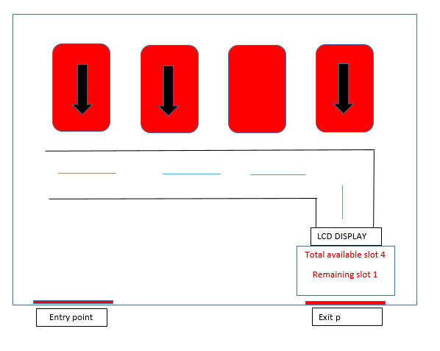

**Block Diagram:**

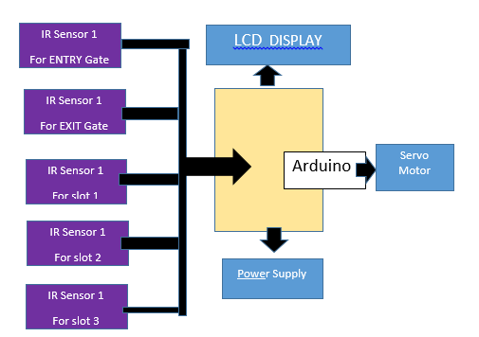

**Flow Chart :**

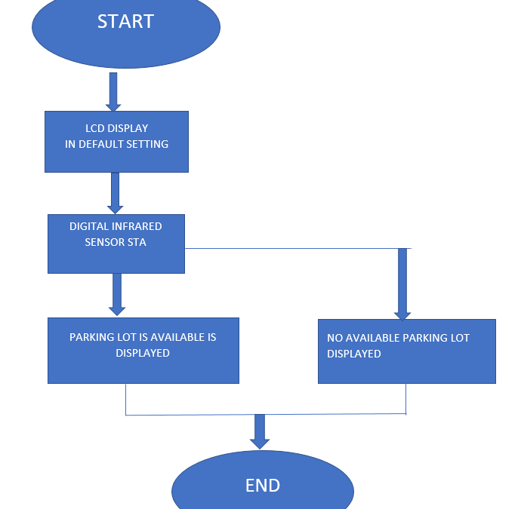

**Implementation:**

To implement a parking slot availability check system using IR sensors and a display with Arduino, first, mount an IR sensor at each parking slot to detect vehicle presence. Connect each sensor to a digital input pin on the Arduino. Write a program for the Arduino to continuously read the sensor data: when a sensor detects a vehicle, it marks the corresponding slot as occupied; otherwise, it marks the slot as available. Interface the Arduino with a display, such as an LCD or LED matrix, to show the status of each parking slot in real-time. This display is updated by the Arduino based on the sensor readings, providing a clear and immediate visual indication of available and occupied slots. This setup automates the monitoring process, ensuring efficient management of parking spaces.

**Conclusion:**

The study aims to optimize the identification of available parking slots to reduce congestion. Advances in machine learning and vision-based technology enable cost-effective automatic parking systems that help drivers find available spaces. Future research can focus on allocating specific locations to customers registered through an online parking management system.

**Future Enhancement:**

Real-time space guidance: Integrate with a mobile app to show drivers available spaces and guide them directly to them.

Advanced sensor fusion: Combine camera data with additional sensors (magnetic, ultrasonic) for better low-light/weather performance.

Multi-level display: Show not only total availability but also specific floor or zone information on the LCD.

Reservation system: Implement a system allowing drivers to reserve parking spaces in advance via the LCD or app.

**References:**

K. Malarvizhi, A. Kayathiri and K. G. Subadra, "Survey paper on vehicle parking slot detection using internet of things," 2017 International Conference on Computation of Power, Energy Information and Commuincation (ICCPEIC), Melmaruvathur, India, 2017, pp. 279-282, doi: 10.1109/ICCPEIC.2017.8290377.

S. Vishwanath, S. Sharma, K. Deshpande and S. Kanchan, "Vehicle Parking Management System," 2020 International Conference on Convergence to Digital World - Quo Vadis (ICCDW), Mumbai, India, 2020, pp. 1-6, doi: 10.1109/ICCDW45521.2020.9318673.