**INNOVATION / PROTOTYPE PROJECT REPORT**

**on**

**Parking Slot Availablity Checkup**

**for**

**S. Y. B. Tech in Artificial Intelligence and Data Science**

**Submitted To**



**Artificial Intelligence and Data Science Department**

**Annasaheb Dange College of Engineering and Technology**

**Ashta, Sangli**.

(An Autonomous Institute)

**By**

**Mr. Sanket Ramchandra Lohar**

**Mr. Suraj Popat Padalkar**

**Under the Guidance of**

**Prof. Krishna Kumar L.**

**Academic Year**

**2023 – 2024**

**Sant Dnyaneshwar Shikshan Sanstha’s**

**ANNASAHEB DANGE COLLEGE**

**OF ENGINEERING AND TECHNOLOGY**



**CERTIFICATE**

**This is to Certify that project work entitled**

**Parking Slot Availablity Checkup**

**Submitted By**

This is a Bonafide record of project work carried out in this Institute / Department / Programme in the partial fulfillment of the requirement for the award of the Degree in Artificial Intelligence and Data Science Department as a part of the curriculum laid down during the academic year 2023 – 2024.

**Mr. Sanket Ramchandra Lohar 2009**

**Mr. Suraj Popat Padalkar 2011**

Prof. Krishna Kumar L

Project Supervisor

Submitted in partial fulfillment of the End Semester Practical Examination held on………….

**INTERNAL EXAMINER EXTERNAL EXAMINER**

**DECLARATION**

We hereby declare that the work reported in the project report entitled "Smart Energy Meter" which is being submitted in partial fulfillment of the requirements for the award of the Degree of Bachelor of Technology in Artificial Intelligence & Data Science from Annasaheb Dange College of Engineering. Ashta. The material contained in this project report has not been submitted to University/Institution/Department/Program for the award of a degree.

Place: Ashta

Date: 04-08-2023

**Name of students URN Sign**

Sanket Ramchandra Lohar 1022091009

Suraj Popat Padalkar 1022091012



We would like to express our deep and sincere gratitude to our Dean, Director, Executive Director, and Supervisor Mr. Krishna Kumar L, Department of Artificial Intelligence & Data Science, for guiding us to accomplish this work. It was our privilege and pleasure to work under his able guidance. We are indeed grateful to him for providing helpful suggestions, from time to time. Due to his constant encouragement and inspiration, we can: present this Innovation/Prototype project.

1.**Sanket Ramchandra Lohar**

**2.Suraj Popat Padalkar**

# **CONTENTS**

Abstract……………………………………………………… …………………….………...1

**1. Introduction**

1.1 Introduction……………………………………………………………………………...3

1.2 Literature Survey……………………………………………………………..….………5

**2. Related Work**

2.1 Methodology…...…………………………………………….………………………….6

**3. Proposed Work**

3.1 Architecture Diagram ………………………………….……………………….……….7

3.2 Block Diagram…………………………………………………………………….…… 8

3.3 Flow control…………………………………………………….……………………… 9

**4. Implementation and Testing**

4.1 Implementation and Testing …………………………………..……………………… 10

4.2 Future Enhancement……………………………………………….….11

**5. Conclusion**……………………………………………..……...…**…12**

**6. Reference …………………………………………………………….…….13**

**7. Result / Output……………………………………………..………………18**

**8. IEEE Document…………………………………………………………....19**

**Parking Slot Availblity Checkup**

**Abstract:**

Parking in a busy city can be a frustrating experience for drivers, often causing significant traffic jams. To address this challenge, researchers are exploring the use of automated smart parking systems that leverage computer vision technology. This paper proposes a vision-based smart parking framework to help drivers locate and reserve available parking spots efficiently. Our system first segments the parking area into designated blocks through a calibration process. Then, it analyzes each block to determine if a vehicle is present and informs drivers of the parking status, indicating whether it's free or reserved. This system offers superior performance accuracy compared to existing hardware-based solutions, making it a promising alternative.

**Chapter I**

**Introduction:**

Finding for a parking spot is a familiar frustration for many drivers. Circling around a crowded parking lot, waiting for someone to leave, and dealing with the uncertainty of finding a vacant spot can be a stressful and time-consuming experience. According to a study, drivers spend an average of 17 hours per year searching for parking, which translates to a significant amount of time, fuel, and emissions wasted. To alleviate this issue, a parking slot availability checkup system is proposed. This system aims to provide real-time information on the availability of parking slots, enabling drivers to make informed decisions and reducing congestion in parking lots.

**1.Impact on Environment:**

The traditional method of searching for a parking spot is not only frustrating but also has a significant impact on the environment. Idling vehicles emit pollutants, contributing to air pollution and climate change. Moreover, the lack of parking information leads to increased traffic congestion, which in turn affects the overall traffic flow and safety. A study by the International Parking Institute found that 30% of traffic congestion in urban areas is caused by drivers searching for parking.

**2.Data Analysis**

By leveraging advanced technologies such as sensors, IoT, and data analytics, the system can accurately detect the occupancy status of each parking slot and display the information in real-time. This innovative solution has the potential to transform the parking experience, making it more efficient, convenient, and environmentally friendly. The system can be integrated with existing parking infrastructure, making it a cost-effective solution for parking lot operators.

3**.Installation :**

The proposed system consists of several components, including sensors to detect the presence of vehicles, a central server to process and analyze the data, and a user interface to display the parking availability information. The system can be accessed through a mobile app or a digital display board, providing drivers with real-time information on parking availability.

**4.Benifits :**

The benefits of the parking slot availability checkup system are numerous. It reduces the time spent searching for parking, decreases traffic congestion, and minimizes the environmental impact of idling vehicles. Additionally, the system provides valuable insights for parking lot operators, enabling them to optimize their parking infrastructure and improve the overall parking experience.

In this project, we aim to design and develop a parking slot availability checkup system that is efficient, reliable, and scalable. We will explore the use of various sensors and technologies to detect parking availability and develop a user-friendly interface to display the information. The system will be tested and evaluated in a real-world setting to assess its performance and effectiveness.

Top of Form**Literature Survey:**

Various methods have been proposed to address parking issues in congested areas. Ming-Yee Chiu et al. suggested using induction loop sensors under the road surface to count vehicles at checkpoints, providing data on available parking spaces. While cost-effective and accurate, these sensors are difficult to install, can damage roads, and are challenging to maintain.

Other methods use sensors like ultrasonic, infrared, and microwave, placed beneath each parking space. Wan-Joo Park et al. proposed ultrasonic sensors mounted on cars to find free spaces, but these are affected by weather conditions. Vamsee K. Boda et al. introduced wireless sensor nodes at critical points in parking lots, such as entrances and exits, to count cars based on incoming and outgoing traffic. This method is cost-effective but does not provide detailed location information.

Vision-based methods offer a comprehensive solution by using cameras to monitor the entire parking area. Zhang Bin et al. highlighted that these methods are easy to install, low-cost, and adjustable. They provide rich data from images, though accuracy depends heavily on camera placement.

Thomas Fabian proposed an unsupervised vision-based system for detecting parking space occupancy with low computational complexity and minimal image frames per minute. He noted that occlusions and shadows are major issues in image detection. H. Ichihashi et al. highlighted that vision-based systems are affected by weather and lighting conditions, making them more suitable for indoor parking.

R. Yusnita et al. introduced a method where a brown round patch is drawn in each parking space; if the patch is visible, the space is free. However, this system struggles in heavy rain and snow. N. True suggested using a combination of color histogram and vehicle feature detection for efficient parking space detection. Najmi Hafizi proposed a cost-effective image-based method using low-resolution web cameras for outdoor parking, applying a Region of Interest (ROI) to each section to improve reliability.

Other methods include using image processing techniques to detect brown circles in parking spaces and edge detection to compare current images with reference images to identify free and reserved slots. Numerous methods have been proposed for image feature extraction.

In this paper, we designed and implemented an automatic parking system framework. Experimental results show that our system achieves remarkable accuracy compared to state-of-the-art methodologies.

**Chapter II**

**Methodology:**

The proposed parking availability checkup system will be developed using a combination of hardware and software components. The following methodology will be employed to design and implement the system:

1.Hardware Components:

Sensors: IR Sensors will be installed in the the In Gate and for Out Gatewhich detect the incoming and outgoing of a vehicle. These sensors will transmit the data to the central server.

We Install the LCD Display for display the available slots

2.Connecting Wires : Connect the jumpier Wire to the Ardino As it defined in the Code.

Connect Ardino: An Ardino will be used to connect the sensors to the central server. The Arduino will receive the data from the sensors and transmit it to the server.

4. Software Application:

ARDINO_IDE : An Ardino_IDE is used for writing code for Arduino for parking slot availability checkup.

5. Sensor Installation:

Mount The IR Sesonr in front of IN and Out Gate On that the Gate will be Opening and closed

6. Display:

The display will display the Available Slots

7. Real Time Updates:

Ensure the Ardino Continuously reads the sensor Data and display the ouput as real time updates.

8. Maintenance:

Regularly Check Sensors and the ardino system for any malfunctions. Ensure the display is functioning correctly and visible to drivers

**Chapter III**

**Architecture** **Diagram:**

Exit p

Entry point

Total available slot 4

Remaining slot 1

LCD DISPLAY

Fig 3.1.1) Architecture of Parking Slot Availiblity Checkup

**Block Diagram:**

IR Sensor 1

For ENTRY Gate

IR Sensor 1

For EXIT Gate

IR Sensor 1

For slot 1

IR Sensor 1

For slot 2

IR Sensor 1

For slot 3

LCD DISPLAY

Servo Motor

Power Supply

Arduino

Fig 3.2.1) Block diagram Parking Slot availiblity Checkup

**Flow Chart :**

NO AVAILABLE PARKING LOT DISPLAYED

PARKING LOT IS AVAILABLE IS DISPLAYED

DIGITAL INFRARED SENSOR START SENCING

LCD DISPLAY  
IN DEFAULT SETTING

**Chapter IV**

**Implementation:**

To implement a parking slot availability check system using IR sensors and a display with Arduino, first, mount an IR sensor at each parking slot to detect vehicle presence. Connect each sensor to a digital input pin on the Arduino. Write a program for the Arduino to continuously read the sensor data: when a sensor detects a vehicle, it marks the corresponding slot as occupied; otherwise, it marks the slot as available. Interface the Arduino with a display, such as an LCD or LED matrix, to show the status of each parking slot in real-time. This display is updated by the Arduino based on the sensor readings, providing a clear and immediate visual indication of available and occupied slots. This setup automates the monitoring process, ensuring efficient management of parking spaces.

**Future Enhancement:**

The parking slot availability checkup system has the potential to be enhanced with various features to improve its efficiency and user experience. Some of the future enhancements that can be considered are:

Integration with Mobile Apps:

The system can be integrated with mobile apps to provide users with real-time parking availability information on their smartphones. This can be achieved through APIs that connect the parking system to the mobile app.

AI-powered Predictive Analytics:

The system can be enhanced with AI-powered predictive analytics to predict parking availability based on historical data and other factors such as weather, events, and time of day. This can help users plan their parking in advance and reduce congestion.

Smart Parking Guidance:

The system can be integrated with smart parking guidance systems that provide users with turn-by-turn directions to available parking slots. This can reduce congestion and improve the overall parking experience.

Electric Vehicle Charging Integration:

The system can be enhanced to provide information on electric vehicle charging stations and their availability. This can be particularly useful for users with electric vehicles.

Sustainability Initiatives:

The system can be integrated with sustainability initiatives such as carbon footprint tracking and green parking options. This can encourage users to adopt more sustainable parking practices.

Big Data Analytics:

The system can be enhanced with big data analytics to provide insights on parking behavior, traffic patterns, and other factors that can help improve the parking experience.

IoT-powered Smart Sensors:

The system can be integrated with IoT-powered smart sensors that can detect parking availability in real-time and provide accurate information to users.

Security Enhancements:

The system can be enhanced with security features such as CCTV cameras and secure payment gateways to ensure a safe and secure parking experience.

User Feedback and Rating System:

The system can be enhanced with a user feedback and rating system that allows users to rate their parking experience and provide feedback on the system.These are some of the future enhancements that can be considered to improve the parking slot availability checkup system. By integrating these features, the system can provide a more efficient, convenient, and sustainable parking experience for users.

**Conclusion:**

The parking slot availability checkup system is a innovative solution that provides real-time information on parking availability, reducing congestion and improving the overall parking experience. The system's accuracy and reliability are ensured through the use of ultrasonic sensors and a robust software application. The system's user-friendly interface and mobile app integration make it easily accessible to drivers.

The system's benefits extend beyond convenience, as it also promotes sustainability by reducing the time spent searching for parking, thereby decreasing fuel consumption and emissions. Additionally, the system's data analytics capabilities provide valuable insights for parking lot operators, enabling them to optimize their operations and improve revenue.

Future enhancements, such as integration with AI-powered predictive analytics and IoT-powered smart sensors, will further improve the system's accuracy and efficiency. The system's potential for widespread adoption is significant, with applications in various settings, including shopping malls, airports, and city centers.

In conclusion, the parking slot availability checkup system is a cutting-edge solution that addresses a common urban problem, providing a convenient, sustainable, and efficient parking experience. Its potential for growth and development makes it an exciting innovation in the field of smart parking.

**References:**

K. Malarvizhi, A. Kayathiri and K. G. Subadra, "Survey paper on vehicle parking slot detection using internet of things," 2017 International Conference on Computation of Power, Energy Information and Commuincation (ICCPEIC), Melmaruvathur, India, 2017, pp. 279-282, doi: 10.1109/ICCPEIC.2017.8290377.

S. Vishwanath, S. Sharma, K. Deshpande and S. Kanchan, "Vehicle Parking Management System," 2020 International Conference on Convergence to Digital World - Quo Vadis (ICCDW), Mumbai, India, 2020, pp. 1-6, doi: 10.1109/ICCDW45521.2020.9318673.

**Ardino Code :-**

#include <LiquidCrystal_I2C.h>

#include <Wire.h>

#include <Servo.h>

Servo Myservo1;

Servo Myservo2;

int supply = 1;

int in = 3;

int out = 6;

int counter = 6;

bool objectCounted = false; // Flag to track whether an object has been counted

LiquidCrystal_I2C lcd(0x3F,16,2);

void setup() {

// put your setup code here, to run once:

lcd.init();

lcd.backlight();

pinMode(supply, INPUT);

pinMode(in, INPUT);

pinMode(out, INPUT);

Myservo1.attach(2);

Myservo2.attach(7);

Myservo1.write(0);

Myservo2.write(0);

lcd.setCursor(0,0);

lcd.print("WelCome To Parking");

delay(2000);

lcd.clear();

}

void loop() {

// put your main code here, to run repeatedly:

//int Power = digitalRead(supply);

int Entry = digitalRead(in);

int Exit = digitalRead(out);

//if(Power==1)

// {

if (Entry == 0)

{

counter = counter -1;

Myservo1.write(90);

delay(2000);

if(counter<=0)

{

counter = 0;

lcd.clear();

lcd.setCursor(0,1);

lcd.print("Parking Full");

delay(2000);

}

}

else //if(Entry==0)

{

Myservo1.write(0);

counter = counter;

}

if(Exit==0)

{

Myservo2.write(90);

delay(2000);

counter = counter + 1;

if(counter>=6)

{

counter = 6;

}

}

else //if(Exit==0)

{

Myservo2.write(0);

counter = counter;

}

lcd.clear();

lcd.setCursor(0,0);

lcd.print("Available Slots:");

lcd.setCursor(0,1);

lcd.print(counter);

delay(1500);

}

**Result/Output:**

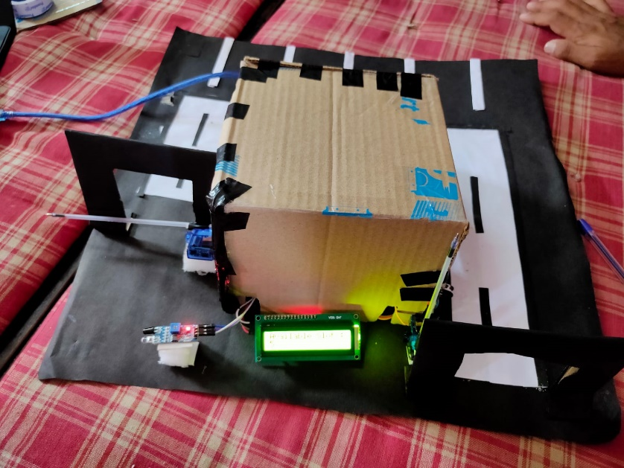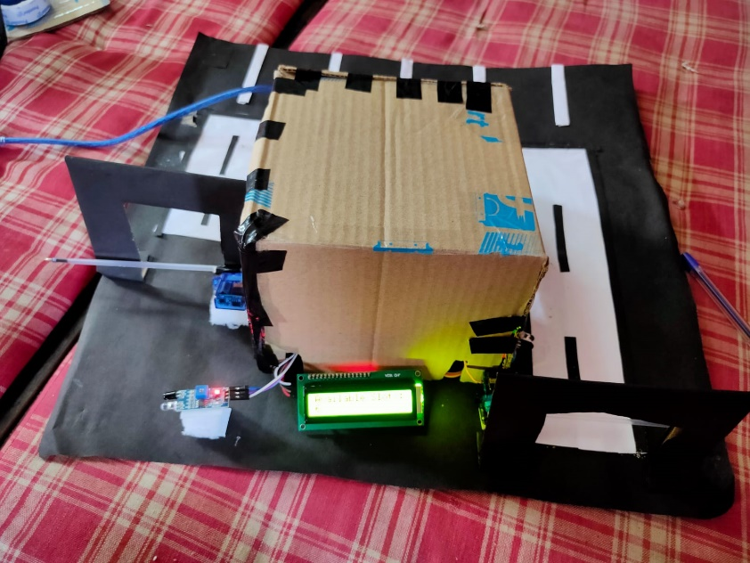

**Parking Slot Availablity Checkup**

**Abstract :**

Parking in a busy city can be a frustrating experience for drivers, often causing significant traffic jams. To address this challenge, researchers are exploring the use of automated smart parking systems that leverage computer vision technology. This paper proposes a vision-based smart parking framework to help drivers locate and reserve available parking spots efficiently. Our system first segments the parking area into designated blocks through a calibration process. Then, it analyzes each block to determine if a vehicle is present and informs drivers of the parking status, indicating whether it's free or reserved. This system offers superior performance accuracy compared to existing hardware-based solutions, making it a promising alternative

**Introduction:**

Finding for a parking spot is a familiar frustration for many drivers. Circling around a crowded parking lot, waiting for someone to leave, and dealing with the uncertainty of finding a vacant spot can be a stressful and time-consuming experience. According to a study, drivers spend an average of 17 hours per year searching for parking, which translates to a significant amount of time, fuel, and emissions wasted. To alleviate this issue, a parking slot availability checkup system is proposed. This system aims to provide real-time information on the availability of parking slots, enabling drivers to make informed decisions and reducing congestion in parking lots.

1.Impact on Environment:

The traditional method of searching for a parking spot is not only frustrating but also has a significant impact on the environment. Idling vehicles emit pollutants, contributing to air pollution and climate change. Moreover, the lack of parking information leads to increased traffic congestion, which in turn affects the overall traffic flow and safety. A study by the International Parking Institute found that 30% of traffic congestion in urban areas is caused by drivers searching for parking.

2.Data Analysis

By leveraging advanced technologies such as sensors, IoT, and data analytics, the system can accurately detect the occupancy status of each parking slot and display the information in real-time. This innovative solution has the potential to transform the parking experience, making it more efficient, convenient, and environmentally friendly. The system can be integrated with existing parking infrastructure, making it a cost-effective solution for parking lot operators.

3.Installation :

The proposed system consists of several components, including sensors to detect the presence of vehicles, a central server to process and analyze the data, and a user interface to display the parking availability information. The system can be accessed through a mobile app or a digital display board, providing drivers with real-time information on parking availability.

4.Benifits :

The benefits of the parking slot availability checkup system are numerous. It reduces the time spent searching for parking, decreases traffic congestion, and minimizes the environmental impact of idling vehicles. Additionally, the system provides valuable insights for parking lot operators, enabling them to optimize their parking infrastructure and improve the overall parking experience.

In this project, we aim to design and develop a parking slot availability checkup system that is efficient, reliable, and scalable. We will explore the use of various sensors and technologies to detect parking availability and develop a user-friendly interface to display the information. The system will be tested and evaluated in a real-world setting to assess its performance and effectiveness.

Top of Form**Literature Survey:**

Various methods have been proposed to address parking issues in congested areas. Ming-Yee Chiu et al. suggested using induction loop sensors under the road surface to count vehicles at checkpoints, providing data on available parking spaces. While cost-effective and accurate, these sensors are difficult to install, can damage roads, and are challenging to maintain.

Other methods use sensors like ultrasonic, infrared, and microwave, placed beneath each parking space. Wan-Joo Park et al. proposed ultrasonic sensors mounted on cars to find free spaces, but these are affected by weather conditions. Vamsee K. Boda et al. introduced wireless sensor nodes at critical points in parking lots, such as entrances and exits, to count cars based on incoming and outgoing traffic. This method is cost-effective but does not provide detailed location information.

Vision-based methods offer a comprehensive solution by using cameras to monitor the entire parking area. Zhang Bin et al. highlighted that these methods are easy to install, low-cost, and adjustable. They provide rich data from images, though accuracy depends heavily on camera placement.

Thomas Fabian proposed an unsupervised vision-based system for detecting parking space occupancy with low computational complexity and minimal image frames per minute. He noted that occlusions and shadows are major issues in image detection. H. Ichihashi et al. highlighted that vision-based systems are affected by weather and lighting conditions, making them more suitable for indoor parking.

R. Yusnita et al. introduced a method where a brown round patch is drawn in each parking space; if the patch is visible, the space is free. However, this system struggles in heavy rain and snow. N. True suggested using a combination of color histogram and vehicle feature detection for efficient parking space detection. Najmi Hafizi proposed a cost-effective image-based method using low-resolution web cameras for outdoor parking, applying a Region of Interest (ROI) to each section to improve reliability.

Other methods include using image processing techniques to detect brown circles in parking spaces and edge detection to compare current images with reference images to identify free and reserved slots. Numerous methods have been proposed for image feature extraction.

In this paper, we designed and implemented an automatic parking system framework. Experimental results show that our system achieves remarkable accuracy compared to state-of-the-art methodologies.

**Methodology:**

The proposed parking availability checkup system will be developed using a combination of hardware and software components. The following methodology will be employed to design and implement the system:

1.Hardware Components:

Sensors: IR Sensors will be installed in the the In Gate and for Out Gatewhich detect the incoming and outgoing of a vehicle. These sensors will transmit the data to the central server.

We Install the LCD Display for display the available slots

2.Connecting Wires : Connect the jumpier Wire to the Ardino As it defined in the Code.

Connect Ardino: An Ardino will be used to connect the sensors to the central server. The Arduino will receive the data from the sensors and transmit it to the server.

4. Software Application:

ARDINO_IDE : An Ardino_IDE is used for writing code for Arduino for parking slot availability checkup.

5. Sensor Installation:

Mount The IR Sesonr in front of IN and Out Gate On that the Gate will be Opening and closed

6. Display:

The display will display the Available Slots

7. Real Time Updates:

Ensure the Ardino Continuously reads the sensor Data and display the ouput as real time updates.

8. Maintenance:

Regularly Check Sensors and the ardino system for any malfunctions. Ensure the display is functioning correctly and visible to drivers

**Architecture** **Diagram:**

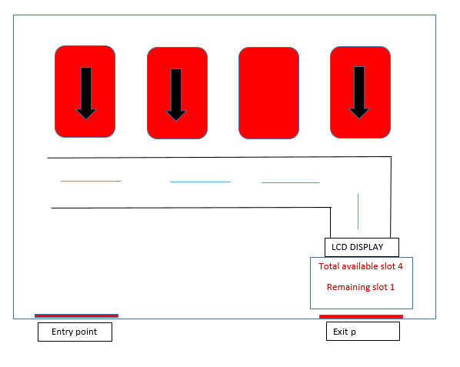

**Block Diagram:**

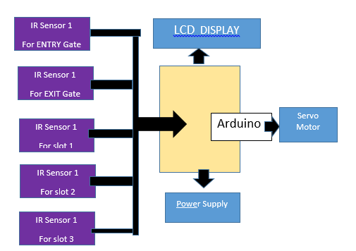

**Flow Chart :**

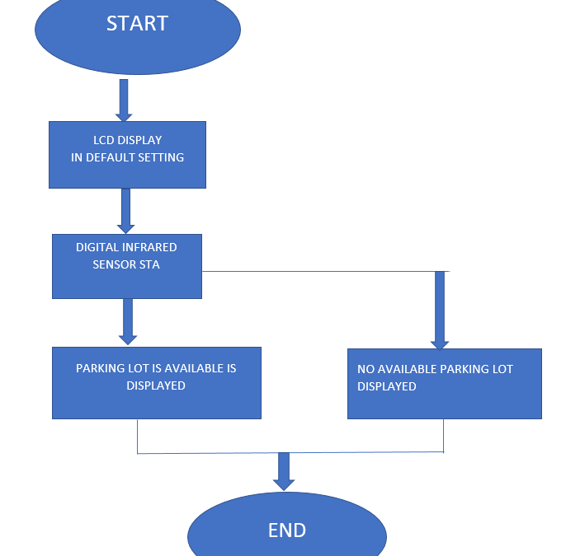

**Implementation:**

To implement a parking slot availability check system using IR sensors and a display with Arduino, first, mount an IR sensor at each parking slot to detect vehicle presence. Connect each sensor to a digital input pin on the Arduino. Write a program for the Arduino to continuously read the sensor data: when a sensor detects a vehicle, it marks the corresponding slot as occupied; otherwise, it marks the slot as available. Interface the Arduino with a display, such as an LCD or LED matrix, to show the status of each parking slot in real-time. This display is updated by the Arduino based on the sensor readings, providing a clear and immediate visual indication of available and occupied slots. This setup automates the monitoring process, ensuring efficient management of parking spaces.

**Conclusion:**

The study aims to optimize the identification of available parking slots to reduce congestion. Advances in machine learning and vision-based technology enable cost-effective automatic parking systems that help drivers find available spaces. Future research can focus on allocating specific locations to customers registered through an online parking management system.

**Future Enhancement:**

Real-time space guidance: Integrate with a mobile app to show drivers available spaces and guide them directly to them.

Advanced sensor fusion: Combine camera data with additional sensors (magnetic, ultrasonic) for better low-light/weather performance.

Multi-level display: Show not only total availability but also specific floor or zone information on the LCD.

Reservation system: Implement a system allowing drivers to reserve parking spaces in advance via the LCD or app.

**References:**

K. Malarvizhi, A. Kayathiri and K. G. Subadra, "Survey paper on vehicle parking slot detection using internet of things," 2017 International Conference on Computation of Power, Energy Information and Commuincation (ICCPEIC), Melmaruvathur, India, 2017, pp. 279-282, doi: 10.1109/ICCPEIC.2017.8290377.

S. Vishwanath, S. Sharma, K. Deshpande and S. Kanchan, "Vehicle Parking Management System," 2020 International Conference on Convergence to Digital World - Quo Vadis (ICCDW), Mumbai, India, 2020, pp. 1-6, doi: 10.1109/ICCDW45521.2020.9318673.

**BIODATA OF AUTHORS**

|  |  |
| --- | --- |
|  | Name – Suraj Popat Padalkar  Address – Vita, Tal –Khanapur, Dist – Sangli,  415 311  Qualification details – S. Y. B. Tech AI&DS  Email Address – surajpadalkar173@gmail.com  Contact No – 8432135507 |
|  | Name – Sanket Ramchandra Lohar.  Address – Islampur, Tal – Walwa, Dist – Sangli, 415 1409  Qualification details – S. Y. B. Tech AI&DS  Email Address – sanketlohar067@gmail.com  Contact No – 7218323379 |