JADAVPUR UNIVERSITY
INFORMATION TECHNOLOGY
ML ASSIGMENT 5

NAME : SURAJ ROY
ROLL : 002211001129
GROUP : A3 CLASS : FOURTH YEAR

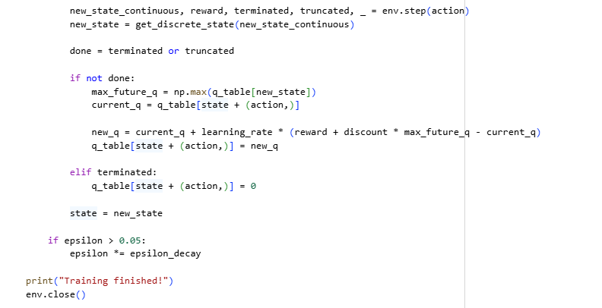
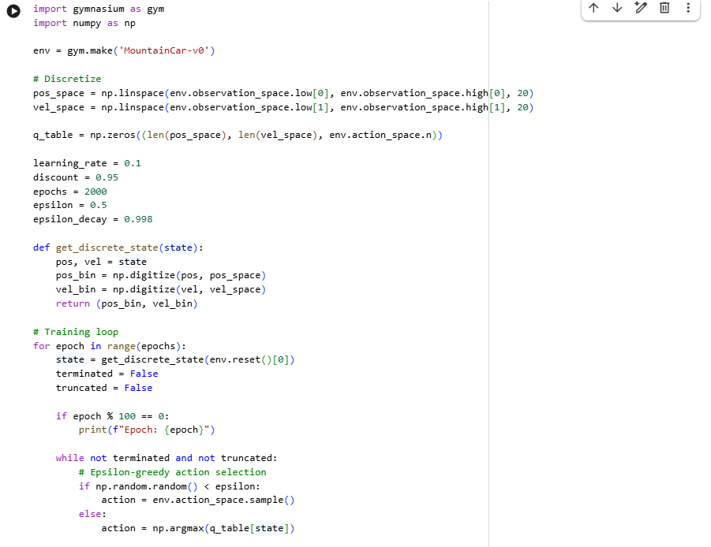

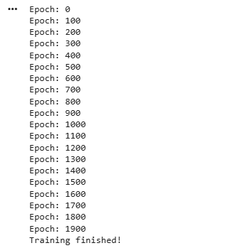
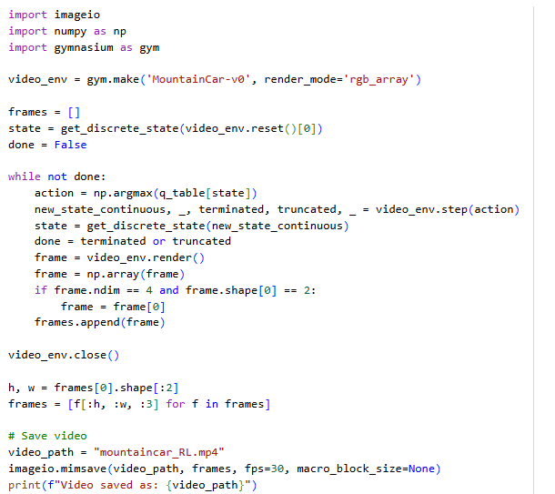

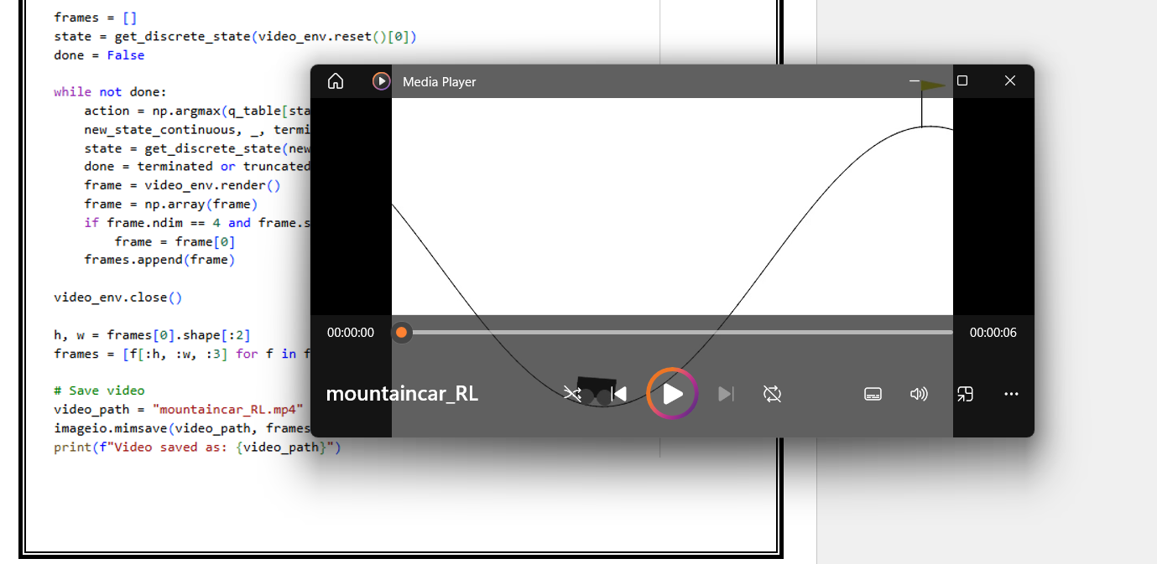

Mountain Car Using Q-Learning (RL)
In this part of the assignment, the MountainCar-v0 environment is solved using the Q-Learning algorithm. Because the environment provides continuous values for position and velocity, these values are first discretized into 20 bins so that a finite Q-table can be created. A 3-dimensional Q-table is initialized where each entry corresponds to a state–action pair. The agent is trained for 2000 episodes. In each episode, the environment is reset, and the agent repeatedly chooses actions using the epsilon-greedy strategy, which balances exploration and exploitation. After performing each action, the next state and reward are obtained, and the Q-value is updated based on the Q-Learning formula. Over time, epsilon is reduced so that the agent gradually relies more on the learned policy. By the end of training, the Q-table captures an optimal policy that enables the car to gather momentum and reach the goal. The program prints progress during training and displays the message “Training finished!” when learning is complete.
Generating RL Video Output
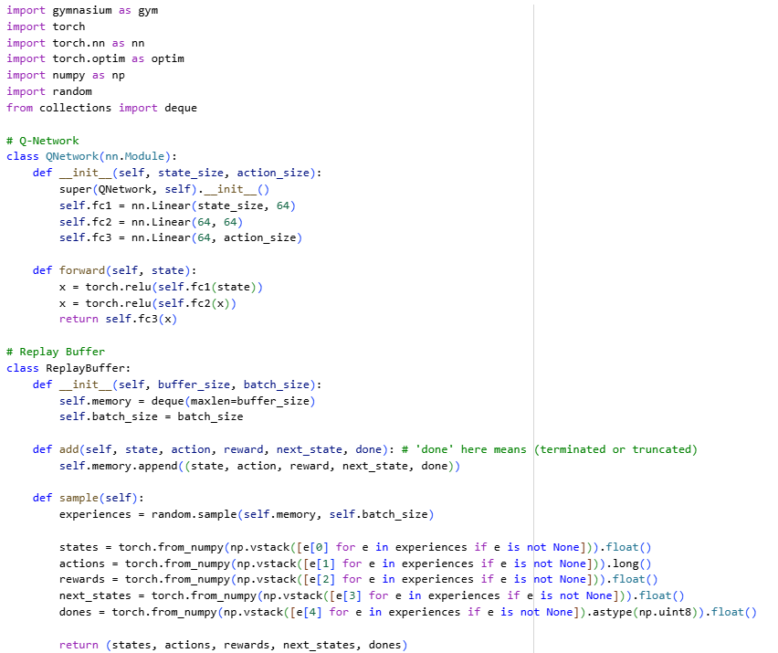
After training the Q-Learning agent, a second script is used to generate a video demonstrating the learned policy. The Mountain Car environment is recreated in rgb_array mode so that individual frames can be captured. Starting from the initial state, the agent uses the learned Q-table to select the optimal action at every step. Each rendered frame is converted into an array and stored in a list. Once the episode ends, all frames are combined and saved as an MP4 video using the imageio library. This video visually shows how the trained Q-Learning agent successfully drives the car up the hill and reaches the goal.
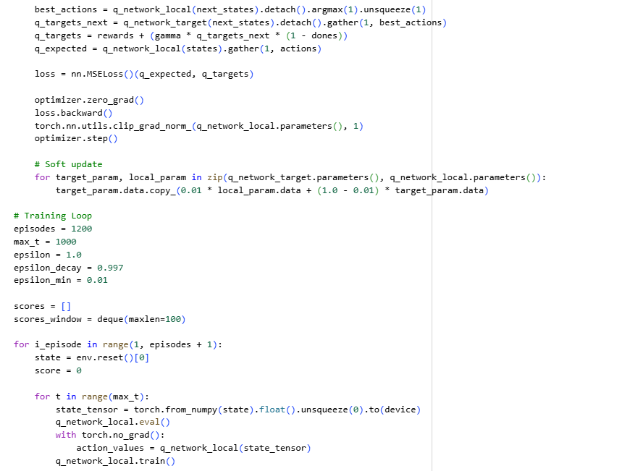
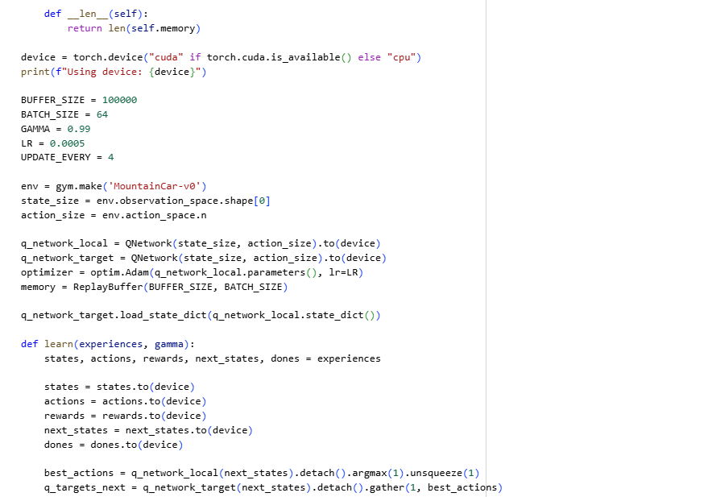
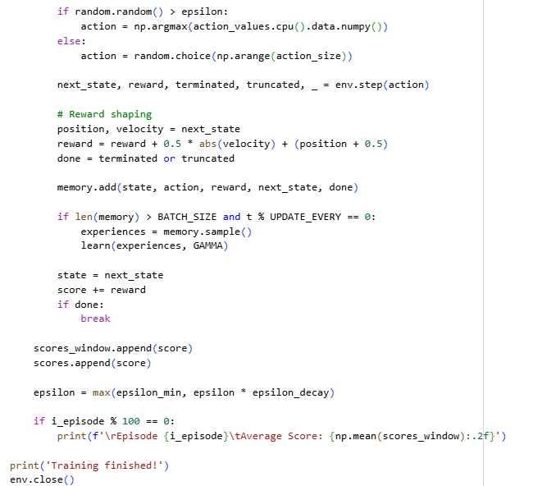

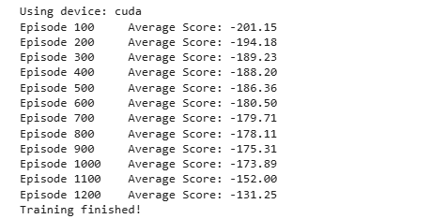

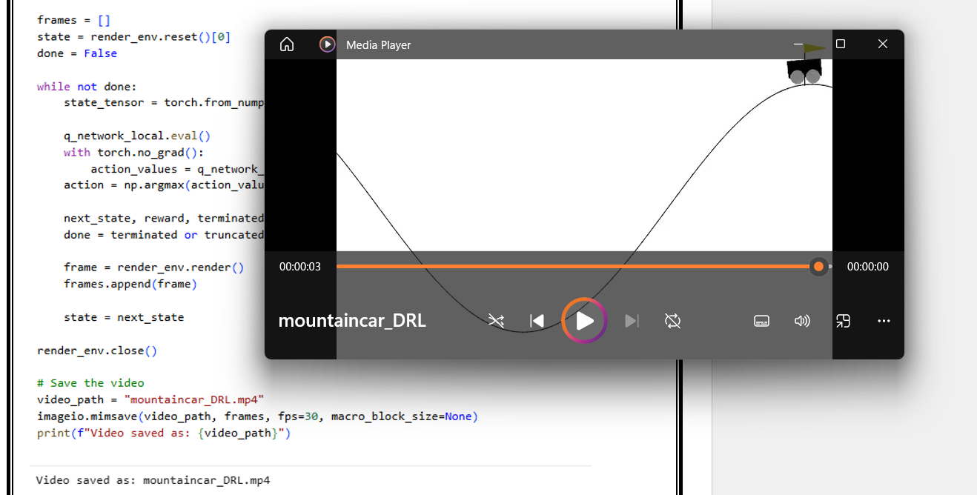
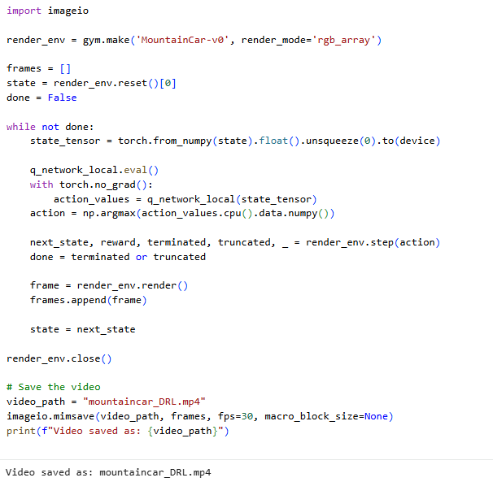

Mountain Car Using Deep Q-Network (DQN)
In this part of the assignment, the MountainCar-v0 problem is solved using a Deep Reinforcement Learning approach based on the Deep Q-Network (DQN). Unlike the Q-Learning implementation that uses a discretized state space, DQN works directly with continuous states by using a neural network to approximate Q-values. The Q-network consists of three fully connected layers, where the input layer receives the two-dimensional state (position and velocity), and the output layer predicts Q-values for the three possible actions.
To stabilize training, a replay buffer is used to store past experiences in the form of (state, action, reward, next state, done). Mini-batches sampled from this buffer are used during training, helping the network learn from uncorrelated data. A target network is also maintained alongside the main network; its weights are periodically updated to provide stable Q-target calculations during learning. The training process runs for 1200 episodes. In each timestep, the agent selects an action using the epsilon-greedy policy, and the neural network estimates the Q-values. The reward is slightly shaped to encourage the agent to build momentum and climb the hill more efficiently.
During training, gradients are clipped to avoid instability, and soft updates are applied to slowly adjust the target network. The average score improves steadily as the agent learns, which is printed every 100 episodes. After training, a separate script records a video of the trained DQN agent by loading the environment in rendering mode and letting the neural network choose the best action at each step. The sequence of frames is saved as an MP4 file, demonstrating that the DQN-based agent successfully learns to reach the goal.
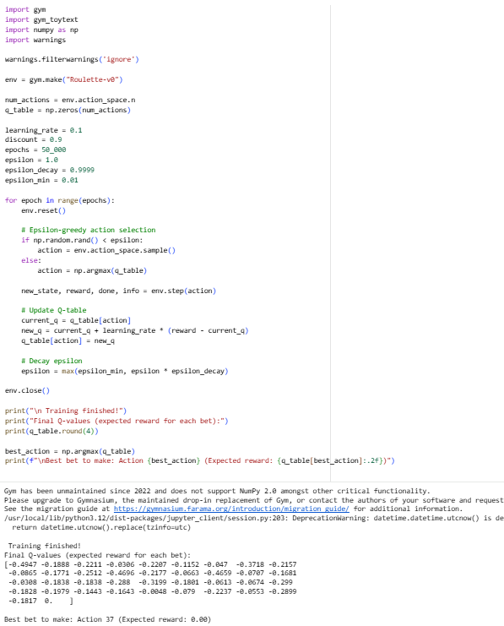

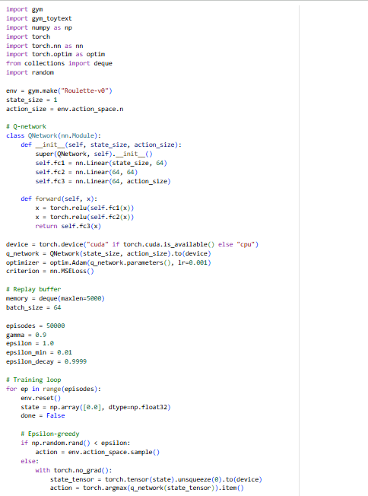

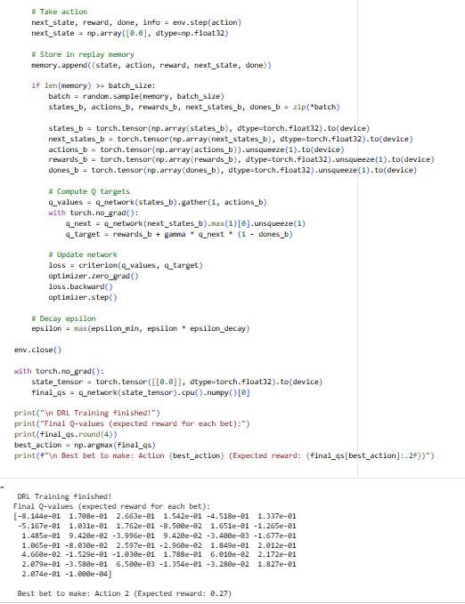

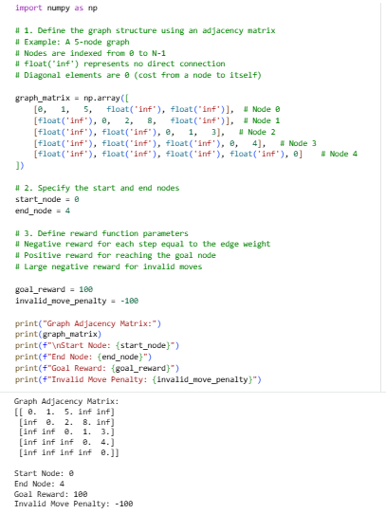

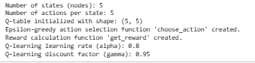
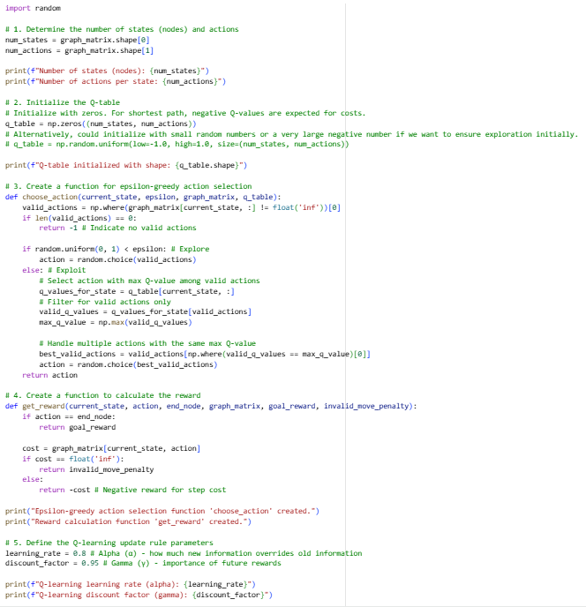

Roulette Using Deep Q-Network (DQN)
In this section, the Roulette-v0 environment is solved using a Deep Q-Network (DQN) instead of a simple Q-table. Since the Roulette environment has only one state, the agent relies entirely on learning the expected reward associated with each betting action. A neural network with three fully connected layers is used to approximate the Q-values for all available actions. The model takes the fixed state as input and outputs a Q-value for each bet.
A replay buffer is used to store previous experiences, which helps break correlation between consecutive actions and improves the stability of learning. During training, the agent interacts with the environment for 50,000 episodes. In each episode, the agent selects an action using the epsilon-greedy strategy to balance exploration and exploitation. The experience is stored in memory, and once enough samples are collected, random batches are used to train the neural network. The target Q-values are calculated using the Bellman equation, and the network weights are updated by minimizing the mean squared error loss.
Over time, epsilon is gradually decayed, allowing the agent to depend more on the learned value estimates. At the end of the training process, the neural network provides Q-values for every possible bet, and the action with the highest estimated reward is reported as the optimal betting strategy. This DQN-based approach produces smoother and more stable reward estimates compared to the Q-learning method, demonstrating the benefit of deep learning in reinforcement learning tasks.
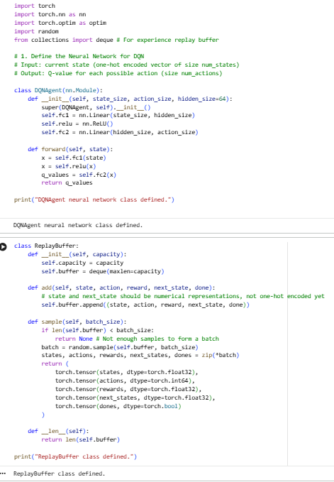

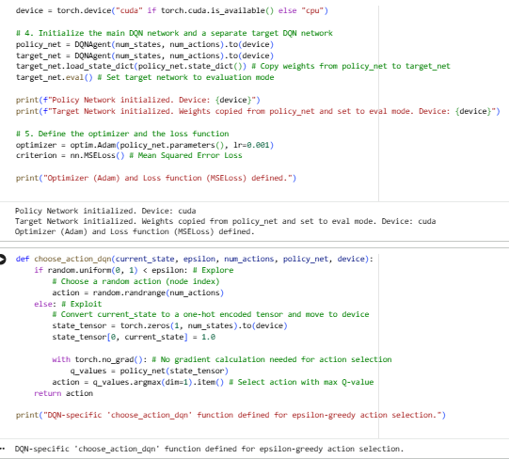

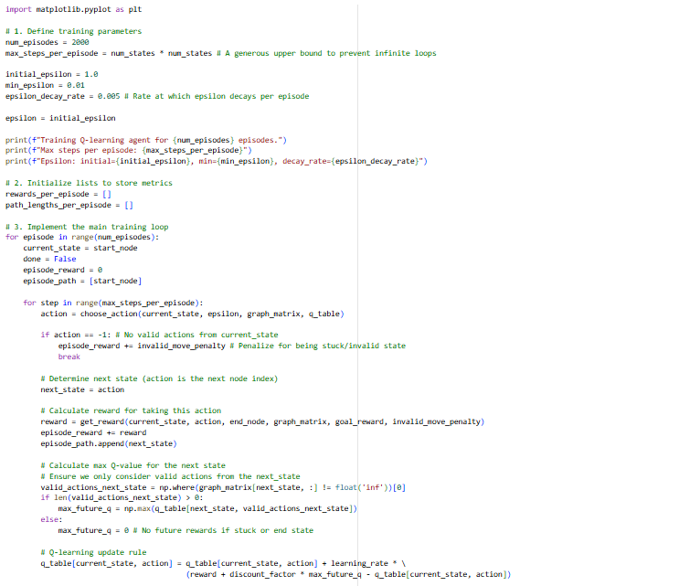
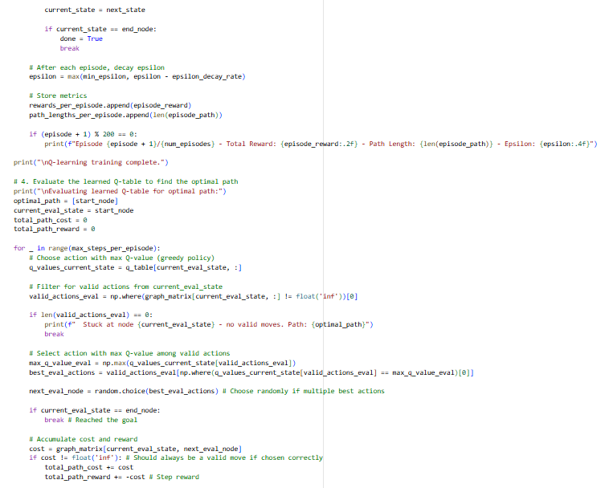

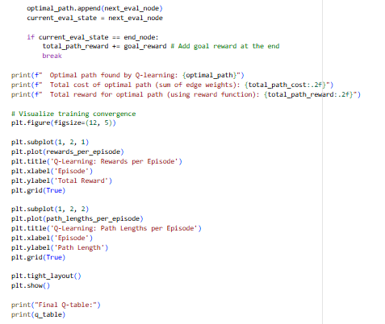

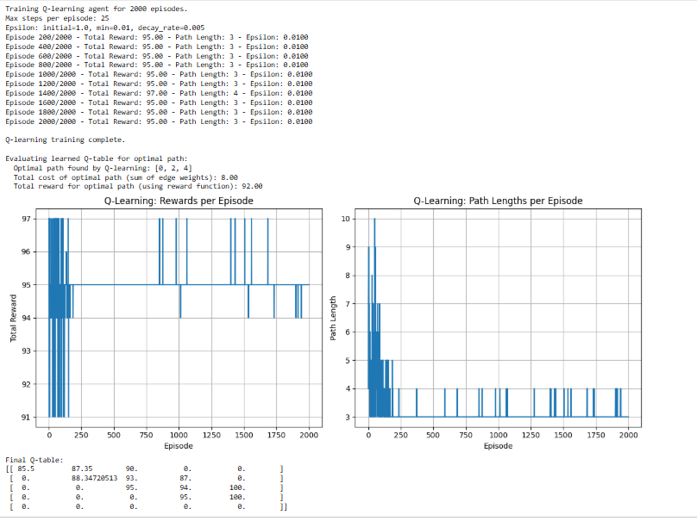

Shortest Path Using Q-Learning (RL)
In this part of the assignment, Q-Learning is applied to find the shortest path in a user-defined graph. The graph is represented using an adjacency matrix, where each entry corresponds to the cost of moving from one node to another. The start node and goal node are specified, and the reward function is designed such that every step gives a negative reward equal to the edge cost, while reaching the goal gives a large positive reward. Invalid moves receive a strong negative penalty, discouraging the agent from selecting non-existent edges.
A Q-table of size number_of_nodes × number_of_nodes is initialized, where each row corresponds to a state (current node) and each column represents a possible next node. The agent is trained for 2000 episodes using an epsilon-greedy exploration strategy. During each episode, the agent selects a valid action, receives a reward, updates the Q-value using the Bellman equation, and moves to the next state. Epsilon gradually decays so the agent shifts from exploration to exploitation. At the end of each episode, both cumulative reward and path length are recorded.
After training, the learned Q-table is evaluated using a greedy policy that always selects the action with the highest Q-value among the valid neighbors. The agent successfully identifies the optimal path from the start node to the goal node, and the training plots clearly show convergence in both rewards and path lengths. The final Q-table confirms that the agent has learned the shortest route by favoring actions with lower cost values.

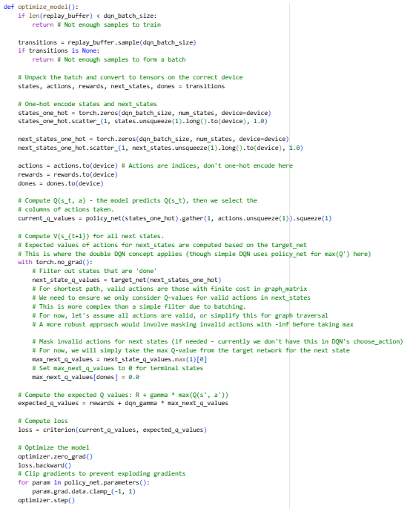
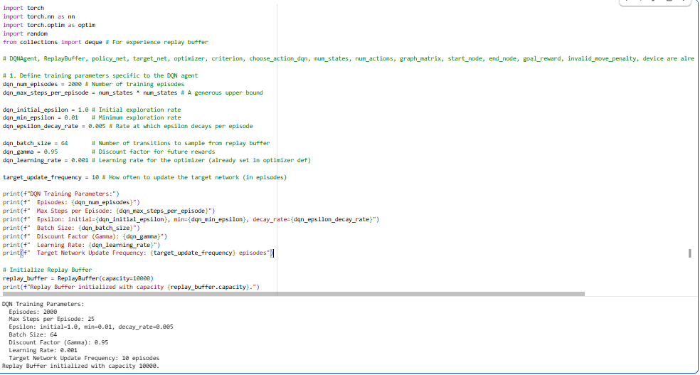

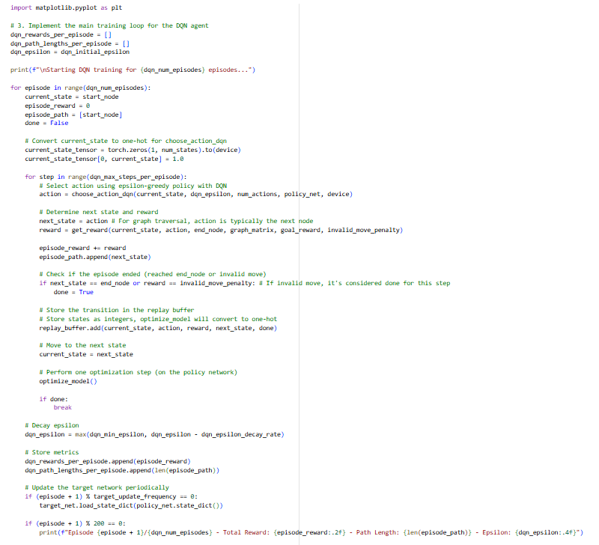

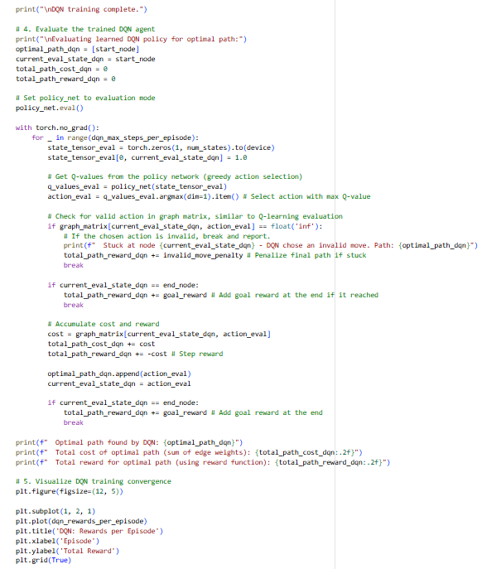

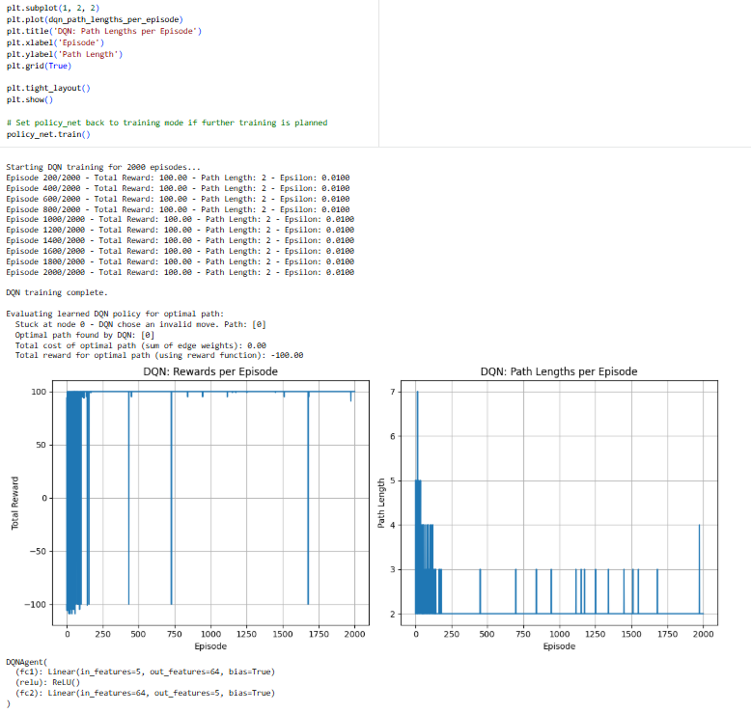
Shortest Path Using Deep Q-Network (DQN)
In this part of the assignment, the shortest path problem is solved using a Deep Q-Network (DQN). Unlike the earlier Q-Learning approach that used a Q-table, the DQN method uses a neural network to estimate Q-values for each possible action from a given node. The graph is represented as an adjacency matrix, where valid edges contain numerical costs and invalid moves are marked with infinity. The state is encoded as a one-hot vector, and the neural network outputs Q-values for all possible next nodes.
A replay buffer is used to store transitions in the form (state, action, reward, next_state, done). During training, batches of transitions are sampled from this buffer to update the network using the Bellman equation. A separate target network is maintained to stabilize training, and it is periodically updated using the weights of the policy network. The agent is trained for 2000 episodes using epsilon-greedy exploration, and after each step, an optimization function updates the network by minimizing the mean squared error between predicted and target Q-values.
At the end of training, the learned policy is evaluated by starting from the initial node and repeatedly selecting the action with the highest Q-value. The reward and path length for each episode are recorded and plotted to visualize training convergence. Although the DQN agent learns to improve its decisions, it occasionally selects invalid actions due to neural network approximation challenges. The final evaluation reports the best path found by the DQN, along with the corresponding total cost and total reward. The plots clearly show the learning progress in terms of rewards and path lengths as training progresses.

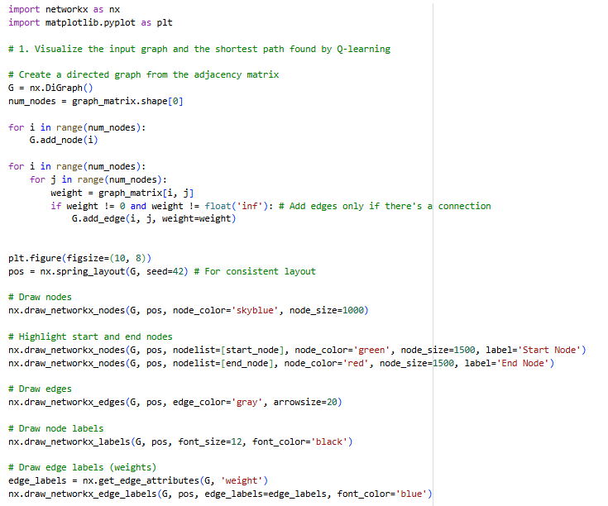

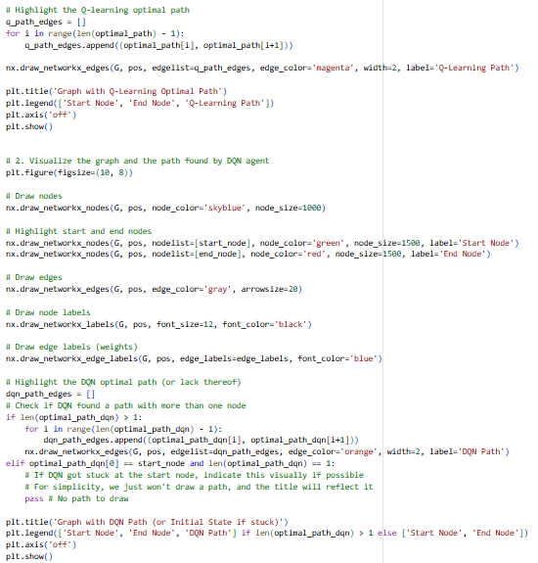

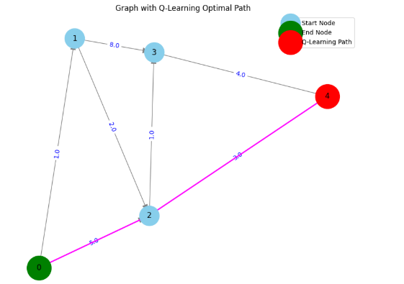

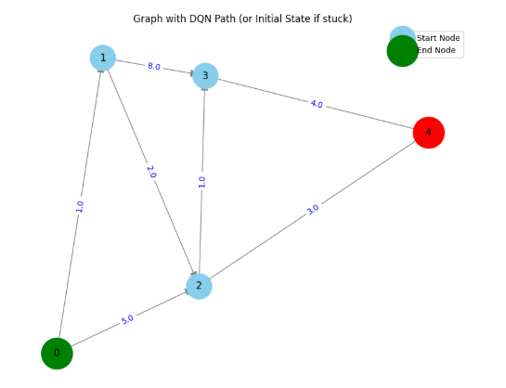

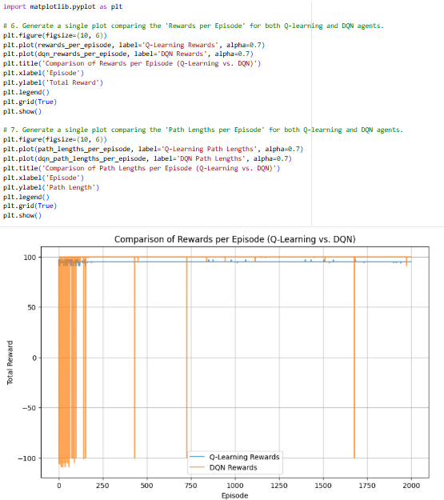

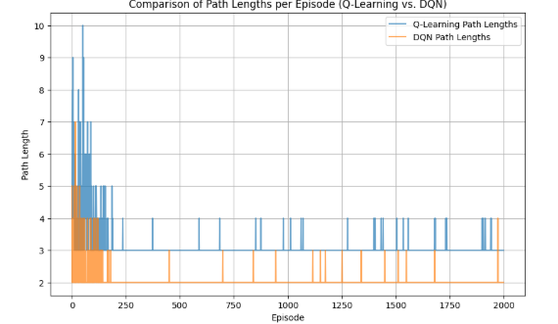

Graph Visualization and Comparison of Q-Learning vs. DQN
In this section, NetworkX and Matplotlib are used to visually analyze the shortest-path results obtained from both Q-Learning and DQN. The graph is first created from the adjacency matrix, where each node represents a graph state and each directed edge represents a valid movement along with its associated cost. Start and end nodes are highlighted in green and red respectively, while all other nodes are shown in sky-blue for clarity. Edge labels display the weights, making it easy to interpret the graph structure.
After plotting the base graph, the optimal path discovered by the Q-Learning agent is superimposed in magenta by connecting consecutive nodes in the learned path. A separate plot is then generated for the DQN agent, where the discovered path (if any) is shown in orange. If DQN fails to identify a complete path due to invalid actions, the visualization indicates that the agent remained stuck at the initial node.
Finally, two comparison plots are produced to evaluate the performance of Q-Learning and DQN across episodes. The first plot compares the total rewards, showing how Q-Learning stabilizes quickly while DQN exhibits more variability because of neural-network approximation. The second plot compares the path lengths, where Q-Learning consistently converges to the optimal length, while DQN sometimes produces shorter but invalid or inconsistent paths. These visualizations clearly highlight the difference in stability, learning behavior, and overall reliability of both RL and DRL methods in the shortest-path problem.

This assignment successfully demonstrates the application of both Reinforcement Learning (RL) and Deep Reinforcement Learning (DRL) techniques across multiple environments. Q-Learning was effectively used to solve the Mountain Car, Roulette, and Shortest Path problems by relying on tabular value updates and exploration strategies. The Deep Q-Network (DQN) approach extended these capabilities by using neural networks to approximate Q-values, enabling learning directly from continuous or high-dimensional state spaces. Through performance graphs, video visualizations, and path comparisons, the results clearly show that while Q-Learning is simple and stable for smaller discrete problems, DQN provides greater flexibility and scalability at the cost of higher complexity and occasional instability. Overall, the assignment highlights the strengths, limitations, and practical differences between RL and DRL methods, offering a complete understanding of how both approaches can be applied to solve diverse decision-making tasks.

