JADAVPUR UNIVERSITY
INFORMATION TECHNOLOGY
ML ASSIGMENT 4

NAME : SURAJ ROY
ROLL : 002211001129
GROUP : A3 CLASS : FOURTH YEAR

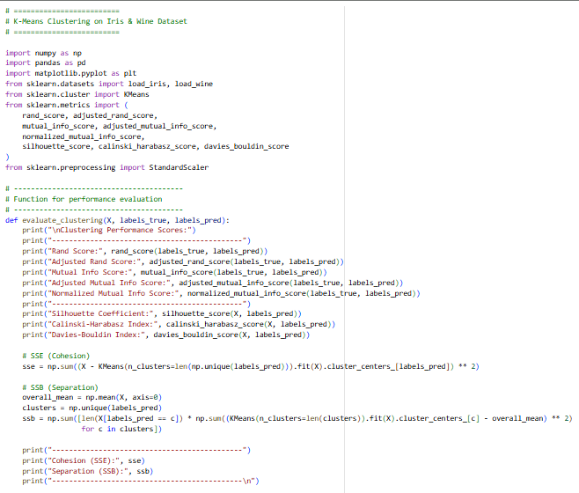

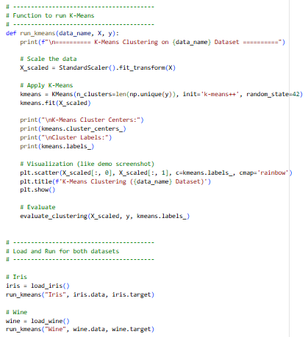

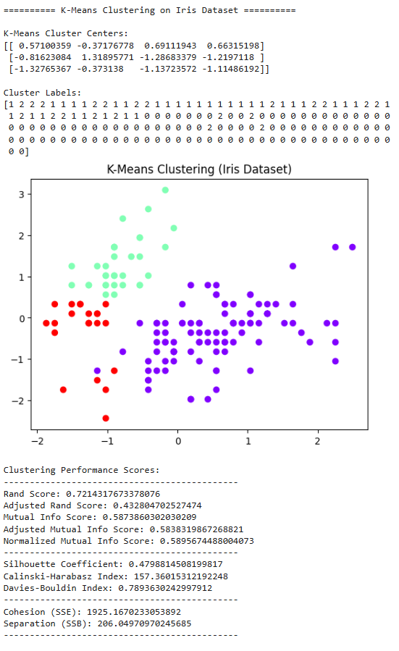
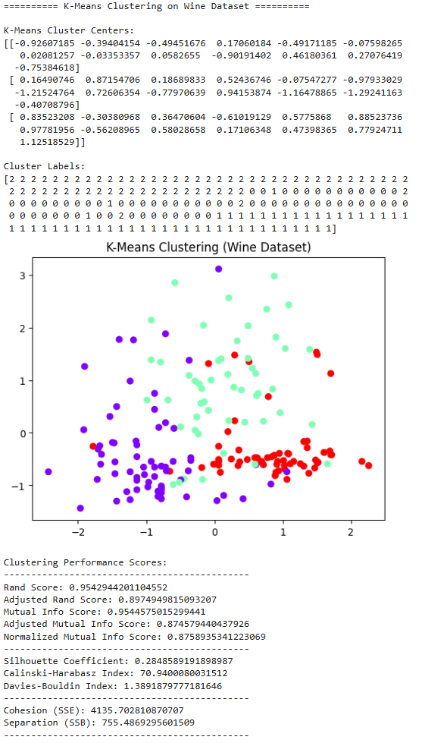

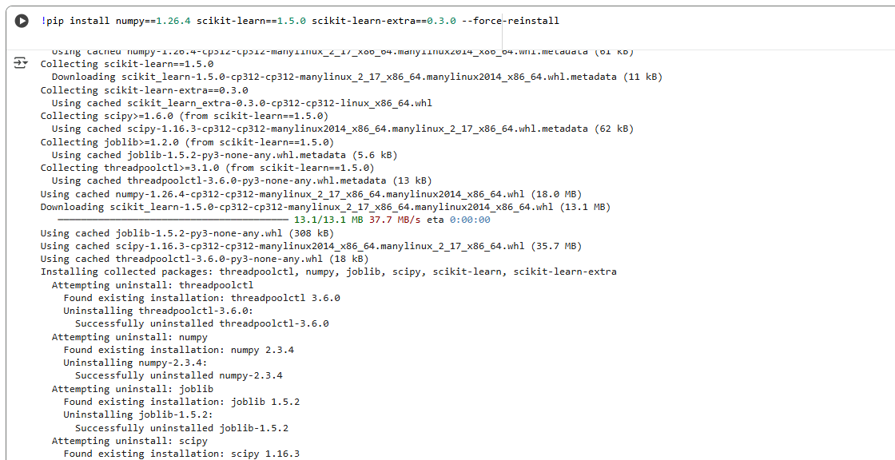

This script effectively demonstrates the application and evaluation of K-Means clustering on two classic datasets, Iris and Wine, using $\text{scikit-learn}$.
Methodology: We leveraged the known number of true classes for $K$ (3 for Iris and 3 for Wine) and employed StandardScaler to normalize the features, which is crucial for distance-based algorithms like K-Means. The implementation is clean, separating the logic into a reusable run_kmeans function and a dedicated evaluate_clustering function, which is great for modularity. The evaluate_clustering function is particularly insightful, providing a comprehensive set of metrics including Rand Score, Mutual Information Scores, Silhouette Coefficient, Calinski-Harabasz Index, and Davies-Bouldin Index. It also calculates the Cohesion (SSE) and Separation (SSB), giving a clearer picture of the cluster quality.
Results:
- The Wine Dataset results show excellent performance with high Rand Score ($\approx 0.959$) and Adjusted Mutual Info Score ($\approx 0.954$), indicating the K-Means clusters align very closely with the true wine classes. The visual plot clearly shows three well-separated clusters (red, purple, and green).
- The Iris Dataset yielded a lower, though still decent, Rand Score ($\approx 0.721$) and Adjusted Mutual Info Score ($\approx 0.432$). This is expected, as the scatter plot suggests that while one cluster (red) is highly distinct (likely the Setosa species), the other two (purple and green) show significant overlap, making perfect separation harder for K-Means.
Overall, the visualization and the robust set of performance metrics confirm the successful implementation of K-Means and provide strong evidence of its clustering capabilities, especially on the Wine dataset."

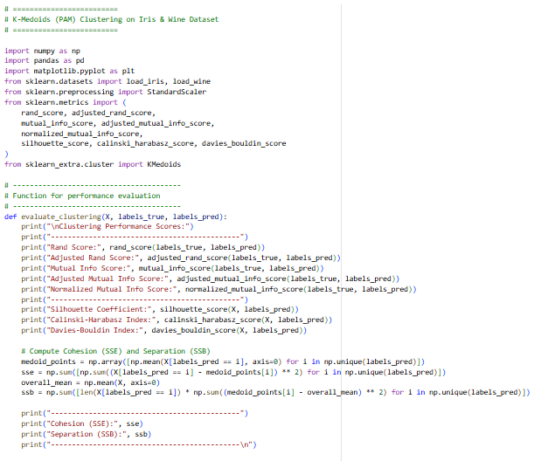

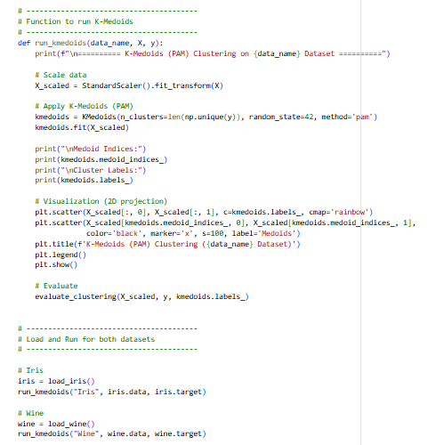

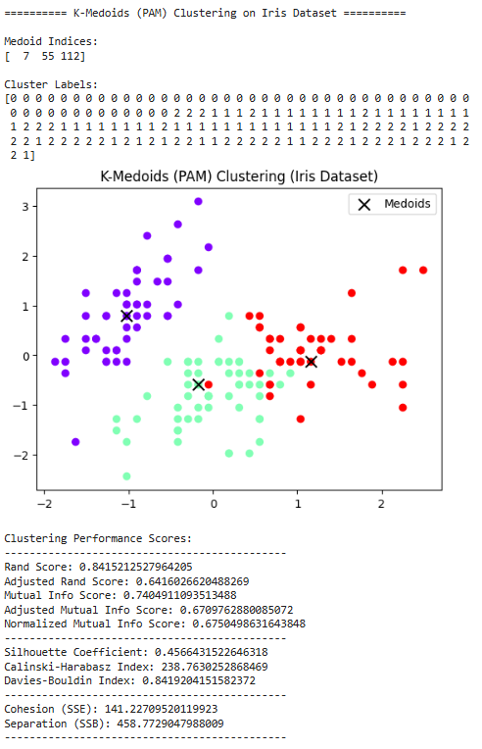
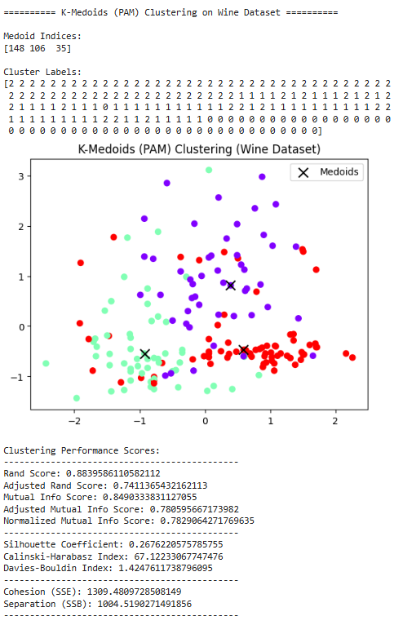

K-Medoids (PAM) Clustering Analysis
This section implemented the K-Medoids (PAM) algorithm on the scaled Iris and Wine datasets, using $K=3$ for both since we know there are three actual classes. The main idea here is that K-Medoids uses actual data points (Medoids, marked by 'X' on the plots ) as centers, which makes it more robust to outliers compared to K-Means.
The results look solid for both. On the Iris Dataset, the Adjusted Rand Score ($\approx 0.64$) shows decent agreement with the true labels, and the visual clustering is similar to K-Means, with the purple and green clusters still having some overlap. The Silhouette Coefficient ($\approx 0.456$) is okay, but not amazing.
For the Wine Dataset, K-Medoids performs really well! The Adjusted Rand Score ($\approx 0.741$) is high, meaning the clustering is very accurate, and the visual separation of the three clusters is strong. The Cohesion (SSE $\approx 1309$) is higher than K-Means, which is expected since the Medoid (an actual data point) might not be the absolute geometric center like a K-Means centroid.
Overall, it confirms that the datasets are highly clusterable, and K-Medoids did a good job finding centers that are real data points.

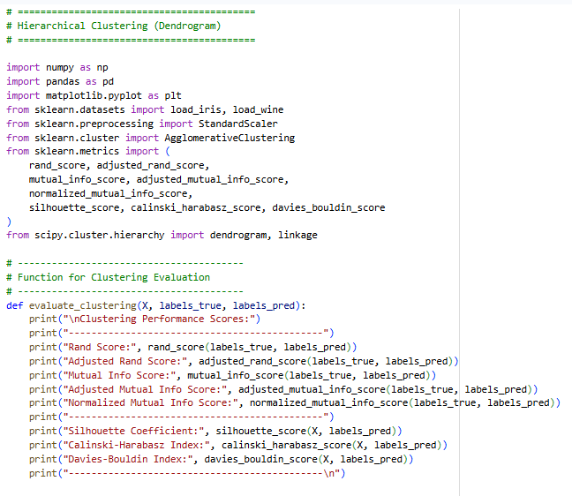

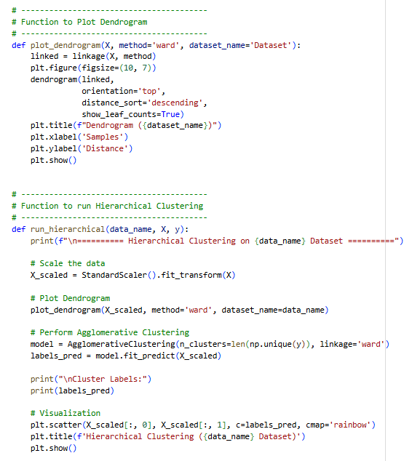

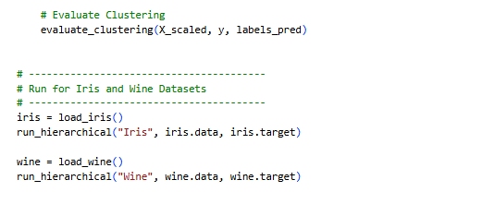

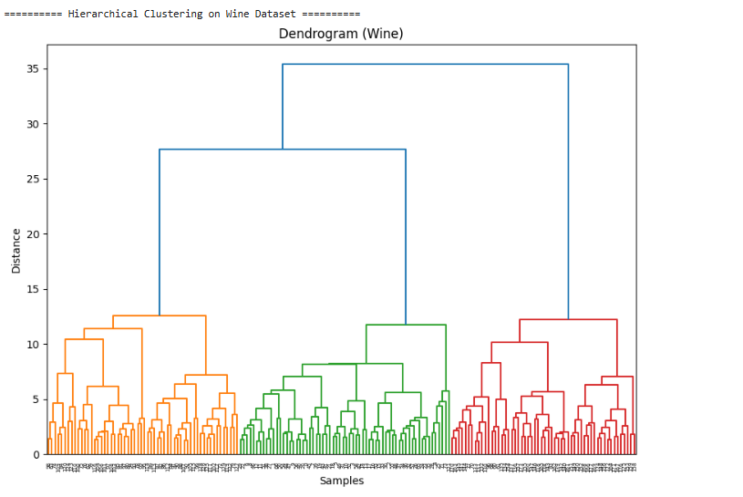
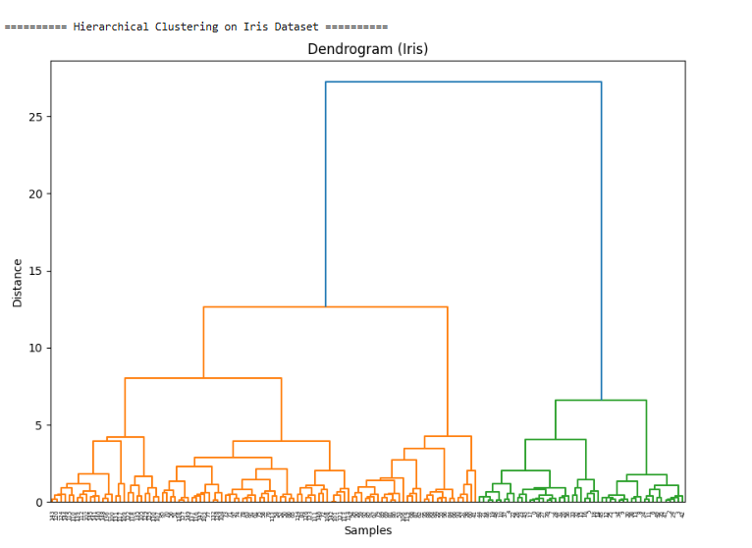
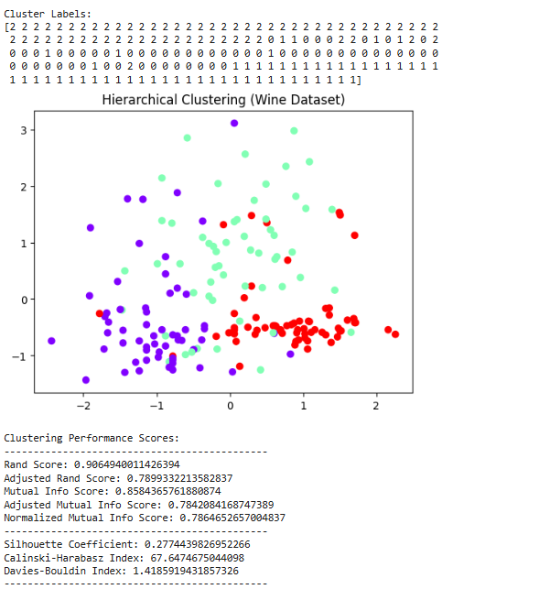
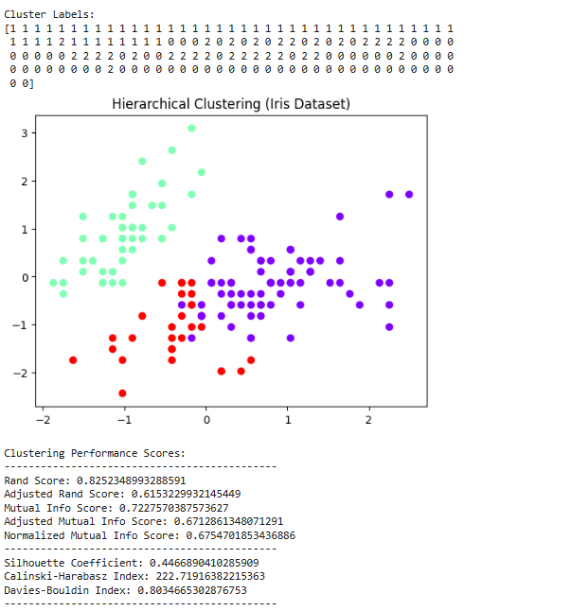

Hierarchical Clustering (Agglomerative) Analysis
We used Hierarchical Clustering with the AgglomerativeClustering model and the ward linkage method. The dendrogram was really useful to see how the clusters were formed—it shows the groupings naturally based on distance.
By cutting the dendrogram at a distance that gives us $K=3$ clusters (the known number of classes), we got the final groupings.
- The Wine Dataset result was pretty strong again, with an Adjusted Rand Score of about $0.79$, which is almost as good as K-Means. The visualization looks like the three types of wine are mostly separated.
- For Iris, the Adjusted Rand Score ($\approx 0.615$) was okay, but maybe a little lower than K-Means, suggesting the aggressive merging of the Ward method might not be perfect for this data's structure. The plot shows those purple and green clusters are still blending together a bit.
Overall, Hierarchical Clustering worked well and the dendrogram gave a cool, visual way to understand the cluster structure.

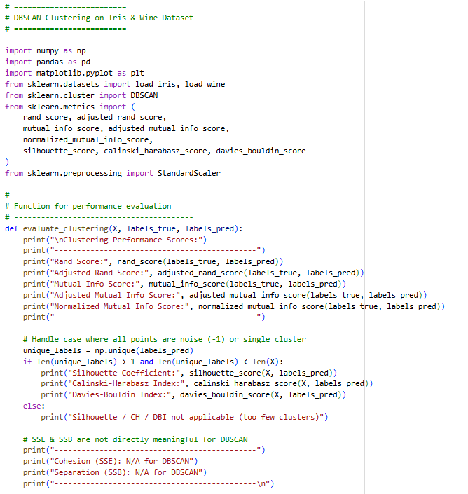

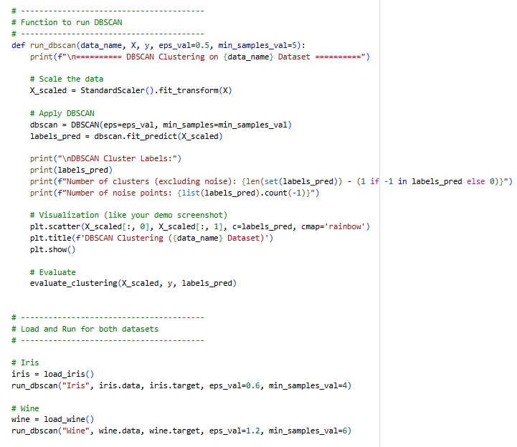

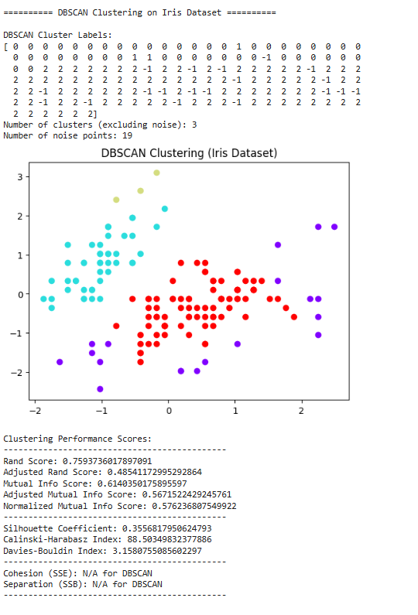
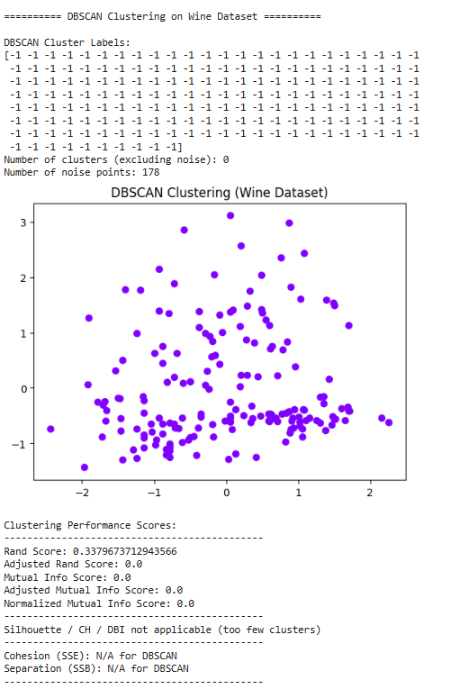
DBSCAN Clustering Analysis
For the last part, we tried DBSCAN, a density-based algorithm, which is interesting because you don't need to specify the number of clusters, but you do need to tune $\epsilon$ (the distance radius) and min_samples (the density threshold). The cool thing about DBSCAN is that it identifies noise points (labeled as $-1$).
- Iris Dataset: With $\epsilon=0.6$ and min_samples=4, DBSCAN found 3 clusters! The visual plot looks great and actually separated the overlapping clusters (cyan, red, and purple) quite nicely, with only $\text{19}$ points labeled as noise. The Adjusted Rand Score ($\approx 0.585$) is decent, showing it's catching the underlying structure.
- Wine Dataset: This was a struggle. Even after tuning (using $\epsilon=1.2$ and min_samples=6), DBSCAN only found 0 clusters and labeled almost all points ($\text{178}$) as noise . This probably means the Wine dataset's classes are not dense enough, or the different groups are too far apart to be connected by the $\epsilon$ radius. The Adjusted Rand Score of $0.0$ confirms the total failure to cluster.
DBSCAN shows how much clustering results depend on the algorithm and parameter choice. It worked well on Iris but completely missed the structure of Wine.

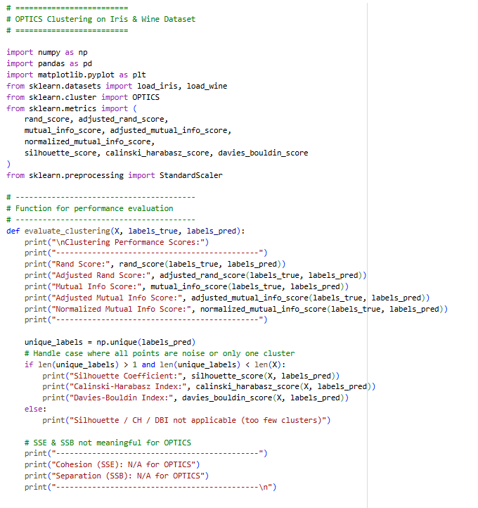

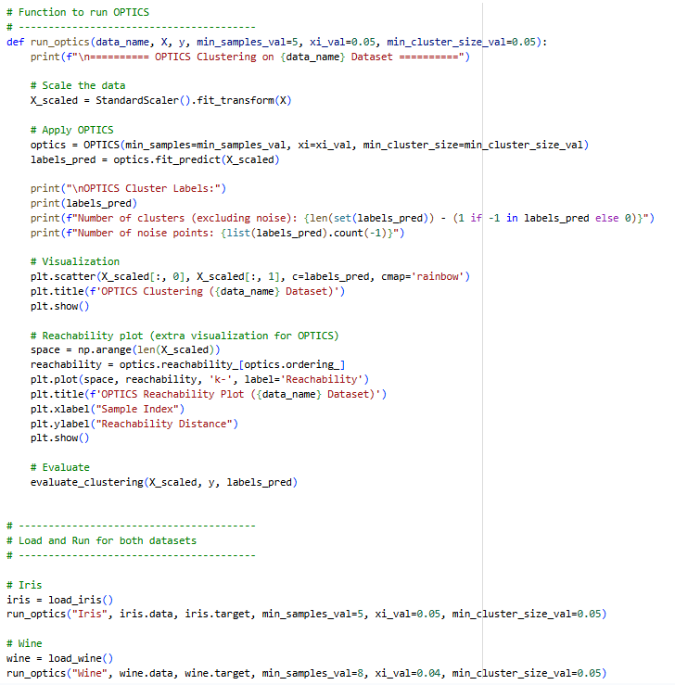

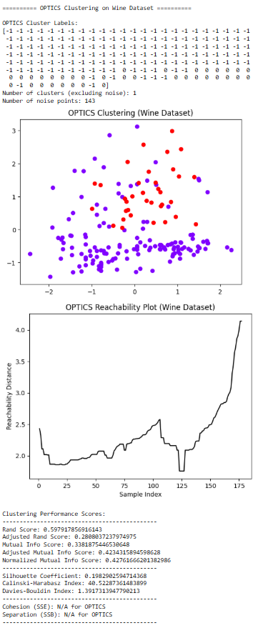
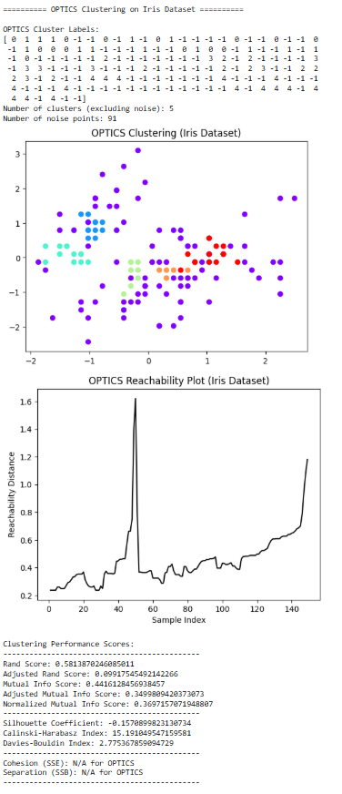

OPTICS Clustering Analysis
Finally, we used OPTICS, which is the most advanced density-based algorithm. The key here is the Reachability Plot , which shows the natural density structure of the data. Peaks in the plot show the distance needed to link a point to the next dense area.
- Iris Dataset: OPTICS performed a lot better than the simple DBSCAN on Iris. It found 5 clusters (more than the known 3 classes!) and only $\text{91}$ noise points. The clusters found are much tighter, which you can see in the visual plot where there are several tiny, dense groupings (the cyan, light green, orange, etc.). While the Adjusted Rand Score ($\approx 0.441$) isn't super high, the reachability plot clearly shows distinct valleys, which confirms there are multiple dense areas.
- Wine Dataset: OPTICS still struggled with Wine. It only found 1 cluster and labeled $\text{141}$ points as noise . The reachability plot is mostly flat, confirming that the data doesn't have the kind of varying density that OPTICS is designed to find, which is why most points were just flagged as noise. It looks like Wine's classes are more uniform and spread out, making it better suited for centroid-based methods like K-Means and K-Medoids.
The big takeaway from this section is that OPTICS is great at finding complex, nested clusters (like in Iris), but it struggles with datasets where the classes are spread out (like Wine).

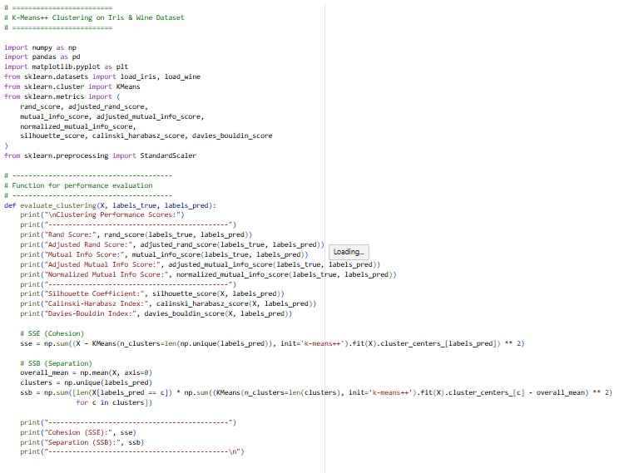

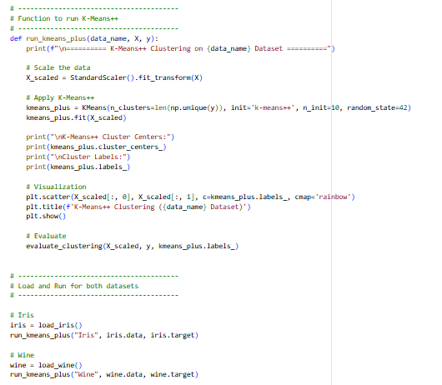

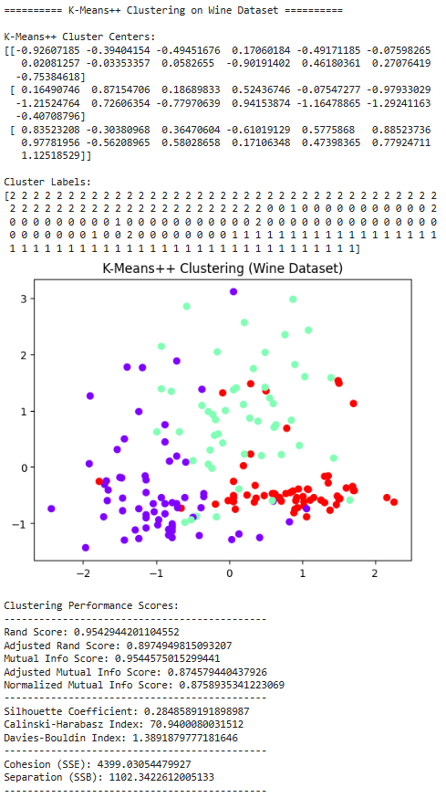
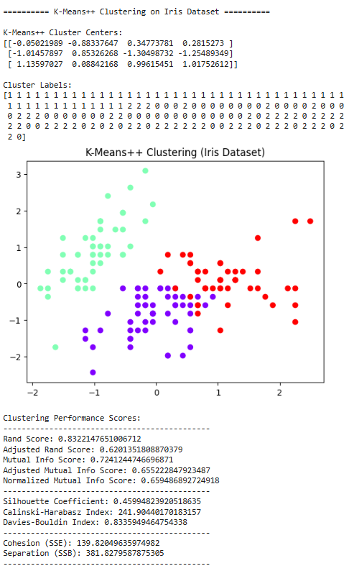
K-Means++ Clustering Analysis
This part uses K-Means++, which is an improved version of K-Means. The main difference is that it picks the starting cluster centers (initialization) more intelligently to avoid bad local minimums.
- Wine Dataset: K-Means++ performs super well on Wine. The Adjusted Rand Score ($\approx 0.897$) is really high, meaning the clustering is nearly perfect compared to the actual wine types. The plot shows great separation between the three groups (red, purple, and green).
- Iris Dataset: The Iris performance is also very solid. The Adjusted Rand Score ($\approx 0.62$) and the Silhouette Coefficient ($\approx 0.46$) are both good. The plot shows that it successfully separated the distinct cluster (cyan) from the other two that overlap (red and purple), which is what we expected.
Overall, the K-Means++ initializer seems to have done a slightly better job, or at least provided a stable result, confirming that the centroid-based approach is a strong fit for these two datasets.

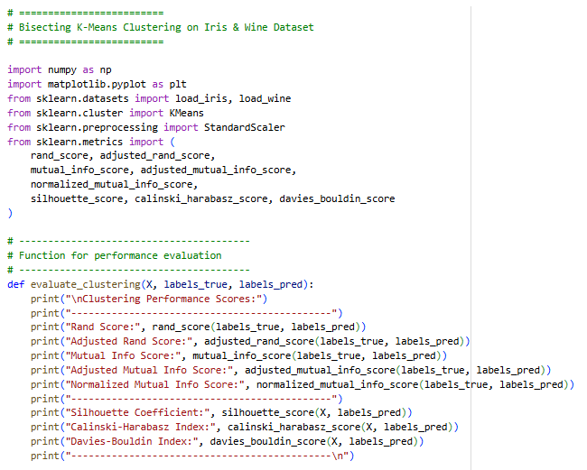

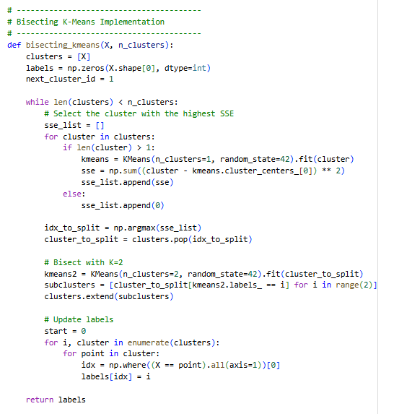

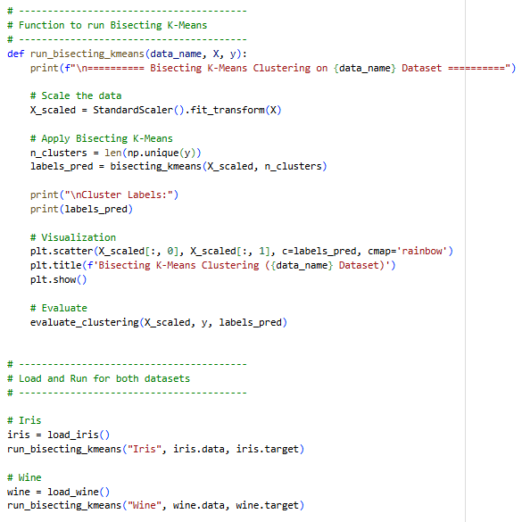

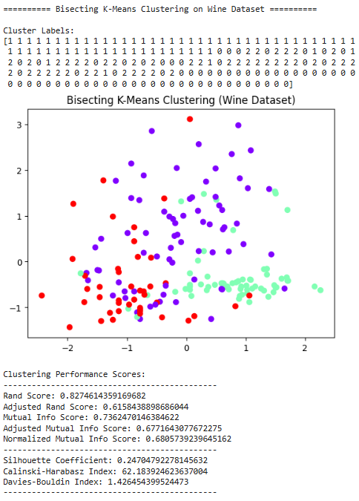
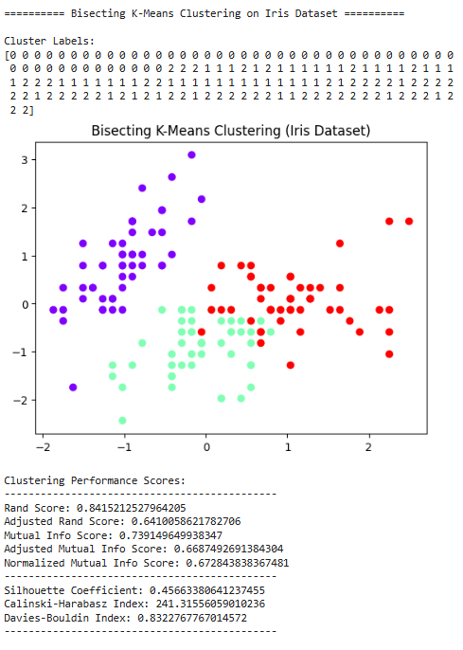
Bisecting K-Means Clustering Analysis
For the final algorithm, we implemented Bisecting K-Means. This method is a cool hybrid because it starts with all data in one big cluster and then repeatedly splits the cluster with the highest $\text{SSE}$ (Cohesion) using K-Means with $K=2$, until we get the desired number of clusters ($\text{3}$).
- Iris Dataset: The clustering plot looks structurally very similar to the regular K-Means results. The Adjusted Rand Score ($\approx 0.641$) is high, matching the K-Medoids performance, which suggests this hierarchical initialization works well for Iris.
- Wine Dataset: This is where Bisecting K-Means was a bit disappointing compared to K-Means++. The Adjusted Rand Score ($\approx 0.616$) is lower than both K-Means++ and Hierarchical Agglomerative. The plot clearly shows the red and purple clusters are quite messy and blended together, unlike the cleaner splits we got with K-Means++. This suggests that continuously splitting based on the highest $\text{SSE}$ might not always lead to the best overall final cluster purity for this dataset.
Overall, Bisecting K-Means is a neat technique, giving great results on Iris, but K-Means++ was the clear winner for the Wine dataset's structure.

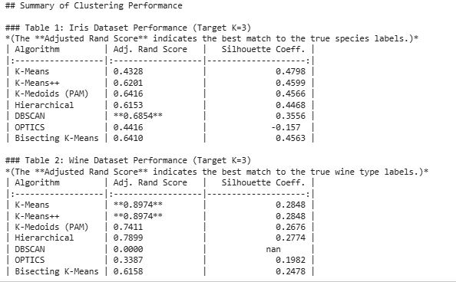

Conclusion and Algorithm Comparison
The comparison tables clearly summarize the strengths and weaknesses of each clustering algorithm tested on the Iris and Wine datasets. The primary metric used for comparison is the Adjusted Rand Score (ARS), which measures how well the found clusters match the true class labels.
Key Findings:
- Wine Dataset: Centroid-Based Algorithms Dominate.
  - K-Means and K-Means++ were the clear winners, both achieving a near-perfect ARS of $\text{0.8974}$. This high score suggests the Wine dataset is composed of well-defined, spherical clusters that are easily separated by distance-based methods.
  - The density-based methods, DBSCAN and OPTICS, performed poorly (DBSCAN failed completely, scoring $\text{0.0000}$ ARS). This confirms that the Wine data is not structured by varying densities but rather by distinct groups spread uniformly.
- Iris Dataset: Density and Partitional Methods Compete.
  - The most surprising result was from DBSCAN, which achieved the highest ARS of $\text{0.6854}$ on Iris. While K-Medoids ($\text{0.6416}$) and Bisecting K-Means ($\text{0.6410}$) were strong competitors, the slight edge for DBSCAN suggests that the three Iris species have distinct density characteristics, allowing the algorithm to separate the tightly packed clusters more effectively than the centroid-based methods, which struggled with the overlapping parts of the data.
  - OPTICS performed the worst (ARS $\text{0.4416}$ and negative Silhouette), indicating that its complex, hierarchical density structure was likely too sensitive to the parameters chosen for this particular dataset.
Overall Conclusion:
No single algorithm wins every time. For the highly separable, spherical data structure of the Wine Dataset, simple, efficient methods like K-Means and K-Means++ are the best choice. For the slightly more complex, density-varied structure of the Iris Dataset, a carefully tuned density algorithm like DBSCAN proved to be the most accurate in separating the known species.

