Chapter No. 1

**INTRODUCTION**

In this era, data is biggest asset one can hold. This is why it is taken as one of the

most important assets of an organisation. Hence if the data is accurate, complete,

organised and consistent, it will contribute to the growth of the organisation. And

considering the case of the opposite, it would become a very big liability. In addition,

the amount of data connected to an organisation today is on an unprecedented scale

and impossible to process manually; this is why it is important to invest in an effective

data management system.

A Data management system is important because they provide a highly efficient

method for handling multiple types of data. Data management involves collection,

storage, organization, security, verification, and processing of essential data and

making it available to your organization. There are different steps that are part of the

overall data management process, from data processing and storage to governance of

how data is formatted and used in operational and analytical systems.

A data architecture is designed and deployed with database systems and other

types of repositories for an organisations data. Data models are then created to map

workflows and the relationships in data sets so that the information can be organized

to meet business needs. Data is generated, processed and stored in a database, file

system, cloud object storage service, or other data repositories. Data quality checks

are done to identify data errors and inconsistencies so they can be resolved.

An effective data management solution can help you achieve each of these best

practices.

In this era, data is biggest asset one can hold. This is why it is taken as one of the

most important assets of an organisation. Hence if the data is accurate, complete,

organised and consistent, it will contribute to the growth of the organisation. And

considering the case of the opposite, it would become a very big liability. In addition,

the amount of data connected to an organisation today is on an unprecedented scale

and impossible to process manually; this is why it is important to invest in an effective

data management system.

A Data management system is important because they provide a highly efficient

method for handling multiple types of data. Data management involves collection,

storage, organization, security, verification, and processing of essential data and

making it available to your organization. There are different steps that are part of the

overall data management process, from data processing and storage to governance of

how data is formatted and used in operational and analytical systems.

A data architecture is designed and deployed with database systems and other

types of repositories for an organisations data. Data models are then created to map

workflows and the relationships in data sets so that the information can be organized

to meet business needs. Data is generated, processed and stored in a database, file

system, cloud object storage service, or other data repositories. Data quality checks

are done to identify data errors and inconsistencies so they can be resolved.

An effective data management solution can help you achieve each of these best

practices.

In this era, data is biggest asset one can hold. This is why it is taken as one of the

most important assets of an organisation. Hence if the data is accurate, complete,

organised and consistent, it will contribute to the growth of the organisation. And

considering the case of the opposite, it would become a very big liability. In addition,

the amount of data connected to an organisation today is on an unprecedented scale

and impossible to process manually; this is why it is important to invest in an effective

data management system.

A Data management system is important because they provide a highly efficient

method for handling multiple types of data. Data management involves collection,

storage, organization, security, verification, and processing of essential data and

making it available to your organization. There are different steps that are part of the

overall data management process, from data processing and storage to governance of

how data is formatted and used in operational and analytical systems.

A data architecture is designed and deployed with database systems and other

types of repositories for an organisations data. Data models are then created to map

workflows and the relationships in data sets so that the information can be organized

to meet business needs. Data is generated, processed and stored in a database, file

system, cloud object storage service, or other data repositories. Data quality checks

are done to identify data errors and inconsistencies so they can be resolved.

An effective data management solution can help you achieve each of these best

practices.

In this era, data is biggest asset one can hold. This is why it is taken as one of the

most important assets of an organisation. Hence if the data is accurate, complete,

organised and consistent, it will contribute to the growth of the organisation. And

considering the case of the opposite, it would become a very big liability. In addition,

the amount of data connected to an organisation today is on an unprecedented scale

and impossible to process manually; this is why it is important to invest in an effective

data management system.

A Data management system is important because they provide a highly efficient

method for handling multiple types of data. Data management involves collection,

storage, organization, security, verification, and processing of essential data and

making it available to your organization. There are different steps that are part of the

overall data management process, from data processing and storage to governance of

how data is formatted and used in operational and analytical systems.

A data architecture is designed and deployed with database systems and other

types of repositories for an organisations data. Data models are then created to map

workflows and the relationships in data sets so that the information can be organized

to meet business needs. Data is generated, processed and stored in a database, file

system, cloud object storage service, or other data repositories. Data quality checks

are done to identify data errors and inconsistencies so they can be resolved.

An effective data management solution can help you achieve each of these best

practices.

In this era, data is biggest asset one can hold. This is why it is taken as one of the

most important assets of an organisation. Hence if the data is accurate, complete,

organised and consistent, it will contribute to the growth of the organisation. And

considering the case of the opposite, it would become a very big liability. In addition,

the amount of data connected to an organisation today is on an unprecedented scale

and impossible to process manually; this is why it is important to invest in an effective

data management system.

A Data management system is important because they provide a highly efficient

method for handling multiple types of data. Data management involves collection,

storage, organization, security, verification, and processing of essential data and

making it available to your organization. There are different steps that are part of the

overall data management process, from data processing and storage to governance of

how data is formatted and used in operational and analytical systems.

A data architecture is designed and deployed with database systems and other

types of repositories for an organisations data. Data models are then created to map

workflows and the relationships in data sets so that the information can be organized

to meet business needs. Data is generated, processed and stored in a database, file

system, cloud object storage service, or other data repositories. Data quality checks

are done to identify data errors and inconsistencies so they can be resolved.

An effective data management solution can help you achieve each of these best

practices.

In this era, data is biggest asset one can hold. This is why it is taken as one of the

most important assets of an organisation. Hence if the data is accurate, complete,

organised and consistent, it will contribute to the growth of the organisation. And

considering the case of the opposite, it would become a very big liability. In addition,

the amount of data connected to an organisation today is on an unprecedented scale

and impossible to process manually; this is why it is important to invest in an effective

data management system.

A Data management system is important because they provide a highly efficient

method for handling multiple types of data. Data management involves collection,

storage, organization, security, verification, and processing of essential data and

making it available to your organization. There are different steps that are part of the

overall data management process, from data processing and storage to governance of

how data is formatted and used in operational and analytical systems.

A data architecture is designed and deployed with database systems and other

types of repositories for an organisations data. Data models are then created to map

workflows and the relationships in data sets so that the information can be organized

to meet business needs. Data is generated, processed and stored in a database, file

system, cloud object storage service, or other data repositories. Data quality checks

are done to identify data errors and inconsistencies so they can be resolved.

An effective data management solution can help you achieve each of these best

practices.

In this era, data is biggest asset one can hold.

This is why it is taken as one of the most important assets of an organisation. Hence if the data is accurate, complete, organised and consistent, it will contribute to the growth of the organisation. And considering the case of the opposite, it would become a very big liability.

In addition, the amount of data connected to an organisation today is on an unprecedented scale and impossible to process manually; this is why it is important to invest in an effective data management system. A Data management system is important because they provide a highly efficient method for handling multiple types of data. Data management involves collection, storage, organization, security, verification, and processing of essential data and making it available to your organization.

There are different steps that are part of the overall **data management process**, from data processing and storage to governance of how data is formatted and used in operational and analytical systems. A data architecture is designed and deployed with database systems and other types of repositories for an organisations data. Data models are then created to map workflows and the relationships in data sets so that the information can be organized to meet business needs. **Data** is generated, processed and stored in a database, file system, cloud object storage service, or other data repositories.

**Objectives:**

1. Create a user-friendly graphical interface for managing different systems within an organization.

2. Develop a login interface that allows users to select a specific management system based on their role.

3. Implement a secure login mechanism to authenticate users using username and password credentials.

4. Provide a welcoming message upon successful login, indicating the selected management system.

5. Open corresponding management scripts based on the user's selection to facilitate system-specific tasks.

6. Enhance the usability of the interface by incorporating visually appealing elements, such as images and background.

7. Validate user input to ensure that required fields are not left empty.

8. Display error messages for invalid credentials or missing input fields to guide users.

9. Utilize sound effects to provide a more engaging user experience during login.

10. Enable the application to be run on different screen resolutions by setting a fixed window size.

**Problem Statement:**

Problem Statement: Design and implement a user-friendly graphical interface and management system selection mechanism that allows users to securely access and manage different systems within an organization.

**Description**:

Our organization requires a centralized platform to manage various systems efficiently. The current manual processes are time-consuming and prone to errors. Therefore, we need to develop a solution that simplifies the management tasks by providing a user-friendly graphical interface and secure login mechanism.

The solution should include the following features:

1. Graphical Interface: Design an intuitive and visually appealing interface using Tkinter library that enhances user experience.

2. Login System: Implement a secure login system where users can enter their credentials (username and password) to access the management system.

3. System Selection: Allow users to select a specific management system (e.g., Student, Hospital, Vehicle) from a dropdown menu.

4. Authentication: Validate user credentials to ensure authorized access to the selected system.

5. Error Handling: Display appropriate error messages when incorrect credentials are entered or required fields are left empty.

6. Welcome Message: Upon successful login, provide users with a welcoming message indicating the selected management system.

7. Script Execution: Open the corresponding management script based on the user's selection to facilitate system-specific tasks.

**Organizational Structure of the Project:**

1. Project Overview:

- Provide a brief overview of the project, including its purpose, goals, and intended outcomes.

- Define the scope of the project and identify key stakeholders involved.

2. Requirements Analysis:

- Gather and analyze the requirements for the graphical interface and management system.

- Identify the functionalities, features, and user interactions required for the system.

- Create a detailed requirements document outlining the project's specifications.

3. Design Phase:

- Design the graphical interface, including layout, color scheme, and visual elements.

- Define the login mechanism and system selection components.

- Plan the user flow and navigation within the interface.

- Specify the data validation and error handling processes.

- Document the design decisions and create mockups or wireframes to visualize the interface.

4. Development Phase:

- Set up the development environment with the required libraries and tools.

- Implement the graphical interface using Tkinter, including the login and system selection components.

- Integrate the sound effects functionality.

- Develop the logic to validate user input, authenticate credentials, and handle errors.

Chapter No. 2

**LITERATURE SURVEY**

1. Introduction:

- Provide an overview of the purpose and objectives of the literature survey.

- Clearly define the scope and boundaries of the survey.

2. Graphical User Interfaces:

- Discuss the principles and best practices for designing user-friendly graphical interfaces.

- Explore relevant literature on interface layout, color schemes, visual elements, and usability.

3. Management Systems:

- Explore literature related to management systems in various domains (e.g., education, healthcare, transportation).

4. Tkinter and GUI Development:

- Review literature on the Tkinter library and its capabilities for GUI development in Python.

5. Login and Authentication:

- Investigate literature on secure login mechanisms, authentication protocols, and user credential

6. Error Handling and Validation:

- Discuss literature on error handling techniques in GUI applications.

Chapter No. 3

**Methodology**

Methodology for the **Interface.py :**

1. Requirements Gathering:

- Identify the project requirements and goals by understanding the purpose and scope of the code.

2. Design:

- Design the graphical interface by selecting appropriate visual elements, colors, and layout.

3. Development:

- Set up the development environment with the necessary dependencies, including Tkinter and pygame.

4. Testing and Debugging:

- Conduct thorough testing of the code to ensure proper functionality and user experience

5. User Feedback and Iteration:

- Gather feedback from users or stakeholders on the usability and functionality of the code.

- Incorporate user feedback into the codebase, making improvements and refinements as necessary.

**ER Diagram:**

Username Gender

Image PhoneNo Stud_Name

Password Student Email

Interface Manages Patient_Name

Hospital

Have

PhoneN_No Gender

Bg_image

INTERFACE VIEW:

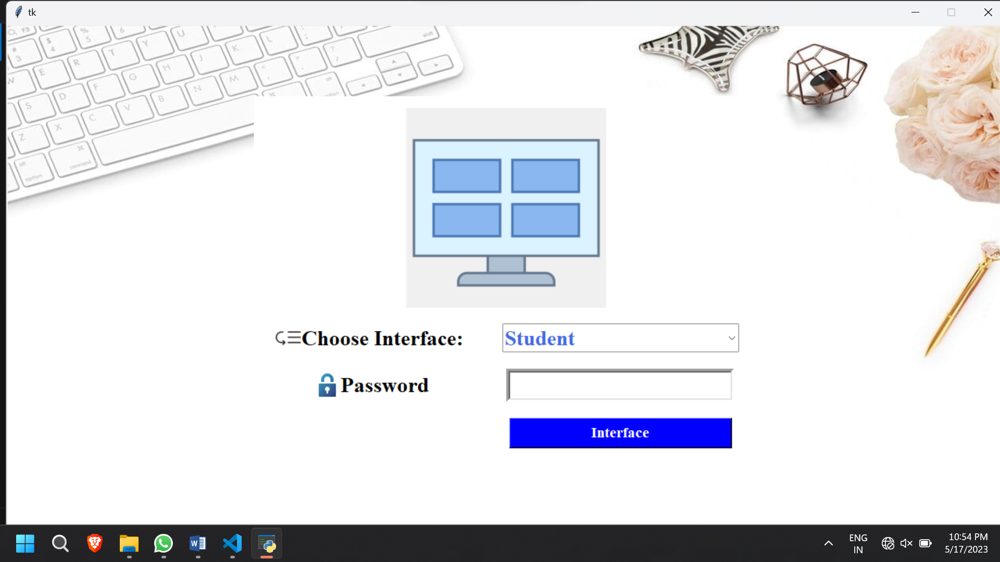

__________________________________________________

SELECT INTERFACE

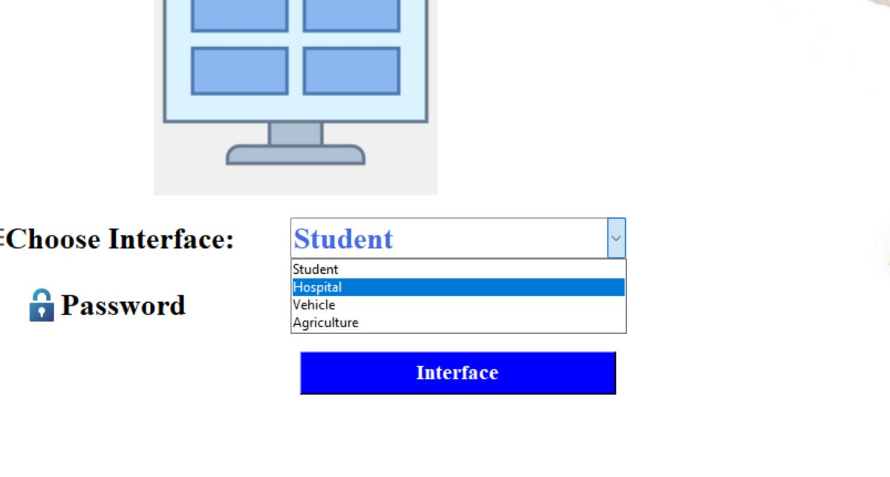

Select Database with HOST Name

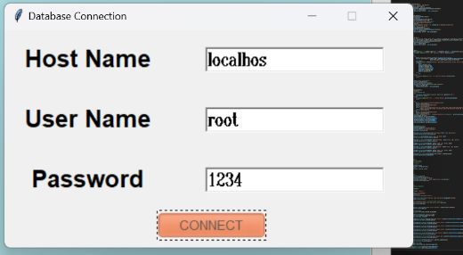

Adding Student info

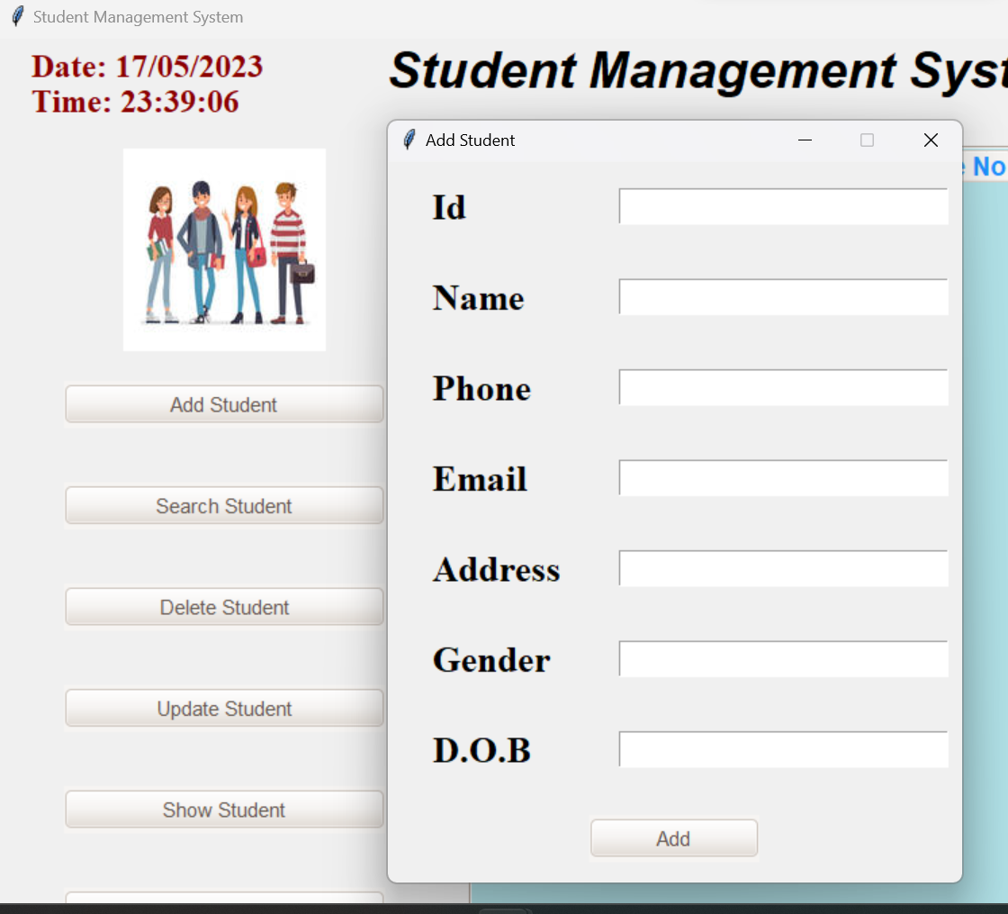

Interface of Student management System

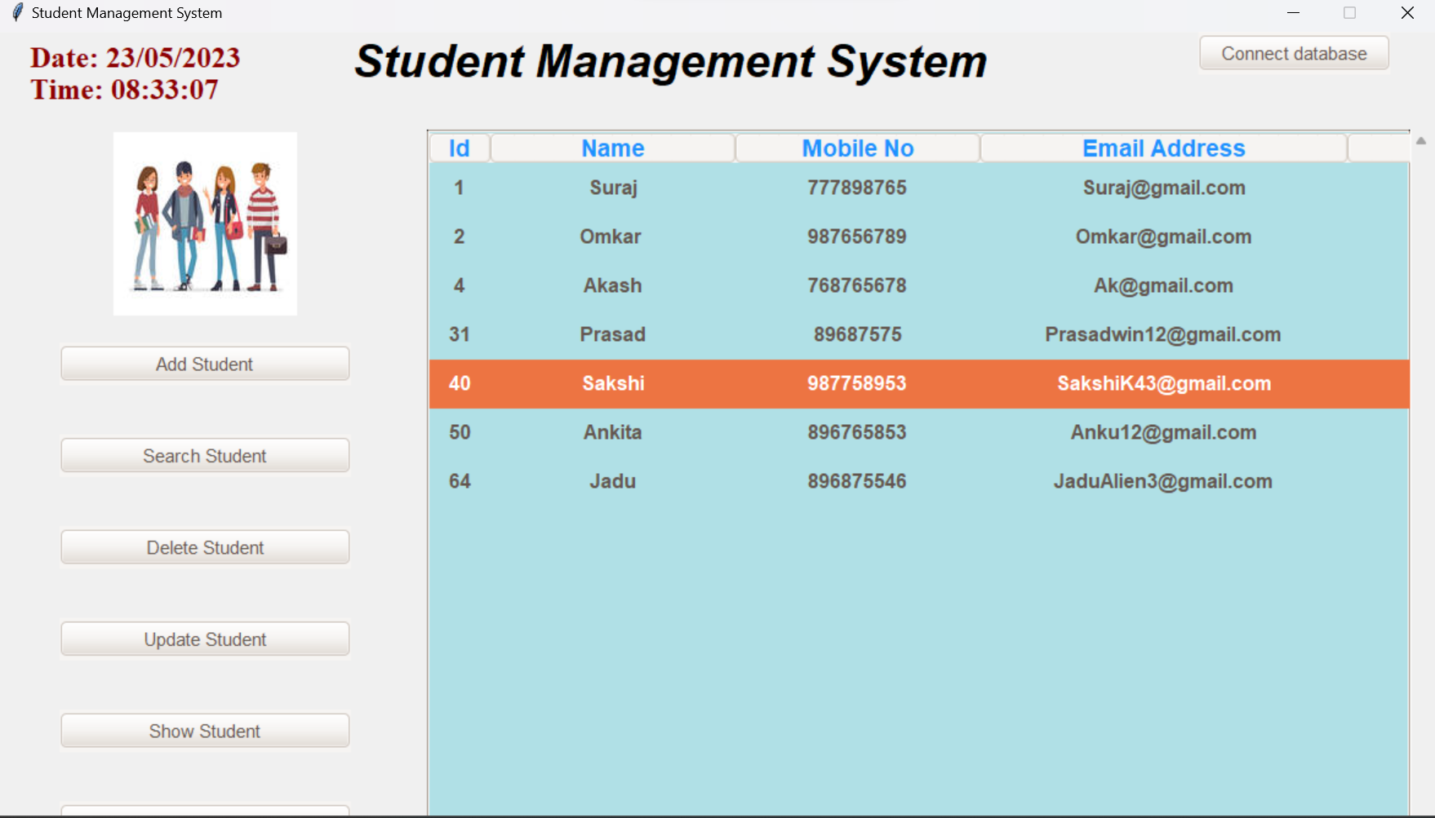

DATABASE Connected:

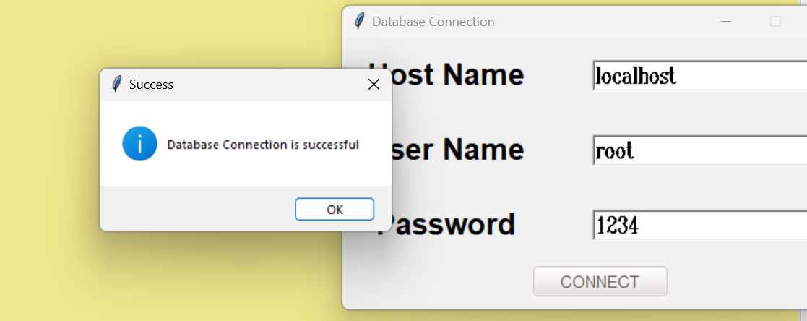

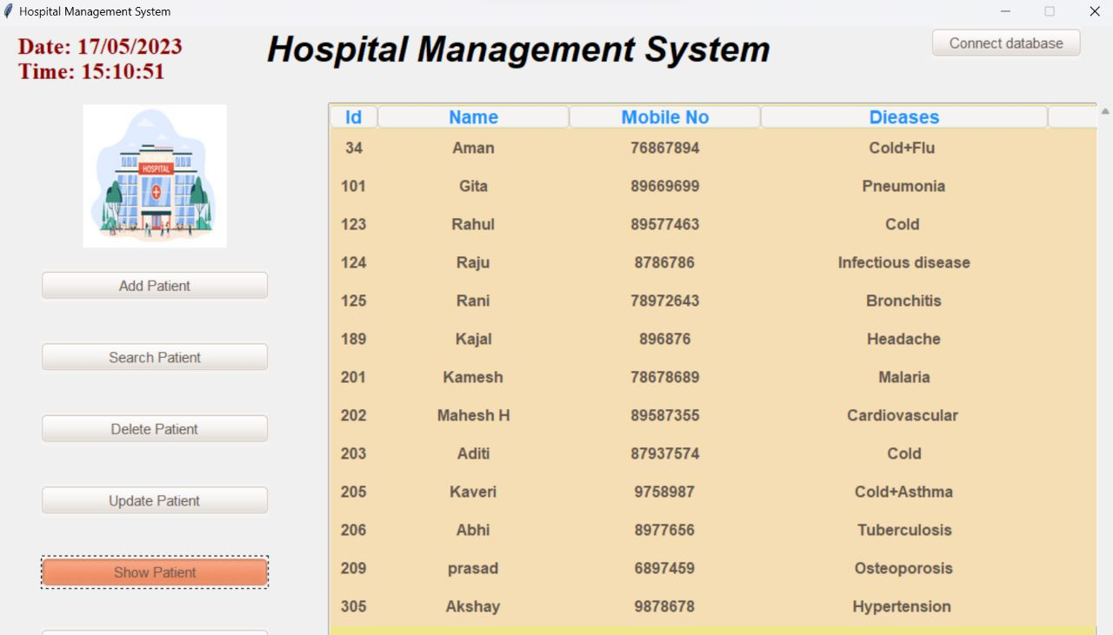-------------------------------------------------------------------------------------------------------------------------------------

Chapter No. 4

**SOFTWARE / HARDWARE**

**IMPLEMENTATION**

The software implementation of the given codes involves the development and execution of a graphical user interface (GUI) application using the Tkinter library in Python. The software provides functionality for managing different aspects such as vehicle, student, and hospital information. It consists of two separate code files.

1. Main Interface:

- This code creates a main window using the Tkinter library.

- It defines a function called "Interface" that handles user login and interface selection based on the entered credentials.

- The main window includes background image, login frame, logo, username entry, password entry, and login button.

2. Student Management:

- This code is responsible for managing student information.

- It defines various functions for adding, updating, deleting, and searching student data.

- The code utilizes the Tkinter library to create a graphical user interface for interacting with the user.

**HARDWARE IMPLEMENTATION THEORY:**

The given codes primarily focus on software implementation; however, hardware implementation can be incorporated to enhance the overall system functionality. Hardware implementation involves integrating physical devices or components with the software to enable specific features or interactions. Here are some hardware implementation ideas:

1. Computer: This project required a very less H/W but the most important is Computer. Computer help to create, manipulate the all processes.
2. Keyboard: For the typing purpose, the keyboard is required

**ADVANTAGES, DISADVANTAGES**

**AND APPLICATIONS**

**Student Management**

**Advantages**:

- Centralized storage and management of student data.

- Efficient enrollment and registration processes.

**Disadvantages**:

- Initial setup and data entry can be time-consuming.

- May require continuous updates to reflect changes in student information.

**Applications**:

- Schools and educational institutions.

- Colleges and universities.

**Hospital Patient Management System:**

**Advantages:**

- Efficient management of patient records and medical histories.

- Streamlined appointment scheduling and tracking.

**Disadvantages:**

- Initial setup and integration with existing hospital systems can be complex.

- Relies on accurate data entry, which may introduce errors.

**CONCLUSION**

In conclusion, the vehicle management system, student information system, and hospital patient management system are valuable software solutions designed to streamline and enhance specific operations within their respective domains. Each of these codes offers unique advantages, alongside some inherent limitations, and finds applications in various industries.

The student information system offers centralized storage and management of student data, simplifying enrollment, grading, and communication processes. Though initial setup and data entry can be time-consuming, it greatly benefits educational institutions, online learning platforms, and student counseling centers.

Overall, these codes provide valuable tools for automating and streamlining processes, ultimately benefiting the organizations that adopt them and the users who interact with the systems. Continued development and refinement of such software solutions contribute to advancing efficiency and productivity in various industries

**REFERENCES:**

1. <https://chat.openai.com/> - OpenAI ChatGPT_2021_098444D3r9
2. <https://pythontutor.com/> - Python tutor_
3. <https://en.wikipedia.org/wiki/SQL> - Wikipedia Sql Information
4. <https://en.wikipedia.org/wiki/Python> - Wikipedia Python Information
5. <https://www.simplilearn.com/top-python-libraries-for-data-science-article> - Python libraries for data science
6. <https://learn.microsoft.com/en-us/sql/ssms/download-sql-server-management-studio-ssms?view=sql-server-ver16> – SQL Database-Server
7. <https://www.sqlmanager.net/products/mssql/manager> - Server Management info
8. <https://www.youtube.com/results?search_query=python+sql+projects> – YouTube Ideas and Learn