Title
Building an LLM-Powered AI Chatbot using Python and Qwen 2.5
Aim
To understand the fundamentals of Generative AI and Large Language Models (LLMs) by developing a Python-based AI chatbot using the Qwen2.5-1.5B-Instruct open-source language model running directly in the Google Colab environment.
Objectives
- To understand the basic concepts of Generative AI and Large Language Models.
- To understand how LLMs process user input and generate natural-language responses.
- To learn about tokens and tokenization.
- To implement a working AI chatbot using Python.
- To use the Hugging Face Transformers library for loading and interacting with an LLM.
- To run an open-source LLM using Google Colab's GPU.
- To implement basic conversation memory so that the chatbot can maintain the conversation context.
- To develop a chatbot without depending on a paid cloud-based API.

Theory & Background Knowledge

Before understanding the implementation, it is important to understand the basic concepts behind the AI chatbot.

1. Generative AI
- Generative AI refers to artificial intelligence systems that can generate new content based on the input provided by the user. The generated content can include text, code, images, audio, and other forms of data.
- In this project, Generative AI is used to generate natural-language responses to questions asked by the user.

2. Large Language Model (LLM)
- A Large Language Model is an AI model trained on a large amount of text data. It learns patterns in language and can generate meaningful responses based on the given input.
- In our project, we use the Qwen2.5-1.5B-Instruct model. It is an instruction-tuned language model designed to follow user instructions and generate useful responses.

3. Transformer Architecture
- Modern LLMs such as Qwen are based on the Transformer architecture.
- Transformers use a mechanism called self-attention to understand the relationship between different parts of the input text. This allows the model to understand context and generate appropriate responses.

4. Tokens and Tokenization
- LLMs do not directly process complete sentences as humans do. They process smaller units called tokens.
- Tokenization is the process of converting text into tokens that can be understood by the language model.

5. Parameters
- Parameters are the internal values learned by an AI model during its training process.
- The Qwen2.5-1.5B-Instruct model contains approximately 1.5 billion parameters. These parameters help the model understand language patterns and generate responses.

6. Inference
- Inference is the process in which a trained AI model receives input and generates an output.
In our project:

User Question
↓
Tokenization
↓
Qwen LLM
↓
Text Generation
↓
Decoded Answer
7. Conversation Context
A chatbot can maintain previous messages as conversation context.
For example:
User: What is Java?
Bot: Java is a programming language.

User: What is it used for?
Bot: Java is used for application development...
Overview
This project demonstrates how to build a simple LLM-powered AI chatbot using Python in Google Colab.
Unlike API-based chatbot implementations, this project loads the open-source Qwen2.5-1.5B-Instruct model directly into the Google Colab environment.
The main technologies used are:
- Python
- Google Colab
- PyTorch
- Hugging Face Transformers
- Qwen2.5-1.5B-Instruct
- Google Colab Tesla T4 GPU
The chatbot accepts questions from the user, processes them using the Qwen language model, and generates an AI-based response.
Prerequisites & Environment Setup
The following environment is required to run the project.
Required Software
- Google Account
- Google Colab
- Python
- PyTorch
- Hugging Face Transformers
Hardware
The project can use a GPU available in Google Colab.
In our implementation, the model was successfully executed using:
GPU: Tesla T4
PyTorch: 2.11.0+cu128
Using a GPU makes LLM inference faster compared with CPU execution.

Installing Required Libraries
The following command is used to install the required Python libraries:
!pip install -q -U transformers torch accelerate
Libraries Used
Transformers:
Used to download and interact with the Qwen language model and tokenizer.
PyTorch:
Used as the machine-learning framework for running the model.
Accelerate:
Helps with efficient model execution and hardware utilization.
Loading the Qwen Model
The Qwen model is loaded using the Hugging Face Transformers library.
from transformers import AutoTokenizer, AutoModelForCausalLM
import torch
model_name = "Qwen/Qwen2.5-1.5B-Instruct"
tokenizer = AutoTokenizer.from_pretrained(model_name)
model = AutoModelForCausalLM.from_pretrained(
model_name,
torch_dtype=torch.float16
).to("cuda")
print("LLM loaded successfully!")

Chatbot Implementation
The chatbot accepts questions continuously until the user enters exit.
print("Qwen AI Chatbot")
print("Type 'exit' to stop\n")

messages = [
{
"role": "system",
"content": "You are a helpful assistant. Answer clearly and briefly."
}
]

while True:
user = input("You: ")
if user.lower() == "exit":
print("Bot: Goodbye! 👋")
break

messages.append({
"role": "user",
"content": user
})

prompt = tokenizer.apply_chat_template(
messages,
tokenize=False,
add_generation_prompt=True
)
inputs = tokenizer(
prompt,
return_tensors="pt"
).to("cuda")

outputs = model.generate(
**inputs,
max_new_tokens=200,
do_sample=True,
temperature=0.7,
top_p=0.9,
pad_token_id=tokenizer.eos_token_id
)

input_length = inputs["input_ids"].shape[1]

answer = tokenizer.decode(
outputs[0][input_length:],
skip_special_tokens=True
).strip()

messages.append({
"role": "assistant",
"content": answer
})
print("Bot:", answer)

Output:-
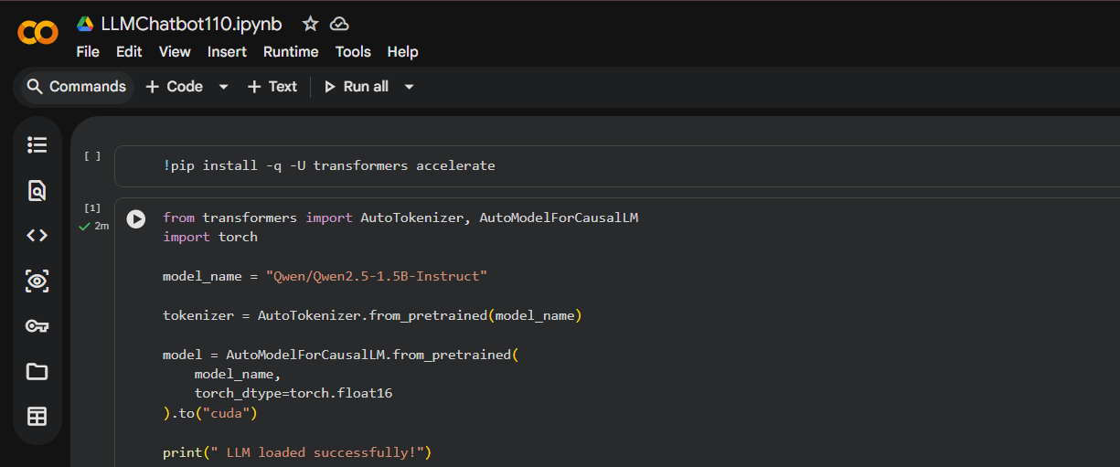
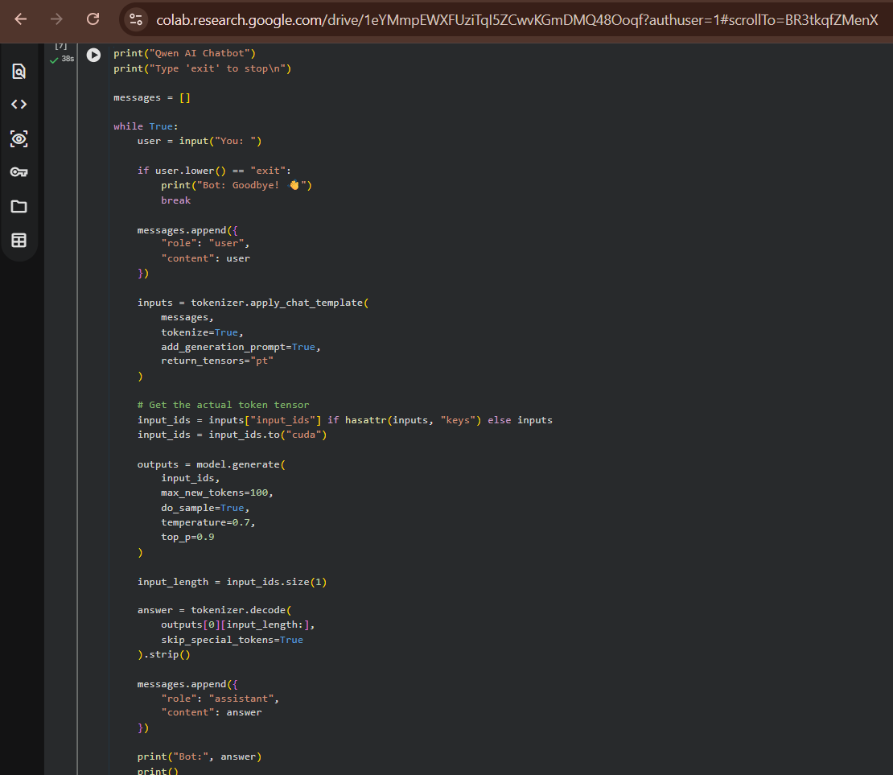

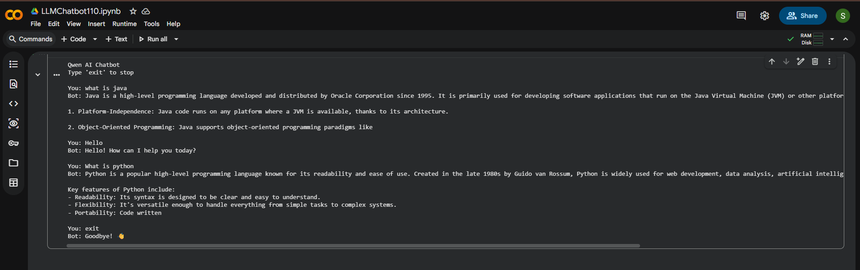
Technologies Used
Technology | Purpose
Python | Main programming language
Google Colab | Development environment
PyTorch | Machine learning framework
Hugging Face Transformers | LLM and tokenizer
Qwen2.5-1.5B-Instruct | Language model
CUDA | GPU acceleration
Tesla T4 | GPU used for model execution

Advantages
- Uses an open-source language model.
- Does not require a paid LLM API.
- Can run directly in Google Colab.
- Provides natural-language responses.
- Supports conversation history.
- Easy to modify and extend.
- Demonstrates practical use of Generative AI and LLM concepts.

Limitations
- The model is relatively small compared with larger LLMs.
- Response quality may not always be perfect.
- The chatbot depends on the available Google Colab GPU resources.
- The model does not have guaranteed access to real-time information.
- Long conversations require more memory because previous messages are stored as context.
Applications
The chatbot concept can be used in many applications, such as:
- Educational assistants
- Customer support systems
- Programming assistants
- FAQ chatbots
- Personal AI assistants
- College information systems
- Technical support systems
Future Scope
The current chatbot can be further improved by adding:
- A web-based graphical user interface.
- Voice input and voice output.
- Document/PDF question answering.
- Retrieval-Augmented Generation (RAG).
- Database integration.
- User authentication.
- Multiple language support.
- Larger and more powerful LLMs.
- Chat history storage.
- AI agents and tool integration.

Conclusion & Key Takeaways
Building this LLM-powered AI chatbot helped bridge the gap between theoretical Generative AI concepts and their practical implementation.
Through this project, we successfully implemented several important concepts:

Generative AI & LLMs
- We interacted directly with a Large Language Model to generate human-readable responses dynamically based on user questions.

Tokenization
- The project demonstrated how user text is converted into tokens before being processed by the language model and how generated tokens are converted back into readable text.

Transformer-Based LLM
- The Qwen2.5-1.5B-Instruct model demonstrates the practical use of Transformer-based language models for text generation.

Python for AI Applications
- Python was used as the primary programming language to load the model, process user input, generate responses, and manage the chatbot conversation.

Local/Open-Source LLM
- Instead of depending on a paid API, the project uses an open-source Qwen model directly inside Google Colab.

GPU-Based Inference
- The Qwen model was executed using the Google Colab Tesla T4 GPU, demonstrating how GPU acceleration can be used for efficient LLM inference.
- Ultimately, this project provides a foundation for developing more advanced AI applications such as RAG-based chatbots, document assistants, voice assistants, AI agents, and web-based intelligent applications.

