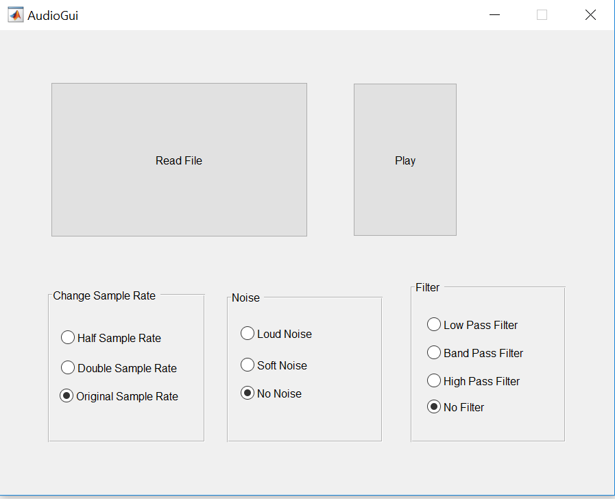

**Step 1:**

Read a file using the “Read File” button. A pop-up window will allow you to select an audio file from your computer. Supported file types include .wav and .mp3.

**Step 2:**

Choose a sample rate by selecting one of the radio buttons under “Change Sample Rate.” There are 3 options: “Half Sample Rate,” which will play the file at half the frequency, “Double Sample Rate,” which will play the file at double the frequency, and “Original Sample Rate,” which will play the file at the original frequency.

**Step 3:**

Choose a noise option by selecting one of the radio buttons under “Noise.” There are 3 options: “Loud Noise” adds noise at a Signal to Noise ratio of 10, “Soft Noise” adds noise at a Signal to Noise ratio of 25, and “No Noise” adds no noise.

**Step 4:**

Choose a filter option by selecting one of the radio buttons under “Filter.” “Low Pass Filter” only plays low frequencies, “Band Pass Filter” only plays mid-range frequencies, and “High Pass Filter” only plays high frequencies. The “No Filter” option plays all frequencies.

**Step 5:**

Press the “Play” button to play your selected sound.