Activity Diagram

Like a flow chart but not

Dynamic behaviour

No data flow represent

Flow of control

Swimlane fork and join

Swquential branching concurrent



Initial state

Start state



Final state :

End of the activity flow

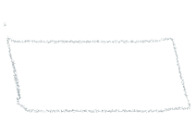

activity behavioural action



control flow destination of flow



Srartt game

Join

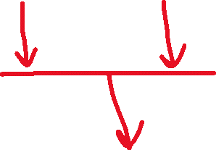

Two or more collab to one

Fork :one to concurrent two

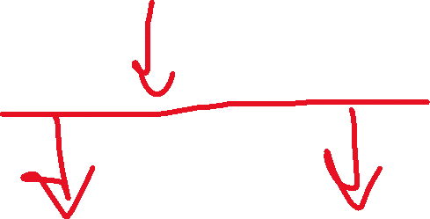

Atm withdrawl

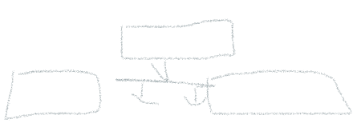

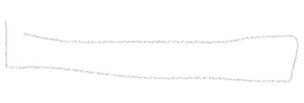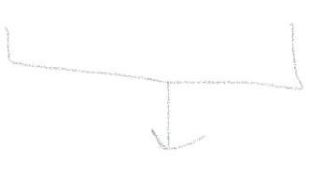Take money Take receipt

Ejectcard()

Decision

Condition

de[emdong



on the condition you can go to the particular cnditon merge:

ordreris special thern gift orr norma packing this or this

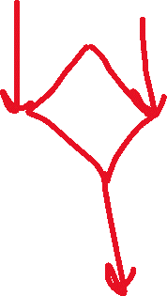





orderplaced

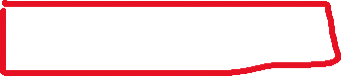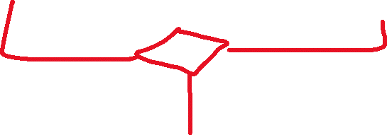

Regualars giftpack

dispatch

final flow node

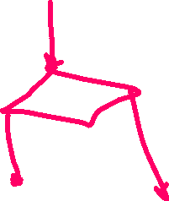

comment



if age is graater than 18



Proceed

Not allowed



Notaions :

Grop the actionns carried out by diff actors

Atm Bank



Insert card authenticate

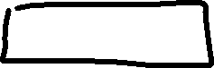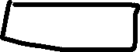

enterpin

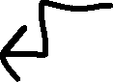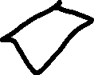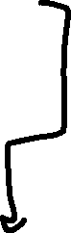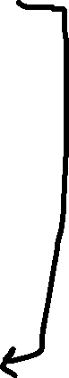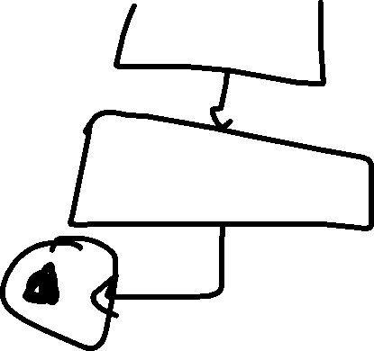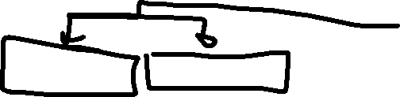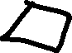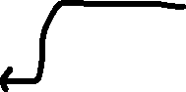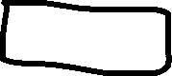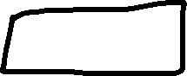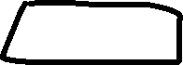

Valid incalid

Inter amount check balance

Fork

Take money take receipt

Join

Eject the card