Collaboration diagram

Collaboration off object and its interaction

Communication diagram

Some type of interaction to perform a task

Dynamic behaviour

Message is added by number

Analysis and activities for simpler interaction and smaller no of object

Organization of object and there relation ship

Visualising the object

Collaboration

To represent relationship with interaction

To visualise collaboration pattern

To analyse all the effect with object

Sequence

To represent sequence of flow

Visualising overall flow

Realtime scenario

Accociation

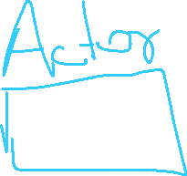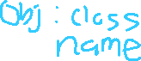

Communication actor object:classname



Message



1.requestTransaction()



2 entertransaction()



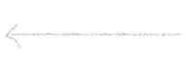3.request amount



4.Enter amount 5.proceedtest()



6.withdraw()



7.withhdeaw success

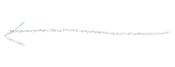 8 Transaction success

9Dispensecash()

10 reqto take cash



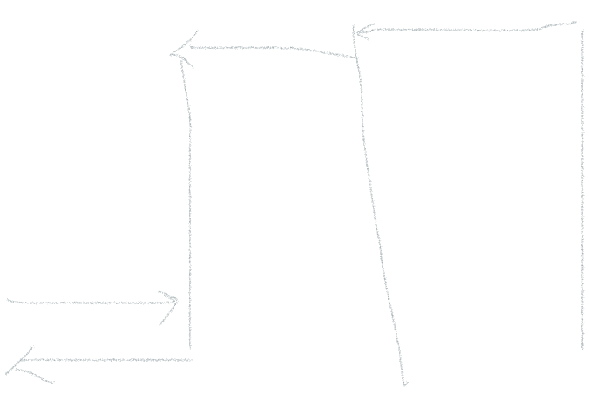

11 requestcontinuatio()

12terminate()

13 balanceRecept

Converting this to collaboration diagram



2 ` entertransaction()

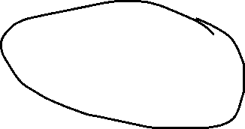

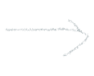



Marrry: Atm1: MerryAcc:

Client Atm Accounts



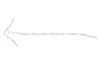

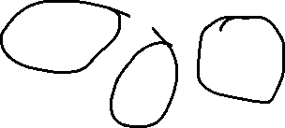

1.requestTransaction()



3



 Db1:Bank

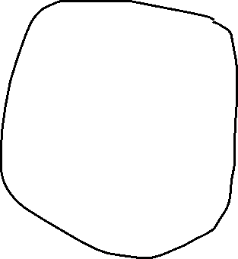

Database

