Uml:use case diagram

Generate reqirement

Used to represent internal and external functionality oof the influiences

System :use cases are here main goal or feature

Use case --🡪 name

Actor 🡪 customer user admin external system outside the system also an actor

Association `



Include (if you want to buy ticket the <<include>>



You have to fill the detail of the requirements like

Pyjjent and user details this is what include means) <<extends>

Extends (it is ottional entity ) if you have server not available extensions exception handeling is extends )

Dependency: if one usecase is dependent on another entity



Functionality is used the network then the dependency is there

generalisatin : common or base class for the new enttitite

person ---🡪faculty and student is the generalized class for both of them

Cellular system ::include the functionality

Make a call <<extends> additinonal call



Receive a call network

Schedule a call

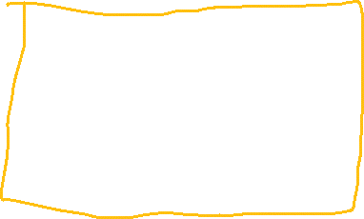

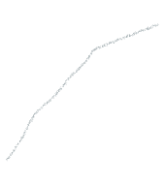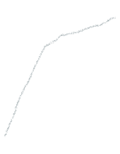Locate user

Generate bill Check usage

<<include>>



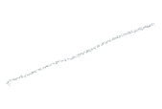User Gps system

Provider

1. Airtrl



1. Bsnl -----------------🡪generalized