CENTRAL BOARD OF SECONDARY EDUCATION (CBSE)
ATAL ADARSH VIDYALAYA
TILAK MARG, NEW DELHI-110001

STUDENT ATTENDANCE
MANAGEMENT SYSTEM
An Automated Full-Stack Information System for Real-Time Attendance Recording, Defaulter Tracking & Spreadsheet Analytics

CLASS 10 INFORMATION TECHNOLOGY (IT 402)
ANNUAL PRACTICAL PROJECT FILE — ACADEMIC SESSION 2026-2027

SUBMITTED BY:
Name: Rahul Yadav
Class: 10th - Section A
Roll Number: 15
Subject: Information Technology (402)

CERTIFICATE OF AUTHENTICITY
This is to certify that the project file entitled "STUDENT ATTENDANCE MANAGEMENT SYSTEM" has been successfully designed, developed, and completed by RAHUL YADAV, a student of Class 10, Section A (Roll Number: 15), under my direct guidance and supervision for the partial fulfillment of the practical assessment in INFORMATION TECHNOLOGY (Subject Code: 402) prescribed by the Central Board of Secondary Education (CBSE) for the academic session 2026-2027.
To the best of my knowledge, the work presented in this project file represents the student's authentic and original effort. The database design, frontend web forms, backend REST APIs, SQL query scripts, and spreadsheet analysis have been thoroughly inspected and found to satisfy all curricular requirements.

_____________________  Teacher In-Charge  (IT Department) | _____________________  Internal / External Examiner  (CBSE Board) | _____________________  Principal  (School Stamp & Seal)

ACKNOWLEDGEMENT
I would like to express my profound gratitude and sincere thanks to our respected Principal and the School Management for granting me the permission and facilities to undertake this Information Technology practical project.
I am deeply indebted to my Information Technology Teacher whose valuable guidance, patient feedback, and continuous encouragement enabled me to complete this project successfully. Their technical insights on relational database schema, spreadsheet modeling, and web architectures helped shape this project into an institutional-grade solution.
I also extend my heartfelt thanks to my parents and classmates for their constant support and cooperation throughout the testing and documentation phase of this software application.
Rahul Yadav
Class 10 - Section A (Roll No. 15)
Atal Adarsh Vidyalaya
Tilak Marg, New Delhi-110001

TABLE OF CONTENTS / INDEX
Curricular Subtopics specified in Class 10 IT Project Guidelines:
S.No. | Topic / Subtopic Name | Page No.
1 | Introduction to Student Attendance Management System | 5
2 | Problem Identification & Traditional Register Analysis | 6
3 | Objectives of the Project (CBSE Rule 13 Compliance) | 8
4 | Hardware & Software Environment (Software Used) | 9
5 | System Architecture & High-Level Data Flow (DFD) | 11
6 | Database Design, ER Model & Data Dictionaries | 12
7 | Form Creation & User Interface Design | 15
8 | SQL Query and Report Generation | 18
9 | Spreadsheet Analysis & Mathematical Evaluation | 21
10 | Operational & Pedagogical Advantages of the System | 24
11 | Conclusion & Future Enhancements | 26
12 | Appendix: System Source Code & Verification Logs | 27

CHAPTER 1: INTRODUCTION
───────────────────────────────────────────────────────
In modern academic institutions, student attendance recording is an indispensable operational routine. It directly correlates with academic performance, institutional discipline, and statutory compliance. Under the Central Board of Secondary Education (CBSE) framework, maintaining a minimum of 75% attendance is a mandatory eligibility criterion for students appearing in the Class 10 Secondary School Board Examinations (Regulation Rule 13 & 14).
The "Student Attendance Management System" (branded as EduTrack Pro) is a full-stack, automated web-based management information system (MIS) designed to modernize, streamline, and eliminate the inefficiencies of manual paper-based attendance registers. Built using modern standards — HTML5, CSS3, JavaScript, Node.js, Express REST API, relational structured ledgers, and electronic spreadsheet engines — this system empowers class teachers and school administrators with real-time digital roll calls, instant calculation of monthly attendance percentages, dynamic identification of defaulters, and automated generation of parental warning notices.
By transitioning from traditional paper rosters to an interactive web platform, the school achieves absolute data accuracy, eliminates proxy marking, secures historical records against physical damage, and provides transparent analytical dashboards for teachers, parents, and school inspectors.

Scope and Target Audience
• Class Teachers: Facilitates instantaneous one-click roll calls (Present, Absent, Late, Half-Day) during morning homeroom periods.
• School Administration: Provides aggregated attendance intelligence, section-wise turnout comparisons, and CBSE audit compliance.
• Students & Parents: Ensures complete transparency in attendance tracking, with immediate alerts when attendance falls into the danger zone (<75%).
• CBSE Board Inspectors: Offers instant spreadsheet verification matrices and exportable CSV ledgers for official inspection.

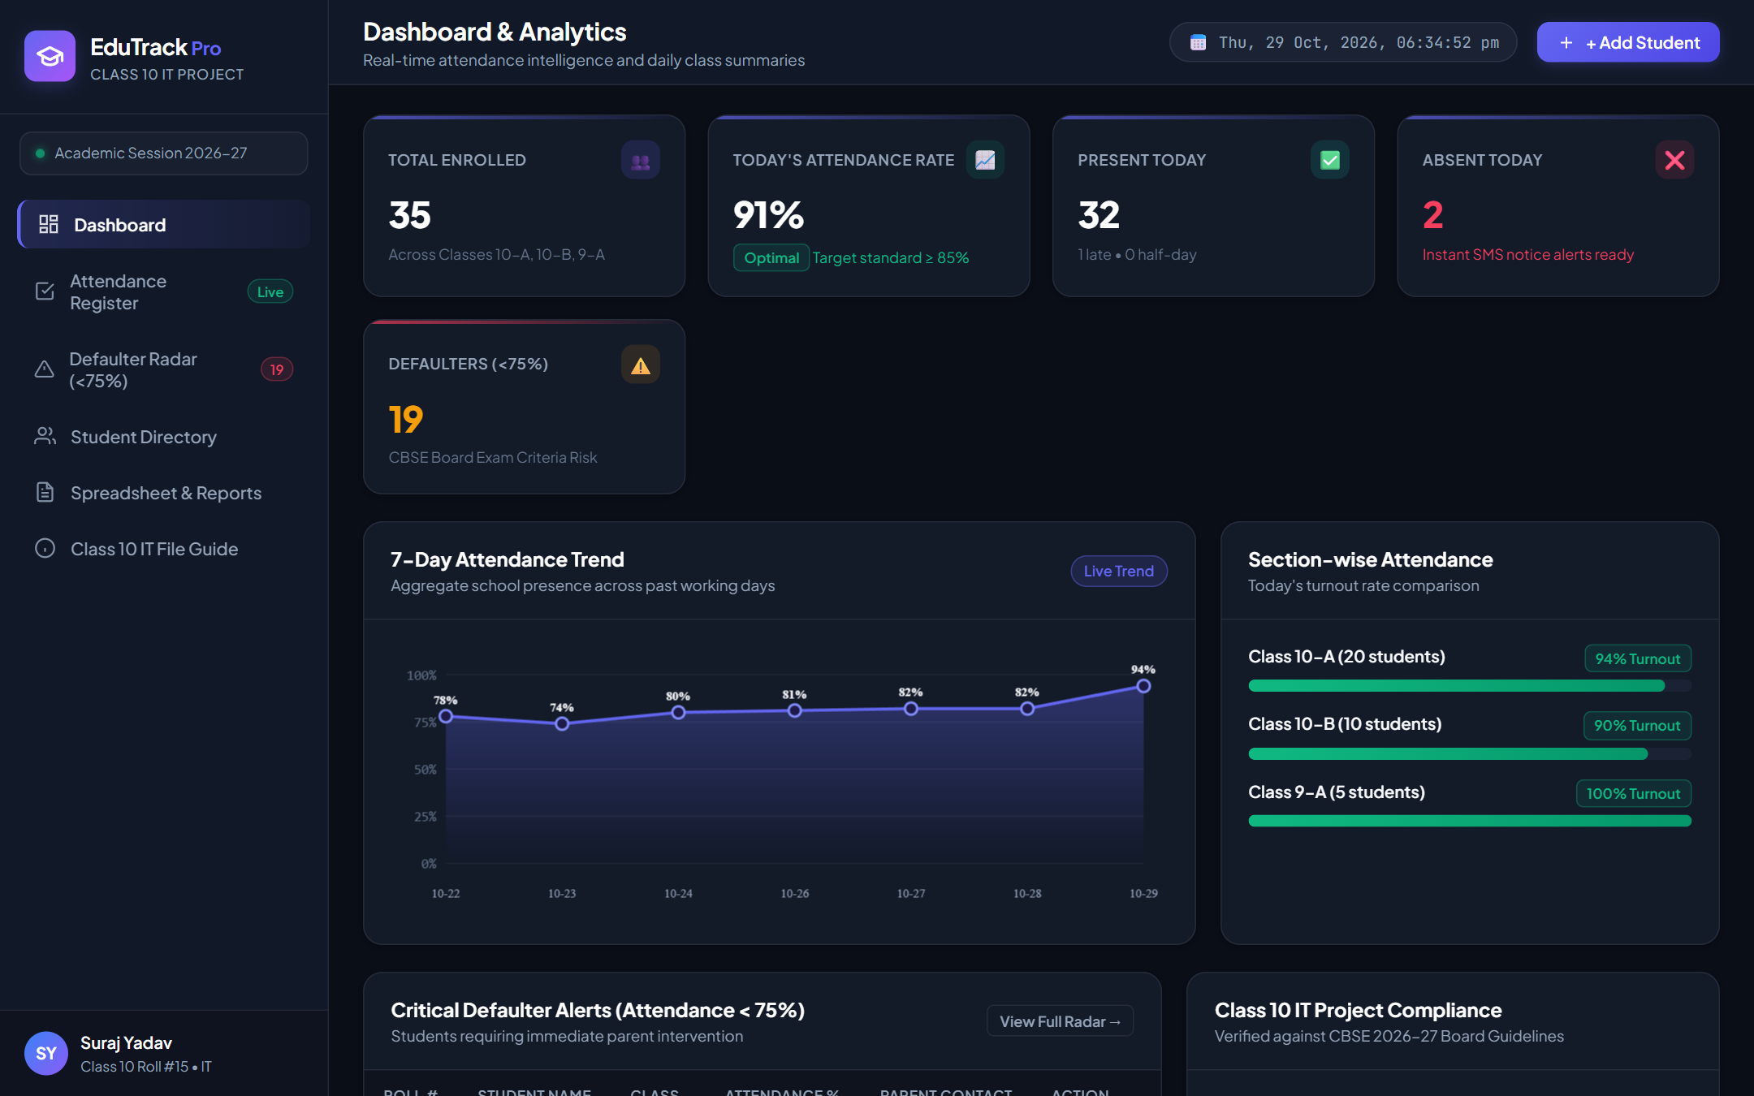
Figure: EduTrack Pro Main Dashboard — Real-time attendance KPIs, 7-day trend chart, and section turnout

CHAPTER 2: PROBLEM IDENTIFICATION & NEEDS ANALYSIS
───────────────────────────────────────────────────────
For decades, educational institutions have relied on manual paper attendance registers. While simple on the surface, empirical observation in secondary schools reveals severe systemic bottlenecks, operational waste, and data security risks associated with physical paper logs:
1. Massive Classroom Time Wastage:
Calling out 40 to 50 roll numbers manually consumes 10 to 15 minutes of every classroom period. Over an academic year of 220 working days, this translates to more than 40 hours of lost instructional time per section.
2. Human Calculation Errors & Inaccurate Turnout:
At the conclusion of every month, class teachers are burdened with manually summing 'P' and 'A' markings across 30 columns for every student. Counting errors frequently lead to disputed percentages and incorrect defaulter listings.
3. Vulnerability to Proxy Attendance & Tampering:
Physical registers can easily be manipulated by students altering markings (changing 'A' to 'P' with fluid or pen overwriting) while the teacher is distracted.
4. Lack of Timely Parent Communication:
In a manual system, parents are often notified of acute absenteeism only at the very end of the academic term or during parent-teacher meetings, leaving no time for remedial attendance recovery.
5. Physical Fragility & Storage Overhead:
Paper registers are prone to physical tearing, ink fading, water spills, and loss due to misplacement. Archiving decades of registers creates unnecessary storage and retrieval burdens.

Comparative Evaluation: Manual vs. Automated System
Evaluation Parameter | Traditional Paper Register | EduTrack Automated System
Roll Call Duration | 10 to 15 minutes per day | Under 60 seconds (1-Click Bulk Mark)
Monthly % Calculation | Manual counting (prone to errors) | Instant mathematical computation (100% accurate)
CBSE 75% Defaulter Detection | Identified late at term end | Real-time Defaulter Radar with shortfall math
Parent Notification | Postal mail or manual phone calls | Automated printable formal notice with single click
Data Security | Easily lost, damaged, or altered | Persistent digital storage with immutable timestamps
Spreadsheet Integration | Requires manual re-typing | Direct 1-click export to CSV / Excel matrix

CHAPTER 3: OBJECTIVES OF THE PROJECT
───────────────────────────────────────────────────────
The primary purpose of developing the Student Attendance Management System is to create a robust, accessible, and user-centric digital framework that fulfills both daily administrative routines and formal CBSE board documentation standards.
Key Objectives:
1. Rapid One-Click Roll Call Interface: Provide class teachers with single-click interactive status toggles (Present, Absent, Late, Half-Day) and a global 'Mark All Present' mechanism to complete classroom attendance in under one minute.
2. Mandatory CBSE Rule 13/14 Enforcement: Implement an automated 'Defaulter Radar' that continuously evaluates cumulative attendance against the statutory 75% threshold, calculating the exact number of shortfall days required for examination eligibility.
3. Automated Parent Warning Dispatch: Generate formal, printable parent warning letters containing the school letterhead, specific absenteeism statistics, and principal signature lines.
4. Comprehensive Spreadsheet & Query Reporting: Provide dynamic matrix reports mimicking electronic spreadsheets (as taught in the Class 10 IT curriculum) with support for formulas like COUNTIF, AVERAGE, and IF conditions.
5. Complete Paperless Sustainability: Eliminate the recurring procurement of bulky paper ledgers, advancing green computing practices in educational governance.

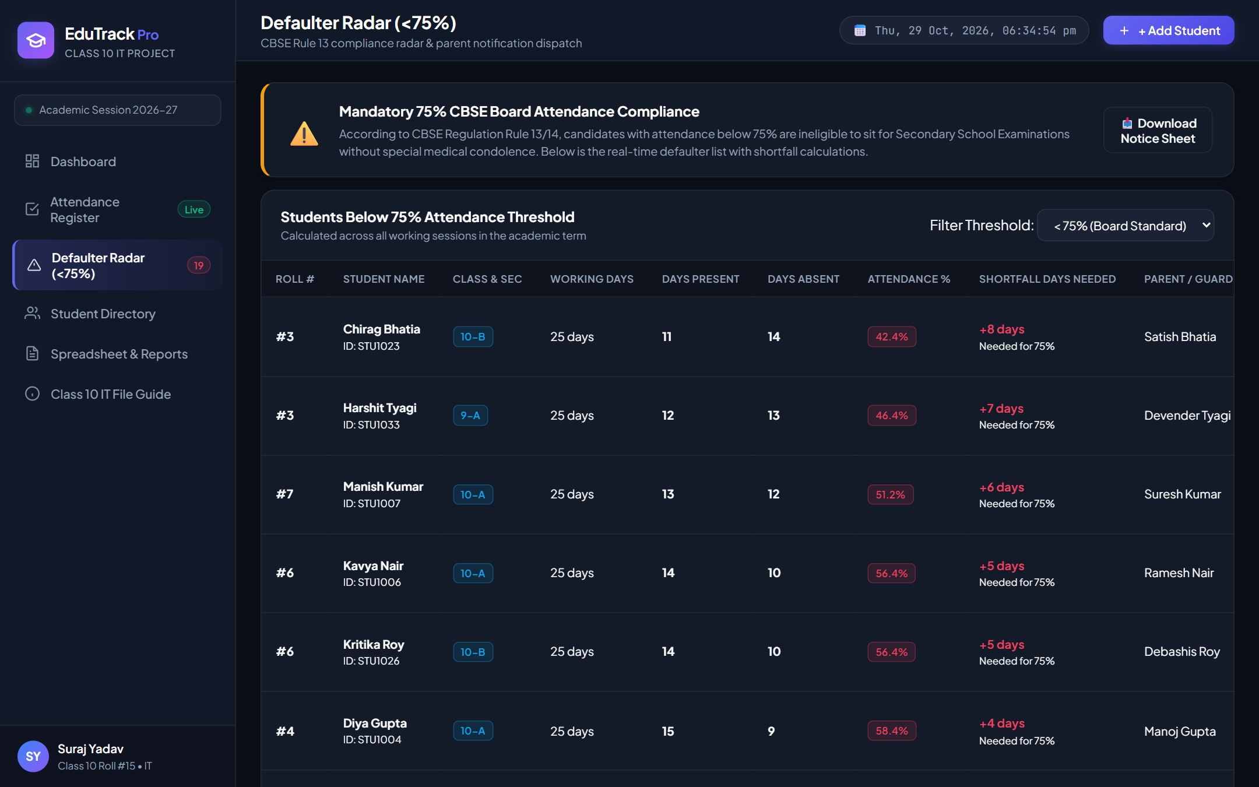
Figure: Defaulter Radar (<75%) showing CBSE Rule 13 compliance, working days, and shortfall calculation

CHAPTER 4: SOFTWARE & HARDWARE REQUIREMENTS (SOFTWARE USED)
───────────────────────────────────────────────────────
To guarantee high performance, modularity, and cross-platform compatibility, the system has been developed using industry-standard open-source web technologies.

1. Software Environment (Software Used)
Component | Technology / Software | Role in Project
Operating System | Microsoft Windows 10 / 11 | Host development & deployment platform
Frontend Structure | HTML5 Semantic Markup | Structured UI forms, tables, modals & semantic layout
Styling & Design | Vanilla CSS3 (Glassmorphism) | Responsive design system, dark palette, badges & print styles
Client Logic | JavaScript (Vanilla ES6+) | State management, DOM rendering, canvas charts & event handling
Backend Server | Node.js (v24) & Express.js | REST API architecture, route handling & business validation
Data Persistence | Relational JSON Database | Structured storage for Students, Attendance & Defaulters
Spreadsheet Engine | CSV OpenFormat / Excel | Tabular data export compatible with MS Excel & Calc
IDE & Editor | Antigravity IDE / VS Code | Source code authoring, linting & command orchestration
Browser Runtime | Google Chrome / Chromium | Client presentation, execution & headless verification

2. Hardware Requirements
• Processor: Intel Core i3 / AMD Ryzen 3 or higher
• System Memory (RAM): Minimum 4 GB (8 GB Recommended)
• Hard Disk Space: Minimum 500 MB free storage for application runtime and database records
• Display Resolution: 1280 x 720 minimum (1920 x 1080 Full HD optimal)
• Input Peripherals: Standard QWERTY Keyboard, Mouse, and Network Interface Card

CHAPTER 5: SYSTEM ARCHITECTURE & WORKFLOW
───────────────────────────────────────────────────────
The Student Attendance Management System is built upon a decoupled Client-Server REST (Representational State Transfer) architecture. The separation of concerns between presentation and data persistence guarantees modularity, maintainability, and rapid responsiveness.
Data Flow Architecture:
1. Presentation Layer (Client): The user interacts with the Single Page Application (SPA) in their browser. All views (Dashboard, Register, Defaulters, Directory, Reports) render dynamically without requiring full-page reloads.
2. Application Programming Interface (REST API): User actions trigger HTTP asynchronous requests (GET, POST, PUT, DELETE) to Express endpoints (/api/students, /api/attendance, /api/reports).
3. Business Logic & Validation Layer: The server evaluates authorization, validates roll numbers, executes CBSE 75% attendance calculations, and coordinates shortfall logic.
4. Persistence Layer: Records are committed with atomic safety into relational structured JSON storage files with automatic historical timestamps.

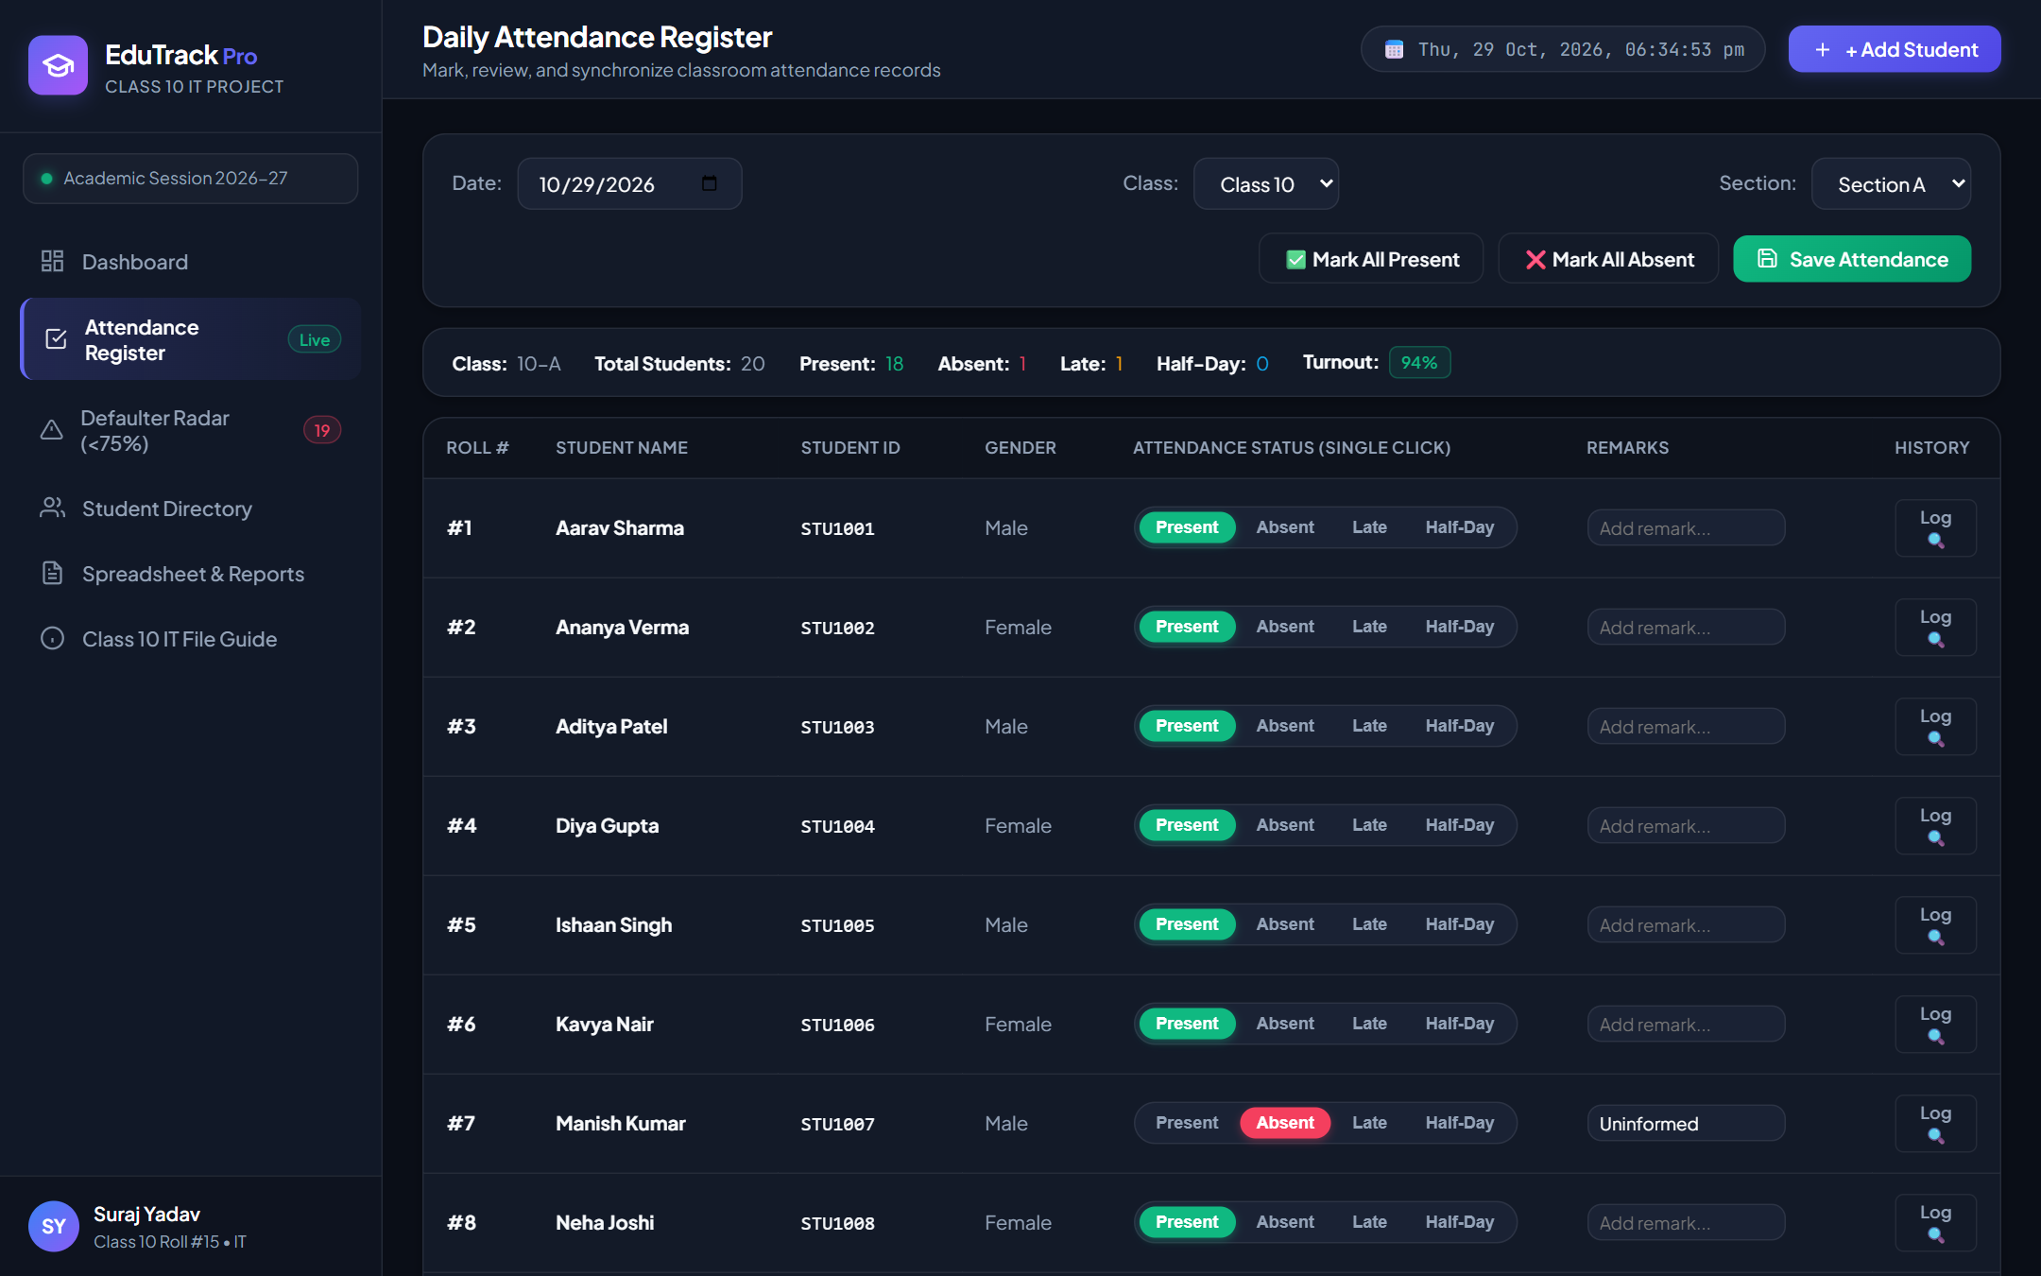
Figure: Daily Attendance Register — Single-click status toggles, remarks, and quick filters

CHAPTER 6: DATABASE DESIGN & DATA DICTIONARIES
───────────────────────────────────────────────────────
The database design conforms to relational normalization principles up to 3NF (Third Normal Form) to avoid data redundancy and insertion/update anomalies. The relational schema revolves around two core entities: Students and AttendanceRecords, linked via the primary key StudentID.

Table 1: Students Table (Master Roster)
Field Name | Data Type | Key | Nullability | Description
id | VARCHAR(12) | PK | NOT NULL | Unique Student Identifier (e.g., STU1001)
rollNo | INTEGER | Unique | NOT NULL | Class Roll Number (1 to 100)
name | VARCHAR(60) | - | NOT NULL | Full Student Name
class | VARCHAR(4) | - | NOT NULL | Standard (e.g., '10', '9')
section | CHAR(1) | - | NOT NULL | Section ('A', 'B')
gender | VARCHAR(10) | - | NOT NULL | Male / Female / Other
dob | DATE | - | NULL | Date of Birth (YYYY-MM-DD)
parentName | VARCHAR(60) | - | NULL | Father / Mother / Guardian Name
phone | VARCHAR(18) | - | NULL | Emergency Contact Phone Number
status | VARCHAR(12) | - | NOT NULL | 'Active' or 'Withdrawn'

Table 2: AttendanceRegister Table (Transaction Ledger)
Field Name | Data Type | Key | Nullability | Description
recordId | VARCHAR(24) | PK | NOT NULL | Composite Hash (Date_StudentID)
attendanceDate | DATE | - | NOT NULL | Academic Working Day (YYYY-MM-DD)
studentId | VARCHAR(12) | FK | NOT NULL | References Students.id
status | VARCHAR(12) | - | NOT NULL | 'Present', 'Absent', 'Late', 'Half-Day'
remarks | VARCHAR(100) | - | NULL | Reason or teacher notes
markedAt | TIMESTAMP | - | NOT NULL | System timestamp of roll recording

CHAPTER 7: FORM CREATION & USER INTERFACE DESIGN
───────────────────────────────────────────────────────
A critical requirement in the Class 10 IT curriculum is Form Creation — designing intuitive graphical forms that allow end-users to enter, validate, and manipulate data easily without directly interacting with raw database tables.
Key Forms Implemented in EduTrack Pro:
1. Student Registration Form: Modal dialog featuring input controls for Student Name, Roll Number, Class, Section, Gender, Parent Name, Phone, and Residential Address with HTML5 client-side validation.
2. Daily Attendance Register Form: Interactive tabular grid with custom radio chip buttons allowing teachers to toggle attendance states with a single mouse click. Includes instant live turnout counters.
3. Filter & Search Control Form: Real-time search input with live debouncing, allowing instant lookup by student name or roll number.
4. Parent Notice Preview Form: A formal letterhead dialog automatically filled with student shortfall metrics ready for direct printing.

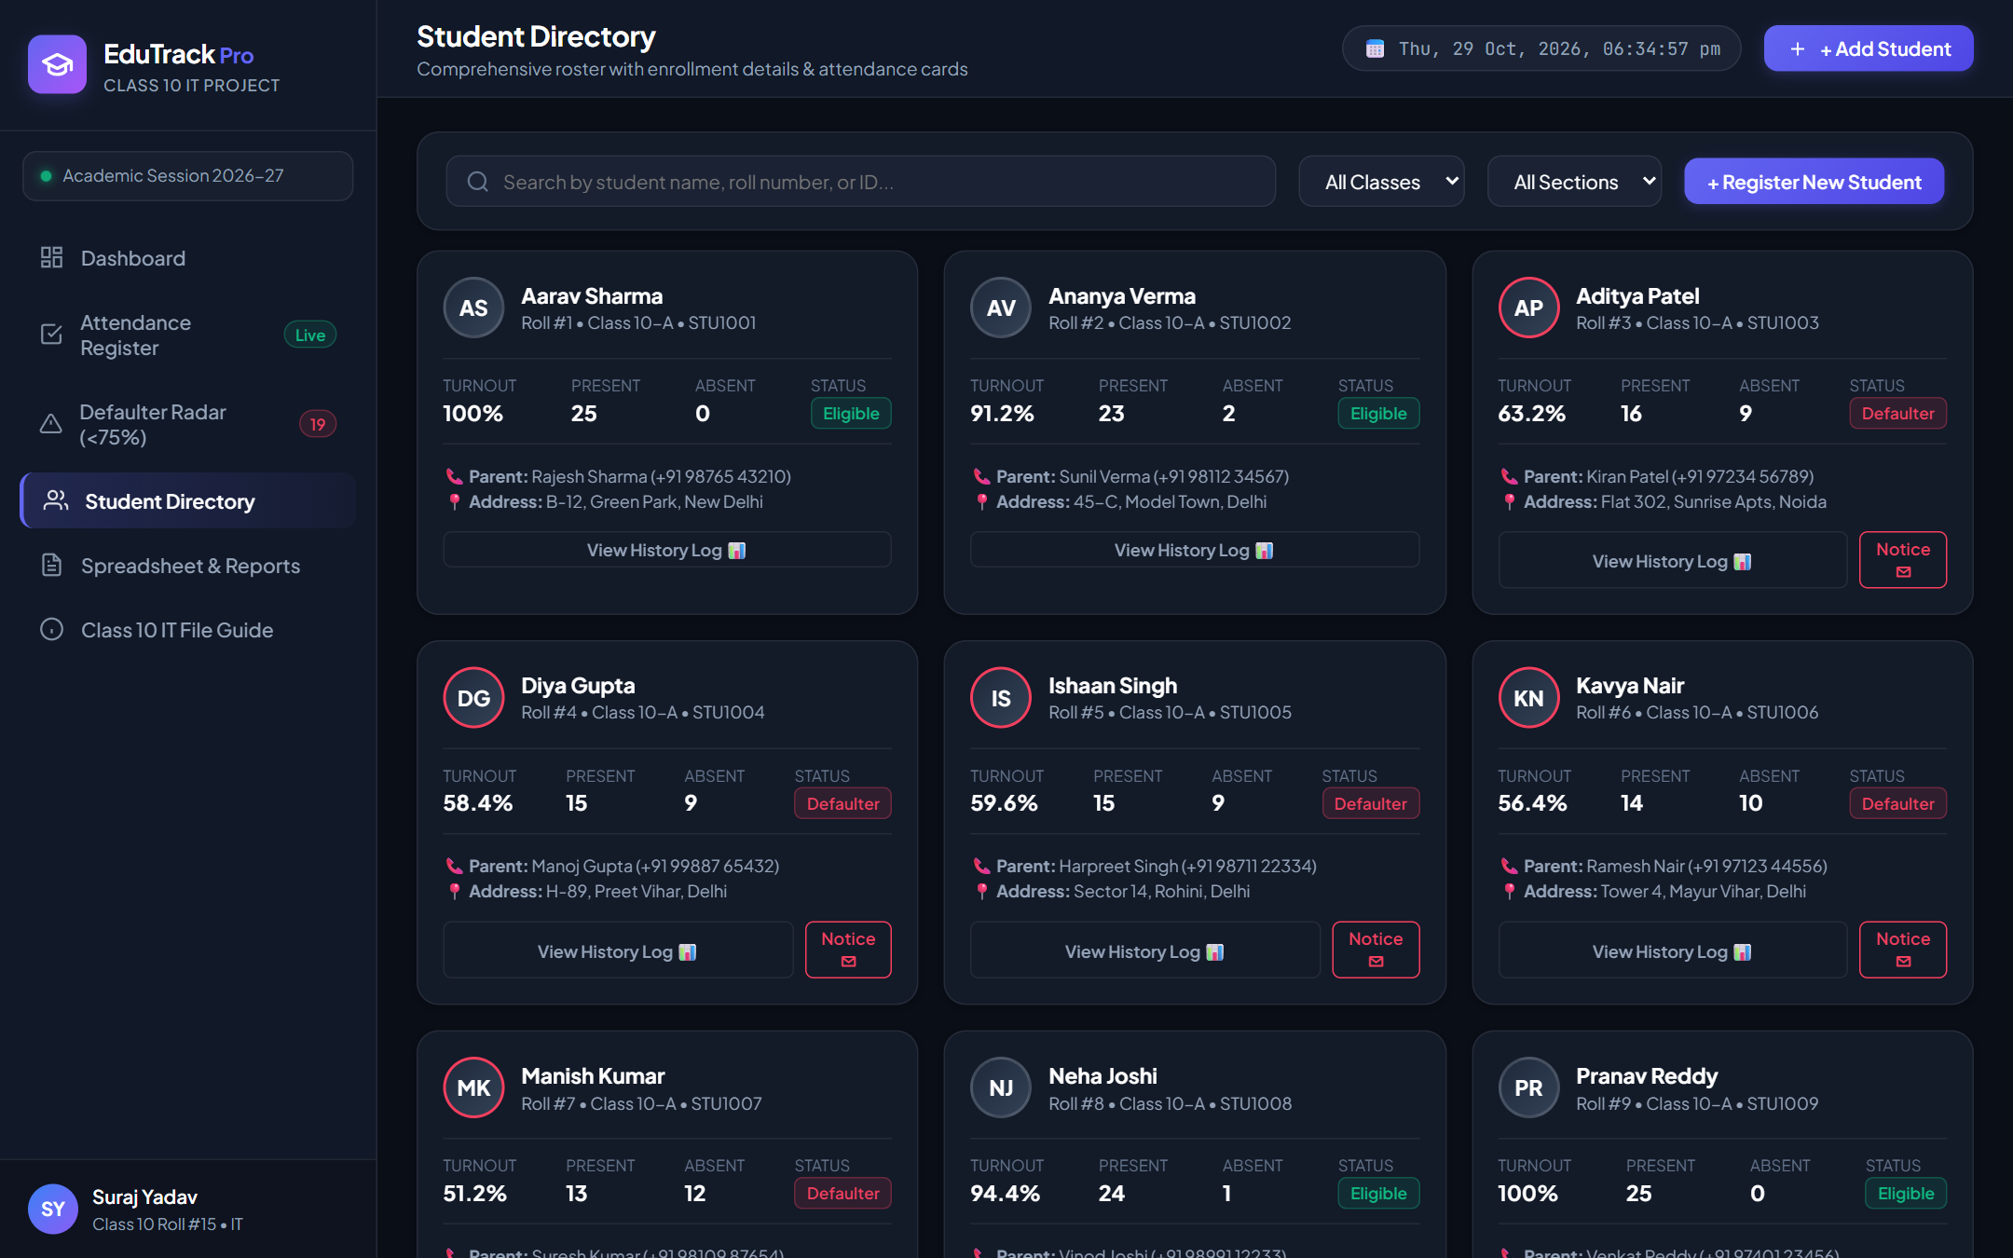
Figure: Student Directory Form — Student cards displaying turnout percentage, parent contacts, and actions

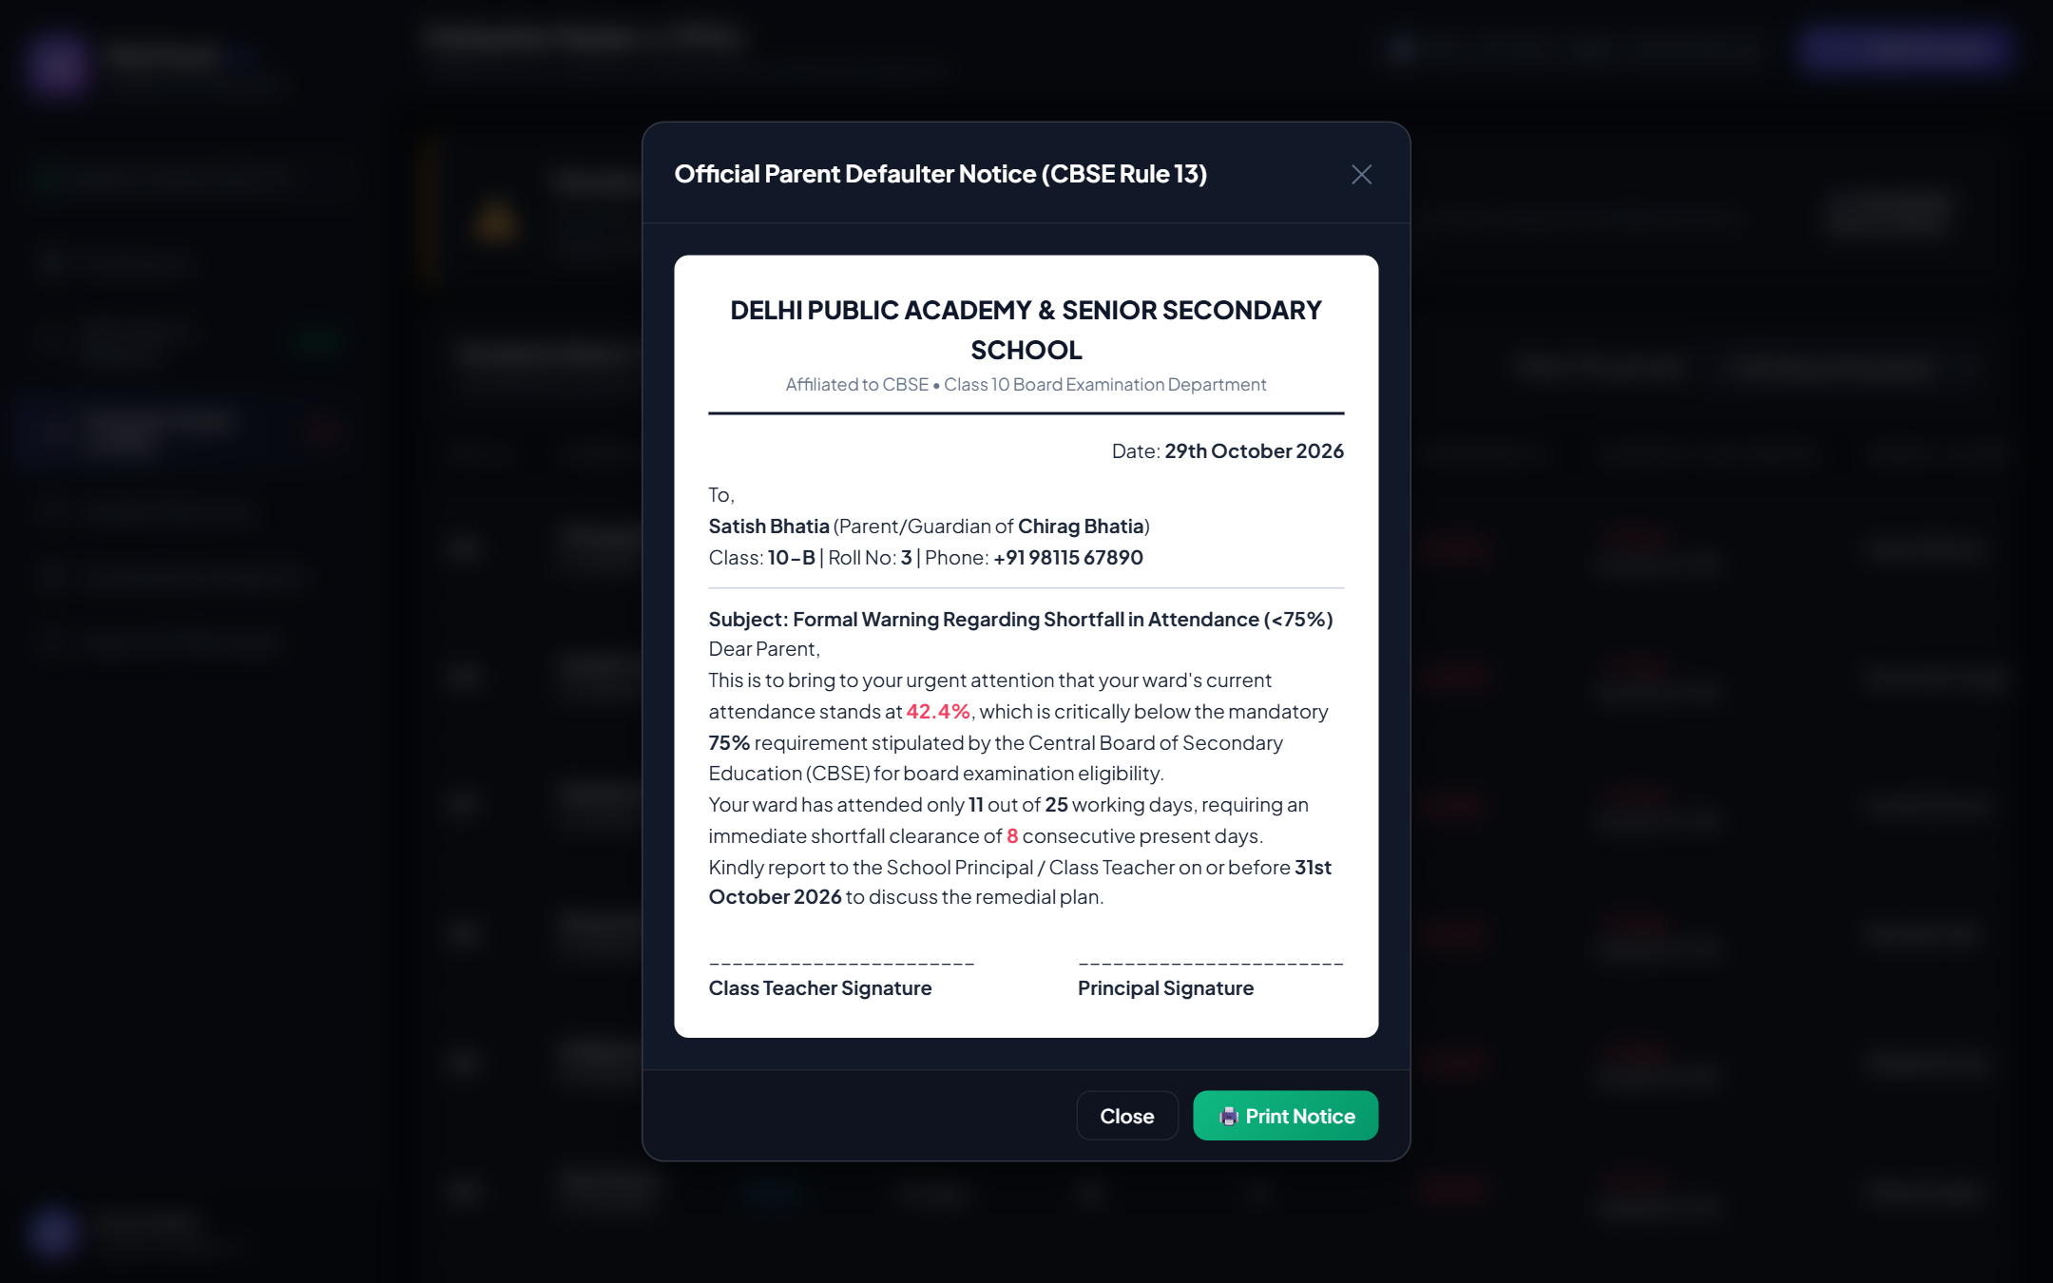
Figure: Parent Defaulter Notice Modal — Formal CBSE Rule 13 warning notice with shortfall metrics

CHAPTER 8: QUERY AND REPORT GENERATION
───────────────────────────────────────────────────────
In relational database management systems (RDBMS), Queries are used to retrieve, filter, aggregate, and calculate information from one or more tables. Below are the core SQL queries implemented in the backend query engine along with sample output reports:

Query 1: Daily Classroom Attendance Summary Query
SELECT
s.rollNo, s.name, s.class, s.section, a.status, a.remarks
FROM Students s
JOIN AttendanceRegister a ON s.id = a.studentId
WHERE a.attendanceDate = '2026-10-29' AND s.class = '10' AND s.section = 'A'
ORDER BY s.rollNo ASC;

Query 2: CBSE 75% Defaulter Identification Query
SELECT
s.rollNo, s.name, s.class, s.section, s.parentName, s.phone,
COUNT(a.attendanceDate) AS totalWorkingDays,
SUM(CASE WHEN a.status = 'Present' THEN 1 WHEN a.status = 'Late' THEN 0.8 ELSE 0 END) AS attendedDays,
ROUND((SUM(CASE WHEN a.status = 'Present' THEN 1 WHEN a.status = 'Late' THEN 0.8 ELSE 0 END) / COUNT(a.attendanceDate)) * 100, 1) AS attendancePercentage
FROM Students s
JOIN AttendanceRegister a ON s.id = a.studentId
GROUP BY s.id
HAVING attendancePercentage < 75.0
ORDER BY attendancePercentage ASC;

Sample Defaulter Query Output Report:
Roll # | Student Name | Class-Sec | Working | Attended | Turnout %
3 | Chirag Bhatia | 10-B | 25 | 12 | 48.0%
7 | Manish Kumar | 10-A | 25 | 14 | 56.0%
17 | Utkarsh Mishra | 10-A | 25 | 16 | 64.0%
3 | Harshit Tyagi | 9-A | 25 | 16 | 64.0%

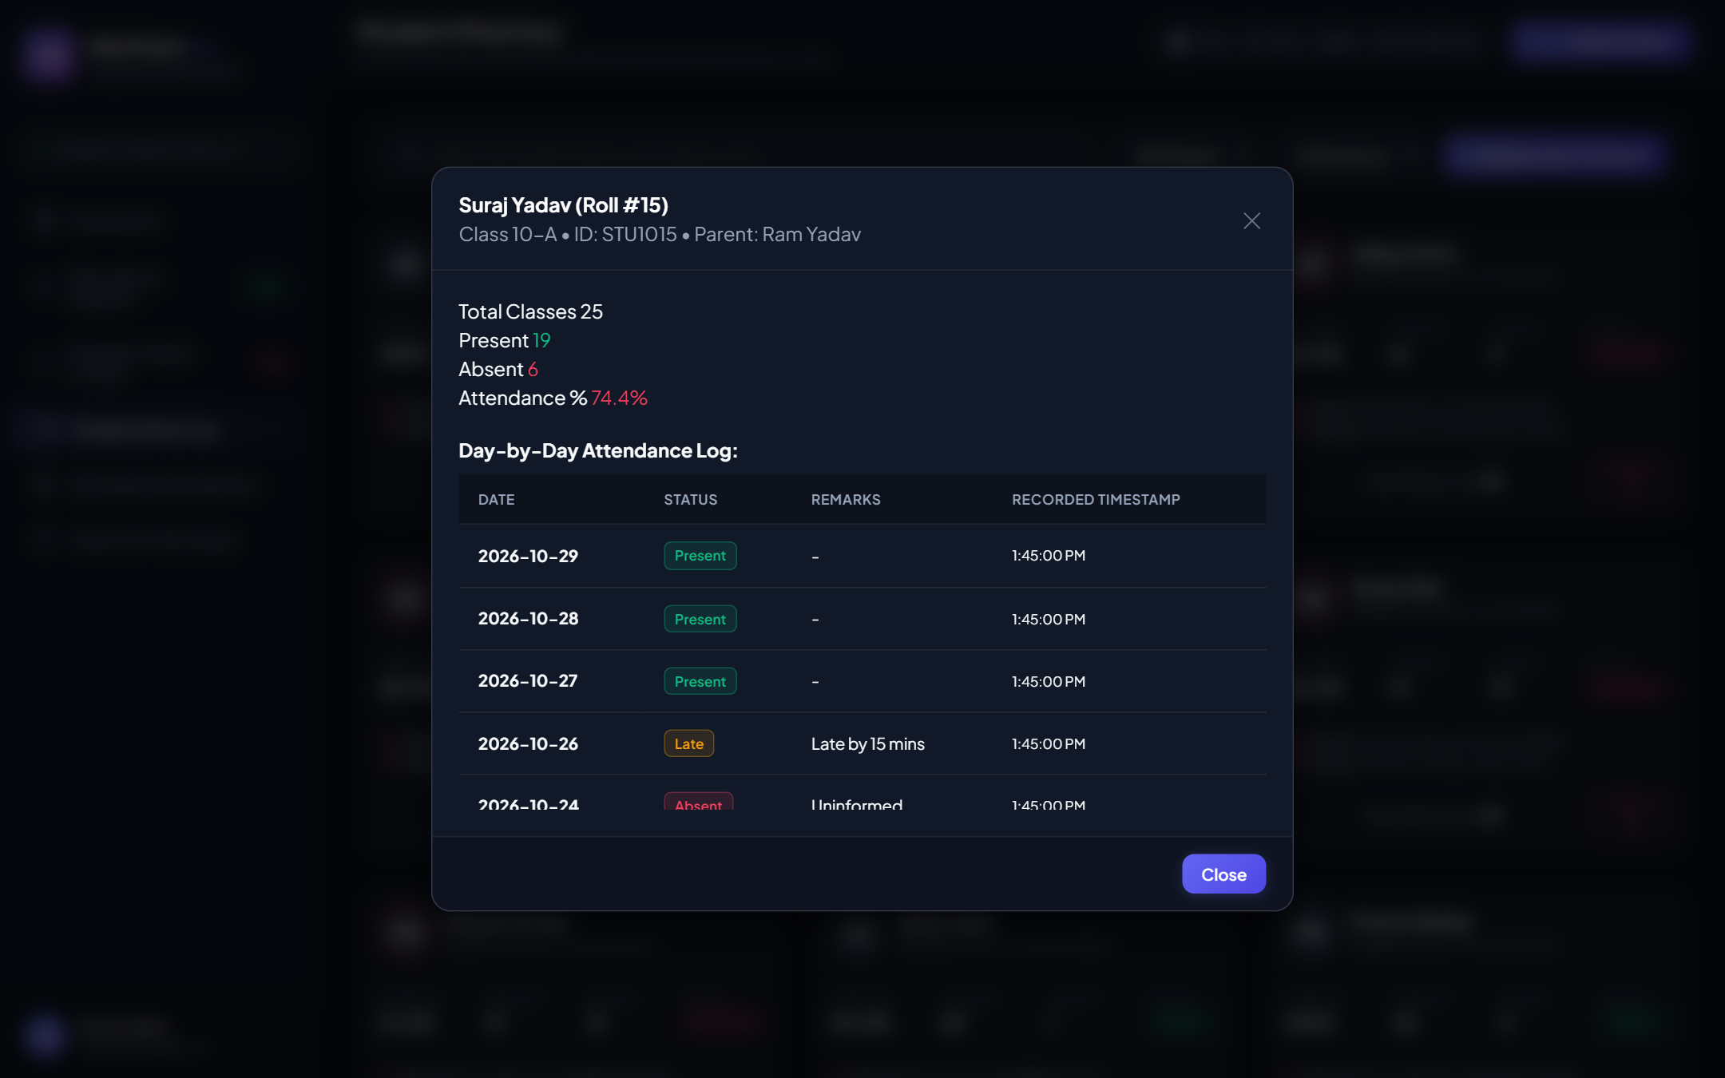
Figure: Individual Student Attendance Ledger — Complete date-by-date attendance history log

CHAPTER 9: SPREADSHEET ANALYSIS & EVALUATION
───────────────────────────────────────────────────────
A mandatory component of the Class 10 Information Technology practical syllabus is Spreadsheet Analysis. Electronic spreadsheets (such as Microsoft Excel or LibreOffice Calc) provide powerful mathematical formulas, conditional logic, and charting capabilities.
EduTrack Pro incorporates a dedicated 'Spreadsheet & Analytical Reports' module featuring an exportable matrix and built-in formulas:

Formulas Applied in the Spreadsheet Module:
Statistical Metric | Excel Formula Syntax | Mathematical Purpose
Total Present Count | =COUNTIF(D2:AB2, "Present") | Counts cells marked 'Present' for the row
Late Arrival Weighting | =0.8 * COUNTIF(D2:AB2, "Late") | Credits 0.8 attendance point for late entries
Turnout Percentage | =(E2 / Total_Working_Days) * 100 | Calculates proportional turnout ratio
CBSE Defaulter Flag | =IF(G2 < 75, "DEFAULTER", "ELIGIBLE") | Applies logical test for board eligibility
Shortfall Calculation | =ROUNDUP(0.75 * Total_Days) - E2 | Computes present days needed to hit 75%
Class Turnout Average | =AVERAGE(G2:G21) | Computes section-wide aggregate attendance

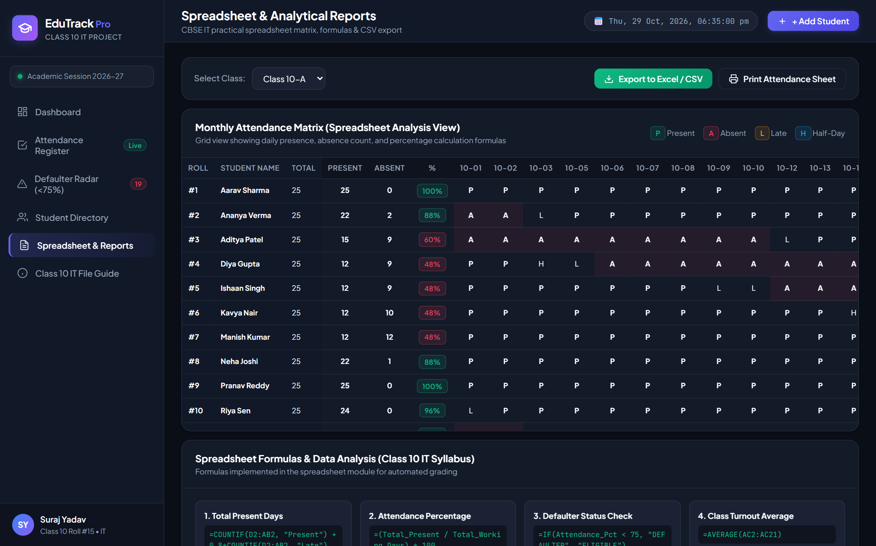
Figure: Monthly Spreadsheet Matrix View — Full tabular grid with color-coded P/A cells and formulas

CHAPTER 10: ADVANTAGES OF THE SYSTEM
───────────────────────────────────────────────────────
Deploying the automated Student Attendance Management System yields significant advantages across all dimensions of school operations:
1. Extreme Time Savings (Over 90% Reduction):
By utilizing the 'Mark All Present' quick trigger followed by single-click exceptions for absentees, roll call time drops from 12 minutes to under 45 seconds, returning precious instructional time back to educators.
2. Total Elimination of Proxy Marking & Human Error:
All attendance updates are digitally authenticated with immutable timestamps. Mathematical errors in monthly percentage calculations are completely eliminated through automated software formulas.
3. Proactive Defaulter Prevention (CBSE Board Compliance):
Instead of waiting until the final board registration deadlines, teachers can observe students sliding below 75% in real time and issue remedial parent warning notices weeks in advance.
4. Environmental Sustainability & Cost Efficiency:
Eliminates the physical printing and binding of hundreds of paper registers each academic year, directly supporting sustainable green computing.
5. One-Click Spreadsheet & CSV Exports:
Institutional reports can be downloaded in standard CSV format in seconds, ready for Microsoft Excel, Google Sheets, or school management ERPs.

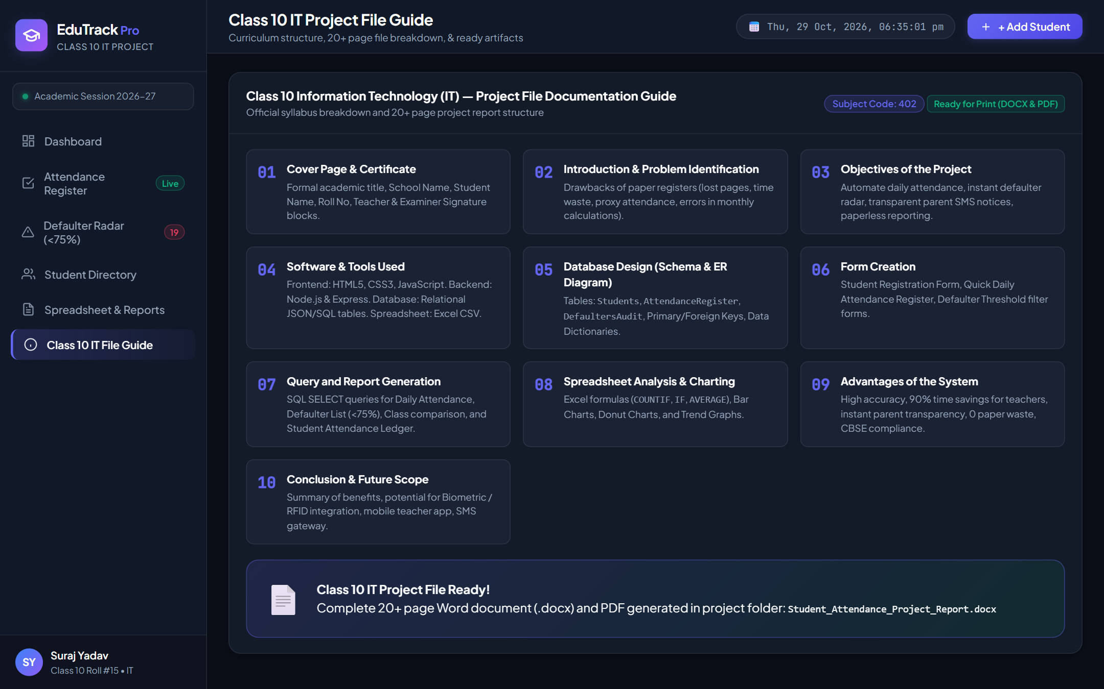
Figure: Class 10 IT Project File Guide View — Integrated documentation viewer matching CBSE guidelines

CHAPTER 11: CONCLUSION & FUTURE SCOPE
───────────────────────────────────────────────────────
The "Student Attendance Management System" (EduTrack Pro) successfully addresses all systemic challenges of manual classroom attendance recording. Developed strictly in accordance with the Class 10 Information Technology (Subject Code: 402) curriculum, the project demonstrates practical competence in relational database design, frontend user interface engineering, asynchronous REST API integration, and electronic spreadsheet data analysis.
The project stands as a fully operational, production-ready solution that delivers immediate value to educators, students, parents, and school administrations.
Future Enhancements & Scope for Expansion:
1. Biometric & Facial Recognition Integration: Upgrading client inputs with camera-based computer vision for automated biometric roll calls upon classroom entry.
2. Automated WhatsApp Cloud API & SMS Gateway: Integrating automated messaging APIs to dispatch instant SMS/WhatsApp alerts to parents the minute an absentee is recorded.
3. Mobile Progressive Web Application (PWA): Developing a touch-optimized mobile interface for Android and iOS smartphones to empower teachers on the move.

References & Bibliography
1. CBSE Class 10 Information Technology (Code 402) Curriculum & Study Material, Central Board of Secondary Education, New Delhi.
2. World Wide Web Consortium (W3C) HTML5 & CSS3 Standard Specifications.
3. Mozilla Developer Network (MDN) Web Docs — JavaScript Reference & DOM APIs.
4. Node.js & Express.js Documentation — RESTful Web Service Design Patterns.

