Plasma–Based Propulsion System
Vijaya N. Aher¹, Suraj N. Yadav², Shraddha L. Warkhade³, Pranav G. Waghmare⁴, Aryan G. Pingale⁵, Prathamesh K. Wankhede⁶

Vijaya.aher@vit.edu¹,suraj.yadav24@vit.edu²,shraddha.warkhade24@vit.edu² ,pranav.waghmare24@vit.edu⁴,aryan.pingale24@vit.edu⁵, prathmesh.wankhede24@vit.edu⁶
Department of Engineering, Sciences, and Humanities
Vishwakarma Institute of Technology, Pune,
Maharashtra, India

Abstract— The rapid development of space exploration has necessitated propulsion systems that are efficient enough to handle long-duration missions, deep space travel, and delicate in-space maneuvering. Conventional chemical propulsion, though good for launch, has poor fuel efficiency and short operational life. This project investigates plasma-based propulsion, primarily the ion thruster, because of its high specific impulse and steady low-thrust capability. The goal is to design a streamlined plasma propulsion system from the electrostatic acceleration paradigm. The focus is on basic ion acceleration mechanisms, charge separation, and a low-cost and scalable design with available materials. The resulting prototype exhibits significant plasma propulsion characteristics and serves as the basis for continued research. Applications are nanosatellites and CubeSats. Future activities will focus on increasing performance through combined power systems and magnetic confinement to offer more efficient and controllable thrust. This study provides an early but promising step toward more sustainable and accurate space propulsion technology.
Keywords— plasma Thruster, Ionic Propulsion, Ring-based propulsion, Portable High-Voltage Ionization

Introduction
In response to increased demand for deep space travel and maneuvering efficiency in space, conventional chemical propulsion systems are not adequate anymore. Such systems are fuel-inefficient and have limited thrust duration and are not suitable for missions requiring steady control and long-term operation, i.e., satellite placement, interplanetary missions, and orbital station-keeping. Yet, plasma-based systems such as ion thrusters offer high specific impulse and low-thrust steady-state operation, which is essential for modern space missions.

This project is motivated by the need to study other means of propulsion that will be suitable for future space travel. It proposes to design and conceptualize a plasma propulsion system with simplified principles based on uncomplicated electrostatic theory. In so doing, the project seeks to surpass the limitations of traditional propulsion and set the stage for even more efficient, scalable, and environmentally friendly space propulsion systems.

OBJECTIVE
Designing and conceptualizing a simplified plasma-based propulsion system that uses electrostatic principles for thrust generation and ion acceleration is the main goal of this project. In order to overcome the drawbacks of traditional chemical propulsion, specifically its low efficiency and short operational life, alternative ion-based systems that are appropriate for deep-space maneuvering, satellite station-keeping, and long-duration space missions are being investigated. The focus is on using reasonably priced materials to create a model that is student-accessible, scalable, and economical.

LITERATURE REVIEW

The paper "Magnetic nozzle radiofrequency plasma thruster approaching twenty percent thruster efficiency"[1] by Kazunori Takahashi discusses the advancements in electrodeless plasma thrusters, with special focus given to magnetic nozzle RF plasma thrusters that ensure electrode erosion is avoided since they utilize RF or microwave fields to accelerate and generate the plasma. Concepts like VASIMR, HDLT, and ECRT use magnetic nozzles to convert electron thermal energy into ion momentum. Plasma dynamics, electron temperature gradients, antenna geometry, gas distribution, and magnetic field shape are the significant parameters in efficiency enhancement.

The article "A Brief Review of Alternative Propellants and Requirements for Pulsed Plasma Thrusters in Micro-propulsion Applications" [2] by William Yeong Liang Ling et al. is a review of pulsed plasma thrusters (PPTs) for micro/nano-satellites and miniaturization challenges, as well as issues for propulsion. It points to the flaws of PTFE, i.e., carbon deposition reducing performance and lifetime, and examines substitutes such as PFPE, ETFE, a blend of PTFE, solid reagents, and sulfur. Though PTFE is still in the forefront, others have promise for increasing efficiency and dependability for future missions.

The paper "An Investigation of Discharge Characteristics of an Electrothermal Pulsed Plasma Thruster" [3] by Yanan Wang et al. is a criticism of the discharge mode of electrothermal PPTs of capillary types used in micro-satellite propulsion applications.

It highlights their simplicity, ruggedness, and efficiency, and contrasts with traditional methods and today's tunnel-type structures. The study cites key works on performance, such as research on resistance in circuits, cavity dimensions, and high-power electromagnetic PPTs. The authors call attention to the importance of discharge behavior at low energies and call for the study of plasma dynamics within capillary geometries.

The research "Design and testing of a Mini-RF plasma thruster with permanent magnets" [4] by Yuzhe Sun, Jikun Zhang, and Zun Zhang presents the design and test of a miniature RF plasma thruster using permanent magnets for micro/nano-satellites. It is an expansion on earlier work with helicon and asymmetrical RF thrusters, focusing on magnetic confinement to improve performance.

The paper "Plasma Thrusters: A New Frontier in Advanced Propulsion"[5] by Prachurjya Das (Roudh) identifies the constraints of chemical rockets to travel very deep into space and discusses electric propulsion possibilities like ion, Hall, MPD thrusters, and laser plasma accelerators. They have high specific impulse and efficiency but low thrust. The article identifies iodine as an inexpensive, perfect xenon substitute, as shown by studies done by Holste, Grondein, and several others.

The journal "New Low-Power Plasma Thruster for Nanosatellites" [6] by J. P. Sheehan et al. describes a low-power, small plasma thruster (CAT) for nanosatellites. Utilizing a helicon wave to create plasma with no exposed electrodes, CAT is packaged inside a CubeSat unit and powered by 10–50 W, generating a maximum of 4 mN thrust with 400–800 s specific impulse. Its three-dimensional print design uses 3D-printed parts, permanent magnets, and a quartz liner in order to make manufacturing easy and robust.

Xenon-tested, CAT is furthermore usable on alternative propellants like iodine, allowing for efficient, nimble nanosatellite propulsion. J.P. Boeuf and L. Garrigues's article "Low Frequency Oscillations in a Stationary Plasma Thruster"[7] discusses electrical behavior and low-frequency oscillations in SPTs, which are well-suited for station-keeping and orbit transfer. Plasma-wall interactions, magnetic confinement, and the potential of plasma thrusters for long-duration, efficient space missions are what the study highlights.

The research "Application and development of the pulsed plasma thruster"[8] by Zhiwen Wu et al. provides an overview of the development and application of PPTs, with easy operation, low power requirement, compact size, and cost benefits to small satellites, though less efficient compared to other electric propulsion systems. It describes structural design, operation, and performance, and recent developments in electrodes, discharging mechanisms, and propellants for improving efficiency and reliability.

The paper "Pulsed Plasma Thrusters (PPTs)" [9], authored by R.L. Burton and P.J. Turchi, presents one of the oldest and simplest electric propulsion systems. PPTs generate thrust by ejecting high-current pulses onto a solid propellant, often Teflon, to create plasma. They have been proven to be compact, reliable, and economical. PPTs have flown on lots of missions despite less efficiency compared to newer electric thrusters. They carry precision to deliver accurate impulse bits, thus suitable for attitude control and formation flight. PPT physics, design forms, operation, and past use in spaceflight are discussed in the paper.

The research “Experimental Study on the Propulsion Performance of Laser Ablation Induced Pulsed Plasma” [10] by Hang Song et al. discusses a hybrid propulsion system for micro- and nano-satellites based on laser ablation and electromagnetic acceleration. Nanosecond laser pulses produce plasma from material such as PTFE, and capacitor-driven Lorentz forces accelerate it. Experiments indicate that although the laser causes plasma, electromagnetic fields play a dominant role in determining thrust, with charging voltage having more influence than laser power. This compact, hybrid technique has strong prospects for future space missions.

METHODOLOGY/EXPERIMENTAL
The research design for this project is experimental and involves prototype development. The aim is to construct a simple plasma thruster model that demonstrates the principle of ion propulsion using an electric field generated by high voltage. The design focuses on a hardware-based approach, where a lithium-ion battery powers a high-voltage generator, which in turn applies a strong electric field between two copper rings to ionize air and create plasma.
Materials & Components for Plasma Thruster Project:

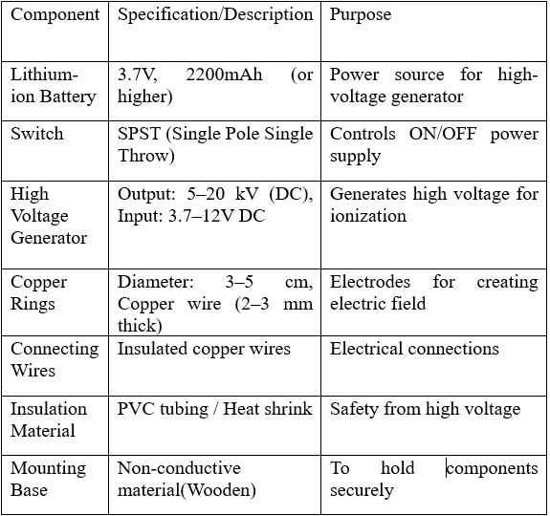

Fig.1: Key components and their functions in the plasma propulsion system.

FLOWCHART

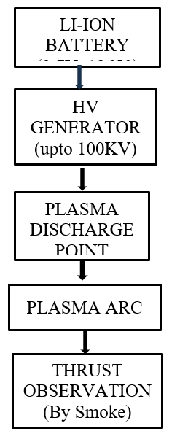

Fig.2: Operational flow of the plasma propulsion system from power supply to thrust observation.

Working Principle:
The plasma thruster works on the principle of electric field ionization and plasma acceleration. Here’s how it operates:

1. Power Supply
A lithium-ion battery provides low-voltage DC power, which is stepped up to high voltage (in kV range) using a high-voltage generator.

2. Electric Field Creation
The high-voltage generator applies a potential difference across two copper rings. One ring acts as the positive electrode (anode) and the other as the negative electrode (cathode).

3. Ionization of Air
The strong electric field between the two rings accelerates electrons, which collide with air molecules. These collisions ionize the air, creating a plasma (a partially ionized gas of ions and electrons).

4. Plasma Discharge
Once the plasma is generated, it forms a visible plasma arc or plume between the rings. The charged particles are accelerated by the electric field, creating micro-thrust.

CIRCUIT DIAGRAM
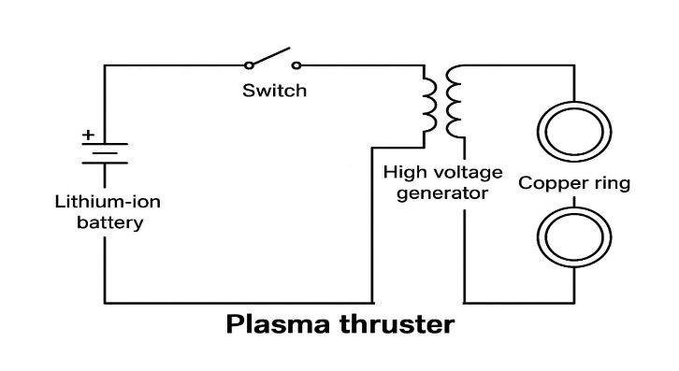
Fig.3: Circuit diagram of the plasma thruster system using a lithium-ion battery, switch, high-voltage generator, and copper rings.

.

RESULTS AND DISCUSSION

When activated, the prototype was able to produce a visible plasma arc at the copper ring electrode when supplied by the high-voltage DC-DC converter. Under darkened environments, the plasma arc was easily visible and consistently created close to the electrode's surface. The arc was accompanied by a clear humming noise, signaling stable air ionization. Video inspection found a directional plasma jet with irregular brightness and form, as would be expected of atmospheric air high-voltage discharges. When set down on a low-friction surface (like aluminum foil or ball bearings), the prototype sometimes showed brief recoil or vibration in the direction opposite the plasma jet. This had implied the creation of a small but quantifiable reactive force.

The constricted motion and roundabout airflow patterns revealed through smoke testing ensured that, although there was thrust, it was minimal. This is typical considering the very small mass flow and low-density plasma created at atmospheric pressure. Unlike vacuum-based ion thrusters in space, this ground prototype experiences severe air resistance and loses energy due to heat dissipation and uncontrolled discharge channels. The plasma arc's performance is controlled by ambient air pressure, electrode design, and non-uniform ion flow, which restricts its propulsion effectiveness. However, the successful production of a plasma arc and observation of directional effects prove the principle and present a basis for more sophisticated designs, particularly in vacuo, where plasma propulsion is much more effective.

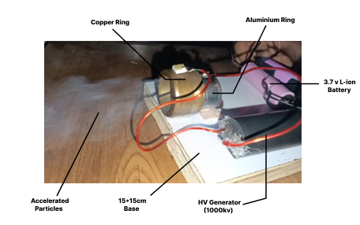
Fig 4: Experimental setup of the plasma thruster showing key components including copper and aluminum rings, high-voltage generator, lithium-ion battery, and visible particle acceleration.

Future Work

To improve the system’s performance and features, the following enhancements can be made :
1. Longer Deep Space Missions:
Through the provision of high specific impulse and continuous low-thrust levels, plasma propulsion can facilitate longer interplanetary missions, asteroid mining activities, and deep space exploration.

2. Scalability for Multiple Applications:
An uncomplicated electrostatic design provides simpler scalability, making plasma propulsion viable not just for large satellites but also for CubeSats and small spacecraft.

3. Sustainable and Green Propulsion:
Plasma systems utilize inert gases such as xenon or argon, which are less environmentally friendly compared to chemical propellants, in line with the increasing need for green aerospace technologies.

4. Increased Satellite Lifespan and Precision Maneuvering:
Enhanced station-keeping and fine attitude control through low but sustained thrust can markedly increase satellite mission lifetimes and lower maintenance expenses.

5. Foundation for Future Research:
The simplified model is a stepping stone towards future improvements with magnetic confinement, hybrid systems, and AI-optimized control algorithms.

Conclusion

Lastly, the increasing requirements of contemporary space missions—ranging from deep space travel to satellite station-keeping—emphasize the shortcomings of conventional chemical propulsion technologies. Plasma-based propulsion, especially ion thrusters, offers a revolutionary alternative with high efficiency in fuel, extended thrust duration, and eco-friendliness. This project, through its investigation of simplified electrostatic plasma propulsion concepts, adds to the basis needed in research for next-generation space traveling technologies.

By proving the viability of such systems on a reduced scale, this work paves new paths for innovation in scalable, accurate, and long-term propulsion. Not only does it overcome the limitations of traditional techniques, but it also meets the future requirements of commercial, scientific, and defense-oriented space activities. Finally, this project represents an essential step toward making safer, more efficient, and more sustainable exploration of the last frontier possible.

ACKNOWLEDGMENT

We wish to extend our heartfelt thanks to all those who
helped and advised us in the course of this project. To begin with, we are immensely grateful to our project guide, Prof. Vijaya Aher Ma’am, for their help, guidance, and valuable advice, which immensely contributed to defining the direction and outcome of this work.

REFERENCES

- K. Takahashi, "Magnetic nozzle radiofrequency plasma thruster approaching twenty percent thruster efficiency," 2021.
- W. Y. L. Ling, S. Zhang, H. Fu, M. Huang, J. Quansah, X. Liu, and N. Wang, "A brief review of alternative propellants and requirements for pulsed plasma thrusters in micro-propulsion applications," 2020.
- Y. Wang, W. Ding, L. Cheng, J. Yan, Z. Li, J. Wang, and Y. Wang, "An investigation of discharge characteristics of an electrothermal pulsed plasma thruster," IEEE, 2017.
- Y. Sun, J. Zhang, and Z. Zhang, "Design and testing of a Mini-RF plasma thruster with permanent magnet," 2024.
- P. Das, "Plasma thrusters: A new frontier in advanced propulsion," 2021.
- J. P. Sheehan, T. A. Collard, B. W. Longmier, and I. M. Goglio, "New low-power plasma thruster for nanosatellites," 2014.
- J.P. Boeuf and L. Garrigues, “Low Frequency Oscillations in a Stationary Plasma Thruster,” 1998.
- Z. Wu, T. Huang, X. Liu, W. Y. L. Ling, N. Wang, and L. Ji, "Application and development of the pulsed plasma thruster," 2020.
- P. Turchi and R. L. Burton, "Pulsed Plasma Thruster," 1998.
- H. Song, J. Ye, M. Wen, H. Cui, and W. Zhao, "Experimental study on the propulsion performance of laser ablation induced pulsed plasma," 2024.
- C. Charles, "Plasmas for spacecraft propulsion," 2009.
- K. Polzin, A. Martin, J. Little, C. Promislow, B. Jorns, and J. Woods, "State-of-the-art and advancement paths for inductive pulsed plasma thrusters,”2020.
- D. Palla and G. Cristoforetti, "Laser–accelerated plasma propulsion system," 2021.
- J. A. Bonometti, P. J. Morton, and G. R. Schmidt, "External pulsed plasma propulsion and its potential for the near future," 2001.
- M. L. McGuire and R. Myers, "Pulsed plasma thrusters for small spacecraft attitude control," 1996.
- R. M. Myers, S. R. Oleson, M. McGuire, N. J. Meckel, R. J. Cassady, and W. Redmond, "Pulsed plasma thruster technology for small satellite missions," 1995.
- E. Gove, "Magnetoplasmadynamic thrusters magnetohydrodynamics," 2024.
- F. Taccogna, F. Cichocki, D. Eremin, G. Fubiani, and L. Garrigues, "Plasma propulsion simulation using particles," 2023.
- G. Herdrich, U. Bauder, A. Boxberger, R. A. Gabrielli, M. Lau, D. Petkow, M. Pfeiffer, C.Syring, S.Fasoulas, “Advanced plasma (propulsion) concepts at IRS,” 2011.
- S.N. Bathgate, M.M.M. Bilek, D.R. McKenzie, “Electrodeless plasma thrusters for spacecraft: a review,”2017.

