AUTONOMOUS MAZE SOLVING ROBOT USING ALPHABOT 2 (ARDUINO)
Vijaya Aher followed by Sachin Tiwari
Department of Engineering, Science and Humanities (DESH)
Vishwakarma Institute of Technology, Pune, Maharashtra, India
Abstract - This project involves developing an “Autonomous Maze Solving Robot using Alphabot2 (Arduino)” using the Alphabot platform. The robot will be equipped with sensors for obstacle detection and navigation and will utilize path finding algorithms such as BFS or DFS to solve mazes. The goal is to design a system that can efficiently navigate through complex maze layouts, demonstrating effective integration of hardware and software for real time problem solving. This project will provide insights into autonomous navigation and algorithm application in robotics. Obstacle avoidance is achieved through a combination of ultrasonic and infrared sensors, allowing the robot to dynamically adapt to its environment and avoid collisions. The incorporation of a video surveillance system provides real-time monitoring and enhancing security and operational oversight. A wireless web server interface enables location and tracking, allowing the robot to perform tasks over large areas with precision.

Keywords — Alphabot2, Arduino, Maze-solving, Obstacle avoidance, Robotics

INTRODUCTION
The primary objective of this project is to create an autonomous maze-solving robot that can navigate a complex maze without human intervention. This involves developing an accurate map of the maze, localizing the robot’s position, and planning an optimal path to the destination. The robot must also be robust enough to adapt to changing maze configurations or unexpected obstacles. To achieve this, the project utilizes the
AlphaBot2 AR platform, which is equipped with three ultrasonic sensors for obstacle detection and navigation. A key component of the system is the implementation of a modified
The need for this system is driven by both industrial and practical applications, as well as research and development goals. In industry, such robots can automate tasks to increase efficiency and productivity, while also navigating hazardous environments to minimize human risk. For research, the project serves as a testbed for developing and testing advanced AI algorithms, improving sensor accuracy, and enhancing autonomous systems. On a social and humanitarian level, these technologies have potential applications in search and rescue missions and healthcare.

LITERATURE REVIEW
[1] “Micromouse Maze-Solving Algorithms” by David Otten (MIT): This foundational paper provides a comprehensive overview of popular maze-solving algorithms such as the Wall-Following, Flood Fill, and the Left and Right-Hand Rules. It also explores the logic and complexity behind each algorithm, making it essential reading for understanding navigation strategies.
.[2] “An Improved Flood-Fill Algorithm for Maze-Solving Robots” by R.A. Mahmood: This paper discusses enhancements to the classic Flood Fill algorithm, focusing on how these modifications improve robot performance in more complex mazes.
[3] “Implementation of Ultrasonic and Infrared Sensors in Autonomous Maze Navigation” by H. Lee et al.: This paper dives into the types of sensors commonly used in maze-solving robots, analyzing their effectiveness in detecting walls, obstacles, and pathways.
[4] “A Survey on Autonomous Mobile Robots’ Sensors and Perception” by A. Ramli and M. Ismail: Although broader in scope, this survey provides valuable insights into sensor technologies like LIDAR, ultrasonic, and infrared, explaining how these technologies support navigation and decision-making.
[5] “Educational Robotics: Maze-Solving as a Teaching Tool” by J. Moreno: This paper discusses the importance of maze-solving robots in educational settings, where students learn principles of robotics, AI, and programming through hands-on experimentation.
[6] “Autonomous Robots for Search and Rescue Applications” by C. Murphy: This article explores real-world applications of maze-solving techniques, such as search and rescue missions, where navigating through complex environments is crucial.

Methodology/Experimental
Choose any one from A,B,C given below as applicable to your Project

Components –

1. Ultrasonic sensor:- Ultrasonic sensors function by emitting high-frequency sound waves and measuring the time it takes for the echoes to return after bouncing off an object. They are commonly used for:

A. Distance Measurement: Determining how far away an object is by calculating the time delay of the returned sound waves.

B. Obstacle Detection: Identifying the presence of nearby objects in applications like robotics and parking sensors.

2. DC Gear Motor:- These sensors are valued for their accuracy, non-contact operation, and ability to work in various environmental conditions. In the Alphabot2 AR robot, the gear motors serve several key functions:

A. Movement: They drive the wheels, enabling the robot to move forward, backward, and turn. Right Ultrasonic Sensor Front Ultrasonic Sensor Left Ultrasonic Sensor Right Gear DC Motor Left Gear DC Motor Arduino Uno (Alphabot2) (Atmega 328P) 7

B. Speed Control: The gear motors allow for precise speed adjustments, essential for navigating different terrains and avoiding obstacles. These functions make the gear motors integral to the robot's mobility and overall performance in various applications.

3. Power supply:- It is used to provide power to the whole system such as ultrasonic sensor, DC gear Motor and Arduino UNO. It has two lithium ion battery connected in series which makes 7.4V(3.7+3.7) of package for supply power to the system.

Flowchart

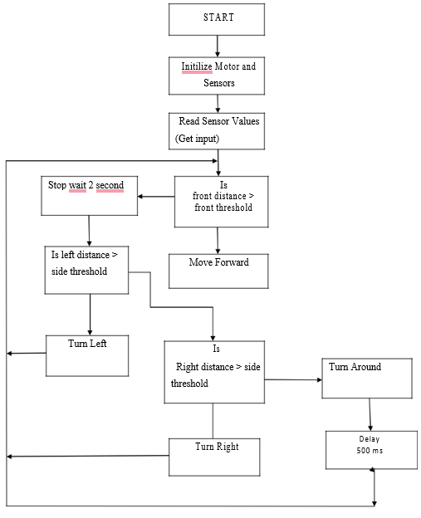

Results and Discussions
Gljkdgji dfgjidfp pgjpjk ghpojkfhp pfghp piojgh lijghopoj lifjghij lijfghoij lkgjhoidjfgh ldigjolijdgh lkjndghojd lkjghlkjh lkjhjkhg

Procedure for Paper Submission

Review Stage
Instructions about final paper and figure submissions in this document are for IEEE journals; please use this document as a “template” to prepare your manuscript. For submission guidelines, follow instructions on paper submission system as well as the Conference website. .

Final Stage
Instructions about final paper and figure submissions in this document are for IEEE journals; please use this document as a “template” to prepare your manuscript. For submission guidelines, follow instructions on paper submission system as well as the Conference website. You must also send your final manuscript on a disk, which IEEE will use to prepare your paper for publication. Write the authors’ names on the disk label. If you are using a Macintosh, please save your file on a PC formatted disk, if possible. You may use Zip or CD-ROM disks for large files, or compress files using Compress, Pkzip, Stuffit, or Gzip.
so send a sheet of paper with complete contact information for all authors. Include full mailing addresses, telephone numbers, fax numbers, and e-mail addresses. This information will be used to send each author a complimentary copy of the journal in which the paper appears. In addition, designate one author as the “corresponding author.” This is the author to whom proofs of the paper will be sent. Proofs are sent to the corresponding author only.
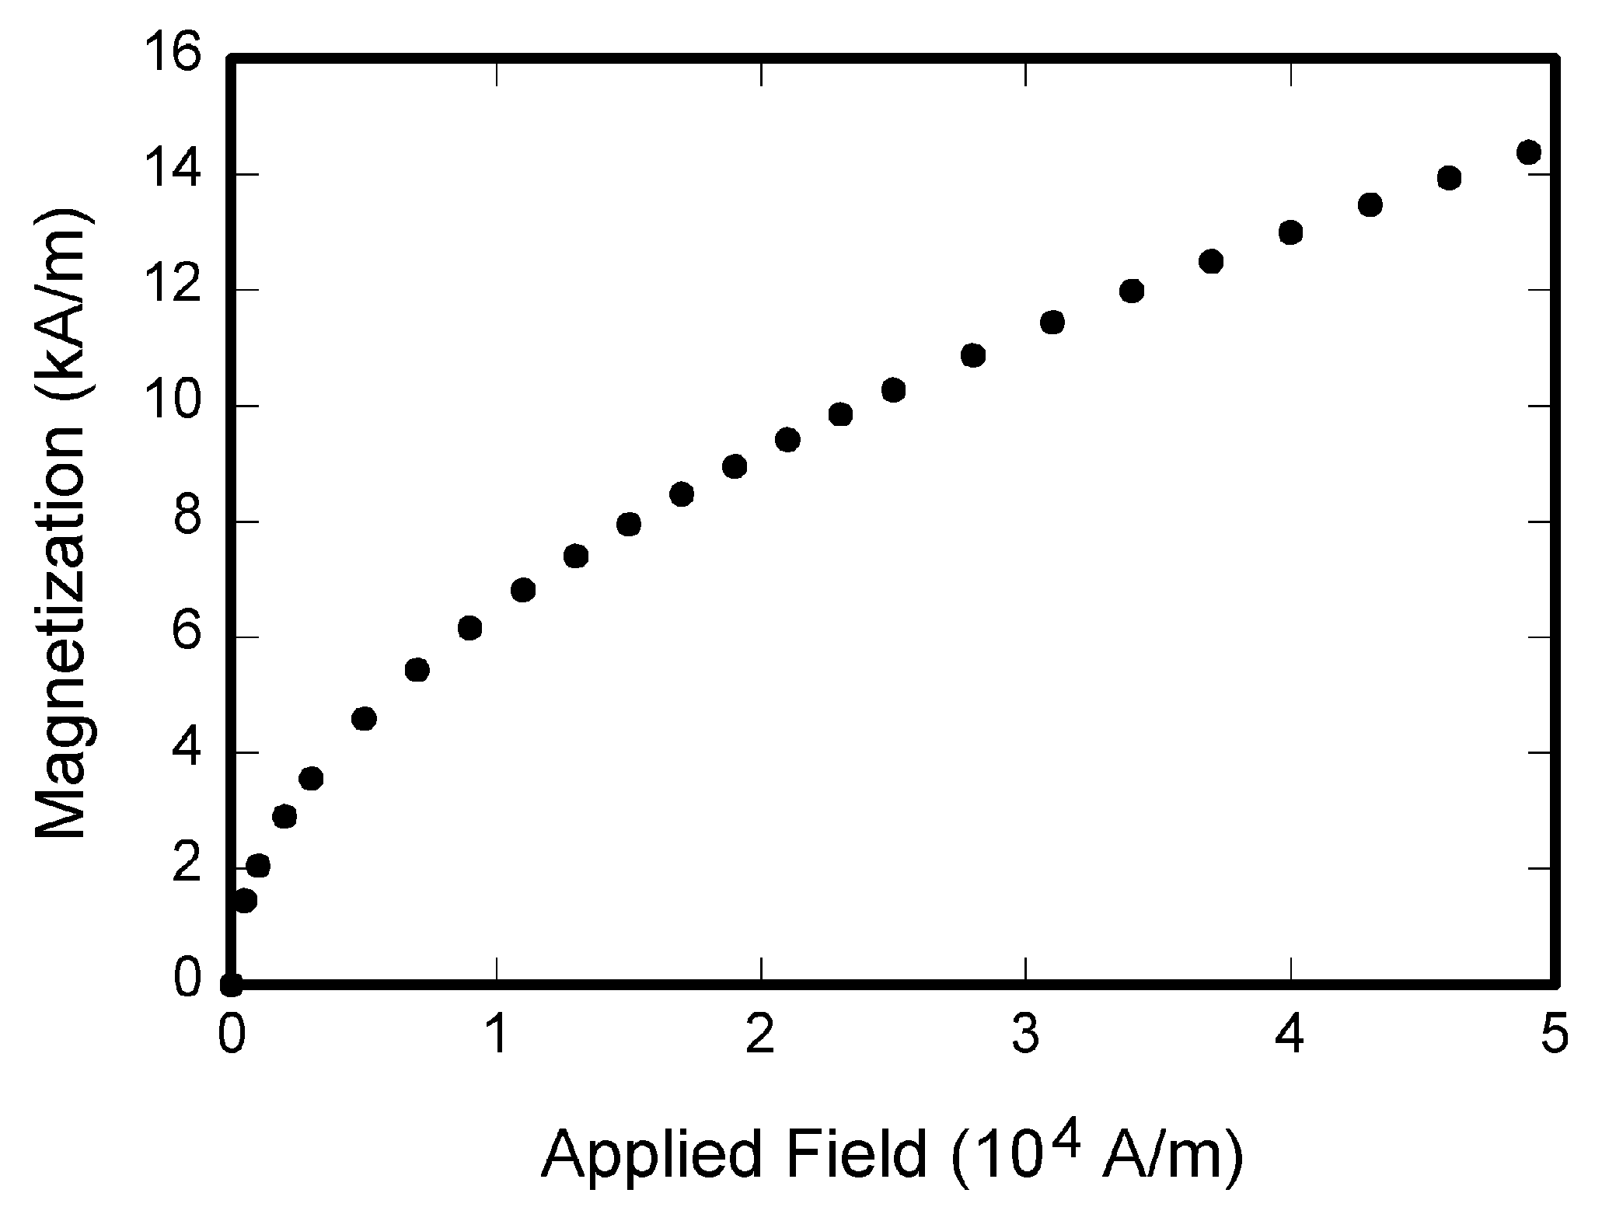
Fig. 1. Magnetization as a function of applied field. Note that “Fig.” is abbreviated. Bvb.nbnblvmnnm There is a period after the figure number, followed by two spaces. It is good practice to explain the significance of the figure in the caption.

Figures
All tables and figures will be processed as images. However, IEEE cannot extract the tables and figures embedded in your document. (The figures and tables you insert in your document are only to help you gauge the size of your paper, for the convenience of the referees, and to make it easy for you to distribute preprints.) Therefore, submit, on separate sheets of paper, enlarged versions of the tables and figures that appear in your document. These are the images IEEE will scan and publish with your paper.

Electronic Image Files (Optional)
You will have the greatest control over the appearance of your figures if you are able to prepare electronic image files. If you do not have the required computer skills, just submit paper prints as described above and skip this section.
For more information on TIFF files, please go to http://www.ieee.org/organizations/pubs/transactions/information.htm and click on the link “Guidelines for Author Supplied Electronic Text and Graphics.”
3) Somewhat Harder Way: If you do not have a scanner, you may create non-color PostScript figures by “printing” them to files. First, download a PostScript printer driver from http://www.adobe.com/support/downloads/pdrvwin.htm
(for Windows) or from
http://www.adobe.com/support/downloads/pdrvmac.htm
(for Macintosh) and install the “Generic PostScript Printer” definition. In Word, paste your figure into a new document. Print to a file using the PostScript printer driver. File names should be of the form “fig5.ps.” Use Adobe Type 1 fonts when creating your figures, if possible.
4) Other Ways: Experienced computer users can convert figures and tables from their original format to TIFF. Some useful image converters are Adobe Photoshop, Corel Draw, and Microsoft Photo Editor, an application that is part of Microsoft Office 97 and Office 2000 (look for C:\Program Files\Common Files \Microsoft Shared\ PhotoEd\ PHOTOED.EXE. (You may have to custom-install Photo Editor from your original Office disk.)
A way to convert a figure from Windows Metafile (WMF) to TIFF is to paste it into Microsoft PowerPoint, save it in JPG format, open it with Microsoft Photo Editor or similar converter, and re-save it as TIFF.
Microsoft Excel allows you to save spreadsheet charts in Graphics Interchange Format (GIF). To get good resolution, make the Excel charts very large. Then use the “Save as

Copyright Form (optional)
An IEEE copyright form should accompany your final submission. These will be custom generated for you at the submission time. Authors are responsible for obtaining any security clearances.

MATH

If you are using Word, use either the Microsoft Equation Editor or the MathType add-on (http://www.mathtype.com) for equations in your paper (Insert | Object | Create New | Microsoft Equation or Math Type Equation). “Float over text” should not be selected.

Units
Use either SI (MKS) or CGS as primary units. (SI units are strongly encouraged.) English units may be used as secondary units (in parentheses). This applies to papers in data storage. For example, write “15 Gb/cm² (100 Gb/in²).” An exception is when English units are used as identifiers in trade, such as “3½ in disk drive.” Avoid combining SI and CGS units, such as current in amperes and magnetic field in oersteds. This often leads to confusion because equations do not balance dimensionally. If you must use mixed units, clearly state the units for each quantity in an equation.
The SI unit for magnetic field strength H is A/m. However, if you wish to use units of T, either refer to magnetic flux density B or magnetic field strength symbolized as µ₀H. Use the center dot to separate compound units, e.g., “A·m².”

Helpful Hints

Figures and Tables

Fig. 1. Magnetization as a function of applied field. Note that “Fig.” is abbreviated. There is a period after the figure number, followed by two spaces. It is good practice to explain the significance of the figure in the caption.

Instructions about final paper and figure submissions in this document are for IEEE journals; please use this document as a “template” to prepare your manuscript. For submission guidelines, follow instructions on paper submission system as well as the Conference website. Because IEEE will do the final formatting of your paper, you do not need to position figures and tables at the top and bottom of each column. In fact, all figures, figure captions, and tables can be at the end of the paper. Large figures and tables may span both columns. Place figure captions below the figures; place table titles above the tables. If your figure has two parts, include the labels “(a)” and “(b)” as part of the artwork. Please verify that the figures and tables you mention in the text actually exist. Please do not include captions as part of the figures. Do not put captions in “text boxes” linked to the figures. Do not put borders around the outside of your figures. Use the abbreviation “Fig.” even at the beginning of a sentence. Do not abbreviate “Table.” Tables are numbered with Roman numerals. Data charts which are typically black and white, but sometimes include color

TABLE I
Units for Magnetic Properties
Symbol | Quantity | Conversion from Gaussian and  CGS EMU to SI ª
Φ | magnetic flux | 1 Mx → 10⁻⁸ Wb = 10⁻⁸ V·s
B | magnetic flux density,  magnetic induction | 1 G → 10⁻⁴ T = 10⁻⁴ Wb/m²
H | magnetic field strength | 1 Oe → 10³/(4π) A/m
m | magnetic moment | 1 erg/G = 1 emu  → 10⁻³ A·m² = 10⁻³ J/T
M | magnetization | 1 erg/(G·cm³) = 1 emu/cm³  → 10³ A/m
4πM | magnetization | 1 G → 10³/(4π) A/m
σ | specific magnetization | 1 erg/(G·g) = 1 emu/g → 1 A·m²/kg
j | magnetic dipole  moment | 1 erg/G = 1 emu  → 4π × 10⁻¹⁰ Wb·m
J | magnetic polarization | 1 erg/(G·cm³) = 1 emu/cm³  → 4π × 10⁻⁴ T
χ, κ | susceptibility | 1 → 4π
χ_{ρ} | mass susceptibility | 1 cm³/g → 4π × 10⁻³ m³/kg
μ | permeability | 1 → 4π × 10⁻⁷ H/m  = 4π × 10⁻⁷ Wb/(A·m)
μ_{r} | relative permeability | μ → μ_{r}
w, W | energy density | 1 erg/cm³ → 10⁻¹ J/m³
N, D | demagnetizing factor | 1 → 1/(4π)
Vertical lines are optional in tables. Statements that serve as captions for the entire table do not need footnote letters.

Color printing of figures is available, but is billed to the authors (approximately $1300, depending on the number of figures and number of pages containing color). Include a note with your final paper indicating that you request color printing. Do not use color unless it is necessary for the proper interpretation of your figures. If you want reprints of your color article, the reprint order should be submitted promptly. There is an additional charge of $81 per 100 for color reprints.
Figure axis labels are often a source of confusion. Use words rather than symbols. As an example, write the quantity “Magnetization,” or “Magnetization M,” not just “M.” Put units in parentheses. Do not label axes only with units. As in Fig. 1, for example, write “Magnetization (A/m)” or “Magnetization (Am⁻¹),” not just “A/m.” Do not label axes with a ratio of quantities and units. For example, write “Temperature (K),” not “Temperature/K.”
Multipliers can be especially confusing. Write “Magnetization (kA/m)” or “Magnetization (10³ A/m).” Do not write “Magnetization (A/m) × 1000” because the reader would not know whether the top axis label in Fig. 1 meant 16000 A/m or 0.016 A/m. Figure labels should be legible, approximately 8 to 12 point type.

References
Number citations consecutively in square brackets [1]. The sentence punctuation follows the brackets [2]. Multiple references [2], [3] are each numbered with separate brackets [1]–[3]. When citing a section in a book, please give the relevant page numbers [2]. In sentences, refer simply to the reference number, as in [3]. Do not use “Ref. [3]” or “reference [3]” except at the beginning of a sentence: “Reference [3] shows ... .” Unfortunately the IEEE document translator cannot handle automatic endnotes in Word; therefore, type the reference list at the end of the paper using the “References” style.
Number footnotes separately in superscripts (Insert | Footnote). Place the actual footnote at the bottom of the column in which it is cited; do not put footnotes in the reference list (endnotes). Use letters for table footnotes (see Table I).
Please note that the references at the end of this document are in the preferred referencing style. Give all authors’ names; do not use “et al.” unless there are six authors or more. Use a space after authors' initials. Papers that have not been published should be cited as “unpublished” [4]. Papers that have been submitted for publication should be cited as “submitted for publication” [5]. Papers that have been accepted for publication, but not yet specified for an issue should be cited as “to be published” [6]. Please give affiliations and addresses for private communications [7].
Capitalize only the first word in a paper title, except for proper nouns and element symbols. If you are short of space, you may omit paper titles. However, paper titles are helpful to your readers and are strongly recommended. For papers published in translation journals, please give the English citation first, followed by the original foreign-language citation [8].

Abbreviations and Acronyms
Define abbreviations and acronyms the first time they are used in the text, even after they have already been defined in the abstract. Abbreviations such as IEEE, SI, ac, and dc do not have to be defined. Abbreviations that incorporate periods should not have spaces: write “C.N.R.S.,” not “C. N. R. S.” Do not use abbreviations in the title unless they are unavoidable (for example, “IEEE” in the title of this article).

Equations
Number equations consecutively with equation numbers in parentheses flush with the right margin, as in (1). First use the equation editor to create the equation. Then select the “Equation” markup style. Press the tab key and write the equation number in parentheses. To make your equations more compact, you may use the solidus ( / ), the exp function, or appropriate exponents. Use parentheses to avoid ambiguities in denominators. Punctuate equations when they are part of a sentence, as in

(1)

Be sure that the symbols in your equation have been defined before the equation appears or immediately following. Italicize symbols (T might refer to temperature, but T is the unit tesla). Refer to “(1),” not “Eq. (1)” or “equation (1),” except at the beginning of a sentence: “Equation (1) is ... .”

Other Recommendations
Use one space after periods and colons. Hyphenate complex modifiers: “zero-field-cooled magnetization.” Avoid dangling participles, such as, “Using (1), the potential was calculated.” [It is not clear who or what used (1).] Write instead, “The potential was calculated by using (1),” or “Using (1), we calculated the potential.”
Use a zero before decimal points: “0.25,” not “.25.” Use “cm³,” not “cc.” Indicate sample dimensions as “0.1 cm × 0.2 cm,” not “0.1 × 0.2 cm².” The abbreviation for “seconds” is “s,” not “sec.” Do not mix complete spellings and abbreviations of units: use “Wb/m²” or “webers per square meter,” not “webers/m².” When expressing a range of values, write “7 to 9” or “7-9,” not “7~9.”
A parenthetical statement at the end of a sentence is punctuated outside of the closing parenthesis (like this). (A parenthetical sentence is punctuated within the parentheses.) In American English, periods and commas are within quotation marks, like “this period.” Other punctuation is “outside”! Avoid contractions; for example, write “do not” instead of “don’t.” The serial comma is preferred: “A, B, and C” instead of “A, B and C.”
If you wish, you may write in the first person singular or plural and use the active voice (“I observed that ...” or “We observed that ...” instead of “It was observed that ...”). Remember to check spelling. If your native language is not English, please get a native English-speaking colleague to proofread your paper.

Future Scope
Dsflhljk ;tjkd ;ljkth ;lk;okh ;lkghlk ‘lsdfnm ;’lm, ‘;lgth ‘skfl’m, jk ;tjkd ;ljkth ;lk;okh ;lkghlk ‘lsdfnm ;’lm, ‘;lgth ‘skfl’m, jk ;tjkd ;ljkth ;lk;okh ;lkghlk ‘lsdfnm ;’lm, ‘;lgth ‘skfl’m, ljkth ;lk;okh ;lkghlk ‘lsdfnm ;’lm, ‘;lgth ‘skfl’m, ljkth ;lk;okh ;lkghlk ‘lsdfnm ;’lm, ‘;lgth ‘skfl’m, ljkth ;lk;okh ;lkghlk ‘lsdfnm ;’lm, ‘;lgth ‘skfl’m, ljkth ;lk;okh ;lkghlk ‘lsdfnm ;’lm, ‘;lgth ‘skfl’m, ljkth ;lk;okh ;lkghlk ‘lsdfnm ;’lm, ‘;lgth ‘skfl’m,

Conclusion
Although a conclusion may review the main points of the paper, do not replicate the abstract as the conclusion. A conclusion might elaborate on the importance of the work or suggest applications and extensions.

X . Acknowledgment
The preferred spelling of the word “acknowledgment” in American English is without an “e” after the “g.” Use the singular heading even if you have many acknowledgments. Avoid expressions such as “One of us (S.B.A.) would like to thank .” Instead, write “F. A. Author thanks ..” Sponsor and financial support acknowledgments are placed in the unnumbered footnote on the first page.

References
- Maireva S., Usai T. and Manhokwe S., "The Determination of Adulteration in Orange Based Fruit Juices", International Journal of Science and Technology Volume 2 No. 5, May, 2013.
- A. H. Kiranmayee, P. C. Panchariya, P. B. Prasad and A. L. Sharma, "Biomimetic cIassification of juices", Proceeding of 20 I 2 Sixth International Conference on Sensing Technology (ICST), pp. 551-556,2012.
- W.-K. Chen, Linear Networks and Systems (Book style). Belmont, CA: Wadsworth, 1993, pp. 123–135.
- G. Eason, B. Noble, and I. N. Sneddon, “On certain integrals of Lipschitz-Hankel type involving products of Bessel functions,” Philosophical Transaction Royal Society London, volume A-247, pp. 529–551, April 1955.
- B. Smith, “An approach to graphs of linear forms (Unpublished work style),” unpublished.
- E. H. Miller, “A note on reflector arrays (Periodical style—Accepted for publication),” IEEE Trans. Antennas Propagat., to be published.
- J. Wang, “Fundamentals of erbium-doped fiber amplifiers arrays (Periodical style—Submitted for publication),” IEEE J. Quantum Electron., submitted for publication.
- C. J. Kaufman, Rocky Mountain Research Lab., Boulder, CO, private communication, May 1995.
- Y. Yorozu, M. Hirano, K. Oka, and Y. Tagawa, “Electron spectroscopy studies on magneto-optical media and plastic substrate interfaces (Translation Journals style),” IEEE Transl. J. Magn.Jpn., vol. 2, Aug. 1987, pp. 740–741 [Dig. 9th Annu. Conf. Magnetics Japan, 1982, p. 301].
- M. Young, The Techincal Writers Handbook. Mill Valley, CA: University Science, 1989.
- J. U. Duncombe, “Infrared navigation—Part I: An assessment of feasibility (Periodical style),” IEEE Trans. Electron Devices, vol. ED-11, pp. 34–39, Jan. 1959.

(Footnotes like this may be included as per requirement) It is recommended that footnotes be avoided (except for the unnumbered footnote with the receipt date on the first page). Instead, try to integrate the footnote information into the text.

