Plasma–Based Propulsion System
Suraj N. Yadav¹, Shraddha L. Warkhade², Pranav G. Waghmare³, Aryan G. Pingale⁴, Prathamesh K. Wankhede⁵, Kalpana L. Pardeshi⁶, Vijaya N. Aher⁷

suraj.yadav24@vit.edu¹,shraddha.warkhade24@vit.edu², pranav.waghmare24@vit.edu³, aryan.pingale24@cit.edu⁴ ,prathmesh.wankhede24@vit.edu⁵,kalpana.pardeshi@vit.edu⁶ ,vijaya.aher@vit.edu⁷
Department of Instrumentation and Control Engineering,
Vishwakarma Institute of Technology, Pune,
Maharashtra, India

Abstract— The dramatic growth of space exploration has increased the demand for propulsion systems to satisfy long missions into deep space and move about the inside of the craft during critical, sensitive timeframes. Chemical propulsion works well for launches of spacecraft; however, their fuel efficiency falls well short, and they tend to have a short life span. This project is investigating plasma propulsion, i.e., the ion thruster, with its high specific impulse and continuous, constant low-thrust electrical capacitor power supply. The project objective is to develop a plasma propulsion system with a thinner profile using the electrostatic accelerator model. The research will assess the basic parameters for ion acceleration, charge separation, and model design of a low-cost, scalable device using basic, common, readily available materials. The final prototypes showed acceptable plasma propulsion characteristics and a good foundation for further research into the potential of plasma propulsion. The areas that offer the most immediate utility are for nanosatellites and CubeSats. The next steps will be to enhance performance by combining power sources and utilizing magnetic confinement for more controlled thrust in an efficient manner. Overall, this project represents a very early and hopeful step towards a new, sustainable, and more correct branch of propulsion technology.
Keywords— Plasma Thruster, Ionic Propulsion, Ring-based propulsion, Portable High-Voltage Ionization

Introduction
The traditional chemical propulsion systems have been surpassed due to their inefficiency with fuel and thrust durations, and traditionally, chemical propulsion systems are unsuitable for mission types that require control for lengthy periods (i.e., placement types such as satellite missions, planetary missions, or station-keeping and either in orbit or deep space). Traditional chemical propulsion systems will not withstand a greater demand for longer-duration deep space travel and the challenge of not having maneuverability. Plasma-based propulsion systems, such as ion thrusters, will allow for greater specific impulse, although they require a lower-thrust steadily state operation, which will aid in existing space exploration missions.

As a study for propulsion alternatives will be warranted for long-term space travel, the stated aim of the project report is to see if a plasma propulsion system study and design can be completed by following "clean", "simple" directives and engine-powered operations based on a few principle-based theories of electrostatics. In the design and study for the project, the research will collide with necessary issues often faced in traditional propulsion and try to provide the cornerstones for a more purposeful, effective, and environmentally sustainable space propulsion system.

OBJECTIVE
The primary goal of the project is to design and conceptualize a simplified plasma-based propulsion system that follows electrostatic principles of accelerating ions to create thrust. Chemical propulsion has limitations (i.e., inefficient mass use of propellant and lifetime operations), and a long-duration space propulsion option is eagerly awaited; for example, lighter-than-air Ion Thrusters or Ion propulsion systems are another option for external deep-space maneuver yards and satellite station-keeping operations. Along with our configuration available to students and a residential amount accessible, user-defined objectives are flexible with inexpensive materials and readily available resources, while being modular and affordable.

LITERATURE REVIEW

The paper "Magnetic Nozzle Radiofrequency Plasma Thruster Nearing Twenty Percent Thruster Efficiency" by Kazunori Takahashi [1] presents advancements in electrodeless RF plasma thrusters that aim to avoid erosion of electrodes by using radiofrequency or microwave energy to ionize and accelerate the plasma. The research particularly emphasizes magnetic nozzle configurations, which achieve a high conversion rate of electron thermal energy to axial ion momentum. This applies to most thruster designs like VASIMR (Variable Specific Impulse Magnetoplasma Rocket), HDLT (Helicon Double Layer Thruster), and ECRT (Electron Cyclotron Resonance Thruster). The article cites some of the principal regions influencing global efficiency, and they are plasma dynamics, electron temperature gradients, antenna geometry, gas flow distribution, and magnetic field structure. Takahashi’s research brings the technology closer to practical application, with reported efficiencies approaching 20%, marking a significant step forward for long-duration and deep-space missions using RF-based propulsion.
The paper "A Brief Review of Alternative Propellants and Requirements for Pulsed Plasma Thrusters in Micro-propulsion Applications" [2] by William Yeong Liang Ling et al. addresses pulsed plasma thrusters from miniaturization issues as well as micro/nano-satellites and propulsion issues. It does address the issue of PTFE, i.e., carbon deposition decreasing life and performance. It is mentioned about other propellants like PFPE and ETFE, and PTFE blending with solid reagents and sulfur. Although PTFE is the best propellant, these alternative propellants have strong efficiency and reliability in the future.

Yanan Wang et al.'s "An Investigation of Discharge Characteristics of an Electrothermal Pulsed Plasma Thruster" (3) is an overview of electrothermal PPTs of capillary type discharge mode for micro-space vehicles' propulsion.
The authors appreciate the earlier PPTs for being robust, simple, and efficient capillary-type electrothermal PPTS compared to traditional approaches and tunner-type configurations that were traditionally utilized. The paper makes a reference to a large-scale performance study before the present investigation, with targeted studies referred to on resistance in circuits, cavity dimension effect, and high-power electromagnetic PPTs. The authors are right to call attention to the low-energy discharge character and need for study of plasma dynamics in capillary geometries.

Yuzhe Sun, Jikun Zhang, and Zun Zhang's "Design and Testing of a Mini-RF Plasma Thruster with Permanent Magnets" [4] is organized research into the design and experimental testing of a mini-radio-frequency (RF) plasma thruster using permanent magnets. The thruster is proposed for micro- and nano-satellite missions and was based on improvements of previous research on helicon and asymmetric RF thrusters. But what is important in this paper is that the authors particularly diverged from standard magnetic confinement techniques. Rather than relying on magnetic fields to control and enhance plasma performance, authors look into new geometries to maximize efficiency and thrust. Their system-level observations and experimental results all find applicability to RF-based electric propulsion research development, which is potentially high because high-efficiency low-power propulsion of small spacecraft. Not only does the paper enhance the integration of permanent magnets, but it also calls for more research on hybrid magnetic-plasma interaction systems.

The paper "Plasma Thrusters: A New Frontier in Advanced Propulsion" by Prachurjya Das (Roudh) [5] continues further into the vast area of the limitations of conventional chemical rockets, i.e., they are inefficient and not suitable for traveling to deep space. The author has made a very strong argument for the transition to electric propulsion systems that are much more efficient when it comes to specific impulse and fuel usage. The article provides an overview of some of the new electric propulsion systems, such as Ion Thrusters, Hall Effect Thrusters, Magnetoplasmadynamic (MPD) Thrusters, and newer ones, such as laser plasma accelerators. While these systems provide comparatively low thrust values, they would be more than adequate for long-term missions where efficiency will have to come before sheer power. One of the rather interesting things that this article actually talks about is iodine substitution with xenon, the conventional propellant utilized in most EP systems. Data from Holste, Grondein, and others is employed in deciding that iodine is as comparable as xenon in operation but one-tenth as expensive, with far higher storage and accessibility. This shift would highly probably make electrical propulsion even more alluring to budget-constrained missions like constellations and CubeSats.

Journal paper "New Low-Power Plasma Thruster for Nanosatellites" by J.P. Sheehan et al. [6] is a presentation of a new, extremely miniaturized propulsion system known as the CubeSat Ambipolar Thruster (CAT). The CAT system is designed for nanosatellite-class missions and is the sole one amongst all those available on the market in that it generates plasma from helicon waves, without exposed electrodes — the vulnerability point of conventional design. This property significantly improves the lifetime of the thruster and operation time in the environment of space. The system itself is very compact, such that it can be placed within a regular unit of CubeSat and operates accurately using a power range of 10-50 watts, thus making it extremely attractive to power-limited missions. Using the limited energy, the CAT produces 4 milliNewtons of thrust and a specific impulse in the range of 400 to 800 seconds, impressive considering the size and energy input. The CAT system design utilizes standard fabrication techniques. It uses 3D-printed parts, permanent magnets, and quartz coating, which not only make it light and rugged but also inexpensive to manufacture and assemble. First demonstrated with xenon, the CAT thruster is equally well adapted to be used with iodine and other propellant alternatives, too. This makes it operationally flexible and offers economically viable solutions for long-duration small-satellite missions, especially deep space or orbit raising missions where fuel efficiency is of topmost priority.

In one of the recent papers, J.P. Boeuf and L. Garrigues, in their research article "Low Frequency Oscillations in a Stationary Plasma Thruster" [7], describe the physics of Stationary Plasma Thrusters (SPTs) — now commonly referred to as Hall Effect Thrusters. The article connects naturally occurring low-frequency oscillations during thruster operation, originally thought to be parasitic but now established as essential for electron transport and discharge stability. Oscillations are controlled by intricate parameters like plasma-wall interactions, magnetic field topology, and thruster structure. Authors present such dynamics through analysis models and computer simulations and show their impact on thruster performance and operational time. The conclusions impart trust in SPTs for station-keeping and orbit-transfer maneuvers, especially in long-duration missions. The paper concludes that better knowledge of such plasma dynamics inside is needed to create next-generation plasma propulsion, and especially space spacecraft with demands of continuous operation and increased space service lifetimes. The results also provide additional remarks to the whole electric propulsion community, whose plasma dynamics optimization is one of the most important frontier research topics.

The article "Application and Development of the Pulsed Plasma Thruster" by Zhiwen Wu et al. [8] gives extensive information about Pulsed Plasma Thruster (PPT) systems and the way that their application has developed over time as propulsion systems in small satellites. In the research, it is explained how easy and lightweight PPTs are; they mimic plasma using high-voltage discharges and solid propellant, commonly Teflon. Experts credit ongoing advances in structure, electrode, and discharge circuit design to improved efficiency and longer life of such systems. Although overall PPTs entail lower specific impulse and total thrust than new electric propulsion, they are used because of low power requirement, high reliability, and minimal production cost. Hence, they are ideally suited for attitude control, de-orbit, and drag make-up of microsatellites and CubeSats. Other alternative switch-mode and propellant-based optimization techniques are also discussed within the paper to enhance plasma homogeneity and reduce wear.

The basic paper "Pulsed Plasma Thrusters (PPTs)" by R.L. Burton and P.J. Turchi [9] is also a highly cited paper about PPT operation and design. This document includes a physical description of processes involved in pulsed plasma generation, where high-current discharges vaporize and ionize a solid fuel to produce thrust impulses. It refers briefly to the two most primitive design layouts, coaxial and parallel-plate geometries, and gives mass bit, thrust per pulse, and efficiency equations. Authors also give descriptive background information, referencing some space missions where PPTs were used to great advantage in an attempt to realize accurate maneuvering and attitude control. The article puts into perspective how much PPTs are worth in providing real impulse bits that are very crucial in mission-critical applications like formation flying, navigation accuracy, or accurate attitude control. Although less performance-efficient than existing electric thrusters, their proven design, simplicity of operation, and flight history ensure a specialized market for the small satellite propulsion systems, even in the present scenario

The article "Experimental Study on the Propulsion Performance of Laser Ablation Induced Pulsed Plasma" by Hang Song et al. [10] is an introduction to a new hybrid propulsion technique that reconciles electromagnetic acceleration with laser ablation for application in micro- and nano-satellites. They are conducting their experiment on the nanosecond laser pulse focusing on a solid target, commonly PTFE (Teflon), to produce a plasma plume. This plasma is then accelerated with the assistance of Lorentz forces produced by a capacitor-induced discharge mechanism. It is also included in the study that electromagnetic force is responsible for an even greater contribution to the generation of thrust than stored energy within the laser, because charging voltage higher than others produced higher thrust than the power rise of the laser. The authors put it down as an important observation for future optimization. In short, this small hybrid concept has tremendous potential for efficient, mass-effective propulsion systems to be used in the next generation of small spacecraft.

METHODOLOGY/EXPERIMENTAL
The project involves an experimental research approach aimed at creating and experimentally validating physical models to describe the fundamental operating principles of ion propulsion. The aim is to design a low-cost, uncomplicated plasma thruster model and demonstrate how an electric field can be utilized to accelerate ions as part of an attempt to produce thrust. The demonstration would be an ion drive hardware simulation within an electric space propulsion concepts show-and-tell demonstration. The arrangement will power a high-voltage generator from a lithium-ion battery, which will produce a high electric field between two copper ring electrodes. The electric field will ionize the surrounding air to form a visible plasma arc and expose the mechanism of thrust at its most basic level. Although not for spaceflight, the model is a proof-of-concept machine and functional to examine plasma action and electric field acceleration in drive systems.

Materials & Components for Plasma Thruster Project:

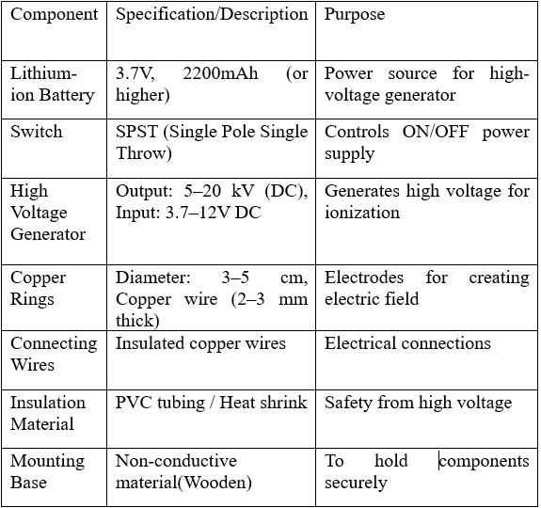

Fig.1: Key components and their functions in the plasma propulsion system.

a)FLOWCHART: -

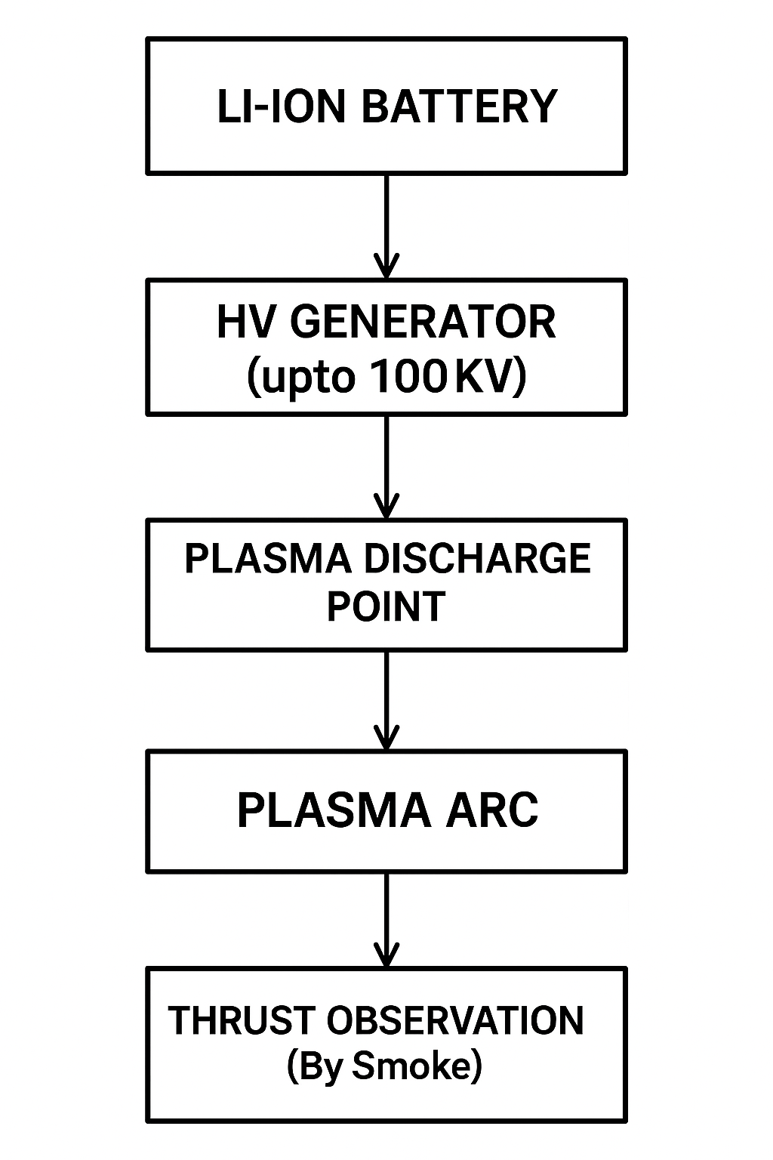

Fig.2: Operational flow of the plasma propulsion system from power supply to thrust observation.

How it works:
The plasma thruster produces plasma using electric field ionization and then accelerates the plasma using an electric field. The process occurs in the following way:

1. Power supply
A lithium-ion battery supplies low-voltage DC power, which is converted to high voltage (in the kV range) with a high-voltage generator.

2. Electric field
The high voltage generator creates a potential difference across two copper rings; one ring acts as the positive electrode (anode) and the other acts as the negative electrode (cathode).

3. Ionization of air
The electric field between the two rings is strong enough to accelerate electrons, which collide with the air molecules, ultimately knocking out electrons and ionizing the air, creating a plasma (or partially ionized gas comprised of ions and electrons).

4. Plasma discharge
Once plasma is created, an arc (or visible plume) forms between the two rings. The electric field accelerates charged particles, which creates a micro-thrust.

b)CIRCUIT DIAGRAM:-
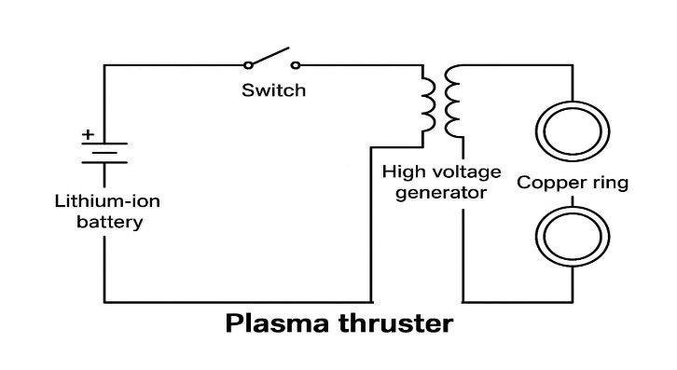
Fig.3: Circuit diagram of the plasma thruster system using a lithium-ion battery, switch, high-voltage generator, and copper rings.

.

RESULTS AND DISCUSSION
When the prototype was activated, it displayed the expected discharge of visible arc plasma at the copper-ring electrode from the high voltage DC-to-DC power converter. The arc, under darkness, was a striking visual contrast to ambient light and always developed at a point close to the electrode surface. There was also an audible hum produced by the arc that would allow identification of the arc as a stable ambient air ionized plasma. There was also some video examination, which comprised a lot of the bias observed on the temporally directional hierarchy from the source of the audio, indicating the presence of brightness changes and morphological changes consistent with high voltage discharges in atmospheric air. The prototype was tested on low low-friction surface as aluminum foil or a ball bearing, and each showed occasional rapid unidirectional recoil or vibrations opposite to the direction of the experimental plasma jet, indicating there was a small directional, measurable, and potentially reactive force.

Although the plasma visualization and additional smoke tests indicated the presence of some circumstantial motion and some remarkable transient airflow, it would suggest that possibly thrust was present in the experiment, which would probably be a negligible thrust. This would be expected due to the combination of very small mass flow and very poor density of a plasma formed from an object at atmospheric ambient pressure while the plasma is produced through the very small point of the copper electrode plasma and in the gaseous surroundings of the tip, the aircraft was likely subjected to an extremely small perturbation, but one that could be suggestive as a thrust force.

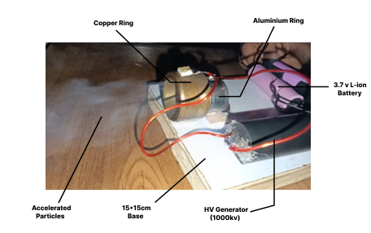
Fig 4: Experimental setup of the plasma thruster showing key components including copper and aluminum rings, high-voltage generator, lithium-ion battery, and visible particle acceleration.

Applied Voltage (V) | Qualitative Thrust Level | Visible Arc Plasma | Recoil/Motion Observed | Airflow/Smoke Jet | Audible Indicator
2000 | Very Weak | Yes | None | Barely visible | Low hum
3000 | Weak | Yes | Occasional vibration | Slight movement | Audible hum
4000 | Moderate | Yes | Small recoil | Visible short jet | Clear hum
5000 | Moderate-Strong | Intense | Noticeable recoil | Stronger plume | Loud hum
6000 | Strong | Very intense | Consistent movement | Pronounced jet | Loud, steady
7000 | Strong | Very intense | Repeated recoil | Obvious particle | Loud, sharp
8000 | Strongest | Max intensity | Clear, strong motion | Max effect | Max intensity

Fig 5: Schematic airflow vector field illustrating the plasma jet and induced motion around the electrode tip,
visualized via smoke particle motion. The arrows indicate the direction and relative intensity of airflow generated by the plasma discharge.

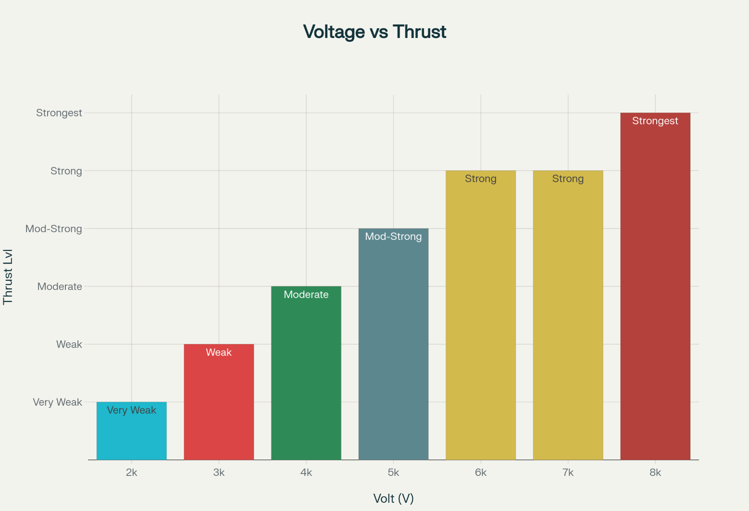
Fig. 6: Relationship between applied voltage and qualitative thrust level for the plasma thruster system. The bar chart illustrates the progressive increase in observed thrust intensity—from 'Very Weak' to 'Strongest'—as supply voltage is raised from 2000 V to 8000 V. Thrust levels were qualitatively assessed based on arc visibility, motion effects, airflow, and acoustic feedback during testing.

Test Surface | Observation of Motion | Directionality | Remarks
Aluminum Foil | Small vibrations, recoil | Opposite to the plasma jet | Minor impulses, amplified on smooth low-friction
Ball Bearing Mount | Smooth micro-oscillations | Consistent unidirectionality | Recoil is clearer due to reduced resistance

Test Surface | Observation of Motion | Directionality | Remarks
Aluminum Foil | Small vibrations, recoil | Opposite to the plasma jet | Minor impulses, amplified on smooth low-friction
Ball Bearing Mount | Smooth micro-oscillations | Consistent unidirectionality | Recoil is clearer due to reduced resistance

Fig 7: Motion observations on test surfaces. Aluminum foil showed small vibrations and recoil opposite to the plasma jet, amplified by its low friction. The ball bearing mount exhibited smooth, consistent micro-oscillations with clearer unidirectional recoil due to reduced resistance.

Future Work

The following improvements can be made to the system to further the offerings:
1. What about longer deep-space missions?
Plasma propulsion utilizes high specific impulse and constant low thrust, making it possible to increase planned interplanetary missions and asteroid mining, and deep space missions.

2. How scalable to multiple applications?
Simplicity with a simple electrostatically based design enables much easier scaling. Because of this, plasma propulsion will not be limited to large satellites, but also CubeSats and small spacecraft.

3. Green. Xenon and argon *are not the most environmentally friendly* as inert gases used in plasma systems, and using chemical

Propellants are not as environmentally friendly as other transportation *this is still the way to go* with the continuing need for green aerospace technology.
4. Improved satellite precision and functioning lifetime.
Significantly improving the precision of attitude control, along with improved weeks of station-keeping with constant.

Conclusion
Modern space missions, ranging from deep space operations to satellite station-keeping, require high-performance out of
propulsion technologies; it has become apparent that existing chemical propulsion technologies cannot meet these evolving requirements. Plasma-based propulsion methods, specifically ion thrusters, present a new high-performance and eco-friendly alternative to existing outdated propulsion paradigms by delivering high fuel efficiency and long-duration thrust. Our project advances an existing body of work in research by presenting a simplified approach to electrostatic plasma propulsion, which, through the investigation of its application within the space setting, contributes to the basis necessary for next-generation space traveling technologies.

This work provides a clear pathway of how to demonstrate the feasibility of such systems in a reduced capacity; there is an improvement to scalability in a space setting, accuracy toward thrust force, and dependency for propulsion over time. This work not only overcomes the limitations of established ways of propulsion, but also meets the future needs of commercial, scientific, and defence space opportunities. Overall, this project provides an important advancement toward making exploration of the last frontier safer, less dependent on standard high and low thrust systems, and less resource-intensive.
.

ACKNOWLEDGMENT
We'd also like to extend our heartfelt gratitude to all those who helped and guided us throughout this project. To begin with, we would like to thank our project guide, Prof. Vijaya Aher Ma'am, for the same without whose support, guidance, and friendly advice throughout this project, which was of immense benefit in ensuring this project had the correct vision and conclusion.

REFERENCES

- K. Takahashi, "Magnetic nozzle radiofrequency plasma thruster approaching twenty percent thruster efficiency," 2021.
- W. Y. L. Ling, S. Zhang, H. Fu, M. Huang, J. Quansah, X. Liu, and N. Wang, "A brief review of alternative propellants and requirements for pulsed plasma thrusters in micro-propulsion applications," 2020.
- Y. Wang, W. Ding, L. Cheng, J. Yan, Z. Li, J. Wang, and Y. Wang, "An investigation of discharge characteristics of an electrothermal pulsed plasma thruster," IEEE, 2017.
- Y. Sun, J. Zhang, and Z. Zhang, "Design and testing of a Mini-RF plasma thruster with permanent magnet," 2024.
- P. Das, "Plasma thrusters: A new frontier in advanced propulsion," 2021.
- J. P. Sheehan, T. A. Collard, B. W. Longmier, and I. M. Goglio, "New low-power plasma thruster for nanosatellites," 2014.
- J.P. Boeuf and L. Garrigues, “Low Frequency Oscillations in a Stationary Plasma Thruster,” 1998.
- Z. Wu, T. Huang, X. Liu, W. Y. L. Ling, N. Wang, and L. Ji, "Application and development of the pulsed plasma thruster," 2020.
- P. Turchi and R. L. Burton, "Pulsed Plasma Thruster," 1998.
- H. Song, J. Ye, M. Wen, H. Cui, and W. Zhao, "Experimental study on the propulsion performance of laser ablation induced pulsed plasma," 2024.
- C. Charles, "Plasmas for spacecraft propulsion," 2009.
- K. Polzin, A. Martin, J. Little, C. Promislow, B. Jorns, and J. Woods, "State-of-the-art and advancement paths for inductive pulsed plasma thrusters,”2020.
- D. Palla and G. Cristoforetti, "Laser–accelerated plasma propulsion system," 2021.
- J. A. Bonometti, P. J. Morton, and G. R. Schmidt, "External pulsed plasma propulsion and its potential for the near future," 2001.
- M. L. McGuire and R. Myers, "Pulsed plasma thrusters for small spacecraft attitude control," 1996.
- R. M. Myers, S. R. Oleson, M. McGuire, N. J. Meckel, R. J. Cassady, and W. Redmond, "Pulsed plasma thruster technology for small satellite missions," 1995.
- E. Gove, "Magnetoplasmadynamic thrusters magnetohydrodynamics," 2024.
- F. Taccogna, F. Cichocki, D. Eremin, G. Fubiani, and L. Garrigues, "Plasma propulsion simulation using particles," 2023.
- G. Herdrich, U. Bauder, A. Boxberger, R. A. Gabrielli, M. Lau, D. Petkow, M. Pfeiffer, C.Syring, S.Fasoulas, “Advanced plasma (propulsion) concepts at IRS,” 2011.
- S.N. Bathgate, M.M.M. Bilek, D.R. McKenzie, “Electrodeless plasma thrusters for spacecraft: a review,”2017.

