EngineerOS: An AI-Powered Unified Academic Workspace for Engineering Students

Micro Project Report

SUBMITTED BY

Suraj Rameshwar Bhandare
ISTU No.: 24010050006
Shraddha Shivkumar Shukla
ISTU No.: 24010050001



DEPARTMENT OF COMPUTER SCIENCE & ENGINEERING
(Artificial Intelligence and Machine Learning)

G H RAISONI INTERNATIONAL SKILL TECH UNIVERSITY, PUNE

2025-26



CERTIFICATE
I hereby certify that the work presented in the Micro Project entitled “EngineerOS: An AI-Powered Unified Academic Workspace for Engineering Students”, in partial fulfillment of the requirements of the curriculum for the academic year 2025–26, submitted in the Computer Engineering Department, School of Engineering & Technology, G. H. Raisoni International Skill Tech University, Pune, is an authentic record of the work carried out by Suraj Rameshwar Bhandare (Roll No: SA260, Registration No: ISTU24010050006) during the period from January 2026 to April 2026, under the supervision of Dr. Ravi Kumar Ranjan, Assistant Professor, School of Engineering & Technology, G. H. Raisoni International Skill Tech University, Pune.
The matter presented in this micro-project has not been submitted earlier by the candidate for the fulfilment of any degree or diploma in any other Institute or University.
Signature of Student
Suraj Rameshwar Bhandare
Roll No: SA260
Registration No: ISTU24010050006
Branch: Computer Science Engineering (AIML)
This is to certify that the above statement made by the candidate is correct to the best of my knowledge.
Dr. Ravi Kumar Ranjan
Project Guide
School of Engineering & Technology
The evaluation of the above micro-project has been conducted as per the prescribed norms of the University held on _________________.

Signature of Project Guide Signature of External Examiner

ACKNOWLEDGMENT

We would like to express our sincere gratitude to G. H. Raisoni International Skill Tech University, Pune, especially the School of Engineering & Technology, for providing us with the opportunity and resources to carry out this micro-project.
We express our profound gratitude to our guide, Dr. Ravi Kumar Ranjan, Assistant Professor, School of Engineering & Technology, for his continuous guidance, valuable suggestions, motivation, and support throughout the development of this micro-project. His expertise, encouragement, and insightful feedback played a crucial role in the successful completion of our work.
We are also thankful to Dr. R. D. Kharadkar, Vice-Chancellor, along with the Head of the Department, faculty members, and staff of the Computer Engineering Department (AIML) for their constant support and cooperation.
We extend our appreciation to our friends and classmates for their encouragement and assistance during the course of this project.
Finally, we express our heartfelt gratitude to our parents and family members for their unwavering support, encouragement, and understanding throughout this journey.

Names of Team Members with Roll Numbers:
- Suraj Rameshwar Bhandare (SA260)
- Shraddha Shivkumar Shukla (SA258)

ABSTRACT

EngineerOS is a comprehensive, AI-driven academic ecosystem designed to modernize and optimize the learning experience for engineering students. Developed with a focus on the specific challenges of technical education, the platform integrates advanced artificial intelligence to transform passive studying into an interactive, high-performance workflow.
The core of the platform is the EngineerOS Chat, a multimodal workspace that allows students to interact with technical documents and diagrams through a sophisticated reasoning engine. By leveraging large language models (LLMs) and Retrieval-Augmented Generation (RAG), the system provides deep, first-principles explanations of complex engineering topics, complete with mathematical rigor and real-world analogies.
Key specialized components of the ecosystem include:
- VivaAI: An automated oral exam simulator that prepares students for technical evaluations through realistic, voice-enabled interactions with an AI "Professor."
- Smart CGPA Predictor: A predictive analytics tool that enables students to track their academic performance, forecast future grades, and set data-driven goals.
- Digital Notebook & Engineer Drive: AI-enhanced resource management systems that organize study materials and extract key insights from dense academic files.
- Inclusivity & Accessibility: Native support for regional languages, ensuring that complex engineering concepts are accessible to students regardless of their primary language.
Built using a modern technical stack of Next.js, Supabase, and Groq-powered AI models, EngineerOS serves as a centralized "Operating System" for students. It bridges the gap between traditional study materials and personalized, real-time academic assistance, ultimately empowering the next generation of engineers to learn smarter and achieve academic excellence.
Keywords: EngineerOS, Llama 4 Scout, Edge Computing, Groq LPU, Reasoning AI, Client-Side OCR, Hierarchical File Management, Next.js 16, Cloud-Native Education.

1.Introduction

1.1 Background
The landscape of higher education, particularly in the field of engineering, has seen a dramatic shift from traditional classroom learning to a more decentralized, digital-first approach. With the advent of Large Language Models (LLMs) and advanced data processing, the potential for personalized education has never been higher. However, existing general-purpose AI tools often lack the specialized "reasoning" capabilities required for engineering disciplines, which rely heavily on complex mathematical derivations, circuit analysis, and structural diagrams.

In the Indian engineering context, students are required to master a vast array of subjects within a rigid semester-based system. The evaluation process is multi-faceted, involving written examinations, practical sessions, and oral vivas. Despite the availability of massive open online courses (MOOCs) and digital libraries, there remains a significant gap: the lack of a real-time, interactive companion that can assist with specific academic tasks while maintaining the technical depth required for an engineering degree.

1.2 Purpose of the Project
The primary purpose of EngineerOS is to create a centralized, AI-powered academic ecosystem that acts as a personalized tutor and academic manager for engineering students. The project aims to consolidate the most critical aspects of an engineer's academic life—learning, evaluation, and analytics—into a single, high-performance interface.

Specifically, the project serves to:
- Facilitate Multimodal Learning: Allow students to interact with diverse data types (PDFs, images, diagrams) through a specialized AI reasoning engine.
- Standardize Viva Preparation: Provide a safe, AI-driven environment for students to practice and improve their verbal technical skills.
- Enable Data-Driven Success: Empower students with analytics tools to track their grades and predict their future academic standing (CGPA).
- Promote Linguistic Inclusivity: Remove the language barrier in technical education by offering support in regional Indian languages.

1.3 Motivation
The motivation behind EngineerOS stems from the common "academic friction" points experienced by almost every engineering student. Many students feel overwhelmed by the transition from theory to application, often finding themselves lost in dense textbooks or struggling to articulate technical concepts during viva-voce examinations.

The drive to build this project is rooted in three core observations:
1. The "Black Box" of AI: Most AI tools provide answers without showing the "thinking" process. We were motivated to build a "Reasoning Engine" that shows the logical steps, fostering true understanding.
2. The Viva Anxiety: A significant number of students excel in written exams but struggle in oral evaluations due to pressure and lack of practice. The motivation was to build an "AI Professor" that could provide unlimited, non-judgmental practice.
3. The Need for Centralization: Engineering students often juggle multiple apps for notes, grade tracking, and AI chat. EngineerOS was motivated by the need for a singular "Operating System" that handles everything, allowing students to focus on learning rather than managing tools.

By addressing these pain points, EngineerOS seeks to turn academic pressure into academic confidence.

2. Problem Statement

The current landscape of engineering education is characterized by high complexity and a fragmented ecosystem of study tools. Engineering students frequently encounter several critical hurdles that impede their academic progress and overall conceptual understanding:

- Complexity and Lack of Reasoning Clarity: Engineering disciplines rely on intricate mathematical derivations and diagrammatic logic. Standard AI tools and online resources often provide "final answers" without detailing the logical "thinking process" (Reasoning Engine), leaving students with a surface-level understanding that fails during complex examinations.

- Multimodal Content Barriers: A significant portion of engineering data is locked in unstructured formats like textbooks (PDFs) and hand-drawn circuit or mechanical diagrams (Images). Most existing academic platforms lack the capability to seamlessly ingest, parse, and reason through these multimodal inputs in a unified workspace.

- High Anxiety in Oral Evaluations (Vivas): Oral examinations are a cornerstone of engineering evaluation, yet students have virtually no dedicated platform to practice their verbal technical communication. This leads to high stress, poor performance, and an inability to articulate technical knowledge effectively before a panel of examiners.

- Academic Analytics and Goal Fragmentation: Students often lack a quantitative method to track their semester-wise performance and predict future CGPA scenarios. Without a smart analytics tool, academic goal-setting becomes guesswork, leading to a lack of strategic focus on critical subjects.

- Language Barrier and Inclusivity: In the diverse Indian academic landscape, many students are more comfortable grasping technical concepts in their regional language. The lack of multilingual support in advanced technical AI tools creates a significant barrier for students from non-English speaking backgrounds.

- Tool Fatigue: Students are forced to switch between multiple disjointed applications—one for document storage, another for AI chat, a third for grade tracking, and a fourth for notes. This fragmentation leads to cognitive load and a disorganized study workflow.

EngineerOS is proposed as a solution to these problems, providing a unified, reasoning-first, and multimodal ecosystem that addresses the cognitive, emotional, and analytical needs of the modern engineering student.

3. Objectives

The primary objective of this project is to develop EngineerOS, a comprehensive AI-powered platform that serves as a specialized "Academic Operating System" for engineering students. The specific goals are as follows:

1. To Implement a Multimodal AI Reasoning Engine: Develop a chat interface that can process both text and visual inputs (PDFs/Images), providing transparent "Cognitive Trace" reasoning to help students understand the step-by-step logic of engineering problems.

2. To Create an Automated Viva Simulator (VivaAI): Build a voice-enabled, AI-driven environment that simulates a professional oral examination, allowing students to practice technical communication and receive real-time feedback on their performance.

3. To Provide Predictive Academic Analytics: Design a Smart CGPA Predictor that enables students to input historical grades and use predictive modeling to forecast future academic outcomes and set realistic goals.

4. To Centralize Academic Resource Management: Develop a unified file management system (Engineer Drive) and an AI-enhanced note-taking tool (Digital Notebook) to consolidate all study materials into a searchable, interactive repository.

5. To Bridge the Linguistic Divide: Integrate regional language support across the platform to ensure that complex technical concepts can be explained in the student's preferred language, improving conceptual retention.

6. To Optimize the Technical Learning Workflow: Reduce "tool fatigue" by integrating disparate study aids into a single, high-performance web interface built with modern technologies like Next.js and Supabase.

7. To Foster Community-Based Learning: Implement a collaborative space (Engineering Square) where students can share knowledge and solve technical problems collectively.

8. To Deliver a Premium User Experience: Ensure the platform is fast, responsive, and aesthetically designed with a "tech-forward" dark mode interface that minimizes eye strain during long study sessions.

4. Literature Review

The development of EngineerOS is informed by an analysis of existing educational technologies and AI systems. While several platforms address individual aspects of student life, there remains a significant gap in providing a unified, reasoning-first ecosystem for engineering.

4.1 General-Purpose AI Chatbots (ChatGPT, Claude, Gemini)
General-purpose Large Language Models (LLMs) have revolutionized information retrieval. However, in an engineering context, they often operate as "black boxes"—providing answers without detailing the step-by-step derivation or the logic used to solve a problem. Furthermore, while they have multimodal capabilities, they are not optimized for the specific parsing of dense academic PDFs or hand-drawn technical diagrams common in engineering.
- Gap: Lack of specialized "Engineering Reasoning" transparency and a structured, document-centric workspace.

4.2 Passive Learning Platforms (Coursera, Udemy, NPTEL)
Platforms like NPTEL and Coursera provide high-quality video content from experts. While excellent for initial learning, these platforms are inherently passive. They do not offer real-time interaction, personalized tutoring based on a student’s specific notes, or a way to test verbal communication skills.
- Gap: No interactive 1-on-1 feedback or active evaluation mechanisms like viva simulators.

4.3 Technical Calculation Tools (Wolfram Alpha, Symbolab)
Tools like Wolfram Alpha are the gold standard for symbolic mathematics and technical computation. They are highly accurate but are primarily "utility tools" rather than "learning environments." They solve specific equations but do not provide the conceptual, conversational dialogue required to clear a student’s fundamental doubts.
- Gap: Lack of conversational context and inability to ingest unstructured PDF/Image study materials for conceptual analysis.

4.4 Academic Management & Grade Tracking Apps
There are numerous mobile and web applications designed for tracking grades and attendance. Most of these, however, function as simple digital ledgers or spreadsheets. They lack the predictive intelligence to forecast future CGPA scenarios or correlate study habits with academic outcomes.
- Gap: Absence of AI-driven predictive analytics and goal-setting capabilities.

4.5 Specialized Voice & Communication Apps
While apps like Duolingo use AI for language practice, there is a notable absence of platforms that use voice-enabled AI to simulate high-pressure technical oral examinations (vivas). Students are often left to practice for vivas with peers or alone, without professional-grade feedback.
- Gap: No dedicated AI-simulated technical examination environment.

4.6 Summary of the Gap
Existing systems are fragmented. A student might use ChatGPT for questions, Wolfram Alpha for math, NPTEL for lectures, and an Excel sheet for grades. **EngineerOS** addresses this by integrating these disparate functions into a single, cohesive "Academic Operating System" that combines multimodal reasoning, active evaluation, and predictive analytics in one place.

5. Methodology
The design of EngineerOS follows a modern, serverless architecture optimized for high-performance AI interactions and secure data management. The system is built using the Next.js 16 framework, leveraging its robust server-side capabilities and seamless integration with external AI APIs and databases

5.1 System Architecture
The architecture is divided into three primary layers: the Client Layer (UI), the Logic Layer (Server Actions & API), and the Data Layer (Storage & AI)..
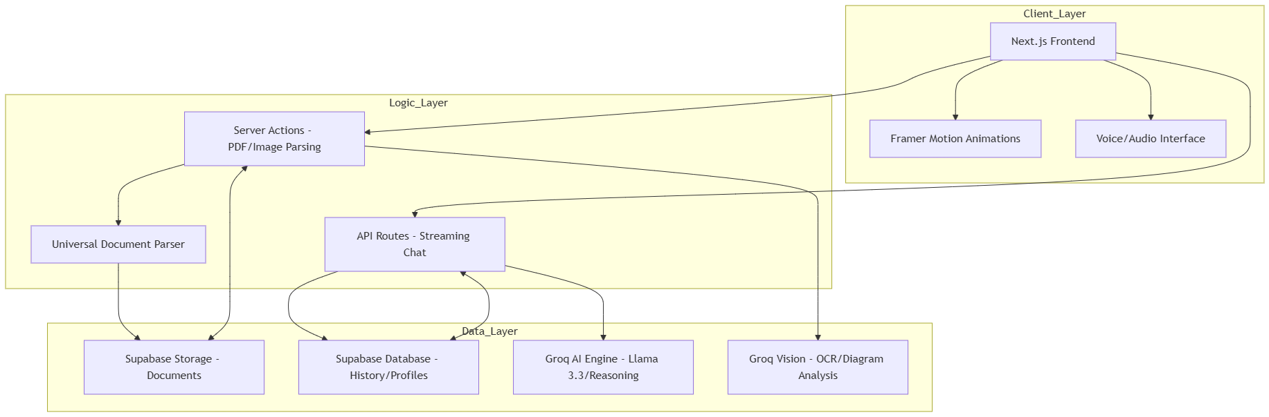5.2 Core Components
5.2.1 Frontend Development
The user interface is built using React and Tailwind CSS, prioritizing a "Premium Dark Mode" aesthetic that reduces eye strain. Framer Motion is utilized for micro-animations and smooth transitions, creating an interface that feels alive and responsive. The Language Provider context ensures that regional language settings persist across all components.
5.2.2 AI Engine & Multimodal Processing
The intelligence of EngineerOS is powered by the Groq SDK, which provides low-latency inference for Large Language Models.
- Reasoning Mode: Uses advanced models (Llama-3.3-70B) to provide "Cognitive Traces," allowing students to see the AI's internal derivation process.
- Multimodal Parsing: Employs a universal parser that combines PDF.js for text extraction and Vision-enabled models for analyzing complex engineering diagrams and handwritten notes.
5.2.3 Backend & Database
Supabase acts as the unified backend-as-a-service (BaaS):
- Authentication: Secure user login and profile management.
- PostgreSQL Database: Stores chat history, document metadata, and student academic performance for the CGPA predictor.
- Storage Buckets: Securely hosts user-uploaded study materials with restricted access.

5.3 Data Flow Methodology
The following diagram illustrates the lifecycle of a user interaction, from document upload to AI-driven analysis:
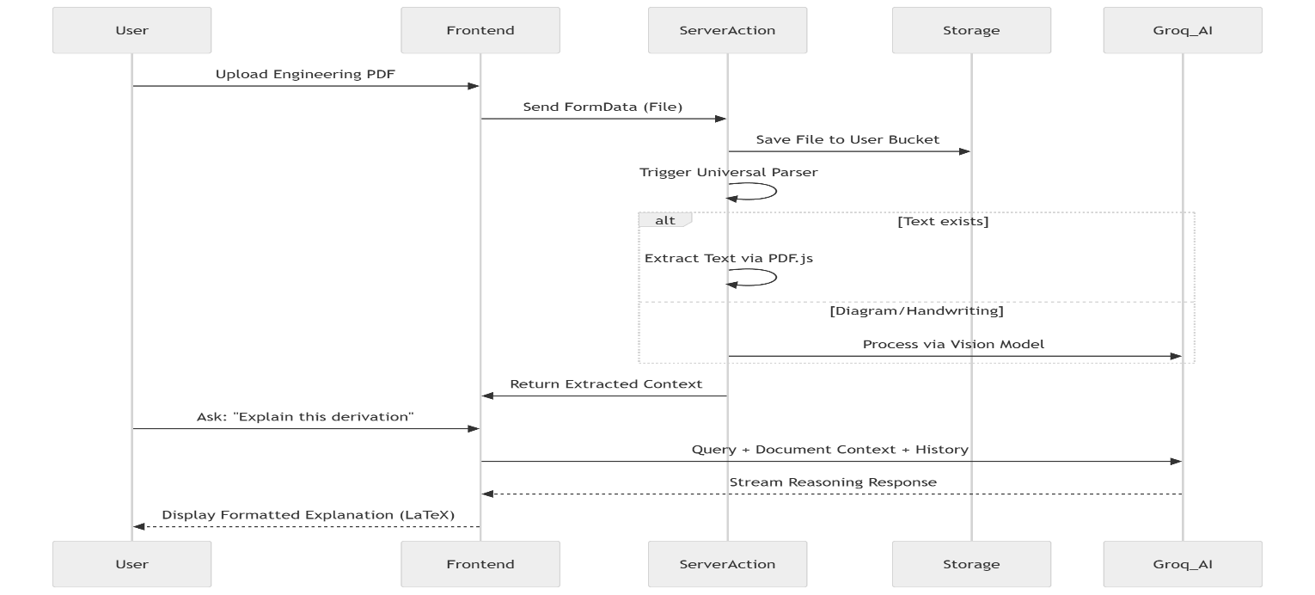
5.4 Development Workflow
The project follows an iterative Agile development workflow:
- Requirement Analysis: Identifying the specific pain points of engineering students (vivas, math, documents).
- Prototyping: Developing the core "OS Chat" interface and document parsing logic.
- Integration: Connecting the Supabase backend for persistent session management.
- Optimization: Implementing streaming AI responses to minimize latency and adding "Deep Think" reasoning tags.
- Testing: Validating the system with real engineering datasets (circuit diagrams, university syllabi).

6. Tools & Technologies Used
The development of EngineerOS leveraged a modern, full-stack development suite designed for high-performance AI applications and a premium user experience.
6.1 Programming Languages
- TypeScript: Used as the primary language for both frontend and backend logic to ensure type safety and code reliability.
- JavaScript (ES6+): Utilized for client-side scripting and asynchronous operations.
- HTML5 & CSS3: For semantic web structure and custom styling implementation.
6.2 Frameworks & UI Libraries
- Next.js 16 (App Router): The core framework used for server-side rendering, API routing, and optimized client-side navigation.
- React 19: The underlying UI library for building modular, component-based interfaces.
- Tailwind CSS: A utility-first CSS framework used for rapid, responsive design and implementing the "Premium Dark Mode" aesthetic.
- Framer Motion: An advanced animation library used for implementing micro-interactions, smooth page transitions, and interactive UI elements.
- Lucide React: For a consistent and modern iconography system throughout the platform.
6.3 AI Intelligence & SDKs
- Groq SDK: The primary interface for high-speed AI inference, enabling real-time streaming of complex engineering explanations.
- Llama 3.3 (70B-Versatile): The core Large Language Model (LLM) used for standard engineering chat and interactive tutoring.
- Vision-Enabled Models: Specialized AI models used for OCR and analyzing technical engineering diagrams.
- Reasoning Models: Utilized in "Complex Mode" to provide deep conceptual derivations and "Cognitive Trace" transparency.
6.4 Backend-as-a-Service (BaaS)
- Supabase:
  - PostgreSQL: A robust relational database for storing user profiles, academic grades, and chat histories.
  - Supabase Auth: For secure authentication via Magic Links and email/password.
  - Supabase Storage: For encrypted hosting of user-uploaded PDFs and images.
  - Edge Functions: Used for handling server-side AI logic and secure data processing.
6.5 Supporting Libraries
- PDF.js: For client-side and server-side parsing of engineering documents.
- React Markdown: For rendering AI-generated technical content and LaTeX formulas into readable formats.
- React Syntax Highlighter (Prism): For providing professional syntax highlighting for code snippets in various engineering languages.
- Unpdf: A lightweight utility for universal document parsing and text extraction.
6.6 Development & Deployment Tools
- VS Code: The primary Integrated Development Environment (IDE).
- Vercel: The cloud platform used for hosting and continuous deployment of the EngineerOS ecosystem.
- Node.js & npm: The runtime and package management environment for development.
- Git & GitHub: For version control and collaborative development tracking.
6.7 Hardware Requirements (Development)
- Standard development workstation with an internet connection.
- Minimum 8GB RAM and an SSD for efficient Next.js build processes and local development server performance.

7. Implementation & Final Results
This section details the development phases of EngineerOS and the resulting outputs. By integrating advanced AI logic with a premium user interface, the project delivers a high-performance ecosystem tailored for engineering students.
7.1 Secure Authentication: Login & Onboarding
- Implementation: Using Supabase Auth, we implemented a high-performance entry point for the platform. The system supports secure email/password and Magic Link authentication, ensuring that all student data is private and encrypted.
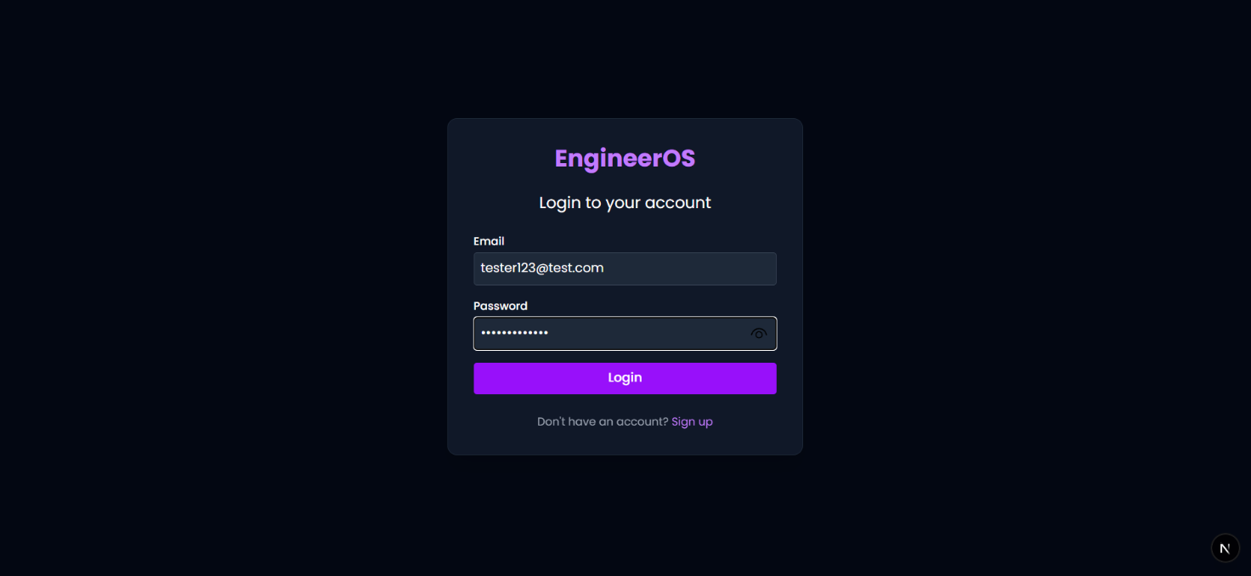
- Final Output: A sleek, dark-mode login interface that provides a seamless gateway into the EngineerOS ecosystem, featuring real-time validation and responsive design.
Caption: The premium authentication screen providing a secure gateway for engineering students.

7.2 Core AI Workspace: EngineerOS Chat
- Implementation: This module was built by integrating the Groq SDK with Next.js API routes. We implemented a multimodal pipeline that parses PDFs and images using Llama Vision models.
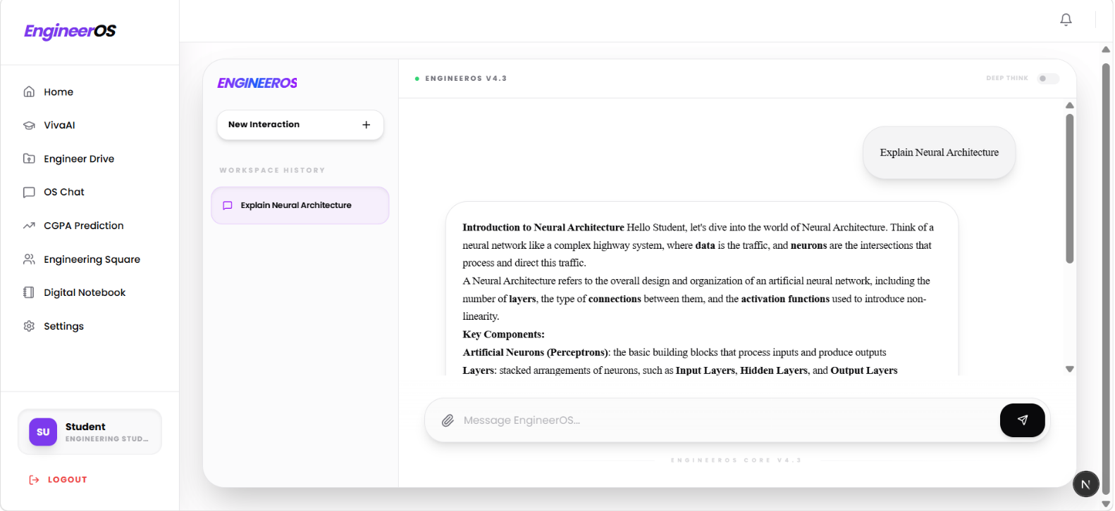
- Final Output: The result is a high-fidelity chat interface that provides "Cognitive Trace" reasoning (Deep Think) and LaTeX mathematical formatting. It breaks down complex engineering derivations into intuitive, step-by-step explanations.

Caption: The primary workspace showing a technical derivation with visible reasoning steps and multimodal document context.

7.3 Specialized Evaluation: VivaAI
- Implementation: VivaAI uses specialized system prompts to create a "Strict AI Professor" persona. We implemented a voice-enabled feedback loop that evaluates student responses in real-time.
- Final Output: Students receive a structured performance report at the end of each session, including technical accuracy scores and areas for improvement, effectively simulating a real-world oral examination.
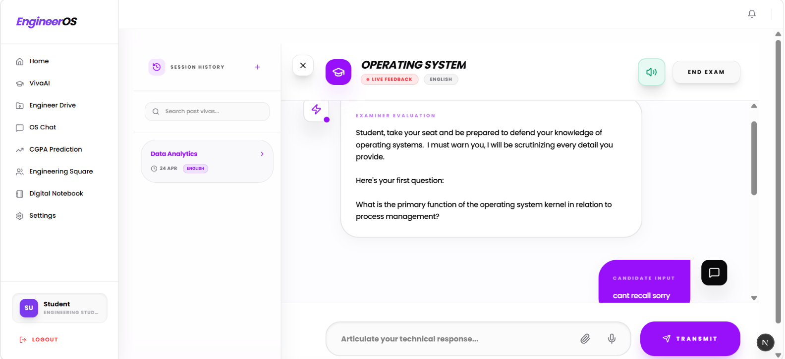

Caption: An active oral exam simulation followed by the AI professor's final evaluation and technical score.

7.4 Academic Analytics: Smart CGPA Predictor
- Implementation: This was developed using a React-based analytics dashboard connected to Supabase PostgreSQL. It uses predictive mathematical models to calculate GPA scenarios based on historical and target grades.
- Final Output: A visual dashboard that forecasts future CGPA trends, allowing students to set data-driven goals and visualize their academic trajectory.

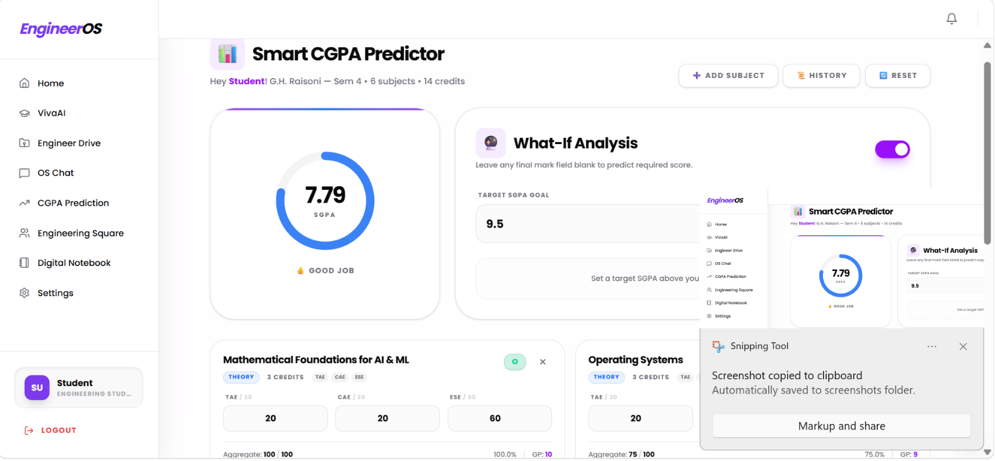
Caption: The analytics view showing GPA trends and future grade predictions based on user goals.

7.5 Digital Notebook (Notes Refinement)
- Implementation: The Digital Notebook was designed as an intelligent transformation engine. It takes raw, unorganized student notes and processes them through an AI refinement layer that enhances structure, adds clarity to technical terms, and generates interactive study summaries.
- Final Output: Students can convert basic, handwritten, or typed notes into "Enhanced Learning Notes" that are optimized for revision and conceptual understanding.
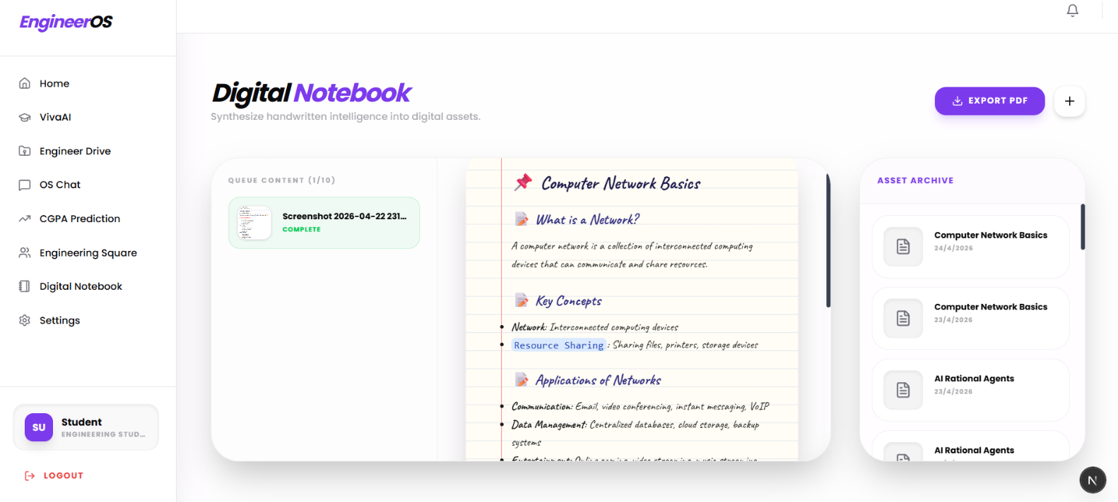
Caption: A basic note being transformed into a high-quality, structured learning note by the AI engine.

7.6 Engineer Drive (Cloud Storage & Sync)
- Implementation: This feature utilizes Supabase Storage for secure, cloud-based file management. We implemented an automated synchronization logic that ensures all refined notes from the Digital Notebook are automatically backed up and categorized within the Drive.
- Final Output: A centralized, secure repository where all academic assets—including PDFs, images, and AI-enhanced notes—are organized and accessible across any device.

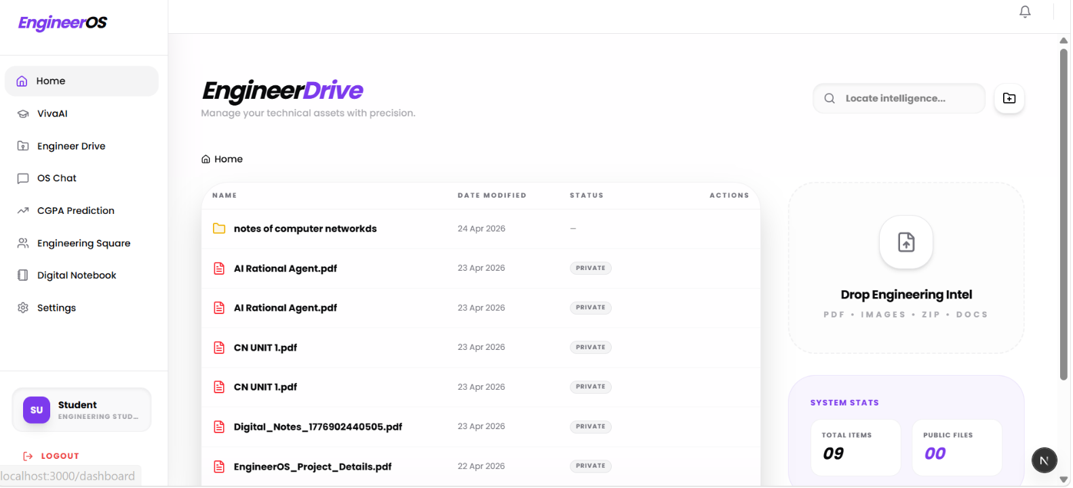
Caption: A basic note being transformed into a high-quality, structured learning note by the AI engine.

7.7: Collaborative Intelligence: Engineering Square
- Implementation: A decentralized, identity-neutral community quadrant where students engage in anonymous technical discourse. It features a "Mentor Status" gamification system that tracks peer-to-peer assistance through points and provides advanced filtering by Academic Year (FE, SE, TE, BE) and Core Department.
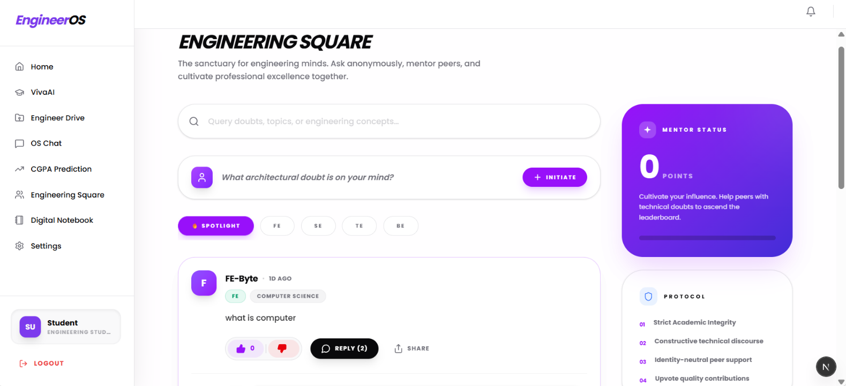
- Final Output: A self-sustaining peer-support ecosystem that lowers the psychological barrier to asking technical questions. The platform rewards accurate contributions through community upvotes, effectively cultivating a culture of collaborative academic excellence.
Caption: The anonymous community dashboard showcasing the "Mentor Status" progression and the identity-neutral technical discussion threads.

8. Advantages & Limitations

8.1 Advantages (Pros)
- Unified Academic Ecosystem: Replaces 5–6 fragmented tools (Drive, Chatbots, CGPA Calculators, Note-taking apps) with a single, high-performance "Operating System" designed specifically for engineers.
- Identity-Neutral Collaboration: The Engineering Square allows students to seek help and mentor peers without the social anxiety of being judged, fostering a more honest and technical discourse.
- Advanced Synthesis Logic: Unlike basic OCR tools, the Digital Notebook uses Llama-based reasoning to not just transcribe, but summarize and visualize messy handwritten data into structured learning assets.
- Reduced Exam Anxiety: VivaAI provides a safe, low-stakes environment for students to practice oral examinations, which is a major stress point in Indian engineering colleges.
- Automated Organization: The auto-sync feature between Digital Notes and Engineer Drive ensures that students never lose their study material, even if they forget to save it manually.

8.2 Limitations (Cons)
- API Dependency: As a cloud-heavy platform, EngineerOS requires a stable internet connection and is subject to the rate limits and availability of third-party AI providers (Groq/Supabase).
- Initial Setup Complexity: The platform relies on correctly configured database tables and RLS policies; any manual interference with the database schema can disrupt the automation logic.
- Token Window Constraints: When processing extremely large textbooks or long handwritten PDFs, the AI engine may truncate text to fit within the current LLM token window.
- Voice Latency: In VivaAI, there can be a slight delay between the user's speech and the AI's response due to the sequential processing of STT (Speech-to-Text), LLM reasoning, and TTS (Text-to-Speech).

9. Conclusion

The EngineerOS project successfully demonstrates the transformative potential of integrating specialized Artificial Intelligence into the engineering education landscape. By consolidating disparate academic workflows—from syllabus-aware chatting and voice-based viva simulation to automated note digitization—the platform provides a cohesive and efficient environment for students.
Key achievements of the project include:
- Seamless Data Synthesis: The transition from raw handwritten input to structured digital archives through the Digital Notebook and Engineer Drive integration.
- Psychological Safety: The creation of a safe space for doubt resolution and peer mentoring through the anonymous Engineering Square.
- Predictive Analytics: Empowering students with the CGPA Predictor to move from reactive studying to proactive goal setting.
In summary, EngineerOS effectively bridges the gap between traditional engineering study methods and modern technological requirements. It reduces the cognitive load on students by handling the organization and synthesis of information, allowing them to focus entirely on conceptual mastery. This project sets a benchmark for how educational platforms can evolve into "Cognitive Partners" that actively support and enhance the student's academic journey.

10. Future Scope
The current implementation of EngineerOS serves as a foundational platform, with several avenues for future enhancement and expansion:
- 10.1 Advanced Predictive Analytics: Integrating Machine Learning models to analyze past performance and attendance data to provide "Early Warning" alerts for subjects where a student might be at risk of falling behind.
- 10.2 AR/VR Laboratory Integration: Developing Virtual Reality modules that allow students to perform hazardous or expensive engineering experiments (like high-voltage testing or chemical reactions) within a safe, simulated 3D environment inside EngineerOS.
- 10.3 Personalized AI Tutors: Moving from a general AI response system to specialized agents trained on specific engineering disciplines (e.g., a "Thermodynamics Agent" or a "VLSI Expert") for deeper conceptual accuracy.
- 10.4 Multi-Institutional Community: Expanding the Engineering Square to connect students across different universities, creating a nationwide "Peer-Knowledge Grid" for better exposure to diverse technical approaches.
- 10.5 Offline-First Capability: Implementing PWA (Progressive Web App) features and local DB syncing to ensure that students can access their Digital Notebook and Drive assets even in areas with low connectivity.
- 10.6 Blockchain for Credentialing: Integrating a blockchain-based reward system where "Mentor Points" earned in Engineering Square can be converted into verified "Peer-Mentorship" certificates for professional resumes.

11. References

11.1 Technical Documentation & Frameworks
[1] Vercel Inc. (2024). Next.js documentation: React framework for the web. https://nextjs.org/docs
[2] Supabase Inc. (2024). Supabase documentation: The open source Firebase alternative. https://supabase.com/docs
[3] Groq Inc. (2024). Groq API documentation: Fastest AI inference cloud. https://console.groq.com/docs
[4] Tailwind Labs. (2024). Tailwind CSS: Utility-first CSS framework for rapid UI development. https://tailwindcss.com/docs
[5] Lucide Contributors. (2024). Lucide React: Beautiful & consistent icon toolkit. https://lucide.dev/docs

11.2 AI & Machine Learning Research
[6] Meta AI. (2024). The Llama 3 herd of models [Research paper]. Meta AI Research. https://ai.meta.com/research/publications/
[7] Vercel Inc. (2024). Vercel AI SDK: Toolkit for building AI-powered web applications. https://sdk.vercel.ai/docs
11.3 Educational Research & Methodologies

[8] Bloom, B. S. (1956). Taxonomy of educational objectives: The classification of educational goals. DavidMcKayCoInc.
[9] Pashler, H., McDaniel, M., Rohrer, D., & Bjork, R. (2008). Learning styles: Concepts and evidence. Psychological Science in the Public Interest, 9(3), 105–119.
[10] National Programme on Technology Enhanced Learning. (2024). IIT open learning resources. Indian Institutes of Technology. https://nptel.ac.in/

11.4 Libraries & Utilities

[11] Framer. (2024). Framer Motion: A production-ready motion library for React. https://www.framer.com/motion/
[12] Mozilla Foundation. (2024). PDF.js: A general-purpose, web standards-based platform for parsing and rendering PDFs. https://mozilla.github.io/pdf.js/

