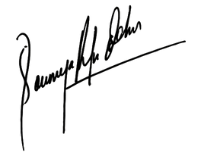

{{cd}}

Director

Soumya Behera

Certificate Date

Has successfully Completed Intensive {{md}} Months Software Testing Certification

Training and has completed all mandated course requirements and

industry projects with distinction.

{{name}}

THIS IS TO CERTIFY THAT

CERTIFICATE PROGRAM

Duration: {{ d}}

SOFTWARE TESTING

CERTIFICATE OF ACHIEVEMENT