

Experience Letter

**{{date}}**

This is to certify that **{{name}}**, holder of Employee ID **{{emi}}**, was employed with **KASPER ANALYTICS** as a **{{des}}** from **{{jdate}}** to **{{rdate}}**.

During their tenure with us, **{{name}}** was responsible for sourcing, screening, and recruiting candidates for various IT positions across domestic locations. Their key responsibilities included:

- Understanding client requirements and job descriptions.

- Sourcing candidates through job portals, social media, and networking.

- Conducting initial screening and interviews. - Coordinating with hiring managers and clients for scheduling interviews.

- Following up with candidates and ensuring a smooth onboarding process.

{{name}} demonstrated strong skills in communication, negotiation, and

candidate management. Their understanding of IT technologies and market trends

helped us in fulfilling critical staffing requirements efficiently. They have been diligent,

proactive, and professional throughout their employment.

We appreciate {{name}}’s contributions to the organization and wish them

all the best in their future endeavours.

**Yours truly,**

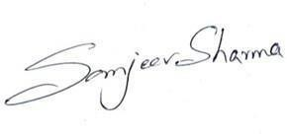**For, Kasper Analytics Pvt. Limited**

**(Authorised Signatory) Sanjeev Sharma**

**HR. Manager Kasper Analytics**