Increment Letter

{{dol}}

{{name}}

{{des}}

{{empi}}

Subject: Increment on Performance

Dear Mr./Ms. {{name}}

We would like to congratulate you on completion of the One Year with us. We are pleased to inform you of your salary increase effective from {{doi}} {{yoi}} The amount of your revised **CTC** is **₹INR {{ctc}}/-**. We understand that this is a substantial increase in your pay and we appreciate your hard work and dedication to our company.

We also want to take this opportunity to thank you for all of your contributions over the past year. Your performance has been exemplary and we appreciate the valuable advice and guidance you have provided during this period.

Please accept this letter as formal notification of your salary increase and as a gesture of appreciation from the management team at Ascloud Secure.

Best Wishes

For Ascloud Secure

(Authorized Signatory)

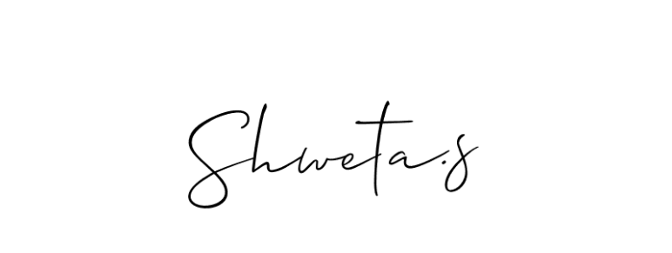

Shweta S.

Manager HR