**{{name}} {{date}}**

**Emp. ID:- {{emi}}**

TO WHOMSOEVER IT MAY CONCERN

This is to certify that **{{name}}** was working with **Precesion Staffing** from **{{jdate}} – {{rdate}}.** The individual's designation at the time of departure was an **{{des}}**.

H{{x}} brief experience summary during the stay with the organization is given below:

* Manage the entire life cycle of the recruitment process for clients.
* Work closely with the Recruiting leads and hiring managers.
* Work on strategic hiring programs.
* Develop an action plan for recruiting the best fit for the organization.
* Procure people for different IT Requirements.
* Use niche platforms related to IT, to source potential candidates.
* Personally conduct interviews, document the same, and report as the need arises.

During this tenure we found h{{x}} performance and conduct to be satisfactory. We wish them the very best in their future endeavors..

This letter is issued on the request of the employee

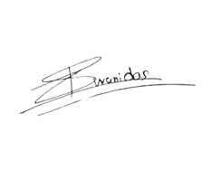

**Yours truly,**

(Authorized Signatory)

Shivani Das

Human Resources-Manager