{{name}} {{date}}
Emp. ID:- {{emi}}

TO WHOMSOEVER IT MAY CONCERN

This is to certify that {{name}} was working with ASCLOUD SECURE from {{jdate}} – {{rdate}}
The individual's designation at the time of departure was {{des}}.
H{{x}} brief experience summary during the stay with the organization is given below:
- Served as the first point of contact for customers seeking technical assistance via phone, email, or chat.
- Diagnose and troubleshoot basic technical issues related to software, hardware, and networking.
- Provide step-by-step guidance to customers to resolve their technical problems.
- Log all support requests, issues, and resolutions accurately in the ticketing system.
- Monitor and follow up on open tickets to ensure timely closure.
- Maintain a high level of customer satisfaction through professional communication and problem-solving.
During this tenure we found h{{x}} performance and conduct to be satisfactory.
This letter is issued on the request of the employee

Yours truly,
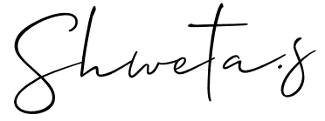

(Authorized Signatory)
Shweta S.
Human Resources-Manager

