{{name}}
{{date}}

Emp. ID:- {{emi}}

TO WHOMSOEVER IT MAY CONCERN

This is to certify that {{name}} was working with PRECISES RCM HEALTHCARE from {{jdate}} – {{rdate}}
The individual's designation at the time of departure was {{des}}.
H{{x}} brief experience summary during the stay with the organization is given below:
- Manage the entire lifecycle of the accounts receivable process for clients in the healthcare sector.
- Collaborate closely with billing leads and healthcare providers to ensure accurate and timely claims processing.
- Contribute to strategic initiatives for optimizing revenue cycle operations.
- Develop action plans to streamline processes and improve financial performance.
- Identify and address various billing and collections needs for different healthcare services.
- Utilize specialized healthcare platforms to source and analyze potential billing candidates.
- Conduct interviews, document findings, and provide reports as necessary.
During this tenure we found h{{x}} performance and conduct to be satisfactory.
This letter is issued on the request of the employee

Yours truly,
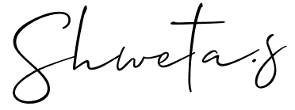

(Authorized Signatory)
Shweta S.
Human Resources-Manager

