SALARY CERTIFICATE

PRECISES RCM HEALTHCARE
B-7, 1st floor, B Block, Sector 2,
Noida, Uttar Pradesh 201301

{{dol}}

To whom it may concern,
This is to certify that {{name}}, holding the position of {{des}}, is working at PRECISES RCM HEALTHCARE since {{doj}} and is earning ₹ {{ctc}}/- as CTC annually. A breakdown of their monthly and annual salary is given below:

Earnings | Monthly amount | Annual amount
Basic pay | ₹ {{mbs}} | ₹ {{abs}}
House rent allowance | ₹ {{mhra}} | ₹ {{ahra}}
Statutory Bonus | ₹ {{msb}} | ₹ {{asb}}
Special Allowance | ₹ {{msa}} | ₹ {{asa}}
Total CTC | ₹ {{mgs}} | ₹ {{ags}}

Deductions | Monthly amount | Annual amount
Professional Tax | ₹ 200 | ₹ 2400
Admin Charges | ₹ 600 | ₹ 7200
Total deductions | ₹ 800 | ₹ 9600

This certificate is issued upon the request of the employee for a legal purpose. We confirm that the information provided is true and accurate to the best of our knowledge.

Sincerely,
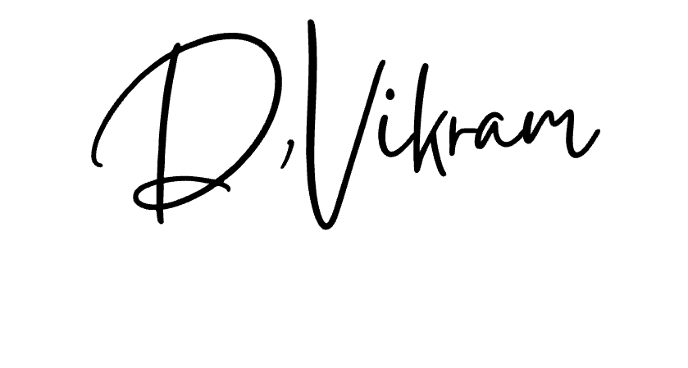
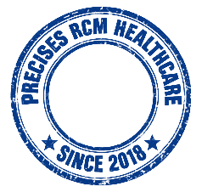
For, PRECISES RCM HEALTHCARE Pvt. Limited

(Authorized Signatory)
Vikram Das
Manager - Payroll

