TO WHOMSOEVER IT MAY CONCERN

{{name}}
{{date}}

Emp. ID:- {{emi}}

This is to certify that {{name}} was working with Kasper Analytics from {{jdate}} – {{rdate}}
The individual's designation at the time of departure was an {{des}}.

H{{x}} brief experience summary during the stay with the organization is given below :
- Served as the first point of contact for customers seeking technical assistance via phone, email, or chat.
- Diagnose and troubleshoot basic technical issues related to software, hardware, and networking.
- Provide step-by-step guidance to customers to resolve their technical problems.
- Log all support requests, issues, and resolutions accurately in the ticketing system.
- Monitor and follow up on open tickets to ensure timely closure.
- Maintain a high level of customer satisfaction through professional communication and problem-solving.

During this tenure we found h{{x}} performance and conduct to be satisfactory. We wish them the very best in their future endeavors.
This letter is issued on the request of the employee.

Yours truly,
For, Kasper Analytics Pvt. Limited
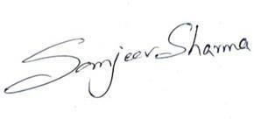

(Authorised Signatory)
Sanjeev Sharma
HR. Manager Kasper Analytics

