STUDENT EXAM SCORE PREDICTOR

A Project Report Submitted
in the partial fulfillment of the requirements for the award of the degree of

BACHELOR OF TECHNOLOGY
In

DEPARTMENT OF COMPUTER SCIENCE AND ENGINEERING
By
Suraj Gaur 2420030108
M. Jathin Kumar 2420030673
D. Shiva Ganesh 2420030035

Under the Esteemed Guidance of

Dr. N. Sunanda

Associate Professor

Department of Computer Science and Engineering

2026–2027

Semester: ODD SEMSITER




K L (Deemed to be) University |
Department of Computer Science and Engineering

Declaration

The Project Report entitled “Student Exam Score Predictor” is a record of bona fide project work by Suraj Gaur ,M. Jathin Kumar and D. Shiva , submitted in partial fulfillment of the requirements for the award of B.Tech in Computer Science and Engineering at K L (Deemed to be) University. The project uses a transparent weighted scoring rule. All implementation and evaluation claims in this report should be verified against the final working program before submission.

Suraj Gaur – 2420030108
M. Jathin Kumar – 2420030673
D. Shiva Ganesh - 2420030035

K L (Deemed to be) University | Department of Computer Science and Engineering

CERTIFICATE

This is to certify that the project report entitled “Student Exam Score Predictor” is a bona fide work carried out by Suraj Gaur ,M. Jathin Kumar and D. Shiva Ganesh in partial fulfillment of the requirements for the award of the degree of Bachelor of Technology in Computer Science and Engineering at K L (Deemed to be) University during the academic year 2026–2027.

Signature of the Guide: Dr. N. Sunanda

Signature of the Course Coordinator Signature of the HOD

ACKNOWLEDGEMENT
We express our sincere gratitude to our guide, Dr. N. Sunanda, Associate Professor, for her guidance and encouragement during the planning and documentation of the Student Exam Score Predictor project. We also thank the Department of Computer Science and Engineering, KLH Bachupally Campus, for providing an academic environment to develop our project skills.

We thank our course coordinator and faculty members for their suggestions and support. Their feedback helped us organise the project requirements, scoring approach, testing plan and final documentation.

We are grateful to the Head of the Department and the university for providing the facilities required for learning and project work.

Finally, we thank our parents, friends and classmates for their encouragement and cooperation.

Suraj Gaur – 2420030108
M. Jathin Kumar – 2420030673
D. Shiva Ganesh - 2420030035

Abstract
The Student Exam Score Predictor is a Python-based academic support prototype designed to estimate a student’s exam score from five inputs: previous marks, internal marks, attendance, assignment score and study-time score. It applies a fixed weighted formula: previous marks 30%, internal marks 25%, attendance 20%, assignment score 15% and study-time score 10%. Each input is expected to be normalised to a value between 0 and 100. The resulting estimate is mapped to one of four performance bands: Excellent (80–100), Good (60–79), Average (40–59) or Needs Support (below 40). The proposed workflow includes input collection, validation, score calculation and result display. The prototype does not train a machine-learning model, and its weights have not yet been validated against a verified historical dataset. Therefore, its output should be treated as guidance for revision and mentoring, not as a guaranteed exam result.

This report describes the project motivation, objectives, system requirements, technology choices, architecture, scoring methodology, implementation plan, testing approach, limitations and future enhancements. The system is intended to make the calculation transparent so that users can understand how each academic indicator contributes to the estimated score. Before the system is used for real academic decisions, the chosen weights should be assessed using consented student records and compared with actual exam marks.

The project is a lightweight rule-based prototype implemented using Python in Visual Studio Code. Python is the primary language; the standard library is sufficient for the core calculation. pandas or NumPy may be used if CSV/Excel data handling is included, while Streamlit or Tkinter may be added for an optional user interface. No machine-learning framework is required for the current approach.

Index
S. No. | Chapters | Topics | Page.no
 | Acknowledgement
 | Abstract
1 | Introduction | 1.1 Background of the project; 1.2 Problem statement; 1.3 Scope; 1.4 Objectives; 1.5 Importance; 1.6 Target users | 1–10
2 | System Requirements | 2.1 Problem statement; 2.2 Technologies used; 2.3 Software and hardware requirements | 11–20
3 | System Design | 3.1 System architecture and data flow; 3.2 Input validation; 3.3 Weighted scoring design | 21–30
4 | Implementation | 4.1 Main modules; 4.2 Input collection; 4.3 Validation; 4.4 Score calculation; 4.5 Result display | 31–45
5 | Testing & Limitations | 5.1 Functional tests; 5.2 Boundary tests; 5.3 Limitations; 5.4 Evaluation requirements | 46–55
6 | Conclusion and Future Enhancements | 6.1 Conclusion; 6.2 Future enhancements | 56–60
7 | References | Python and optional data-library documentation; project presentation | 61–62
8 | Appendices | Scoring pseudocode; input validation; testing checklist; implementation notes | 63–70
9 | Deployment | 9.1 Steps to deploy  9.2 Environment configuration  9.3 Hosting of frontend and backend | 68-73
10 | Challenges & Limitations | 10.1 Issues faced during development  10.2 Solutions applied  10.3 Current limitations or known bugs | 74-80
11 | Future Enhancements | 11.1 Planned features  11.2 Possible integrations or optimizations | 81-88
12 | Conclusion | 12.1 Summary of the project  12.2 What was achieved  12.3 Skills learned during development | 89-100
13 | References | - Books, tutorials, APIs, documentation sites used
14 | Appendices | - Screenshots of the app  - Sample code snippets  - Installation/setup instructions  - User manual or guide  -certifications

CHAPTER 1
Introduction

  - Motivation

Student performance can be influenced by previous academic results, internal assessments, attendance, assignment completion and study habits. Students may find it difficult to combine these indicators into a single estimate, while teachers may need an early signal to identify students who could benefit from additional revision or mentoring. This project proposes a simple and explainable scoring tool that combines these indicators using fixed weights.

  - Objectives
The main objective of the Student Exam Score Predictor is to estimate an exam score from five academic inputs using a transparent weighted formula. The system validates inputs, calculates a score on a 0–100 scale, assigns a performance category and displays an understandable result. The estimate is intended to support planning and discussion; it does not replace formal examination results or teacher judgement.
1.3 Background of the Project
Academic performance assessment commonly uses multiple indicators, such as previous marks, internal assessment scores, attendance, assignments and study time. Looking at each indicator separately may not provide a quick overall view. A rule-based score combines these values into one interpretable estimate using explicitly defined weights.web siteInternetWorld Wide Webintranetstatic pageplain textinternet applicationselectronic businessessocial network servicesweb engineeringweb designweb content developmentclient-sideserver-sidescriptingwebserver
Unlike a machine-learning model, this prototype does not learn from training data. The scoring weights are defined in advance, which makes the calculation easy to inspect, explain and reproduce. The weights are design choices and should be validated using real student records before relying on the estimate.markupcodingcontent management systems
The system is designed as a small educational prototype suitable for execution on a standard laptop. It can accept values entered by a user and may be extended to read a CSV/Excel file. A simple local interface can be added later if required.web developersAgile methodologiesgraphic designerinformation systemsfront-end developerfull-stack developer

1.4 Scope of the Project
The project covers collection of five academic indicators, validation of values, weighted score calculation, classification into performance bands and display of supportive guidance. It is limited to a rule-based estimate and does not attempt to diagnose learning difficulties or make official academic decisions.web resourcesmultimediadomain nameweb serverwikipedia.orggoogle.comamazon.com
The current design can run locally using Python in VS Code. File-based data input and a simple graphical or web interface are optional extensions rather than confirmed features of the core prototype.Internet ProtocolInternetlocal area networkuniform resource locator
Potential users include students, tutors, teachers and academic advisors who want a simple estimate to support revision planning and mentoring conversations. Student data should be handled responsibly and only with appropriate permission.personal websitesocial networkingWorld Wide Webintranet
1.5 Importance of the Application
A transparent estimate can help students reflect on their current academic inputs and plan revision. Teachers may use the output as an early discussion point when considering additional support. Because the weights are fixed and not empirically validated, the result must be interpreted cautiously and must not be used as the sole basis for high-stakes decisions.web resourceWorld Wide Webweb browsersoftwareInternetmonitormobile devicehypertexthyperlinks
The project also provides practical experience in Python programming, input validation, formula-based computation, software testing and technical documentation.source codetext filehypertextHTMLmarkup languageweb resourcestyle sheetsscripts

CHAPTER 2
System Requirements

2.1 Problem Statement
Students and teachers may find it difficult to combine several academic indicators into one clear estimate of exam performance. The project addresses this by applying a fixed weighted formula to previous marks, internal marks, attendance, assignment score and study-time score. The input values must be numeric and within 0–100. The output is an estimated score and performance category, not a guaranteed result.
  - 2.2 Technologies Used

- Python 3.x: The main programming language used for input handling, validation, weighted score calculation, performance-band classification and output display.markup languageweb browserCascading Style Sheetsscripting languagesJavaScript
Weighted score formula:
Estimated Score = (Previous Marks × 0.30) + (Internal Marks × 0.25) + (Attendance × 0.20) + (Assignment Score × 0.15) + (Study-Time Score × 0.10)

- Input validation: Each of the five values must be present, numeric and between 0 and 100. Attendance and study time should be converted to a comparable 0–100 scale before the formula is applied.style-sheetHTMLXMLSVGMath-MLXHTML
Performance classification: 80–100 = Excellent; 60–79.99 = Good; 40–59.99 = Average; below 40 = Needs Support. The implementation should use consistent numeric boundaries.W3C specificationCSS3
2.3 Software Requirements
Operating system: Windows or another operating system supported by Python.
Python 3.x and Visual Studio Code (VS Code) are the primary development tools. The VS Code terminal and debugger can be used to run and troubleshoot the program.
Optional data handling: pandas and NumPy may be used if the implementation reads CSV/Excel files or performs additional numerical analysis. They are not required for the basic formula.

- Optional user interface: Streamlit or Tkinter may be used to create a simple form. A local command-line program is sufficient for the core scoring logic. No machine-learning library is required.free and open-sourceCSS frameworkfront-end web developmentCSSJavaScripttypographyformsbuttonsnavigationGit-Hubfree Code CampVue.jsAlexa RankTwitter

  - Hardware and Development Tools
Hardware: a standard laptop or desktop computer with keyboard, display, basic memory and storage. Internet access may be needed to install Python or optional packages.source code editorAdobe Systemsfree and open-source softwareMIT LicenseGit-HubJavaScriptHTMLCSScross-platformmac-OSWindowsLinux distributionsHTMLCSSJavaScript
AdobeSoftware: Python 3.x, Visual Studio Code, its integrated terminal/debugger, and optional pandas/NumPy or Streamlit/Tkinter depending on the final implementation.web developmentEdge CodeAdobeAdobeweb developmentGit-Hub

CHAPTER 3
System Design
3.1 System Architecture and Data Flow
The system follows a simple pipeline: student-entered values or a data file → input collection → input validation → weighted scoring engine → score and performance category → guidance for revision or mentoring. The input layer collects five indicators. The validation layer rejects missing, non-numeric or out-of-range values. The scoring layer applies the five fixed weights. The output layer displays the estimate and category.processinformation systemflowchart
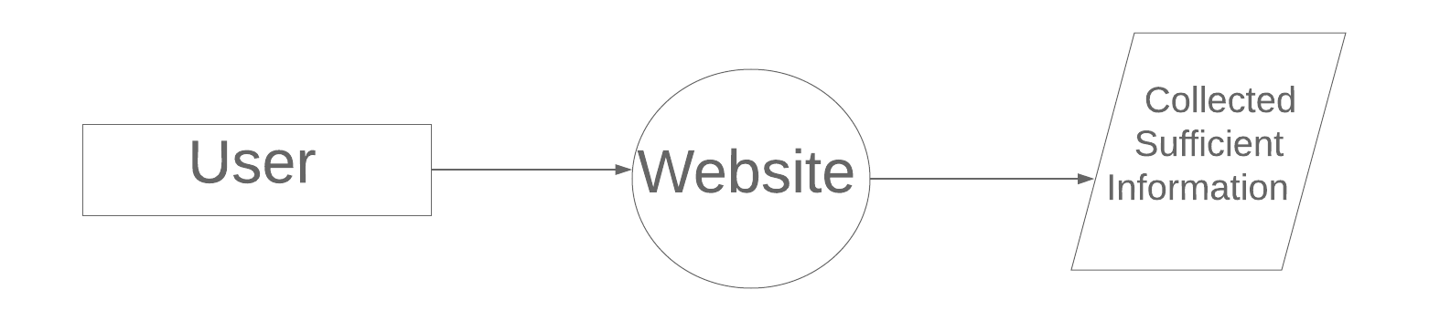
Fig. 3.1: Student Exam Score Predictor data-flow pipeline (refer to the architecture diagram in the project presentation).

CHAPTER 4
Implementation and User Interface

4.1 Main Modules
- Input Collection: receives the five academic values from the user or an optional CSV/Excel file.
- Input Validation: checks that each value is present, numeric and between 0 and 100.
- Weighted Score Engine: multiplies each validated input by its assigned weight and adds the results.
- Performance Band Classification: maps the estimated score to Excellent, Good, Average or Needs Support.
- Result Display: shows the estimated score out of 100, performance band and a reminder that the score is guidance only.

4.2 Detailed Description of Modules
1. Input collection: The program requests previous marks, internal marks, attendance, assignment score and study-time score. Each field uses a 0–100 scale so that the values are comparable.

Fig. 4.1: Example student input fields (refer to the prototype mockup in the presentation).

2. Validation and preprocessing: The program checks for missing or non-numeric values and rejects values outside the accepted range. When using a file, duplicate rows and missing cells should also be checked.

Fig. 4.2: Input validation and preprocessing workflow.

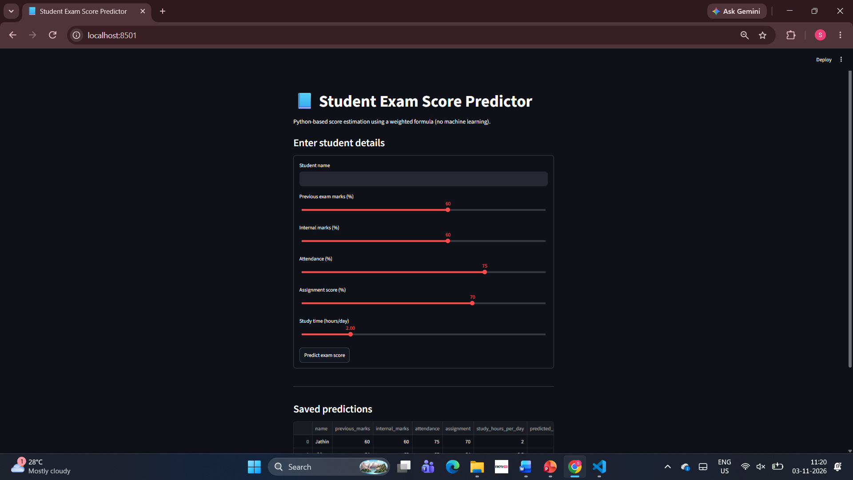

CHAPTER 5

Conclusion and Future Enhancements

5.1 Conclusion
The Student Exam Score Predictor defines a simple Python-based approach for estimating exam performance from five academic indicators. It uses fixed, explainable weights and assigns the result to one of four performance bands. The design provides a clear flow from input collection through validation and calculation to result display. Since the weights have not been validated against verified historical data, the report does not claim measured accuracy or predictive performance. The result should be used only as a guide for revision planning and mentoring.
5.2 Future Enhancements
- Validate the chosen weights by comparing estimated scores with actual exam marks from an appropriately consented dataset.
- Add CSV/Excel import, input summaries and charts for academic indicators when reliable records are available.
- Build a user-friendly interface with Streamlit or Tkinter, and improve privacy controls and documentation.
CHAPTER 6
References

- https://www.w3schools.com/html/default.aspPython Software Foundation, “Python Documentation,” https://docs.python.org/3/
- https://www.w3schools.com/css/default.asppandas development team, “pandas Documentation,” https://pandas.pydata.org/docs/ (optional file handling)
- https://www.w3schools.com/bootstrap4/default.aspNumPy developers, “NumPy Documentation,” https://numpy.org/doc/ (optional numerical operations)
- https://mdbootstrap.com/docs/jquery/javascript/carousel/Student Exam Score Predictor project presentation, methodology and weighted scoring design, 2026.

CHAPTER 7

Appendices

Appendix A: Scoring Pseudocode
- Read previous marks, internal marks, attendance, assignment score and study-time score.
- For each input, check that the value is numeric and between 0 and 100.
- If any input is invalid, display an error message and request valid input.
- Calculate score = previous × 0.30 + internal × 0.25 + attendance × 0.20 + assignment × 0.15 + study time × 0.10.
- If score >= 80, category = Excellent; else if score >= 60, category = Good.
- Else if score >= 40, category = Average; otherwise category = Needs Support.
- Display the estimated score, category and guidance-only notice.
- opacity: 0.6;
- }

- Appendix B: Input Validation
- Input values must be present, numeric and within the 0–100 range.
- Attendance and study time should be normalised to 0–100 before scoring.
- The formula uses fixed weights and does not train a model.
- A real evaluation requires labelled historical records and actual exam scores.
- The result must not be treated as a guaranteed exam result.
- }

- Appendix C: Testing Checklist
- Test all inputs at 0 and 100, typical values, missing values, non-numeric values and out-of-range values.
- Check category boundaries at 40, 60 and 80 and verify displayed score formatting.
- When actual exam marks are available, compare estimated and actual scores and report an appropriate error metric such as MAE.
- Do not report accuracy or performance figures until tests have been executed and recorded.

Appendix D: Implementation Notes
- <!DOCTYPE html>

- <head>
- <meta charset="utf-8">
- <meta name="viewport" content="width=device-width, initial-scale=1.0">
- Student Exam Score Predictor

7.3 Navigation Bar

- <button class="navbar-toggler" type="button" data-toggle="collapse" data-target="#navbarSupportedContent" aria-controls="navbarSupportedContent" aria-expanded="false" aria-label="Toggle navigation">
- <span class="navbar-toggler-icon"></span>
- </button>

- <ul class="navbar-nav mr-auto">
- <li class="nav-item active">

- </li>
- <li class="nav-item">

- </li>
- <li class="nav-item dropdown">

- Rewards
- </a>

- </div>
- </li>
- </ul>
- <form class="form-inline my-2 my-lg-0">

- <button class="btn btn-outline-success my-2 my-sm-0" type="submit">Search</button>
- </form>
- </div>
- </nav>

7.4 Carousel Card

- <ol class="carousel-indicators">
- <li data-target="#carouselExampleIndicators" data-slide-to="0" class="active"></li>
- <li data-target="#carouselExampleIndicators" data-slide-to="1"></li>
- <li data-target="#carouselExampleIndicators" data-slide-to="2"></li>
- </ol>

- </div>

- </div>

- </div>
- </div>

- <span class="carousel-control-prev-icon" aria-hidden="true"></span>
- <span class="sr-only">Previous</span>
- </a>

- <span class="carousel-control-next-icon" aria-hidden="true"></span>
- <span class="sr-only">Next</span>
- </a>
- </div>
7.5 Description About the Page

- The project combines five academic inputs using fixed weights to produce an estimated score and a performance band. This output is intended to support revision planning and academic mentoring.
- The tool validates inputs before calculation. Invalid or missing values should be rejected so that they do not produce misleading results.
- The weighted formula is transparent, but the weights have not yet been validated using a verified historical dataset. Results must be interpreted as estimates only.
- Future work may add a simple user interface, file import, charts and evaluation against actual exam marks.
- </p>
- </h5>

- </div>
- </div>
- </div>

- </div>
- ent....">

