
DEPARTMENT OF CSE
PROJECT ABSTRACT SUBMISSION
COURSE: SOA PROGRAMMING AND MICROSERVICES– (24SDCS03) A.Y. 2026 - 2027
TITLE OF THE PROJECT | AI-Enabled Student Admission and Management System
S. No. | University ID | Name
1 | 2420030108 | SurajGaur
2 | 2420090065 | p.pranav
3 | 2420090035 | B. Ruthvik
4 | 2420090152 | s.santhosh
Name of the Guide

Abstract:
The AI-Enabled Student Admission and Management System is a proposed microservices-based application designed to simplify and automate the student admission process and subsequent student record management. Traditional admission procedures often involve manual data entry, document verification, eligibility checking, course selection, and status tracking, which can be time-consuming and may lead to data-entry errors and delays. The proposed system provides a centralized digital platform through which students can submit admission applications, manage their profiles and documents, and track application status, while administrators can review applications and maintain student records efficiently.
The system incorporates Artificial Intelligence to support admission-related decision making. Based on student academic information, eligibility criteria, entrance or examination scores, and course preferences, the AI component can assist in checking eligibility and recommending suitable courses or programs. The system is intended to reduce repetitive manual work and provide faster, more consistent processing while keeping final admission decisions under authorized institutional control.
The application follows a Service-Oriented Architecture using independent microservices. An API Gateway provides a single entry point for client requests, while service discovery through Eureka enables communication among the microservices. The proposed architecture includes Student Service for profile and academic information, Admission Service for application processing and status management, Course Service for course and eligibility information, AI Recommendation Service for eligibility analysis and course recommendations, and Notification Service for application updates. A database layer stores student, admission, course, and application information securely.
The proposed system improves scalability, maintainability, and reliability by separating major functions into independent services. Each service can be developed, tested, deployed, and updated independently, making the system suitable for an academic admission environment. The AI-enabled features can help students identify appropriate programs and help administrators process applications more efficiently. The overall system aims to provide a transparent, user-friendly, and efficient admission and student management platform.

Project Architecture/Project Overview:
Project Overview: The system uses an API Gateway as the entry point and Eureka for service discovery. Independent microservices handle admission processing, student records, course information, AI-based eligibility/course recommendations, and notifications. The services communicate through REST APIs and use a database layer for persistent records.
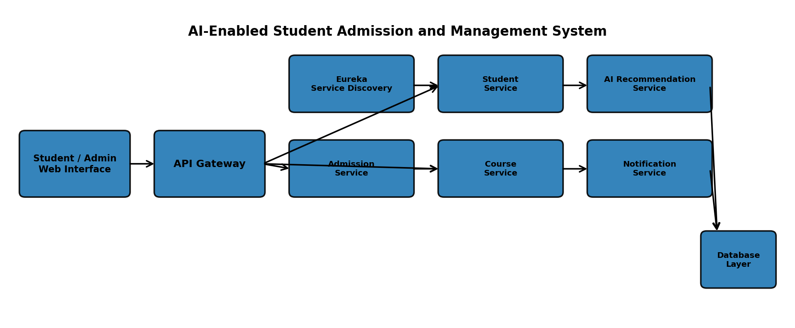
Main workflow: Student/Admin → API Gateway → Microservices → AI Recommendation/Admission Processing → Database and Notifications.

