HTML
Form Tag:
Form tag is used to collect the information from users. It creates a web form within website where users can enter their record.
It contains different input elements for taking different types of information, those are:
- <input>
- <label>
- <select>
- <button>
- <textarea>
- <button> etc
Application:
- Registration form
- Login Page
- Add new contract
- Messaging Page
- Add New Post to Socia Media
- Payment page etc.
Syntax:
<form>
Form content….
</form>
Example:
<!doctype html>
<html>
<head>
<title> Form Tag </title>
<head>
<body>
<h2> Student Registration Form </h2>
<form>
<label> Full Name: </label><input type="text"><br><br>
<label>Email :</label><input type="email"><br><br>
<label>Password :</label><input type="password"><br><br>
<label> Mobile Number :</label><input type="number"><br><br>
<label> Date of Birth :</label><input type="date"><br><br>
<label>Gender :</label>
<input type="radio" name="gender" value="male"><label>Male</label>
<input type="radio" name="gender" value="female"><label>Female</label>
<input type="radio" name="gender" value="other"><label>Other</label><br><br>

<label> Skills </label>
<select>
<option>---Select Course---</option>
<option>BCA</option>
<option>B.Tech</option>
<option>M.Tech</option>
</select><br><br>
<label> Put Photo :</label><input type="file">
<button>Upload</button><br><br>
<label> Remarks:</label><textarea></textarea><br><br>
<input type="submit">
<input type="reset">
</form>
</body>
</html>
Output:
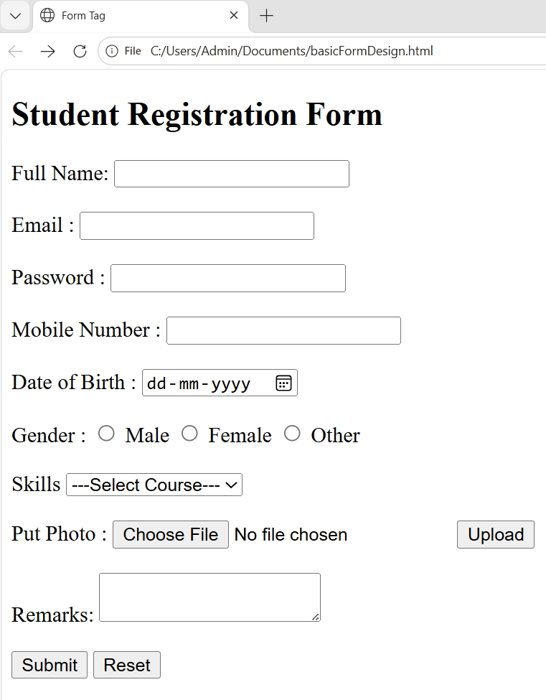
<input>: Input tag has different type of attributes. The attributes are:
- type attribute: It set the type of information to be taken from users
The type values are –
- text: It takes all types of text.
Syntax:
<input type=”text”>
Example:
<!doctype html>
<html>
<head>
<title> Input Tag </title>
<head>
<body>
<form>
<input type="text">
</form>
</body>
</html>
output:
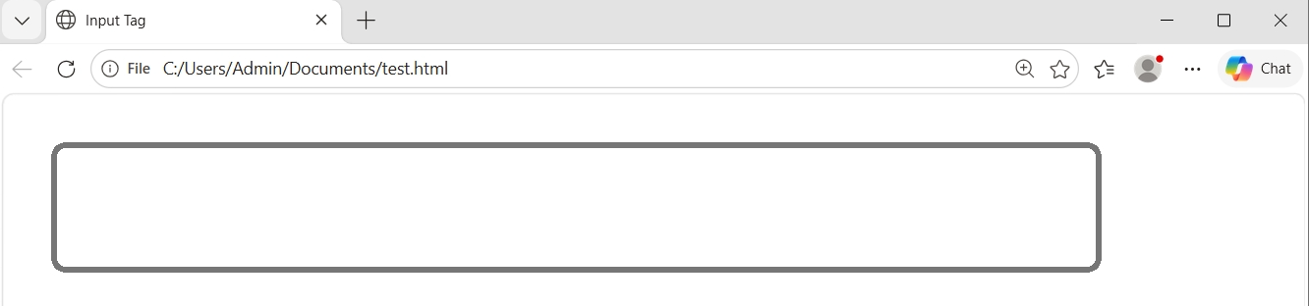
- number: It takes only number.
Syntax:
<input type="number">
Example:
<!doctype html>
<html>
<head>
<title> Input Tag </title>
<head>
<body>
<form>
<input type="number">
</form>
</body>
</html>
Output:

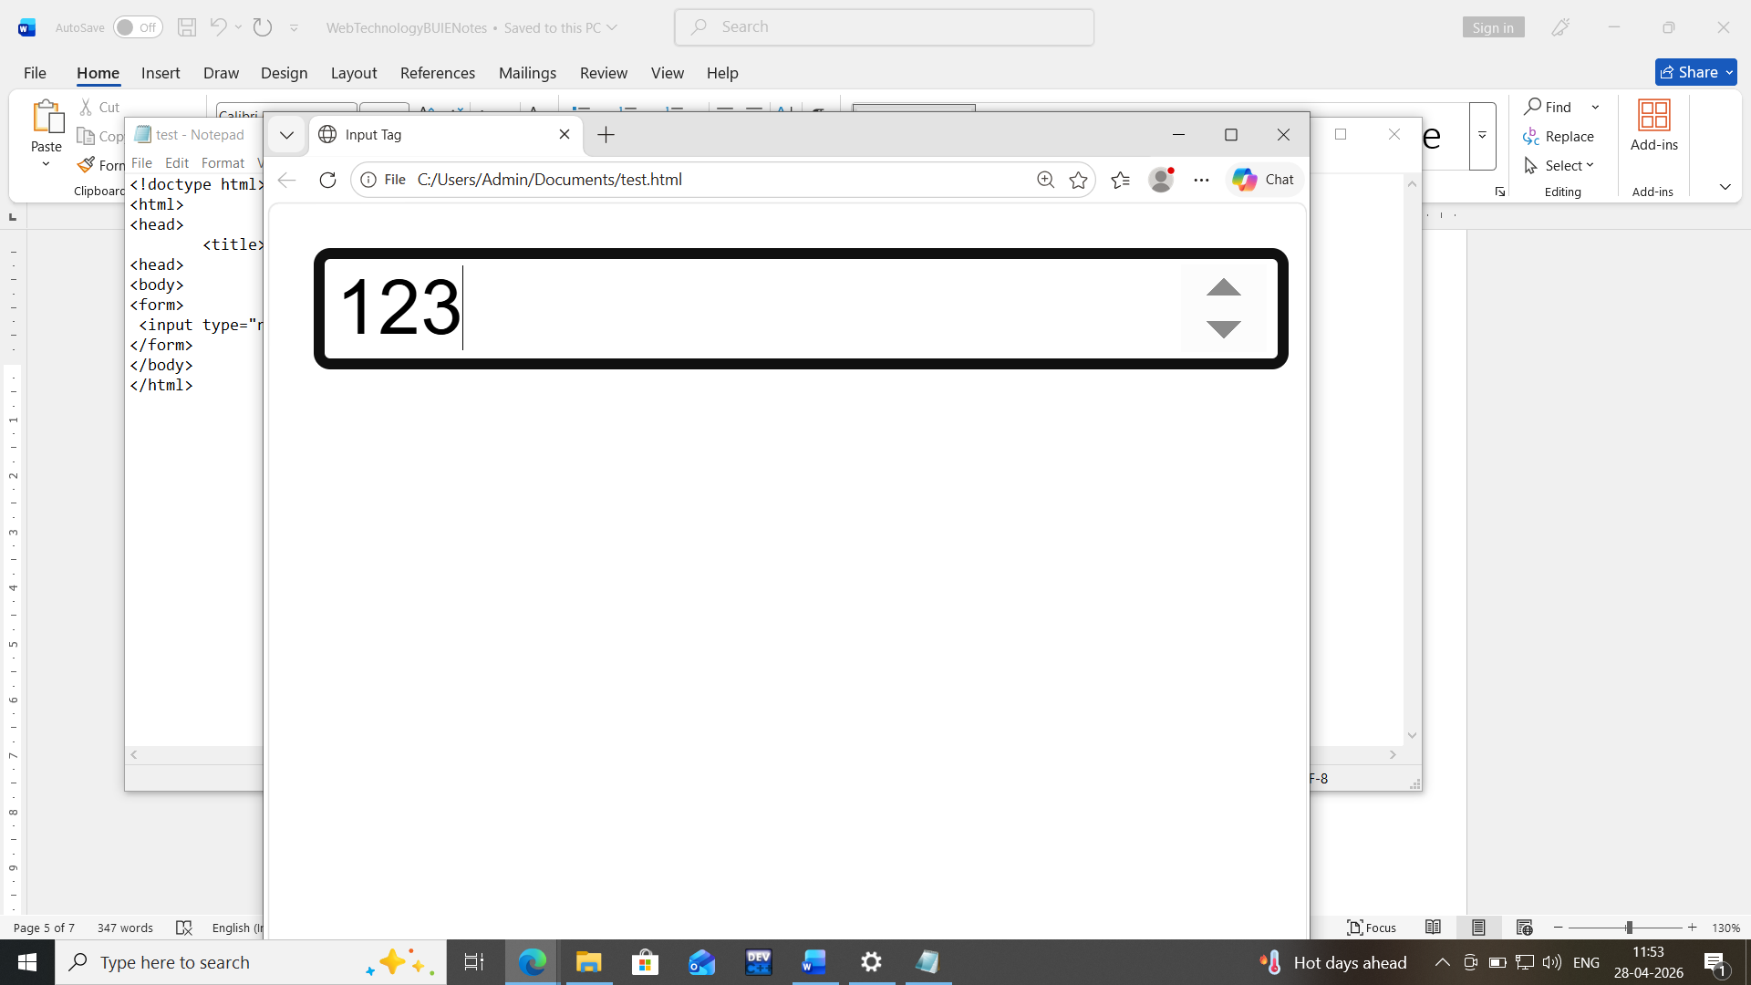
- email: It must need a email address.
Syntax:
<input type="email">
Example:
<!doctype html>
<html>
<head>
<title> Input Tag </title>
<head>
<body>
<form>
<input type="email">
</form>
</body>
</html>
Output:

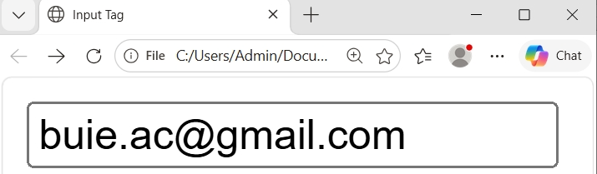

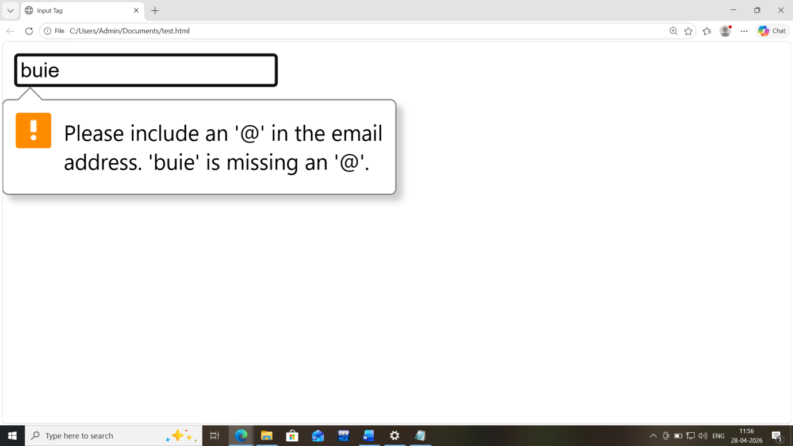
- password: It uses to take sensitive data from users.
Syntax:
<input type="password">
Example:
<!doctype html>
<html>
<head>
<title> Input Tag </title>
<head>
<body>
<form>
<input type="password">
</form>
</body>
</html>
Output:
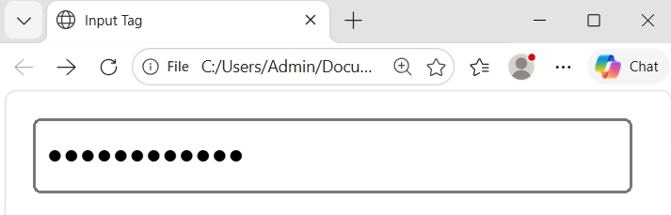
- radio: It helps to make only one chosen option from group of options.
Syntax:
<input type="radio" name="radio_variable" value="val1">
<input type="radio" name="radio_variable" value="val2">
<input type="radio" name="radio_variable" value="val3">
.
.
.
<input type="radio" name="radio_variable " value="valN">
Example:
<!doctype html>
<html>
<head> <title> Input Tag </title> <head>
<body>
<form>
<input type="radio" name="gender" value="male"><label>Male</label>
<input type="radio" name="gender" value="female"><label>Female</label>
<input type="radio" name="gender" value="other"><label>Other</label><br><br>
</form>
</body>
</html>
Output:
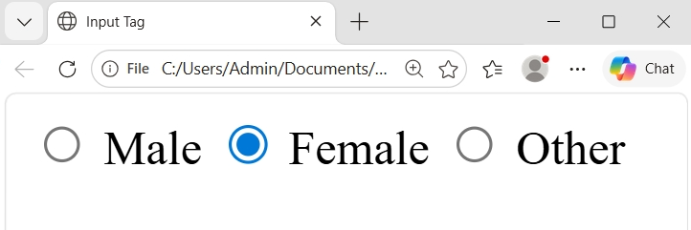
- checkbox:Itallows users to select one or more options from a set.
Syntax:
<input type="checkbox" name="var_name" value="val1">
<input type="checkbox" name="var_name " value="val2">
<input type="checkbox" name="var_name " value="val3">
.
.
.
<input type="checkbox" name="var_name" value="valN">

Example:
<!doctype html>
<html><head> <title> Input Tag </title><head>
<body>
<form>
<label>Skills :</label><br><br>
<input type="checkbox" name="skill" value="c"><label>C Programming</label><br>
<input type="checkbox" name="skill" value="java"><label>Java Programming </label><br>
<input type="checkbox" name="skill" value="html"><label>HTML</label><br>
<input type="checkbox" name="skill" value="css"><label>CSS</label><br>
<input type="checkbox" name="skill" value="js"><label>Javascript</label><br>
</form></body></html>
Output:
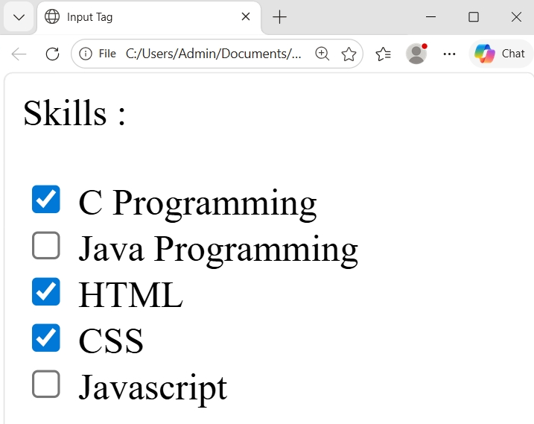
- file:It allows users to upload file (image,video,pdf etc) through web form.
Syntax:
<input type=”file”>
Example:
<!doctype html>
<html>
<head> <title> Input Tag </title><head>
<body>
<form>
<label>Upload image: </label>
<input type="file">
</form>
</body>
</html>
Output:
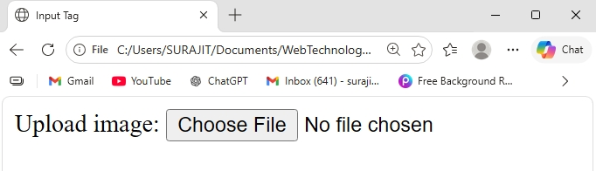
- submit:It create a submit form in a web form and help to send the form data to the server.
Syntax:
<input type=”submit”>
Example:
<!doctype html>
<html>
<head> <title> Input Tag </title><head>
<body>
<form>
<input type="submit">
</form>
</body>
</html>
Output:
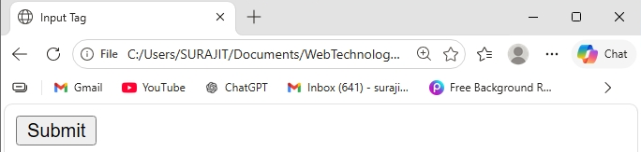
- reset:It create a reset button in the web form and it helps to clear all record from all input field of the web form .
Syntax:
<input type=”reset”>
Example:
<!doctype html>
<html><head> <title> Input Tag </title><head>
<body>
<form>
<input type="reset">
</form>
</body>
</html>
Output:
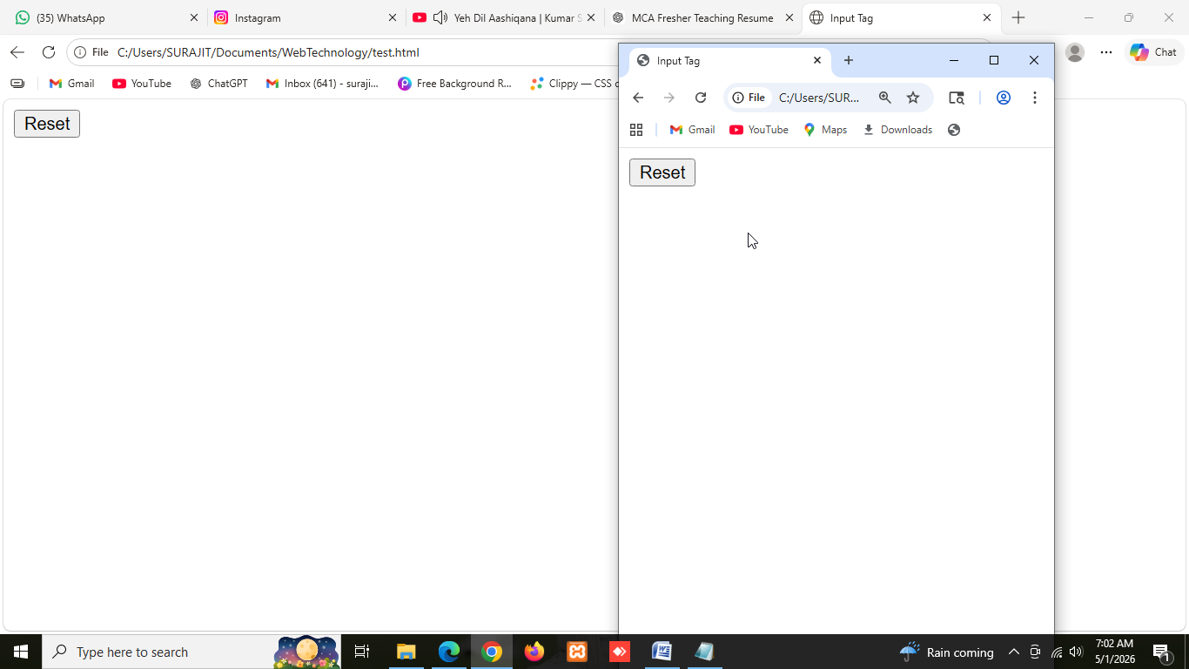
- name attribute:This attribute specifies the user value for the server with submitting the form.
Syntax:
<input type=”text” name=”var1”>

Example:
…….
<label>Enter your age : </label>
<input type="number" name="age"><br><br>
<input type="submit">
……..
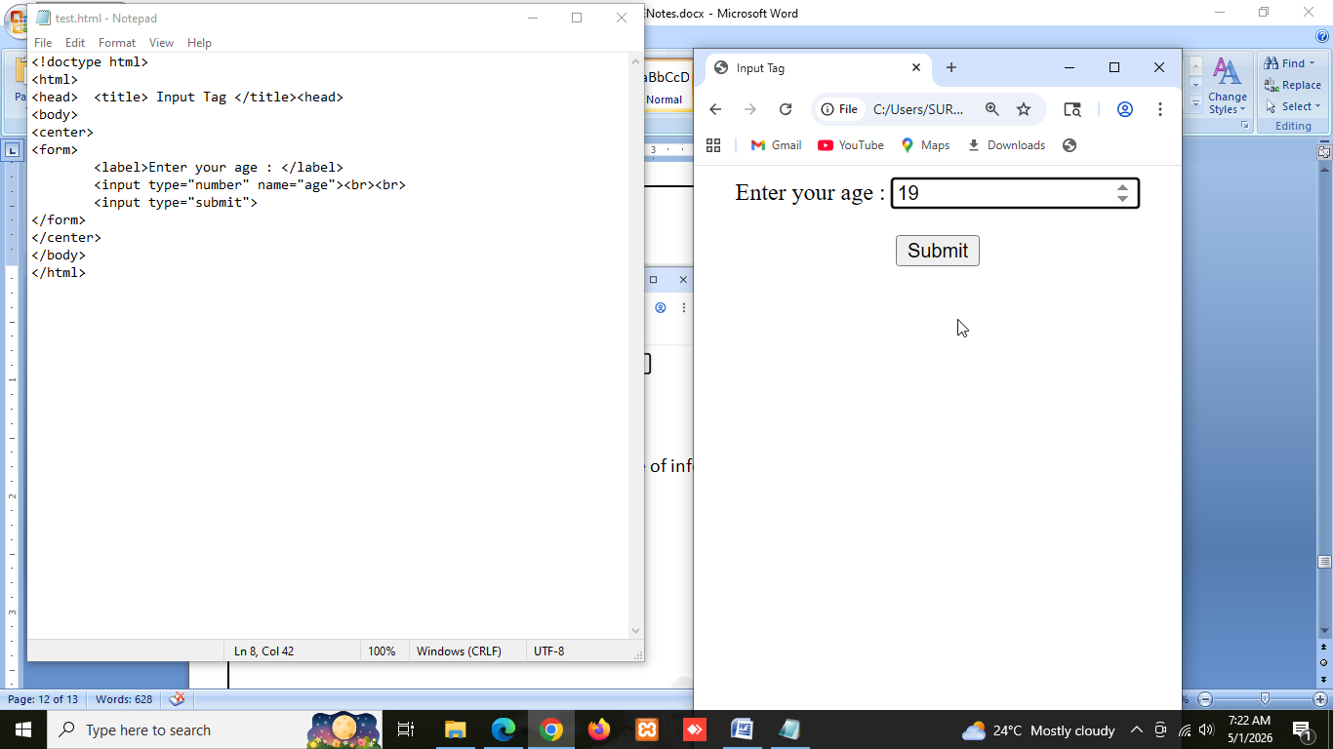
After putting the value and submitting the server takes the value -
array_name[“age”]=19

- placeholder attribute:Displays hint text inside the input about the input field until the user types.

<input type="number" name="age" placeholder="Enter Your age">

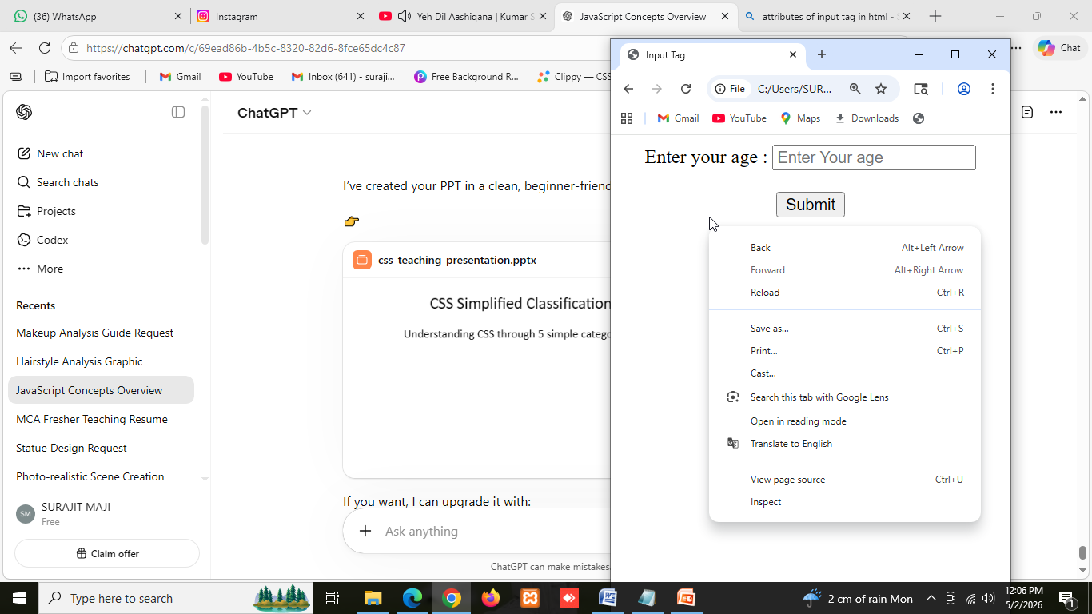

- value attribute:Sets the initial or default value of the input field in the web form. If we want change the default value of the form we have to erase the field first.

<input type="text" name="age" value="Rishi Dhawan">

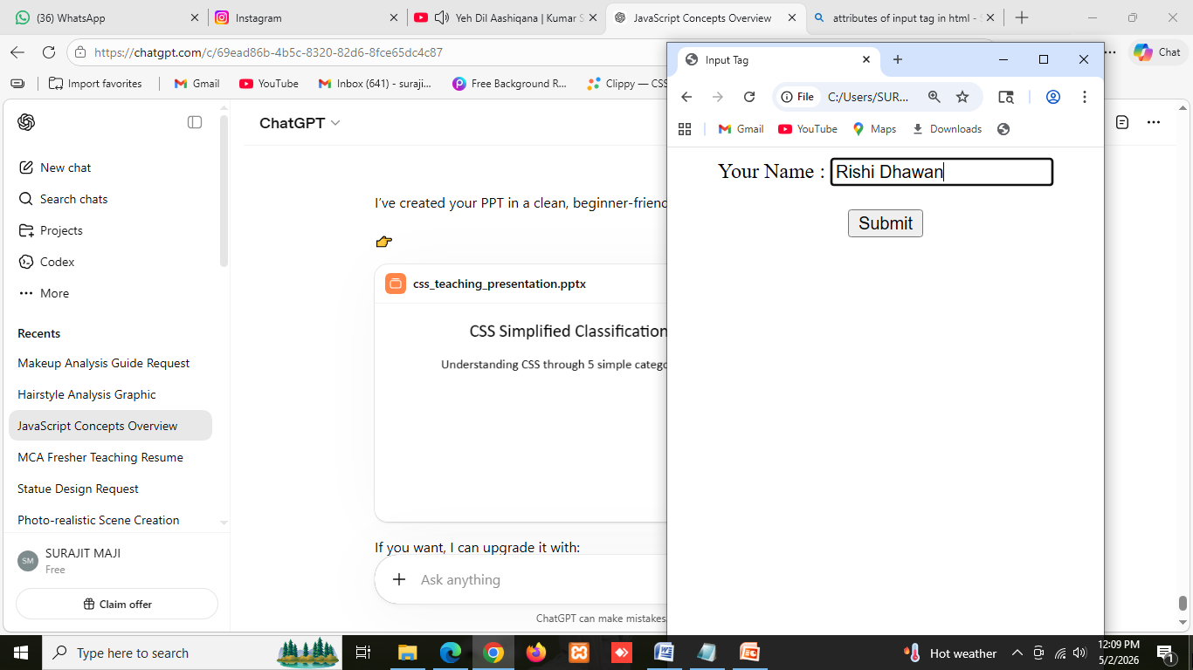
- class attribute :Its help to create styling using css.
<input type="text" name="age" class=”age_css”>
- id attribute:Unique identifier for controlling using Javascript.
<input type="text" name="age" class=”age_css”>

<label>:
It used to define a label for an input element.
Syntax:
<label >Label</label>
Example:
<label for="name">Name:</label>
<input type="text" id="name">
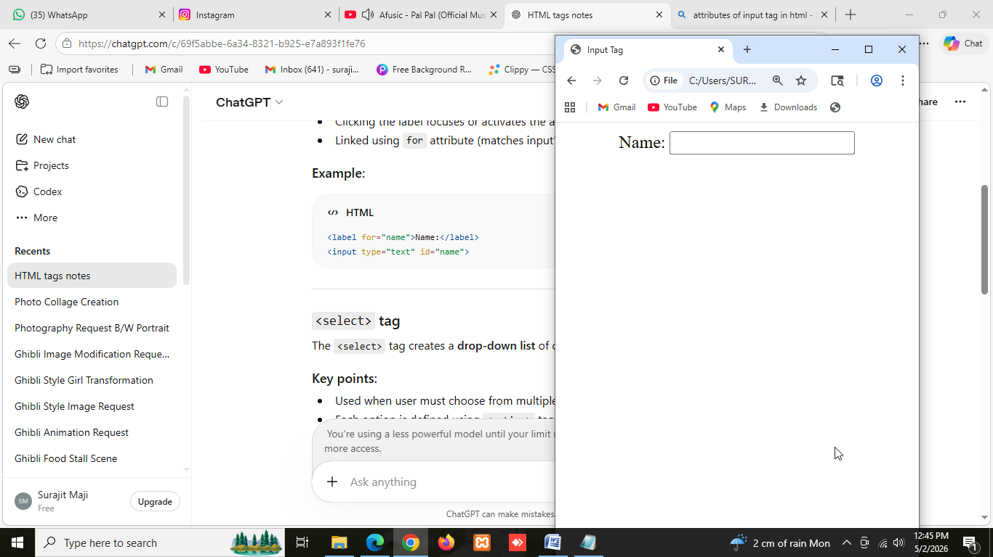
1.for attribute:
It is used to explicitly associate a label with a specific form control
- The value of the “for” attribute must match the “id” of the form control you want to label.
- Clicking the label will focus or activate the associated control.
- Improves accessibility for screen readers and keyboard navigation.
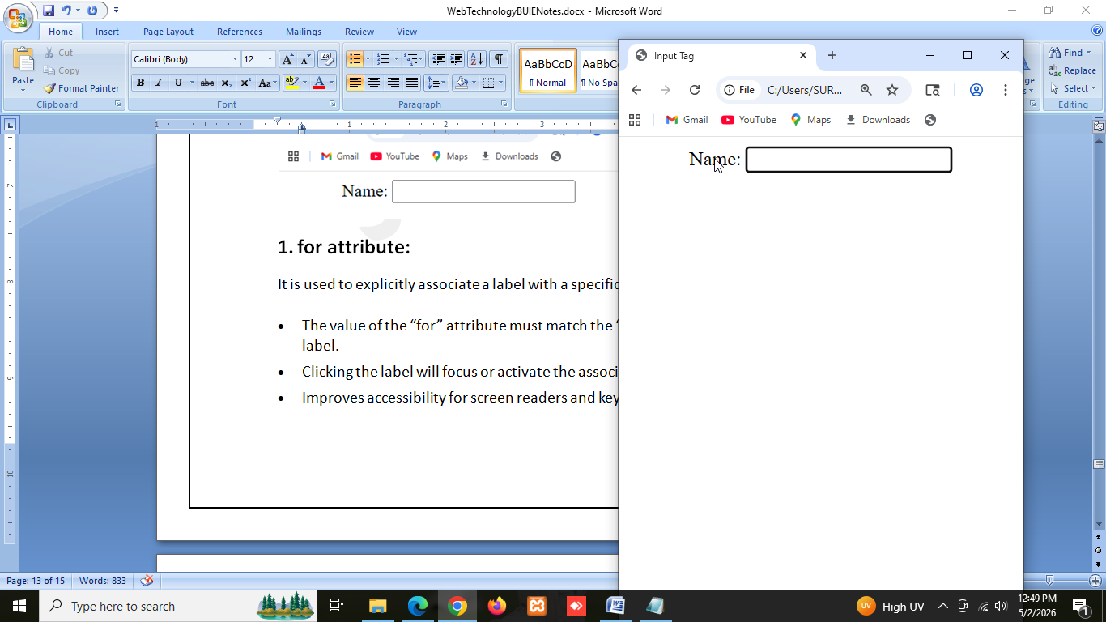
After clicking on label the related input field automatically focused.
<select>:
It helps to create dropdown list options to web form with multiple values.
- Used when user must choose from multiple options.
- Each option is defined using <option> tag.
- Can allow single or multiple selections.
Syntax:
<select name=”varOption”>
<option value=”val1”> Option1</option>
<option value=”val2”> Option2</option>
<option value=”val3”> Option3</option>
.
.
.
<option value=”valN”>OptionN</option>
</select>
Example:
<label for="city">City:</label>
<select name="city" id="city">
<option value="kolkata">Kolkata</option>
<option value="delhi">Delhi</option>
<option value="mumbai">Mumbai</option>
</select>

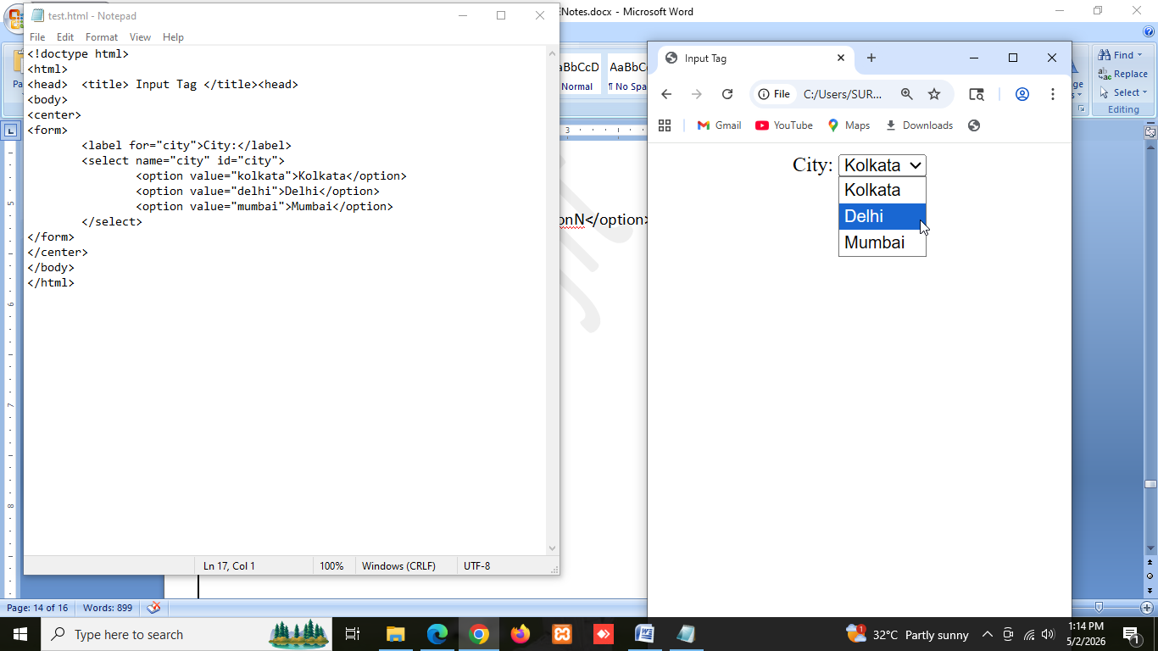
After choosing the Delhi option : array_name[“city”]=delhi
<button>:

<textarea>:

Iframe Tag:

Div Tag:

Span Tag:

CSS
CSS (Cascading Style Sheets) is used to control the appearance and design of web pages. HTML creates the structure of a webpage, while CSS makes it attractive and visually appealing.
Without CSS, webpages would appear as simple text and plain layouts.
These categories help in understanding how CSS controls the appearance and structure of a webpage.

Selectors:
A CSS Selector is used to select HTML elements and apply styles to them.
Selectors tell CSS which HTML element should receive the styling.
Without selectors, CSS would not know where to apply the design.
Used For
- Apply styles to specific elements
- Control multiple elements together
- Avoid repeating CSS code
- Make webpage design easier
- Separate content and design
Syntax:
selector{
property:value;
}
Tyes of Selectors:

Properties:
1. To Add Colors
CSS allows us to apply colors to:
- Text
- Background
- Borders
Example
h1{
color:blue;
background-color:yellow;
border:2px solid red;
}
Ouput:
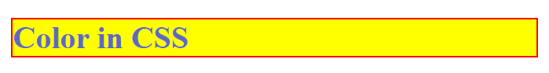
Application
Makes websites attractive and improves user experience.
2. To Control Size
CSS controls:
- Width
- Height
- Font size
- Image size
Example
img{
width:200px;
height:150px;
}
Output:

Application
Helps maintain proper page structure.

3. To Manage Spacing
CSS controls spacing using:
- Margin
- Padding
Example
body{
border:1px solid blue;
padding:0px;
margin: 0px;
}
div{
margin:20px;
padding:20px;
border:1px solid black;
background-color:pink;
}
Output:
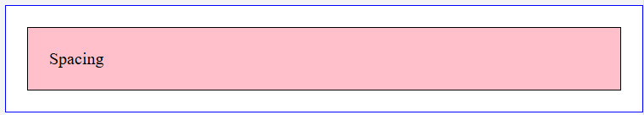
4. To Create Layout
CSS arranges webpage elements. Using layout property we arranging the html element with row-column structure, within a single line etc.
Example
div.container{
display:flex;
justify-content: center;
border: 1px solid red;
}
div.box{
text-align:center;
background-color: yellow ;
padding:10px;
margin:5px;
}
Output:
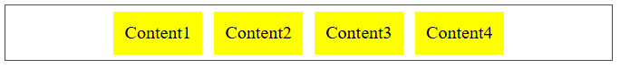
Used for:
- Navigation bars
- Sidebars
- Columns
- Sections

5. To Make Responsive Webpages
Responsiveness in CSS means designing a webpage so that it can automatically adjust its layout, size, and content according to different screen sizes and devices.
A responsive website works properly on:
- Mobile phones 📱
- Tablets 📱
- Laptops 💻
- Desktop computers 🖥️
The webpage changes its appearance based on screen width and resolution.

Example
body{
background-color:blue;
}
@media(max-width:600px){
body{
background:red;
}
}
Output:
Computer Screen

Mobile Screen
Application
Makes websites work on different screen sizes.
Types:
CSS (Cascading Style Sheets) is used to control the appearance of web pages. CSS helps in designing webpages by changing:
- Colors
- Fonts
- Layout
- Spacing
- Responsiveness
There are three main types of CSS:
- Inline CSS
- Internal CSS
- External CSS

1. Inline CSS
Inline CSS is written directly inside an HTML tag using the style attribute.
CSS affects only that specific element.
How to Apply
Write CSS inside the opening tag:
<tag style="property:value;">
Syntax
<h1 style="color:red;">
Hello
</h1>
Example
<!DOCTYPE html>
<html>
<body>
<h1 style="color:blue;">
Welcome to BCA
</h1>
<p style="font-size:20px;">
Learning CSS
</p>
</body>
</html>

Use Cases
- Apply style to a single element
- Quick testing
- Temporary styling
- Small modifications

Advantages
- Easy to write
- No separate CSS file required

Disadvantages
- Difficult to maintain
- Repeated code

Output Screenshot (Representation)

2. Internal CSS
Internal CSS is written inside the <style> tag within the <head> section.
It affects the entire webpage.
How to Apply
Place CSS inside:
<head>
<style>
CSS code
</style>
</head>
Syntax
<style>
h1{
color:red;
}
</style>
Example
<!DOCTYPE html>
<html>
<head>
<style>
h1{
color:green;
}
p{
font-size:20px;
}
</style>
</head>
<body>
<h1>Welcome</h1>
<p>Learning Internal CSS</p>
</body>
</html>

Use Cases
- Small websites
- Single page projects
- Classroom demonstrations
- Page-specific design

Advantages
- No extra file needed
- Controls full page design

Disadvantages
- Cannot reuse across multiple pages
- Large code becomes difficult

Output Screenshot (Representation)

3. External CSS
External CSS stores CSS code in a separate file (.css) and links it with HTML.
How to Apply
Step 1: Create CSS file
style.css
Step 2: Link file in HTML

Syntax
<link rel="stylesheet"href="style.css">

CSS File Example
style.css
h1{
color:purple;
}
p{
font-size:20px;
}

HTML File Example
<!DOCTYPE html>
<html>
<head>
<link rel="stylesheet"
href="style.css">
</head>
<body>
<h1>Welcome</h1>
<p>External CSS Example</p>
</body
</html>

Use Cases
- Large websites
- Multi-page websites
Advantages
- Reusable across pages
- Easy maintenance
- Cleaner HTML code

Disadvantages
- Requires separate file
- Link errors possible

Output Screenshot (Representation)

Comparison Table
Feature | Inline | Internal | External
Location | Inside tag | Head section | Separate file
Reusable | No | Limited | Yes
Suitable for | Single element | Single page | Large websites
Maintenance | Difficult | Medium | Easy
Priority Order of CSS:
Inline CSS → Highest Priority
Internal CSS → Medium Priority
External CSS → Lowest Priority
If multiple styles apply, higher priority CSS overrides lower priority CSS.

Bootstrap
Bootstrap is a free and open-source CSS framework used to create responsive and mobile-friendly websites quickly.
It contains pre-designed:
- CSS classes
- Components
- Buttons
- Forms
- Navigation bars
- Grid systems
- Cards and layouts
Bootstrap reduces coding effort and helps create attractive webpages easily.
Why Bootstrap is Used?
Bootstrap is used because:
- Creates responsive webpages
- Saves development time
- Provides ready-made classes
- Easy to use
- Mobile-first framework
- Supports modern browsers

Features of Bootstrap
- Responsive design
- Grid system
- Predefined CSS classes
- Ready components
- Faster webpage development
- Mobile-first approach

Downloading and Linking Bootstrap
Bootstrap can be used in two ways:
- Download Bootstrap files
- Use CDN link

Method 1: Download Bootstrap
Steps
- Visit Bootstrap website
- Download Bootstrap CSS and JS files
- Save files in project folder
- Link files inside HTML

Features:

Advantages:

Bootstrap Connect:

JavaScript

Applications:
- Form validation
- Pop Up
- Image slider
- Dynamic Content
- Games
- Chat Application
Features:
- Scripting language
- Light Interpreted Language
- Interacting with HTML page

Array:
An Array in JavaScript is used to store multiple values in a single variable.
let arr=["Apple","Banana","Mango"];
- push:
The push() method is used to add one or more elements at the end of an array.
Application
- Add new items dynamically
- Store user input
- Append data into a list
Syntax:
array_name.push(value);
Example:
let arr=["Apple","Banana","Mango"];
arr.push(“Grape”);
console.log(arr);
Output:
["Apple","Banana","Mango",”Grape”]
- pop:
The pop() method removes the last element from an array.
Application
- Remove recently added data
- Undo with array
Syntax:
array_name.pop();
Example:
let fruits=["Apple","Banana","Mango"];
fruits.pop();
console.log(fruits);
Output:
["Apple","Banana"]

- length:
length returns the total number of elements present in an array.
Application
- Count items
- Loop through arrays
Syntax:
array_name.length
Example:
let fruits=["Apple","Banana","Mango"];
console.log(fruits.length);
Output:
3
- accessing :
Array elements are accessed using their index number.
Index starts from 0.
Application
- Display particular data
Syntax:
array_name[index]
Example:
let fruits=["Apple","Banana","Mango"];
console.log(fruits[0]);
console.log(fruits[1]);
console.log(fruits[2]);
Output:
Apple
Banana
Mango
- updating :
Array values can be modified by assigning a new value to a specific index.
Application
- Modify existing records
- Edit user data
- Update values dynamically
Syntax:
array_name[index]=newValue;
Example:
let fruits=["Apple","Banana","Mango"];
fruits[1]="Orange";
console.log(fruits);
Output:
["Apple","Orange","Mango"]
Problem:
- Add minimum 5 courses
- Access the third course
- Update one course name
- Remove one course
- Display total registered courses
Functions:
Function is a block of code that encapsulates a specific task for execution.
- It specifies with name, may have parameters and return values.
- It breaks the large task into smaller parts.
Syntax:
- Without return type
function <function_name>(){
// write function code here
}
- without return
function <function_name>(){
// write code here
return value;
}
Example:
<script>
function add(a,b){
console.log(“Addition =”,a+b);
}
function sub(a,b){
let c=a-b;
return c;
}
let x=10,y=7;
add(x,y);
let s=sub(x,y);
console.log(“Difference =”,a-b);
</script>
Output:
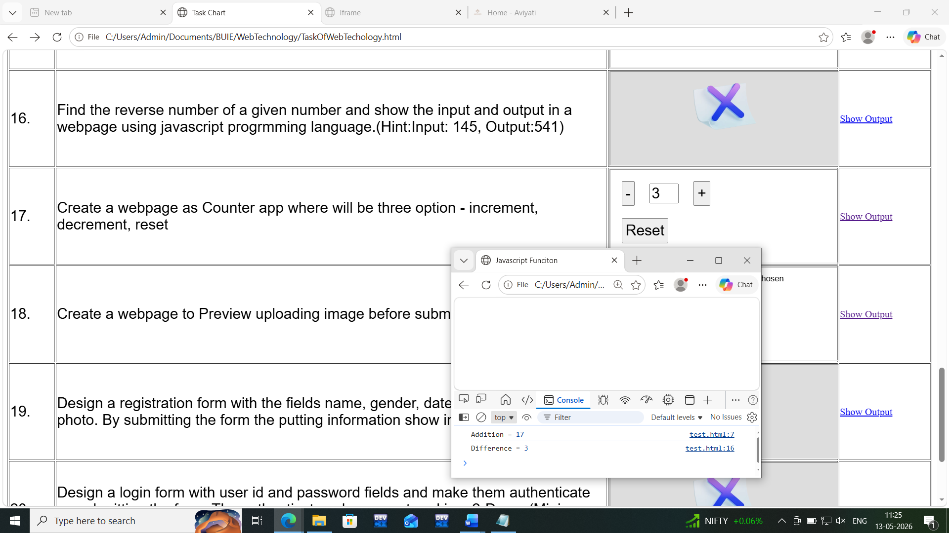
Events:
Events in JavaScript are actions that occur in the browser due to user interaction or browser activity.

Examples:
- Clicking a button
- Moving mouse
- Typing text
- Loading page
- Submitting form
JavaScript can detect these events and execute functions.

- onclick: The onclick event occurs when the user clicks on an element.
Applications
- Submit button
- Login button
- Menu click
Syntax:
<tag onclick="functionName()">

Example:
<button onclick="show()">
Click Here
</button>
<script>
function show(){
document.write(“I am visible”);
}
</script>
Output:

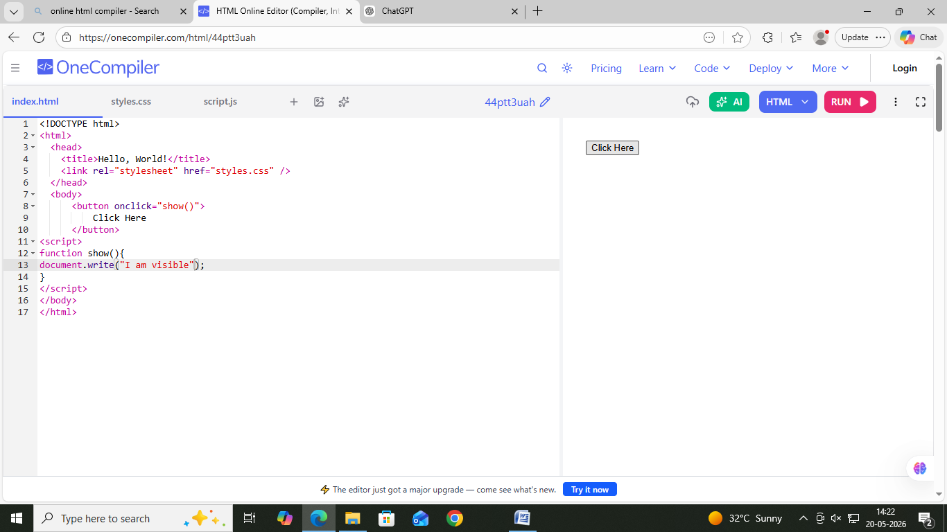after click 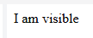

- onmousehover
The onmouseover event occurs when the mouse pointer moves over an element.
Syntax:
<tag onmouseover="functionName()">
Example:
<body>
<p onmouseover="change()" id="area">
Move mouse here
</p>
<script>
let a=document.getElementById("area");
function change(){
a.innerHTML=("You touch on me");
}</script>
</body>
Output:
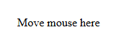After touch on text 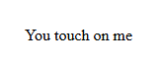

- onmouseout :
The onmouseout event occurs when mouse leaves an element.
Applications
- Remove hover effects
- Restore original style

Syntax:
<tag onmouseout="functionName()">
Example:
<body>
<p onmouseout="changeOut()" id="area">
Move mouse here
</p>
<script>
let a=document.getElementById("area");
function changeOut(){
a.innerHTML=("Oh!! You out from me");
}
</script>
</body>
Output:
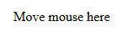on mouse out 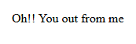

- onchange
The onchange event in JavaScript is used when the value of an HTML element changes.
It is commonly used with:
- <input>
- <select>
- <textarea>
Syntax:
<tagname onchange=”function_name()”>
Example:
<body>
Enter your Name: <input type="text" onchange="showValue()" id="name">
<p id="result"></p>
<script>
let a=document.getElementById("name");
let b=document.getElementById("result");

function showValue(){
let val=document.getElementById("name").value;
b.innerHTML="You have entered : "+val;
}
</script>
</body>
Output:
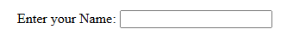
After putting value in field
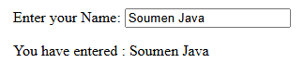
- onload
The onload event is used to execute JavaScript code when a webpage or an element finishes loading.
It is commonly used to:
- Display messages after page load
- Load images
Syntax:
<body onload="functionName()">
Example:
<body onload="showMessage()">
<h1>Welcome</h1>
<script>
function showMessage() {
alert("Page Loaded Successfully");
}
</script>
</body>
Output:
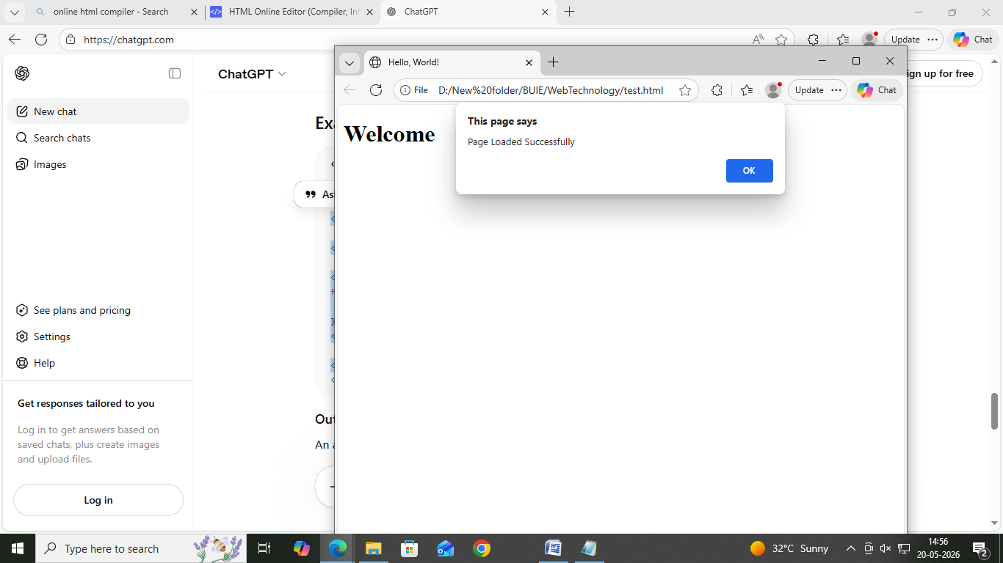

- onfocus:
The onfocus event occurs when an HTML element gets focus.
An element receives focus when:
- The user clicks on it
- The user tabs into it using the keyboard
It is mostly used with:
- <input>
- <textarea>
- <select>
Syntax:
<input type="text" onfocus="functionName()">
Example:
<body>
Enter your name:
<input type="text" onfocus="field_focused()" id="field">
<script>
function field_focused() {
let a=document.getElementById("field");
a.style.backgroundColor="pind";
a.style.outline="2px solid red";

}
</script>
</body>
Output:
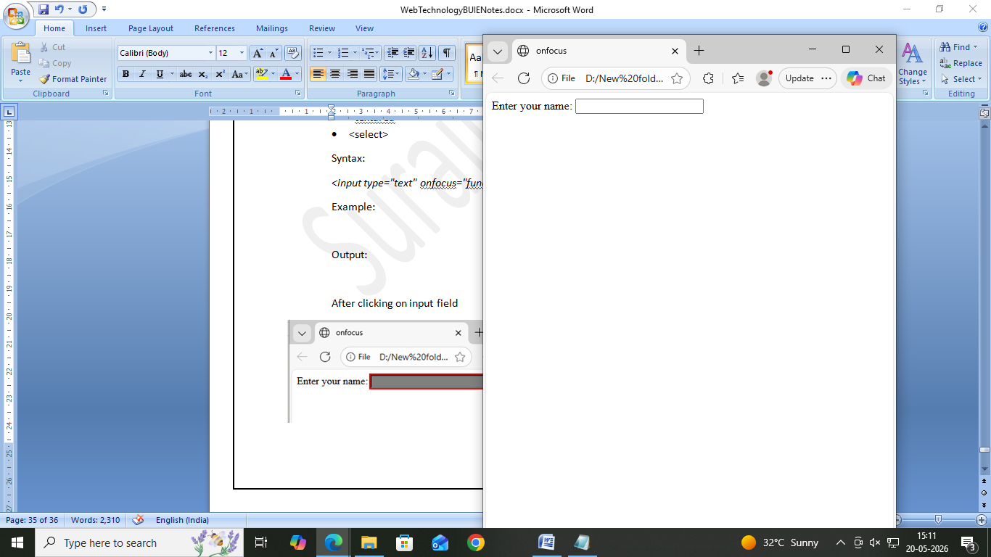
After clicking on input field
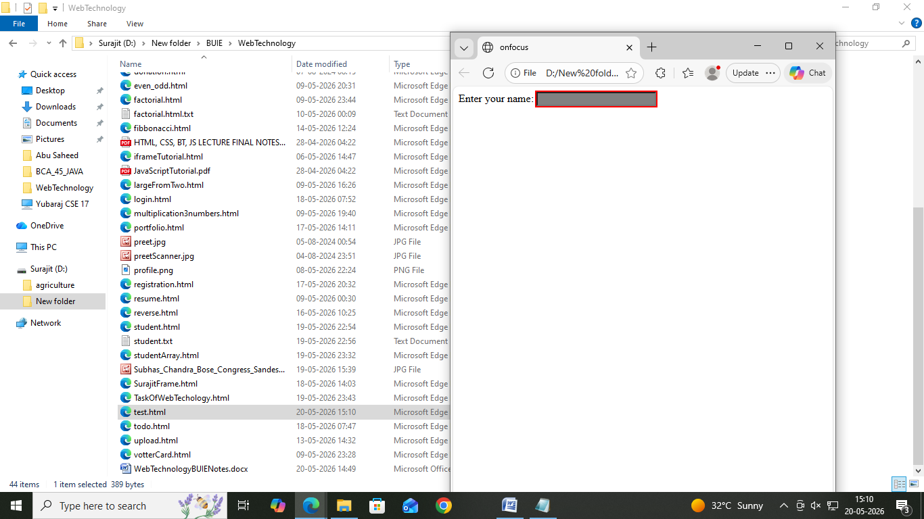

- onsubmit
The onsubmit event occurs when a form is submitted.
It is mainly used for:
- Form validation
- Checking user input
- Preventing empty fields
- Confirming submission
The event works with the <form> element.
Syntax:
<form onsubmit="functionName()">
Example:
<body>
<form onsubmit="showMessage()">
Name:<input type="text">
<input type="submit" value="Submit">
</form>
<script>
function showMessage() {
alert("Form Submitted");
}
</script>
</body>
Output:

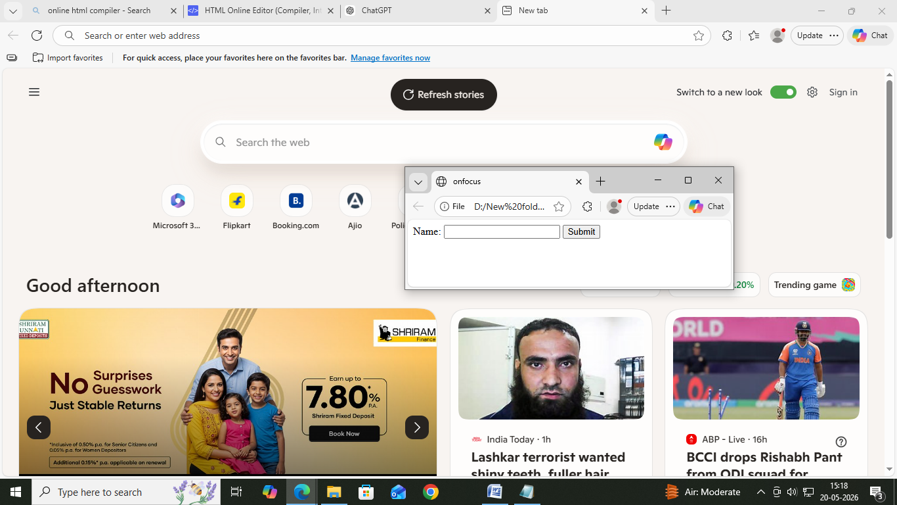
After click on submit button
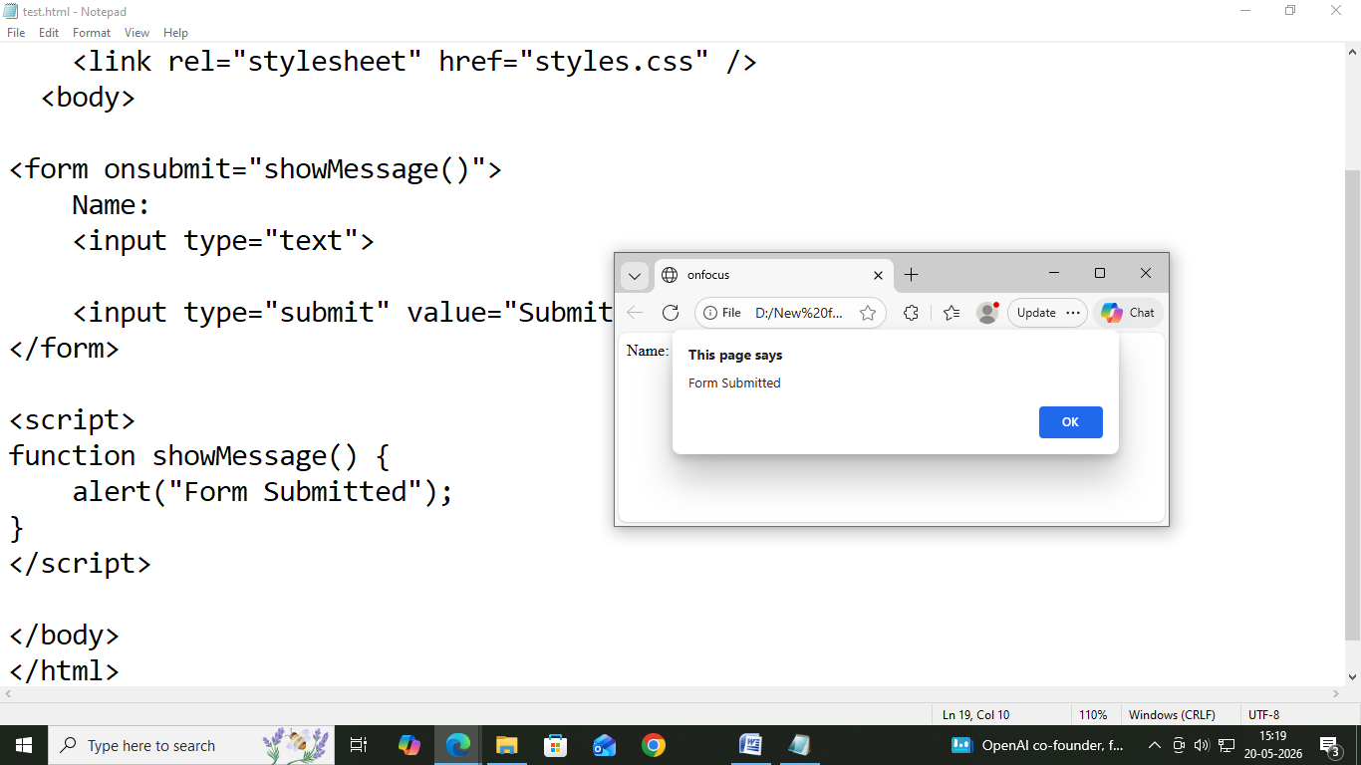

Document Object Model in Javascript:
The Document Object Model (DOM) is a programming interface that represents an HTML document as a tree structure of objects.
JavaScript uses the DOM to:
- Access HTML elements
- Read data from elements
- Modify webpage contents
- Change styles
- Add or remove elements
Each HTML tag becomes an object (node) in the DOM tree.
Example:
<html>
<head>
<title>My Title</title>
</head>
<body>
<h1>My Header</h1>
<a href=”www.google.com”>Content</a>
</body>
</html>

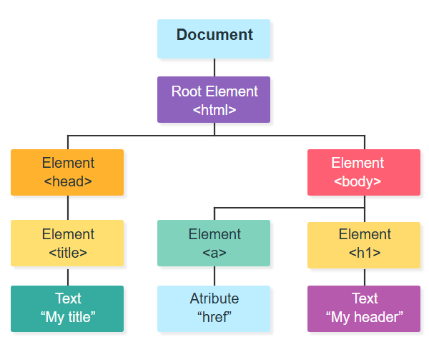Application:
DOM is used because JavaScript needs a way to communicate with HTML elements.
- Change the content of HTML elements
- Change the style (CSS) of HTML elements
- Add and delete HTML elements
- React to events in from HTML elements
DOM Traversing:
DOM Traversing means moving from one HTML element to another element in the DOM tree using JavaScript.
Traversal allows us to move:
- Parent → Child
- Child → Parent
- One sibling → Another sibling
Types of DOM Traversing
- Parent Traversing
- Child Traversing
- Sibling Traversing

1. Parent Traversing
Used to move from a child element to its parent.

Syntax
element.parentElement

Example
<div id="box">
<p id="para">
Hello Students
</p>
</div>
<script>
let x=document.getElementById("para");
console.log(x.parentElement);
</script>

Output
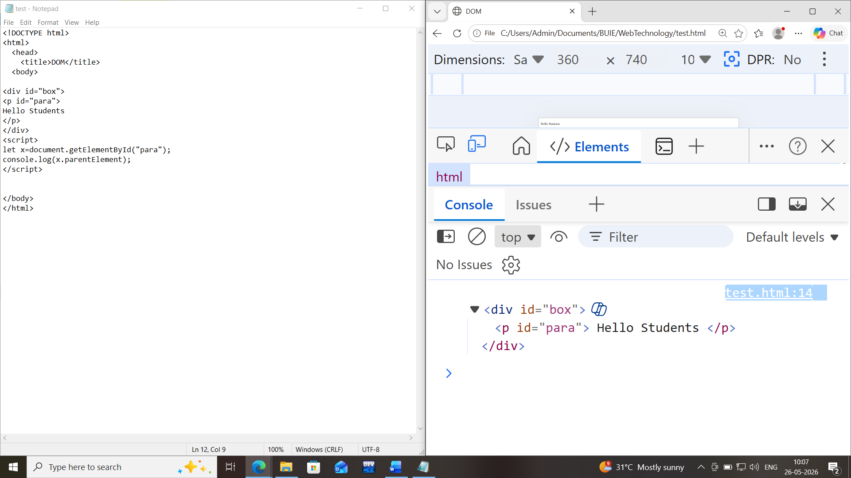
Explanation:
JavaScript moves from <p> to <div>.

2. Child Traversing
Used to access child elements inside a parent.

Syntax:
element.children

Example:
<div id="container">
<h1>Hello</h1>
<p>HTML</p>
<button>Click</button>
</div>
<script>
let x=document.getElementById("container");
console.log(x.children);
</script>

Output
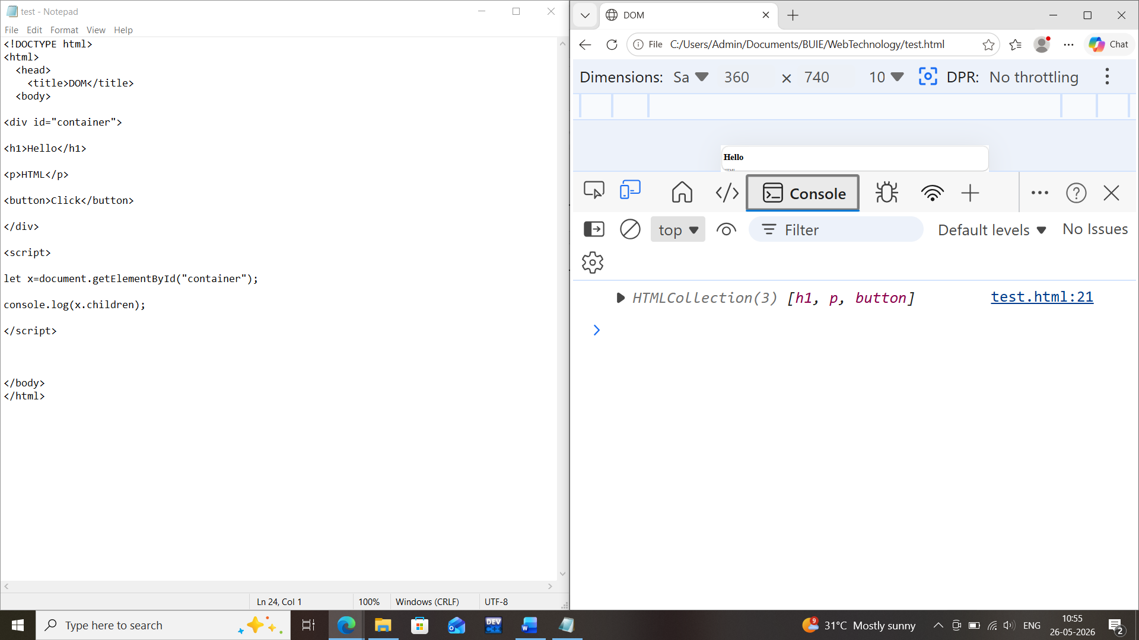
Returns all child elements.

Sibling Traversing

Sibling means elements having same parent.

Syntax:

nextElementSibling
previousElementSibling

Example:

<h1 id="first">HTML</h1>

<h2 id="second">CSS</h2>

<h3 id="third">Javascript</h3>

<script>

let x=document.getElementById("second");

console.log("The Previous Sibling =>",x.previousElementSibling);

console.log("The Next Sibling =>",x.nextElementSibling);

</script>

Output

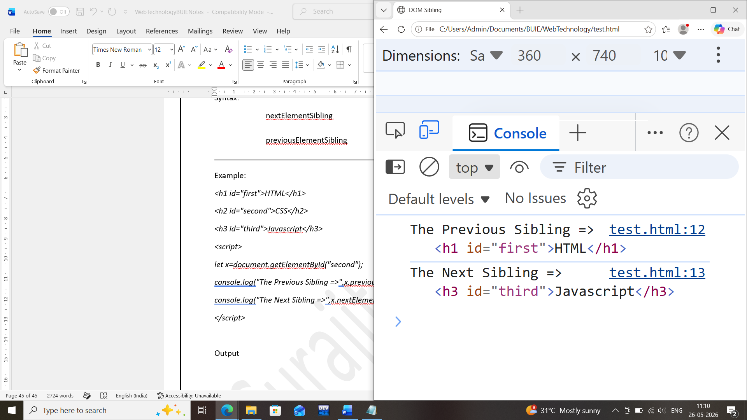

CSS Manipulation Using Javascript:
CSS Manipulation means changing the style of HTML elements dynamically using JavaScript.
JavaScript can:
- Change colors
- Change fonts
- Hide/show elements
- Add animations
- Change layouts dynamically
Syntax:
document.getElementById(id).style.property= new style
Example:
document.getElementById("p2").style.color = "blue";

Assignment : Dynamic Traffic Signal

Problem Statement
Create three circles:
- Red
- Yellow
- Green
AJAX (Asynchronous JavaScript and XML)
Introduction to AJAX
AJAX stands for:
A → Asynchronous
J → JavaScript
A → And
X → XML
AJAX is a technique used to exchange data between a web browser and a server without reloading the entire webpage.
Using AJAX, webpages can update content dynamically in the background.

Definition
AJAX allows JavaScript to send and receive data from the server asynchronously, meaning the webpage continues working while data is being processed.
Without AJAX:
User Request → Server → Entire page reload
With AJAX:
User Request → AJAX → Server → Update specific content only

Why AJAX is Needed?
Normally, when users submit forms or click buttons:
- Browser sends request
- Server processes request
- Entire page reloads
This creates:
❌ Slow performance
❌ Unnecessary page refresh
❌ Poor user experience
AJAX solves this problem.

Working Process of AJAX
AJAX mainly uses:
- HTML/CSS
- JavaScript
- DOM
- XML/JSON
- XMLHttpRequest object
Flow:
User Action
↓
JavaScript
↓
AJAX Request
↓
Server
↓
Response
↓
Update Page Content

Syntax of AJAX
Using XMLHttpRequest
let xhttp=new XMLHttpRequest();
xhttp.open(
"GET",
"data.txt",
true
);
xhttp.send();

