### **Analysis of Information Leaks from 2014 to 2024**

Let's take a look at the graph showing the number of information leaks each year from 2014 to 2024. We'll explain what happened during each period, why it happened, and how you can protect yourself. Let's make it simple, like a school project!

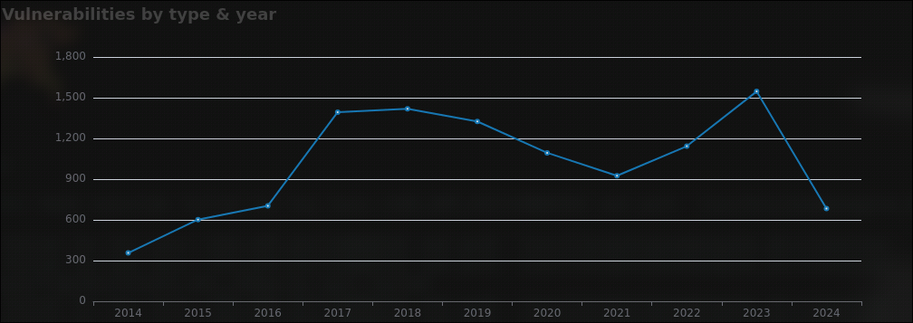

#### **1. Between 2014 and 2016**

* **Steady Numbers**: From 2014 to 2016, the number of information leaks stayed pretty low, between 300 and 600.
* **Relevance**: At this time, there weren't as many big data breaches making the news. People were starting to use more online services, but security wasn't a huge focus yet.

#### **2. Big Jump in 2017**

* **Why the Big Jump?** In 2017, the number of information leaks jumped up a lot. Here’s why:
* **Major Cyber Attacks**:
* **Equifax Data Breach (September 2017)**: This was a huge data breach where personal information of 147 million people was stolen, including Social Security numbers and birthdates.
* **Yahoo Data Breach (2016-2017)**: Yahoo announced that data from all 3 billion user accounts had been compromised, though it happened earlier, it was discovered and reported around this time.
* **Better Reporting**: Companies and governments started reporting more data breaches because people wanted to know when their information was stolen.

#### **3. Gradual Increase and Peak in 2017-2018**

* **Why the Increase?** The number of information leaks kept increasing in 2017 and peaked in 2018. This can be because:
* **Increased Cybercrime**: Hackers were getting better at breaking into systems and stealing data.
* **More Online Services**: More people were using online services for banking, shopping, and social media, which created more opportunities for information leaks.

#### **4. Decrease in 2019-2021**

* **Why the Decrease?** From 2019 to 2021, the number of information leaks went down a bit. Here’s why:
* **Improved Security**: Companies started using better security measures to protect their data.
* **Less Reporting**: There might have been fewer big data breaches reported during this time.

#### **5. Peak in 2023**

* **Why the Peak?** In 2023, the number of information leaks peaked again. Possible reasons include:
* **COVID-19 Impact**: With more people working from home due to the pandemic, there were more opportunities for data breaches.
* **High-Profile Attacks**: There might have been some big cyber attacks that caused a lot of information leaks.

#### **6. Drop in 2024**

* **Why the Drop?** In 2024, the number of information leaks went down again. Here are some reasons why this might have happened:
* **Better Security**: Companies might have improved their security measures, making it harder for hackers to steal data.
* **Incomplete Data**: The data for 2024 might not be complete yet, so the final number might be higher later.

### **What Went Wrong?**

* **Weak Passwords**: People often use weak or common passwords that are easy to guess.
* **Phishing Attacks**: Hackers trick people into giving away their personal information through fake emails or websites.
* **Old Software**: Companies sometimes use outdated software that has security vulnerabilities.
* **Lack of Awareness**: Many people and companies are not aware of the best practices for cybersecurity.

### **How to Protect Yourself**

* **Use Strong Passwords**: Make sure your passwords are long, unique, and include numbers and symbols.
* **Enable Two-Factor Authentication (2FA)**: This adds an extra layer of security by requiring a second form of verification.
* **Be Careful with Emails**: Don’t click on links or open attachments from unknown senders. Always check the sender's email address.
* **Update Your Software**: Keep your computer, phone, and other devices updated with the latest security patches.
* **Use Antivirus Software**: Install antivirus software to protect your devices from malware and viruses.
* **Be Aware**: Learn about common cyber threats and how to avoid them. Stay informed about the latest security news.

### **Conclusion**

The graph shows that the number of information leaks has changed a lot over the years. From 2014 to 2016, the numbers were steady, but there was a big jump in 2017 due to major data breaches like Equifax and Yahoo. The numbers kept increasing till 2018, then decreased a bit until 2021. In 2023, the number of leaks peaked again, possibly due to the effects of the pandemic and high-profile attacks. Finally, the drop in 2024 might be because of better security or incomplete data.

Understanding these trends helps us know how important it is to keep improving our cybersecurity measures to protect against information leaks. Stay safe online by using strong passwords, enabling two-factor authentication, being careful with emails, updating your software, using antivirus software, and staying aware of cyber threats.