**BIOAWARE ZONE**

**Currently, awareness of biosafety standards and ethics is growing, but gaps remain in understanding and implementation across various sectors. While many institutions have established biosafety protocols, the consistency and depth of these measures vary significantly. There is a need for uniform biosafety regulations that are accessible and understandable to all stakeholders, including researchers, healthcare workers, and policymakers. Additionally, the ethical dimensions of biosafety, such as equitable access to safety resources and transparency in research practices, often do not receive enough attention. As a result, a holistic approach to biosafety awareness that integrates both safety protocols and ethical considerations is essential.**

**Raising awareness about biosafety standards and ethics is critical to fostering a culture of safety and responsibility in biological research and healthcare settings. As the use of biological materials expands in various fields, the potential risks to public health and the environment also increase. Awareness initiatives can help bridge the knowledge gap, ensuring that all individuals involved in biological research and healthcare are equipped with the necessary information and resources to implement safe and ethical practices. Enhancing biosafety education is particularly important in regions where such standards are less developed, thereby promoting global standards of safety and ethics.**

**To effectively spread awareness of biosafety standards and ethics, a dedicated website should be developed with comprehensive content tailored to different audiences. This platform should provide educational resources, such as guidelines, case studies, and best practices, in an easy-to-understand format. Interactive elements like quizzes, webinars, and discussion forums can engage users and facilitate knowledge sharing. The website should also incorporate visual aids, such as infographics and videos, to make complex topics more accessible. Additionally, ensuring accessibility, multilingual support, and regular updates will be essential to reach a broader audience and keep them informed on the latest developments in biosafety and ethics.**

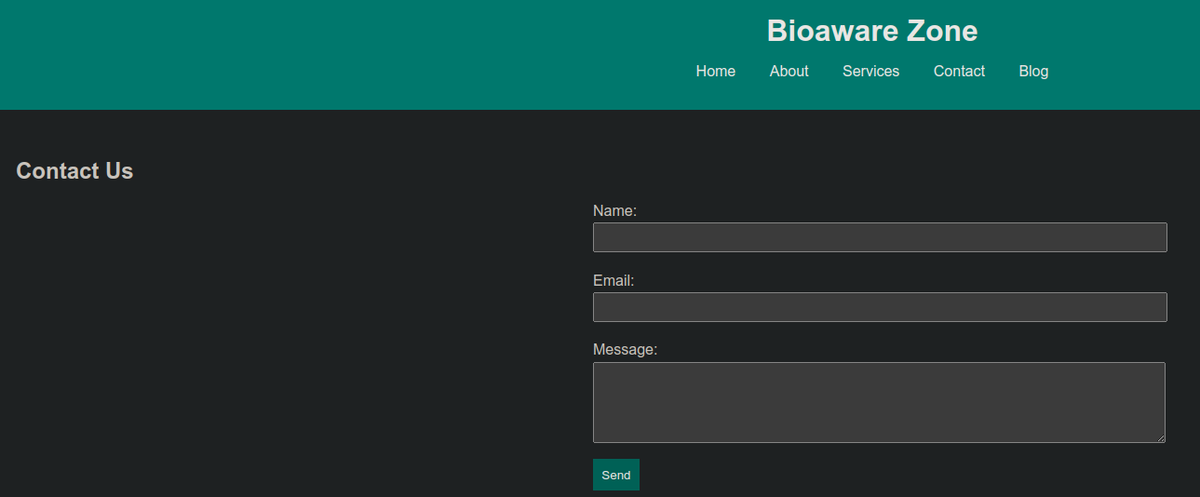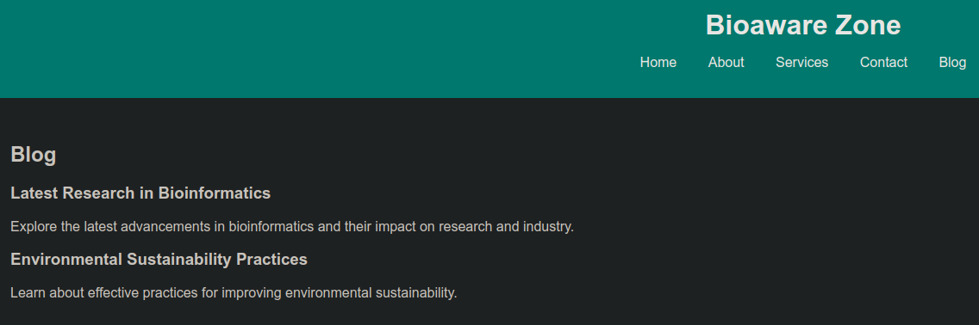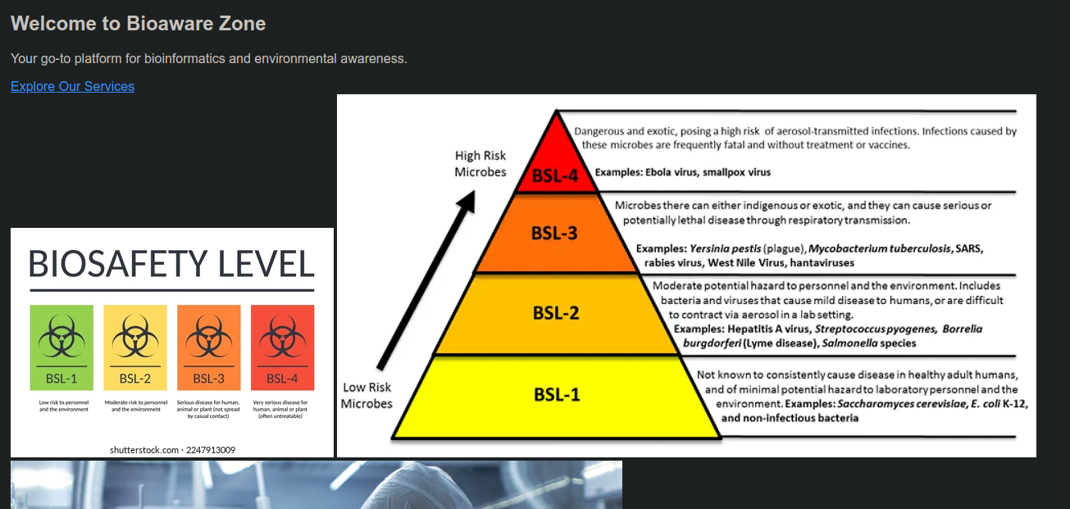

BY:

KAPSHA SURAJ SINGH [ 1RV23CY402 ]