UNIT 4:

**GMP**

Good Manufacturing Practices (GMPs) describe the methods, equipment, facilities, and controls for producing processed food. As the minimum sanitary and processing requirements for producing safe and wholesome food, they are an important part of regulatory control over the safety of the nation's food supply.

The first 5 golden rules for GMP production are:

* Get the facility design right from the start.
* Validate processes.
* Write good procedures and follow them.
* Identify who does what.
* Keep good records.

The 5M stands for: Machine (equipment) ; Medium (environment); Method (process) Material (raw materials) ; Workforce. With the 5M, you can create a diagram helping you to identify the causes of the problem

 The 5 P's of GMP – Products, Processes, Procedures, Premises and lastly, People – to guarantee strict adherence to quality standards throughout the production process.

**cGMP in the food industry**

Current Good Manufacturing Practices (cGMP) or Good Manufacturing Practices (GMP) are mandatory practices developed by the FDA to ensure basic processing and sanitary requirements are met to make safe food. Your GMPs are the first line of defense in keeping your product safe.

**GAP**

Good Agricultural Practices (GAP) is a voluntary certification program which verifies through an audit that sound food safety practices are being used. This helps reduce the risk of microbial contamination in fruits, vegetables and nuts and aims to make sure these foods are safe for you to eat.

The promotion and adoption of GAP from farm to fork will help improve the safety and quality of food and agricultural products. In addition, producers and consumers will benefit from global markets and improve their livelihoods and the national economy as a whole.

GAP implementation, and especially record-keeping and certification, will increase production costs. Thereby various technical opportunities are emerging in order to ensure food quality and safety to protect people’s health and participate in the global economy with the help of GAP and Global GAP.

Global GAP certification which is the abbreviation for Global Good Agricultural Practices is a certification scheme that applies to the agro commodities. These include fruits and vegetables, spices, tea, aromatic crops, etc to name a few. This scheme is managed through an experienced scheme owner who define the rules and requirements to be followed within this scheme.

This scheme can be implemented by a single farmer growing a single crop to a group of farmers wherein generally 1 farmer heads the entire group and is responsible towards the entire group’s compliance to requirements. Each farmer wanting to get certified under this scheme has a unique registration number called as the GGN number which becomes their unique identification globally.

The assessments carried out at the farm level to verify compliance to scheme requirements includes various checkpoints such as site conditions verification, pest management practices carried out at the farm, water and fertilizer usage practices, traceability systems, hygiene principles and sanitary practices followed at the farm level by the operators. Additionally, there is a Quality Management System (QMS) module which focusses on the management system principles such as policy, internal audits, complaint handling, etc. Completion of a successful assessment leads to issuance of a certificate which is valid for a year with update of the same information on the GlobalGap portal.

So what benefits does this scheme offer:

1. Enables producers in making their systems more sustainable through improved system implementation.
2. Visibility of the certified producers on the global database giving an access to local and global customers, markets, suppliers and retailers.
3. Gives buyers a strong sense of trust based on the assurance of having a certified system in place.

There are several benefits of becoming [GAP certified](https://agriculture.sc.gov/good-agricultural-practices-gap/). Food safety is an ever-growing concern, and with it, several buyers are requiring GAP certification before they will consider doing business. If you were to become GAP certified, this opens new market opportunities for your operation. Not only will you have access to new markets, you will also be reducing the risk of foodborne illnesses, and therefore, consumer trust will increase. If you are taking extra steps in your daily process to put on-farm food safety at the forefront, you are demonstrating that you care about the quality of your produce.

GHP:

Good Hygiene Practices, or GHPs, form the basis of all food hygiene systems that support the production of safe and suitable food. Food business operators must be aware of hazards that could affect their food and ensure that such hazards are properly managed to protect consumer health.

Good Hygiene Practices (GHPs): Fundamental measures and conditions applied at any step within the food chain to provide safe and suitable food. Good Hygiene Practices are the set of requirements to prevent contamination of food in order to provide safe food to the consumers.

GENERAL PRINCIPLES OF FOOD HYGIENE-GHP

Facilities (Directly or indirectly impact food safety : water quality, air quality, drainage and waste disposal, temperature control, personal hygiene, lighting, storage- ensure effective protection from contamination during storage.)



LINK

<https://www.hqts.com/ghp-gmp-food-industry/>

GLP IN FOOD INDUSTRY

In the food industry, GLP is a quality management system used to control color additives, food additives, food contamination limits, and food packaging

**GLP: Good Laboratory Practices**

* Documentation. Laboratory documentation should follow the principles that are explained in this guideline. ...
* Sampling. An SOP that describes the sampling steps should be in place. ...
* Testing. ...
* Ongoing stability program. ...
* Technical transfer of testing methods.

REFER LINK

<https://fssai.gov.in/upload/uploadfiles/files/Manual_GFLP_06_09_2018.pdf>

BAP

Best Aquaculture Practices. The Best Aquaculture Practices is the only third-party aquaculture certification program that encompasses the entire production chain, including the processing plant, farm, hatchery and feed mill.

One of the easiest ways to know that your seafood was produced in a safe, responsible, and ethical way is to look for the Best Aquaculture Practices (BAP) label when you shop for seafood products.

Best Aquaculture Practices (BAP) is a seafood-specific certification program that addresses the four key areas of responsible seafood—environmental, social, food safety, and animal health & welfare—at each step of the aquaculture production chain

BAP (Best Aquaculture Practices) is one of the most comprehensive and best-known certification systems for ensuring the sustainability of aquaculture products. Four-star certification indicates that the entire system—from feed mill to hatchery, the farm to processing plant—comply with BAP's standards.

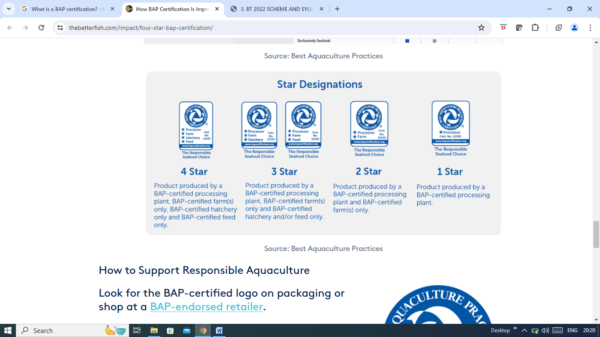

LINK

<https://www.thebetterfish.com/impact/four-star-bap-certification/>

UNIT-5:

HISTORY OF FOOD SAFETY:

Food Safety through the Years It is believed that the first English food law – the Assize of Bread – was proclaimed by King John of England in 1202, prohibiting adulteration of bread with ingredients such as ground peas or beans

Link

<https://www.food-safety.com/articles/6448-an-historical-food-safety-approach-for-the-world-we-want>

Role of preservatives in food:

Preservatives are added to foods to help prevent or slow spoilage due to bacteria, molds, fungi or yeast, as well as to slow or prevent changes in the food's color, flavor or texture, delay rancidity, and maintain freshness.

Food additives are substances which are added to food to preserve its flavor or enhance its appearance, taste, or other qualities. The food additives currently in use are added to food as emulsifiers, colorants, flavorants, nutrients, or preservatives. Preservatives inhibit the growth of yeasts, bacteria, and molds in foods. Food additives can be directly (intentional) or indirectly (unintentional) added. Foods may contain some residues of chemicals used during production of animal or plant crops, including growth hormones, pesticides, antibiotics, etc. The use of most food additives is visibly beneficial as it results in improved the public health and the prevention of spoilage, which enhances food supply. However, there is controversy over the use of some common food additives. This is partly due to some individuals are hypersensitive and suffer allergic reactions if they are exposed to some of these chemical additives. Additionally, some individuals hold the belief that low levels of chronic toxicities and diseases might be caused in larger population by exposures to some of these chemical substances. There are many thousand food additives currently in use, all of which are designed to do specific function in making food safer, more nutritious, more appealing, or last longer.



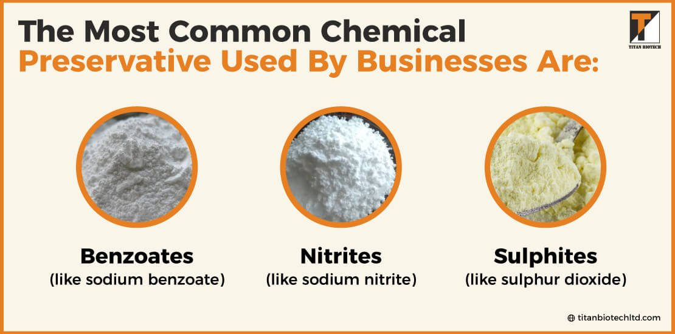

### ****Physical Food Preservatives****

Some of the **most common food preservatives** methods are listed below:

1. **Chilling and freezing:** Chilling and freezing are one of the **best physical ways to preserve food**.
2. **Canning:** It is another way to preserve food by preventing spoilage caused by bacteria and other microorganisms that are present in the surrounding environment. After being canned in boiling water (212°F), jars are cooled quickly to prevent them from cracking or exploding during processing.
3. **Use high-quality ingredients to preserve food:** The quality of canned products depends on what goes into them.
4. **Dehydrating:** Another way to preserve food is by dehydrating it (i.e., drying); this process uses heat, so one needs to know how much time it takes for the food to be completely dehydrated before starting.
5. **Adding salt:** You may also ferment foods or add salt to allow them to last longer without rotting or use sugar syrup as an addition for pickling vegetables.

### ****Chemical Food Preservatives****

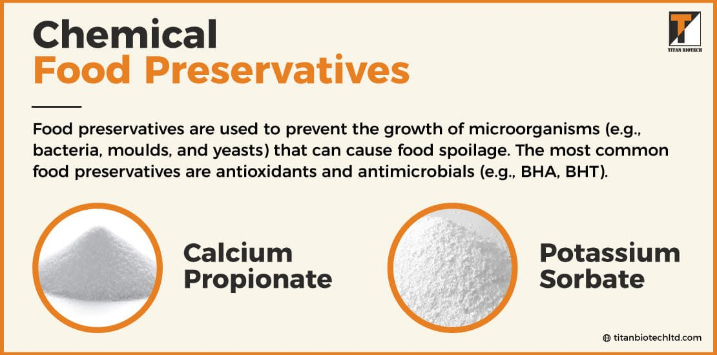



Chemical Food Preservatives

Food preservatives are used to prevent the growth of microorganisms (e.g., bacteria, moulds, and yeasts) that can cause food spoilage. The most **common food preservatives** are antioxidants and antimicrobials (e.g., BHA, BHT).

Antioxidants prevent the oxidation of fats (lipids) in foods by preventing oxygen from reacting with them.

Antimicrobial agents stop bacterial or mold growth in food by killing microorganisms or inhibiting their growth. The most commonly used antimicrobial agents are benzoates (sodium benzoate and potassium benzoate).

##### **Calcium Propionate Powder**

Calcium propionate, also called calcium salt of propionic acid, is a type of acid, which is a chemical compound that has an acidic taste and odor. Calcium propionate has been used in foods for many years to prevent spoilage and keep foods from becoming discolored or losing flavor or texture.

##### **Potassium Sorbate**

Potassium sorbate is an antioxidant that helps prevent spoilage caused by bacteria. It is also used by the food industry as it helps prevent mould growth on fresh fruits and vegetables that have been exposed to the air. Potassium sorbate is often used by businesses in jam and jelly making as a preservative to prevent fruit from turning brown while it sits on the countertop. It’s also added to packaged baked goods like cookies, crackers, and pieces of bread to help keep them fresh longer without sacrificing flavour or texture.

The most common chemical preservative used by businesses are:

* Benzoates (like sodium benzoate)
* Nitrites (like sodium nitrite)
* Sulphites (like sulphur dioxide)

## ****List of Natural Preservatives for Food****

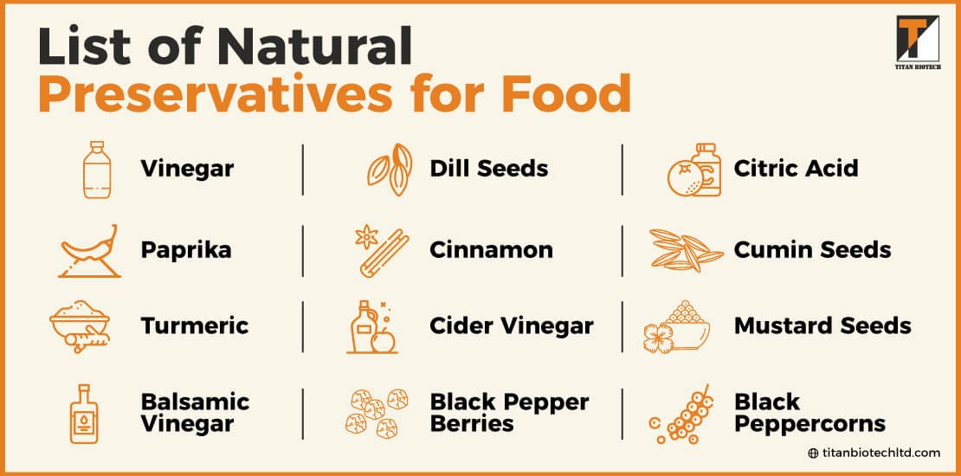

Natural preservatives are an effective way to preserve food. They are a natural, safe way to extend the shelf life of many foods. **Natural preservatives for foods** can be used in foods and drinks to help prevent spoilage and maintain freshness without artificial ingredients or chemicals.

###### **Vinegar**

Vinegar is one of the oldest and **safest methods used to preserve foods**. It’s great for pickling and canning fruits and vegetables, but it also works as a natural preservative in baked goods, condiments, and even salad dressings.

###### **Cider Vinegar**

Cider vinegar is made from fermented apples (obviously). It has many health benefits including lowering cholesterol levels, fighting cancer cells, and even helping you lose weight! Cider vinegar also has antibacterial properties thanks to its high acetic acid content (which is formed during fermentation).

###### **Balsamic Vinegar**

Balsamic vinegar, which is made by the fermentation of grapes, has been used for centuries to preserve food. It has a low acidity level and can inhibit the growth of bacteria and fungi that cause decay.

###### **Black Peppercorns**

Black peppercorns are the dried berries of a tree that grows in India, Africa, and Southeast Asia. They have antimicrobial properties and can be used to preserve foods by preventing spoilage or inhibiting the growth of bacteria.

###### **Citric Acid**

Citric acid is a natural preservative that inhibits spoilage by forming a protective coating on food surfaces which prevents them from absorbing moisture and air, thereby preventing microbial growth and food deterioration.

###### **Dill Seeds**

Dill seeds have been used as a preservative since ancient times; they contain an antioxidant called phenolic compounds which are antibiotic and antifungal agents that inhibit bacteria growth on food surfaces such as meats and fish by inhibiting their ability to attach to surfaces or produce colonies

1. Paprika (red pepper) powder, turmeric, asafoetida (hing) powder, mixed spice (papain), annatto extract, carotenoids (provitamin A), cayenne pepper, garlic, and onion powders.
2. Spices such as allspice berries, cinnamon, cloves, aniseed, black pepper berries, cumin seeds, and mustard seeds (which contain paprika).

**FOOD ADDITIVES:**

Food additive is any substance intentionally added to food for a technological purpose. This may be to improve shelf life, maintaining its nutritional qualities and sensorial attributes (taste, texture, appearance). Food additives are not normally consumed as a food by itself.

**Most Common Additives**

1. Monosodium Glutamate (MSG) Monosodium glutamate, or MSG, is a common food additive used to intensify and enhance the flavor of savory dishes.
2. Artificial Food Coloring.
3. Sodium Nitrite.
4. Guar Gum.
5. High-Fructose Corn Syrup.
6. Artificial Sweeteners.
7. Trans Fat.

LINK

<https://www.britannica.com/topic/food-additive/Preservatives>

**FOOD ALERGENS:**

<https://www.fda.gov/food/buy-store-serve-safe-food/food-allergies-what-you-need-know#:~:text=While%20many%20different%20foods%20can,peanuts%2C%20wheat%2C%20and%20soybeans>.

Antibiotics in Food

<https://www.healthline.com/nutrition/antibiotics-in-your-food>

Harmones in food:

The hormones find their way into our food source along with the milk. More research is needed to determine how safe and healthy these artificial hormones are for human use. Meat and milk (and some food including plants) are never "hormone-free". All humans and animals produce hormones naturally.

A salmon that grows to market size twice as fast as normal. Dairy cows that produce 15 percent more milk. Beef cows that grow 20 percent faster.

What do these hyper-productive animals have in common? Thanks to injections and implants (in the case of cows) or genetic engineering (in the case of salmon), they contain artificially high levels of sex or growth hormones.

Are these hormones dangerous to the humans who eat the food or drink the milk? The food industry says no -- and the Food and Drug Administration (FDA) agrees, at least when it comes to cows.

The FDA, which regulates the use of hormones in livestock, hasn't yet decided whether it will approve the sale of a genetically engineered salmon patented by the biotech company AquaBounty. If the salmon -- which is wired to produce growth hormone year-round, instead of just in the spring and summer -- gets an OK from the agency, it will be the first genetically engineered animal to wind up on your dinner plate. (Genetically engineered fruits and vegetables have been around for years.)

The FDA's stamp of approval isn't likely to reassure those who worry that excess hormones in the food supply are contributing to cancer, early puberty in girls, and other health problems in humans. For years, consumer advocates and public health experts have fought to limit the use of hormones in cows, and some support a ban on the practice similar to the one in place in Europe, where food regulations are generally more stringent than in the U.S.

But it's not clear if such hormones truly are bad for our health. Surprisingly little research has been done on the health effects of these hormones in humans, in part because it's difficult to separate the effects of added hormones from the mixture of natural hormones, proteins, and other components found in milk and meat. Buying organic may reassure shoppers, but there's little proof these products are indeed safer.

**Growth Hormones**  
In 1993, the FDA approved recombinant bovine growth hormone (rBGH), a synthetic cow hormone that spurs milk production when injected into dairy cows, and consumer groups have been concerned about it ever since. The manipulation of growth hormone in the AquaBounty salmon has sparked similar concerns.

By itself, rBGH has no discernible effect in humans and is of little concern to your health, and the growth hormone in AquaBounty's salmon is expected to be inconsequential to your health as well. The actual fear is that manipulating growth hormones in cows -- or salmon -- may increase another hormone, insulin-like growth factor (IGF), which could mimic the effects of human growth hormone in harmful ways. In fact, research has found that milk from rBGH-treated cows contains up to 10 times more IGF than other milk.