## ****FOOD SPOILAGE BY MICROORGANISMS****

## 

## ****Detection Methods of Foodborne viruses****

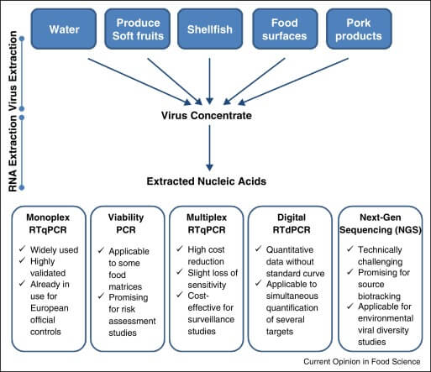

Detection Methods of Foodborne viruses. Image Source: [Albert Bosch et al. 2016](https://www.sciencedirect.com/science/article/pii/S2214799316300546).

* Foodborne viruses are detected using bioassays to determine their cytopathic effect but are not applicable to human norovirus and HAV.
* Gastroenteritis infections are diagnosed using the stool sample under an electron microscope which is still the gold standard for virus detection.
* Immunological assays such as ELISA and immunoelectron microscopy are used nowadays using antibodies against the known genotypes of the viruses.
* Molecular-based detection methods are currently used as it gives valid result though the process is not simple and requires skilled manpower.
* Reverse transcription-quantitative PCR (RT-qPCR) is used for the detection of human enteric viruses from food and environmental samples.
* But the main disadvantage of this method is that it fails to provide specific infectious and non-infectious viral particles which gives a false-positive result.

# Microbial Food Spoilage

**Food spoilage is a metabolic process that causes foods to be undesirable or unacceptable for human consumption due to changes in sensory characteristics.**

* Spoilage of food is identified by off-colors, off-odors, softening of vegetables, fruits, and slime production.
* Spoilage may arise from insect damage, physical damage, and indigenous enzyme activity in food or by microorganisms (bacteria, viruses, fungi).
* The spoilage microbe’s common inhabitants are [**soil**](https://microbenotes.com/soil/), water, or the intestinal tracts of animals or they are dispersed through the air and water.
* Food spoilage by microorganisms depends upon intrinsic (pH, water activity, nutrient content, oxidation-reduction potential, antimicrobial property) and extrinsic factors (temperature, relative humidity, pressure).
* Different spoilage-causing microorganisms have different nutrients requirements.
* Microorganisms are the biological agents that cause foodborne diseases when consumed however the microorganisms not only cause spoilage, some of them are beneficial for food fermentation.

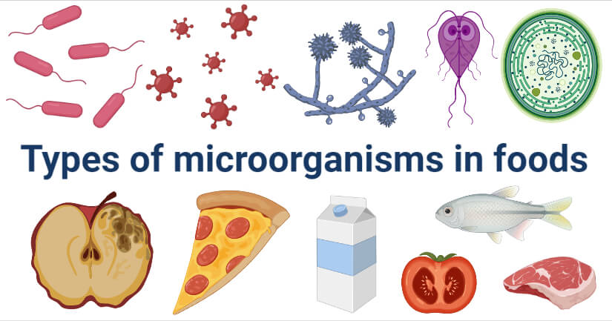

## Bacteria in food

* Food is most commonly spoiled by bacteria as it can grow in a wide variety of conditions however bacteria are used for beneficial fermentations of pickles, milk products, and some fermented vegetable products.
* Bacteria do not grow at a water activity level below 0.91 and require neutral pH (6.5-7) to cause food spoilage (e.g. milk, meat, green vegetables, fruits, etc.)
* Some bacteria are capable of spore formation so they are highly heat resistant and some are capable of producing heat-resistant toxins.
* The consumption of such spoiled food leads to foodborne illness.
* The most common bacteria that cause food spoilage are-
  + Gram-positive bacteria such as *Staphylococcus aureus, Bacillus*spp*, Clostridium* spp, Lactic acid bacteria (LAB), *Leuconostoc*spp, *Streptococcus* spp, *Brochothrix* spp, *Weissella* spp, *Mycobacterium bovis,* etc.
  + Gram-negative bacteria such as *Salmonella*spp*, Shigella,* *Vibrio* spp, *Escherichia coli,* *Campylobacter jejuni*, *Yersinia enterocolitis, Brucella*spp, *Coxiella burnetii, Aeromonas*spp, *Plesiomonas shigelloides,* etc.
* These bacteria cause off-odors and off-flavors, discolorations, gas production, slime production, and decreases in pH in food.

Genetically Modified Purple Tomato ‘Superfruit’ Awaits FDA Distribution Approval

## Fungi in food

* Fungi is the most abundant group of microorganisms that plays important role in food spoilage.
* Fungi are osmotrophic they obtain their nutrients by absorption.
* Fungi can be divided into mold and yeast.

### ****Molds****

* Molds are the most common food spoilage-causing microorganisms.
* Molds grow on the surface of food (they require free oxygen for growth) and in a wide range of pH values (from 2 to 8.5), but the majority of them prefer acidic pH.
* Molds can grow at very low water activity levels (0.7–0.8) on dried foods (e.g. grains, beans, peanuts, and some spices)
* The most common food spoilage causing molds are *Mucor, Aspergillus*spp*, Rhizopus*spp*, Penicillium*spp*, Alternaria*spp*, Bothrytis, Byssochlamys, Fusarium*spp*.*
* This mold causes off-flavors, mycotoxins contamination, discoloration, rotting, and is externally visible in the food.

### ****Yeasts****

* Compared to bacteria and molds, yeasts play a minor role in food spoilage
* Yeasts can grow with or without oxygen and are used for beneficial fermentation in bread and alcoholic drinks fermentation.
* They often spoil food that has high sugar or salt content (e.g. maple syrup, pickles, jams, soy sauce, and sauerkraut.)
* Yeasts require a water activity level of 0.90–0.95 for growth and they can grow in a wide range of pH (3 – 8) but in general, they prefer acidic pH (4.5-5.5).
* Most commonly food spoilage causing yeasts are *Zygosaccharomyces* spp, *Saccharomyces* spp., *Candida* spp, *Dekkera* spp
* These yeasts cause a change in color, a change in texture, an unpleasant odor, or an undesirable taste in food.

## Protozoa in food

* Protozoa are one-celled microorganisms without a rigid cell wall and the transmissible form of these organisms is termed cysts.
* Protozoan parasites are highly associated with foodborne and water-borne outbreaks of disease. The water and food act as a carrier for transmission of protozoan parasites from one host to another.
* The most common foodborne parasites are *Giardia* *lamblia*, *Entamoeba histolytica*,  *Cyclospora cayetanensis, Toxoplasma gondii,*and*Trichinella spiralis.*

## Algae in food

* Algae are primary producers which are a source of different nutrients and they are usually of aquatic habitats.
* They contaminate the water source with their toxin and cause them to accumulate in fish and marine life. The toxic may or may not be harmful to marine lives. When such fish or other marine lives are consumed by humans, it leads to foodborne illness.
* The algae that cause poisoning are *Gonyaulax catenella, Gonyaulax tamarensis, Gambierdiscus toxicus, Ptychodiscus brevis, Microcystis aeruginosa*, Blue-green Algae.

## Viruses in food

* Viruses are obligate intracellular parasites that cause a wide range of diseases in plants, animals, and humans.
* Viruses need specific living cells to replicate and therefore they cannot replicate in food or water. The water and food act as a carrier for transmission of viruses from one host to another.
* Foodborne viruses are quite stable outside the host and are acid-resistant.
* Some of the foodborne viruses are Norovirus, *Hepatitis A virus*(HAV), *Hepatitis E virus*(HEV),*Astrovirus*(AstV), *Rotavirus* (RV), *Coronavirus*, *Sapovirus* (SaV).

Top of Form

Bottom of Form

## Prions in food

* Prions are infectious disease-causing agents which are the normal protein of a brain that gets misfolded that lacks genome resulting in a pathological, infectious conformation.
* Once misfolded, it can induce other normally folded proteins to become misfolded.
* Prion diseases can affect both humans and animals. It can also get transferred from animal to human through the consumption of infected meat and meat products.
* Some examples of prion disease are Bovine spongiform encephalopathies’ (BSE), Scrapie, Chronic wasting disease (CWD), Creutzfeldt-Jacob Disease (CJD).

# Microbial spoilage of meat and meat products

## Introduction

* Meat and its product are highly nutritious food that is widely consumed by people all over the world.
* Meat can be obtained from various birds (chicken, turkey, ducks, etc.) or mammals (pork, mutton, buffalo, sheep), and after slaughtering, carcasses and primary cuts are processed to raw or processed food products.
* It is a nutritious, protein-rich food that is highly perishable and has a short shelf life.
* The biological and chemical nature of meat leads to its deterioration from the time of slaughter until consumption.
* Meat and its products such as ham, sausages, cooked meat, dry meats, smoked meats, vacuum-packed meat, minced meat, etc. are all susceptible to [**microbial spoilage**](https://microbenotes.com/food-spoilage-microorganisms/).

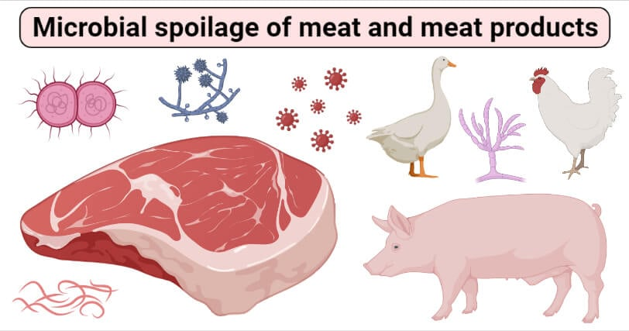

## Contamination source and causes

Meat spoilage can be caused by natural processes, such as lipid oxidation or autolytic enzymatic that occurs in the muscle after slaughtering. Several factors are responsible for microbial contamination of meat such as:

1. Bacterial flora of animal.
2. Knives, utensils, hands, and clothing of the workers.
3. Pre-slaughter handling of livestock and post-slaughter handling of meat.
4. handling during slaughtering, evisceration, and processing
5. temperature controls during slaughtering,
6. processing and distribution
7. type of packaging used
8. Handling and storage

A series of the event takes place during rigor mortis after the slaughter of the animal such as:

1. Respiration ceases, which stops ATP synthesis.
2. The lack of ATP causes stiffening of muscle
3. Reduction of oxidation-reduction potential due to lack of oxygen
4. The loss of vitamins and antioxidants causes the development of rancidity.
5. Glycolysis begins in which most glycogen is converted to lactic acid that reduces pH
6. The ending of a reticuloendothelial system leads to the susceptibility of meat to microorganisms.
7. Nervous and hormonal regulations cease, thereby causing the temperature of the animal to fall and fat to solidify.
8. Various metabolites accumulate that also aid protein denaturation.

## Spoilage of fresh meat

* Fresh meat is subjected to spoilage by its enzymes and microbial action.
* The autolysis changes cause proteolytic action on muscle and connective tissue and hydrolysis of fats.
* The survival and growth of microorganisms are influenced by the composition of the atmosphere surrounding the meat.
* Fresh meat contains nutrients such as sugars, amino acids, vitamins, cofactors, etc and it had pH (5.5-5.9) and Aw (0.85) values that influence the growth of microorganisms.
* The most common bacteria isolated from fresh meat are bacteria of the genera *Acinetobacter, Pseudomonas, Brochothrix thermosphacta, Flavobacterium, Psychrobacter, Moraxella, Staphylococci, Micrococci, lactic acid bacteria (LAB),* and various genera of the *Enterobacteriaceae*.
* The microbial pathogens found in fresh meat are *Salmonella, Campylobacter, E.coli, Listeria monocytogenes.*

There are two types of spoilage of meat:

1. Spoilage under aerobic condition
2. Spoilage under anaerobic condition

The kind of defects caused by microorganisms on fresh meat

|  |  |  |
| --- | --- | --- |
| **Condition** | **Kind of defects** | **Microorganisms** |
| Aerobic condition | Surface slime | *Pseudomonas, Moraxella, Streptococcus, Bacillus, micrococcus* |
| The red color of meat called “bloom” caused by the production of an oxidizing compound | *Lactobacillus, Leuconostoc* |
| Oxidative rancidity | *Pseudomanas*spp,*Archromobacter* |
| Red spot | *Serratia marcescens,* |
| Blue color | *Pseudomonas syncyanea* |
| Greenish blue or brownish black spot | *Chromobacterium lividum* |
| Stickiness, whiskers, Green patches | Mold |

|  |  |  |
| --- | --- | --- |
| Anaerobic condition | Putrefaction | *Clostridium*spp,*Alcaligennes, Proteus* |
| Souring | Lactic acid bacteria |

## Spoilage of meat

* Microbial growth, oxidation, and enzymatic autolysis are the three basic mechanisms responsible for the spoilage of meat.
* The nutrient composition, high water content, and moderate pH of meat make it an excellent medium for microbial growth.
* The normal flora of an animal’s lymph nodes contaminating meat is *Staphylococcus, Streptococcus, Clostridium, and Salmonella.*
* Meat may contain different bacteria that include species of *Acinetobacter, Aeromonas, Alcaligenes, Alteromonas, Brochothrix, Carnobacterium, Escherichia, Enterobacter, Enterococcus, Flavobacterium, Lactobacillus, Leuconostoc, Micrococcus, Proteus, Pseudomonas, Sarcina, Serratia,*and*Streptococcus*.
* Pathogenic microbial species contaminating meat are *Salmonella enteric strains, Yersinia enterocolitica, Campylobacter jejuni, Aeromonas hydrophila, Listeria monocytogenes,* and *Escherichia coli*.
* Mold species found in meat include *Cladosporium, Sporotrichum, Geotrichum, Penicillium,* and *Mucor* while yeasts species include *Candida spp., Cryptococcus spp*., and *Rhodotorula spp.*
* The main defects observed in meat are off-odor, off-flavor, discoloration, and gas production.

Some defects caused by microorganism in different kinds of meat are:

|  |  |  |
| --- | --- | --- |
| **Products** | **Defects** | **Microorganisms** |
| Vacuum packed meat | Sulfide odor | *Clostridium*spp*., Hafnia*spp. |
| H2S greening | *Shewanella*spp*.* |
| Blown Pack | *Clostridium*spp*., lactic acid bacteria* |
| Fresh meat | Putrefaction | *Alcaligenes, Clostridium, Chromobacterium, Proteus vulgaris, Pseudomonas fluorescens* |
| Souring | *Chromobacterium, Pseudomonas* |
| Cured meat | Moldy odor | *Aspergillus, Penicillium, Rhizopus* |
| Greening | *Pediococcus, Streptococcus* |
| Souring | *Micrococcus, Pseudomonas* |
| Slimy | *Leuconostoc* |
| Modified atmosphere packaging meats | Souring, off-odor | *Leuconostoc, Lactobacillus* |
| Souring | *B. thermosphacta* |
| Refrigerated packaged meat | Off-flavors, slime, putrefaction | *Pseudomonas, Acinetobacter, Moraxella* |
| sour, slime, and flavor change | Lactic acid bacteria |

## Spoilage of refrigerated meat

* When fresh meat is refrigerated at 4 ± 1°C, they remain in good condition for 5-7 days
* Refrigerated temperature favors the growth of psychrophilic organisms in due course of time.
* The contaminations occur during slicing and serving operations, from hands, slicing machines, and other equipment.
* Inadequate hygiene can lead to meat contamination by spoilage and pathogenic microorganisms
* The important bacterial genera associated with spoilage of refrigerated meat are *Acinetobacter, Moraxella, Pseudomonas, Aeromonas, Alcaligenes*, and*Micrococcus.*
* The mold genera associated with spoilage of refrigerated meat are *Alternaria, Cladosporium, Geotrichum, Mucor, Monilia, Penicillium, Sporotrichum, and Thamnidium*; and yeast genera associated with spoilage of refrigerated meat are *Candida, Torulopsis, Debaryomyces,*and *Rhodotorula.*
* Generally, *Brochothrix thermosphacta* and lactic acid bacteria are the bacteria that cause spoilage of refrigerated meat.
* Pathogenic microorganisms found in refrigerated meats include *C. botulinum type E, Yersinia enterocolitica, enteropathogenic Escherichia coli, Listeria monocytogenes, and Aeromonas hydrophila* as they are capable of growing at temperatures below 5°C.

## Spoilage of cured meat

* Cured meat is the meats in which are preserved by aging, drying, canning, brining, or smoking for enhancement of flavor and to extends its shelf life.
* Some examples of cured meats are sausage, bacon, salami, ham, canned meat, dry spicy meat, meat pickles, kebab, meatballs, meat patty, etc.
* The cured meat has a long shelf-life compared to fresh and raw meat however they are not immune to spoilage.
* The bacterial spoilage causing organisms in processed and cured meats are lactic acid bacteria (such as *Lactobacillus sake, Lactobacillus curvatus, Leuconostoc gelidium, Leuconostoc carnosum, Leuconostoc mesenteroides*), *Acinetobacter, Bacillus, Micrococcus, Serratia,*and*Staphylococcus*.
* The spoilage causing  mold found in cured meat includes *Aspergillus, Penicillium, Rhizopus,*and*Thamnidium*
* The spoilage causing yeast found in cured meat includes *Candida, Debaryomyces, Torula, Torulopsis,*and *Trichosporon.*
* Other spoilage causing microorganism found in cured meats includes *Clostridium*spp*, Hafnia*spp*, Weisella*spp*, Shewanella*spp*, Pseudomonas*spp*, Enterococcus*spp*, etc.*
* The pathogenic microorganisms found in cured meat include *Escherichia coli, Salmonella, Staphylococcus aureus, Listeria monocytogenes, Clostridium botulinum,*and*Toxoplasma gondii.*
* Microbial growth in cured meat can result in slime formation, structural components degradation, decrease in water holding capacity, off odors, and texture and changes in appearances.

Some defect in different cured meat products caused by microorganism are:

|  |  |  |
| --- | --- | --- |
| **Cured meat products** | **Defects** | **Microorganisms** |
| Dried-fermented sausage | small dark spot | *B.thermosphacta, Lactobacillus, Leuconostoc, Microbacterium, Micrococcus, Alternaria* |
| CO2 production | heterofermentative LAB |
| Nitric oxide gas production | nitrate-reducing bacteria |
| Greening with H2O2 | heterofermentative *Lactobacillus fructivorans, L. jensenii, L. viridescens, Leuconostoc*, *Enterococcus faecium, Enterococcus faecalis*, *Pediococcus* |
| Slime layer on the surface | *Micrococcus*and yeasts |
| fuzziness and discoloration | *Penicillum verrucosum*  *Aspergillus glaucus* |
| Cured meats | H2S production | *Vibrio, Enterobacteriaceae* |
| Bacon | Cabbage odor | *Providencia* |
| white and gray or grayish-green spot | *Aspergillus, Alteraria, Fusarium, Mucor, Rizopus* |
| Ham | Putrefaction | *Enterobacteriacae, Proteus* |
| Souring | Lactic acid bacteria*, Enterococcus, Micrococcus, Bacillus, Clostridium* |
| Bone taint | *Serratia*spp*, Clostridium*spp*, Proteus*spp |
| Red spot | *Halobacterium salinarum* |
| Blue spot | *Pseudomonas syncyanea, Penicillum Soinulosum, Rhodotonela*spp |
| Dark spot | *Alternaria* |
| Sausages | Souring, off-odor | Lactic acid bacteria |
| Surface slime | *Bacillus, Lactobacillus, Leuconostoc* |
| Greening | *Enterococcus, Lactobacillus, Leuconostoc, Pediococcus* |
| Dried meats | Surface slime | *Micrococcus* |
| souring | *Halobacterium salinarum* |
| Off-odor | *Flavobacterium* |
| Blue color | *P. syncyanea, P. Spinulosum* |
| red color | *Bacillus spp* |
| Smoked products | Off-odor | *Micrococcus,*yeasts, molds |
| Souring | *Lactobacillus Plantarum, L. Mesenteroides, Clostridium*spp |
| Pickled meat | Putrefaction | *Vibrio, Alcaligenes, Spirillum* |
| souring | *Lactobacillus, Micrococcus* |
| Slime formation | *Leuconostoc.* |

# Preservation of meat and meat products from microbial spoilage

Meat and its products consist of numerous nutrient content, it serves as an excellent [growth medium for all of the microorganisms](https://microbenotes.com/factors-affecting-the-growth-of-microorganisms-in-food/). Thus, various preservation methods are used to eliminate the growth of spoilage-causing microorganisms and maintaining the nutritional properties of meat. Several techniques have been used to limit the growth of organisms in meat and meat products.

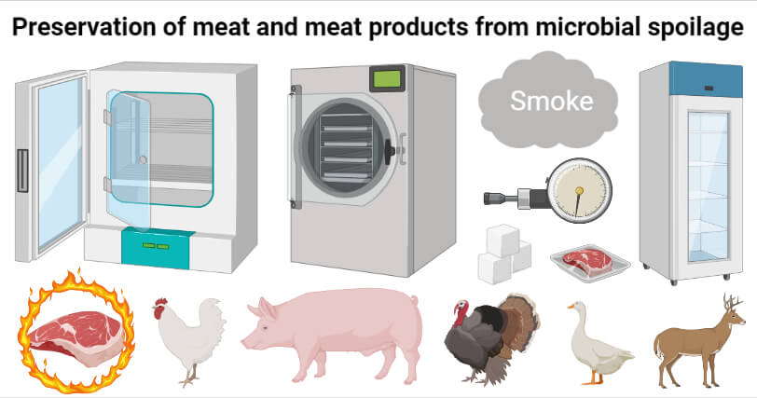

## A. Asepsis

* The aseptic condition should be maintained during slaughtering and handling of meat to avoid microbial contamination.
* It can also be maintained by spraying water on animals before slaughter to remove gross dirt.
* Use sterile knives, utensils, clothes, etc. to avoid microbial contamination.

Could Drones Use Facial Recognition? We Could Be Just One Step Closer to That Actually Happening

## B. Thermal method

### 1. Heat processing

* Sterilization refers to the heating of meat at temperatures above 100°C in which spoilage-causing microbes in meat are killed.
* Various meat products differ in water content, fat and consistency so these factors are considered during heat processing.

### 2. Dehydration.

* Dehydration lowers the water activity to prevent the growth of spoilage-causing microbes.
* The meat is dehydrated mainly in two ways:
  + **Sun drying** of meat chunks as a means of preservation was practiced in ancient days.
  + **The mechanical drying** process involves the passage of hot air with controlled humidity.
* Dehydrated meat can be stored for few months to a year in air-tight containers without refrigeration.

### 3. Canning

* Canning is one of the preservation methods that is achieved by thermal sterilization of a product held in hermetically sealed containers.
* The canning of meat involves several steps including preparation of meat, precooking, filling, exhausting, seaming, thermal processing, cooling, and storage.
* The canned meat products have a shelf life of at least two years at ambient temperature.

### 4. Smoking

* Smoking is an ancient preservation technique, where meat is subjected to smoke, which enhances the sensory and nutritional characteristics of meat products.
* The meat is exposed to smoke from burning wood or any other plant materials to combustion with or without curing. Curing and smoking of meat are closely related.
* Smoke helps in the preservation of meat by dehydrating the meat surface, lowering the surface pH and antioxidant property of smoke constituents.
* Smoking extends the shelf life of meat up to a year or longer without the need for refrigerated conditions.
* Smoking is an effective treatment against pathogenic microorganisms (*Staphylococcus aureus, Escherichia coli, Listeria monocytogenes, Salmonella spp*., etc.) and it also reduces lipid oxidation.
* Common smoking methods are hot smoking, smoke roasting, and cold smoking.
  + **Hot smoking**: In this method, the meat will be hot smoked with mild addition of salt to inhibit bacterial growth. Hot smoking is done with temperatures ranges from 60°C to 93°C.
  + **Smoke roasting:** In this method, the meat with curing will hot smoked at the temperature of about 300°C. Many spices are added to meat for flavor enhancement and also to inhibit bacterial growth.
  + **Cold smoking:** In this method, the meat after partially or fully cured is usually hung or placed on racks and allowed to smoke for days at an optimum temperatures ranges of 23-48 °C.

## C. Non-thermal method

### 1. Freezing method

* Freezing is the best method for preserving fresh meat as well as keeping the original characteristics of fresh meat by slowing down the enzymatic reactions and growth of microbes.
* A temperature of –55 °C is the ideal temperature for frozen meat to completely prevent quality changes and reduce microbial spoilage.
* The microbial growth will be arrested without killing microbes which slows the spoilage process.
* Uncooked meat such as steaks or chops could be frozen for 4-12 months and the cooked meat can be stored for 2-3 months.

### 2. Chilling

* This is the most widely used method of preservation for the short-term storage of meat.
* The fresh meat is stored at a refrigeration temperature of 0ºC to 8ºC
* Generally, fresh meat remains in good condition for a period of 5-7 days if kept at a refrigerated temperature of 4 ± 1°C
* Chilling of meat inhibits the multiplication and metabolic activities of pathogenic bacteria, viruses, and toxins.
* Certain parasites such as *Taenia* cysts and all stages of *Trichinella spiralis* might be destroyed by storing infected meat at 18ºC for periods of 20 to 30 days.

### 3. Freeze-drying

* It is a technology which is using the physical principle called sublimation in which the meat is preserved at low temperatures from –10°C to –25°C.
* The meat will be frozen first and then sublimes to reduce the moisture content as low as 0.5%.
* During this method, the chemical reactions tend to be slow and microorganisms won’t survive at low temperatures.

## D. Curing

* Curing of meat has been an old-age technique for the preservation of meat and also gives a desired flavor to the food.
* It preserves the meat by decreasing water activity and by increasing osmotic pressure that delays microbial growth.
* Sodium chloride, sodium nitrite, potassium nitrite, and sugar are the main curing ingredients.
* Curing also involves preserving food items by combinations of salt, nitrates, nitrites, or sugar.
* Salting can be done by rubbing salt on meat or is soaked in brine containing at least 18% salt.
* Sugars bind with moisture and reduce water activity in meat. 20–25% sugar concentration is generally used during curing.
* Dextrose, sucrose, brown sugar, corn syrup, lactose, honey, molasses, maltodextrins, and starches are generally used in meat to enhance flavor, reduce the harshness of salt, and lower water activity.
* Sodium nitrite and potassium nitrite are effective in controlling the growth of anaerobic bacteria, the color of meat, lipid oxidation, and odor.

## E. Spices

* Different types of spices are used in meat to impart unique flavors and to extend its shelf-life.
* These include spices like pepper, black pepper cloves, allspice, cinnamon, garlic, onion, anise, etc.
* The spices act as antioxidants by reducing the rate of oxidative rancidity development.
* The spices are used during curing, smoking, cooking which helps to enhance the flavor.

## F. Fermentation and pickling

* Fermentation is an ancient process that has been used in the meat industry as a method of preserving meat with enhancement in flavor.
* It is a simple and inexpensive method for the preservation of meat and meat products.
* Meat fermentation is a complex biological process in which desirable microorganisms are used with the addition of spices.
* *Lactobacillus* is usually used for meat fermentation.
* The acid production, H2O2 production, and antimicrobial agents produced by starter cultures are responsible for preventing the growth of food-borne pathogens and spoilage-causing microorganisms in meat.
* In pickling, meat products are immersed in brine in containers to store the meat.
* The high concentration of salt and spices in pickling acts as a barrier for pathogens and undesirable bacteria.

## G. Use of preservatives agents

Preservatives are substances that are capable of inhibiting or retarding the growth of microorganisms. Such preservatives used in food can be divided into three types:

1. **Natural preservatives**
2. **Bio preservatives**
3. **Chemical preservatives**

**Some preservatives used in meat and meat products and their effects are:**

|  |  |  |
| --- | --- | --- |
| **Types of preservatives** | **Preservatives used** | **Action** |
| Natural preservatives | Salt, sugar | Increase osmotic pressure, reduce water activity in meat |
| oregano, rosemary, thyme, clove, lemon balm, ginger, coriander, cumin, pepper, garlic, rosemary, turmeric, mustard seed | Affect the enzymatic activity of microorganism**,** increase the permeability of microbial cells |
| Lactoferrin | Antimicrobial activity against bacteria, fungi, viruses, and protozoa. |
| Chemical preservatives | Benzoic acid, citric acid, propionic acid, sorbic acid | effective mold inhibitors,  exhibit antibacterial activity |
| Sulfites | antimicrobial agent, efficient against aerobic Gram-negative bacteria, molds, and  yeasts |
| Nitrites | stabilized red meat color, cured meat flavor, and rancidity retardation, inhibit the growth of  anaerobic bacteria in meat |
| Acetic acid, lactic acid | prevent bacterial growth by reducing pH, the permeability of microbial cells |
| sorbate and acetate | arresting the growth of yeasts in meat |
| Ascorbic acid (vitamin C), sodium ascorbate, and erythorbate | antioxidant properties, enhance the antimicrobial property of sulfites and nitrites |
| Butylated Hydroxyanisole (BHA), Butylated Hydroxytoluene (BHT), tertiary butylhydroquinone (TBHQ), and Proply Gallates (PG) | delay, retard, or prevent the  negative effects of lipid peroxidation, reduce oxidation of meat and meat products, exhibit antimicrobial properties against bacteria (predominately gram-negative bacteria), fungi, viruses, and protozoa |
| Phosphates | exhibit antioxidant activities in meat products, retarding rancidity, reduce oxidation |
| Bio preservatives | Bacteriocin (nisin) | inhibit or kill other unwanted microorganisms by pore formation in the bacterial plasma membrane |
| lysozyme | exhibit antimicrobial activity gram-positive bacteria |
| Chitosan | exhibit antimicrobial activity against bacteria (by chelating ions from lipopolysaccharide, increase cell permeability), act as a barrier against oxygen leading to inhibition of aerobic bacteria |

## H. Irradiation

* Ultraviolet (UV) radiation is electromagnetic radiation having a wavelength of about 10-400 nm.
* UV radiations are mostly bactericidal and used for surface sterilization of meat.
* Gamma rays, X-rays, and accelerated electron beams are the sources of ionizing radiation used for the preservation of foods.
* Irradiation, also known as “cold sterilization “affects the microbes by damaging their DNA and ionization of water.

## I. Hydrostatic pressure processing

* It is a non – thermal pasteurization process in which food is subjected to high pressure in the region of 3300 -600 Mpa for about 10 minutes.
* High pressure affects the cellular physiology of the microorganisms and it is used as an additional final step during the processing of meat.
* It inhibits the microorganism in meat by interfering with regular cellular functions and inactivate certain food enzymes.

## J. Hydrodynamic pressure processing

* Hydrodynamics refers to the motion of fluids and the pressure acting on solid bodies immersed in these fluids.
* It is the concept of tenderizing meat using shock waves from underwater detonation that creates pressure on vacuum-packaged meat in the range of 70 MPa to 100 MPa and reduces the microbes which may be present on meat.

## K. Packaging

* Packaging protects products from microbial spoilage and defects such as discoloration, off-flavor and off-odor development, nutrient loss, texture changes, pathogenicity caused by them.
* There are various types of packaging used for meat products for their preservation without deteriorating it’s nutritive and texture.
* **Vacuum packaging (VP)** is defined as “the packaging of a product in a high barrier package from which air is removed to prevent the growth of aerobic spoilage organisms, shrinkage, oxidation, and color deterioration. In VP, meats are placed in materials such as ethyl vinyl acetate, polyvinylidene chloride. Due to the lack of O2 in packages, the oxidative deteriorative reactions will decrease, and aerobic bacteria growth is reduced.
* **Modified Atmosphere Packaging (MAP)**for meat requires a barrier of either moisture or gas permeation through packaging materials. The major gases used are N2 (78%), O2 (20.99%), argon (0.94%) and CO2 (0.03%).
* **Active packaging (AP)**contains specific compounds into packaging systems that maintain or extend product quality and shelf life. It helps in moisture control, odor controllers, flavor enhancement. Antimicrobial packaging is an example of active food packaging in which bactericidal or bacteriostatic agents into the meat.