# RV College of Engineering®

**(Autonomous Institution Affiliated to VTU, Belagavi)**



# Fall Detection System With IoT

**Experiential Learning Project**

**Submitted by**

Kapsha Suraj Singh - 1RV22CY402

Varshith Y – 1RV22CY059

Sagari Aravind - 1RV22CY049

SHRIDHAR BHAT – 1RV22CD056

**DEPARTMENT:** COMPUTER SCIENCE – CYBER SECURITY [ CY]

**BLOCK DIAGRAM**

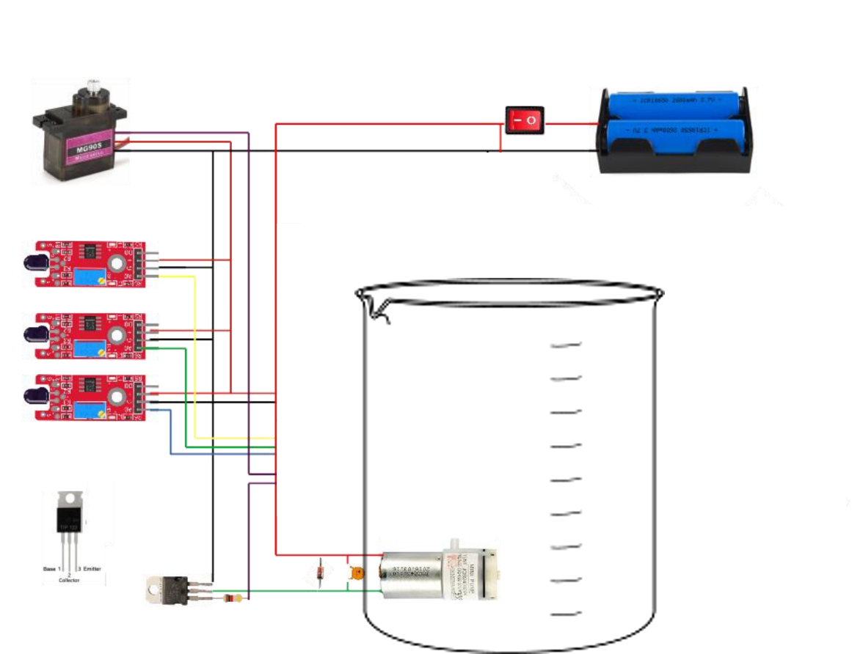

**LN298 Motor**

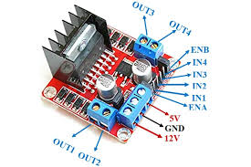

**Pump**

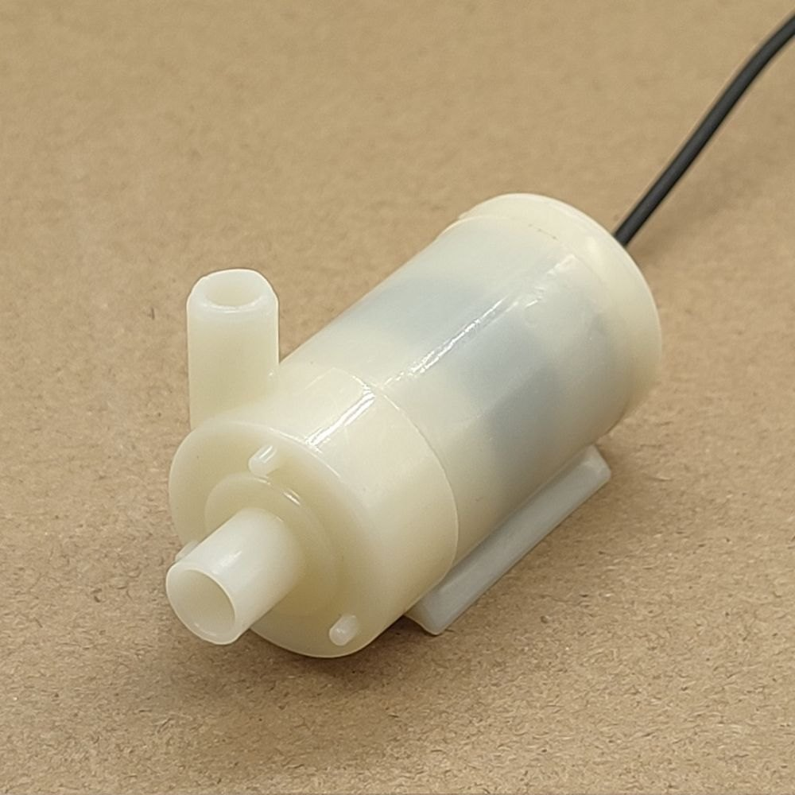

**Buzzer Fire Sensor**

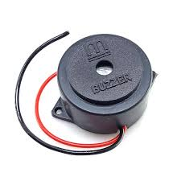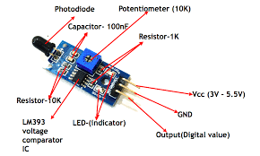

**Necessity of the product:**

Fire accidents are a huge problem in today’s world. A smart fire detector and extinguisher is the need of the hour. We have leveraged our knowledge in IOT to create this smart fire extinguisher.

**Methodology and technology used:**

Circuit Setup:

* Flame Sensor Connection: Connect the VCC pin of the flame sensor to the positive terminal of the power supply (e.g., 5V), GND to the ground, and the D0 (Digital Output) pin to the base of an NPN transistor (e.g., BC547) through a current-limiting resistor (e.g., 1kΩ).
* Transistor as a Switch: The NPN transistor is used to amplify the weak signal from the flame sensor. When a flame is detected, the D0 pin of the flame sensor goes HIGH, causing the transistor to turn ON (saturate).
* Relay Module Connection: Connect the collector pin of the transistor to one side of the relay coil and the other side of the coil to the positive terminal of the power supply. Connect the emitter pin of the transistor to the ground. When the transistor is ON, it allows current to flow through the relay coil, activating the relay.
* Water Pump Motor Connection: Connect the water pump motor to the normally open (NO) contact of the relay. Connect the common (COM) contact of the relay to the positive terminal of a separate power supply (e.g., 12V for the motor), and connect the negative terminal of the motor to the ground. The relay acts as a switch to turn the water pump motor on or off.
* Diode Protection: Place a diode (e.g., 1N4007) across the relay coil with the cathode to the positive terminal to protect against back-emf when the relay is de-energized.

### **Working Model:**

1. **Fire Detection**: When the flame sensor detects a flame, it outputs a HIGH signal to the microcontroller.
2. **Relay Activation**: The relay module, upon receiving the signal from the microcontroller, closes its contacts, completing the circuit for the water pump motor.
3. **Water Pump Activation**: With the relay contacts closed, the water pump motor receives power and starts pumping water.
4. **Extinguishing the Fire**: The water pumped by the motor extinguishes the fire. Once the fire is out, the flame sensor stops sending the HIGH signal.
5. **System Reset**: The microcontroller detects that the fire is extinguished (flame sensor outputs LOW), and it turns off the relay, stopping the water pump motor.

**Outcome:**

* Automatic Fire Detection: The system continuously monitors for fire using flame sensors. When a flame is detected, the sensor sends a signal to the microcontroller.
* Immediate Response: Upon detecting a fire, the system automatically triggers the water pump motor through the relay module, activating it to extinguish the fire. This rapid response helps prevent the fire from spreading.
* Effective Fire Extinguishing: The water pump motor directs water precisely to the location where the flame is detected. This ensures that small fires can be extinguished efficiently without human intervention.
* Low-Cost and Scalable Solution: The system is built with readily available, inexpensive components. It can be easily scaled up by adding more sensors and pumps to cover larger areas, making it suitable for various environments like small homes, server rooms, or workshops.
* Reduced Risk of Damage and Injury: By quickly detecting and responding to fires, the system minimizes potential damage to property and reduces the risk of injury to people.
* System Reset and Readiness: After extinguishing the fire, the system automatically resets itself to its monitoring state, ready to detect and respond to any future fire incidents without the need for manual reset.

**Working of the system**



**Hence to detect a fire:**

### **1. Flame Sensors**

* **Infrared (IR) Flame Sensors**: Detect infrared light emitted by flames. These sensors are sensitive to specific wavelengths in the IR spectrum associated with combustion.
* **Ultraviolet (UV) Flame Sensors**: Detect UV radiation emitted by flames. They are very sensitive and can detect fires quickly but are prone to false positives from other UV sources.
* **UV/IR Flame Sensors**: Combine both UV and IR detection to reduce false alarms and improve accuracy. These sensors are often used in industrial settings.

### **2. Smoke Detectors**

* **Ionization Smoke Detectors**: Detect smoke by ionizing the air and measuring the resulting electrical current. Smoke particles disrupt the current, triggering an alarm. These are good for detecting fast-flaming fires.
* **Photoelectric Smoke Detectors**: Use a light beam and sensor to detect smoke. When smoke particles scatter the light beam, it triggers the alarm. These detectors are more effective for smoldering fires.

### **3. Heat Detectors**

* **Fixed Temperature Heat Detectors**: Trigger an alarm when the ambient temperature exceeds a pre-set threshold, indicating the presence of fire.
* **Rate-of-Rise Heat Detectors**: Detect a rapid increase in temperature, which could signal a fire, even before the temperature reaches a fixed threshold.