### **What is Leadership**

Leadership is a process by which an executive can direct, guide and influence the behavior and work of others towards accomplishment of specific goals in a given situation. Leadership is the ability of a manager to induce the subordinates to work with confidence and zeal.

**Leadership is the potential to influence behaviour of others**. It is also defined as the capacity to influence a group towards the realization of a goal. Leaders are required to develop future visions, and to motivate the organizational members to want to achieve the visions.

According to Keith Davis, “Leadership is the ability to persuade others to seek defined objectives enthusiastically. It is the human factor which binds a group together and motivates it towards goals.”

### **Characteristics of Leadership**

### It is a inter-personal process in which a manager is into influencing and guiding workers towards attainment of goals.

### It denotes a few qualities to be present in a person which includes intelligence, maturity and personality.

### It is a group process. It involves two or more people interacting with each other.

### A leader is involved in shaping and moulding the behaviour of the group towards accomplishment of organizational goals.

### Leadership is situation bound. There is no best style of leadership. It all depends upon tackling with the situations.

**Importance of Leadership**

Leadership is an important function of management which helps to maximize efficiency and to achieve organizational goals.

The following points justify the importance of leadership in a concern.

1. **Initiates action-** Leader is a person who starts the work by communicating the policies and plans to the subordinates from where the work actually starts.
2. **Motivation-** A leader proves to be playing an incentive role in the concern’s working. He motivates the employees with economic and non-economic rewards and thereby gets the work from the subordinates.
3. **Providing guidance**- A leader has to not only supervise but also play a guiding role for the subordinates. Guidance here means instructing the subordinates the way they have to perform their work effectively and efficiently
4. .**Creating confidence-** Confidence is an important factor which can be achieved through expressing the work efforts to the subordinates, explaining them clearly their role and giving them guidelines to achieve the goals effectively. It is also important to hear the employees with regards to their complaints and problems.
5. **Building morale**- Morale denotes willing co-operation of the employees towards their work and getting them into confidence and winning their trust. A leader can be a morale booster by achieving full co-operation so that they perform with best of their abilities as they work to achieve goals.
6. **Builds work environment-**Management is getting things done from people. An efficient work environment helps in sound and stable growth. Therefore, human relations should be kept into mind by a leader. He should have personal contacts with employees and should listen to their problems and solve them. He should treat employees on humanitarian terms.
7. **Co-ordination-** Co-ordination can be achieved through reconciling personal interests with organizational goals. This synchronization can be achieved through proper and effective co-ordination which should be primary motive of a leader.

* **Introduction to Leadership**

Leadership is the ability to influence and guide individuals or groups towards achieving common goals. Effective leadership involves vision, communication, motivation, and adaptability. Leadership theories help understand the different ways individuals can lead and how various factors impact leadership effectiveness.

**Leadership Theories:**

Leadership theories have evolved over time, providing insights into how leaders behave and adapt to different situations. The key leadership theories include:

**A. Trait Theories**

Trait theories focus on identifying the inherent characteristics that make an individual an effective leader. These traits include confidence, intelligence, decisiveness, integrity, and emotional stability.

**B. Behavioral Theories**

Behavioral theories emphasize that leadership is based on learned behaviors rather than inherent traits. One of the most prominent models is:

**Blake & Mouton’s Managerial Grid**

Blake and Mouton developed the Managerial Grid, which identifies five leadership styles based on concern for people and concern for production:

1. **Impoverished Management (Low People, Low Task)** – Minimal effort in both areas.
2. **Country Club Management (High People, Low Task)** – Focus on employee well-being but neglects productivity.
3. **Task Management (Low People, High Task)** – Prioritizes productivity with little regard for employees.
4. **Middle-of-the-Road Management (Moderate People, Moderate Task)** – A balance between both but lacks excellence.
5. **Team Management (High People, High Task)** – The ideal leadership style fostering teamwork and high performance.

The Blake and Mouton Managerial Grid is a mental framework and graphic that can be used to help leaders identify their own leadership style and the style of their subordinates. The x-axis of the grid measures a leader's concern for production. The y-axis of the grid measures a leader's concern for people.

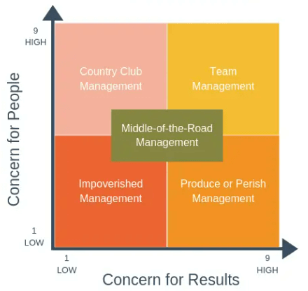

**How it works:**

1.Identify your leadership style:

Consider situations where you were a team leader and write down examples.

2.Identify areas for improvement:

Consider how you can improve your leadership style.

3.Evaluate the context:

Consider the situation you're in when evaluating your leadership style.

The grid depicted two dimensions of leader behavior, concern for people (accommodating people’s needs and giving them priority) on y-axis and concern for production (keeping tight schedules) on x-axis, with each dimension ranging from low (1) to high (9), thus creating 81 different positions in which the leader’s style may fall.

The five resulting leadership styles are as follows:

1.**Impoverished Management (1, 1):** Managers with this approach are low on both the dimensions and exercise minimum effort to get the work done from subordinates.

2.**Task management (9, 1):** Also called dictatorial or perish style. Here leaders are more concerned about production and have less concern for people. The style is based on theory X of McGrer

3.**Middle-of-the-Road (5, 5):** This is basically a compromising style wherein the leader tries to maintain a balance between goals of company and the needs of people.

4**.Country Club (1, 9):** This is a collegial style characterized by low task and high people orientation where the leader gives thoughtful attention to the needs of people thus providing them with a friendly and comfortable environment.

5.**Team Management (9, 9):** Characterized by high people and task focus, the style is based on the theory Y of McGregor and has been termed as most effective style according to Blake and Mouton.

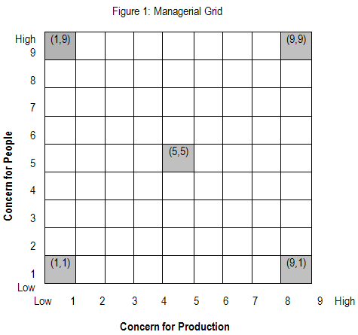

* **Advantages of Blake and Mouton’s Managerial Grid**

The Managerial or Leadership Grid is used to help managers analyze their own leadership styles through a technique known as grid training. This is done by administering a questionnaire that helps managers identify how they stand with respect to their concern for production and people.The training is aimed at basically helping leaders reach to the ideal state of 9, 9.

* **Limitations of Blake and Mouton’s Managerial Grid**

The model ignores the importance of internal and external limits, matter and scenario. Also, there are some more aspects of leadership that can be covered but are not.

**C. Contingency Theories**

Contingency theories suggest that the effectiveness of a leadership style depends on the situation. A key model is:

**Hersey & Blanchard’s Situational Leadership Model**

The Hersey-Blanchard Model is a leadership model that focuses on the ability and willingness of individual employees. Developed by Paul Hersey and Kenneth Blanchard, the model is also referred to as the Situational Leadership Model.

**An important note about Hersey and Blanchard to start with!**

Even though Hersey and Blanchard worked together for years to support the notion that leadership styles should be situational, they decided to go separate ways in 1977 to focus on their own agendas. Hence, the Hersey and Blanchard Situational Leadership Model (Figure 1), which was originally labelled The Life Cycle Theory of Leadership, has developed into two slightly divergent models. Blanchard decided to call his version of the model The Situational Leadership II Model (or SLII Model). Figure 2 shows the two different version next to each other. The major differences are related to semantics: where Hersey used the word ‘Readiness (R)’, Blanchard preferred to use ‘Development (D)’. And where Hersey used ‘Telling’, ‘Selling’ and ‘Participating’, Blanchard used the words ‘Directing‘, ‘Coaching‘ and ‘Supporting‘ respectively.

**[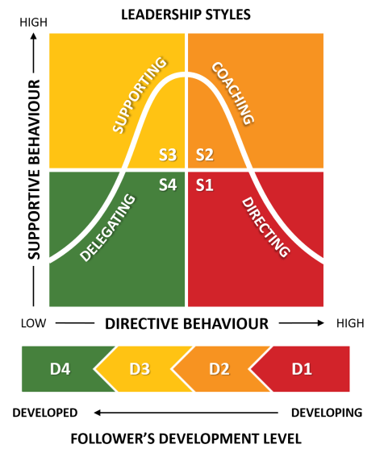](https://i0.wp.com/www.business-to-you.com/wp-content/uploads/2020/03/Hersey-and-Blanchard-Situational-Leadership-Model.png?ssl=1)**

**Figure 1: Hersey and Blanchard Situational Leadership Styles**

Follower’s Task Readiness (Task Development)

A follower’s or subordinate’s Task Readiness covers their ability to deliver what has been asked of them. Their skills, knowledge, and ability will affect their delivery of a task independently of a leader’s guidance. Blanchard preferred to use the word Development instead of Readiness as followers are likely to ‘grow’ in their abilities throughout time. Moreover, Blanchard used the term Competence (meaning: skills, knowledge and abilities) instead of Hersey’s term Ability.

**Follower’s Psychological Readiness (Psychological Development)**

A follower’s or subordinate’s Psychological Readiness is the degree to which they are willing to take on responsibility for their actions. This includes aspects such as their motivation, drive, energy and confidence in their own ability. For this, Blanchard used the term Commitment (meaning: confidence and motivation) instead of Hersey’s term Willingness.

R1 (D2): Unable and Unwilling (Low Competence and Low Commitment)

A follower with a R1-status is unable to complete the required task, because they do not possess the necessary set of skills to perform well. Moreover, they are either unwilling to deliver the required task or lack self-confidence. Note that Blanchard labelled this follower style with D2 instead of D1. The reason behind this choice is that Blanchard views this follower style as the second stage in a follower’s evolutionary development.

R2 (D1): Unable and Willing (Low Competence and High Commitment)

A R2 follower is just like a R1 follower unable to perform a certain task, but in contrast to a R1 follower, willing to try anyway. In other words: they are motivated to attempt the task even though they lack the skills, knowledge and/or ability to do so. This follower style is often seen with new employees who are keen to impress their supervisor, but still lack the work experience to be productive right from the start. Because of this, Blanchard decided to label this follower style with D1, as it is likely to be the first stage of a follower’s development. As followers gain experience they reach development level 2 (D2) and gain some competence, but their commitment drops because the task may be more complex than the follower had originally perceived at the start of the task.

R3 (D3): Able and Unwilling (High Competence and Low Commitment)

R3 followers are likely to be able to perform well on their task, since they have developed the necessary skill set. The problem, however, is that they are unwilling to do so. The reason for this behaviour are twofold: followers could be unmotived to comply with the leader’s request or could (still) be nervous about performing the task without enough support and encouragement from the leader. In Blanchard’s vocabulary of the D3 follower style, commitment is variable as it starts off as low, but gradually grows bigger due to more self-esteem and confidence untill a follower reaches D4.

R4 (D4): Able and Willing (High Competence and High Commitment)

Lastly, we have the R4 followers: they are ready, able and willing to perform. This means that followers are experienced at the required task and comfortable with their own ability to do it well and independently. They are able and willing to not only do the task, but to take responsibility for it. In this stage, both competence and commitment are considered to be high in terms of Blanchard’s version of the Situational Leadership Model.

[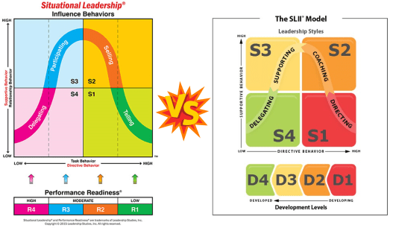](https://i0.wp.com/www.business-to-you.com/wp-content/uploads/2020/03/Hersey-versus-Blanchard-Situational-Leadership-Model.png?ssl=1)

Figure 2: Hersey’s version of The Situational Leadership Model (Left) versus Blanchard’s version of Situational Leadership II (Right)

* **Leader’s Directive Behaviour**

Based on these different follower styles, leaders should adapt their leadership style in such a way that it meets the needs of their subordinates. They can do so by finding the right balance between Directive and Supportive behaviour. A leader’s directive behaviour will fall somewhere on a spectrum from high to low and reflects the ‘concern for production‘-dimension of [Blake and Mouton’s Managerial Grid](https://www.business-to-you.com/blake-mouton-managerial-grid/). This implies to what extent a leader puts emphasis on the concern to get the job done by being task-focused. The appropriate level of directive behaviour that leaders will have to choose depends on the readiness or development level of followers.

* **Leader’s Supportive Behaviour**

A leader’s supportive behaviour reflects the ‘concern for people‘ dimension of Blake and Mouton’s Managerial Grid. This means to what extent a leader puts emphasis on building and maintaining a good relationship with subordinates by paying attention to the security, well-being and personal needs of the employees. The appropriate level of this relationship-focused approach is just like the directive behaviour determined by the readiness or development level of followers.

S1: Telling (Directing)

The S1 leadership style in the Hersey and Blanchard Situational Leadership Model puts a high emphasis on directive behaviour and a low emphasis on supportive behaviour. A leader’s primary concern lays with the task delivery and less with the personal needs of the subordinates. Typical behaviour for a S1 leadership style, according to Hersey, is offering step-by-step instructions, clear explanation of the consequences of non-performance and close supervision. In such a situation, it is important that the task is clearly defined and the stages of the process are easy to follow. This is important because the leader believes that the follower (R1) either does not know what to do or is unwilling and requires therefore a certain degree of coercive power. Blanchard, on the other hand, believes that this style should be used for D1 followers who are highly ‘Enthousiastic Beginners‘. They already have the motivation to do the tasks required, which lowers the need for supportive behaviour. But they still lack the competence, which increases their need for directive behaviour.

S2: Selling (Coaching)

The next leadership style is the high directive and high supportive S2 leadership style. Hersey argued that this style is needed for R2 followers who are willing, but not able to perform a task. The leader’s style should therefore be concerned with increasing the confidence and skills of followers so that they can ultimately take on more responsibility for their actions. Blanchard, however, believes this style is necessary for D2 followers, who used to be highly enthousiastic in the beginning but who lost confidence because their competences are failing them. These ‘Disillusioned Learners‘ therefore need a leader with a higher concern for supportive behaviour that helps them gain confidence and become motivated again.

S3: Participating (Supporting)

The S3 leadership style applies to both R3 and D3 followers. This style (still) shows high supportive behaviours, but low directive behaviours. This may involve listening, praise and a high level of interaction between leader and follower. In addition, the leader puts a high level of trust in the follower to achieve the day-to-day tasks as the follower’s competence has also grown over time. The leader will therefore only encourage and offer feedback when needed to motivate and develop the subordinate, but not as a comment on the task performance. This is because the leader believes that the follower is capable enough of achieving the required tasks largely independently.

S4: Delegating

The final leadership style assumes a low supportive and a low directive behaviour and applies to R4 and D4 followers. This is very much a ‘hands-off approach’ as the subordinate is perfectly able and willing to perform the tasks independently and with great responsibility. The leader can further encourage autonomy, while keeping an eye on not overloading the follower with responsibility and not withdrawing completely from the follower’s proximity. For these type of followers it is thus important as a leader to keep observing and monitoring them (albeit to a far lesser degree), in order to provide the necessary support if needed.

Hersey and Blanchard disagreed with academics like Blake and Mouton on the notion that there would be a single best ‘one-size-fits-all’ leadership approach that could be used within organizations. On the contrary, leadership styles should be adapted to the context. The model can therefore be considered as part of the larger Situational and Contingency Theories of Leadership of which [Fiedler’s Contingency Model of Leader-Situation Matches](https://www.business-to-you.com/fiedler-contingency-model/) is also part.

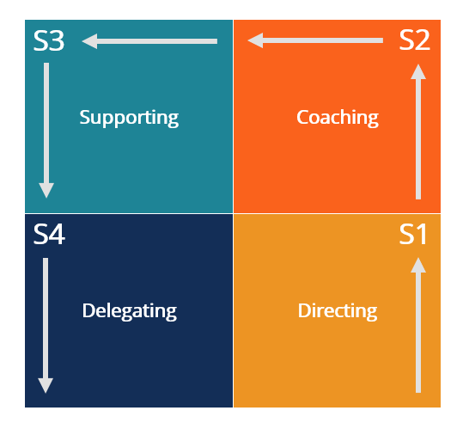

This model emphasizes that leaders must adjust their style based on followers' readiness levels. The four styles are:

1. **Telling (High Task, Low Relationship)** – Directing and closely supervising for low maturity followers.
2. **Selling (High Task, High Relationship)** – Encouraging and coaching for slightly more capable followers.
3. **Participating (Low Task, High Relationship)** – Sharing decision-making for moderately capable but unmotivated followers.
4. **Delegating (Low Task, Low Relationship)** – Entrusting responsibility to highly capable and motivated followers.

Based on the Hersey-Blanchard model, the four groups of followers are:

#### **1. Unable and Unwilling (D1)**

D1 followers are unable to complete their tasks because they lack the proper skills to succeed. They are also unmotivated and lack confidence in their abilities.

#### **2. Unable and Willing (D2)**

D2 followers are unable to complete their tasks, usually due to a lack of skills and experience. However, they are still willing to try and attempt the task. It exemplifies new employees that are motivated to succeed but lack adequate knowledge and ability.

#### **3. Able and Unwilling (D3)**

D3 followers have the capacity and experience to complete their tasks but are unwilling to do so. It can be attributed to a lack of self–confidence in their ability or a lack of motivation to follow their leader’s guidance.

#### **4. Able and Willing (D4)**

D4 followers have the necessary skills and experience, as well as the confidence in their ability to complete tasks successfully. The employees have the highest level of capacity and can complete tasks while also taking responsibility for their work.

**Explanation**

* The Situational Leadership Model was developed by Paul Hersey and Ken Blanchard.
* The model suggests that leaders should adjust their style based on the situation and the maturity level of their followers.
* The model is based on the idea that no one leadership style is appropriate for all situations.
* The model assumes that employees may respond better to different levels of guidance, supervision, and instruction.
* The model suggests that leaders should consider the level of competence and commitment of each individual team member

**D. Contemporary Views of Leadership**

Modern leadership approaches focus on adaptability, emotional intelligence, and transformative impact. Key contemporary leadership styles include:

1. Transformational Leadership – Inspires and motivates followers beyond self-interest.
2. Servant Leadership – Prioritizes the well-being of employees and stakeholders.
3. Authentic Leadership – Focuses on self-awareness, transparency, and integrity.
4. Adaptive Leadership – Encourages leaders to respond effectively to changing environments.

**Transactional leadership** is a leadership style that uses rewards and punishments to motivate employees to perform well. It's also known as managerial leadership.

**Characteristics:**

1. Clear expectations: Leaders set clear expectations for employees
2. Incentives: Leaders offer rewards to employees for completing tasks successfully
3. Monitoring: Leaders monitor employees' performance and correct any deviations from expectations
4. Focus on results: Leaders focus on achieving results
5. Telling style: Leaders use a "telling" style to communicate with employees

**How it works**

1. Transactional leadership is based on the idea that employees need structure, instruction, and supervision to perform well

2.Leaders act as negotiators with employees, identifying their needs and offering rewards in exchange

3.Employees expect to be rewarded with compensation for their work

**Examples:**

* Bill Gates, co-founder of Microsoft, used transactional leadership to manage his team
* Political leaders may use transactional leadership to ensure voter loyalty
* Social media influencers may use transactional leadership to grow their followers
* Factory foremen may use transactional leadership to maintain worker productivity

**Advantages and disadvantages**

Transactional leadership can motivate employees with things that matter to them, like money or recognition

However, employees may focus on achieving short-term goals to get rewards

## Transactional Leadership

Transactional leadership is often associated with a more traditional approach to management. It focuses on maintaining order and achieving short-term goals through a system of rewards and punishments. Leaders who adopt this style rely on a clear chain of command, well-defined roles and responsibilities, and strict adherence to established procedures.

## Characteristics of Transactional Leadership

**1. Contingent Rewards:**Transactional leaders motivate their team members by offering tangible rewards in exchange for meeting specific performance goals. This approach encourages compliance and often relies on extrinsic motivation, such as bonuses or promotions.

**2. Management by Exception:**Transactional leaders monitor their team's performance closely and intervene when deviations from established standards occur. They typically address issues through corrective actions and penalties, reinforcing a culture of accountability.  
**3. Clarity of Expectations:**Team members in a transactional leadership environment know precisely what is expected of them, as roles and responsibilities are clearly defined

## Impact of Transactional Leadership

Transactional leadership can be effective in certain contexts, such as industries with strict regulations or environments where safety and adherence to established protocols are paramount. However, it also has limitations. While it may drive short-term results and maintain order, it can stifle creativity and innovation. Team members may become motivated solely by rewards, leading to a lack of intrinsic motivation and limited personal growth.

## Transformational Leadership

In contrast to transactional leadership, transformational leadership focuses on long-term vision and inspiring change. Transformational leaders seek to motivate and empower their team members by fostering a shared vision, encouraging creativity, and promoting personal growth.

Transformational leadership is a management style that aims to change people and organizations by inspiring and motivating them. Transformational leaders encourage their followers to be innovative, creative, and take risks. They also try to make work more satisfying and rewarding.

**How Transformational Leadership Works:**

Transformational leadership happens when a leader’s actions influence and encourage subordinates to outperform their perceived abilities. Such a type of leadership motivates others to achieve unanticipated or outstanding results.

Transformational leadership provides individuals autonomy over specific duties, as well as the authority to make choices after they’ve been trained. It results in a favorable shift in the mindsets of the participants and the organization as a whole. Transformational leaders often exhibit four unique characteristics, commonly known as the four I’s.

The characteristics are:

Inspiration motivation

Idealistic influence

Intellectual stimulation

Individualized consideration

**Factors of transformational leadership**

1. Idealized influence: The leader sets a vision and leads by example
2. Inspirational motivation: The leader encourages and motivates their followers
3. Intellectual stimulation: The leader encourages their followers to experiment and think outside the box
4. Individualized consideration: The leader understands and addresses the needs of each team member

**Benefits of transformational leadership:**

* Creates positive organizational change

Transformational leadership can help build trust and create a supportive and inclusive workplace

* Promotes innovation and creativity

Transformational leaders can help employees view their organization's culture as more innovative

* Improves employee performance

Transformational leaders can help employees develop their potential and perform in ways that create meaningful change

### **The Four I’s of Transformational Leaders:**

### There are four (4) main characteristics of transformational leadership, and these can be summarized as:

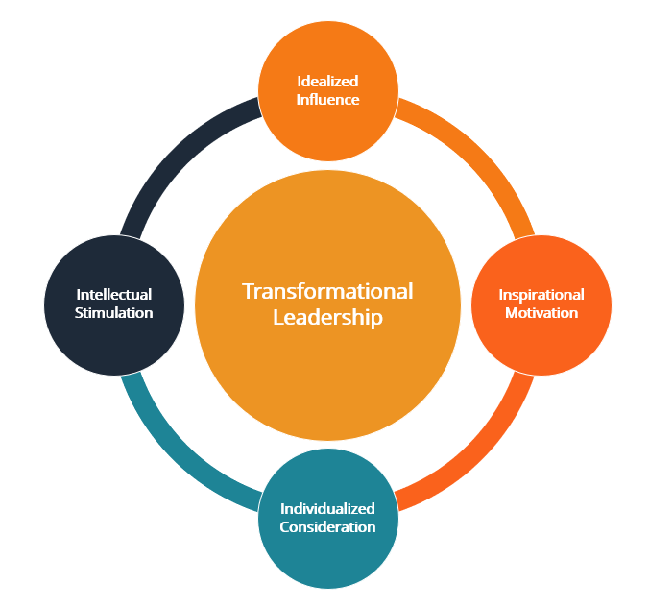

#### **Idealized Influence or “II”**

#### Idealized Influence denotes the leader’s function as an ideal role model for followers. A transformative leader exemplifies the characteristics that they seek in their team. In this instance, the followers regard the leader as a role model to imitate.

#### **2. Inspirational Motivation (IM)**

Transformational leaders may inspire and motivate people by providing a clear vision and communicating that vision. When joined together with “Idealized Influence,” the two characteristics represent the transformational leader’s productivity. With clarity, a transformative leader can readily inspire their people.

#### **3. Individualized Consideration (IC)**

Transformational leaders show genuine care for their followers’ emotions and needs, and they assist them in self-actualization. The individual attention to each follower contributes to the development of trust among the organization and its members and its authority figure(s).

#### **4. Intellectual Stimulation (IS)**

Transformational leaders encourage their followers to be creative and innovative and to question the status quo.